Setup txeis:

1. Setup Database (Mysql )

Demo site is using mysql for database, eventually we will change to Sybase.

* 1. Download mysql:

<https://www.mysql.com/>

Download and install the mysql server in your local, you may use MySQL Workbench or any client tools to connect to the configured mysql database.

* 1. Configure demo database:

Please use this script to create the txeis database:



1. Setup Java env:
   1. Install JDK (1.7 and above)

Download java jdk from: <https://www.oracle.com/technetwork/java/javase/downloads/jdk8-downloads-2133151.html>

* 1. Install Eclipse

Download eclipse from: <https://www.eclipse.org/downloads/>

1. Setup wildfly server in eclipse:
   1. Download wildfly server:

Download wildfly server from: <http://wildfly.org/downloads/>

* 1. Configure wildfly server in eclipse:
     1. Open the server view by clicking Window->Show View -> Other and find the Servers view:

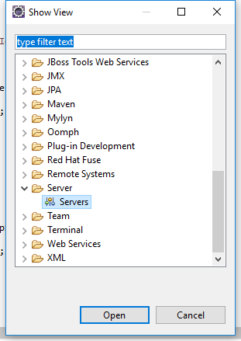

* + 1. At the server view panel, right click and select New-> Server:

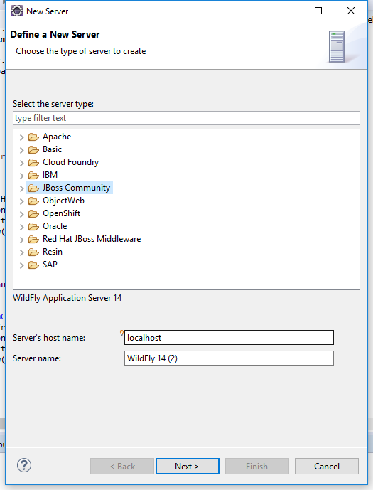

* + 1. Select JBoss Community, define your host name and server name, click next:

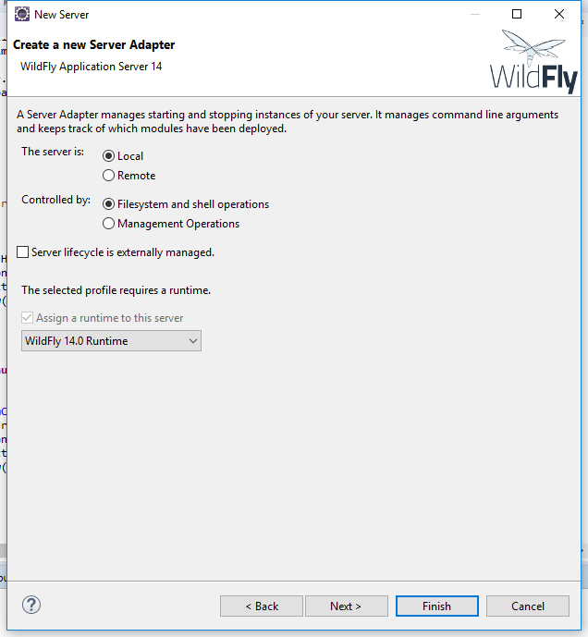

* + 1. Leave as default selection click Finish, the server should be added

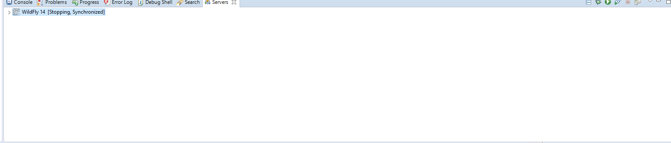

1. Configure project
   1. Download source code from git:

Git address: <https://github.com/Wenhao1015/txeis>

* 1. Import Project
     1. Click File->Import, select Maven->Existing Maven Projects

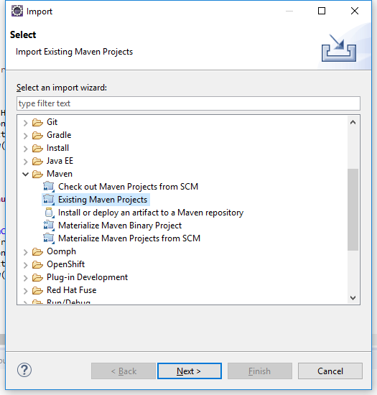

* + 1. Select the folder that the project is cloned from git, and click finish:

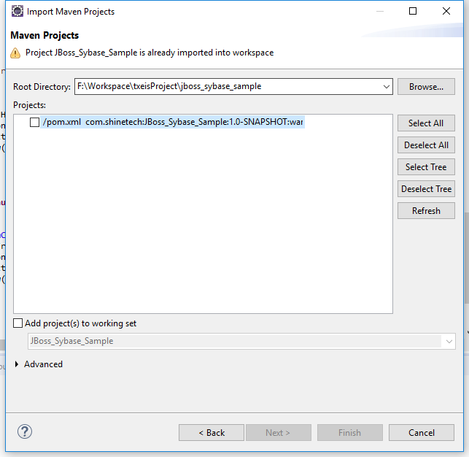

* + 1. Project should then be imported, right click on the project ->Maven -> Update Project:

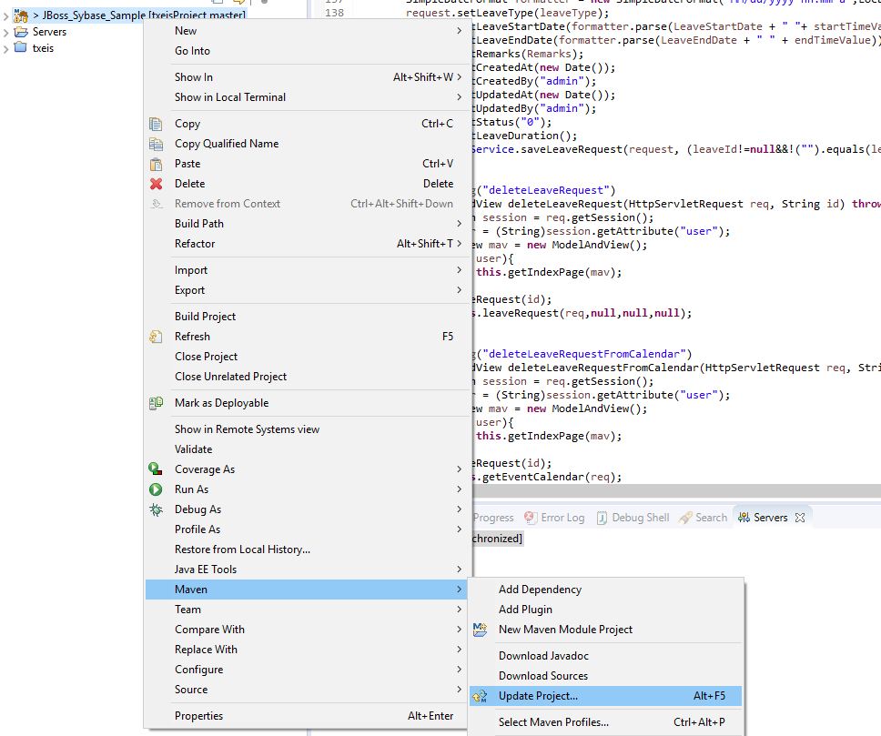

* 1. Setup database connections.

Open /src/main/resources/spring/spring-datasource.xml, change the configuration to be your local mysql settings:

p:jdbcUrl=*"jdbc:mysql://<host>:<port>/<database>?useUnicode=true&amp;characterEncoding=utf8&amp;serverTimezone=GMT%2B8&amp;useSSL=false"*

serverTimeZone is the time zone of your local mysql configuration.

p:user=*"<db user name>"*

p:password=*"<db user password>"*

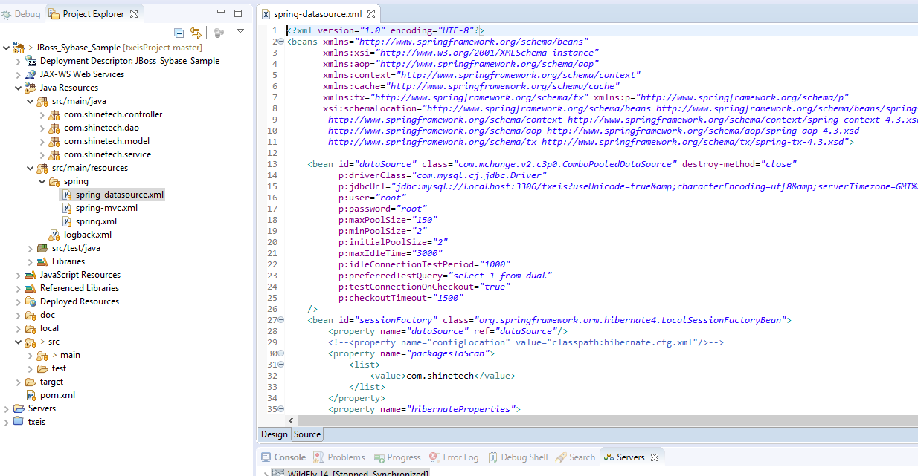

* 1. Configure the application on the wildfly server.
     1. Right click on the server -> Add and Remove, select the imported project and click on add:

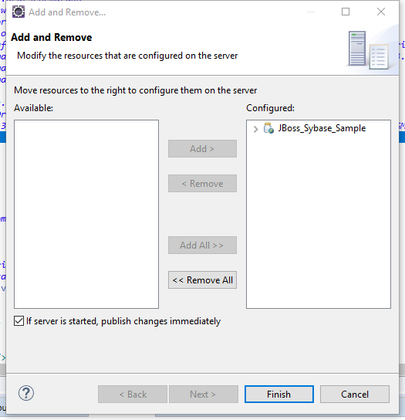

* 1. Maven: build and deploy.
     1. Right click on the project-> Run as -> Maven Clean, it will delete the target folder:

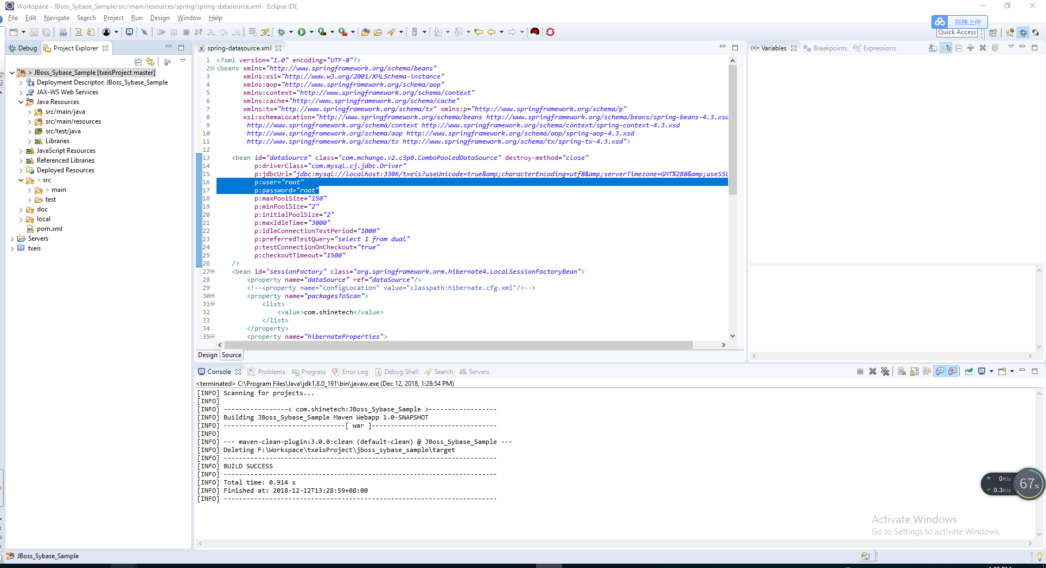

* + 1. Again right click on the project -> Run As -> Maven Install, which will generate the deployed version of the project, after which a war file should be generated upon success.

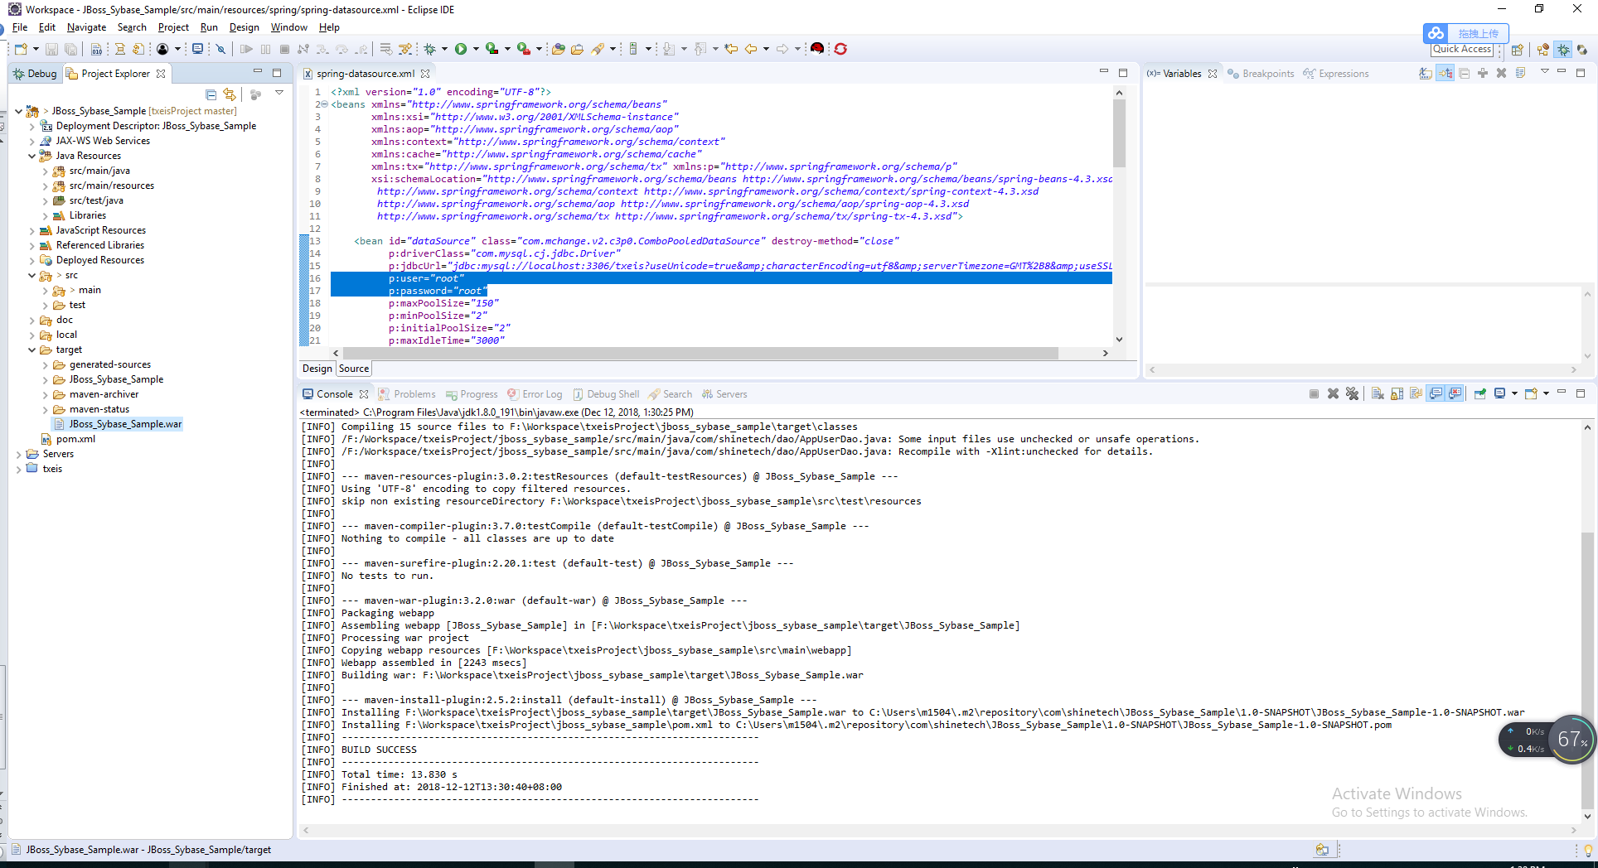

* + 1. After install successful, go to the servers view and click on debug or run to start the server:

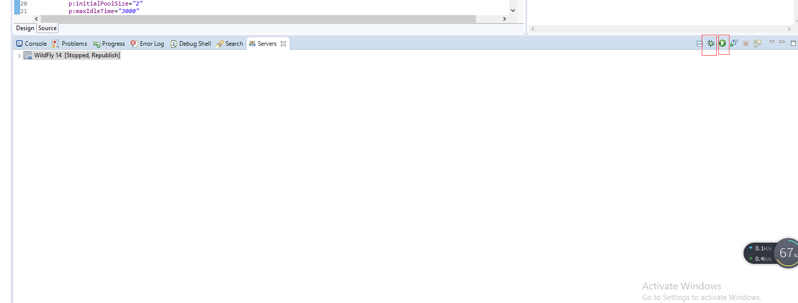

* + 1. If server started successfully, you may access the application at http://<defined host name >:<your port>/txeisDemo/

