Functional Specification

Version Number 1
Revision Date‐Time 9/15/2014 12:20:00 PM

Development Project Member:
Zhengfei Duan
Yaguang Deng
Xiao Han
Rohit

Version | Status | Date | Edited By | Description of Change
1 | Draft | 9/15/14 | Z.Duan | Start of draft template

1 Overview

1.1 Description

Create a Java Web Application using HTML, CSS, JavaScript, JSP, JDBC and AJAX to manage Personal Banking Services.

1.2 Scope
Requirements for this project are:
1.CRUD (Create, Retrieve, Update and Delete) operations for
A. Types of Accounts
B. Customers
2. Range of Online Banking Services to be made available for customers
3. Must be able to generate reports (.xls) on various scenarios
4. Generating Graphs (Bar / Pie) for some data

Based on the requirements provided from the document and our discussion, we decomposed the objectives we intended to achieve into those parts:
1. At the top level, we will have an admin interface, which enables the authorized admin to manipulate the database (CRUD) ,like create User, add/reduce balance etc.
2. Apart from admin, regular users can login as a customer, or register to be a customer.
3. Users can view real-time balances and pending transactions, make payment, schedule money transfer, retrieve their personal information, or deposit by upload a check photo.
4. Users can also generate their bank statements based on different types with pie charts, or export them as .xls.

2 Functionality

This section provides a general and integral view of the functional architecture. It describes functional components at a high level, as well as how they interact.

2.1 Database Design
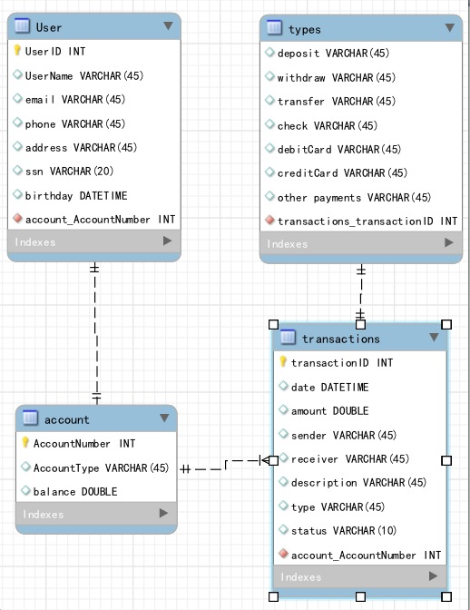

Based on the requirement, we designed 4 tables to deal with those online banking scenarios. They are User, Account, Transactions and Type.

2.2 Description of initial function design

For user side:
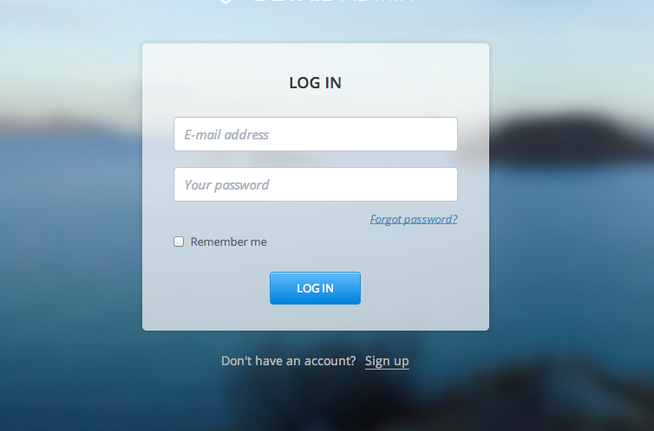
1. Login and register: provide user login and register interface
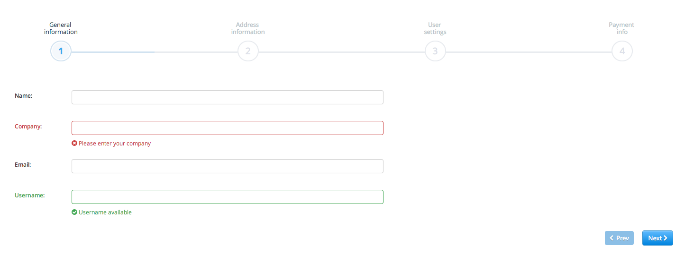


2.When user clicks signed in, display the home page. On the left side are the functions in a navigation bar that users can access, on the right side is the correspond function. The home page will display some statistics as default(user can generate reports).
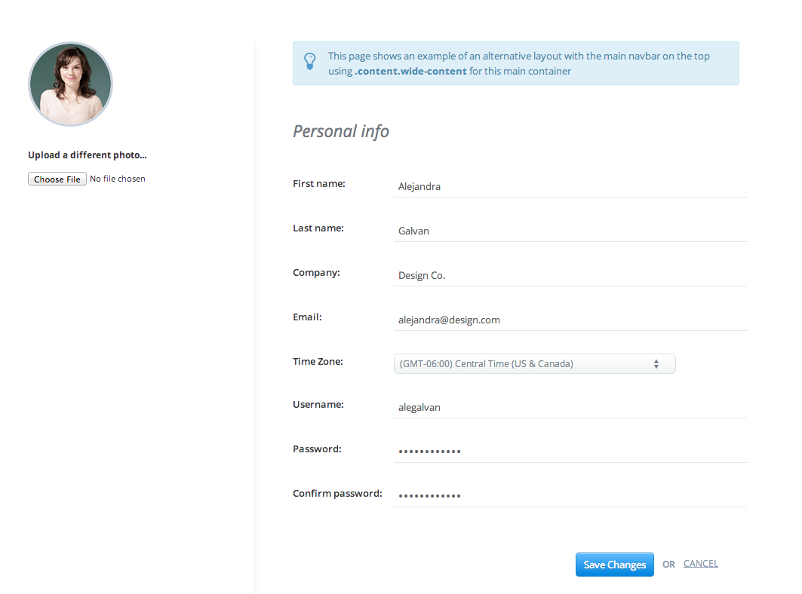
3.user can view/edit his profile with his basic info listed

4. User can view his transaction history, transaction status or search transactions in a table, transactions are divided into different types, and transaction status will be displayed:
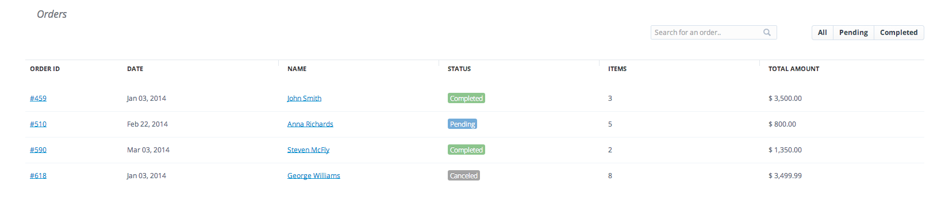
5. User can add transaction and deposit by upload check photo(UI still designing)

For Admin side:
1. Admin can view user list

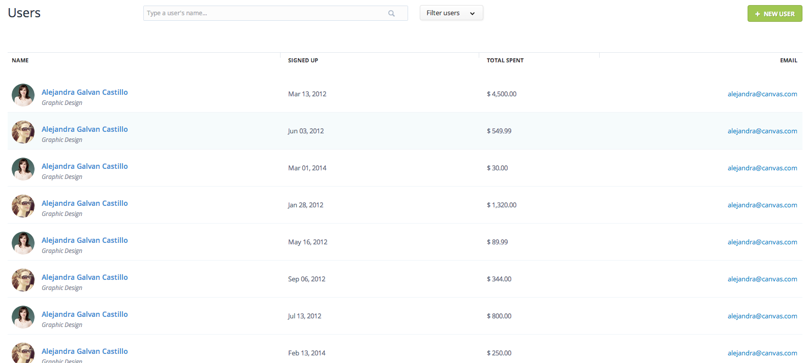
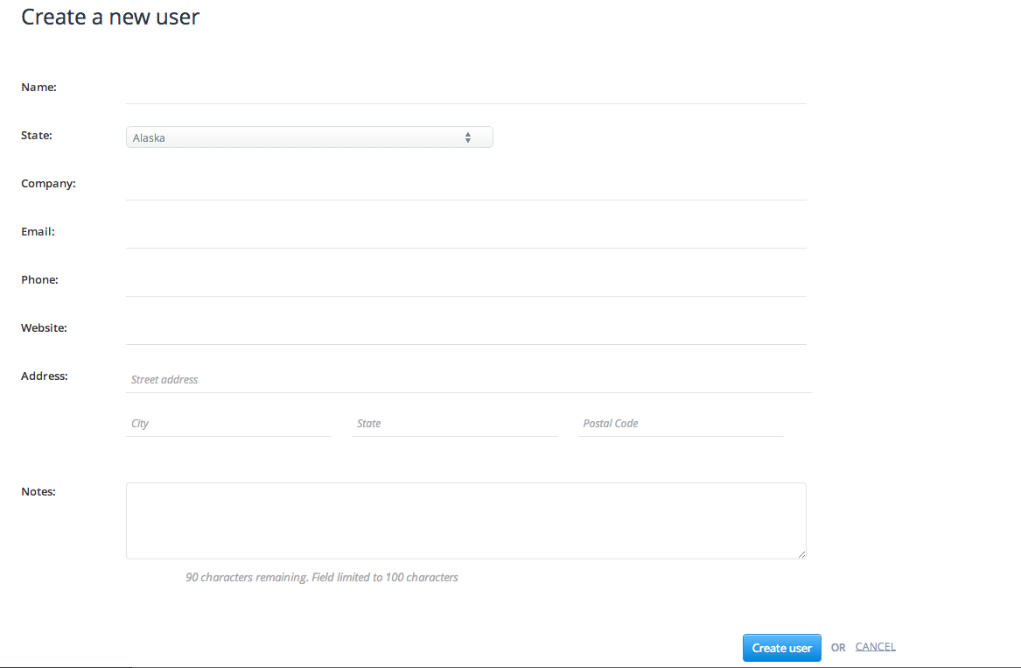
2.Admin can add user

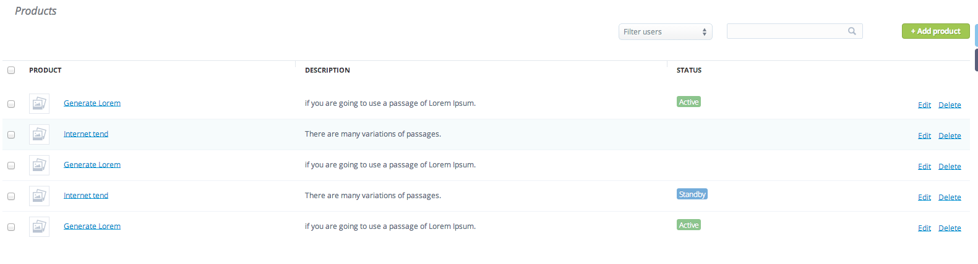
3. Admin can edit transactions (add, delete, edit)

4. Admin can withdraw money based on checking photo user provided(add transaction)

