# Project Report

**1. INTRODUCTION**

**1.1 Overview**

Retail Management deals with selling of goods and services to consumers. It involves a direct

Interaction with the customer and coordinating business activities from designing of a product

to its delivery and post-delivery services. Those who are specialists in retail management are

generally known as Retail Managers. A Retail Manager is expected to address consumers’

problems, monitor retail orders, handle merchandising, manage HR and also supervise the

stocks/inventory and supply chain management.

**1.2 Purpose**

* Making store improvements
* Spending more on marketing
* Expanding your product range
* Producing more goods, faster
* Hiring more skilled staff

**2. PROBLEM DEFINITION & DESIGN THINKING**

**2.1 Empthathy Map**

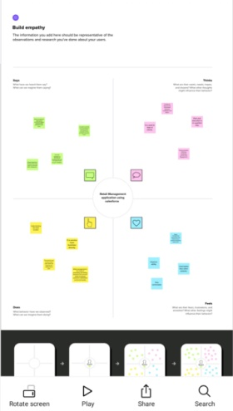

**2.2 Ideation & Brainstorming Map**

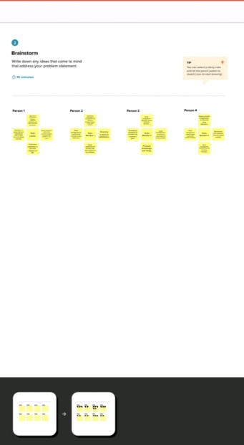 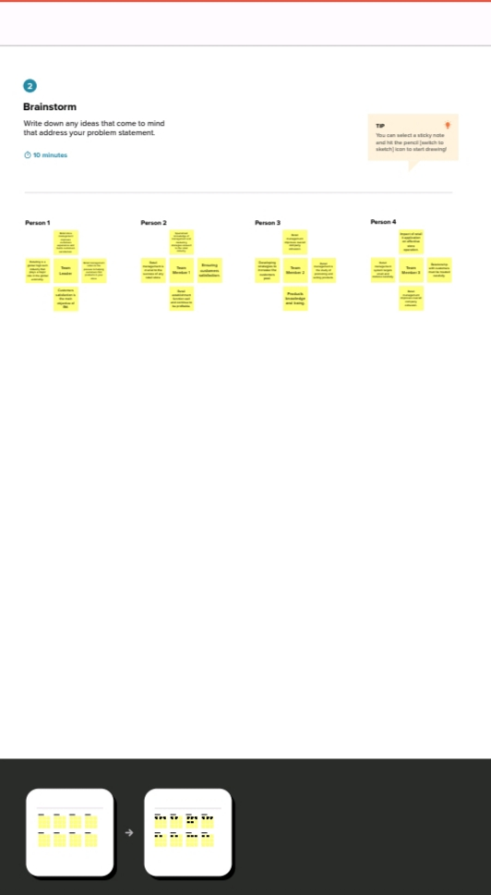

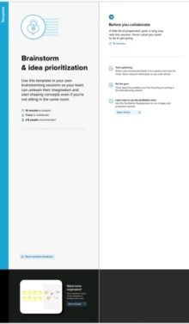 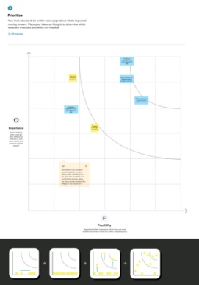

|  |
| --- |
|  |

**3. RESULT**

**3.1 Data Model:**

**3.2 Activity & screenshot**

|  |  |
| --- | --- |
| **Object Name** | **Field in the object** |
| Dispatch/tracking |  |
| |  |  |  |  |  |  |  |  |  |  |  |  | | --- | --- | --- | --- | --- | --- | --- | --- | --- | --- | --- | --- | | |  |  |  | | --- | --- | --- | |  |  | | | **Field Lable** | **Data Type** | | Dispatch/tracking | Text | | Dispatched | Checkbox | | Dispatch/tracking | Master Detail Relationship | | |
| Account | |  |  | | --- | --- | | **Field lable** | **Data Type** | | Phone | Text | |
| Contact | |  |  | | --- | --- | | **Field lable** | **Data Type** | | Account Website | Formula | |
|  |

**3.2 Activity & Screenshot**

First we need to create new custom object that related to our topic , and

Type the other details too.

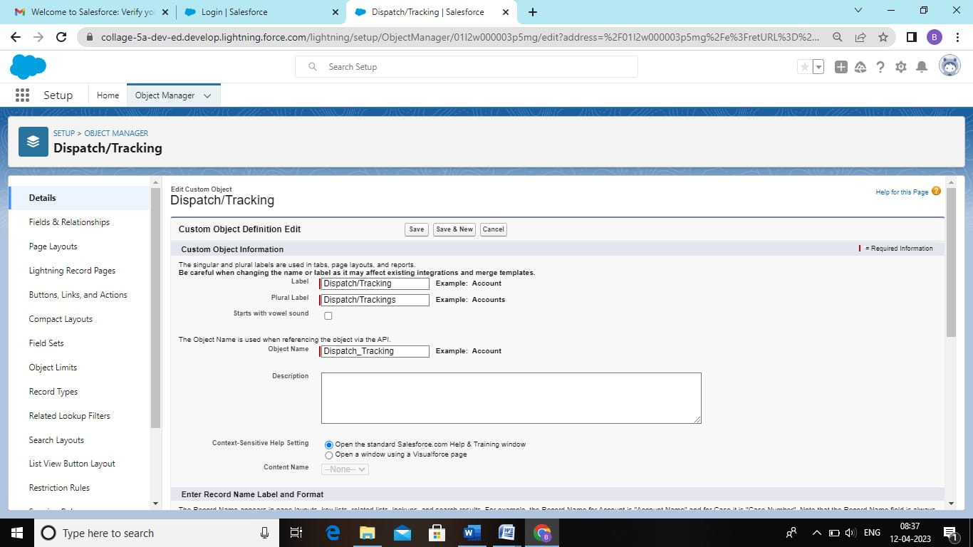

**In this next steps go to the object manager and select the Dispatch/tracking**

**And select the fields and relationship. Click new and select the data type**

**Has Checkbox.**

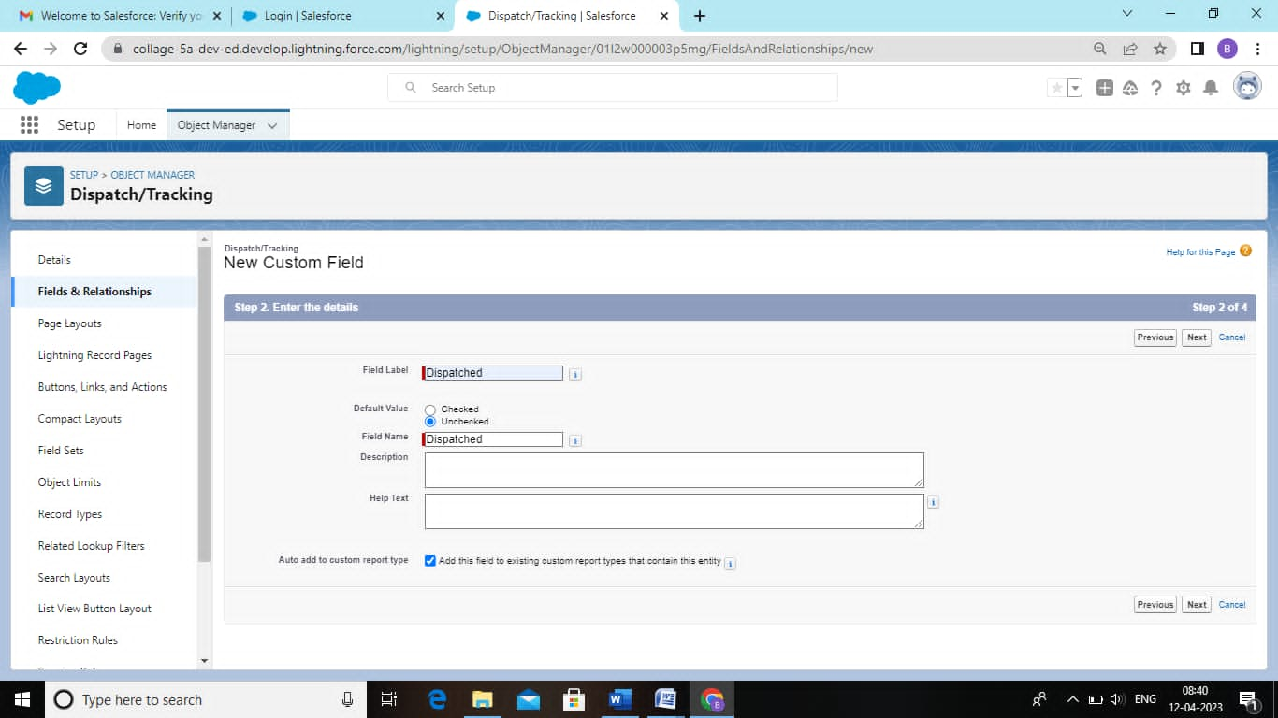

**Creation of custom tabs. For objects select warehouse for tab style select**

**Any icon.**

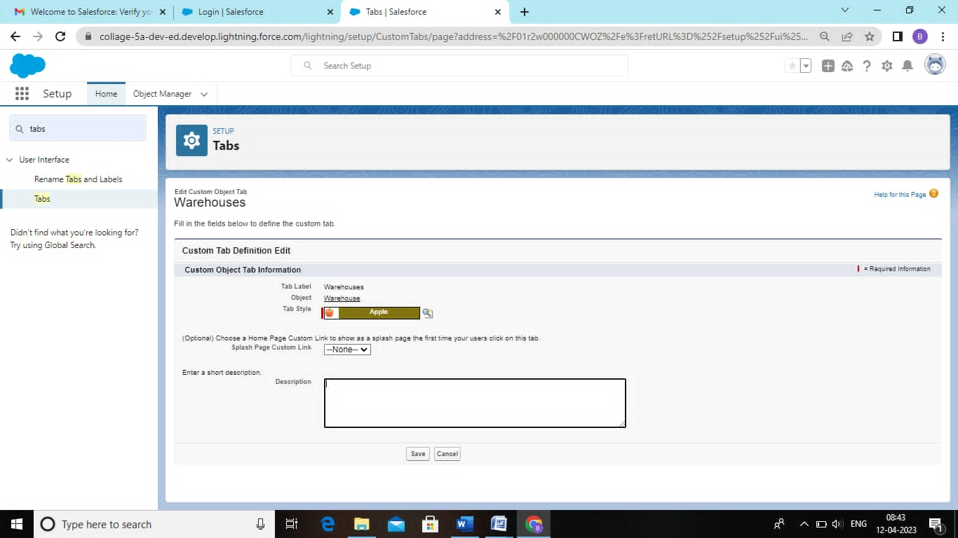

**And we need to create a new user. Give the answers to the particulars.**

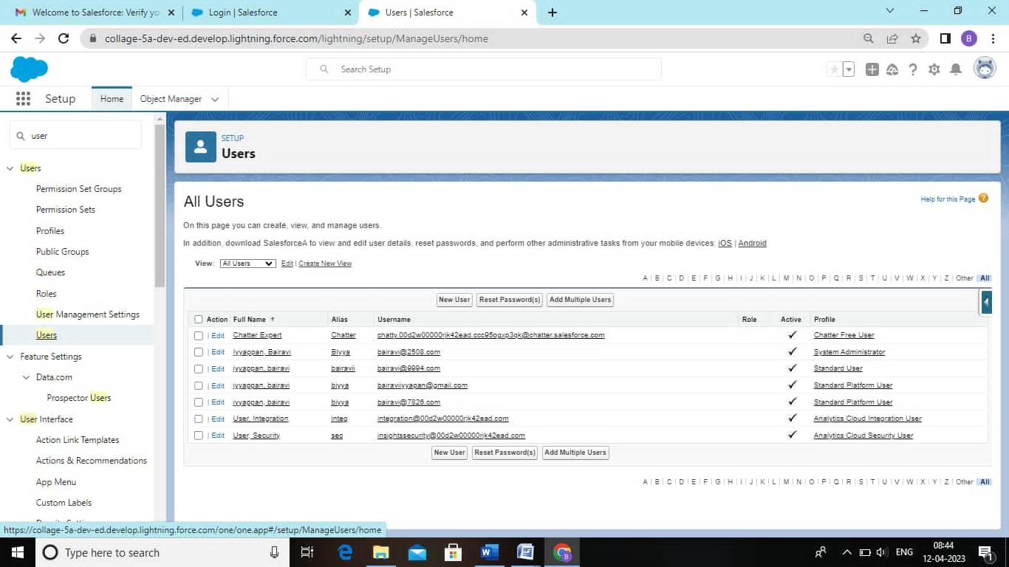

**To create the cross object formula select the object manager and enter**

**The values.**

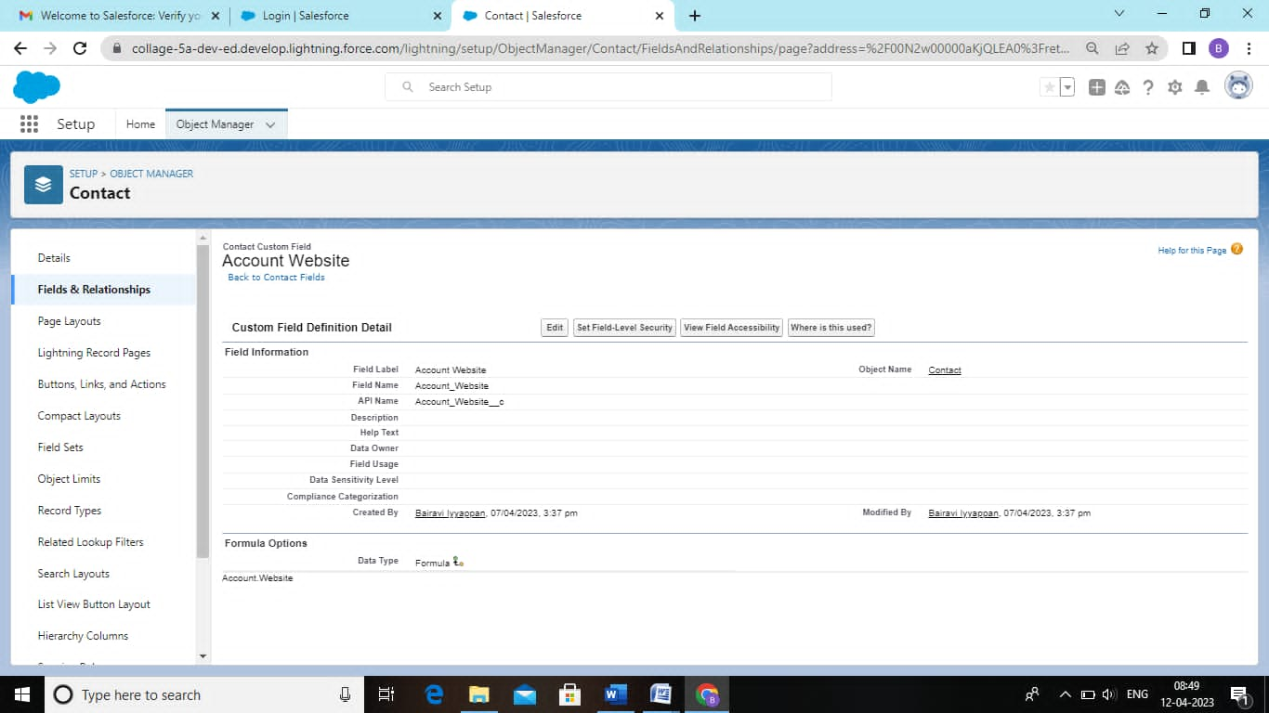

**Finally we got the report by done the step by step of milestones.**

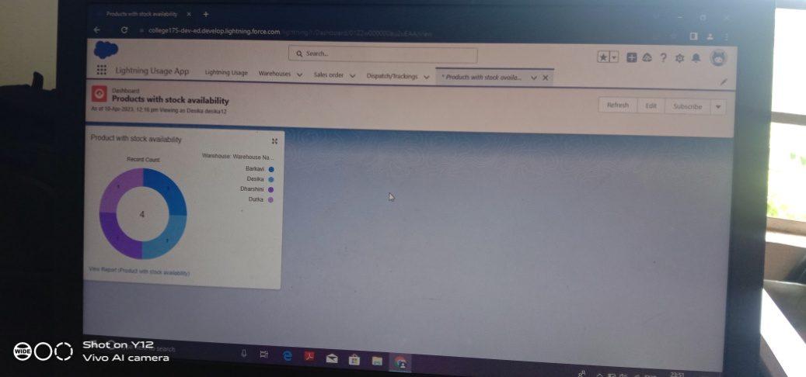

**4. TRAILHEAD PROFILE PUBLIC URL**

**Team Lead –** [**https://trailblazer.me**](https://trailblazer.me) **/id/d2020batch3**

**Team Member 1-** [**https://trailblazer.me/i**](https://trailblazer.me/i)

Team Member 2- <https://trailblazer.me/id/d2020batch5>

Team Member 3- <https://trailblazer.me/id/d2020batch4>

**5. Advantages**

* A Company can increase the efficiency of each process and better ensure

a high-quality standard for employees. As a result, execution may accomplish their goals at faster rates.

* Retail is the maximum direct enterprise shape among the service provider

and the purchaser.

* Retailing affords a facility to have face-to-face interaction. Consumers

Depend on stores for their wished items.

**Disadvantage**

* High Marketing cost
* Selling skill required
* Very high competition
* No economies of buying

**6. Application**

* Sales force can be used to manage orders from retail stores and distributors,

Including tracking orders, processing payments, and managing inventory levels.

* This can help field sales teams ensure that orders are fulfilled quickly

And accurately and that inventory levels are maintained at optimal levels.

* Sales force can be used to create and manage beat plans for field

Sales teams.

* This includes scheduling store visits and tracking the result of those visits.
* Sales force for retail can also be used to track the performance of field

Sales teams, including metrics such as sales and customers satisfaction.

**7. Conclusion**

In this course we have explored the meaning of the terms retailing, Marketing

Communications. We have also considered the importance of the marketing mix and

Identified the different communication tools that a retailer might use to interact and

Communicate with their target customers. You have been introduced to a few theoretical

Concepts and ideas, which have been illustrated using real world examples and cases in

Retailing.

**8. Future scope**

* Growth will be slow initially, but ramp up quickly.
* Smaller retailers will start to close, reducing consumer option and driving

more people online

* The role of the physical store will still be important despite the rise of Onl

In fact, brick-and-mortar retail can still thrive in the new era.

* Supervisory, client communication, merchandise shipment, management

And administrative services are all options for candidates with a retail

Management background.

* More than 2 million jobs are available in retail-management around the world.