---

🎶 Project Title:

Rhythmic Tune – Your Melodic Companion

---

🎯 Objective:

To design a music-based intelligent companion that helps users:

Learn, create, and enjoy music

Reduce stress through personalized melodies

Improve creativity and relaxation with AI-generated tunes

---

🔑 Features:

1. Mood-based Music Recommendation 🎧

Detect user mood (via text, voice, or face recognition)

Suggest soothing / energetic / focus-based tracks

2. AI Tune Generator 🎼

Create new melodies from user’s input (humming / lyrics / instruments).

3. Music Learning Companion 🎤

Step-by-step training for beginners (raga, chords, rhythm).

Real-time feedback on singing/instrument practice.

4. Therapeutic Mode 🧘

Stress relief tunes, sleep melodies, meditation sounds.

5. Community Sharing 🌍

Users can compose and share their own tunes.

---

📱 Tech Stack:

Frontend: Flutter / React Native (for mobile app)

Backend: Django / Node.js

Database: Firebase / MySQL

AI Models:

Speech-to-Text (Google API / Whisper)

Music Generation (Magenta AI, RNN/LSTM models)

Emotion detection (TensorFlow, OpenCV)

---

🛠️ Extensions:

IoT-based “Smart Music Speaker” with voice commands

Integration with Spotify/YouTube for streaming

---

🌍 Use Cases:

Students – Stress relief & focus during study

Elderly – Music therapy for relaxation

Musicians – AI-assisted composition & practice

General users – Personalized music companion

---

🚀 Expected Outcome:

A smart melodic companion app that:

Boosts creativity

Provides emotional support through music

Makes music learning interactive an

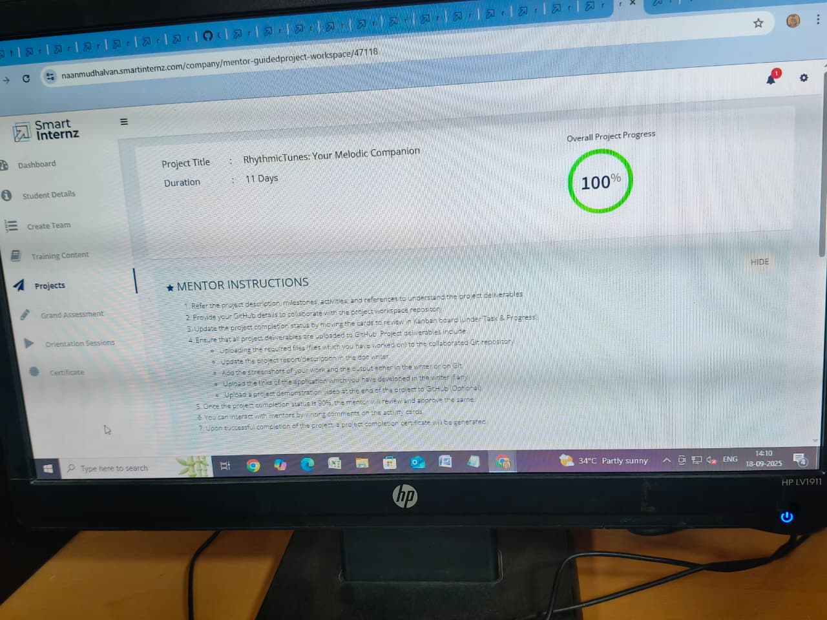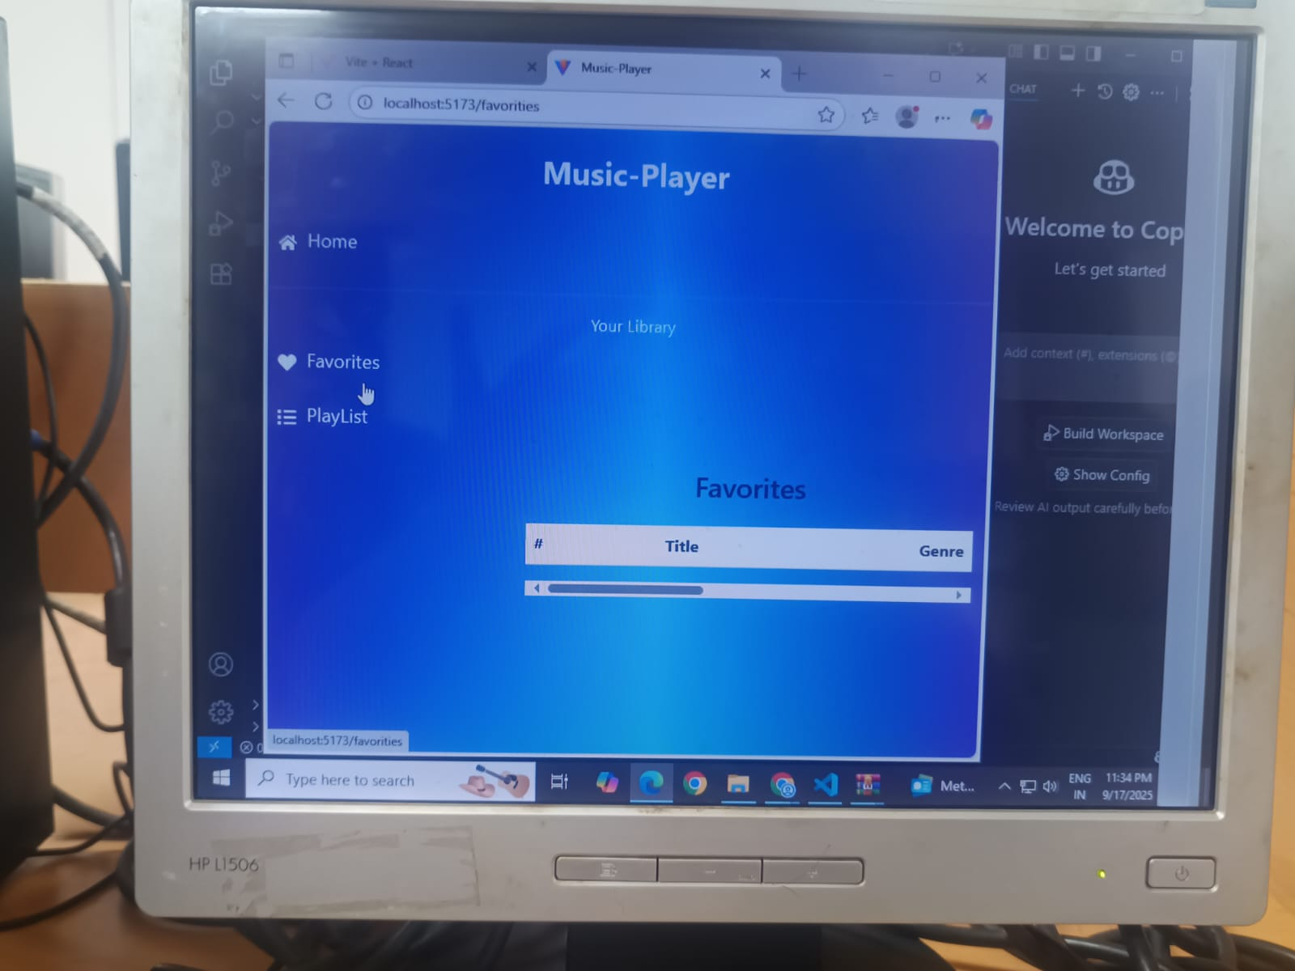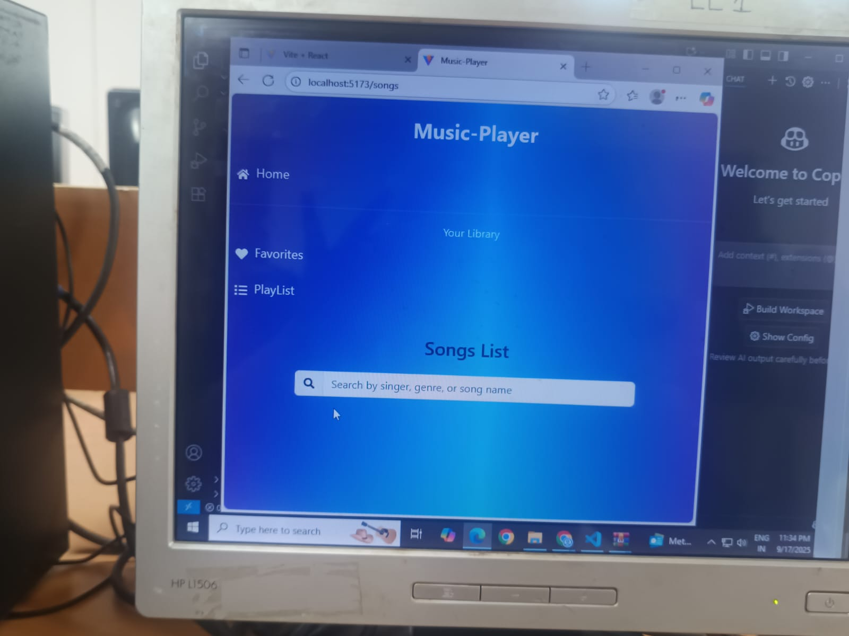

# THANK YOU