rohit sharma odi career

sai prasad desineni

1/30/2022

data101 = read.csv("C:/Users/desineni/Desktop/ROHIT.csv")  
data101

## X Year Innings Runs Balls Outs Avg SR HS X50 X100 X4s X6s Dot..  
## 1 0 2007 3 61 74 3 20.3 82.4 52 1 0 3 1 47.3  
## 2 1 2008 28 532 733 21 25.3 72.6 70 3 0 44 3 53.9  
## 3 2 2009 7 102 155 4 25.5 65.8 43 0 0 5 1 52.3  
## 4 3 2010 14 504 586 13 38.8 86.0 114 1 2 34 7 43.9  
## 5 4 2011 16 611 739 11 55.5 82.7 95 6 0 40 9 45.6  
## 6 5 2012 13 168 251 13 12.9 66.9 68 1 0 12 2 56.6  
## 7 6 2013 27 1196 1480 23 52.0 80.8 209 8 2 119 30 57.8  
## 8 7 2014 12 578 613 11 52.5 94.3 264 3 1 58 22 54.3  
## 9 8 2015 17 815 854 16 50.9 95.4 150 4 3 76 23 51.1  
## 10 9 2016 10 564 592 9 62.7 95.3 171 2 2 46 19 51.2  
## 11 10 2017 21 1293 1300 18 71.8 99.5 208 5 6 116 46 49.5  
## 12 11 2018 19 1030 1029 14 73.6 100.1 162 3 5 104 39 52.4  
## 13 12 2019 27 1490 1657 26 57.3 89.9 159 6 7 146 36 53.0  
## 14 13 2020 3 171 187 3 57.0 91.4 119 0 1 16 6 54.5  
## 15 14 2021 3 90 104 3 30.0 86.5 37 0 0 15 0 56.7  
## 16 15 Total 220 9205 10354 188 49.0 88.9 264 43 29 834 244 52.1  
## HS.in.the.year  
## 1 M HAYDEN  
## 2 B MACCULLUM  
## 3 CK COVENTRY  
## 4 SACHIN  
## 5 SEHWAG  
## 6 V KOHLI  
## 7 ROHIT  
## 8 ROHIT  
## 9 MJ GUPTIL  
## 10 DE KOCK  
## 11 ROHIT  
## 12 FAKHAR ZAMAN  
## 13 JOHN CAMPBELL  
## 14 LITON DAS  
## 15 FAKHAR ZAMAN  
## 16

#ABove is the selected data   
mean(data101$Runs)

## [1] 1150.625

#this is the mean of the number of runs scored by rohit in his career  
sd(data101$Runs)

## [1] 2194.52

#this is the standard deviation fo the runs  
median(data101$Balls)

## [1] 673

data101$Runs_transformed = (data101$Runs - median(data101$Runs)/sd(data101$runs) + mean(data101$Runs))  
data101$Runs_transformed

## [1] NA NA NA NA NA NA NA NA NA NA NA NA NA NA NA NA

#this is the transformation thats is made  
hist(data101$Outs)

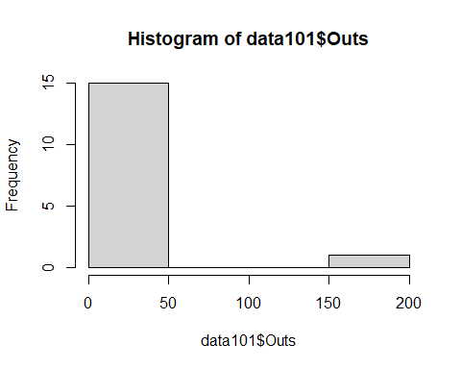

#this is the dipiction of the number of out's on the histogram  
hist(data101$Balls)

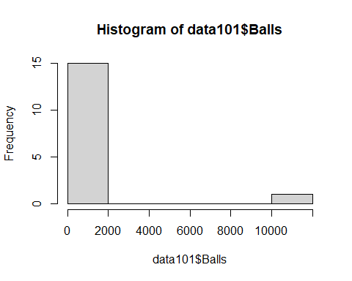

#this is the dipictiopn of the number of balls played on the histogram  
x = data101$Runs  
y = data101$Balls  
plot(x,y, main = "Runs and balls", xlab = "Runs", ylab = "Balls")

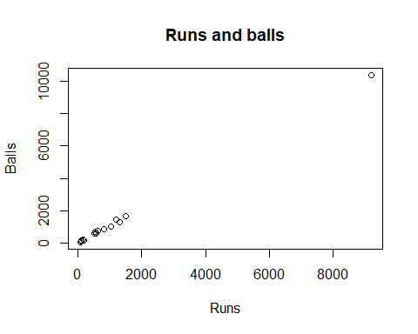

#here is the representation of the x and y variables with the assigned values plotted on the graph