**Immunization Test Suite**

**Receiver SOAP Connectivity Testing**

**Draft 1.9**

**23rd March, 2015**

**Approved**

**Immunization Test Case**

**Receiver**

**SOAPCON_2_SubmitSingleMessage_Response**

**SubmitSingleMessage_Response**

**Test Description**

Description

|  |
| --- |
|  |
| This test evaluates the capability of a receiver (responder) technology conforming to the SOAP 1.2 standard and CDC WSDL 1.0 to receive a SOAP request message (containing an HL7 message), and respond appropriately. |

Test Objectives

|  |
| --- |
|  |
| The receiver (responder) technology will demonstrate the ability to:   * Receive a SOAP message with the Body element containing **submitSingleMessage**, as defined in the CDC WSDL 1.0, and arbitrary conforming values for all child elements**:** *username*, *password*, *facilityID*, and *hl7Message* * Transmit a SOAP response message to the sender (initiator) that contains the element submitSingleMessageResponse, as defined in the CDC WSDL 1.0 with the return child element containing a valid HL7 message |

**SOAP Connectivity Testing Diagram**

**Receiver**

**SOAPCON_2_SubmitSingleMessage_Response**

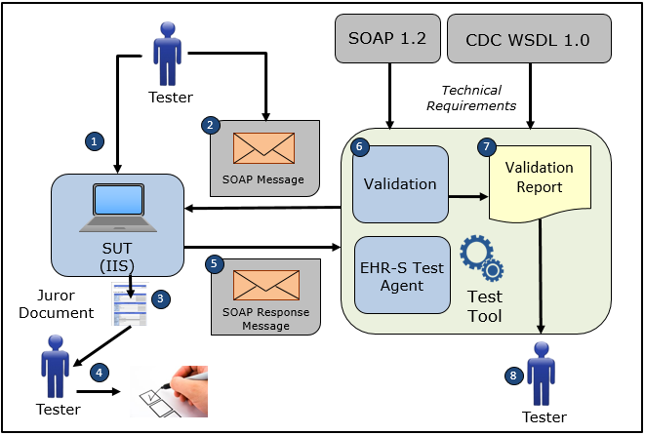

1. The Tester configures the NIST Test Tool with the appropriate Username, Password, FacilityID, and Endpoint information. Note that the values for these parameters must be chosen to be those appropriate to the System Under Test (IIS).
2. The Tester causes the NIST Test Tool to electronically generate and transmit to the System Under Test a SOAP connectivity request message **submitSingleMessage** that conforms to the SOAP 1.2 standard and CDC WSDL 1.0 used for transporting an HL7 request message to an IIS
3. The Tester obtains the Juror Document for the Receiver SOAPCON_2_SubmitSingleMessage_ Response Test Case in the NIST Test Tool
4. The Tester uses the Juror Document to determine if the System Under Test received and processed the conformant SOAP request message completely and correctly
5. The System Under Test electronically generates and transmits to the EHR-S Test Agent in the NIST Test Tool a SOAP connectivity response message **submitSingleMessageResponse** that conforms to the SOAP 1.2 standard and CDC WSDL 1.0 and that is used for transporting an HL7 response message to a sender (initiator) system
6. The Test Tool validates the SOAP connectivity response message for conformance to the SOAP 1.2 standard and CDC WSDL 1.0
7. The Test Tool generates a Validation Report listing the results of the validation
8. The Tester reviews the Validation Report and compares the results to the Objectives and Evaluation Criteria associated with the Receiver SOAPCON_2_SubmitSingleMessage_Response Test Case

**Test Data Specification**

Submit Single Message Request Message Information

|  |  |  |
| --- | --- | --- |
| **Element Name** | **Data** | **Classification of Data** |
| **submitSingleMessage:** username | ??? | User-Provided |
| **submitSingleMessage:** password | ??? | User-Provided |
| **submitSingleMessage:** facilityID | ??? | User-Provided |
| **submitSingleMessage:** HL7 Message | MSH|^~\&amp;|Test EHR Application|X68||NIST Test Iz Reg|201207010822||VXU^V04^VXU_V04|NIST-IZ-007.00|P|2.5.1|||AL|ER&#xD;PID|1||MR-99922^^^NIST MPI^MR||Montgomery^Lewis^^^^^L||20010821|M&#xD;ORC|RE||IZ-783276^NDA&#xD;RXA|0|1|20110215||118^HPV^CVX|999|||01^Historical information - source unspecified^NIP001 | Changeable |

Explanation of Data Classification

| **Data Classification** | **Description** | **Validation** |
| --- | --- | --- |
| **Configurable** | Data typically that are configured by the system (customer-definable). Example data are provided. | Validate for the presence of data |
| **System Generated** | Data typically generated automatically by system, e.g., message time. Example data are provided. | Validate for the presence of data |
| **IG Fixed** | Data that are fixed by the implementation guide; data can’t be changed. Specific data are provided. | Validate for the presence and data content |
| **Test Case Fixed** | Data that are specific and fixed by the test case; data should not be changed. Specific data are provided. | Validate for the presence and selectively validate for data content |
| **Changeable** | Data where the exact content is not relevant for the test case and can be changed for the purposes of testing. Example data are provided. | Validate for the presence of data |
| **Test Tool-Assigned** | Data that are assigned by the test tool for the specific System Under Test in real-time. Example data are provided. | Validate for the presence and for data content |
| **Test System-Provided** | Data that are provided by the System Under Test in real-time. Example data are provided. | Validate for the presence and for data content |

**Example Message Content Table**

Test Case Information

|  |  |
| --- | --- |
| **Element Name** | **Data** |
| Test Case ID | Receiver SOAPCON_2_SubmitSingleMessage_Response |

Submit Single Message Request

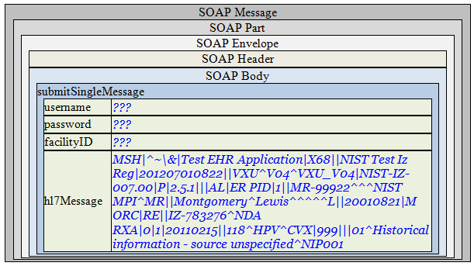

Note: A unique value for the username and password will be assigned by the System Under Test

**Juror Document**

**Example Message Content**

**Request Message Sent by Sender System**

<?xml version='1.0' encoding='UTF-8'?>

<Envelope xmlns="http://www.w3.org/2003/05/soap-envelope">

<Header />

<Body>

<submitSingleMessage xmlns="urn:cdc:iisb:2011">

<username>???</username>

<password>???</password>

<facilityID>???</facilityID>

<hl7Message>MSH|^~\&amp;|Test EHR Application|X68||NIST Test Iz Reg|201207010822||VXU^V04^VXU_V04|NIST-IZ-007.00|P|2.5.1|||AL|ER&#xD;PID|1||MR-99922^^^NIST MPI^MR||Montgomery^Lewis^^^^^L||20010821|M&#xD;ORC|RE||IZ-783276^NDA&#xD;RXA|0|1|20110215||118^HPV^CVX|999|||01^Historical information - source unspecified^NIP001</hl7Message>

</submitSingleMessage>

</Body>

</Envelope>

Note: A unique value for the username and password will be assigned by the System Under Test

**Evaluation Criteria**

Criteria

|  |
| --- |
|  |
| This box **must** contain information that explains how the SUT will be evaluated to determine that successful conformance is demonstrated during the testing.  Need to determine what criteria are needed on a Test Case-by-Test Case basis. |