**Immunization Test Suite**

**Receiver SOAP Envelope Testing**

**Draft 1.4**

**19th December, 2014**

**Immunization Test Case**

**Receiver**

**SOAPENV_1_ConnectivityTest_Response**

**ConnectivityTest_Response**

**Test Description**

Description

|  |
| --- |
|  |
| This test evaluates the capability of a Receiver technology to generate a valid message conforming to the SOAP 1.2 standard and CDC WSDL 1.0 that may be used for confirming the accessibility of the Immunization Information System (IIS) Web Service. |

Test Objectives

|  |
| --- |
|  |
| The Receiver technology will demonstrate the ability to generate the SOAP message where the body of the message contains:   * the element **connectivityTestResponse**, as defined in the CDC WSDL 1.0 * arbitrary string value for the child element of **connectivityTestResponse**:  *return*. |

**SOAP Envelope Testing Diagram**

**Receiver**

**SOAPENV_1_ConnectivityTest_Response**

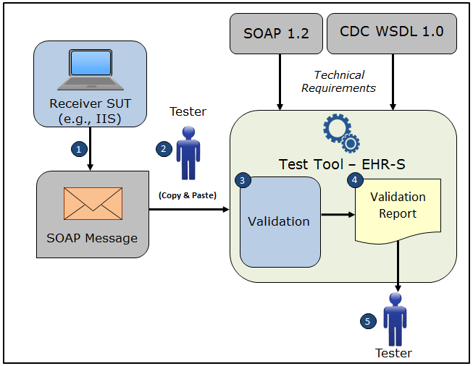

1. The System Under Test (SUT) generates a valid **connectivityTestResponse** message envelope that conforms to the SOAP 1.2 standard and CDC WSDL 1.0 and that confirms the accessibility of the Immunization Information System (IIS) Web Service
2. The Tester copies this SOAP **connectivityTestResponse** message envelope and pastes it into the Test Tool, which is functioning as the initiator system (e.g., EHR-S)
3. The Test Tool validates the SOAP **connectivityTestResponse** message envelope for conformance to the SOAP 1.2 standard and CDC WSDL 1.0
4. The Test Tool generates a Validation Report listing the results of the validation
5. The Tester reviews the Validation Report and compares the results to the Objectives and Evaluation Criteria associated with the SOAPENV_1_ConnectivityTest_Response Test Case

**Test Data Specification**

Need to determine if this information or some other information

is needed for a SOAP Envelope Test Case.

EXAMPLE OF TEST DATA SPECIFICATION VERBIAGE FOR AN IZ MESSAGE TEST CASE

Patient Information

|  |  |
| --- | --- |
| **Element Name** | **Data** |
| Patient Name | Madelynn Ainsley Snow |
| Mother's Maiden Name | Morgan Lam |
| ID Number | D26376273 |
| Date/Time of Birth | 07/06/2007 |
| Administrative Sex | Female |
| Patient Address | 32 Prescott Street Ave Warwick MA 02452 USA |
| Local Number |  |
| Email Address |  |
| Race | Native Hawaiian or Other Pacific Islander |
| Ethnic Group | Non-Hispanic or Latino |
| Birth Order |  |

**Envelope Content Table**

Test Case Information

|  |  |
| --- | --- |
| **Element Name** | **Data** |
| Test Case ID | Receiver SOAPENV_1_ConnectivityTest_Response |

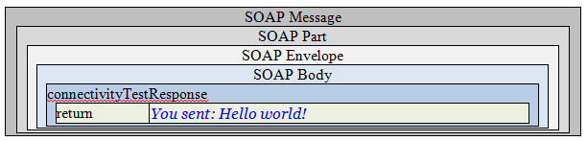

**Envelope Content**

**Connectivity Test Response Message Sent by Receiver System**

<?xml version='1.0' encoding='UTF-8'?>

<Envelope xmlns="http://www.w3.org/2003/05/soap-envelope">

<Body>

<connectivityTestResponse xmlns="urn:cdc:iisb:2011">

<return>You sent: Hello world!</return>

</connectivityTestResponse>

</Body>

</Envelope>

**Evaluation Criteria**

Criteria

|  |
| --- |
|  |
| This box **must** contain information that explains how the SUT will be evaluated to determine that successful conformance is demonstrated during the testing.  Need to determine what criteria are needed on a Test Case-by-Test Case basis. |