**Immunization Test Suite**

**Sender SOAP Envelope Testing**

**Draft 1.7**

**23rd March, 2015**

**Approved**

**Immunization Test Case**

**Sender**

**SOAPENV_2_SubmitSingleMessage_Request**

**SubmitSingleMessage_Request**

**Test Description**

Description

|  |
| --- |
|  |
| This test evaluates the capability of a Sender technology to electronically generate a message envelope conforming to the SOAP 1.2 standard and CDC WSDL 1.0 that may be used for electronically transporting an HL7 message to an immunization information system (IIS). |

Test Objectives

|  |
| --- |
|  |
| The Sender technology will demonstrate the ability to electronically generate the SOAP message where the body of the message contains:   * the element **submitSingleMessage**, as defined in the CDC WSDL 1.0 * arbitrary string values for all child elements of **submitSingleMessage:** *username*, *password*, *facilityID*, and *HL7Message*. |

**SOAP Envelope Testing Diagram**

**Sender**

**SOAPENV_2_SubmitSingleMessage_Request**

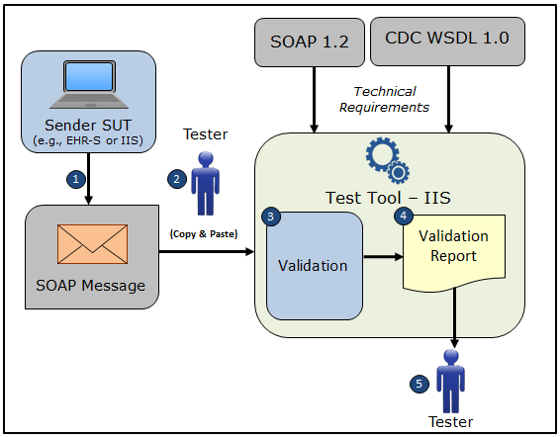

1. The System Under Test (SUT) generates a SOAP **submitSingleMessage** request message envelope
2. The Tester copies this SOAP **submitSingleMessage** request message envelope and pastes it into the Test Tool, which is functioning as the receiver system
3. The Test Tool validates the SOAP **submitSingleMessage** message envelope for conformance to the SOAP 1.2 standard and CDC WSDL 1.0
4. The Test Tool generates a Validation Report listing the results of the validation
5. The Tester reviews the Validation Report and compares the results to the Objectives and Evaluation Criteria associated with the SOAPENV_2_SubmitSingleMessage_Request Test Case

**Test Data Specification**

Message Information

|  |  |  |
| --- | --- | --- |
| **Element Name** | **Data** | **Classification of Data** |
| **submitSingleMessage:** username | leonidas | Changeable |
| **submitSingleMessage:** password | Spartans300! | Changeable |
| **submitSingleMessage:** facilityID | EHR1234 | Changeable |
| **submitSingleMessage:** HL7 Message | MSH|^~\&amp;|Test EHR Application|X68||NIST Test Iz Reg|201207010822||VXU^V04^VXU_V04|NIST-IZ-007.00|P|2.5.1|||AL|ER&#xD;PID|1||MR-99922^^^NIST MPI^MR||Montgomery^Lewis^^^^^L||20010821|M&#xD;ORC|RE||IZ-783276^NDA&#xD;RXA|0|1|20110215||118^HPV^CVX|999|||01^Historical information - source unspecified^NIP001 | Changeable |

Explanation of Data Classification

|  |  |  |
| --- | --- | --- |
| **Data Classification** | **Description** | **Validation** |
| **Configurable** | Data typically that are configured by the system (customer-definable). Example data are provided. | Validate for the presence of data |
| **System Generated** | Data typically generated automatically by system, e.g., message time. Example data are provided. | Validate for the presence of data |
| **IG Fixed** | Data that are fixed by the implementation guide; data can’t be changed. Specific data are provided. | Validate for the presence and data content |
| **Test Case Fixed** | Data that are specific and fixed by the test case; data should not be changed. Specific data are provided. | Validate for the presence and selectively validate for data content |
| **Changeable** | Data where the exact content is not relevant for the test case and can be changed for the purposes of testing. Example data are provided. | Validate for the presence of data |

**Envelope Content Table**

Test Case Information

|  |  |
| --- | --- |
| **Element Name** | **Data** |
| Test Case ID | Sender SOAPENV_2_SubmitSingleMessage_Request |

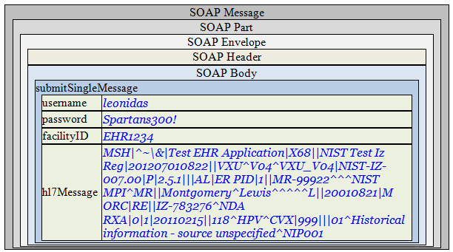

**Envelope Content**

**Request Message Sent by Sender System**

<?xml version='1.0' encoding='UTF-8'?>

<Envelope xmlns="http://www.w3.org/2003/05/soap-envelope">

<Header />

<Body>

<submitSingleMessage xmlns="urn:cdc:iisb:2011">

<username>leonidas</username>

<password>Spartans300!</password>

<facilityID>EHR1234</facilityID>

<hl7Message>MSH|^~\&amp;|Test EHR Application|X68||NIST Test Iz Reg|201207010822||VXU^V04^VXU_V04|NIST-IZ-007.00|P|2.5.1|||AL|ER&#xD;PID|1||MR-99922^^^NIST MPI^MR||Montgomery^Lewis^^^^^L||20010821|M&#xD;ORC|RE||IZ-783276^NDA&#xD;RXA|0|1|20110215||118^HPV^CVX|999|||01^Historical information - source unspecified^NIP001</hl7Message>

</submitSingleMessage>

</Body>

</Envelope>

**Evaluation Criteria**

Criteria

|  |
| --- |
|  |
| This box **must** contain information that explains how the SUT will be evaluated to determine that successful conformance is demonstrated during the testing.  Need to determine what criteria are needed on a Test Case-by-Test Case basis. |