**Immunization Test Suite**

**Sender SOAP Connectivity Testing**

**Version 1.0**

**March 29, 2016**

**Immunization Test Case**

**Sender**

**SOAPCON_3_SubmitSingleMessage_Message**

**SubmitSingleMessage_Message**

**Test Description**

Description

|  |
| --- |
|  |
| This test evaluates the capability of a sender (initiator) technology to connect to an immunization information system (IIS) and to generate and transmit a message conforming to the SOAP 1.2 standard and CDC WSDL 1.0 that may be used for transporting an HL7 message to an immunization information system (IIS). |

Comments

|  |
| --- |
|  |
| The username, password and facilityID for this test are obtained from the test data provided in the test tool. |

Test Objectives

|  |
| --- |
|  |
| The body of the SOAP message must contain   * the element **submitSingleMessage**, as defined in the CDC WSDL 1.0 * the hl7Message element set to a single HL7 v2 message (properly formatted for inclusion within XML, e.g. CDATA) * the tool-assigned string values for the username, password and facilityID elements |

**SOAP Connectivity Testing Diagram**

**Sender**

**SOAPCON_3_SubmitSingleMessage_Message**

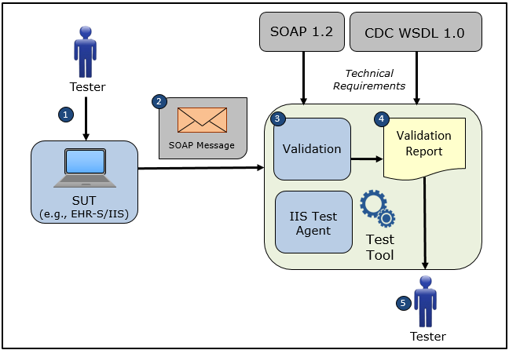

1. The Tester obtains the username, password, and facilityID from the test data provided in the test tool and causes the System Under Test to connect to the NIST Test Tool representing an IIS Test Agent using the NIST web service endpoint specified on the screen of the Test Tool
2. The Tester causes the System Under Test to electronically generate and transmit to the NIST Test Tool a **submitSingleMessage** request message that conforms to the SOAP 1.2 standard and CDC WSDL 1.0 used for transporting an HL7 test message to an IIS
3. The Test Tool validates the **submitSingleMessage** request message for conformance to the SOAP 1.2 standard and CDC WSDL 1.0
4. The Test Tool generates a Validation Report listing the results of the validation
5. The Tester reviews the Validation Report and compares the results to the Objectives and Evaluation Criteria associated with the SOAPCON_3_SubmitSingleMessage_Message Test Case

**Test Data Specification**

Submit Single Message Request Message Information

|  |  |  |
| --- | --- | --- |
| **Element Name** | **Data** | **Classification of Data** |
| **submitSingleMessage:** username | vendor_? | Test Tool-Assigned |
| **submitSingleMessage:**password | vendor_? | Test Tool-Assigned |
| **submitSingleMessage:**facilityID | vendor_? | Test Tool-Assigned |
| **submitSingleMessage:**HL7 Message | MSH|^~\&amp;|Test EHR Application|X68||NIST Test Iz Reg|201207010822||VXU^V04^VXU_V04|NIST-IZ-007.00|P|2.5.1|||AL|ER&#xD;PID|1||MR-99922^^^NIST MPI^MR||Montgomery^Lewis^^^^^L||20010821|M&#xD;ORC|RE||IZ-783276^NDA&#xD;RXA|0|1|20110215||118^HPV^CVX|999|||01^Historical information - source unspecified^NIP001 | Changeable |

Explanation of Data Classification

| **Data Classification** | **Description** | **Validation** |
| --- | --- | --- |
| **Configurable** | Data typically that are configured by the system (customer-definable). Example data are provided. | Validate for the presence of data |
| **System Generated** | Data typically generated automatically by system, e.g., message time. Example data are provided. | Validate for the presence of data |
| **IG Fixed** | Data that are fixed by the implementation guide; data can’t be changed. Specific data are provided. | Validate for the presence and data content |
| **Test Case Fixed** | Data that are specific and fixed by the test case; data should not be changed. Specific data are provided. | Validate for the presence and selectively validate for data content |
| **Changeable** | Data where the exact content is not relevant for the test case and can be changed for the purposes of testing. Example data are provided. | Validate for the presence of data |
| **Test Tool-Assigned** | Data that are assigned by the test tool for the specific System Under Test in real-time. Example data are provided. | Validate for the presence and for data content |
| **Test System-Provided** | Data that are provided by the System Under Test in real-time. Example data are provided. | Validate for the presence and for data content |

**Message Content Table**

Test Case Information

|  |  |
| --- | --- |
| **Element Name** | **Data** |
| Test Case ID | Sender SOAPCON_3_SubmitSingleMessage_Message |

Submit Single Message Request

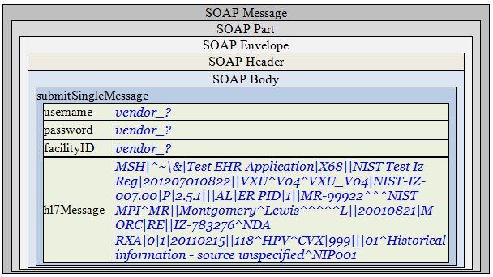

**Message Content**

**Request Message Sent by Sender System**

<?xml version='1.0' encoding='UTF-8'?>

<Envelope xmlns="http://www.w3.org/2003/05/soap-envelope">

<Header />

<Body>

<submitSingleMessage xmlns="urn:cdc:iisb:2011">

<username>vendor_?</username>

<password>vendor_?</password>

<facilityID>vendor_?</facilityID>

<hl7Message>MSH|^~\&amp;|Test EHR Application|X68||NIST Test Iz Reg|201207010822||VXU^V04^VXU_V04|NIST-IZ-007.00|P|2.5.1|||AL|ER&#xD;PID|1||MR-99922^^^NIST MPI^MR||Montgomery^Lewis^^^^^L||20010821|M&#xD;ORC|RE||IZ-783276^NDA&#xD;RXA|0|1|20110215||118^HPV^CVX|999|||01^Historical information - source unspecified^NIP001</hl7Message>

</submitSingleMessage>

</Body>

</Envelope>