**Immunization Test Suite**

**SOAP Envelope Testing**

**Draft 1.4**

**19th December, 2014**

**Immunization Test Case**

**Generic**

**SOAPENV_1_MinTest**

**MinimalTest_Create_SOAP_Envelope**

**Test Description**

Description

|  |
| --- |
|  |
| This test evaluates the capability of a technology to generate a message envelope conforming to the minimal requirements of the SOAP 1.2 standard. |

Test Objectives

|  |
| --- |
|  |
| The generated SOAP message will demonstrate these minimal capabilities:   * element *Envelope* with child element *Body* as defined by the SOAP 1.2 standard * user-chosen (conformant) XML content within *Body* (including no content) is permitted * optional SOAP 1.2 elements (e.g. *Header*) are permissible but not required |

**SOAP Envelope Testing Diagram**

**Generic - SOAPENV_1_MinTest**

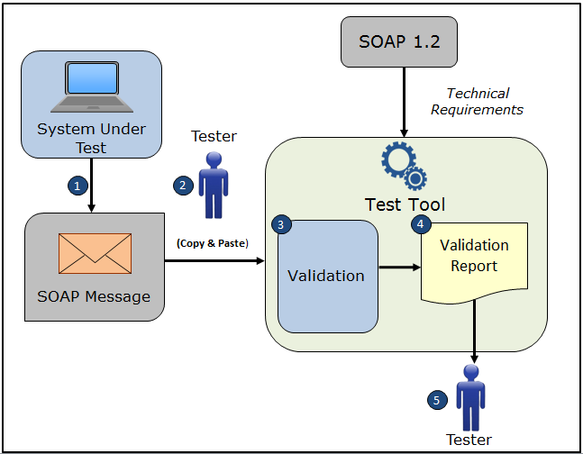

1. The System Under Test (SUT) generates a SOAP message envelope
2. The Tester copies this SOAP message envelope and pastes it into the Test Tool
3. The Test Tool validates the SOAP message envelope for conformance to the minimal requirements of the SOAP 1.2 standard
4. The Test Tool generates a Validation Report listing the results of the validation
5. The Tester reviews the Validation Report and compares the results to the Objectives and Evaluation Criteria associated with the SOAPENV_1_Min_Test Test Case

**Test Data Specification**

Need to determine if this information or some other information

is needed for a SOAP Envelope Test Case.

EXAMPLE OF TEST DATA SPECIFICATION VERBIAGE FOR AN IZ MESSAGE TEST CASE

Patient Information

|  |  |
| --- | --- |
| **Element Name** | **Data** |
| Patient Name | Madelynn Ainsley Snow |
| Mother's Maiden Name | Morgan Lam |
| ID Number | D26376273 |
| Date/Time of Birth | 07/06/2007 |
| Administrative Sex | Female |
| Patient Address | 32 Prescott Street Ave Warwick MA 02452 USA |
| Local Number |  |
| Email Address |  |
| Race | Native Hawaiian or Other Pacific Islander |
| Ethnic Group | Non-Hispanic or Latino |
| Birth Order |  |

**Envelope Content (Example) Table**

Test Case Information

|  |  |
| --- | --- |
| **Element Name** | **Data** |
| Test Case ID | Generic SOAPENV_1_MinTest |

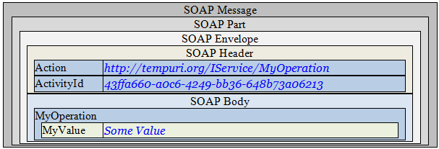

**Example Envelope Content**

**Simple SOAP Message**

<?xml version='1.0' encoding='UTF-8'?>

<!-- this is just an example SOAP message with non-empty Header and Body from the Web -->

<Envelope xmlns="http://www.w3.org/2003/05/soap-envelope">

<Header>

<Action mustUnderstand="1"

xmlns="http://schemas.microsoft.com/ws/2005/05/addressing/none">

http://tempuri.org/IService/MyOperation

</Action>

<ActivityId CorrelationId="7224e2a9-8f9c-4acb-a924-17cb6af67b23" xmlns="http://schemas.microsoft.com/2004/09/ServiceModel/Diagnostics">

43ffa660-a0c6-4249-bb36-648b73a06213</ActivityId>

</Header>

<Body>

<MyOperation xmlns="http://tempuri.org">

<MyValue>Some Value</MyValue>

</MyOperation>

</Body>

</Envelope>

**Evaluation Criteria**

Criteria

|  |
| --- |
|  |
| This box **must** contain information that explains how the SUT will be evaluated to determine that successful conformance is demonstrated during the testing.  Need to determine what criteria are needed on a Test Case-by-Test Case basis. |