**Immunization Test Suite**

**Receiver SOAP Connectivity Testing**

**Draft 1.5**

**23rd March, 2015**

**Approved**

**Immunization Test Case**

**Receiver**

**SOAPCON_4_FaultDetection-Generation_MessageSizeFault**

**FaultDetection-Generation_MessageSizeFault**

**Test Description**

Description

|  |
| --- |
|  |
| This test evaluates the capability of a Receiver technology conforming to the SOAP 1.2 standard and CDC WSDL 1.0 to receive a SOAP request message containing more than a single HL7 message, and respond with an appropriate fault message. |

Test Objectives

|  |
| --- |
|  |
| The Receiver technology will demonstrate the ability to:   * Receive a SOAP message with the Body element containing **submitSingleMessage**, as defined in the CDC WSDL 1.0 with the child element *hl7Message* containing more than a one arbitrary HL7 message, and arbitrary conforming values for all child elements**:** *username*, *password*, *facilityID*. * Transmit a SOAP response message to the Sender that contains the element **MessageTooLargeFault as defined in the CDC WSDL 1.0**   + with arbitrary conforming values for the *Code* and *Detail* child elements   + with conforming fixed value for the *Reason* child element |

**SOAP Connectivity Testing Diagram**

**Receiver**

**SOAPCON_4_FaultDetection-Generation_MessageSizeFault**

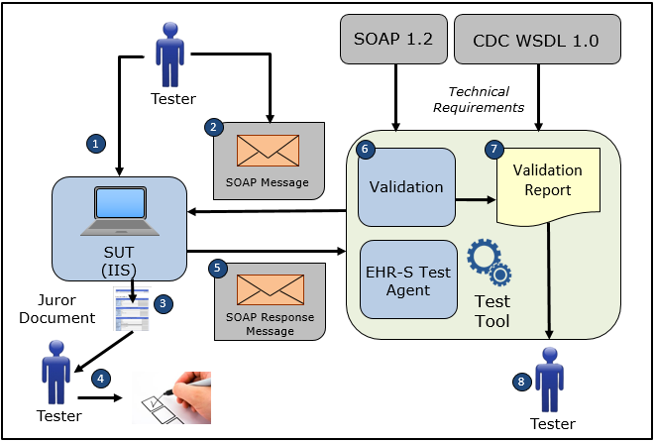

1. The Tester configures the NIST Test Tool with Username, Password, FacilityID, and Endpoint information
2. The Tester causes the NIST Test Tool to electronically generate and transmit to the System Under Test a SOAP connectivity request message **submitSingleMessage** that conforms to the SOAP 1.2 standard and CDC WSDL 1.0 with the exception that the *hl7Message* element contains two HL7 messages, rather than one message as equired by the CDC specification
3. The Tester obtains the Juror Document for the Receiver SOAPCON_4_FaultDetection-Generation_MessageSizeFault Test Case in the NIST Test Tool
4. The Tester uses the Juror Document to determine if the System Under Test received and processed the non-conformant SOAP request message correctly
5. The System Under Test electronically generates and transmits to the EHR-S Test Agent in the NIST Test Tool a SOAP response message **MessageTooLargeFault** that conforms to the SOAP 1.2 standard and CDC WSDL 1.0 and that is used for transporting an appropriate HL7 fault response message to a sender (initiator) system
6. The Test Tool validates the SOAP response message for conformance to the SOAP 1.2 standard and CDC WSDL 1.0
7. The Test Tool generates a Validation Report listing the results of the validation
8. The Tester reviews the Validation Report and compares the results to the Objectives and Evaluation Criteria associated with the Receiver SOAPCON_4_FaultDetection-Generation_MessageSizeFault Test Case

**Test Data Specification**

Submit Single Message Request with Message Size Fault

|  |  |  |
| --- | --- | --- |
| **Element Name** | **Data** | **Classification of Data** |
| **submitSingleMessage:** username | ??? | Test System-Provided |
| **submitSingleMessage:** password | ??? | Test System-Provided |
| **submitSingleMessage:** facilityID | ??? | Test System-Provided |
| **submitSingleMessage:** HL7 Message | MSH|^~\&amp;|Test EHR Application|X68||NIST Test Iz Reg|201207010822||VXU^V04^VXU_V04|NIST-IZ-007.00|P|2.5.1|||AL|ER&#xD;PID|1||MR-99922^^^NIST MPI^MR||Montgomery^Lewis^^^^^L||20010821|M&#xD;ORC|RE||IZ-783276^NDA&#xD;RXA|0|1|20110215||118^HPV^CVX|999|||01^Historical information - source unspecified^NIP001  MSH|^~\&amp;|Test EHR Application|X68||NIST Test Iz Reg|201207010822||VXU^V04^VXU_V04|NIST-IZ-007.00|P|2.5.1|||AL|ER&#xD;PID|1||MR-99922^^^NIST MPI^MR||Montgomery^Lewis^^^^^L||20010821|M&#xD;ORC|RE||IZ-783276^NDA&#xD;RXA|0|1|20110215||118^HPV^CVX|999|||01^Historical information - source unspecified^NIP001 | Changeable |

Note: A unique value for the username, password, and facilityID will be assigned by the System Under Test.

Explanation of Data Classification

| **Data Classification** | **Description** | **Validation** |
| --- | --- | --- |
| **Configurable** | Data typically that are configured by the system (customer-definable). Example data are provided. | Validate for the presence of data |
| **System Generated** | Data typically generated automatically by system, e.g., message time. Example data are provided. | Validate for the presence of data |
| **IG Fixed** | Data that are fixed by the implementation guide; data can’t be changed. Specific data are provided. | Validate for the presence and data content |
| **Test Case Fixed** | Data that are specific and fixed by the test case; data should not be changed. Specific data are provided. | Validate for the presence and selectively validate for data content |
| **Changeable** | Data where the exact content is not relevant for the test case and can be changed for the purposes of testing. Example data are provided. | Validate for the presence of data |
| **Test Tool-Assigned** | Data that are assigned by the test tool for the specific System Under Test in real-time. Example data are provided. | Validate for the presence and for data content |
| **Test System-Provided** | Data that are provided by the System Under Test in real-time. Example data are provided. | Validate for the presence and for data content |

**Example Message Content Table**

Test Case Information

|  |  |
| --- | --- |
| **Element Name** | **Data** |
| Test Case ID | Receiver SOAPCON_4_FaultDetection-Generation_MessageSizeFault |

Submit Single Message Request with Message Size Fault

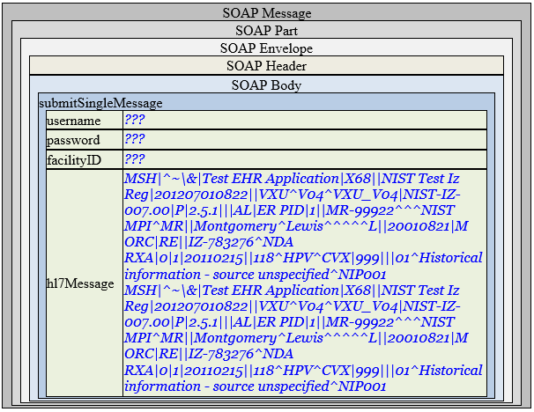

Note: A unique value for the username and password will be assigned by the System Under Test.

**Example Message Content**

**Request Message Sent by Sender System**

<?xml version='1.0' encoding='UTF-8'?>

<Envelope xmlns="http://www.w3.org/2003/05/soap-envelope">

<Header />

<Body>

<submitSingleMessage xmlns="urn:cdc:iisb:2011">

<username>???</username>

<password>???</password>

<facilityID>???</facilityID>

<hl7Message>MSH|^~\&amp;|Test EHR Application|X68||NIST Test Iz Reg|201207010822||VXU^V04^VXU_V04|NIST-IZ-007.00|P|2.5.1|||AL|ER&#xD;PID|1||MR-99922^^^NIST MPI^MR||Montgomery^Lewis^^^^^L||20010821|M&#xD;ORC|RE||IZ-783276^NDA&#xD;RXA|0|1|20110215||118^HPV^CVX|999|||01^Historical information - source unspecified^NIP001

MSH|^~\&amp;|Test EHR Application|X68||NIST Test Iz Reg|201207010822||VXU^V04^VXU_V04|NIST-IZ-007.00|P|2.5.1|||AL|ER&#xD;PID|1||MR-99922^^^NIST MPI^MR||Montgomery^Lewis^^^^^L||20010821|M&#xD;ORC|RE||IZ-783276^NDA&#xD;RXA|0|1|20110215||118^HPV^CVX|999|||01^Historical information - source unspecified^NIP001</hl7Message>

</submitSingleMessage>

</Body>

</Envelope>

Note: A unique value for the username and password will be assigned by the System Under Test.

**Evaluation Criteria**

Criteria

|  |
| --- |
|  |
| This box **must** contain information that explains how the SUT will be evaluated to determine that successful conformance is demonstrated during the testing.  Need to determine what criteria are needed on a Test Case-by-Test Case basis. |