**Immunization Test Suite**

**Receiver SOAP Envelope Testing**

**Draft 1.4**

**21st December, 2014**

**Immunization Test Case**

**Receiver**

**SOAPENV_2_SubmitSingleMessage_Response**

**SubmitSingleMessage_Response**

**Test Description**

Description

|  |
| --- |
|  |
| This test evaluates the capability of a Receiver technology to generate a valid message conforming to the SOAP 1.2 standard and CDC WSDL 1.0 that may be used for transporting an HL7 response message to an electronic health record system (EHR-S) or an Immunization Information System (IIS). |

Test Objectives

|  |
| --- |
|  |
| The Receiver technology will demonstrate the ability to generate the SOAP message where the body of the message contains:   * the element **submitSingleMessageResponse**, as defined in the CDC WSDL 1.0 * arbitrary string values for the child element of **submitSingleMessageResponse**:  *return*. |

**SOAP Envelope Testing Diagram**

**Receiver**

**SOAPENV_2_SubmitSingleMessage_Response**

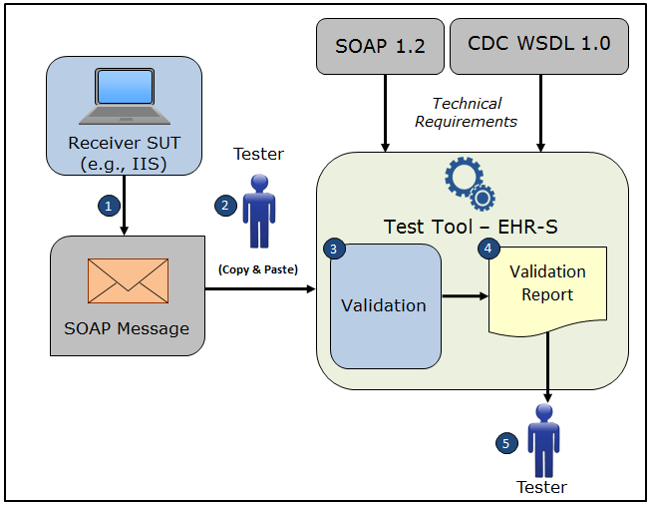

1. The System Under Test (SUT) generates a SOAP **submitSingleMessageResponse** message envelope
2. The Tester copies this SOAP **submitSingleMessageResponse** message envelope and pastes it into the Test Tool, which is functioning as the initiator system (e.g., EHR-S)
3. The Test Tool validates the SOAP **submitSingleMessageResponse** message envelope for conformance to the SOAP 1.2 standard and CDC WSDL 1.0
4. The Test Tool generates a Validation Report listing the results of the validation
5. The Tester reviews the Validation Report and compares the results to the Objectives and Evaluation Criteria associated with the SOAPENV_2_SubmitSingleMessage_Response Test Case

**Test Data Specification**

Need to determine if this information or some other information

is needed for a SOAP Envelope Test Case.

EXAMPLE OF TEST DATA SPECIFICATION VERBIAGE FOR AN IZ MESSAGE TEST CASE

Patient Information

|  |  |
| --- | --- |
| **Element Name** | **Data** |
| Patient Name | Madelynn Ainsley Snow |
| Mother's Maiden Name | Morgan Lam |
| ID Number | D26376273 |
| Date/Time of Birth | 07/06/2007 |
| Administrative Sex | Female |
| Patient Address | 32 Prescott Street Ave Warwick MA 02452 USA |
| Local Number |  |
| Email Address |  |
| Race | Native Hawaiian or Other Pacific Islander |
| Ethnic Group | Non-Hispanic or Latino |
| Birth Order |  |

**Envelope Content Table**

Test Case Information

|  |  |
| --- | --- |
| **Element Name** | **Data** |
| Test Case ID | Receiver SOAPENV_2_SubmitSingleMessage_Response |

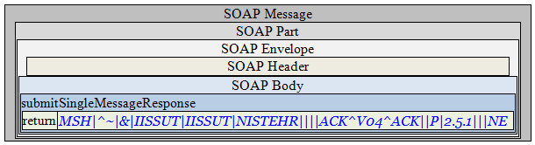

**Envelope Content**

**Response Message Sent by Receiver System**

<?xml version='1.0' encoding='UTF-8'?>

<Envelope xmlns="http://www.w3.org/2003/05/soap-envelope">

<Header/>

<Body>

<submitSingleMessageResponse xmlns="urn:cdc:iisb:2011">

<return>

<![CDATA[MSH|^~|&|IISSUT|IISSUT|NISTEHR||<date/timeMSG>||ACK^V04^ACK|<msgControlID>|P|2.5.1|||NE]]>

</return>

</submitSingleMessageResponse>

</Body>

</Envelope>

**Evaluation Criteria**

Criteria

|  |
| --- |
|  |
| This box **must** contain information that explains how the SUT will be evaluated to determine that successful conformance is demonstrated during the testing.  Need to determine what criteria are needed on a Test Case-by-Test Case basis. |