Home Page (Hero Section)
Placewell Careers
Building Teams. Shaping Leaders (Logo and tag line on the left)
Home| About US| Our Services| Team |Contact US (In the Centre)
Drop Your CV | Enquiry (On the Right)
Founded in 2008, Placewell Careers is a trusted talent solutions partner serving organizations across BFSI, IT/EdTech, Healthcare, and Hospitality sectors.
Backed by a team of 50+ experienced professionals, we combine industry expertise, agility, and a client-centric approach to help businesses build high-performing teams and professionals advance their careers. Our commitment to quality, excellence, and long-term partnerships has made us a preferred recruitment partner across industries.
Carousel Slider Layout – Our Pillars of Success
Slide 1:
17+ Years
Trust in Talent Acquisition
A trusted recruitment partner backed by deep industry expertise.
Slide 2:
10,000+
Placements Across India
Delivering talent across all levels with precision.
Slide 3:
95%
Offer Acceptance Rate
Strong engagement ensuring high conversion and onboarding.
Slide 4:
Faster
Hiring Turnaround
Efficient processes ensuring timely closures.
Slide 5:
Long-Term
Client Partnerships
Built on trust, quality delivery, and responsiveness.
Slide 6:
Smart
Market Insights
Talent mapping, compensation benchmarking, and hiring intelligence.

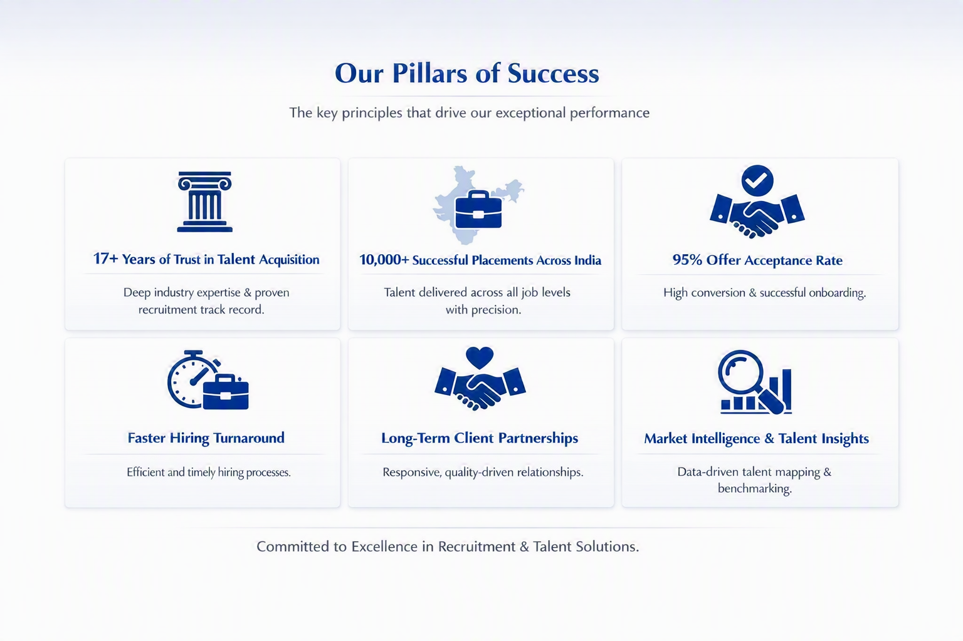

About US
2008 – The Beginning
Placewell Careers was founded with a vision to build a trusted recruitment organization focused on creating meaningful connections between talent and opportunity. Starting with a handful of clients, the company laid the foundation for long-term, relationship-driven growth.

2008–2024 | Growing Through Partnerships
A key differentiator in our journey has been our collaborative partnership model. By bringing together experienced recruitment professionals across industries and geographies, Placewell Careers expanded its reach and built a team of 50+ professionals dedicated to delivering quality hiring solutions.

Today – A Trusted Recruitment Partner
Today, Placewell Careers serves organizations across BFSI, IT/EdTech, Healthcare, Hospitality, and other emerging sectors. Our commitment to quality, agility, and client success has made us a preferred talent solutions partner for leading organizations.

Looking Ahead – Building on Experience
As we enter our next phase of growth, we are focused on strengthening our recruitment capabilities through specialized industry practices, deeper domain expertise, and dedicated teams that deliver exceptional hiring outcomes. Our vision remains the same—to connect great talent with great opportunities while creating long-term value for our clients.

Our Team

Saveena Grover
Promoter
The driving force behind Placewell Careers, Saveena provides strategic direction and long-term vision for the organization. An Economics graduate, she is known for her collaborative leadership style and focus on building a culture of integrity, ownership, and sustainable growth.

Sandeep Grover
Founder & Director
With over 16 years of experience across SBI Life, Aditya Birla Group, and Bajaj Allianz, Sandeep leads Placewell Careers with deep expertise in talent acquisition, recruitment strategy, and business development. His client-centric approach has been instrumental in the company's growth and success.

Seema Bhatia
Director – Leadership and Critical Talent Hiring
A BFSI specialist with over 20 years of experience, Seema focuses on leadership and critical talent hiring. Formerly Team Lead–HR Business Partner (North & East) at YES Bank, she brings expertise in executive search, talent mapping, and strategic hiring across the BFSI sector.
Team Placewell: Powered by Partnerships
Our success is built on a collaborative partnership model that brings together experienced recruitment leaders and dedicated delivery teams. This structure enables us to combine domain expertise, market intelligence, and local insights to deliver exceptional hiring outcomes.
Today, Placewell Careers is supported by a network of 50+ recruitment professionals working across multiple industries and functions. Led by Senior Partners and backed by specialized teams, we provide clients with focused, agile, and consultative talent solutions.
Vision & Misson
Our Vision
To be India's most trusted recruitment and talent solutions partner.
Our Mission
To help organizations build winning teams by delivering quality talent, market insight, and recruitment excellence across every stage of growth.
Our Services

Recruitment Process Outsourcing (RPO) – Core Offering

End-to-end hiring, managed like it's our own.
Placewell Careers takes complete ownership of your recruitment lifecycle - from sourcing and screening to onboarding - acting as a seamless extension of your HR team. Our RPO model is built to scale with your hiring volume, reduce time-to-fill, and improve quality of hire, all while cutting the operational burden on your internal teams.
Key Offerings
- Full-cycle recruitment management
- Dedicated recruitment teams & account managers
- Scalable hiring for Volume and niche roles
- Employer branding support during candidate outreach
- Real-time hiring dashboards & reporting

Market Research

Hiring decisions backed by real market intelligence.
Before we recruit, we research. Our market research services give you a clear view of talent availability, compensation benchmarks, hiring trends, and competitor hiring patterns - so your workforce planning is grounded in facts, not assumptions.
Key Offerings
- Compensation & benefits benchmarking
- Talent availability and demand-supply analysis
- Competitor hiring & attrition insights
- Location & Market feasibility studies

Talent Mapping

Know who's out there — before you need them.
Talent mapping is how we help you build a proactive hiring pipeline instead of reacting to open roles. We identify, profile, and track relevant talent pools — including passive candidates — mapped against skills, seniority, industry, and geography, so you're always hiring-ready for critical or hard-to-fill positions.
Key Offerings
- Passive & Active candidate identification
- Org-structure and competitor talent mapping
- Skill and leadership pipeline building
- Succession planning support

Leadership & Strategic Hiring

Building the next generation of business leaders.
Placewell Careers partners with organizations to identify and attract experienced professionals for middle management and senior leadership roles. Leveraging industry networks, talent intelligence, and a research-driven approach, we help businesses secure talent for critical positions while building strong leadership pipelines for the future.
Key Offerings
- Senior and Middle Management Hiring
- Leadership Pipeline Development
- Strategic Talent Mapping
- Business-critical hiring mandates

Industry Insights (For the placeholder to use in future)

Insights that help you stay ahead of hiring trends.
Our research-driven insights help leadership teams understand emerging skills, workforce trends, and changing talent dynamics across industries.
Key Offerings
- Hiring trend reports
- Emerging skill analysis
- Workforce planning insights
- Sector-specific talent intelligence
A Mindmap for Industries we cater to : BFSI, Fintech
Contact Us:
Chandigarh: Mr. Sandeep Grover39, Anand Shopping Complex (Opp. Hotel Taj), Sector 17 A, Chandigarh sandeep.grover@placewellcareers.com+91 98150 87070
Gurgaon / Delhi: Ms. Seema Bhatia seema.bhatia@placewellcareers.com+91 97119 00305
Jammu: Mr. Jatinder Singh jatinder.singh@placewellcareers.com+91 97973 64187
Punjab / Chandigarh: Ms. Minakshi Deshwal · Mr. Arvin Gupta arvin@placewellcareers.com+91 85289 39811 · +91 87278 79701
Himachal: Mr. Rahul Kumar jobs@placewellcareers.com+91 82190 99919
Haryana: Ms. Shilpa Thakur · Ms. Nidhi Verma shilpa@placewellcareers.com+91 87086 25938 · +91 87086 70408
Rajasthan: Ms. Anjali Rohilla anjali@placewellcareers.com+91 97793 06933
Uttar Pradesh: Mr. Ashish Omar ashish@placewellcareers.com+91 91490 68273

See we can add a map here as well, though our locations are mainly having North presence

Enquiry Form for Corporates to be added here:
Drop Your CV for Candidates:

