title: "Lab3:DataExploration_D.Smith"

subtitle: "Desiree Smith

author: "Worked with Alex Fink"

date: "9/22/2021"

output: html_document

---

```{r}

install.packages("psych")

require(psych)

pairs.panels(iris)

```

```{r}

require(here)

dat_bird = read.csv(here("data", "bird.sta.csv"))

head(dat_bird)

dat_habitat = data.frame(read.csv(here("data", "hab.sta.csv")))

dat_habitat

dat_all = merge(dat_bird,data_habitat)

dat_all

plot(ba.tot ~ elev, data = dat_all)

```

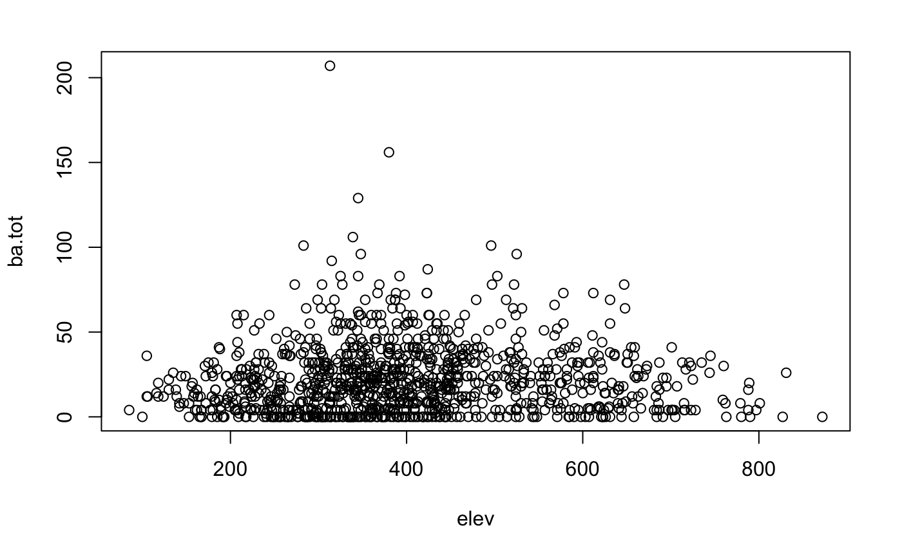

```{r}

sample(dat_all$CEWA, 100)

my_vec = rep(1:3, 5)

my_vec == 3

my_vec > 1

cewa = dat_all$CEWA

cewa

cewa_present_absent = (cewa >= 1)

cewa_present_absent

plot(x = dat_all$elev, y = cewa_present_absent)

# Function to calculate the logistic parameter a given the slope and midpoint

get_logistic_param_a = function(slope, midpoint)

{

b = slope / 4

return (-midpoint * (slope / 4))

}

# Function to calculate the logistic parameter b given the slope

get_logistic_param_b = function(slope)

{

return (slope / 4)

}

# Calculate the value of the logistic function at x, given the parameters a and b.

logistic = function(x, a, b)

{

val = exp(a + b * x)

return(val / (1 + val))

}

# Calculate the value of the logistic function at x, given a slope and midpoint.

logistic_midpoint_slope = function(x, midpoint, slope)

{

b = get_logistic_param_b(slope)

a = get_logistic_param_a(slope, midpoint)

return(logistic(x, a, b))

}

#Positive slope

{

plot(x = dat_all$elev, y = cewa_present_absent)

curve(logistic_midpoint_slope(x, midpoint = 370, slope = 0.05), add = TRUE)

}

#negative slope

plot(x = dat_all$elev, y = cewa_present_absent)

curve(logistic_midpoint_slope(x, midpoint = 400, slope = -0.1), add = TRUE)

#Shallower negative slope

plot(x = dat_all$elev, y = cewa_present_absent)

curve(logistic_midpoint_slope(x, midpoint = 400, slope = -0.05), add = TRUE)

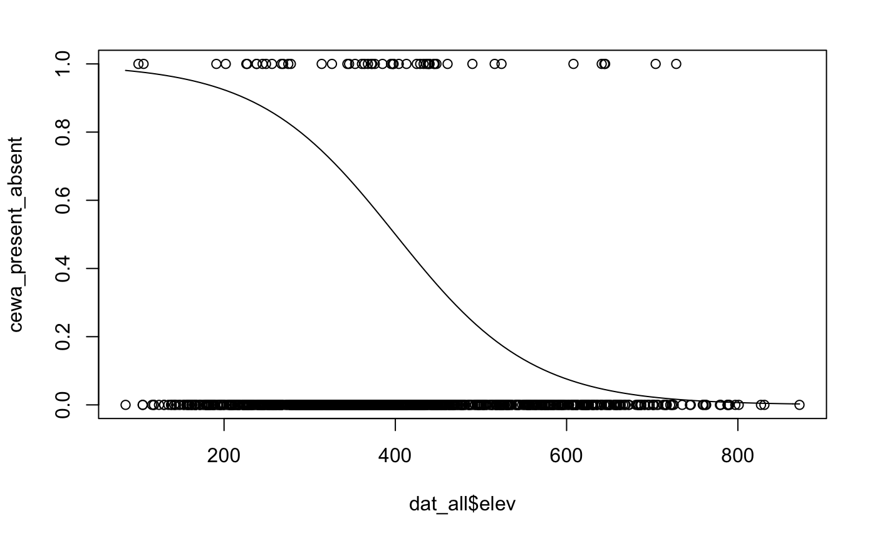

```

__Question 1__

The basal area is square meters per hectares.

__Question 2__

```{r}

require(psych)

pairs.panels(dat_all[ , c("elev", "ba.tot", "slope", "aspect")])

```

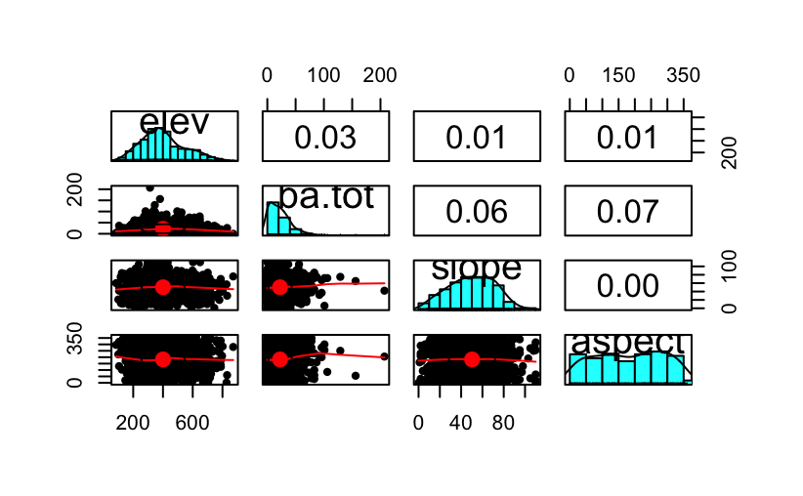

__Question 3__

```{r}

WAVI = dat_all$WAVI

WAVI

wavi_present_absent = (WAVI >= 1)

wavi_present_absent

# Function to calculate the logistic parameter a given the slope and midpoint

get_logistic_param_a = function(slope, midpoint)

{

b = slope / 4

return (-midpoint * (slope / 4))

}

# Function to calculate the logistic parameter b given the slope

get_logistic_param_b = function(slope)

{

return (slope / 4)

}

# Calculate the value of the logistic function at x, given the parameters a and b.

logistic = function(x, a, b)

{

val = exp(a + b * x)

return(val / (1 + val))

}

# Calculate the value of the logistic function at x, given a slope and midpoint.

logistic_midpoint_slope = function(x, midpoint, slope)

{

b = get_logistic_param_b(slope)

a = get_logistic_param_a(slope, midpoint)

return(logistic(x, a, b))

}

plot(x = dat_all$ba.tot, y = wavi_present_absent, col = "orange")

curve(logistic_midpoint_slope(x, midpoint = 100, slope = -0.6), add = TRUE)

```

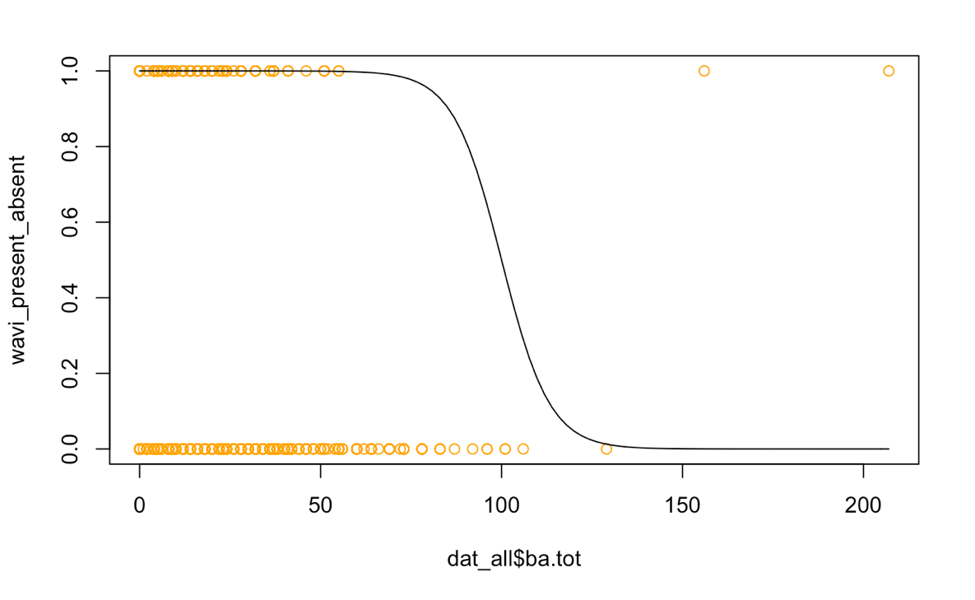

__Question 4__

The birds seem to prefer areas with low tree cover. They were found in area with lower tree densities. There are also a couple birds that were found in an area with high tree cover but the majority of them that are present are in lower tree densities.

__Question 5__

```{r}

SWTH = dat_all$SWTH

SWTH

swth_present_absent = (SWTH >= 1)

swth_present_absent

# Function to calculate the logistic parameter a given the slope and midpoint

get_logistic_param_a = function(slope, midpoint)

{

b = slope / 4

return (-midpoint * (slope / 4))

}

# Function to calculate the logistic parameter b given the slope

get_logistic_param_b = function(slope)

{

return (slope / 4)

}

# Calculate the value of the logistic function at x, given the parameters a and b.

logistic = function(x, a, b)

{

val = exp(a + b * x)

return(val / (1 + val))

}

# Calculate the value of the logistic function at x, given a slope and midpoint.

logistic_midpoint_slope = function(x, midpoint, slope)

{

b = get_logistic_param_b(slope)

a = get_logistic_param_a(slope, midpoint)

return(logistic(x, a, b))

}

plot(x = dat_all$ba.tot, y = swth_present_absent, col = "blue")

curve(logistic_midpoint_slope(x, midpoint = 100, slope = -0.7), add = TRUE)

```

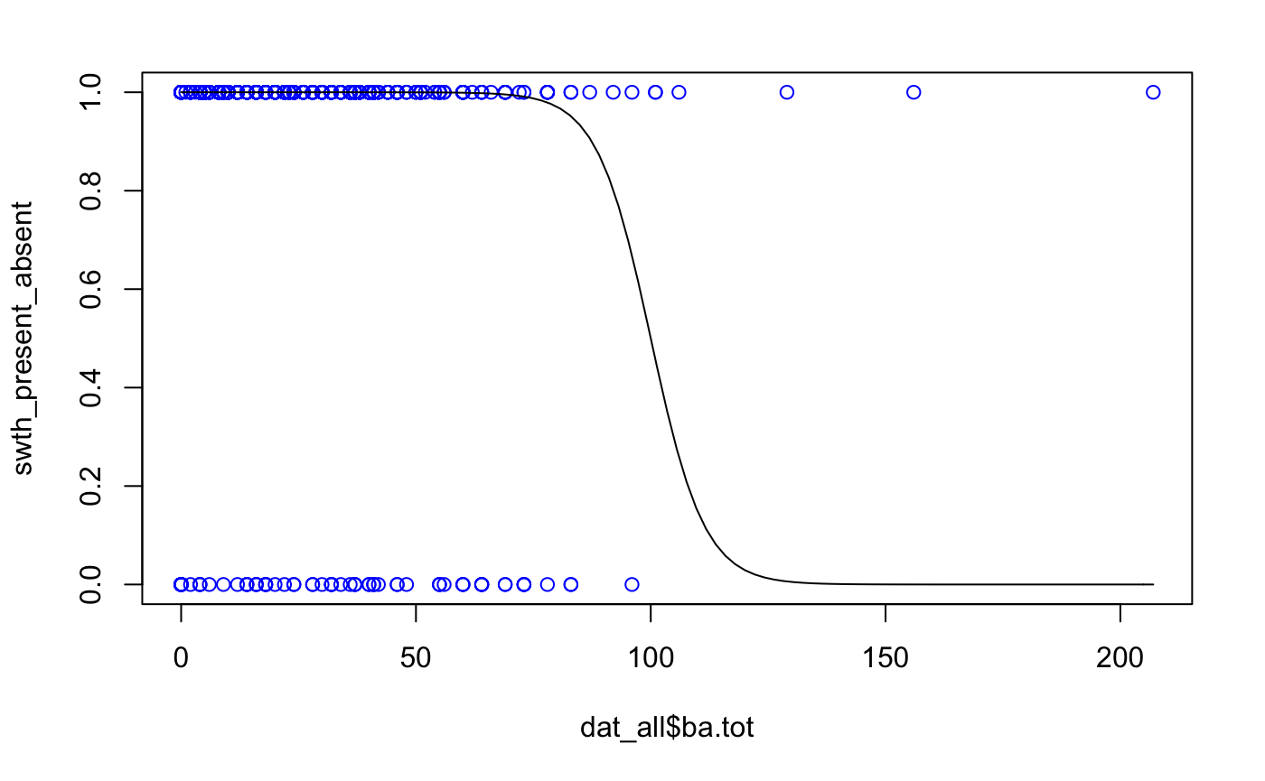

__Question 6__

The birds seem to prefer areas with low tree cover. On the plot there is a lot of birds present in areas with low tree cover on the left top hand corner of the graph.

__Question 7 and Question 8__

```{r}

total_GRJA = dat_all$GRJA

sum(total_GRJA)

#The total number of Gray Jays that were observed were 181

```

__Question 9 and Question 10__

```{r}

my_vec = dat_all$GRJA

my_vec >= 1

sum_vec = as.numeric(my_vec)

sum(my_vec)

my_vec

grja_present_absent = (my_vec >= 1)

grja_present_absent

sum(grja_present_absent)

#The total number of sample sites that the Gray Jays were observed were 110

```