# Exercise: Flexbox

Problems for exercises and homework for the ["HTML and CSS" course @ SoftUni](https://softuni.bg/courses/html-and-css). Submit your solutions in the SoftUni Judge system at <https://judge.softuni.bg/Contests/#!/List/ByCategory/134/HTML-and-CSS-Exercises>.

# Flexbox Layout

Create a web page like the following:

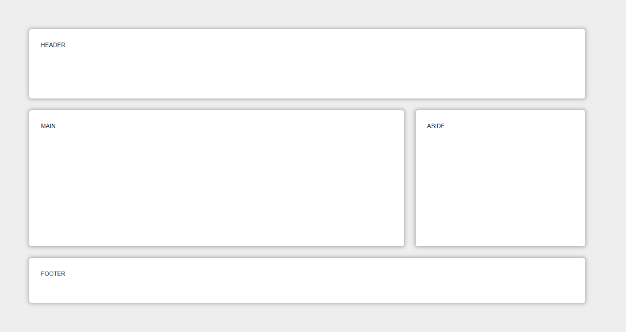

### Constraints

* Change the document **title** to "**Flexbox Layout"**
* Create header, main, aside and footer elements
* Set to the body display property flex
* Each element must have flexgrow, flexshrink and flexbasis

## FlexModel Articles

Create a web page like the following:

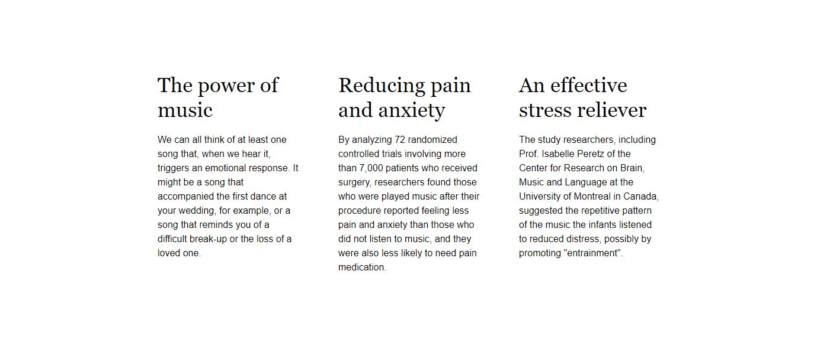

### Constraints

* Change the document **title** to "**Articles"**
* Create a section with three articles inside
* The article should have a h2 title and a paragraph (p)
* Fonts
  + Font family Helvetica, sans-serif with font size 16px and line height 1.5 for the html
  + Font family Georgia, serif with font size 1em and line height 1.2 for the headings
* Change the section display property to flex and set justify-content: space-between
* Set on the section max-width 70vw

## ABC Game

Create a web page like the following:

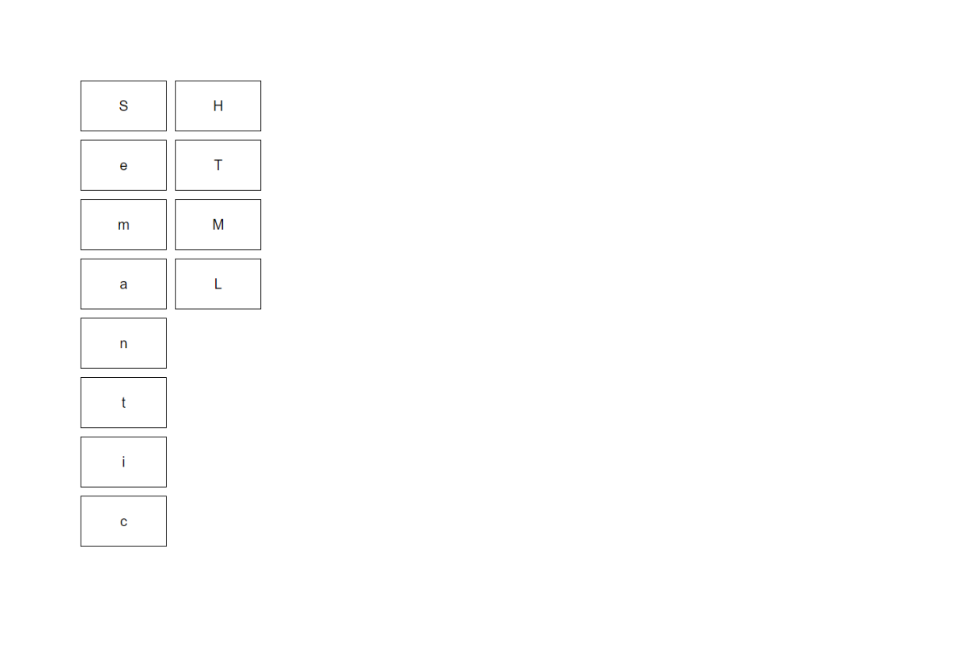

### Constraints

* Change the document **title** to "**ABC Game"**
* Create a section with three articles inside
* Create a div with class container and twelve span tags inside
* Type the letters in the spans EXACTLY as they are in the file text.txt
* Use font-family: Helvetica, sans-serif, with font-size: 20px
* Change the div display property to flex and align the items in center
* Set on the div max-width: 15vw and height 35rem
* The span must have
  + Border width - 1px
  + Border color - black
  + Border style - solid
* To arrange the letters, use the **flex property order**

## Calendar

Create a web page like the following:

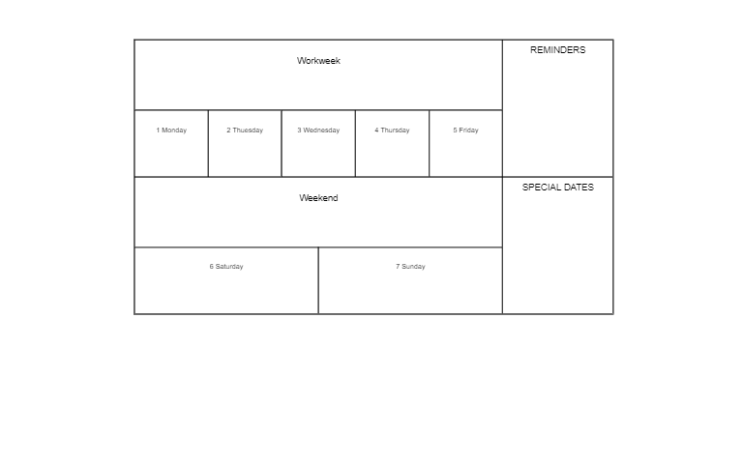

### Constraints

* Change the document title to "**Calendar**"
* Create a div with class container and two sections inside
  + First section has class week
  + Second section has class notes
* Use span tags for all content
* Change the div and sections display property to flex and align the items in **center**
* Set on the div max-width 65vw
* The span must have
  + Border width - 1px
  + Border color - black
  + Border style - solid
* For the section with class notes use the property flex-direction column
* Set on all HTML elements the property box-sizing: border-box

## Navigation Flexbox

Create a web page like the following:

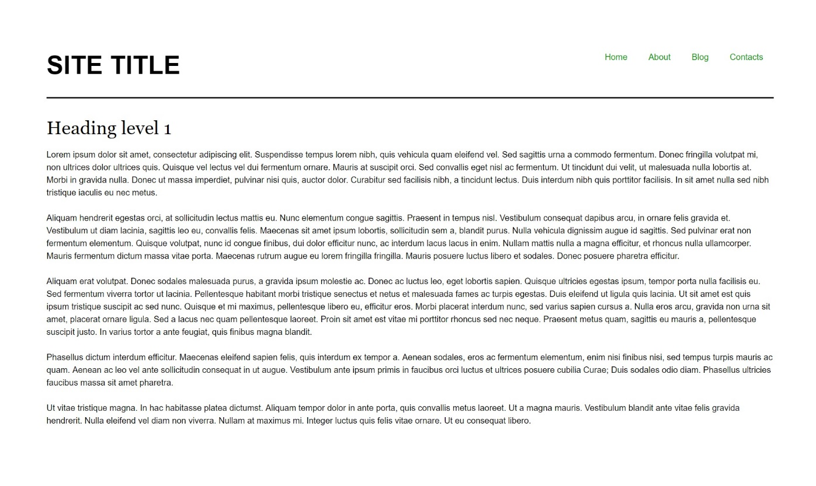

### Constraints

* Change the document title to "**Navigation - Flexbox**"
* Divide the body into header and main tag
* The underline in the header must have
  + Border width - 2px
  + Border color - rgb(0, 0, 0)
  + Border style - solid
* The display property of the header must be flex
* The unordered list in the header must have display property flex
* The anchors text color in the navigation must be rgb(0, 153, 0)

## Photo Gallery - Flexbox

Create a web page like the following:

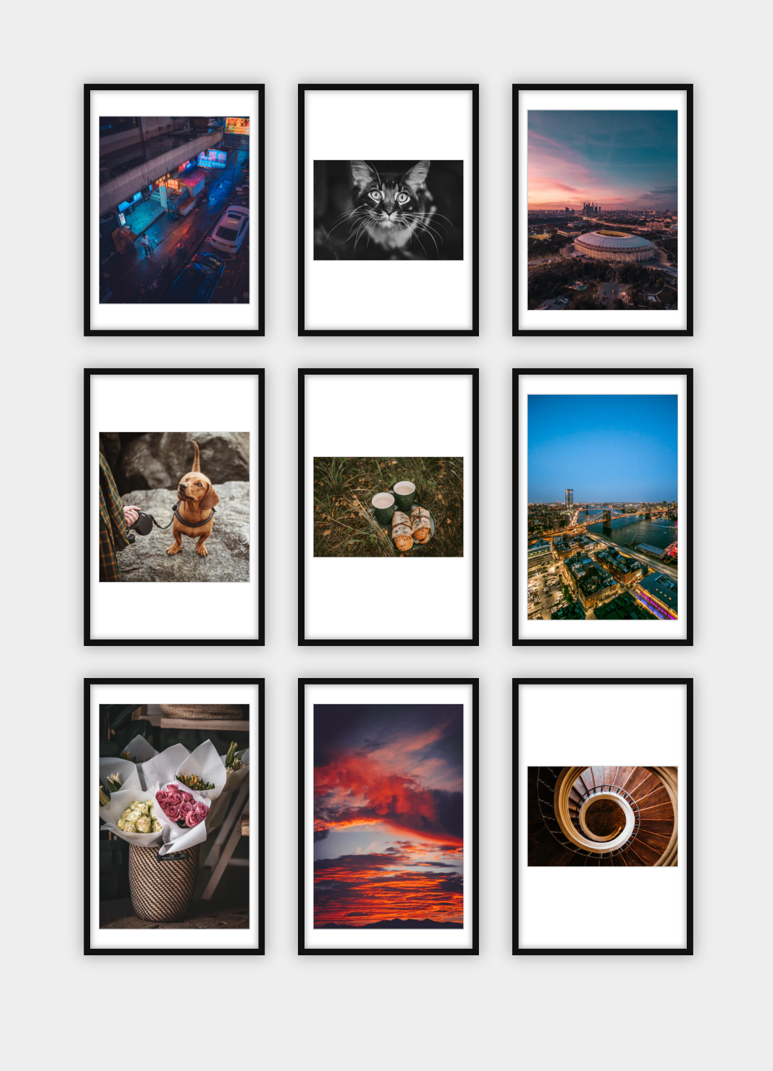

### Constraints

* Change the document title to "**Photo Gallery - Flexbox**"
* Add section with class gallery (section.gallery)
* Add unordered list with list items and images inside
* Change the body, ul and li display property to flex
* Use font Georgia, serifwith size 1em/1.2for the headings

## Blog Layout - Flexbox

Create a web page like the following:

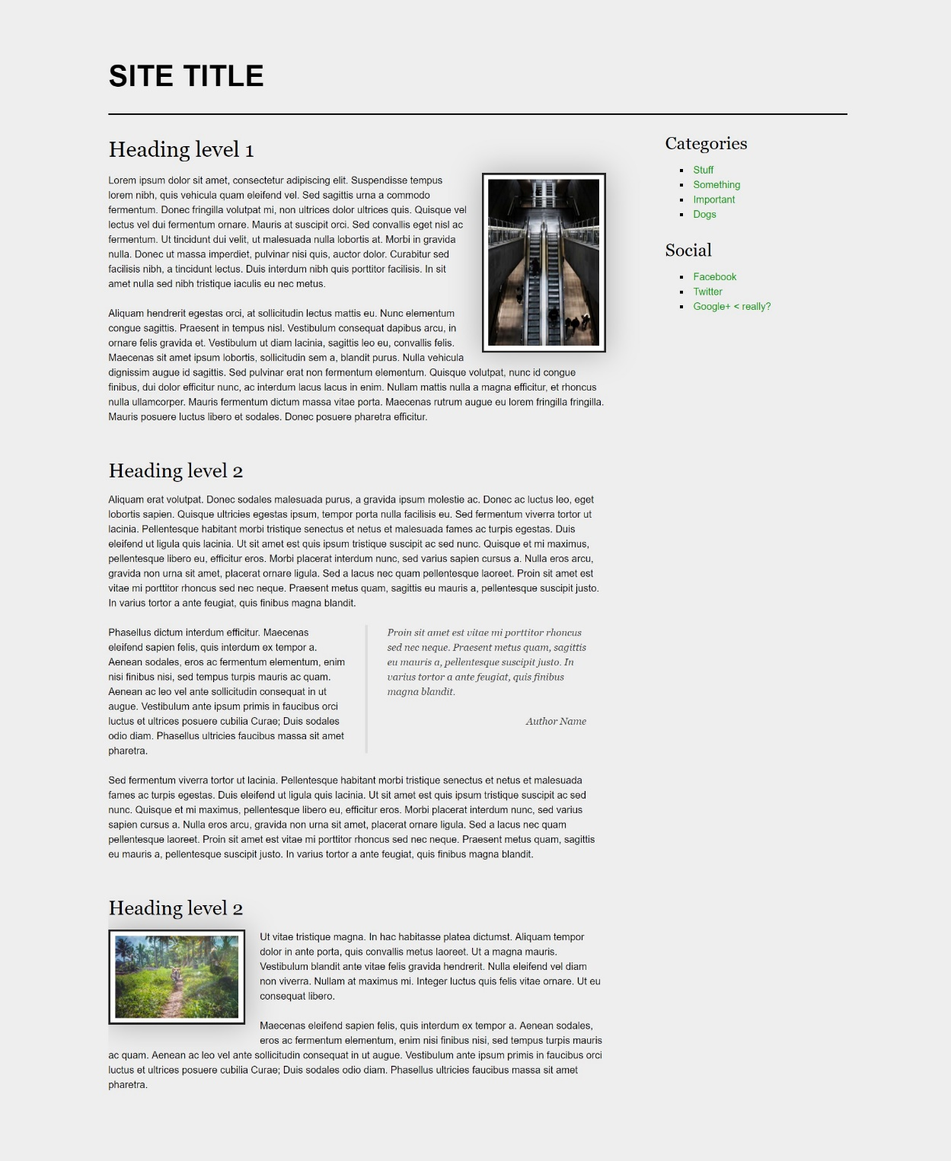

### Constraints

* Change the document title to "**Blog Layout - Flexbox**"
* The entire content must be in div container with class page (div.page)
* The page container (div) must be **flexed** and **wrapped**
* Body background color must be rgb(238, 238, 238)
* Image background color should be rgb(255, 255, 255)
* Blockquote font family must be Georgia, serif
* The anchors text color in the aside section must be rgb(0, 153, 0)
* Page headings font family must be Georgia, serif

## Sticky Footer - Flexbox

Create a web page like the following:

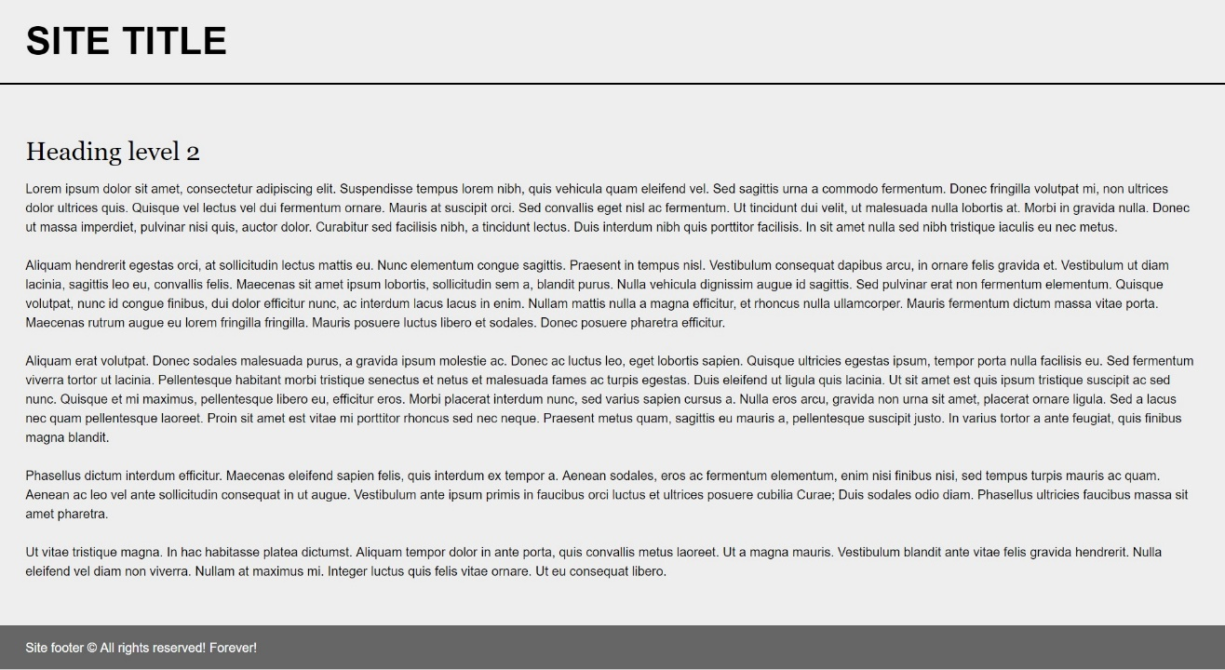

### Constraints

* Change the document title to "**Sticky Footer - Flexbox**"
* Divide your content into header, main and footer tags
* The body must have flex display property
* The body background must be rgb(238, 238, 238)
* Set height to the body: 100vh
* The footer should be at the bottom of the page
  + The footer text color must be rgb(255, 255, 255)
  + The footer background color must be rgb(102, 102, 102)

## Center Flexbox

Create a web page like the following:

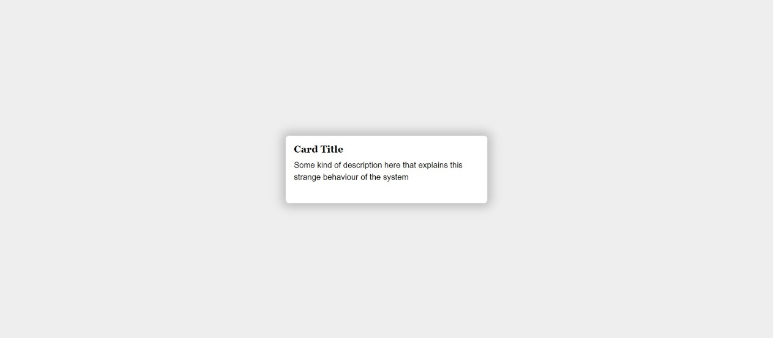

### Constraints

* Change the document title to "**Center Flexbox**"
* The document background color must be rgb(238, 238, 238)
* The body display property must be flex
* The content must be placed into div with class card (div.card)
  + The div background color must be rgb(255, 255, 255)

## Expanding Flex Cards

Create a web page like the following:

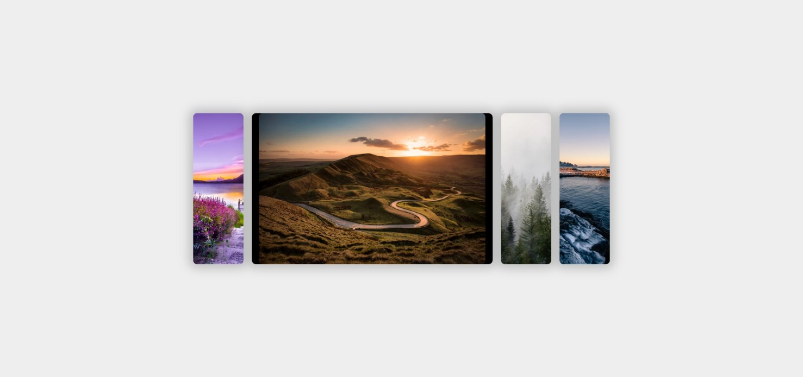

### Constraints

* Change the document title to "**Expanding Flex Cards**"
* Body background color must be rgb(238, 238, 238)
* The body display property must be flex
  + Align the items in **center**
* The entire page content must be inside section with class named container (section.container)
* The container display property must be flex

## Cards with CSS Columns and Flexbox

Create a web page like the following:

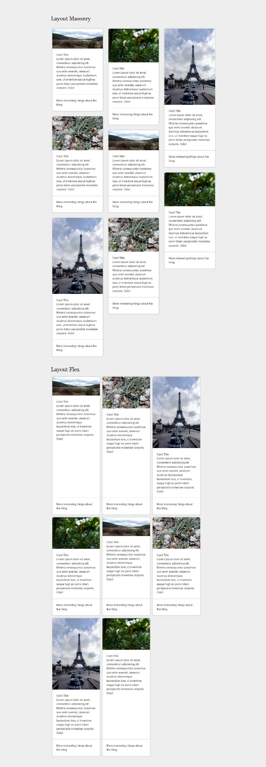

### Constraints

* Change the document title to "**Cards with CSS Columns and Flexbox**"
* Body background color must be rgb(238, 238, 238)
* The content should be divided in two parts:
  + First part is container unit (div) with classes cards-layout and masonry
  + Second part is container unit (div) with classes cards-layout and flex
* Use h2 for the heading