LAND SUBSIDENCE SUSCEPTIBILITY MAPPING
AND SPATIO-TEMPORAL FORECASTING BY
INTEGRATING SENTINEL-1 INSAR IMAGERY WITH
MACHINE AND DEEP LEARNING MODELS
A Thesis
Submitted to the Graduate Faculty of the
Louisiana State University and
Agricultural and Mechanical College
in partial fulfillment of the
requirements for the degree of
Master of Science
in
The Department of Civil and Environmental Engineering
by
Desmond Kangah
B.S., University of Mines and Technology, 2023 May 2025

This thesis is dedicated to me
ii

Acknowledgments The is my Acknowledgments
iii

Table of Contents
Acknowledgments . . . . . . . . . . . . . . . . . . . . . . . . . . . . . . . . . . . . . . iii
List of Tables . . . . . . . . . . . . . . . . . . . . . . . . . . . . . . . . . . . . . . . . v
List of Figures . . . . . . . . . . . . . . . . . . . . . . . . . . . . . . . . . . . . . . . vi
Abstract . . . . . . . . . . . . . . . . . . . . . . . . . . . . . . . . . . . . . . . . . . . vii
Chapter 1. Introduction . . . . . . . . . . . . . . . . . . . . . . . . . . . . . . . . . . 1
1.1. Background . . . . . . . . . . . . . . . . . . . . . . . . . . . . . . . . . . . 1
1.2. Thesis Objectives . . . . . . . . . . . . . . . . . . . . . . . . . . . . . . . . 4
1.3. Thesis Organization . . . . . . . . . . . . . . . . . . . . . . . . . . . . . . 4
Chapter 2. Study Area . . . . . . . . . . . . . . . . . . . . . . . . . . . . . . . . . . . 6
Chapter 3. Literature Review . . . . . . . . . . . . . . . . . . . . . . . . . . . . . . . 8
3.1. Overview of Land Subsidence in Urban Areas . . . . . . . . . . . . . . . . 8
3.2. Advancements in InSAR Monitoring for Subsidence . . . . . . . . . . . . . 8
3.3. Machine Learning for Subsidence Susceptibility Mapping . . . . . . . . . . 10
3.4. Deep Learning and Time Series Forecasting of Subsidence . . . . . . . . . 11
3.5. Hybrid Frameworks: Integrating Machine Learning and Deep Learning . . 11
3.6. Subsidence driving factor Analysis and Explainability . . . . . . . . . . . . 12
Chapter 4. Materials and Methods . . . . . . . . . . . . . . . . . . . . . . . . . . . . 14
4.1. Materials . . . . . . . . . . . . . . . . . . . . . . . . . . . . . . . . . . . . 14
4.2. Methodologies . . . . . . . . . . . . . . . . . . . . . . . . . . . . . . . . . 15
Chapter 5. References . . . . . . . . . . . . . . . . . . . . . . . . . . . . . . . . . . . 27
iv

List of Tables
v

List of Figures
2.1 | PSI Methodology steps . . . . . . . . . . . . . . . . . . . . . . . . . . . . . . . . |  | 7
4.1 | PSI Methodology steps . . . . . . . . . . . . . . . . . . . . . . . . . . . . . . . . |  | 16
4.2 | Architecture of Random Forest . . . . . . . . . . . . . . . . . . . . . . . . . . . |  | 18
4.3 | Architecture of MLP . . . . . . . . . . . . . . . . . . . . . . . . . . . . . . . . . |  | 19
4.4 | Architecture of SVR . . . . . . . . . . . . . . . . . . . . . . . . . . . . . . . . . |  | 20
4.5 | Architecture of LSTM . . . . . . . . . . . . . . . . . . . . . . . . . . . . . . . . |  | 21
4.6 | Architecture of the Hybrid Model . . . . . . . . . . . . . . . . . . . . . . . . . . |  | 22
4.7 | The timeline of my thesis | . . . . . . . . . . . . . . . . . . . . . . . . . . . . . . | 26
vi

Abstract
Land subsidence has become an escalating geohazard in rapidly urbanizing regions such as East Baton Rouge modification, infrastructure loading, and geomorphological variations collectively contribute to ground deformation. Continuous monitoring and forecasting are essential to safeguard infrastructure, water resources, and environmental sustainability. This study develops an integrated framework for land-subsidence susceptibility mapping and spatio-temporal forecasting by combining Sentinel-1 Persistent Scatterer Interferometry (PS-InSAR) observations with machine-learning and deep-learning models. Multi-temporal PS-InSAR data spanning 2017-2022 will be analyzed alongside geospatial factors such as groundwater level, slope, elevation, soil type, land-use/land-cover, and distance from roads and rivers to model subsidence behavior. Machine-learning algorithms, especially Random Forest (RF), will be used to identify spatial susceptibility patterns and rank key environmental and anthropogenic drivers influencing deformation. Building on these insights, a hybrid deep-learning model integrating Long Short-Term Memory (LSTM), Multi-Layer Perceptron (MLP), and Support Vector Regression (SVR) will be implemented for spatio-temporal forecasting of deformation trends. The outputs from the individual models will be fused in a meta-learning ensemble to enhance prediction accuracy, stability, and interpretability. Additionally, feature-importance and SHAP analyses will quantify the contribution of each factor to subsidence dynamics. The proposed framework aims to generate high-resolution susceptibility maps and reliable temporal forecasts, providing actionable insights for urban planning, groundwater management, and hazard mitigation in Baton Rouge and other subsiding environment.
vii

Chapter 1. Introduction
1.1. Background
Land subsidence is a gradual downward movement of the Earth’s surface caused by both natural and human-induced processes. In urban environments, subsidence is often accelerated by activities such as groundwater extraction, soil compaction, and infrastructure development. The phenomenon poses significant risks to infrastructure, water resources, and environmental sustainability, particularly in rapidly urbanizing regions. East Baton Rouge Parish, Louisiana, exemplifies an area where subsidence is driven by a combination of geological, hydrological, and anthropogenic factors.
Historically, monitoring land subsidence relied on geotechnical surveys and statistical models, which often lacked the spatial and temporal resolution needed for effective risk assessment. The introduction of satellite-based Interferometric Synthetic Aperture Radar (InSAR) has revolutionized subsidence monitoring by enabling high-resolution, wide-area measurements of ground deformation. Persistent Scatterer InSAR (PS-InSAR) techniques further enhance the ability to detect subtle, long-term changes in the Earth’s surface.
Recent advances in machine learning (ML) and deep learning (DL) have enabled the integration of multi-source geospatial data for improved subsidence mapping and forecasting. These approaches can capture complex, nonlinear relationships among environmental variables and provide interpretable insights into the drivers of subsidence. The combination of PS-InSAR data with ML/DL models offers a robust framework for understanding, predicting, and mitigating land subsidence in urban areas like East Baton Rouge. Among the most critical environmental and infrastructural risks affecting rapidly
1

urbanizing regions worldwide is land subsidence. The Earth’s surface gradually sinks as a result of both natural and anthropogenic processes, including soil compaction, groundwater extraction, and the overloading of urban infrastructure. Over 80 percent of severe subsidence cases globally are associated with aquifer system compaction and groundwater withdrawal (Galloway et al., 2023). In regions such as East Baton Rouge, Louisiana, rapid urban expansion, heavy infrastructure loads, and land-use changes accelerate the rate and extent of ground deformation, increasing the risks of flooding, pipeline rupture, and foundation failure (Wang et al., 2021).
Traditional subsidence-monitoring techniques, which rely primarily on geotechnical measurements and statistical extrapolation, often do not capture the nonlinear, multi-factor, and spatio-temporal characteristics of deformation processes (Liu et al., 2024). Although physically based numerical models provide valuable insights into deformation mechanisms, they typically require complex soil and hydrological parameters that are seldom available at regional scales (Zhou et al., 2022). The advent of Interferometric Synthetic Aperture Radar (InSAR), particularly Sentinel-1 time-series imagery, has revolutionized subsidence monitoring by providing high-resolution deformation measurements over large areas (Ferretti et al., 2020). However, a significant scientific challenge remains in transforming these large-scale deformation datasets into accurate, predictive, and interpretable models that effectively capture both environmental and human-induced drivers of subsidence.
Although ML and DL approaches such as Random Forest (RS), Support Vector Regression (SVR), Multi-Layer Perceptron (MLP), and Long Short-Term Memory (LSTM) have shown strong potential for modeling land subsidence by capturing complex nonlinear relationships and temporal dependencies (Zheng et al., 2024; Liu et al., 2024; Zhang
2

et al., 2021), most studies still address spatial susceptibility mapping and temporal forecasting separately, limiting both interpretability and predictive capability (Li et al., 2023). To overcome this limitation, this study is guided by the hypothesis that integrating PS-InSAR–derived deformation with hybrid ML/DL models and explainable AI can significantly enhance the accuracy and interpretability of subsidence predictions in East Baton Rouge Parish.
This study develops an integrated hybrid deep-learning framework that combines Sentinel-1 Persistent Scatterer Interferometry (PS-InSAR) data with advanced machine-and deep-learning models for comprehensive land-subsidence susceptibility mapping and spatio-temporal forecasting. Multi-temporal PS-InSAR observations spanning 2017-2022 are analyzed alongside geospatial predictors such as soil type, slope, elevation, groundwater level, land use, and proximity to roads and rivers to characterize deformation behavior. Random Forest (RF) is employed to identify spatial susceptibility patterns and rank key environmental and anthropogenic factors, while Long Short-Term Memory (LSTM), Multi-Layer Perceptron (MLP), and Support Vector Regression (SVR) models are used to capture temporal deformation trends.
To ensure temporal reliability, the forecasting models are trained using earlier PS-InSAR data and validated on recent observations, allowing the hybrid framework to learn long-term deformation dynamics and predict future displacements. Finally, outputs and latent feature representations from individual models are fused within a meta-learning ensemble to enhance overall accuracy, robustness, and interpretability, resulting in a data-driven and explainable framework for monitoring and forecasting land subsidence.
3

1.2. Thesis Objectives
The main research objectives are to:
i. Generate high-resolution land subsidence maps from Sentinel-1 PS-InSAR data (2017–2020) for East Baton Rouge, identifying spatial deformation patterns and major subsidence zones.
ii. Analyze and rank subsidence driving factors using machine-learning models. Evaluate model performance using metrics such as RMSE and R2, supported by SHAP-based explainable AI for improved planning and groundwater management.
iii. Develop individual predictive models for forecasting temporal deformation trends from InSAR-derived time-series data.
iv. Build a hybrid deep-learning framework that integrates outputs and features from the LSTM, MLP, and SVR models through meta-learning to enhance forecasting accuracy.
1.3. Thesis Organization
This thesis is structured into six chapters as follows:
Chapter 1, this chapter, introduces the research topic of land subsidence susceptibility mapping and spatio-temporal forecasting. It provides background information, outlines research objectives, and presents the thesis organization.
Chapter 2 presents the study area characteristics of East Baton Rouge Parish, including its geological setting, hydrogeological conditions, and historical subsidence patterns that make it vulnerable to ground deformation.
Chapter 3 provides a comprehensive literature review covering: advances in InSAR monitoring techniques for subsidence, machine learning applications in susceptibility mapping, deep learning approaches for time-series forecasting, hybrid modeling frameworks, and methods for analyzing subsidence driving factors. The chapter concludes by identifying research gaps this study aims to address.
4

Chapter 4 details the methodology employed, including: PS-InSAR processing of Sentinel-1 data, preparation of environmental and anthropogenic predictor variables, development of machine learning models (Random Forest) for susceptibility mapping, implementation of deep learning models (LSTM, MLP, SVR) for temporal forecasting, and construction of the hybrid stacked ensemble framework. The chapter also describes validation procedures using GNSS data and SHAP-based interpretation methods.
Chapter 5 presents the analysis results and discussion, covering: spatial patterns of observed subsidence, relative importance of driving factors, performance evaluation of individual and ensemble models, and validation against ground-truth measurements. The implications for urban planning and groundwater management are also discussed.
Chapter 6 summarizes key conclusions, provides recommendations for land subsidence monitoring and mitigation in East Baton Rouge, acknowledges study limitations, and suggests directions for future research.
5

Chapter 2. Study Area
This study will be conducted in East Baton Rouge Parish (EBRP), located in southeastern Louisiana and forming part of the Capital Area alongside four neighboring parishes. Covering approximately 471 square miles, the parish is shaped by the Mississippi and Comite Rivers, extensive cypress swamps, and forested plains. Despite its diverse landscape, EBRP faces persistent geological and environmental challenges, including land subsidence, soil instability, and climate-induced ground deformation.
Subsidence in EBRP is primarily caused by the extraction of groundwater, oil, and natural gas, which leads to gradual land sinking. The problem is further aggravated by the area’s soft soil and increasing construction activities, which promote settlement and consolidation. Frequent heavy rainfall and flooding also intensify erosion and ground movement. To ensure the region’s long-term stability, sustainable groundwater management, detailed geotechnical investigations, and effective flood and riverbank control measures are essential. These efforts will help mitigate the effects of natural and human-induced land deformation and strengthen EBRP’s resilience to future environmental challenges.
6

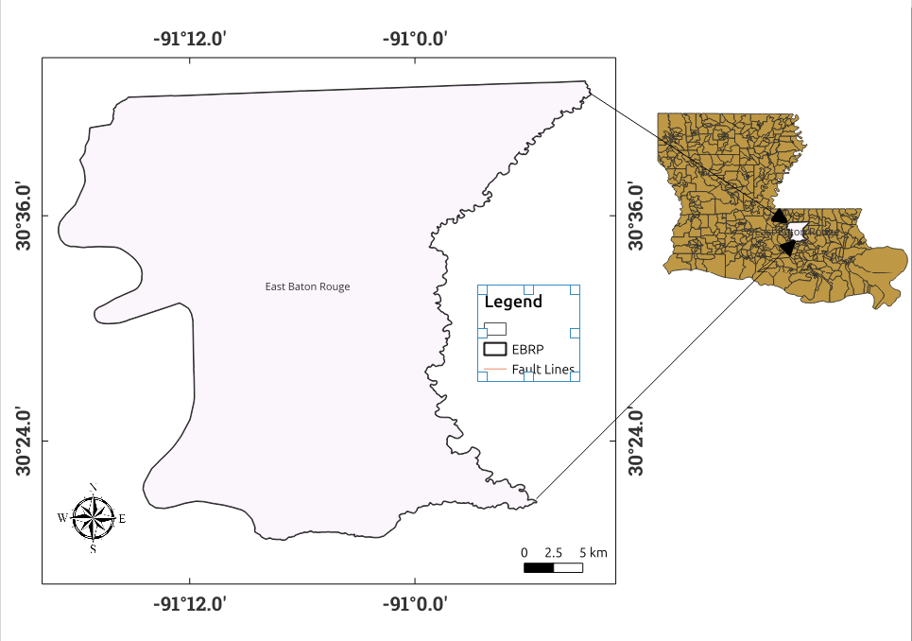
Figure 2.1. PSI Methodology steps
7

Chapter 3. Literature Review
3.1. Overview of Land Subsidence in Urban Areas
Land subsidence, which is defined as the slow downward movement of the Earth's surface, is becoming more widely acknowledged as a significant geohazard in areas of the world that are rapidly becoming more urbanized (Galloway et al., 2023). In urban environments, subsidence processes are fueled by excessive groundwater extraction, sediment consolidation, urban infrastructure loading, and land-use change (Holzer and Johnson, 1985). Research on the Lower Mississippi Basin, for instance, demonstrates how shallow geology and infrastructure growth can intensify surface deformation and compaction (Wang et al., 2021). The hazards include diminished drainage capacity, heightened susceptibility to flooding in low-lying urban corridors, and harm to pipelines and foundations. Subsurface faulting and structural geology make subsidence patterns in many cities even more complex (Younas et al., 2023). These findings highlight the need for reliable frameworks that can both map the areas where subsidence is most likely to occur and predict its future course.
3.2. Advancements in InSAR Monitoring for Subsidence
The development of InSAR has transformed ground-deformation monitoring by providing high-resolution, wide-area, and long-term observations of surface displacement. Unlike traditional geodetic methods such as leveling or GNSS (Global Navigational Satellite Systems, which offer high precision but sparse spatial coverage and high costs, InSAR enables millimeter-scale motion detection across vast regions regardless of weather or lighting conditions (Ferretti et al., 2020; Crosetto et al., 2016). Early Differential InSAR (DInSAR) techniques relied on few acquisitions and were limited by temporal decorrelation,
8

leading to the development of multi-temporal approaches, notably Persistent Scatterer InSAR (PS-InSAR) and Small Baseline Subset (SBAS-InSAR) which use long image sequences to extract continuous deformation trends (Ferretti et al., 2001; Berardino et al., 2002). Among these, PS-InSAR has proven most robust in urban areas by identifying radar targets that remain phase-stable over time, achieving sub-millimeter precision on built infrastructure.
Building on these advances, newer methods such as Distributed Scatterer (DS-InSAR) and Multi-Temporal InSAR (MT-InSAR) extend coherence to mixed urban–rural environments by statistically analyzing pixel clusters (Fattahi and Amelung, 2015). The advent of open-access Sentinel-1A/B data with a 12-day revisit cycle further enhanced PS-InSAR’s operational value for regional subsidence monitoring. Numerous studies have demonstrated its effectiveness: Hakim et al. (2023) used PS-InSAR coupled with hybrid CNN–SVR models to improve deformation prediction in Indonesia; Li et al. (2020) applied PS-InSAR and LSTM networks in Beijing, achieving R2 > 0.85 between deformation and aquifer changes; and Yu, Penna, and Li (2023) integrated PS-InSAR with GNSS in Houston to map displacements of 5–15 mm yr-1. More recent works, including Peng et al. (2024) and Liu et al. (2023), show that data-driven fusion of PS-InSAR with deep-learning architectures like LSTM can outperform traditional regression models in temporal subsidence forecasting.
Beyond urban analysis, PS-InSAR has also advanced environmental and hydrogeological applications, linking surface deformation to aquifer compaction, groundwater extraction, and soil-structure interactions. For instance, Wang et al. (2023) used PS-InSAR and RF regression to identify groundwater depth as the main driver of subsidence in China, while Li et al. (2020) demonstrated strong correlations between deformation and groundwater-level 9

fluctuations. Overall, PS-InSAR’s ability to deliver dense, long-term deformation time series combined with its compatibility with machine-learning and deep-learning frameworks makes it an indispensable tool for both monitoring and forecasting. Yet, most existing studies emphasize where deformation occurs rather than how and when it evolves. The present research bridges this gap by integrating PS-InSAR time-series data with hybrid deep-learning models to perform spatio-temporal forecasting and assess environmental causative factors driving subsidence across East Baton Rouge.
3.3. Machine Learning for Subsidence Susceptibility Mapping
Machine-learning (ML) models are widely used to map subsidence susceptibility by combining deformation evidence (often from InSAR) with environmental and anthropogenic predictor variables (e.g., groundwater depth, land-use, slope, soil type, distance to
infrastructure). | For example, Gharechaee et al. | (2023) applied RF, KNN, and CART
to InSAR-derived subsidence in Iran’s Bakhtegan Basin, finding RF performed best and highlighting that the leading susceptibility factors were not only groundwater withdrawal
but also proximity to dams, faults and mines. | Orlandi et al. | (2024) compared ML
approaches in Murcia, Spain, using land-use, lithology, and other predictors, demonstrating the utility of ML for zonation and factor ranking. Hosseinzadeh et al. (2024) evaluated seven ML methods (CART, BRT, SVM, RF, logistic regression, etc.) in Iran and found BRT outperformed others in susceptibility mapping. These studies show ML’s strength in spatial patterning and factor ranking, but many stop short of integrating forecasting or temporal sequence modelling, limiting their value for prediction of future subsidence trends.
10

3.4. Deep Learning and Time Series Forecasting of Subsidence
Deep-learning (DL) models, especially sequence models like LSTM, are increasingly adopted for subsidence forecasting because of their ability to capture temporal dependencies and non-linear dynamics. Li et al. (2020) applied LSTM to PS-InSAR data in Beijing Plain, showing promise for temporal modelling though with limitations in spatial generalization. Mirmazloumi et al. (2023) used LSTM on InSAR time-series for three mining sites, Liu et al. demonstrating an early-warning capability by forecasting 3–5 steps ahead.
(2023) implemented SBAS-InSAR plus an attention-LSTM (AT-LSTM) model for mining subsidence, highlighting how attention mechanisms improve temporal modelling. Soni et al. (2025) developed a modified LSTM for PS-InSAR in mining-induced subsidence, achieving high accuracy (R2 ~ 0.98). These works confirm that DL sequence modelling is powerful for forecasting, but many studies remain site-specific, focus largely on mining rather than urban settings, and rarely integrate causative-factor analysis or ML-based spatial mapping.
3.5. Hybrid Frameworks: Integrating Machine Learning and Deep Learning The convergence of ML (for spatial susceptibility) and DL (for temporal forecasting) into hybrid frameworks is still emerging in the subsidence domain. Hybrid approaches stack or ensemble multiple models (LSTM + MLP + SVR) to benefit from complementary strengths: ML’s causal-pattern extraction and DL’s temporal learning. Zheng et al. (2024) compared SVR, Holt smoothing and MLP on InSAR time-series and found MLP versatile but did not extend to LSTM or hybrid stacks. Such gaps suggest the potential for stacked models using meta-learning ensembles to combine base-model predictions and latent features for enhanced accuracy and interpretability. Hybrid models are common in other geohazard
11

domains (e.g., landslides, groundwater) but remain under-utilized in urban subsidence. Thus, implementing a hybrid DL/ML ensemble to both map and forecast subsidence fills a methodological gap in current literature.
3.6. Subsidence driving factor Analysis and Explainability
Understanding why subsidence occurs, identifying and quantifying drivers is vital for decision-making. Explainable AI (XAI) tools like SHAP (Shapley Additive Explanations) and permutation importance are increasingly used to interpret ML and DL models. Liu et al. (2025) applied XGBoost and SHAP on PS-InSAR deformation along the Beijing–Xiong’an railway, showing groundwater fluctuations contributed ~35% of subsidence signal. Xue et al. (2024) used ML on InSAR data to inspect deformation along high-speed rail corridors, emphasizing hydrological and structural controls. These studies show how driver-ranking can support mitigation strategies. Nevertheless, few investigations combine hybrid DL forecasting with explicit causative-factor analysis in urban contexts so, the use of SHAP in a hybrid DL/ML framework addresses a real literature gap.
While many studies have applied InSAR and machine or deep learning (ML/DL) methods to analyze land subsidence, most have treated spatial susceptibility mapping and temporal forecasting as separate tasks, often overlooking model interpretability (Gharechaee et al., 2023; Rahmani et al., 2024; Fu et al., 2023). Applications within complex U.S. Gulf Coast urban environments also remain limited. To address these gaps, this study integrates Persistent Scatterer InSAR (PS-InSAR) time-series data with a hybrid ML/DL ensemble and SHAP (SHapley Additive exPlanations) interpretation framework to develop predictive and interpretable subsidence models tailored to Baton Rouge’s unique environmental and
12

infrastructural conditions (Mojtahedi et al., 2025).
13

Chapter 4. Materials and Methods
4.1. Materials
The study will utilize various geospatial and environmental datasets obtained from open-access sources to support the analysis.
4.1.1. InSAR imagery
The second dataset comprises Interferometric Synthetic Aperture Radar (InSAR) data derived from Sentinel-1 SAR acquisitions spanning February 2017 to December 2022. The study utilized data from Sentinel-1A, which operates with a 12-day repeat cycle. A total of 135 Sentinel-1 images were acquired along the same satellite path and frame, covering the entire area of interest. For the Persistent Scatterer Interferometry (PSI) technique to produce reliable results, a minimum of 20 SAR time-series images is generally required; hence, the available dataset was considered sufficient for robust PSI analysis. Additionally, a high-resolution 30 m Digital Elevation Model (DEM) was incorporated to remove the topographic phase contribution, offering higher accuracy compared to global DEM products such as SRTM (Shuttle Radar Topography Mission).
4.1.2. Geospatial Data
The proposed land subsidence suitability analysis will use a comprehensive set of geospatial, environmental, geological, and anthropogenic datasets that influence ground deformation. Core layers will include slope, elevation, precipitation, distance from rivers and roads, soil type, groundwater depth, LULC, NDVI, and population density, while additional layers such as TWI, clay fraction, groundwater recharge, soil moisture, and impervious surface density will enhance the analysis. Data will be sourced from open-access
14

repositories including USGS DEM, ESA WorldCover, Sentinel-2, NASA GPM, SMAP, and OpenStreetMap. All layers will be standardized to a 30 m spatial resolution, normalized, and aligned within a common coordinate system to serve as inputs for Random Forest and SHAP-based modeling of subsidence susceptibility in East Baton Rouge.
4.1.3. GNSS data
In this study, Global Navigation Satellite System (GNSS) data will be used to validate the InSAR-derived land subsidence results for EBRP. GNSS provides precise, continuous, and temporal ground-displacement measurements that serve as an accurate reference for calibrating InSAR observations. According to Abdalla et al. (2024), Louisiana hosts approximately 130 continuously operating reference stations (CORS) under the GulfNet network, with two active stations LSU and GMVS located within East Baton Rouge Parish. Their study demonstrated a strong correlation between InSAR-estimated and GNSS-measured displacements, confirming the robustness of using GNSS as an independent validation dataset. Building on this framework, the present study will utilize the GNSS time-series data from the 1LSU and GMVS stations, along with any nearby GulfNet stations within the surrounding parishes, to validate and assess the accuracy of the PS-InSAR-derived subsidence rates over East Baton Rouge.
4.2. Methodologies
4.2.1. Persistent Scatters Interferometry (PSI) Method.
A total of 135 Sentinel-1 C-band SAR images were utilized for the analysis. PSI was applied to extract stable point targets, known as persistent scatterers (PS), which retain high phase stability over time. The workflow as illustrated in figure 2 began with feature
15

extraction from the SAR images, followed by phase calibration and correction to remove orbital and systematic errors. Temporal and spatial filtering techniques were employed to separate atmospheric phase components from actual ground deformation signals (Ferretti et al., 2001).
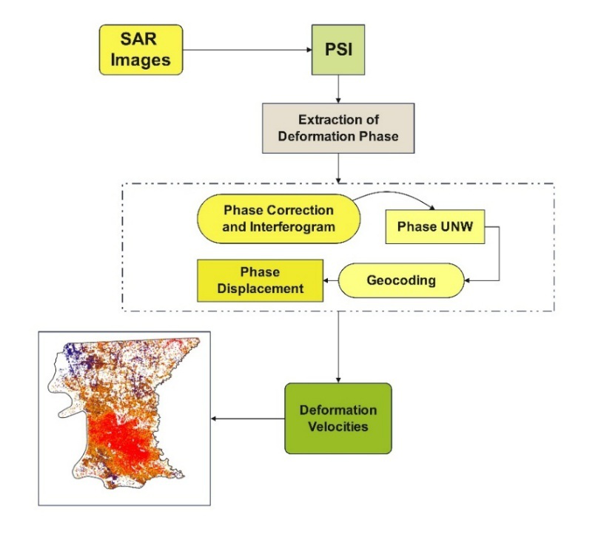
Figure 4.1. PSI Methodology steps
Phase unwrapping was then performed on the corrected interferograms, and a linear temporal model was fitted to each PS point to estimate mean displacement velocities over the study period (Hooper et al., 2004). The resulting displacement velocity maps were geocoded to the study area and validated against available reference measurements, such as GNSS data, to ensure reliability.
This PSI approach enabled millimeter-scale detection of land subsidence and uplift trends, providing a robust method for monitoring infrastructure stability and surface deformation over time. Figure 1 below shows the workflow of PSI.
16

4.2.2. Machine learning methods
Random Forest
Random Forest (RF) is an ensemble machine-learning algorithm that combines the results of multiple decision trees to improve prediction accuracy and reduce overfitting. It uses random sampling of data and features during training, which enhances generalization and minimizes model bias (Breiman, 2001). RF is particularly effective for classification tasks, making it suitable for developing land-subsidence susceptibility maps where spatial and environmental variables interact in complex ways. Its predictive performance can be further improved by tuning key hyperparameters such as the number of trees (n_estimators), maximum tree depth (max_depth), and minimum samples per split (min_samples_split) (Cutler et al., 2007). In this study, the Random Forest model as shown in Figure 3, will be optimized and employed for the susceptibility analysis component to classify and identify areas most prone to ground deformation in East Baton Rouge Parish.
Random Forest (RF) is an ensemble machine-learning algorithm that combines the results of multiple decision trees to improve prediction accuracy and reduce overfitting. It uses random sampling of data and features during training, which enhances generalization and minimizes model bias (Breiman, 2001). RF is particularly effective for classification tasks, making it suitable for developing land-subsidence susceptibility maps where spatial and environmental variables interact in complex ways. Its predictive performance can be further improved by tuning key hyperparameters such as the number of trees (n_estimators), maximum tree depth (max_depth), and minimum samples per split (min_samples_split) (Cutler et al., 2007). In this study, the Random Forest model as shown in Figure 3, will be
17

optimized and employed for the susceptibility analysis component to classify and identify areas most prone to ground deformation in East Baton Rouge Parish.
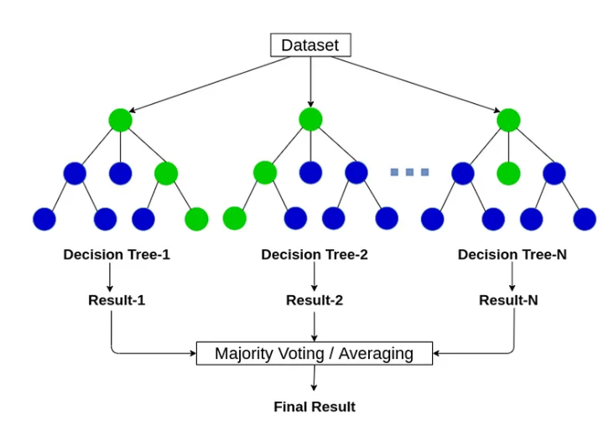
Figure 4.2. Architecture of Random Forest
MLP Methodology
MLP model will be used to learn nonlinear spatial relationships between environmental and geospatial factors that influence land subsidence. Unlike the LSTM, which captures temporal dependencies, the MLP focuses on feature-based patterns derived from engineered variables such as elevation, slope, soil type, distance to roads and rivers, and land-use characteristics (Zhang et al., 2021; Zhou et al., 2020).
The proposed MLP is a feedforward neural network consisting of three hidden layers with 100, 50, and 25 neurons, each activated using the Rectified Linear Unit (ReLU) function. A single neuron in the output layer performs regression to predict displacement values. Feature scaling is applied prior to training, and L2 regularization (α = 0.001) is used to prevent overfitting. The model employs the Adam optimizer (Kingma and Ba, 2015) with an adaptive learning rate and early stopping
18

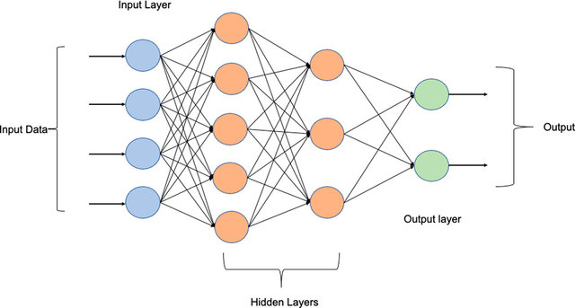
Figure 4.3. Architecture of MLP
Model performance will be evaluated using the coefficient of determination (R2), mean absolute error (MAE), and root-mean-square error (RMSE) under a 5-fold cross-validation scheme. The MLP is expected to capture complex, nonlinear feature interactions that complement the LSTM’s temporal learning component, thereby strengthening the overall hybrid prediction framework. The model’s architecture is as shown below in Figure 4.
SVR Methodology
The SVR model will be employed to capture nonlinear relationships between geospatial features and land subsidence magnitudes. SVR is a regression extension of the Support Vector Machine (SVM), which constructs a function that approximates the relationship between input variables and target values within a specified margin of tolerance (Smola and Schölkopf, 2004). This makes it particularly suitable for modeling continuous, nonlinear deformation patterns where data may contain noise or outliers (Zhou et al., 2020).
The SVR model will use the Radial Basis Function (RBF) kernel to map input features into a higher-dimensional space, allowing the model to learn complex, non-linear

patterns that linear regression cannot capture.
19

The key hyperparameters, C= 150

(regularization), ε = 0.05 (epsilon-insensitive loss), and γ = scale (kernel width) was selected based on performance tuning in the hybrid framework. Feature scaling will be applied using standard normalization to ensure that all variables contribute equally to the regression surface.
SVR training will be conducted under a 5-fold cross-validation scheme to ensure model robustness and generalization. Performance will be evaluated using the Coefficient of Determination (R2), Mean Absolute Error (MAE), and Root Mean Square Error (RMSE) metrics.
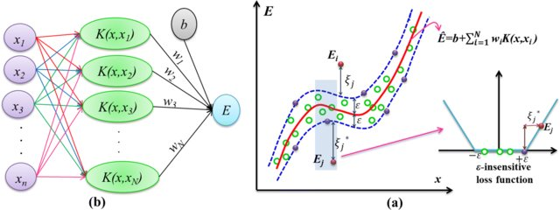
Figure 4.4. Architecture of SVR
By focusing on support vectors (critical boundary points), the SVR model provides a smooth, generalizable regression function, making it robust against overfitting and suitable for small or moderately sized geospatial datasets (Smola and Schölkopf, 2004; Zhang et al., 2021). Within the proposed hybrid ensemble, the SVR component complements the LSTM’s temporal learning and the MLP’s nonlinear spatial modeling, thereby improving the overall accuracy and stability of subsidence forecasting. Figure 4 illustrates the SVR model.
3. Long Short-Term Memory (LSTM) method
LSTM model will be applied to capture the temporal dynamics of land subsidence derived from Sentinel-1 PS-InSAR time-series data. LSTM is an advanced form of the Recurrent Neural Network (RNN) capable of learning both short-term variations and
20

long-term dependencies in sequential data through a memory cell regulated by three gates the forget, and output gates. This structure allows the model to selectively retain relevant deformation information while discarding noise or redundant temporal patterns (Greff et al., 2017).
The model will be trained using 12-step time-series deformation sequences representing Persistent Scatterer (PS) points within East Baton Rouge. Each sequence will be normalized and reshaped into the 3D input format required by the LSTM. A stacked unidirectional architecture will be employed, consisting of two LSTM layers (64 and 32 units) followed by dense layers for regression. The Adam optimizer (Kingma and Ba, 2015) and Huber loss function will be used to ensure stable learning and robustness to outliers. A 5-fold cross-validation approach will validate performance using metrics such as R2, MAE, and RMSE.
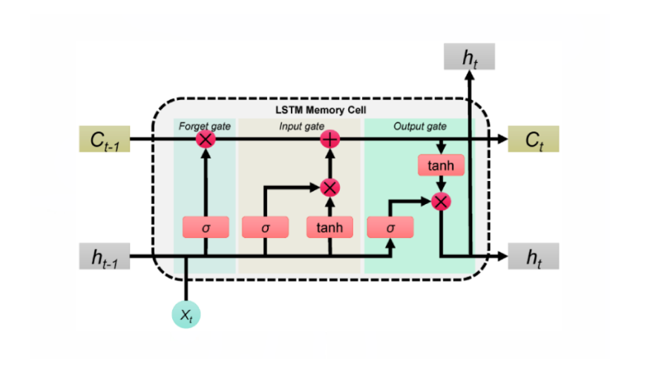
Figure 4.5. Architecture of LSTM
The LSTM model is expected to learn both short-term deformation fluctuations and long-term cumulative subsidence trends, providing a reliable temporal forecasting component within the proposed hybrid framework (Zhang et al., 2021; Zhou et al., 2020). Figure 5
21

illustrates the architecture of LSTM model.
4. Hybrid Stacked Ensemble Model
The proposed Hybrid Stacked Ensemble Model Figure 6 integrates three distinct learning algorithms LSTM, Multilayer Perceptron (MLP), and Support Vector Regression (SVR) to forecast land subsidence from Sentinel-1 PS-InSAR-derived deformation time-series and geospatial features. In the preprocessing phase, PS points with ≥1.5 mm yr-1 were retained, 12-step temporal sequences were generated, and 20 feature groups were extracted All inputs were to represent environmental, topographic, and anthropogenic influences.
standardized to ensure comparable scaling. Each base learner captures unique aspects of the deformation process: LSTM models sequential temporal dynamics (Hochreiter and Schmidhuber, 1997), MLP captures complex nonlinear spatial relationships (Goodfellow et al., 2016), and SVR learns smooth kernel-based mappings between predictors and deformation rates (Smola Schölkopf, 2004).
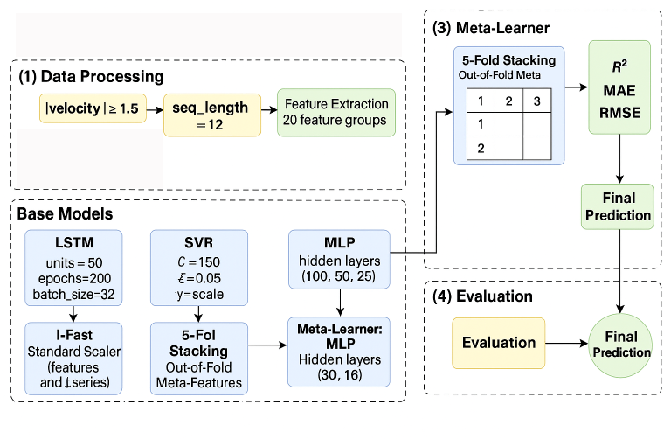
Figure 4.6. Architecture of the Hybrid Model
The model employs a stacking ensemble framework, where each base model was
22

trained independently under 5-fold cross-validation to produce out-of-fold predictions used as meta-features. These features were then input into a meta-learner MLP (30-15-1) that learns the optimal combination of the base model outputs, leveraging their complementary strengths. Evaluation using R2, MAE, and RMSE demonstrated that the hybrid ensemble achieved higher accuracy and generalization compared to any single model. This finding aligns with previous studies emphasizing that stacked hybrid enemies improve robustness and predictive reliability in environmental and geospatial forecasting (Zhou, 2021; Guo et al., 2024; Massaoudi et al., 2021).
5. Processing and validation
1. Data Alignment
All spatial layers will undergo systematic preprocessing to ensure consistency and compatibility for machine-learning analysis. Raster datasets such as slope, elevation, precipitation, soil type, and LULC will first be clipped to the study area boundary of East Baton Rouge using a common geographic coordinate system (WGS 84, UTM Zone 15N). Each layer will then be resampled to a uniform 30-meter spatial resolution to maintain equal pixel dimensions and facilitate pixel-wise comparison across datasets. Vector datasets such as roads, rivers, and groundwater wells will be converted into distance raster’s representing the Euclidean distance from each feature.
Subsequently, all raster layers will be spatially aligned and reprojected to the same grid extent and cell alignment to prevent spatial offsets. Missing or erroneous values will be masked or interpolated, and continuous variables such as precipitation, elevation, and NDVI will be normalized using Min–Max scaling to standardize data ranges between 0 and 1. Categorical data such as soil type and land cover will be encoded into
23

numerical form through one-hot encoding to enable compatibility with machine-learning algorithms. The preprocessed and harmonized datasets will then be stacked into a multi-layer composite, serving as the primary input for the Random Forest and SHAP-based subsidence susceptibility modeling framework.
2. Susceptibility and Driving Factor Analysis
A Land Subsidence Susceptibility Map will be developed to identify and quantify the contribution of key environmental and anthropogenic factors influencing ground deformation in the study area. The map will be generated using geospatial predictors such as slope, elevation, precipitation, land use and land cover (LULC), distance from roads and rivers, groundwater depth, and vegetation indices (NDVI) recognized in previous studies as primary drivers of subsidence (Hong et al., 2020; Chen & Li, 2023). All predictor layers will be resampled to a uniform spatial resolution and normalized using Min–Max scaling to ensure data comparability. A Random Forest (RF) algorithm (Breiman, 2001) will be employed to produce the subsidence susceptibility map using binary deformation labels (1 = subsiding, 0 = stable) derived from the hybrid ensemble model, effectively delineating areas most prone to land subsidence within East Baton Rouge Parish.
3. SHAP (SHapley Additive Explanations)
To interpret the relative importance of each causative factor, SHAP (SHapley Additive Explanations) by Lundberg and Lee, 2017, and RF feature importance metrics were applied. SHAP values provided an explainable AI framework for quantifying each feature’s marginal effect on subsidence probability, while the RF’s mean decreases in Gini and accuracy scores ranked feature relevance. The results showed that slope, precipitation, LULC, and distance from roads were the most influential factors controlling subsidence
24

distribution. Integrating SHAP with RF allowed for both high predictive accuracy and transparent interpretation of the underlying geomorphological and anthropogenic processes driving land deformation, consistent with recent geospatial susceptibility studies (Hong et al., 2020; Chen and Li, 2023).
4. GNSS Validation of InSAR Data
GNSS data will be used to validate the InSAR-derived subsidence results. Two CORS stations, 1LSU and GMVS, located in East Baton Rouge Parish, will provide ground-truth displacement measurements for comparison. This validation ensures that the InSAR-estimated deformation accurately represents real ground movement, consistent with findings by Abdalla et al. (2024).
5. Expected Outcomes
The study will generate high-resolution PS-InSAR subsidence maps for East Baton Rouge Parish (2017–2022) and use machine-learning and deep-learning models including RF, SVM, LSTM, MLP, and SVR to analyze and forecast deformation patterns. A hybrid model will be built through meta-learning integration of these algorithms to enhance prediction accuracy, while SHAP-based explainable AI will be employed to identify key environmental and anthropogenic factors driving land deformation, supporting effective groundwater and land management decisions.
6. Thesis Timeline
25


Figure 4.7. The timeline of my thesis
26

Chapter 5. References
Abdalla, A., Shami, S., Shahriari, M., Azar, M. (2024). Estimation of land displacement in East Baton Rouge Parish, Louisiana, using InSAR: Comparisons with GNSS and machine learning models. EJRS. [Rest of references...]
Abdalla, A., Shami, S., Shahriari, M., Azar, M. (2024). Estimation of land displacement in East Baton Rouge Parish, Louisiana, using InSAR: Comparisons with GNSS and machine learning models. EJRS. Berardino, P., Fornaro, G., Lanari, R., and Sansosti, E. (2002). A new algorithm for surface deformation monitoring based on small baseline differential SAR interferograms. IEEE Transactions on Geoscience and Remote Sensing, 40(11), 2375–2383.
Breiman, L. (2001). Random forests. Machine Learning, 45(1), 5–32.
Chen, W., and Li, H. (2023). Explainable machine learning for land subsidence susceptibility modeling. Science of the Total Environment, 903, 166604.
Crosetto, M., Monserrat, O., Cuevas-González, M., Devanthéry, N., and Crippa, B. (2016). Persistent Scatterer Interferometry: A review. ISPRS Journal of Photogrammetry and Remote Sensing, 115, 78–89. Cutler, D. R., Edwards Jr, T. C., Beard, K. H., Cutler, A., Hess, K. T., Gibson, J., & Lawler, J. J. (2007). Random forests for classification in ecology. Ecology, 88(11), 2783–2792.
27

Fattahi, H., and Amelung, F. (2015). InSAR bias and uncertainty due to the systematic and stochastic tropospheric delay. Journal of Geophysical Research: Solid Earth, 120(12), 8758–8773.
Ferretti, A., Fumagalli, A., Novali, F., Prati, C., Rocca, F., and Rucci, A. (2020). Satellite radar interferometry: Permanent scatterer analysis and applications. Remote Sensing and Digital Image Processing, 24, 21–47.
Ferretti, A., Fumagalli, A., Novali, F., Prati, C., Rocca, F., and Rucci, A. (2020). Sub-millimeter accuracy of InSAR time-series: Principles and applications. Remote Sensing of Environment, 242, 111720.
Galloway, D., Teatini, P., Carreón, D., and Ye, S. (2023). Global land subsidence: Reviews of Geophysics, 61(4), Impact of climate extremes and human activities.
e2023RG000817.
Gharechaee, H., Samani, A. N., Sigaroodi, S. K., Baloochiyan, A., Moosavi, M. S., Hubbart, J. A., and Sadeghi, S. M. M. (2023). Land subsidence susceptibility mapping using Interferometric Synthetic Aperture Radar (InSAR) and machine-learning models in a semiarid region of Iran. Land, 12(4), 843. Goodfellow, I., Bengio, Y., and Courville, A. (2016). Deep Learning. MIT Press.
Greff, K., Srivastava, R. K., Koutník, J., Steunebrink, B. R., and Schmidhuber, J. (2017). LSTM: A search space odyssey. IEEE Transactions on Neural Networks and Learning Systems, 28(10), 2222–2232.
Guo, Y., Zhou, Y., and Zhang, L. (2024). A hybrid stacking model for enhanced
short-term load forecasting. | Electronics, 13(14), 2719. | https://doi.org/10.3390/

Hakim, W. L., Sugianto, E., and Ardiansyah, A. (2023). InSAR time-series analysis and susceptibility mapping for land subsidence in Semarang using ICOPS-CNN and ICOPS-SVR models. International Journal of Applied Earth Observation and Geoinformation, 125, 102552.
Hochreiter, S., and Schmidhuber, J. (1997). | Long short-term memory. | Neural
Computation, 9(8), 1735–1780. Holzer, T. L., and Johnson, A. I. (1985). Land subsidence caused by ground-water
withdrawal in urban areas. | GeoJournal, 11(3), 245–255. | https://doi.org/10.1007/
Hong, H., Panahi, M., Shirzadi, A., Ma, T., Liu, J., Zhu, A. X., and Chen, W. (2020). A novel hybrid integration model using random forest and naive Bayes tree algorithms for landslide susceptibility mapping. Catena, 195, 104790.
Kingma, D. P., and Ba, J. (2015). Adam: A method for stochastic optimization. International Conference on Learning Representations (ICLR).
Land subsidence modelling using Long Li, H., Li, Z., and Gou, W. (2020).
Short-Term Memory (LSTM) and Persistent Scatterer InSAR data: A case study from Beijing Plain. Hydrology and Earth System Sciences, 24(6), 2829–2844.
Hybrid deep learning model for land Li, X., Zhang, Y., and Wang, J. (2023).
subsidence forecasting using InSAR and environmental data. Environmental Modelling and Software, 157, 105535.
29

Liu, J., Chen, H., and Zhao, Q. (2024). Machine learning-based techniques for land subsidence prediction: A review and case study. Journal of Environmental Management, 351, 119732.
Liu, Y., Chen, Z., and Zhang, P. (2023). Integrating SBAS-InSAR and attention-LSTM
for time-series ground-subsidence prediction. | Remote Sensing, 15(13), 3409.
Lundberg, S. M., and Lee, S.-I. (2017). A unified approach to interpreting model predictions. Advances in Neural Information Processing Systems (NeurIPS), 30, 4765–4774.
Massaoudi, M., Refaat, A., and Hamdani, M. (2021). A novel stacked generalization ensemble-based hybrid LGBM-XGB-MLP model for short-term load forecasting. Energy Reports, 7, 5283–5295.
Mirmazloumi, S., Wassie, Y., Nava, L., Cuevas-González, M., Crosetto, M., and InSAR time series and LSTM model to support early warning Monserrat, O. (2023).
detection tools of ground instabilities: Mining site case studies. Bulletin of Engineering Geology and the Environment, 82, 374. Mojtahedi, F. F., Yousefpour, N., Chow, S. H., and Cassidy, M. (2025). Deep learning for time series forecasting: Review and applications in geotechnics and geosciences. Archives

of Computational Methods in Engineering, 32, 3415–3445.

Orlandi, D., Abellan, A., and Moreno, M. (2024). A machine-learning approach for mapping susceptibility to land subsidence in the region of Murcia, Spain. Heliyon, 10(2), e2434.
Peng, M., Tang, C., Sun, D., and Zhu, H. (2024). Characterization and prediction
30

of InSAR-derived ground deformation using ICA and LSTM models. Computers & Geosciences, 174, 105440.
Rahmani, P., Gholami, H., and Golzari, S. (2024). An interpretable deep-learning model to map land subsidence hazard. Environmental Science and Pollution Research.
A tutorial on support vector regression. Smola, A. J., and Schölkopf, B. (2004).
Statistics and Computing, 14(3), 199–222. .
Soni, R., Alam, M. S., and Vishwakarma, G. K. (2025). Prediction of InSAR deformation time-series using an improved LSTM deep learning model. Scientific Reports, 15, 5333.
Analysis Wang, H., Jia, C., Ding, P., Feng, K., Yang, X., and Zhu, X. (2023).
and prediction of regional land subsidence with InSAR technology and machine-learning algorithm—case of Decheng County, Shandong, China. KSCE Journal of Civil Engineering, 27, 782–793.
Wang, L., Zhang, W., and Lin, Y. (2021). Urban land subsidence and its driving factors: A case study of the lower Mississippi River basin. Remote Sensing, 13(19), 3872.
Xue, Y. A., Luo, Q., Li, J., Lin, H., Chen, G., Chen, J., and Wang, H. (2024). Regional subsidence monitoring and prediction along high-speed rail corridors using InSAR and machine learning. Remote Sensing, 16(6), 1275.
Yu, C., Penna, N. T., and Li, Z. (2023). Ground deformation monitoring in Houston
31

using Sentinel-1 InSAR and GNSS data. Remote Sensing, 15(2), 331.
Zhang, L., Ding, X., and Lu, Z. (2021). Integrating PS-InSAR and deep learning for urban subsidence prediction. Remote Sensing of Environment, 258, 112396.
Zhang, Y., Li, X., and Zhou, L. (2021). Spatio-temporal prediction of land subsidence using deep LSTM networks with InSAR time series. Remote Sensing of Environment, 258, 112382.
Development and comparison of Zheng, L., Zhang, F., and Liu, C. (2024).
InSAR-based land subsidence prediction models using SVR, Holt, and MLP approaches.
Remote Sensing, 16(17), 3345.
Zhou, D., Zhao, X., and Huang, X. (2022). Constructing a large-scale urban land subsidence prediction method based on neural network algorithm from the perspective of multiple factors. Remote Sensing, 14(8), 1803. Zhou, Y., Chen, F., and Xu, B. (2020). Deep learning-based spatio-temporal modeling for InSAR deformation prediction. IEEE Journal of Selected Topics in Applied Earth Observations and Remote Sensing, 13, 5397–5408.
Zhou, Z.-H. (2021). Ensemble Methods: Foundations and Algorithms (2nd ed.). CRC Press.
Zhou, Z., Wu, Y., and Lin, Y. (2024). Assessing urban land subsidence susceptibility using Random Forest and SHAP-based interpretation. Remote Sensing Applications: Society and Environment, 33, 101011.
32

