

Instructions and Settings for

SSO OKTA Identity Platform

Introduction

This document brings an agile tutorial on how to set up Single-sign-on authentication method for Okta Identity provider platform.

Contents

**Creating Desko Application on Okta** **Admin portal and setting up SSO (SAML 2.0) 2**

**Versioning** **12**

## Creating *Desko* Application on Okta Admin Portal and setting up SSO (SAML 2.0)

1. Access your Okta Admin Console at [https://<YourCompanyName>-admin.okta.com/admin](%20https://%3cYourCompanyName%3e-admin.okta.com/admin) go to **Applications**and click on **Create App Integration**

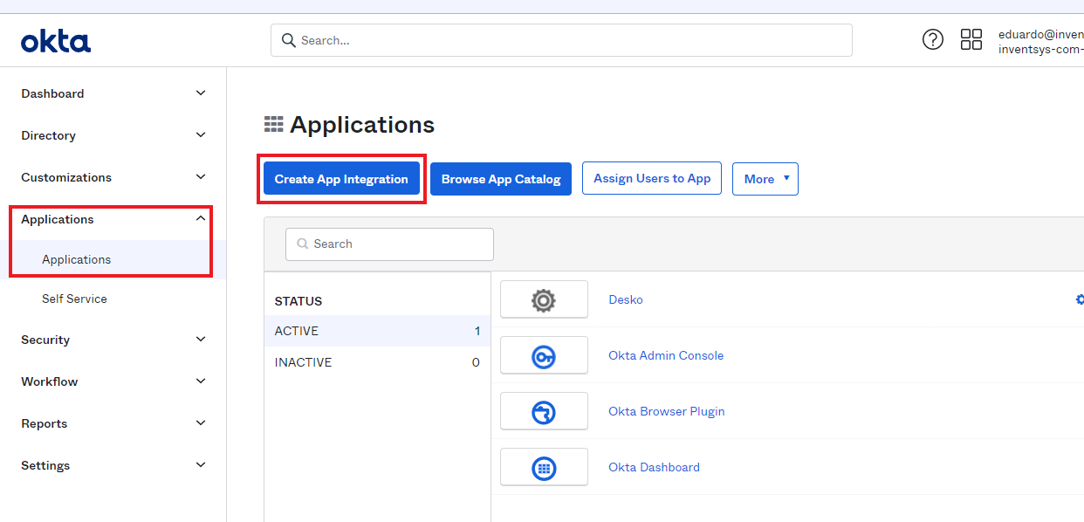

1. Choose **SAML 2.0** option and click on **Next**

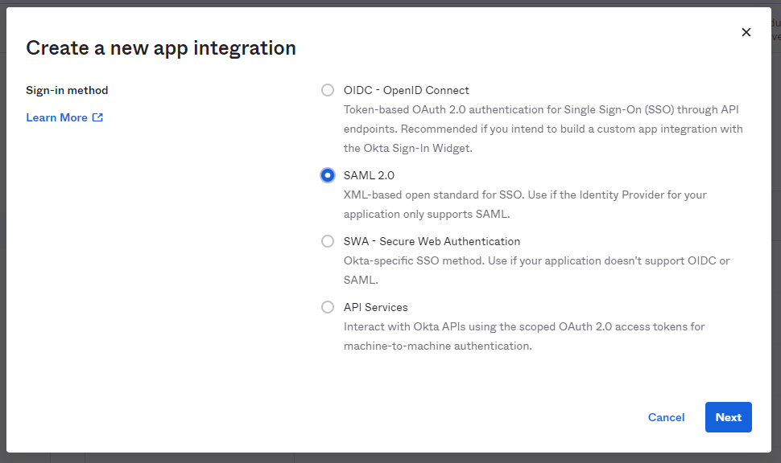

1. Enter a name for your application, add a logo (optional) by clicking on the **upload button**, and click on **Next**

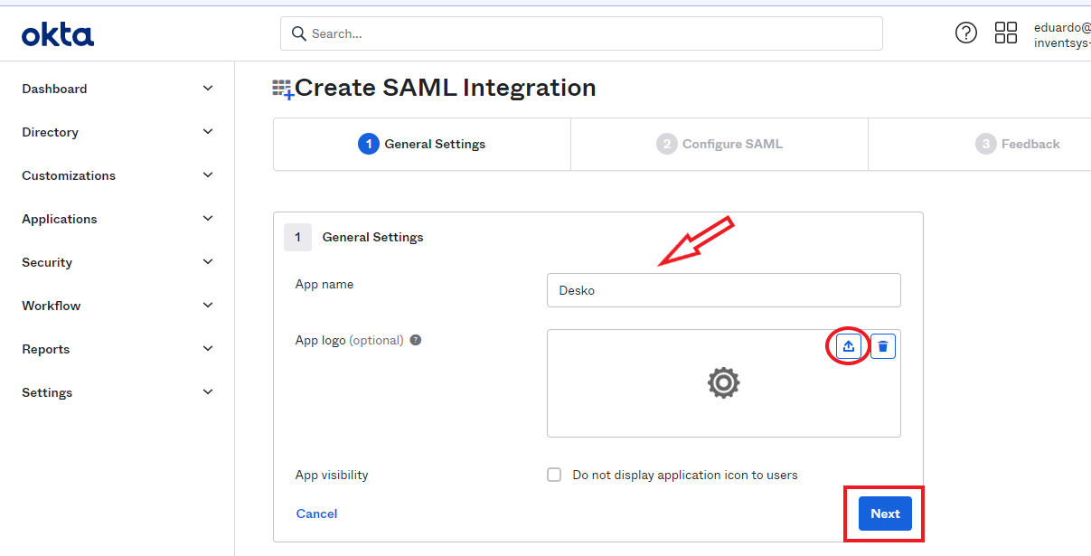

**Note:** Before move on to the **SAML settings**, it is necessary to get the *Desko*’s URLs that is going to be inserted into the URL fields in the next step.

1. Go to your *Desko* panel heading over to **https://<YourCompanyName>.painel.desko.com.br**

**Note: You have to log in using a Master or Admin account.**

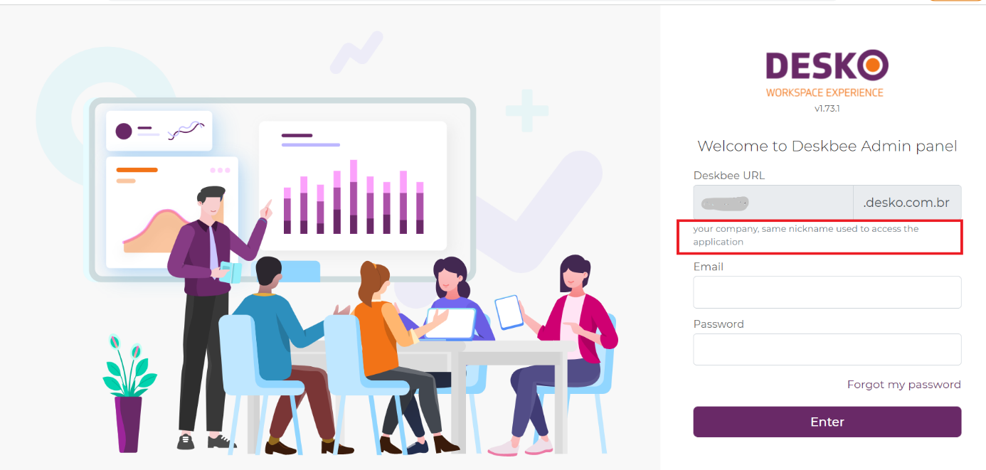

1. Expand **Integrations** and click on **Authentication**

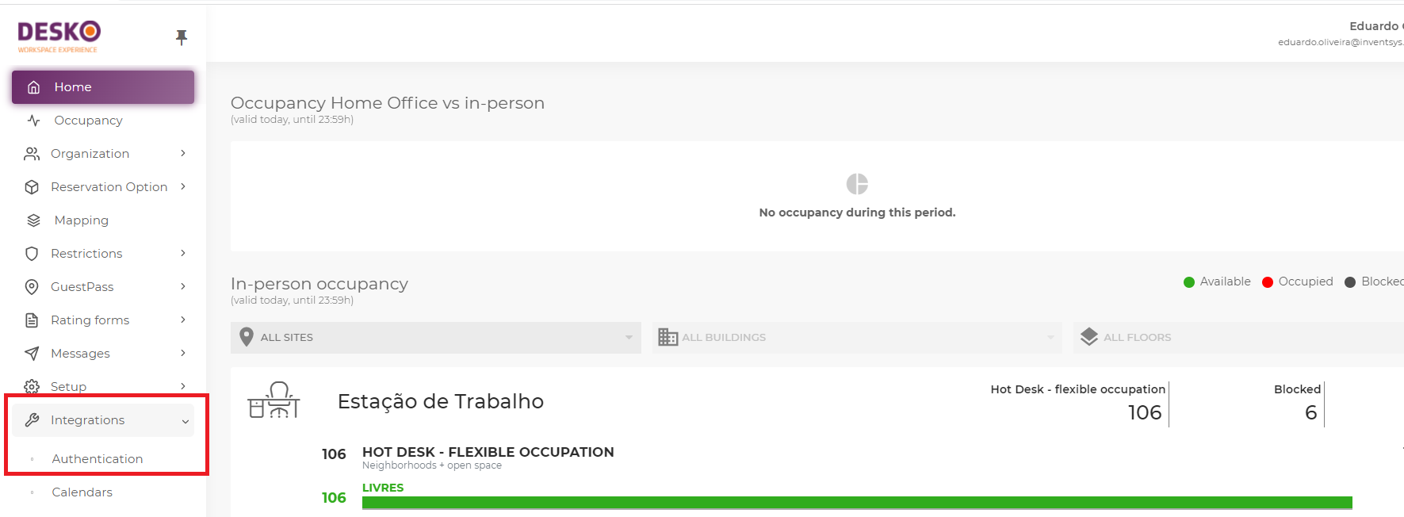

1. Turn on **SSO SAML 2.0 authentication**,

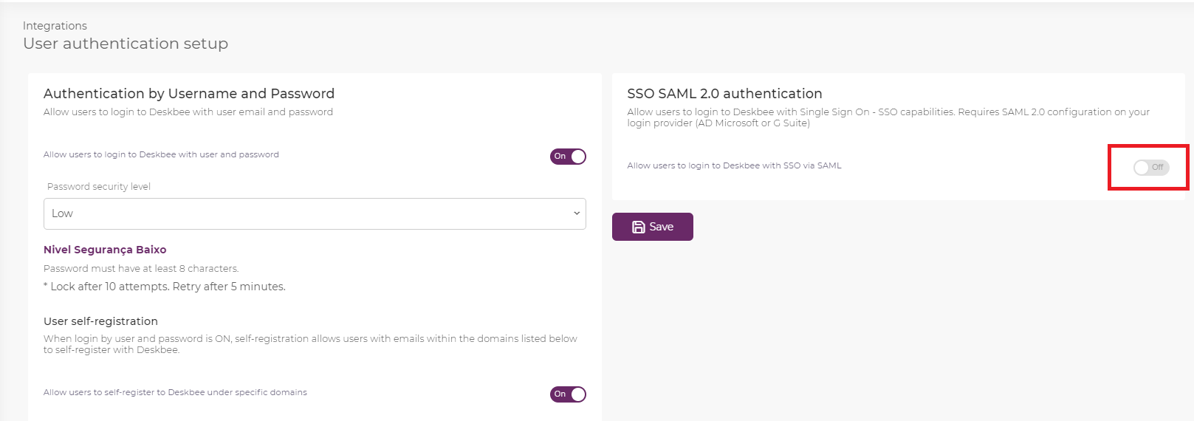

1. Go to the bottom of the page at **SAML Basic setup** and copy the **Entity ID** and the **ACS response URL** as shown below.The **Logout URL** is optional.

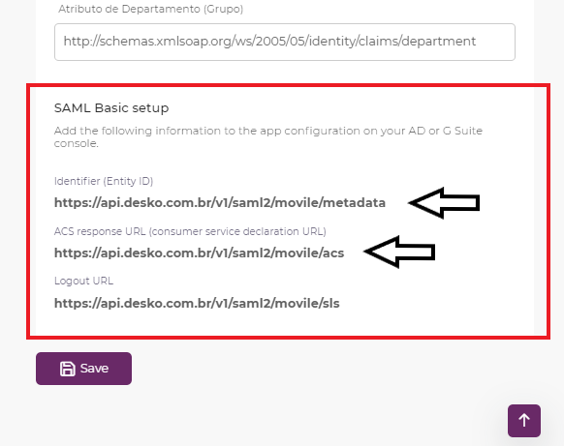

1. Go back to your Okta Admin portal, and paste the 2 URLs mentioned in the previous item into the proper fields as shown below:  
     
   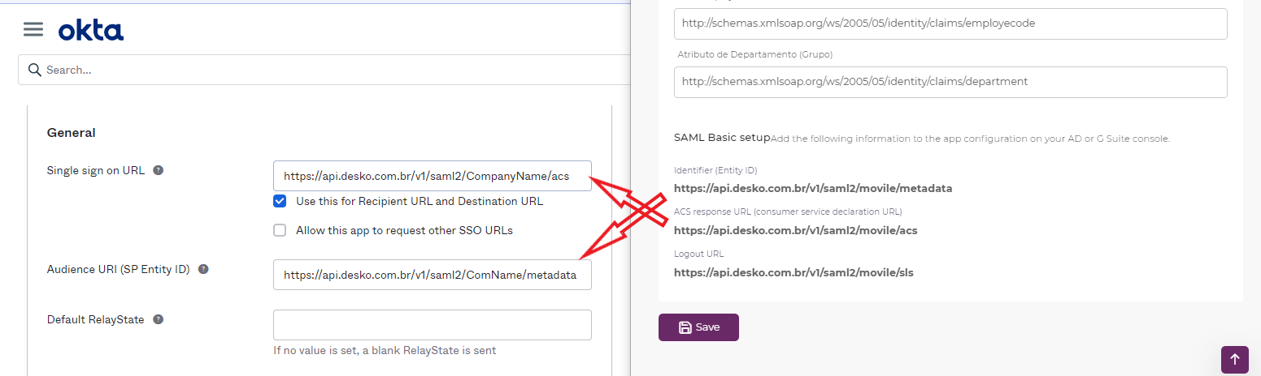

URLs from *Desko* Panel that should match on Okta Admin Portal:

|  |  |
| --- | --- |
| ***Desko* Panel** | **Okta Admin Portal** |
| Identifier (Entity ID) | Audience URI (SP Entity ID) |
| ACS response URL (consumer service declaration) | Single sign on URL |

1. Change the fields **Name ID format** and **Application username** to the values ***“Persistent”*** and ***“Email”*** respectively as shown below  
   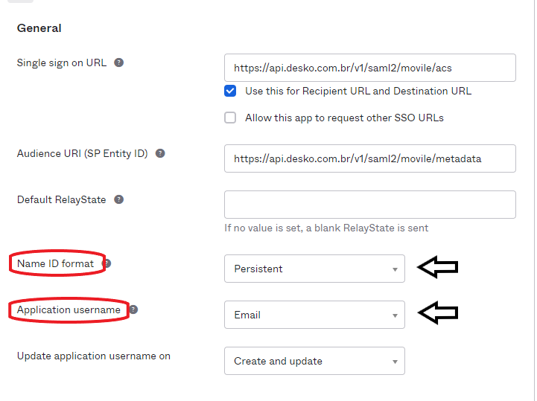
2. On **Attribute Statements** section, add the first Claim value as ***“user.firstName”***, and insert the **User Name attribute** from *Desko* panel as shown below. Keep **Name format** option as ***“Unspecified”***. Click on **Add Another** button and do the same for the Claims ***“user.lastName”*** and **“*user.email”*** just like shown below.

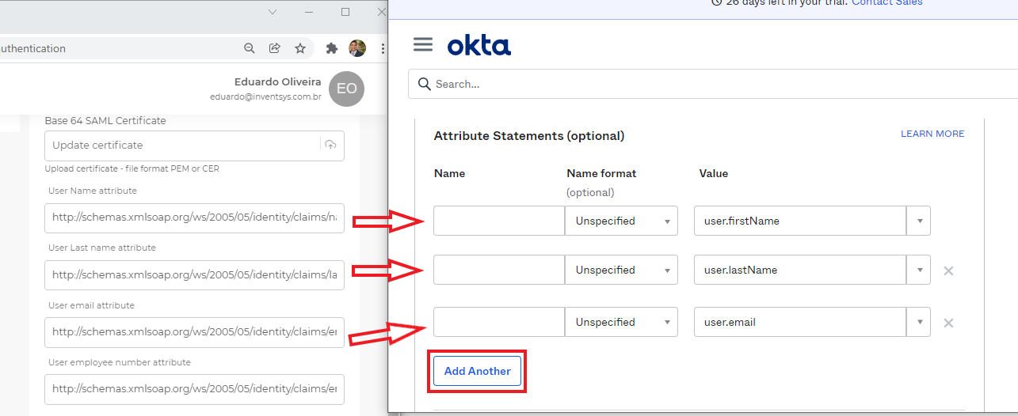

1. Download and save the **Okta certificate**, you will need to upload on *Desko* panel later on

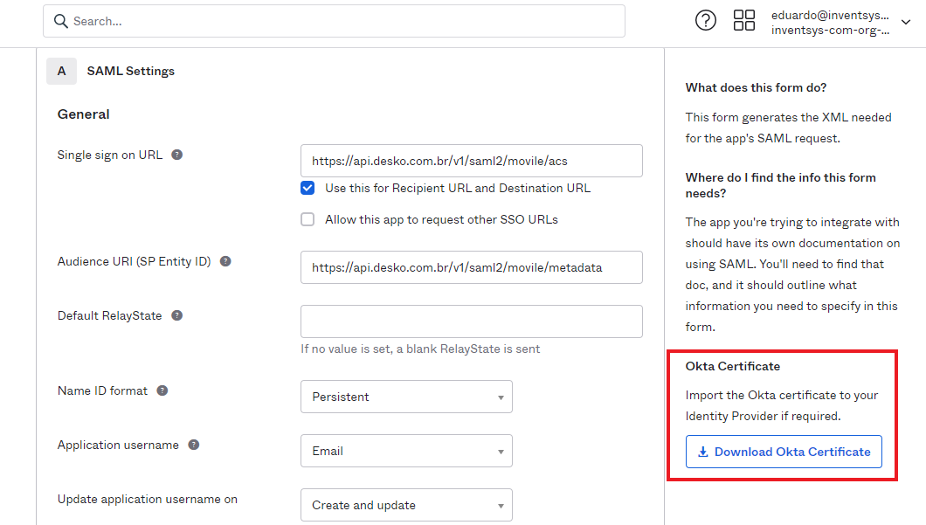

1. Click on **Next**

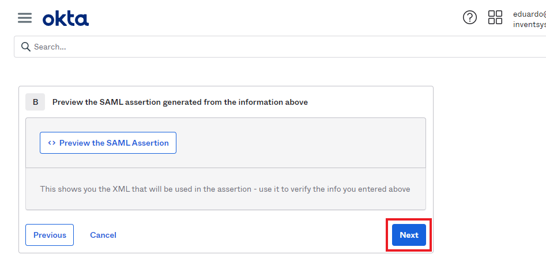

1. On **Feedback** tab, just select the proper options according to your Okta client profile and click on **Finish** button.

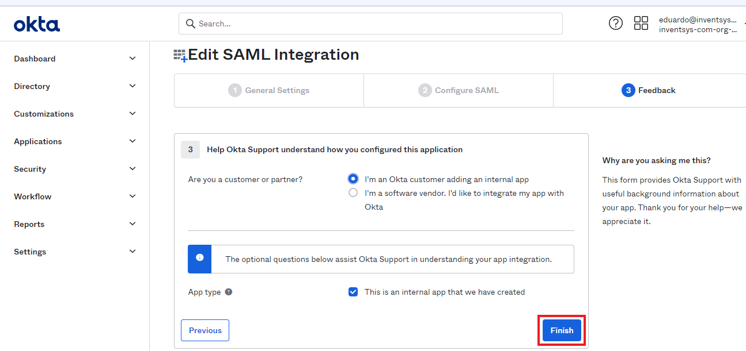

1. In the next screen, click on **View Setup Instructions** and a new tab will be open with the settings needed to configure *Desko* application

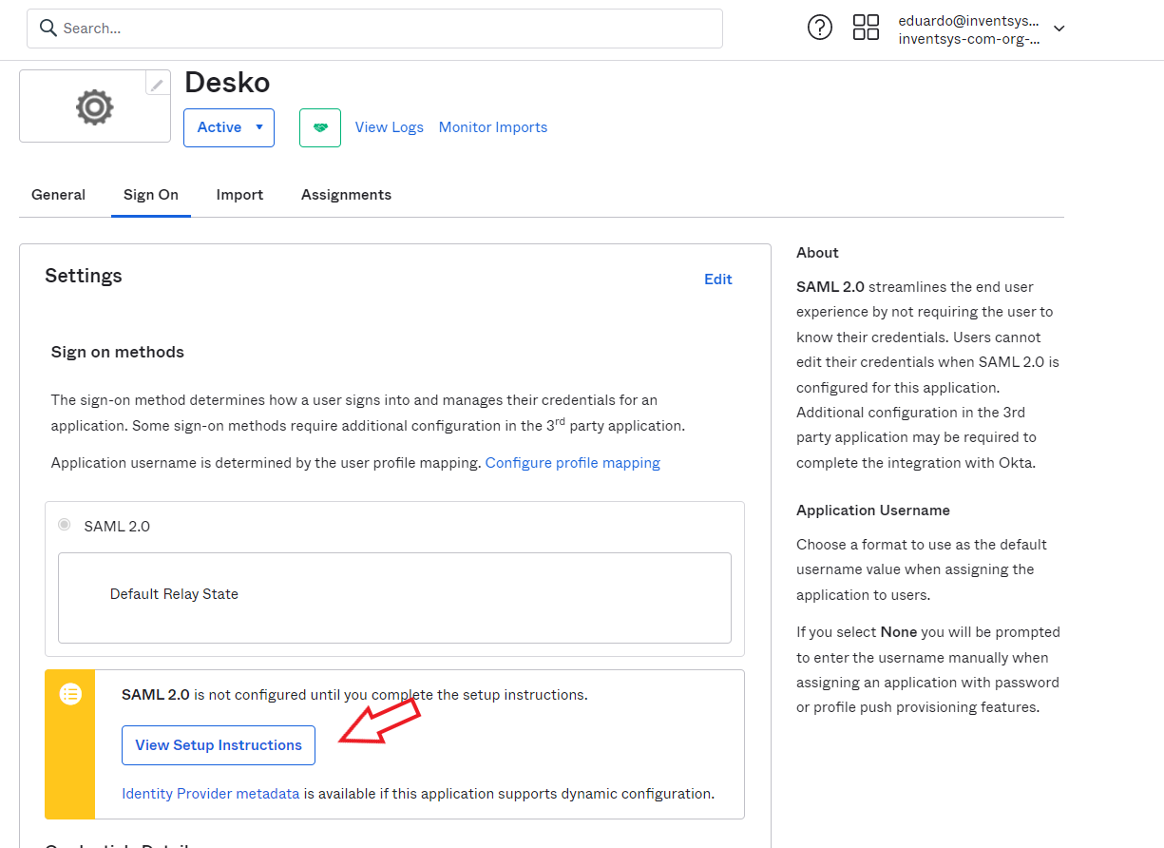

Here you have all the information needed to set up *Desko* application:

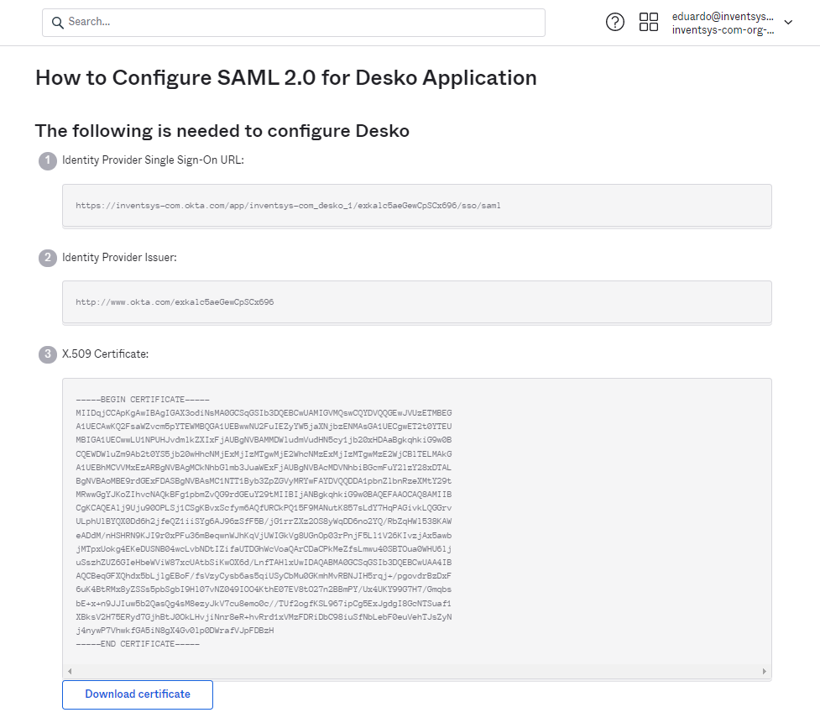

1. Go back to your *Desko* panel. On **Connection name** field, enter a name for your connection and insert the proper URLs matching the fields as shown below

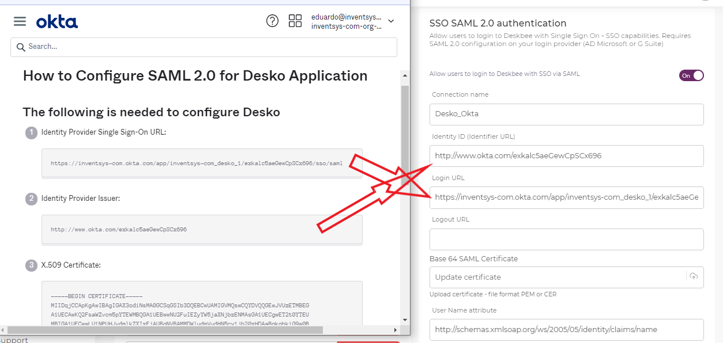

URLs from Okta Admin portal that should match on *Desko* Panel:

|  |  |
| --- | --- |
| **Okta Admin Portal** | ***Desko* Panel** |
| Identity Provider Single-Sign-On URL | Login URL |
| Identity Provider Issuer | Identity ID (Identifier URL) |

1. Upload Okta Certificate that you downloaded in the item 11 by clicking on **Update certificate** field. Before select the cert file, rename it from ***okta.cert*** to ***okta.cer*** (just change the file extension). Then select **okta.cer** and upload it

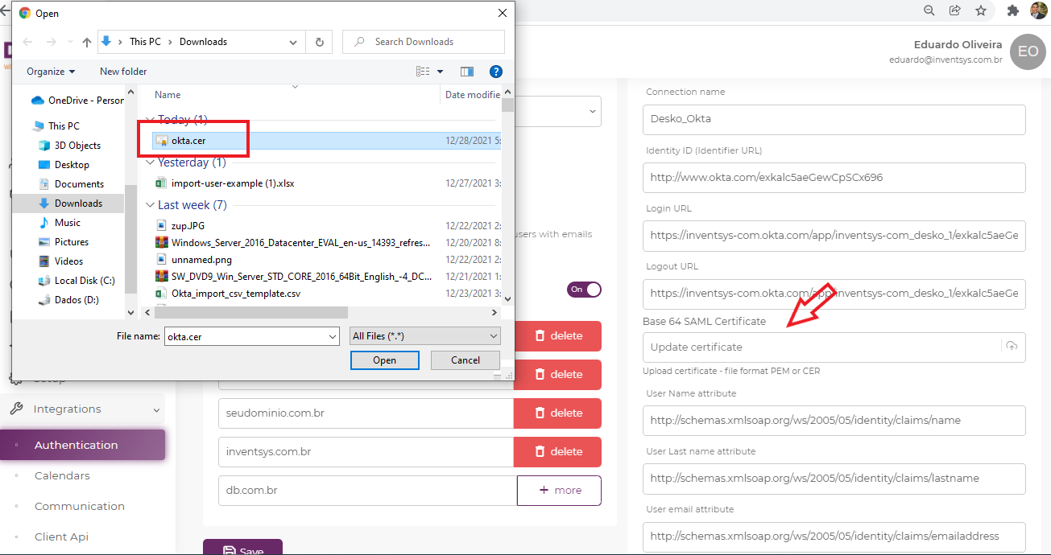

1. Scroll down to the bottom of the page and click on **Save** button

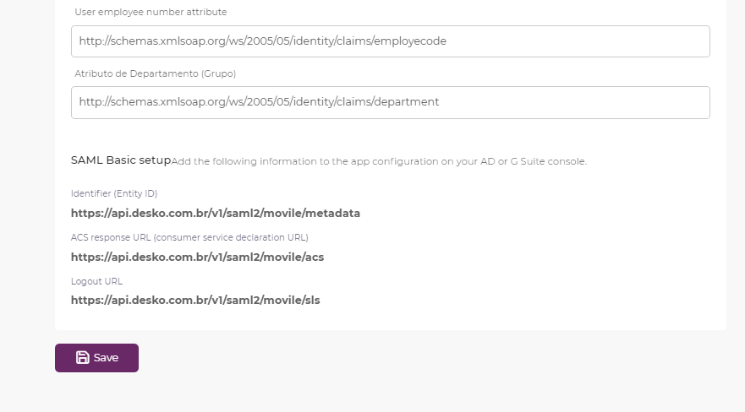

1. In order to make the *Desko* app available to allowed users, do not forget to add them in your Okta Admin portal by clicking on **Applications** and **Assign Users to App**

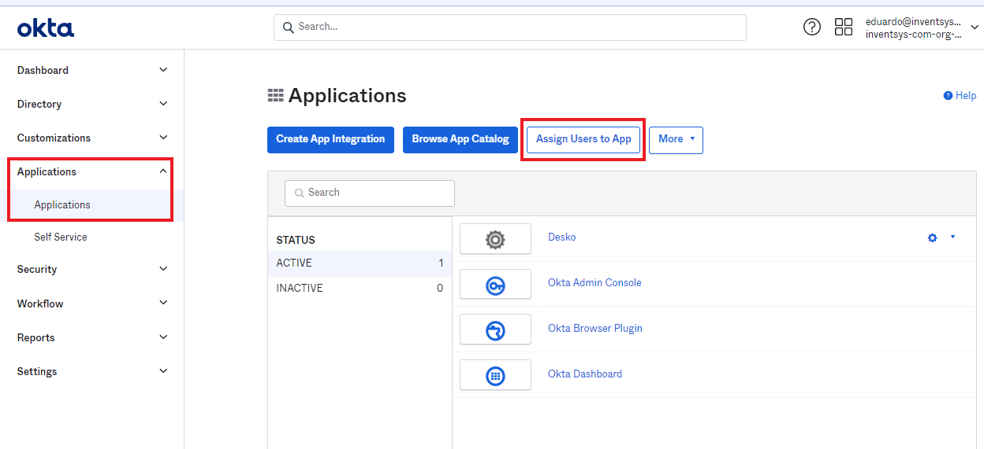

1. To access your *Desko* app, just head over to https://**<YourCompanyName>.desko.com.br** and click on the button you named for your login method.

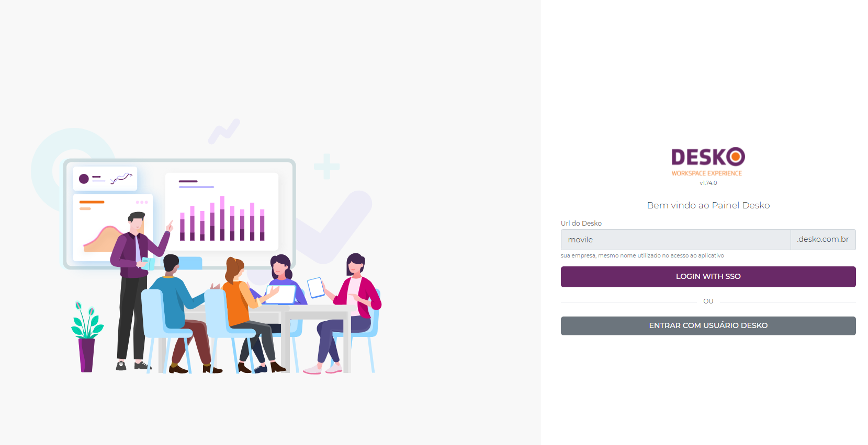

## Versioning

|  |  |  |
| --- | --- | --- |
| **Version** | **Author** | **Date** |
| v1.0 | Eduardo de Oliveira | 01/03/2022 |