Kinetics professional nail systems „BERZIŅŠ”

|  |  |  |  |
| --- | --- | --- | --- |
| **Spec** | **Min** | **Max** | **Unit** |
| Power supply | 8 | 12 | V |
| 3 | 8 | A |
| Power consumption | 1.2 | 60 | W |
|  |  |  |  |
|  |  |  |  |

**Schematic**

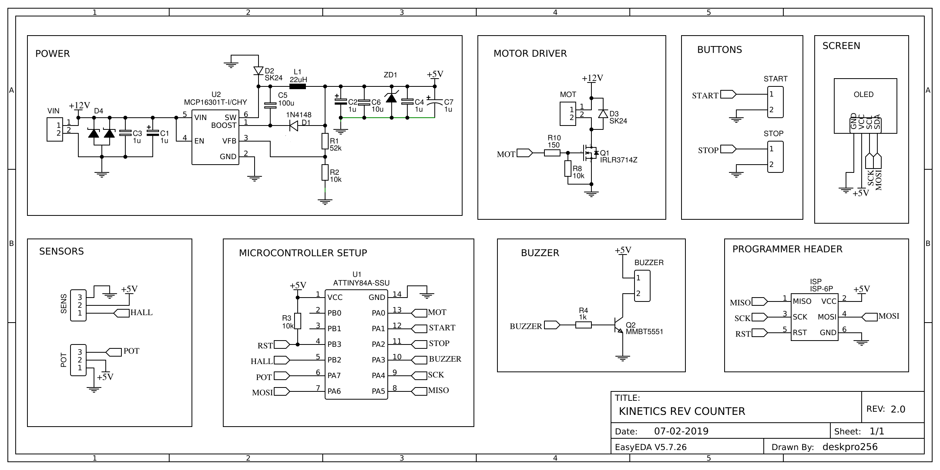

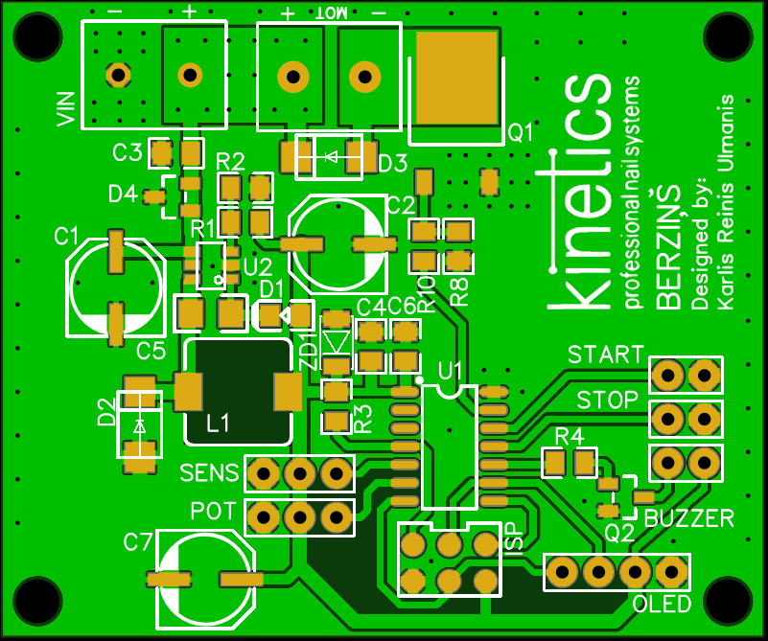**Printed circuit board layout (PCB)**

**Bill of materials (BOM)**

