|  |
| --- |
| Presents: |
| The Wandering Swordsman |
| **“payday”** |
| Version #01  All work Copyright © 2022 by team awesome! Games.  All rights reserved. |
| **Produced by**  **Scott "RockCat" Davis**  **Tyler “tyyislost” Gribbon** |
|  |

|  |
| --- |
| September 22, 2022 |

**Table of Contents**

Table of Contents

Version History 3

Game Overview 4

Game Play Mechanics 4

Camera 4

Controls 4

Saving and Loading 4

Interface Sketch 4

Menu and Screen Descriptions 4

Game World - CREATIVITY! 5

Levels 5

Game Progression 5

Characters 5

Non-player Characters 5

Enemies 5

Weapons 5

Items 5

Abilities 5

Vehicles 6

Script 6

Scoring 6

Puzzles/Mini-games 6

Bonuses 6

Cheat Codes 6

Sound Index 6

Story Index 6

Art / Multimedia Index 6

Design Notes 6

Future Features 6

# Version History

[This is where you keep track of the detailed changes made to your document throughout the course of development.]

[This is the body of your video game design document. You should add and delete sections as they pertain to your game’s design.]

# Game Overview

*The goal of the game is complete all levels, defeat bosses (found at 10 level increments) as well as complete high-scores within the levels.*

## Game Play Mechanics

*Players can run through the course/map and fight enemies and monsters with their sword. Each level progressively gets harder and enemies become stronger.*

## Camera

*60degree isometric. moves with the character*

## Controls

*Walk forward:* ***W*** *OR* ***Right Arrow Key***

*Walk backward:* ***S*** *OR* ***Left Arrow Key***

*Parry left:* ***Q***

*Parry right:* ***E***

*Slash attack:* ***Space bar***

*Rechargeable slash attack (small cooldown): Hold down* ***space bar***

*Special attack (longer cooldown): Double press* ***space bar***

## Saving and Loading

*Saving and loading will take place in between levels (maps)… as well as loading to prepare the new level/map.*

## Interface Sketch

*(What does the game interface look like? Provide a screen shot or sketch)*

## Menu and Screen Descriptions

*(Include additional screen shots and accompanying descriptions for any menus and additional screen)*

***PAUSE SCREEN:*** *Allows the user to pause during levels, has a settings button, sound on/off slider, and an exit to main menu option.*

## Game World - CREATIVITY!

*1400 Japan, forests, mountains, villages*

## Levels

*village to village will be a level*

# Game Progression

## Characters

**The wandering swordsman is an old man with a beard. he is frail looking; however, he can kick your butt.**

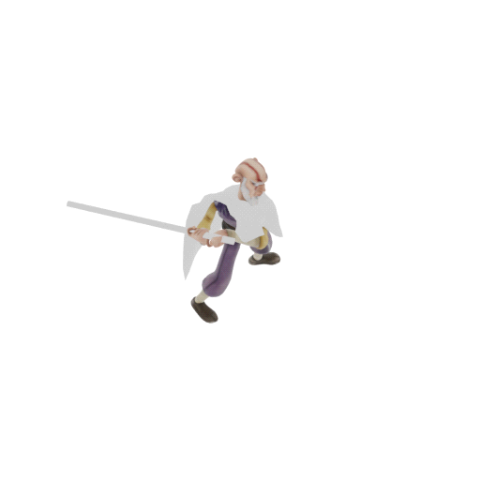

## Non-player Characters

villagers and merchants… give you quests and moneys.

## Enemies

bandits, thieves. gunslingers, ninja

a demon end boss that is near impossible

## Weapons

*katana that has bwwn passed down for generations*

## Items

*alcohol, potions, food*

## Abilities

*Slashes, charged slashes*

## Vehicles

## Script

## Scoring

## Puzzles/Mini-games

## Bonuses

## Cheat Codes

# Sound Index

*(Include an index of all your sound clips)*

# Story Index

*(Outline your game story here)*

# Art / Multimedia Index

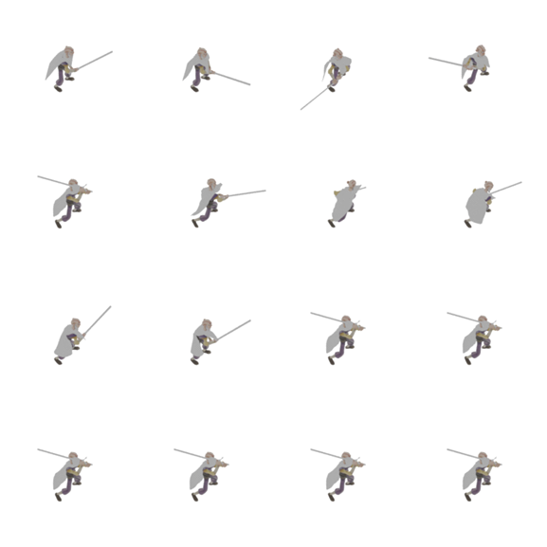

# Design Notes

*(Include additional design notes here)*

# Future Features

*(Include any future features that are planned to be implemented)*