Basic screen:

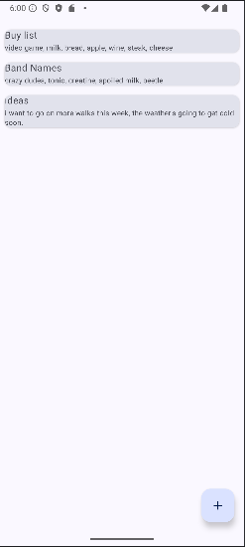

Creating a new note:

Created note appearing in the list:

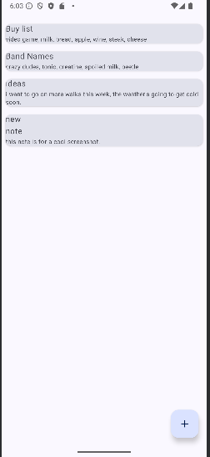

Editing existing note (before / after):

Edited note appearing in the list:

