DATABASE REPORT
Student Management System — CRUD Web Application
Database Engine: SQLite (via Django ORM)
ORM / Framework: Django 6 + Django REST Framework
Prepared for: [Course / Module Name]

1. Purpose of this Report
This report documents the database design used by the Student Management System — a CRUD-based web application built with a Django REST Framework backend and an SQLite database. It covers the entity design, schema, constraints, relationships, normalization, indexing, sample queries, and data-integrity/security measures, in line with the database-design section of the project's SOP.

2. Database Overview
The application currently manages a single core entity, Student, which stores the information needed to administer student records: identity details, the course a student is enrolled in, and the enrollment date. The database is created and evolved entirely through Django's migration system rather than hand-written SQL, so the schema shown in this report is guaranteed to match what migrations produce.
Database engine | SQLite 3 (django.db.backends.sqlite3)
Database file | backend/db.sqlite3
Access layer | Django ORM (QuerySet API) — no raw SQL used
Migration tool | Django migrations (students/migrations/0001_initial.py)
Tables in this app | 1 (students_student) — plus Django's built-in auth/admin/session tables

3. Entity–Relationship Diagram
The system currently uses a single-entity model. The diagram below shows the Student entity, its attributes, data types, and key markers (PK = Primary Key, UQ = Unique constraint).
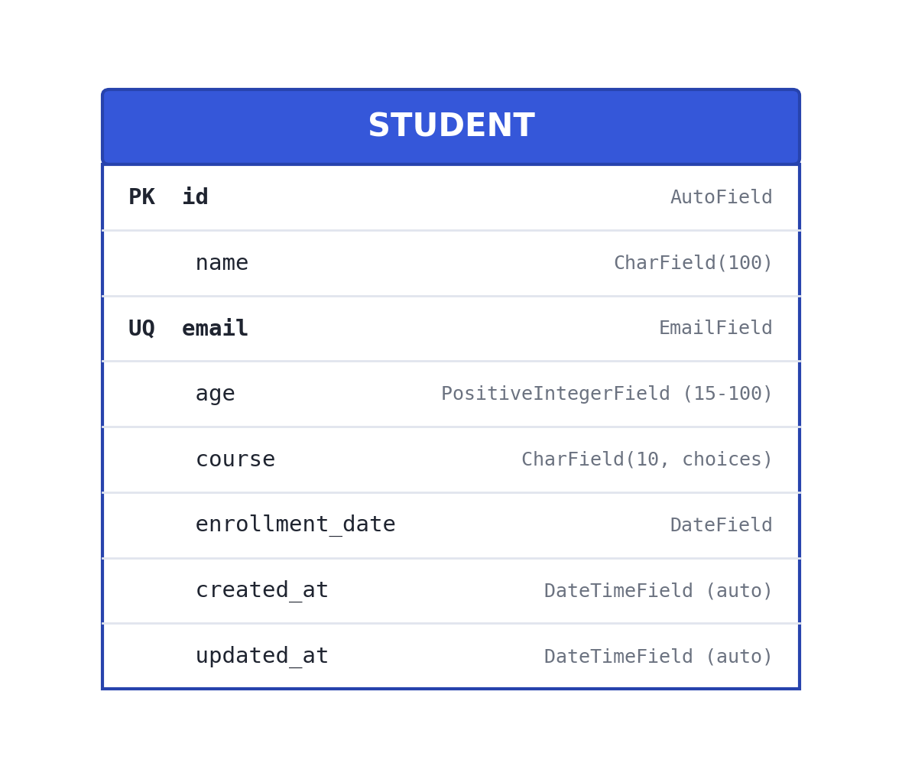
Note: No foreign-key relationships exist yet because the current scope covers only student records. Section 12 (Future Enhancements) outlines how this would extend to a multi-entity schema (e.g. Course, Enrollment, Instructor tables).

4. Table Schema: students_student
Field-level definition of the Student table as created by Django's migrations.
Field | Type / SQLite column | Constraints | Description
id | INTEGER | PRIMARY KEY, AUTOINCREMENT | Unique record identifier
name | VARCHAR(100) | NOT NULL | Student's full name
email | VARCHAR(254) | NOT NULL, UNIQUE | Student's email address
age | INTEGER (unsigned) | NOT NULL, CHECK 15–100 | Student's age in years
course | VARCHAR(10) | NOT NULL, choice constraint | CSE / ECE / MECH / CIVIL / IT / OTHER
enrollment_date | DATE | NOT NULL, ≤ today | Date the student enrolled
created_at | DATETIME | NOT NULL, auto-set | Timestamp the record was created
updated_at | DATETIME | NOT NULL, auto-updated | Timestamp of the last edit

5. Constraints and Validation Rules

Database-level constraints
- id — auto-incrementing primary key (guarantees row uniqueness).
- email — UNIQUE constraint at the database level prevents duplicate accounts even under concurrent writes.
- name, email, age, course, enrollment_date — all declared NOT NULL.

Application-level (serializer) validation
- age must fall between 15 and 100 (MinValueValidator / MaxValueValidator, re-checked in the serializer).
- enrollment_date cannot be a future date.
- email is normalized to lowercase and re-checked for uniqueness on both create and update (excluding the record being edited).
- name is rejected if blank or whitespace-only after trimming.
Enforcing validation at both the database layer (constraints) and the application layer (serializer) means bad data is rejected even if one layer were bypassed — e.g. a script writing directly through the ORM without going through the API would still hit the column constraints.

6. Normalization
The schema is in Third Normal Form (3NF):
- 1NF — every column holds a single, atomic value (no repeating groups or multi-valued fields).
- 2NF — the table has a single-column primary key (id), so there are no partial dependencies to eliminate.
- 3NF — every non-key attribute (name, email, age, course, enrollment_date) depends only on the primary key, not on any other non-key attribute.
Because the current scope is a single entity, normalization is straightforward. If the system is extended (e.g. separate Course or Department entities), those would be split into their own tables with a foreign key from Student to avoid repeating course names as free text — see Section 12.

7. Indexes
Index | Type | Purpose
students_student_pkey (id) | Primary key / B-Tree | Fast lookup by id (retrieve, update, delete by ID)
students_student_email_uniq | Unique index | Enforces & accelerates uniqueness checks on email
These indexes are created automatically by Django's migration for the id (primary key) and email (unique=True) fields — no manual index tuning was required at this scale.

8. Relationships
There are no foreign-key relationships in the current schema — Student is a standalone entity. This keeps the design simple for the current scope (a single admin managing student records) while leaving a clear extension path documented in Section 12.

9. Sample Data
id | name | email | age | course | enrollment_date
1 | Asha Rao | asha@example.com | 20 | CSE | 2024-06-01
2 | Rahul Menon | rahul@example.com | 22 | IT | 2023-08-15
3 | Priya Nair | priya@example.com | 19 | ECE | 2024-01-10

10. Sample Queries (CRUD Operations)
The application never writes raw SQL — all queries go through Django's ORM, which parameterizes them automatically. The equivalent SQL is shown here for documentation purposes.

Create
INSERT INTO students_student (name, email, age, course, enrollment_date, created_at, updated_at)
VALUES ('Asha Rao', 'asha@example.com', 20, 'CSE', '2024-06-01', CURRENT_TIMESTAMP, CURRENT_TIMESTAMP);

Read (list / search / filter)
SELECT * FROM students_student
WHERE name LIKE '%asha%' OR email LIKE '%asha%'
ORDER BY created_at DESC;

Update
UPDATE students_student
SET age = 22, updated_at = CURRENT_TIMESTAMP
WHERE id = 1;

Delete
DELETE FROM students_student WHERE id = 1;

11. Data Integrity, Security & Backup
- Parameterized queries — the Django ORM parameterizes every query it builds, which eliminates SQL-injection risk without any extra effort.
- No hard-coded secrets — the Django SECRET_KEY and DEBUG flag are read from environment variables (.env, git-ignored), not committed to source control.
- db.sqlite3 is git-ignored — the working database file is never committed, preventing accidental exposure of real student data.
- Server-side validation — every write is re-validated in the serializer even though the frontend also validates, so the database can't be corrupted by a client that skips or tampers with client-side checks.
- Backup strategy — for SQLite, backups are a simple file copy of db.sqlite3 (or the standard .backup command); a production deployment would migrate to PostgreSQL/MySQL with scheduled dumps (see Section 12).

12. Future Enhancements to the Database Design
- Migrate from SQLite to PostgreSQL or MySQL for production (better concurrency, remote access).
- Introduce a Course table (id, name, department) and replace the course CharField with a ForeignKey — removes repeated free-text course names and enables richer course metadata.
- Add an Enrollment history table if a student can be linked to multiple courses over time (many-to-many via a through table).
- Add a User/Role table for authentication, with a foreign key linking records to the staff member who created/edited them (audit trail).
- Add scheduled automated backups and point-in-time recovery once migrated to a production-grade database engine.

13. Conclusion
The database layer for the Student Management System is a single, well-constrained Student table in Third Normal Form, with both database-level constraints (NOT NULL, UNIQUE, primary key) and application-level validation enforced through Django REST Framework serializers. All access goes through Django's ORM, which provides automatic protection against SQL injection and keeps the schema fully reproducible via migrations. The design is intentionally simple for the current single-entity scope, with a clear, documented path to a normalized multi-table schema as the system's requirements grow.

