ISKCON – Expressing Devotion through the Arts

I very much welcome events such as this, which will help us all to celebrate the values and benefits of diversity… but also shows the positive expression of belief that is characteristic of the Krishna consciousness movement.

- Tony Blair, Prime Minister, United Kingdom

With roots in the traditions of ancient India, the Hare Krishna movement finds expression in vibrant colors, striking melodies, mouth-watering culinary creations, and joyous festivals—all with glorification of Krishna, or God, in the center. Here are a few of the ways in members of the International Society for Krishna Consciousness (ISKCON) convey their devotion through the arts:

- Music and Dance
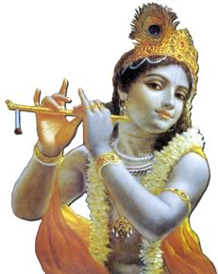
Tradition holds that in Lord Krishna’s abode “every word is a song and every step is a dance.” Music plays a key role in the lives of Krishna devotees. When Srila Prabhupada first brought the Krishna tradition West in 1965, he introduced the art of kirtan, devotional chanting accompanied by traditional Indian instruments. ISKCON devotees have shared this dynamic musical expression with the world, and many have gone on to become accomplished singers and musicians. Hare Krishna temples also regularly host stage performances and teach classes, highlighting classical Indian dance forms, such as Bharata Natyam, Kathak, and Odissi. These intricate and graceful performances are part of a rich tradition of depicting the divine activities of God or His devotees through dance.

- Fine Art
Artists within the Hare Krishna movement have created hundreds of original paintings depicting Lord Krishna and His spiritual abode. With their characteristic blend of Eastern and Western styles, these works of art illustrate multiple volumes of books, decorate ISKCON temples, and help to visually present the Krishna tradition.

MORE…

- Architecture
Many ISKCON temples throughout the world are splendid examples of traditional and neo-Vedic architecture. In Spanish Fork, Utah, the ISKCON temple is modeled after a 15th Century North Indian palace, and boasts elaborately designed arches, columns, verandahs, and waterfalls. In West Virginia, Krishna devotees built a gold-domed temple that was penned “America’s Taj Mahal” by the New York Times. ISKCON has also erected dozens of temples in India which employ classic architectural styles, in major cities such as New Delhi and Mumbai, as well as in sacred pilgrimage towns such as Vrindavana and Mayapur.

- Worship Services
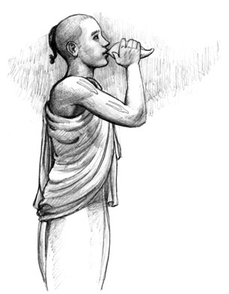
Members and guests are drawn by the authenticity and vibrancy of ISKCON worship services. Krishna theology teaches that all the senses should be engaged in the glorification of God. Thus, upon entering an ISKCON worship service, a visitor’s eyes feast on an elaborately decorated altar; her ears are entreated by melodious chanting; her nose embraces fragrant flowers and incense; and her mouth savors sanctified delicious vegetarian food.

- Holidays and Festivals
Commemorating sacred days of the Vaishnava calendar, the Hare Krishna movement hosts colorful and exciting festivals that draw thousands of guests and worshippers. Holidays such as Janamastami (Krishna’s birth anniversary) and Diwali (the New Year) are observed with great revelry and joy. Perhaps the most famous public festival, called Ratha Yatra, or “Festival of the Chariots,” is celebrated annually in major cities of the world, including marches down New York’s Fifth Avenue, the Venice Beach boardwalk in Los Angeles, and Independence Avenue in Washington, D.C. Patterned after a millennia-old festival held in the Indian city of Jagannath Puri, the fete includes the pulling of ornately decorated 40-foot high chariots.
MORE…

- Food
Sometimes referred to as “the kitchen religion,” ISKCON temples offer visitors delicious sanctified vegetarian food, and host weekly Sunday open house programs that culminate in a free multi-course feast. The internationally inspired menu can range from Punjabi curried vegetables to eggplant parmesan. To better acquaint people with the benefits of a vegetarian diet, the Krishna movement has also established 100 vegetarian restaurants around the world.
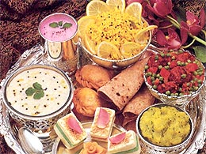
- Literature
With an aim to shed light on the profound philosophy underlying these cultural expressions, the Bhaktivedanta Book Trust (BBT), ISKCON’s affiliated publishing house, has printed and distributed more than 400 million books and magazines. These publications often contain translations from Sanskrit or Bengali, reproductions of rare commentaries, and attractive original illustrations and photographs. Said to be the world’s largest publisher of classic Vaishnava texts, the BBT is renowned as an excellent resource for the study of Indian culture and philosophy.

This material is available online at http://www.iskcon.com/media
# # #

