Working Information Model for WIC
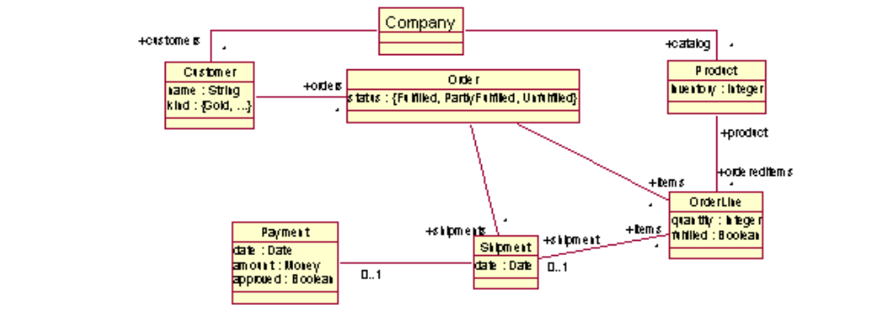
Company | The company itself. | Always exists.
name | String. The company name
customers | Set of Customers: the current clientele of the company.
catalog | Set of Products: the products the company offers.
Product | A product offered by the company | Created: add product to catalog.
inventory | Integer: the current count of the product in inventory. | Changed: ship, spoilage, restock
orderedItems | Set of OrderLines: all order lines for this product | Changed: place order
Customer | A customer of the company | Created: when a new customer first contacts Company.
name | String: the name of the customer | Changed: update customer info
kind | {Gold, Classic}: the category of the customer | Changed: upgrade customer
orders | Set of Orders: all orders placed by this customer | Changed: place order
Order | An agreement between company to ship some items and by customer to pay for them. | Created: Place Order
items | Set of OrderLines: the order lines in this order. Invariant: No two order lines for the same Product.
shipment | Set of Shipment: all shipments made to fulfill this order | Changed: ship
status | {Fulfilled, PartlyFulfilled, Unfulfilled}: the fulfillment status of the order. Invariant: Fulfilled means every Order Line is fulfilled; Partly Fulfilled means some order lines are fulfilled, some not; Otherwise Unfulfilled. | Changed: ship, cancel order
OrderLine | A particular quantity of a product within an order. | Created: Place Order
quantity | Integer: the quantity of a product that is ordered.
fulfilled | Boolean: an OrderLine is fulfilled means it was shipped. | Changed: ship, cancel
shipment | Shipment: the shipment, if any, which fulfilled this line. | Changed: ship

