MAP

Exercises



Notes for Exercises

Lab exercises will be worked first with an initial Instructor section and then with a Student section. The former is for the instructor to work through, in part or in whole, with the students, to explain the problem and illustrate the approach. The latter is for the students to work out in teams. For long exercises with multiple sections, the instructor might work out the instructor example just one section at a time, letting students work on the corresponding section of their student labs.

The [ estimated times ] are shown for each lab student section, not including the time for the instructor to work out the instructor example section.

Some labs have a starting template for the solution. Please begin that lab using that template. If solutions to the previous exercises are available, please use that solution as the starting point for the subsequent exercise so we are always working on a converging solution.

Work on the exercises in a team of 2-4 people. Work around one end of a table if possible. We recommend that you work on a single solution using just one exercise workbook; you can always make photocopies of your solution for the team at the end of each day.

The purpose of many of these labs is to learn to use models to produce clear descriptions with reduced ambiguities and errors. In some cases there will be many ways you can define the problem itself, or the solution to the problem. Remember that our main goal is to focus on applying MAP.

Exercise 1 Describe Objects [30]
Consider the scenario in the table below, then work through the subsequent questions 1(a), 1(b), ..etc.:
- Mary, an employee of Plastic Novelties Inc (PNI), approaches Bert, a loan officer at LotsALoans Corporation (LLC) for a corporate loan to PNI. She specifies the loan amount and preferred term (duration).
- Bert checks PNI’s credit rating, and those of any parent companies of PNI, in the LLC Loans System.
- The LLC Loans System obtains the legal entity credit rating and hierarchy information for PNI from the LLC Reference Data System, and returns it to Bert.
- Bert then checks the total credit exposure of LLC to PNI within the LLC Loans System.
- Since these initial checks were successful, Bert initiates a loan record within the LLC Loans System.
- In accordance with LLC policy, Bert stipulates to Mary the amount and acceptable types of collateral that PNI must post to secure the requested loan.
- Mary arranges via PNI’s Borrower Collateral Management System for the collateral to be posted.
- Some time later, PNI’s Borrower Collateral Management System posts bond and real estate collateral by interacting directly with the LLC’s Bond System and LLC’s Real Estate Collateral Management Systems.
- Once the required amount of collateral has been posted, the LLC Loans System notifies Bert.

1 a) Show Interacting Objects
- Draw the individual objects participating actively in the interactions, without showing interaction. Only show objects that participate actively in the interactions (e.g. an agent or a system), not objects that are part of the information exchanged between them (e.g. a reservation record). Use any icon for each object, writing the object name on or below the object. Include both physical objects and software systems. Don’t show “internal” objects at your current level of description.
- Draw the interactions involved. Use an arrow for any request from object A to object B, or to itself. Number the interactions to show sequencing, optionally using nested numbering to distinguish trigger (3) from responses (3.1, 3.2, …), and label the interaction to name the interaction and to indicate information passed or returned in that interaction.

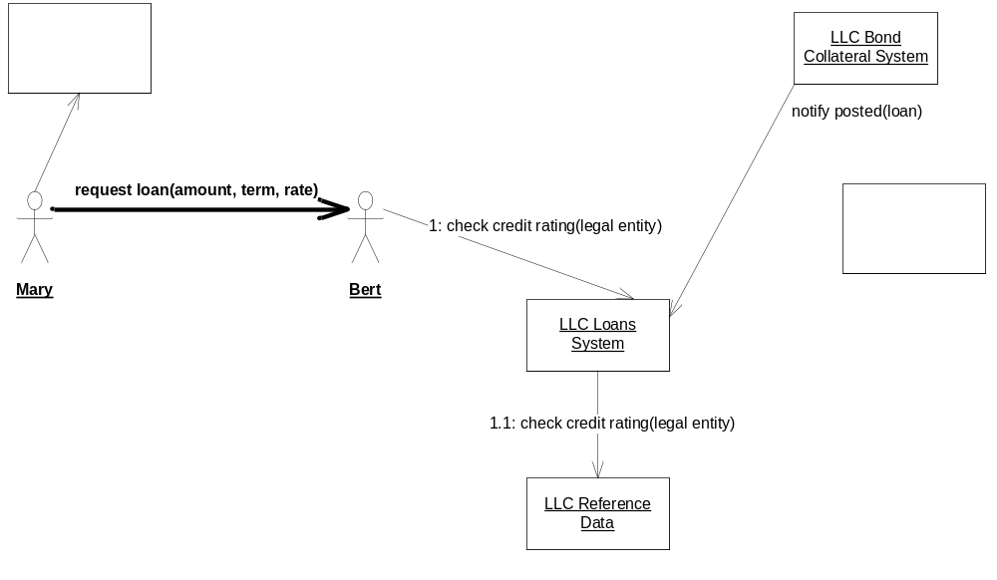

1 b) List Information Owners

List information ownership: Make a list of the objects and attributes that are owned and managed by each software system in your diagram.

Loans System | loan portfolio (including total credit exposure), loans (including principal, rate, term), reference to collateral posted
Reference Data System

Note that you have described distinct kinds of objects: those that interact with others, those that are stored persistently, and those passed around.

1 c) Polymorphic Component Types
Draw a “Polymorphic” component type (one with two different implementations of the same interface). List the operations on that type, both incoming and outgoing.

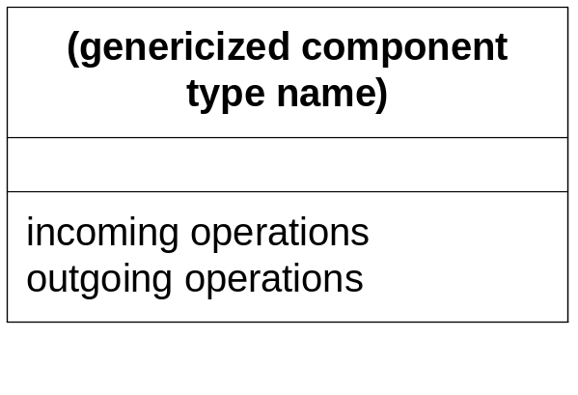

1 d) Find Multiple Types
In the description below, consider the behaviors of the described object, which can be viewed as having two different types by two different applications or components. Name and define those types with some operations and/or attributes.
Discuss a problem that might arise if an object with two types is represented in 2 different software systems as 2 disconnected objects.

LotsALoans Corporation (LLC) Example
- The business event of PNI’s first repayment against its newest loan with LLC appears in the loan system as a repayment type, with a link to its associated loan, an amount and a date of payment, together with a due date and amount due.
- This repayment also appears in the Loans subledger system as a journal entry associated with a debit and a credit transaction against the appropriate subledger accounts.

Exercise 3.1 Objects, Snapshots [15]
You are given the following floor plan of your house that was built in 1950 in Squirrel Hill.

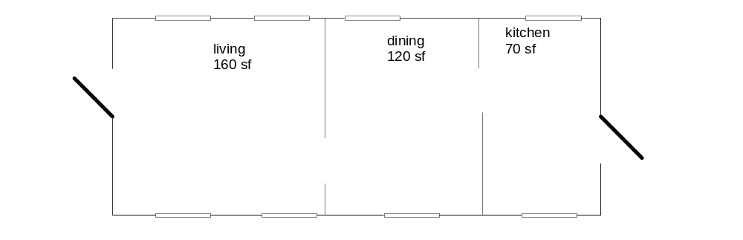

Draw one object representing your residence that tells how many exterior doors and windows it has, when it was built, and what neighborhood it is in. Draw objects representing each room and its approximate size (ignore wall thickness).
Make this collection of objects into a snapshot by drawing links between the objects: Draw links between each pair of rooms that shares a wall and between each room and the residence that encloses it. Label each link.

Exercise 3.2 Information Models [15]
Use the snapshot from the previous lab and create an information model from it.
How would your snapshot change if you were to represent windows and doors as objects? Make this change to your information model (and to your snapshot if you have time).

Exercise 3.3 Snapshot Pairs [15]
Starting with the previous lab, and ignoring doors and windows as objects (simply modeling counts of doors and windows instead):

Draw a before and after snapshot pair for what happens when a window is added to the house.

Draw a before and after snapshot pair for what happens when a wall is removed to join the living and dining rooms of the house.

Draw a before and after snapshot pair for what happens when you remodel the interior of a room (no changes to windows, doors, or room connections). Do you see any changes in your snapshots? Why or why not? Does this mean that your model is “wrong”? Generalizing from this, what should guide the things that should appear in a model?

Exercise 3.4 Actions [15]
Write an informal action specification for the two snapshot pairs from the previous exercise, underlining terms which refer to parameters or attributes in your information model. Choose parameters to the actions to correspond to some object types (or attribute types) in your model.
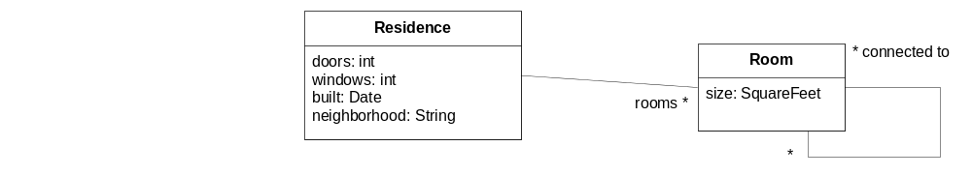
action add window ( )

description

pre

post

action remove wall ( )

description

pre

post

Exercise 3.5 Scenarios with text and snapshots [15]
You are putting a new wing on your mansion, which consists of laying a foundation, adding walls, roofing, adding windows, adding doors, and putting down finished flooring. Windows, doors, and floors you can do yourself; for all the others you sign a contract with a contractor, and he constructs those parts before you do a final walkthrough.
Write a textual scenario of your specific series of renovations to add a wing. Use the scenario format, with scenario title, initial state and final state.
Create snapshots for the before and after states of at least 3 steps in the scenario. Add new types of objects or attributes to your information model if needed. Use simple attributes (such as roof_done: True / False) where it is adequate to describe your scenario.
Scenario name: new wing on mansion

Initial state: Titus is a contractor, Jake the homeowner

- titus and jake sign the contract

- …
Final state:

Exercise 3.6. Role Activity Diagrams [15]
Using the scenario from the last exercise as a guide, draw a Role Activity Diagram (RAD) that ensures that those same actions are done in an appropriate sequence and collaboration occurs when necessary.

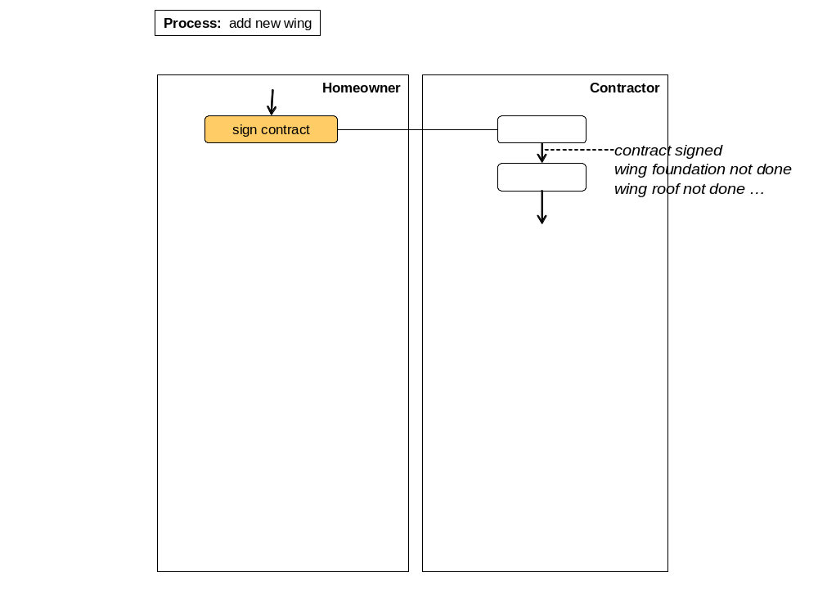

Exercise 4.1 Draw Object Snapshots, Build Information Model from Snapshots. Understand Navigation Expressions. [60 total. Instructor may interleave instructor example with corresponding student lab]

(a) Snapshots [& Optional User Interface]
Read the business state description provided below, and then complete the following steps. (Assume USD currency throughout.)
- Draw a snapshot describing the business state in terms of objects, attributes and links. Your snapshot will show real-world objects, not just software records. If the links between objects gets cluttered, use attr = value as an alternative.
- For each type of object, write down when a new object of that type comes into existence.
- [Optional] Sketch either a user-interface, or a domain-specific drawing, for this snapshot.

- LotsALoans corporation (LL) is a company that provides loans to corporate clients.
- Three of its current clients are Hotels Austerity Limited (HAL), Widget International Corp (WIC), and Daylight Robbery Security Systems Inc (DRS).
- WIC and DRS are both subsidiaries of the Legal Entity called Variegated Holdings, Inc (VHI).
- HAL currently has a loan (hal1) with a principal of $1.5M, an interest rate of 6% and a term of 7 years.
- DRS has a loan (drs1) with a principal of $2M at an interest rate of 7% and a term of 10 years.
- WIC has one loan (wic1) with a principal of $500K and another (wic2) with a principal of $750K. Both are at an interest rate of 5.8%, and extend over a term of 4 years.
- HAL has made three on-time monthly repayments against loan hal1, of $21, 912.83 each, on 3/4/2003, 4/4/2003 and 5/4/2003. The due-dates for these repayments were the same as the repayment dates. Since interest is compounded monthly, the balance on hal1 is now $1,456,544.95.
- HAL has posted collateral for hal1 worth $1,520,000.
- DRS has posted collateral for drs1 worth $2,144,750.

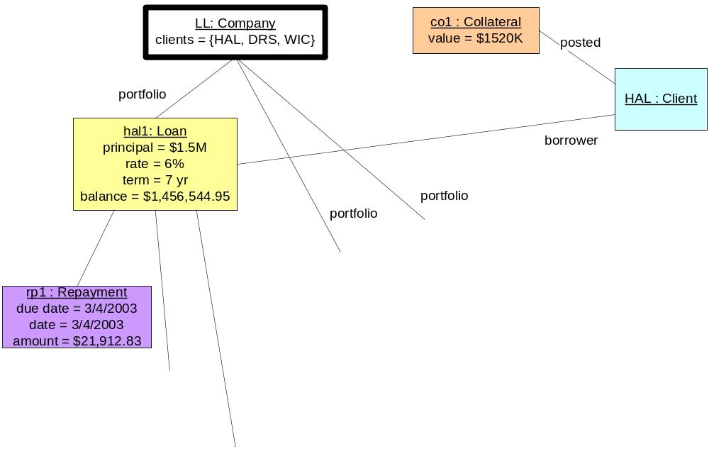

Type of object | Created when …
Client | LLC receives the first ever loan application from that client.
Legal Entity
Loan
Collateral

(b) Build Information Model from Snapshots
Build an information model from the snapshots you have developed, using the solution to the previous lab. You may need to use your general knowledge about the domain.

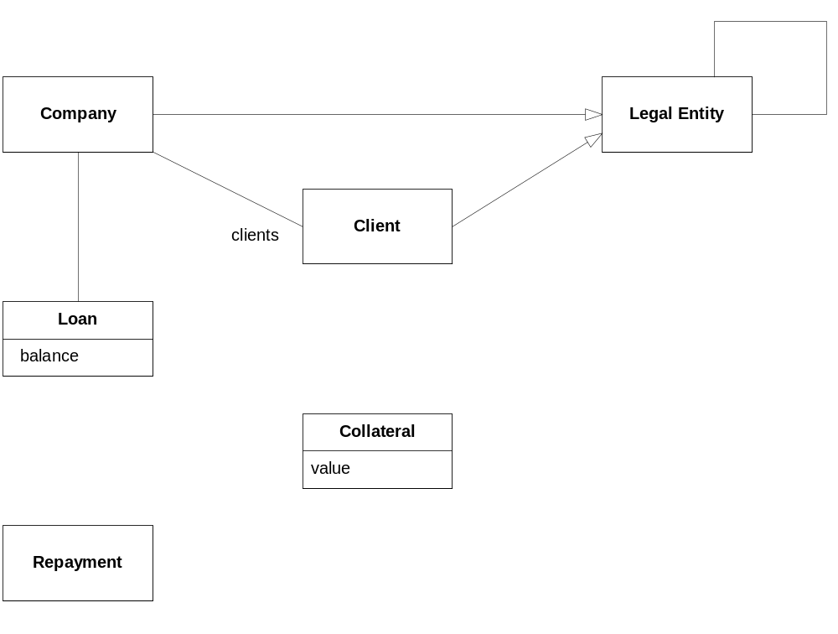

(c) Interpret Navigation Expressions
Identify the result sets of objects the following expressions refer to in the solution snapshot. (Update attributes and association if needed). [Optional] For the informal expressions, write out the formal version. For the formal expressions, re-state informally, underlining attribute references.

1. All borrowers. Result: { ….. }
Formal:
2. All the clients who have loans with principal greater than $750K.
Formal:
3. The loans for which no collateral has yet been posted.
Formal:
4. The amount of the interest element of repayments rp1, rp2 and rp3.
Formal:
5. LL.clients->select(c | c.parent->NotEmpty)
Informal:
6. LL.clients→exclude(LL.portfolio.borrower)
Informal:

(d) Write Navigation Expressions
Write the expressions (both informally and formally) to refer to the following objects in your snapshot, starting from the top-level object. Note that this is a little bit like saying: A is the answer, what is the question? {x, y} means the set of objects x and y.

{ rp1, rp2, rp3 }
{ VHI }
{ 5.8%, 6%, 7% }

Exercise 4.2 Introduce Convenience Attributes. Write Invariants. Utilize Supertypes. [45]

(a) Introduce Convenience Attributes
Introduce a single convenience derived attribute (or association) into your Model for each of the following. Do not describe how that attribute might be derived from others. Use a suitable type for the attribute.
- The total value of the collateral posted for a Loan
Loan: totalCollateral : USD
- The total credit exposure for a Company (sum of loan balances), across its entire portfolio of Loans.
- The number of days by which a Repayment on a Loan is overdue at the present time (assuming a “due date” attribute on Repayment)
- The Repayment amount currently overdue on a Loan, across all overdue Repayments for that Loan. (When doing part (b) for this attribute, assume the existence of an “amount” attribute on Repayment showing the amount due in that repayment.)
- The amount of principal repaid for a Loan.

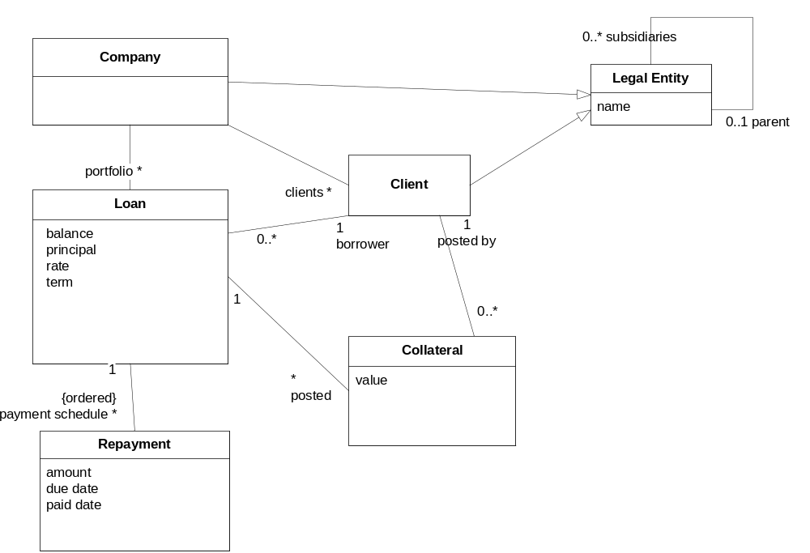

(b) Write Invariants
In this exercise, you might find that requirements can be ambiguous. Working out precise definitions fleshes out many underlying questions.

i. Derivation Invariants for Convenience Attributes
For each of the convenience attributes created in part (a) above:
- Look at (or sketch) a snapshot to understand the values of your derived attributes on a snapshot, and how you derived those values from others.
- Write an informal (and, optionally, a formal) invariant that defines the derivation rule for each derived attribute. On the informal version, underline every term that corresponds to an attribute you have introduced in your information model. For complex cases, break them down into multiple simpler attributes that you put together. You can write these in a simple tabular list; in practice they could be shown as “Constraints” on a UML diagram.

Company: credit exposure | The sum of the balance of all loans in the portfolio
Loan: …

ii. [Optional] Extra Model Constraint
Write an invariant to stipulate that a borrower from a Company is necessarily a Client of that Company. Be careful not to say that every Client is necessarily a borrower.

(c) Utilize Supertypes
Add supertypes and invariants to your model to describe the following by considering these questions:
What object type best encapsulates the variation?
What attributes can be described generically on a supertype across the variations?
Where can those generic attributes be used e.g. to define other derived attributes?
What subtypes would capture the different variations? What attributes do the subtypes need? How do they derive the supertype attributes?
- Loans are secured using different types of collateral holdings: stock holdings, bond holdings, or real estate holdings. Each type of collateral has somewhat different characteristics.
- Stocks and bonds are securities, which are identified by a standard identifier called a CUSIP (Committee on Uniform Security Identification Procedures) number. Every security is issued by a unique Legal Entity called the issuer.
- Bonds have a rating associated with them, which reflects the credit rating of the issuer. They also have a par value, a duration, an interest rate, and a price, which is determined by bond specialists based on current interest rates and other market characteristics.
- Stocks have a price, which is determined by obtaining a quote. (Ignore the bid/ask spread for current purposes.) The exact details of the quoting procedure will not be described further.
- A real estate holding has (minimally) a property value, which is obtained by invoking the services of a real estate valuation expert.

Exercise 4.3 Define Scenarios and Snapshot Pairs. [45]

(a) Scenarios and Snapshot Pairs
- Name a long-lived activity (hint: possibly several years long) that customer Hotel Austerity Limited (HAL) participates in with LotsALoans Corporation (LLC). When does it start, and when does it end?
Answer:
- List the set of finer grained actions that realize the long-lived activity. Introduce and name the long-lived object type if it is missing. What would be states of an object representing one instance of this type progressing through its lifecycle?
Answer:
- Define a scenario which represents a “normal path” through this entire long-lived activity for HAL and LLC. Let each step correspond to one finer-grained action, and pick actions that are conceptually at a consistent level of granularity or abstraction (i.e. agreeAmount Vs. selectLegalEntity). Define your scenario so that one of the states in the scenario is our earlier snapshot from 4.1(a). Consider the states after each step of the scenario, referring to attributes in your information model. Sketch the snapshot after HAL draws down full loan amount.
Scenario: Hal’s loan with full collateral, single draw-down, all on-time repayments
initial state: HAL is not a subsidiary of any other legal entity. It has a credit rating of BBB.
scenario steps
- HAL requests a loan for $1.5M over 8 years from LLC.
- LLC offers a rate of 6%, and counter-proposes a term of 7 years with 84 monthly repayments.
- HAL agrees to the amount, rate, and term.
- LLC stipulates to HAL that collateral must be ….
- Hal agrees and posts the entire collateral of …
Snapshot: the loan is now active

- HAL makes the 84th monthly repayment of ….
final state: HAL’s loan with LLC has a balance of $0, and is closed.

- Sketch some other key snapshots for your scenario.
- List some exceptions that might arise at steps along your scenario.
Answer:
At step (…) :
At step (…) :

(b) Specify an Action
Write an action specification for the actions as outlined below:
- Start with an informal description of the post-condition of the action.
- Identify the parameters of the action, and re-write the post-condition informally, referring to the parameters and navigating from those parameters using attributes from the Information Model. To help identify parameters, look at a before snapshot and decide which object/value (or objects / values) would need to be identified for that snapshot to change. Use the underline convention to show references to attributes and to the parameters. Note that the actions are not independent if they refer to some common attributes.
- Consider making the specification more concise and in terms a client might use to describe it, by introducing convenience attributes and invariants. Move parts of the pre/post into invariants, if they represent constraints on every valid snapshot (not just to the current action).
- Add the pre-condition if any, for which that post-condition applies.
- Formalize parts or all of your specification with formal expressions.

drawDown ( loan: Loan )
-- Increase balance by drawing down the loan amount: assume total principal is always drawn down in a single operation
pre: -- what needs to be true for drawdown to be done? Refer to information model attributes
post: -- what is changed after a drawdown?

scheduleRepayments ( )
-- set up a series of repayments that will pay down the balance over the term
pre: -- refer to information model: what needs to be true before repayments are scheduled e.g. what terms agreed?

post:

makeRepayment ( )
-- pay interest and repay some of the principal

Exercise 5.1 Goals and Domain Modeling [60]
Start with the information model from the last solution. Read through the following rough requirements notes for the LLC Loans System and its associated business processes. Then answer the questions that follow.

- Revenue & Risk: LLC generates revenue by charging interest on the loans that it extends to its (corporate) customers. Lending entails credit risk, which must be monitored and controlled to ensure that the projected revenue is not outbalanced by unacceptable risk. Risk can be controlled by adjusting factors such as to whom LLC makes loans, require collateral, borrower credit ratings, etc.
- Risk in relation to projected revenue must be monitored by loan officers by taking into account:
  - the credit ratings of borrowers;
  - the principals and interest rates on loans;
  - the regularity of the borrowers’ repayments;
  - the rating of any bonds used as collateral;
  - the value of any assets used as collateral, and
  - the credit exposure entailed by loans.
- [Optional] Currently, the only available measure of credit risk is credit exposure. The credit exposure for a set of loans is computed by summing the book values (balances outstanding) on those loans.
- [Optional] Whenever any risk driver mentioned above changes, the loan officers for the affected loan(s) must be notified immediately.
- [Optional] Risk must be controlled by constraining lending activities and by adjusting attributes such as borrower credit rating and required collateral from time to time. These constraints can be varied over time, and be based the parameters mentioned in b, above, and at any meaningful level of aggregation (i.e., all loans, loans for a particular client, etc.).
- [Optional] Loan officers should optimize lending activities by trying out various “what if” scenarios involving hypothetical changes in any of the parameters that can affect projected revenue or risk.
- [Optional] The information that can be made available to the Loans System typically varies in currency as follows:
  - stock price quotes are delayed by 20 minutes;
  - bond valuations and ratings are available each day;
  - real estate valuations are available on request;
  - repayment activities are recorded each day;
  - client credit ratings are available daily;
  - legal entity hierarchy changes are available daily;
  - client credit downgrades may occur at any time intra-day, and must be taken into account immediately.

Questions
- Locate “revenue”, “projected revenue”, “credit risk”, and “repayment regularity” in the information model and understand their derivations.

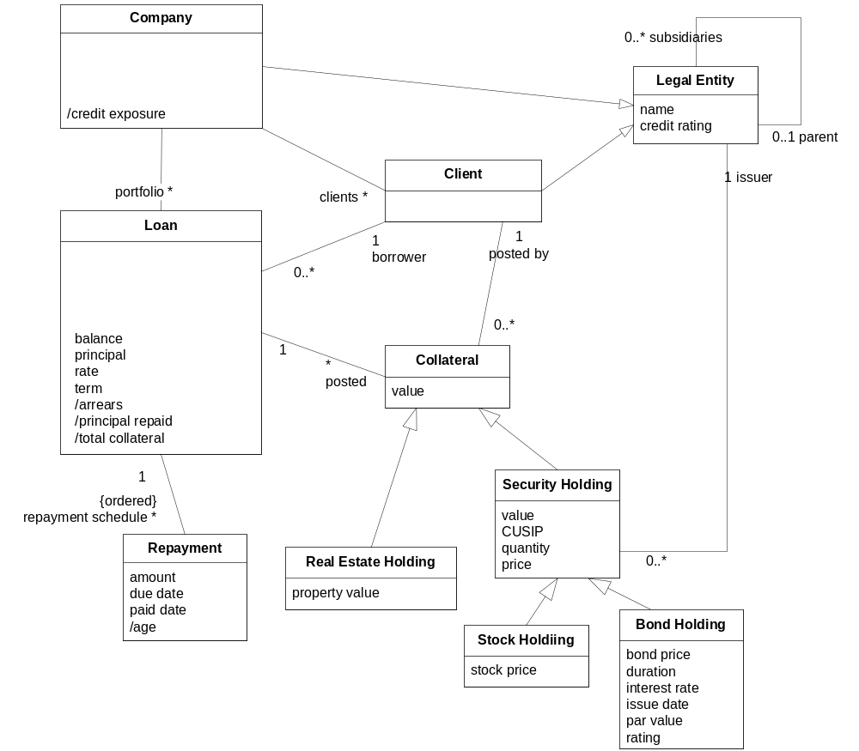

- Statement (a) suggests a high level goal implicit in the information provided above. State that high level goal.
- Consider the goal “Minimize credit risk” which, at all times, minimizes the risk of future credit loss. This goal is fundamentally about the risk of future credit events, and can at best be approximately measured and met. Devise a goal model. Start with identifying what the top-level goal wants to “control”. Then devise a suitable set of sub-goals for this goal, showing which parts of the domain they control/observe. When considering any one sub-goal, you can assume that other sub-goals are met. If there are some addition domain properties (e.g. assumptions you make about risk, or prediction, or history) add them to the goal refinement. Each sub-goal should “at all times” maintain some relationships, based on the following hints:
  - Assuming the existence of some “risk prediction model” that helps predict credit risk
  - A set of risk-related parameters that can be tweaked e.g. collateral demands and credit-ratings
  - Recognizing that no risk model is perfect
  - A desire to improve the risk model over time
Informally list some events that must be handled for your subgoals to be met i.e. which events could perturb the sub-goals.
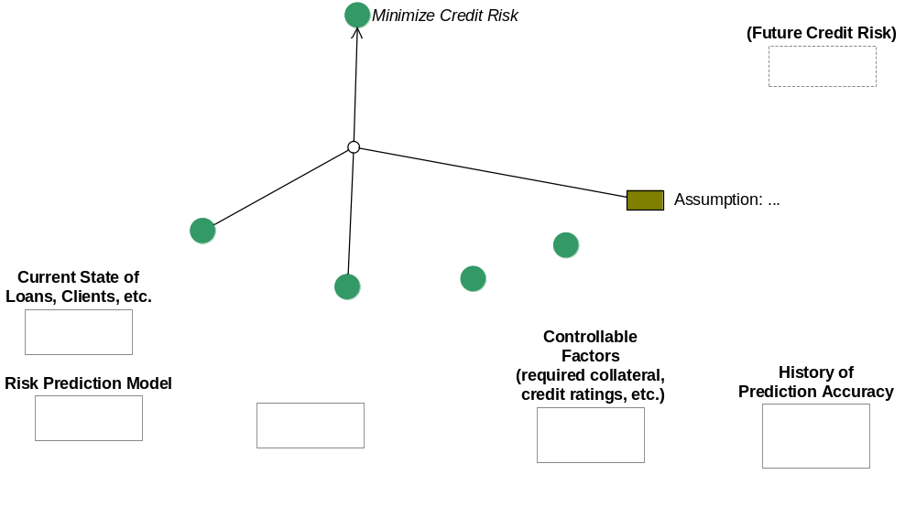
- [Optional] Requirement note (e) mentions “lending activities and attributes” in connection with constraint definition and enforcement. At what point in the specification and development of the Loans System will we have to know exactly what these activities and attributes are? Which models will document them?
- [Optional] In requirement note (f), which is the higher level goal: to support “what if” scenarios, or to optimize lending activities? (Hint: Ask “why” to get to higher level goals; ask “how” to get to lower level ones.)
- [Optional] Propose a definition of “optimal” in the concept of optimizing lending activities in (f).
- [Optional] Describe / discuss some use cases that could provide a refinement of requirement note (f).
- [Optional] Could there be a conflict between the timeliness properties implied in requirement note (g) and the timeliness stated in (d)?

Exercise 5.2 Build a Role Activity Diagram, Activity Specs, Info. Model [30]
Starting with the process and activity descriptions in the table below:
- Build a Role Activity Diagram (RAD):
  - First name the overall process and write a short postcondition for the overall (successful) change of state for the process.
  - Use the list of finer-grained activities below, and write down the main post condition of each. This clarifies the start/end of that activity.
  - Place the activities on a RAD. Make this a "black-box" RAD i.e. minimize "internal" structure or sequencing of actions unless they are right before, after, or directly involved with external interactions. Initially do not connect the activities.
  - Annotate the line ends in and out of the activity with the name of the state before / after the activity.
  - Connect outgoing lines of one activity to incoming lines of another activity if the state annotations are the same. Revise state names.
  - Add other flows and connections, including branches, forks, etc. Use annotations if the formal notation gets complex. If you get hung up on how to graphically show iteration, exceptions, etc. simply annotate the diagram with footnotes or comments e.g. "Activities A, B, C repeated until condition X holds", or "Activities X, Y, Z are interrupted or aborted if event E happens"
  - Check that your RAD works by walking through your earlier scenario (from Exercise 4.3(a)).

- Write an activity specification for draw down and post collateral. You can expect your specification to be very similar to the generic action spec you wrote earlier, but with a RAD you also indicate which role provides each input required for the activity, and if any other roles are involved.

- Update your information model to make sure it supports your specification. Write a short description of the types Loan and Customer, indicating whether, in your business model, these represent types in a software system or not.
The process of obtaining and paying off a loan:
Request a loan
Check borrower credit rating
Check exposure to borrower
Stipulate collateral
Agree principal, rate, & term
Post collateral (assume all collateral must be posted as one unit)
Activate loan
Draw down
Make repayment

5.2(1) Answer:
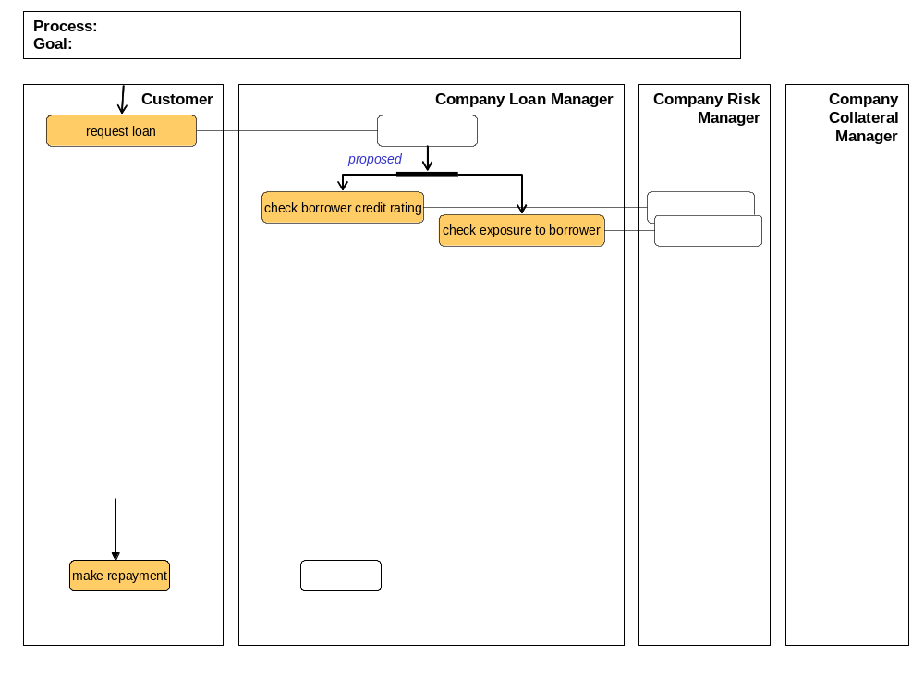
5.2 (2). Activity Specification
activity: post collateral
roles:
inputs: from
precondition:

postcondition:

activity: draw down
roles:
inputs: from
precondition:

postcondition:

5.2 (3) Updated Information Model

Since this is a (case) process for handling a Loan, most of the changes should be centered on the Loan type.
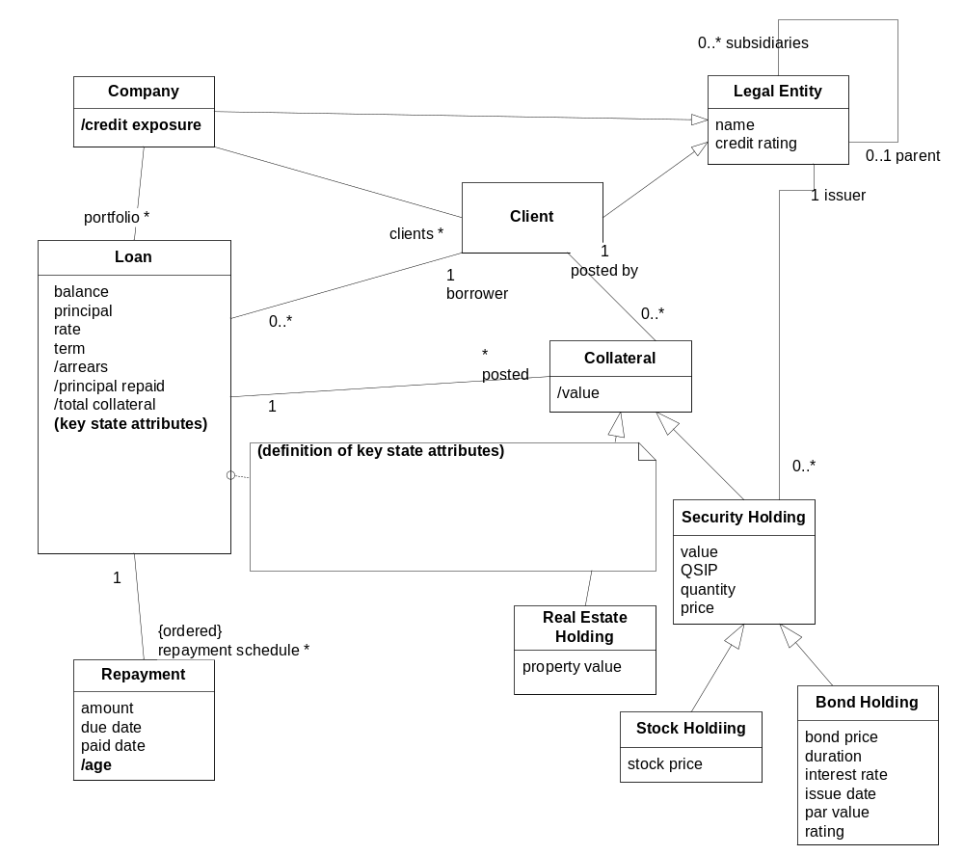

Exercise 5.3 Build a State Diagram and State Definition Matrix.
Based on the RAD you developed, identify the object that has an interesting lifecycle through the entire process.
Sketch a state model for that type. Transitions should correspond to actions in your RAD, and states should include key states on the RAD.

Construct a matrix showing each state and how it is derived from the attributes in your information model.

[Optional] Construct a matrix of states and actions to ensure that you have covered all state transition cases.

State | Derivation Expression

Exercise 6.1 Mapped Black Box Assembly
Your black-box assembly will consist of the Loans System, a Reference Data System, and a Collateral Management System.

Starting with the business information model:
- Add these systems to the model, with UML-composition associations (black diamond) to the types they directly own.
- Trace through the model until you reach a type which is either (a) not owned, or (b) partly owned. Assume that the Loans System owns and tracks the credit rating of its Clients, and in order to do this has to also own and track the credit ratings of its entire legal entity structure. The Reference Data system owns the core Legal Entity structure itself, with the actual parent-subsidiary relations. Model this as split objects, with the credit ratings on the Loans System side, and the parent-subsidiary association on the Reference Data side.
- In the case of a partly owned type, or where portions of the attributes are owned by different systems, introduce a new type name (e.g. “Collateral Management View of XYZ”) with the owned attributes and associations, and introduce an association with the other part of the type. This is a <<cross-system>> association and will typically have some consistency requirements associated with it.
- In case you split a type that has a sub-type relation, break into two separate types (with inherited properties assigned to one or the other) with an association between them i.e. the subtype is represented by two different objects in two different systems, and the association represents the pair-wise correspondence.
- Do any goals or invariants cross the systems? Mark them on your diagram with references into the parts of the model they reference.

Answer. Initial information model is below. Template to show the partition across the black-box assembly is on the next page.
Note: Consider information split across systems, and associations/invariants/goals between them.)
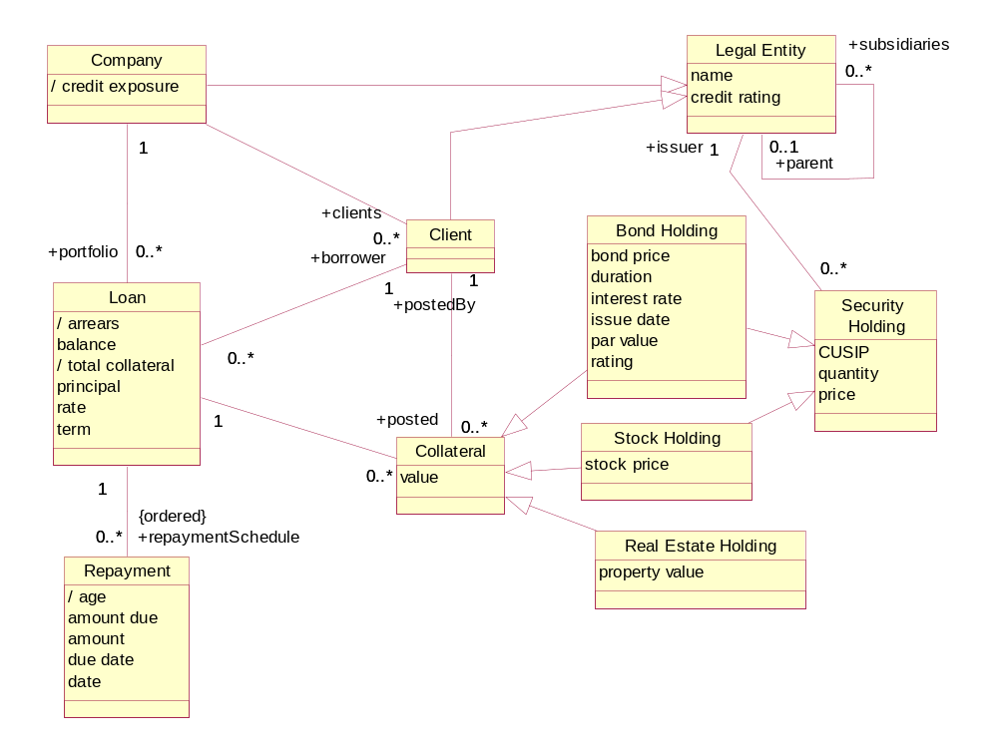
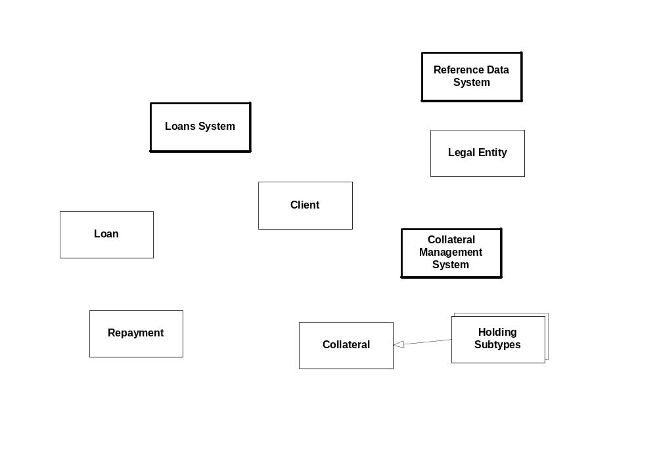

Exercise 6.2 Use Case Specification
- Draw a use case diagram showing the following use cases:
- post collateral (assume all collateral must be posted as one unit)
- draw down
- update LE info. (Just for this use case : assume that, for performance reasons, Loans System will keep a copy of the parent/subsidiary relation from the Reference Data system in order to manage it’s credit ratings properly and efficiently. Such information would typically not be mixed into a purely logical view of the architecture, which should typically just describe the authoritative sources and not performance optimizations.).

Just for the update LE info use case: assume this is a daily batch synchronization of replicated LE hierarchy information across the systems, and that the Loans System stores an extra credit rating attribute on each LE instance that it maintains.

On your use case diagrams, include the following external human roles (actors) and systems:
  - Customer (actor)
  - Loans Officer (actor)
  - Collateral Management System
  - Reference Data System.
Add links from use cases to actors that immediately interact with the loans system in that use case. In the case of “draw down”, assume that there is a direct way for the customer to draw down funds without involving the loan officer, e.g., via electronic funds transfer.
- Specify the three use cases in more detail as shown below. Include the net state change in the “system”, as well as all communications with other actors. Reference and underline attributes or inputs or outputs, remembering that you are now talking about the state of the system, and inputs/outputs to that system. Your inputs and outputs can be simple values (dates, quantities) or objects (e.g. Order), without details about how those objects are identified. Understand how the use cases interact via these attributes.

1: Answer:
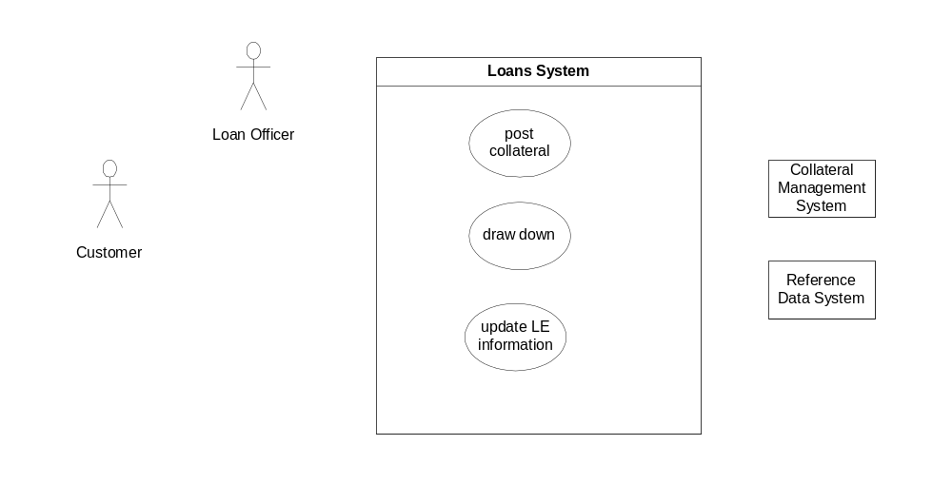

Use case: draw down
Actors:
Inputs: ___________ [from ____________]

Outputs: ___________ [to ____________]

Trigger:
Precondition:

Postcondition:

Use case: post-collateral
Actors:
Inputs: ___________ [from ____________]

Outputs: ___________ [to ____________]

Trigger:
Precondition:

Postcondition:

Use case: update LE info
-- synchronize LE information between systems
Actors:
Inputs: ___________ [from ____________]

Outputs: ___________ [to ____________]

Trigger:
Precondition:

Postcondition:
For every instance of …. In … There is ….

Exercise 6.3 Describe Steps and Alternate Paths.
Elaborate the “post collateral” use case with steps of the main "success" scenario. Underline attributes or include otherUseCases in your steps.
Check that your use case specification abstracts the detailed step-level information exchanged via the inputs/outputs of the specification.
Write at least one successful alternate path description, and one failure alternate path.

Use case: post collateral
Actors: Loan Officer, Loans System
Inputs: Loan, Client, list of assets (obtained from Client representative) to be posted as collateral for Loan
Outputs: Confirmation of posting (to Loan Officer), Collateral Update (to Collateral Management System)
Trigger: Client contacts LLC offering assets as collateral against loan
Precondition: Loan is “proposed”; client offering collateral is client for Loan; collateral fulfils general criteria for suitability.
Postcondition:
If the collateral offered is sufficient, the offered collateral extends the set of holdings (in Collateral Management System) already in use as collateral against loan and the loan is funded. If collateral is insufficient, there is no change to the system.

Main (success) steps:
1.
2.

Alternate paths:
#…

#…

use case <...> (only required if the above use case “includes” other use cases)
post: ...

Exercise 6.4 Identify and Specify Use Case Operations
Look through the steps in your use case solution from the previous exercise, and identify (a) operations that the system provides that are invoked during that use case; (b) <<out>> operations that other actors provide that are invoked by the system; (c) raised <<events>> or other behaviors that the system needs to exhibit. You will sometimes need to consciously choose the granularity and level of abstraction you want to call “one operation” e.g. placing an entire order Vs. adding one line item at a time.
Identify all inputs and outputs for each such operation. You should be able to describe what the operation does and its outputs in terms of its inputs and persistent state.
Specify at least 2 operations with at least its names, signature of all parameter types, and informal description of its postcondition. Reference and underline attributes in the postcondition. Remember that all the terms referred to in a postcondition should be one of (a) an input parameter provided to that operation; (b) an attribute of that input parameter; (c) an attribute that was part of the system state.

Use case post collateral

Exercise 6.5 User Interface Specification
Using the steps of your use case and the information model:
- Draft a list of named windows, and describe each.
- Sketch an information model with the main UI state, including the information model of each view and its relation to the core information model
- Define any application-specific UI events if they correspond to multiple detailed UI alternatives
- Show state diagram of main UI windows, labeled by all UI events
- Describe operating procedures for users using terms from the information model and use cases.

We will skip this lab. It is included for outside class use.

use case post collateral

Exercise 6.6 Specify Black Box Ports and Assembly
In this exercise we will set up our system description for consistent and recursive treatment between black box and white box views.
Note: This exercise can be scoped down to the ports and operations required by the “post collateral” use case for the purposes of focus and continuity with the previous exercises.
- Draw the ports on your “system”, with the system having a «comp spec» stereotype and icons for each port that provide or require services from other actors. Name each port.
- Separately show each port as a type, listing the system operations in/out of each port including incoming and <<out>> or <<event>>.
- Show the connectors from these ports to the actors or external systems.
- For each black-box involved, list the elements (types, attributes) of the information model it owns.

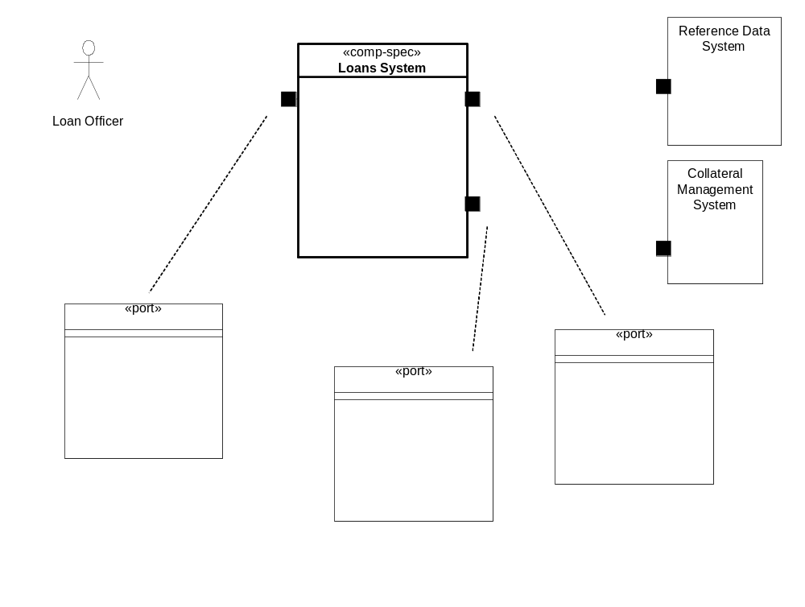

Exercise 7.1 Draft Core Type Components and Use-Case Coordinator Components.

(a) Find Core Type Components
Using your black box information (adapted from the business information model) from 6.1:
Identify the «core» types. These types tend to have a unique identification in the business, 1-to-many associations to other types that can be considered "detailing" types on them, associations to some type that serves primarily to "classify" them, an association to the "top", and do not have mandatory ("1") associations to other types. Defer analysis of any derived associations you might have. Optionally, if you have objects with a complex lifecycle that is quite different from that of the core type, consider partitioning that (with its detailing types) into a separate component i.e. treat it as its own «core» type by bending the above rules a bit.
Assign each core type <X>, with its detailing types, to its own component. Typically name that component something like <X>Mgr, <X>Manager, or <X>Mgmt. Show assignment by the UML black-diamond (called "composition" in UML).
Check your model and its associations to see if all core and detailing types are unambiguously associated with just one component. You may need to associate a direction with some associations to reduce bi-directional dependencies across components. Think about likely navigation paths across components in making this decision (it will be validated when designing end-to-end collaborations across components).

Lab – LotsALoans Corp (LLC)

(b) Add Use-Case Based Components
Using your initial component partition and the use case model:
Introduce a component for each large-grained use case on the system, with the operations from the steps of that use case. This component will act as the primary initial "receiver" of the external operation requests (e.g. via a UI) from the steps of that use case, and will also typically act as coordinator across the «core» type components. It does not hold session-specific dialog logic or state; that is considered part of the UI/dialog tiers. Typically name component for use case <U> something like <U> Controller or <U>Coordinator, or a role-name version of the use case.

Lab – LotsALoans Corp (LLC)

(c) [Optional] Add UI / Dialog Components
If your system has a user interface, add a UI component (pure presentation) and a corresponding dialog component (remembers the state of the dialog, with preceding selections and the results of preceding requests).

Exercise 7.2 Design Collaborations across Sub-Components
Starting with your candidate set of sub-components, including those based on «core» types and those that support use cases. Keep your model of white-box information ownership front of you. Pay special attention to the directions on cross-component associations.

Draw an instance of each sub-component, and each external system you interact with (layout the sub-components in a consistent and intuitive way).
For each “architecturally significant” operation (likely to uncover new paths/interaction), draw a collaboration diagram as follows:
- Select the use-case component that is the "receiver" of that operation.
- Draw the request and label it: x := request (a, b), where x is the result expected back (if any), and a,b are the objects or values passed in with the request. Note that x, a, b are variables, not types. Remember that a given sub-component can process a request using (a) any input parameters it received; (b) any information it receives from other components it interacts with; (c) anything it "knows" as part of its own information model.
- Follow through the rest of the interactions that ensue, using the names x, a, b, names of attributes defined in the information model of each sub- component, and introducing new names ("local" variables) as needed. Note that an arrow with 1.1 x := r(a,b) simply means that at step 1.1, the method r is executed, using parameters a, b; it does not mean a hard-coded invocation from one sub-component to another. You can add annotations and/or UML icons as information explanation of iteration, conditions, etc. if you need to.
Check that you have accomplished all of the post conditions specified for that use case, and completed all external communications.
Lab – LotsALoans Corp (LLC)
use cases: draw down, post collateral

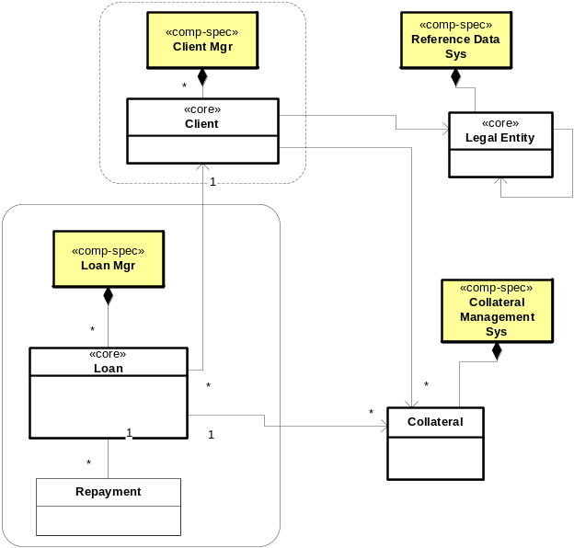

Exercise 7.3 Define Sub-Component Assembly
Assume that you have the following two kinds of connectors available to connect your sub-components:
A default “call” connector: it requires an outgoing method call from one end to exactly match the invoked method on the other end. It provides synchronous call-and-return behavior.
An «event» connector: it takes several pairs of:
an event to be raised at one end, with some name and event information type.
a method to be invoked at the other end, with some method parameter types.
a definition of the mapping from event information to method parameters
It provides asynchronous communication of the event, resulting in the invocation of the method.
Build your sub-component assembly as follows:
Draw a line connecting sub-components that interact in your collaboration diagrams, and connecting them to external actors.
Decide what connector type you will use and annotate the connector with «connector type», unless using “call” connector.
Define a «port» at each end of the connectors. Name the port ~A if it is purely a client port to a port A for a set of client-server interactions across a default “call” connector. Name the port something like <X>Events for a port that is nothing more than a source of events.
Define at least two ports with some of their operations, <<out>> calls, and <<events>>, including parameters and their types.
Lab – LotsALoans Corp (LLC)

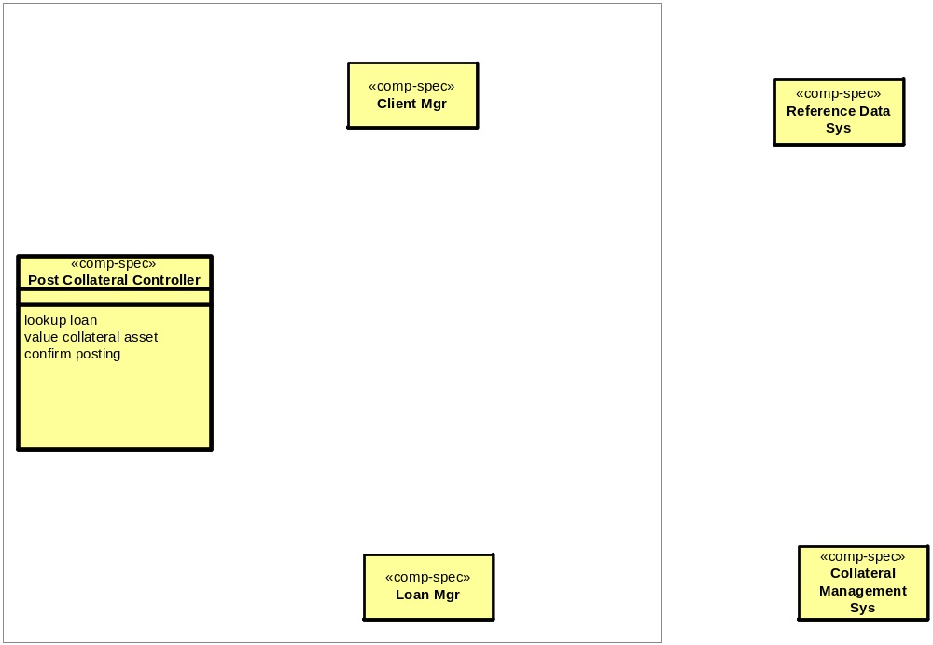

Exercise 7.4 [Optional] Specify Sub-Components
Specify each sub-component as follows:
Draw a «comp spec» with associations to a set of «port»s.
For a server port A, or an event port: list the incoming operations or outgoing events with names and signatures. For a client port, the name ~A can suffice as a reference to the corresponding server port A, without ~A having to list operations or events.
Draw the information model of the «comp spec». Use UML "composition" from the «comp spec» to show the relationship.
Add a «data type» class for any input or output parameters referred to in the ports. There will typically be some attributes in the persistent information model and in the data types that "link" them together.
Write a short post-condition specification for at least two of the operations on one of the component ports. Underline terms that refer to attributes in the information model.

Exercise 8.1 Apply a Pattern
You are given the following technical architecture style, mapping from logical components, ports, events, and methods to the Java platform:

Logical Model | Platform Mapping
Any element name | Spaces replaced with “_”
Component | Java package
Port | A public Java class in that package
<<event>> e (x, y) | An interface:  interface E_Listener {  void notify_e (T) ; // where T is a struct-like object combining event parameters x and y  }  A collection of 3 methods and 1 data member on the port:  - add_e_listener (E_Listener o): adds o to a list of E-Listeners  - remove_e_listener (E_Listener o): removes o from the list of E-Listeners  - notify (): calls notify_e on each listener in the list
Event-method connector | [Optional] If you are familiar with dynamic proxies in Java, sketch a generic event-method connector class which could take a pair of ports and multiple event-method pairs, and do the right event registration and adaptation between the ports.

Create the result of applying this style to the following logical white-box model:
Logical Model | Platform Mapping
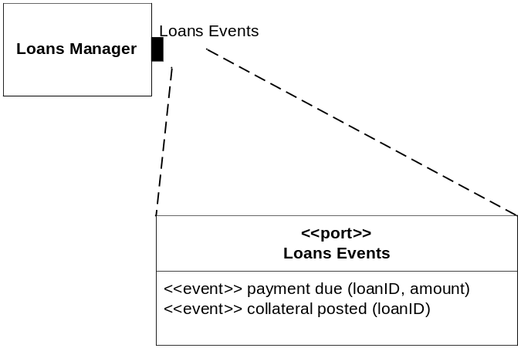 | package Loans_Manager;  interface payment_due_listener {  ….;  }  interface collateral_posted_listener {  ….;  }  public class ….. {  }

Exercise 8.2 Extract a Pattern
Identify a named pattern in your information model, as suggested below.
Define the "parameters" of that pattern as types and/or their attributes. Simply write the parameters as <Type, attribute, ...> <Type, attribute, ...>. Other parts of the pattern can be "generated" from those parameters. If you need to "generate" a name for an element in your model from the pattern write a compound name e.g. <Resource>_Consumer becomes Room_Consumer if <Resource> = Room.
Define the "expansion" of that pattern that should result when it is applied to given parameters.
Apply the pattern to your model by showing a dependency arrow from your package to the pattern package, annotated with bind [pattern parameters] i.e. the bindings of pattern parameters.
Lab – LotsALoans Corp (LLC)
We will skip this student lab. It is included for outside class use. Do one or more of the following:

Loans may have a start and end date. Purchase bids might have a minimum and maximum dollar amount.
Extract a pattern for a Range of <X>, including some common attributes on Ranges and <X>s.
There is an underlying pattern for resource allocation. Define this pattern using things like <Resource>, <Capability>, <Resource Owner>, <Job>, etc. Include the main attributes and associations, and an invariant for “no double booking”. Check that it can cover such uses as:
  - dentists to appointments, or
  - rooms to hotel guests, or
  - cars to rental requests.

Each Legal Entity can have any number of subsidiaries. In other contexts, a product might have a corresponding bill-of-materials. When you got an order, or when inventory ran low, you had to order more from suppliers based on the bill of materials. Hence, each product is comprised of parts; and some parts (excepting the "atomic" ones) are comprised of sub-parts. Find, extract, and apply the pattern "Composite" to your model.

Exercise 8.3 Design a Connector Spec + Realization
For the connector described below:
Sketch one connector specification pattern. This will include enough information that someone can use it in a white-box assembly and understand its effect, without knowing about the protocol or technology detail that underlies it. Create one example of "applying" that pattern, and work out the "expanded" result of that application.
Sketch one possible connector realization for that same connector on a platform such as .NET or J2EE.
On your existing case study model, or inventing a small fragment for the purpose, show how you might apply the connector spec in your white-box architecture, and its realization in the technical architecture. Work out the "expanded" result of applying those patterns.
Instructor Example - Hotel Austerity Limited (HAL) | Lab – LotsALoans Corp (LLC)
A connector that:  Spec: Keeps a property at a "sink" end updated with any change in a corresponding property at the "source" end. The properties may be simple (numbers, strings), or complex (structured objects, or entire sets of objects).  Realization: Does the above by:  - Requiring the "source" end to offer an outgoing event with data about changed values  - Requiring the connector itself to offer event subscribers an interface via which different sets of published properties can be referred to by a single subscriber, in order to subscribe to their changes:  subscribe(PropertyName, Subscriber), with an unsubscribe() operation.  - Requiring every interested "sink" end to subscribe with the connector itself, and to provide an operation to be invoked when a change has taken place. | We will skip this student lab.

Exercise 8.4 Design a Component Realization
Consider a single target technology for (some of) your components e.g. J2EE, .NET, a proprietary component platform, or a legacy environment, perhaps choosing something that is relevant to your project. Discuss any regular mappings you can find between the logical view of components and their interactions, and how those might map to the target technology e.g. names of components, how they are located by others, what the operations correspond to in the technology, how in or out parameters are communicated, etc.
Instructor Example - Hotel Austerity Limited (HAL) | Lab – LotsALoans Corp (LLC)
 | We will skip this student lab.

Exercise 8.5 Define a Data Model
Define a pattern for dealing with one (simplified) part of an object-relational mapping. Find one place to apply this pattern to your information model Work out the expanded result of applying that pattern.
Instructor Example - Hotel Austerity Limited (HAL) | Lab – LotsALoans Corp (LLC)
Mapping a subtype to separate tables | We will skip this student lab.  Mapping a N-M association to an associative table

Exercise 9.1 Document a Given Deployment Design
Given the deployment decisions below, build a deployment architecture with the diagrams and text descriptions.
Instructor Example - Hotel Austerity Limited (HAL) | Lab – LotsALoans Corp (LLC)
HAL is a hotel chain with 2 hotels in Chicago (Chic1 and Chic2), and 1 in New York (Man1). The IT headquarters is in Denver.  Each hotel has three machines for reservations and one back office server. Each reservation machine is a Macintosh G4 and the office server is an Athalon Linux server with a RAID array.  The IT headquarters has a round-robin load balancing router, five transaction-processing machines, and one DB2 database. The TP machines are rack mounted Athalon Linux servers and the DB2 database runs on a mainframe.  Each hotel has a 100mb LAN and a T1 connection to IT headquarters. There is also a backup dial-up connection.  The hotel machines run OS X and the Opera web browser for reservations. The back office server runs the client version of a custom J2EE application, and the IT headquarters runs the server version of the same application.  What happens when a reservation machine crashes? When the T1 link to the IT headquarters is down? When a transaction-processing machine fails? | Construct a plausible deployment design for LLC. Be sure to cover all of the steps in the deployment design process.  Identify scenarios for failure, overload, and security violation cases. Evaluate your deployment with respect to these scenarios.  Does your deployment assume anything not specified about the connectors? For example, guaranteed delivery of messages after outage, in-order delivery of messages, timely delivery.

