MAP
Possible Solutions to Exercises



1 Describe Objects
1.a Show Interacting Objects
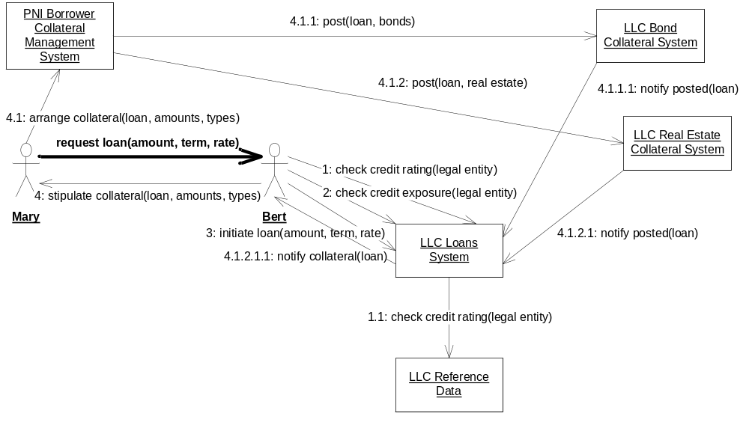
1 b. Kinds of Objects and Attributes Managed
Loans System | loan portfolio (including total credit exposure), loans (including principal, rate, term), reference to collateral posted
Reference Data System | legal entity hierarchy (parents and subsidiaries), credit ratings;
Borrower Collateral Management System | obligations to provide collateral, and details of assets posted as collateral, together with references to the relevant loans
Bond Collateral System | details of bonds posted as collateral
Real Estate Collateral System | details of real estate posted as collateral

1 c. Polymorphic Type
Detailed handling of collateral types varies, but same operations are supported.
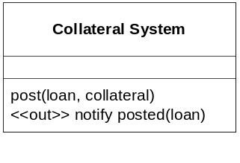

1 d) Find Multiple Types
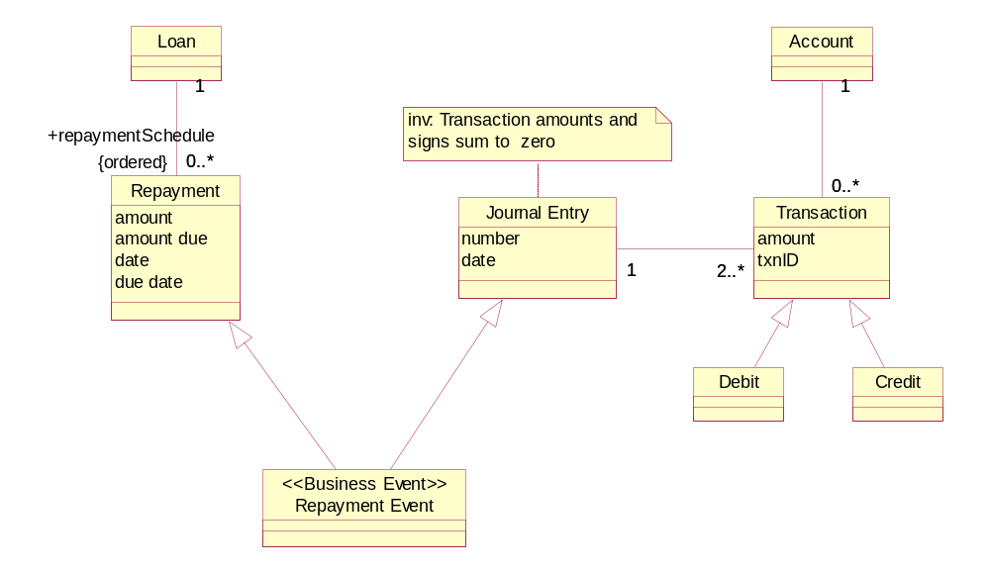
If a two or more aspects (types) of the behavior of a single underlying object are tracked by separate computer systems as though they are totally separate objects, serious inconsistencies typically arise. For example, in this case, the asset corresponding to the unpaid balance on a loan should be correctly reduced over time as repayments take place. There must therefore be communication between the loans system and the subledger system whereby the business event of repayment is converted into an appropriate journal entry and posted to the ledgers.

3.1 Objects, Snapshots
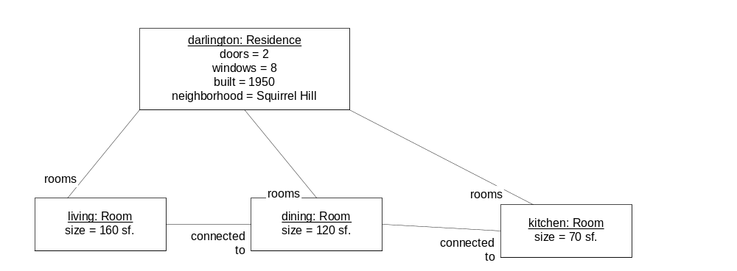

3.2 Information Model

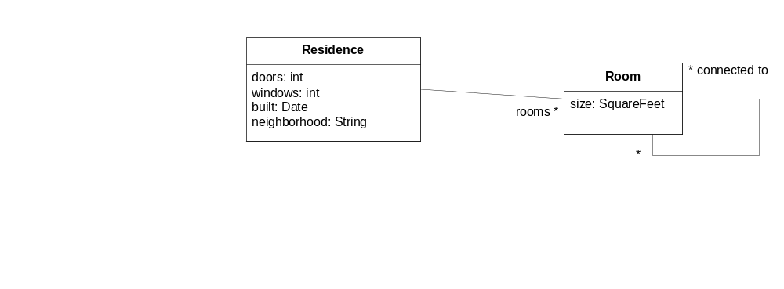

3.3 Snapshot Pairs
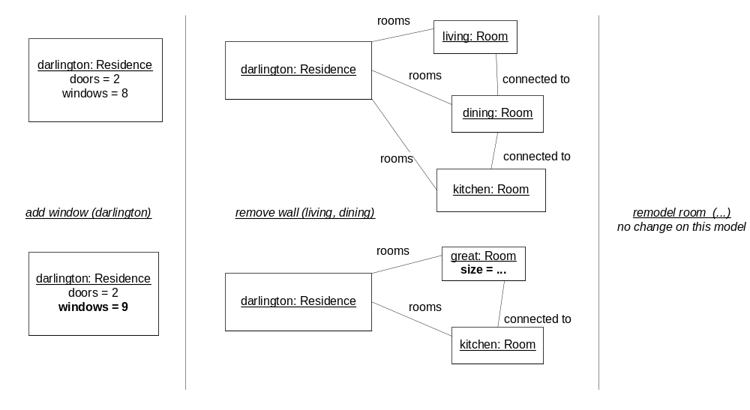

The fact that remodel_room has no visible effect on our model of the residence means either:
- That action and its effect is not relevant to our purpose, or
- Our model needs to be extended to allow a description of what (relevant) changes take place when a room is re-modeled.

3.4 Actions

action add Window ( r : Residence)
description: the house is remodeled to add a new window to a residence
precondition: none
postcondition: the number of windows in the residence r is one greater than before

action remove Wall ( r1: Room, r2: Room)
description: the house is remodeled to join two contiguous rooms into one
precondition: the two rooms r1 and r2 are connected to each other
postcondition: A new room, r3, is created and added to house rooms.
r3 is connected to all the rooms that r1 and r2 were connected to.
the size of r3 is the sum of the sizes of r1 and r2.
the rooms r1, r2 are gone.

3.5 Scenarios with text and snapshots
Scenario name: new wing on mansion
Initial state: Titus is a contractor, Jake the homeowner
- titus and jake sign the contract
- titus lays the foundation
- titus raises the walls
- titus adds the roof
- titus and jake do the walkthrough
- jake adds the windows
- jake adds the doors
- jake adds the finished flooring
Final state: the new wing is complete

Snapshots: This would probably require new types of objects for Contractor, Homeowner, Wing, Contract, and possibly Foundation, Roof, Wall (although these could be modeled with simple T/F attributes on the wing to indicate if the foundation, roof, walls etc. were completed or not, assuming there was no need to capture deeper details of the domain).

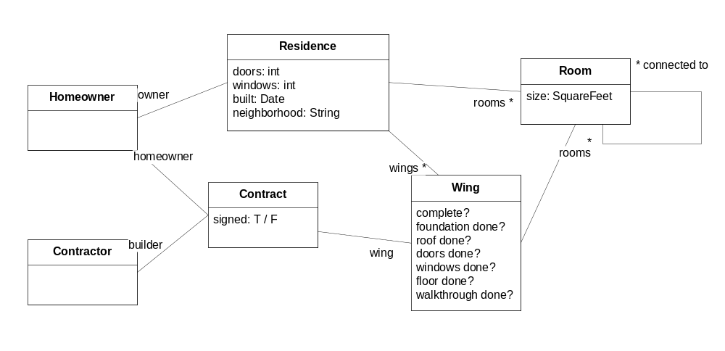

3.6 Role Activity Diagrams
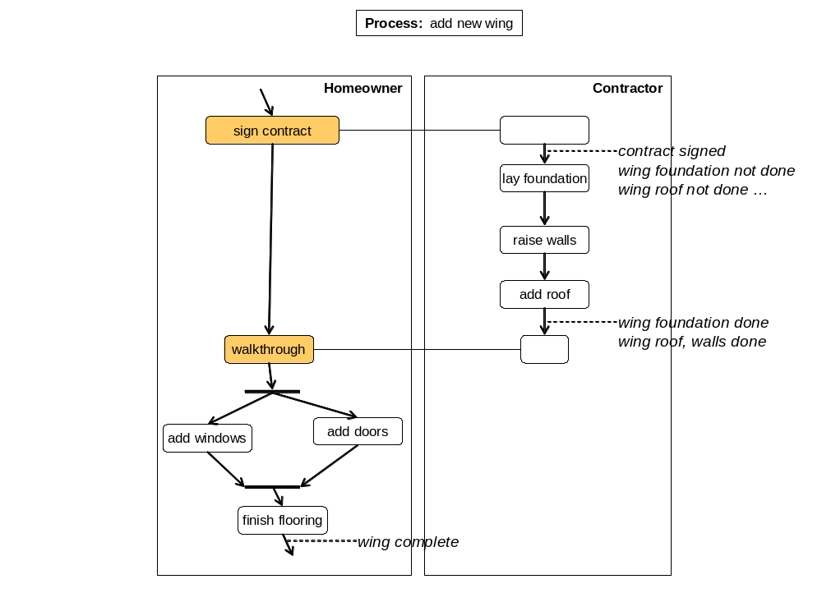

4.1 Draw Object Snapshots, Build Information Model from Snapshots. Understand Navigation Expressions.

Snapshots & User Interface
Note: information not shown in snapshot is simply omitted, rather than lost.
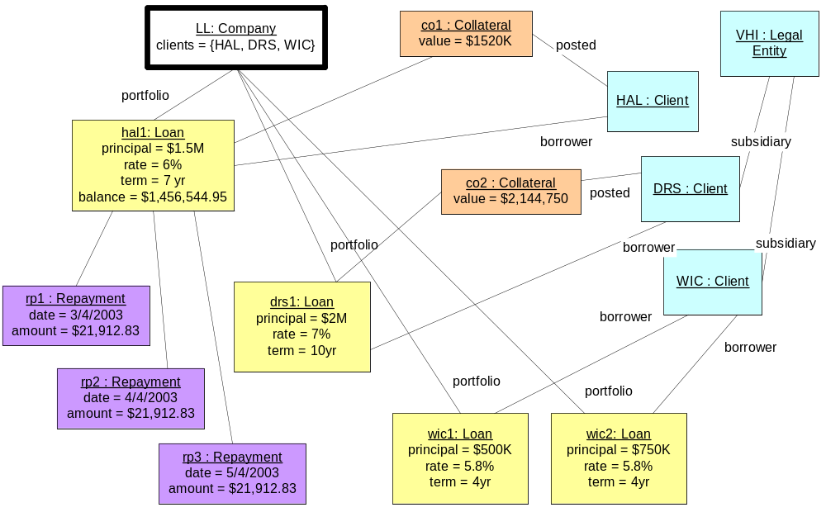

Creation:
Type of object | Created when …
Client | LLC receives the first ever loan application from that client.
Legal Entity | When any kind of legal entity becomes known to the company in any capacity.
Loan | When a new loan is requested between the company and a client.
Collateral | When collateral is posted against a loan.
Repayment | As soon as the repayment is scheduled.

Build Information Model from Snapshots
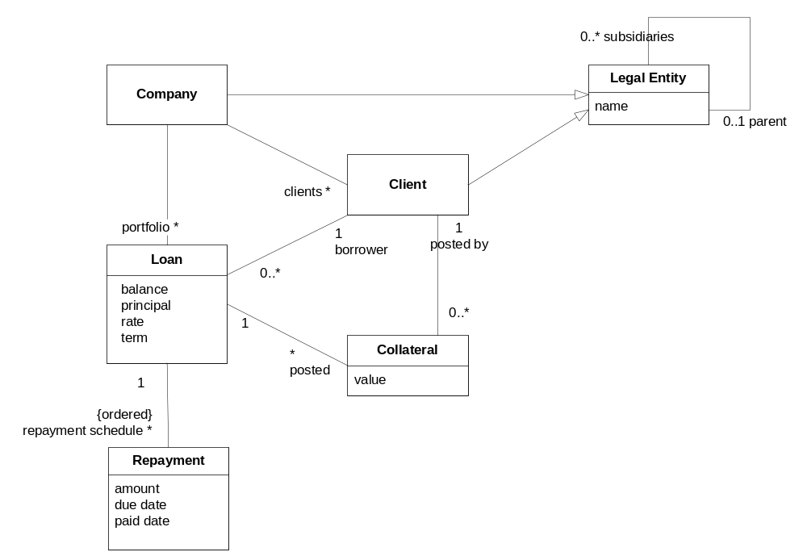

(c) Interpret Navigation Expressions
- LL.portfolio.borrower = {HAL, DRS, WIC}
- LL.portfolio → select(principal > $750K).borrower = {HAL, DRS}
- LL.portfolio → select(l | l.collateral->IsEmpty) = { wic1, wic2 }
- hal1.repaymentSchedule → sum(amount) – (hal1.principal – hal1.balance) = $22,283.45
- The borrowers who are subsidiaries of some parent LE = { DRS, WIC }
- The clients who do not have any loans = {}

(d) Write Navigation Expressions
- Informal: All repayments made to LL.
Formal: LL.portfolio.repaymentSchedule
- Informal: Legal Entities who are parents of borrowers.
Formal: LL.portfolio.borrower.parent
- Informal: The interest rates on loans in the portfolio
Formal: LL.portfolio.rate

4.2 Convenience Attributes. Invariants. Supertypes.

a) Introduce convenience attributes
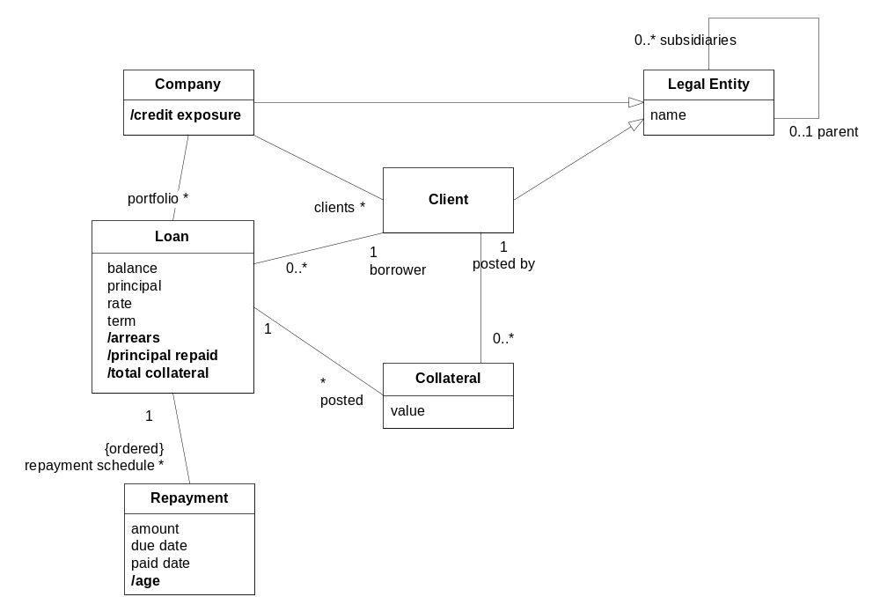

b) Write Invariants

i. Derivation Invariants for Convenience Attributes
- The total value of the collateral posted for a Loan: sum of the value of all the loan’s posted collateral
Loan: totalCollateral = posted → sum(value)

- The total credit exposure for a Company, across its entire portfolio of Loans: the sum of the balance on all loans in the portfolio.
Company: creditExposure = portfolio → sum(balance)

- Assuming a “due date” attribute on Repayment, the number of days by which a Repayment on a Loan is overdue at the present time: age = current date – due date (roughly)
Repayment:
if (paid_date = null & now > due date)
then age = now – due date
else age = 0
- The Repayment amount outstanding on a Loan, across all overdue Repayments for that Loan. Assume the existence of an “amount” attribute showing the amount due on a Repayment.
Loan: arrears = repayment schedule → select(age > 0) → sum(amount)
- The amount of principal repaid for a Loan.
Loan: principal repaid = principal – balance

ii. Extra Model Constraint
Informal: A Borrower from a Company is necessarily a Client of that Company.
Formal: Company inv : self.clients → includesAll(self.portfolio.borrower)
Equivalent set expression: self.portfolio.borrower ⊆ self.clients.
Note: this invariant restricts the cyclic associations between Company, Client and Loan.

c) Utilize Supertypes
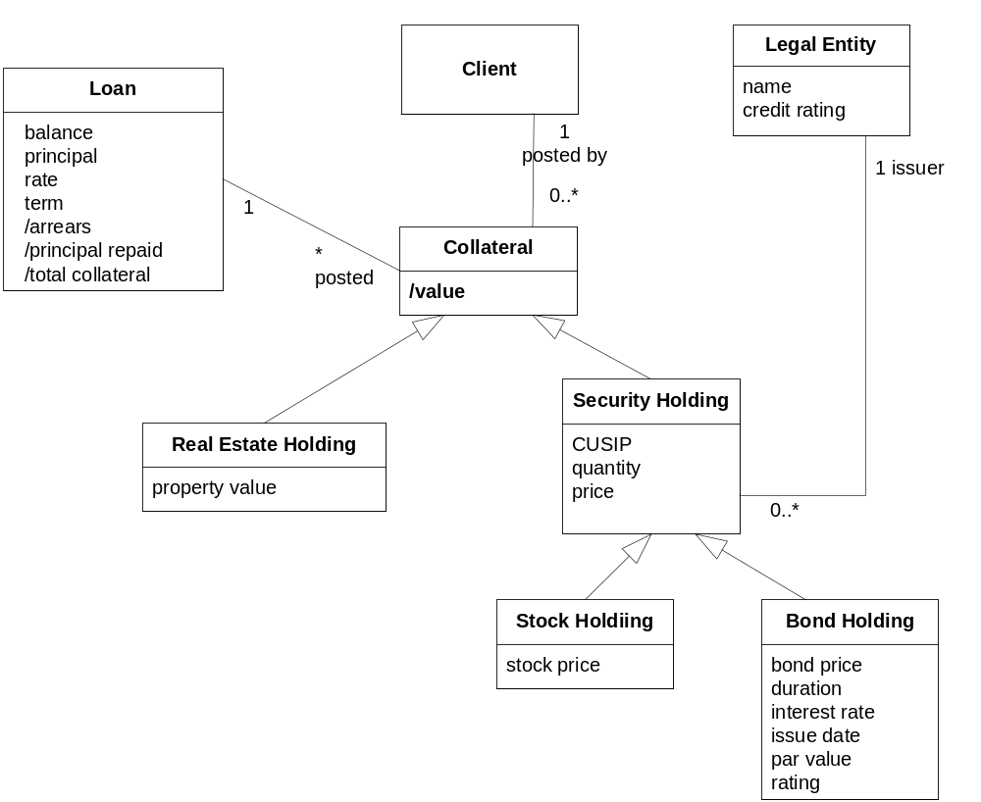

Invariant on Bond Holding: rating is the same as the issuer’s credit rating
There are different types of collateral: Stock Holding, Bond Holding and Real Estate Holding.
The supertype is Collateral.
In addition, Stock Holding and Bond Holding are both types of Security Holding.
The generic attribute Collateral::value puts a USD value on a collateral holding. Each subtype has its own valuation attribute: BondHolding::bondPrice; StockHolding::stockPrice and RealEstateHolding::propertyValue, whose value is determined using a procedure (whether manual, semi-automatic or full automatic) specific to that type of holding. For SecurityHoldings, the Collateral::value requires further computation to multiply the respective price attribute by the SecurityHolding::quantity attribute.

Resulting Information Model
/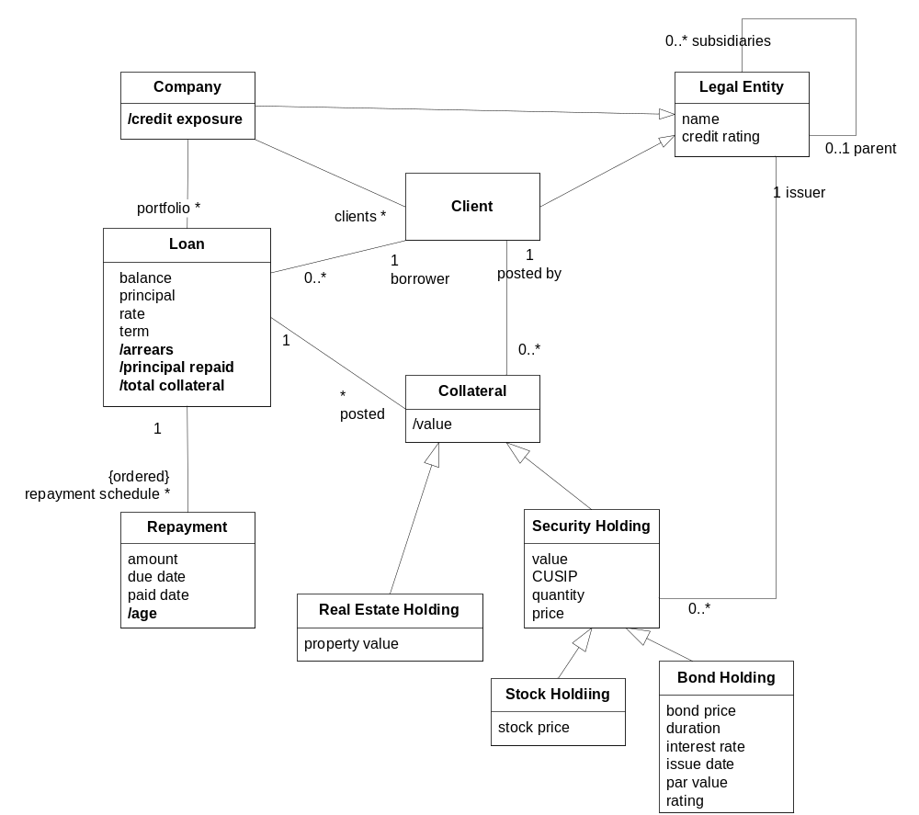

4.3 Define Scenarios and Snapshot Pairs.

(a) Scenarios and Snapshot Pairs
- the long-lived activity could be: complete loan
starts – when HAL requests a loan from LLC.
ends – when HAL has completed all the scheduled repayments on the loan.
- the finer grained actions could be: request loan, agree amount, offer term, agree term, offer rate, agree rate, post collateral, activate loan, draw down, make repayment.
the type could be: Loan.
the states could be: proposed, active, closed.
- scenario: HAL borrows from LLC and then pays off the loan
initial state: HAL is not a subsidiary of any other legal entity. It has a credit rating of BBB.
scenario steps
- HAL requests a loan for $1.5M over 8 years from LLC.
- LLC offers a rate of 6%, and counter-proposes a term of 7 years.
- HAL agrees to the amount, rate, and term.
- LLC stipulates to HAL that collateral must always be greater than or equal to the balance outstanding on the loan at any given time.
- HAL agrees and posts initial collateral whose value is $1520K.
- LLC schedules all 84 repayments and activates the loan.
- HAL draws down the full loan amount.
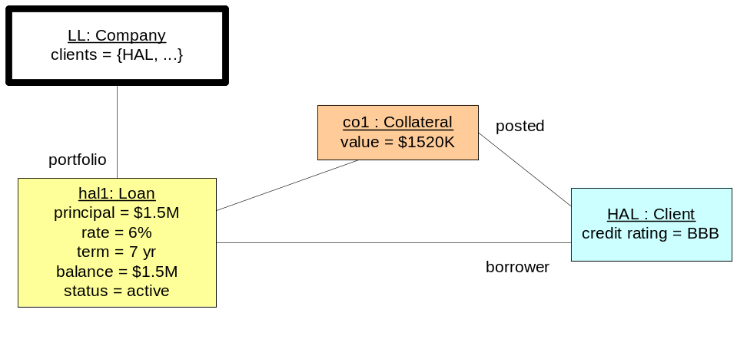
- HAL makes the first monthly repayment of $21, 912.83 on 3/4/2003.
- HAL makes the second monthly repayment of $21, 912.83 on 4/4/2003.
- HAL makes the third monthly repayment of $21, 912.83 on 5/4/2003…
- HAL makes the 84th monthly repayment of $21, 912.83 on 2/4/2009.
final state: HAL’s loan with LLC has a balance of $0, and is closed.
- after step 3 – hal1 has a principal of $1.5M, a rate of 6% and a term of 7 years, the balance
is $0 and status is “proposed”.
after step 7 – collateral of $1520K has a new link to hal1 and a new link to HAL, the balance
equals the principal at $1.5M, and status is “active”.
after step 91 – the full set of 84 repayments is in place and linked to hal1; the balance is
reduced to $0 and status is “closed”.
- possible exceptions
HAL’s credit rating is downgraded, resulting in a requirement for more collateral and/or adjustments to other loan parameters; e.g., interest rate, term.
HAL fails to make timely repayments, loan is foreclosed, and collateral is seized by LLC
Collateral asset value falls, resulting in need for posting of further collateral
HAL files for bankruptcy, increasing the risk that the loan will become a bad debt.

(b) Specify an Action
drawdown (ln: Loan)
precondition:
-- the loan has been designated as active by the lender
-- and the repayment scheduled has been established
ln.active and ln.repaymentSchedule → NotEmpty
postcondition:
-- the balance on the loan equals the principal (which remains unchanged)
ln.balance = ln.principal and ln.principal = ln.principal@pre

scheduleRepayments (ln: Loan, firstRepaymentDate : Date)
precondition:
-- Principal, rate and term have been agreed
ln.principal <> 0 and ln.rate <> 0 and ln.term <> 0
postcondition:
-- A set of monthly scheduled repayments amortizing the principal over the
-- term at the agreed rate is created with due-dates, and associated with the loan.
-- (Assume existence of necessary amortization and date functions.)
let amountDue be amortizedRepayment(ln.principal, ln.rate, ln.term) and
numRepayments be 12 * ln.term in
ln.repaymentSchedule→size == numRepayments and
ln.repaymentSchedule→forall(r | r.amountDue = amountDue) and
ln.repaymentSchedule→dueDate =
dateSequence(firstRepaymentDate, Month,
numRepayments)

makeRepayment (r: Repayment)
precondition: Loan has a balance
postcondition:
-- The repayment amount and date are filled in and the balance on the loan
-- is reduced by the amount determined by the amortization schedule.
-- Assume existence of a “principalRepaid” convenience attribute on
-- Repayment.
r.amount = r.amountDue and r.date = now and
r.loan.balance -= r.principalRepaid
-- Note that this post condition could have been simplified by defining an invariant
-- forcing the balance to be in line with the principal repaid by all repayments

5.1 Define Business Goals and Architecture
  - These concepts are mentioned in the goals/requirements, and so must be formalized. This can be done in the business information model that accompanies the goal model.
- The interest paid per loan to date can be formalized as a convenience attribute on Loan, by summing over the interest repaid on all the repayments made so far.
- Projected interest can be computed for a given future time period for a loan by summing over the interest element of the relevant scheduled repayments, perhaps present valued at some rate.
- Credit risk could be a (complex, future-valued) attribute on both Loan and Company.
- Repayment regularity could be an attribute on Client, determined by it’s repayment history. 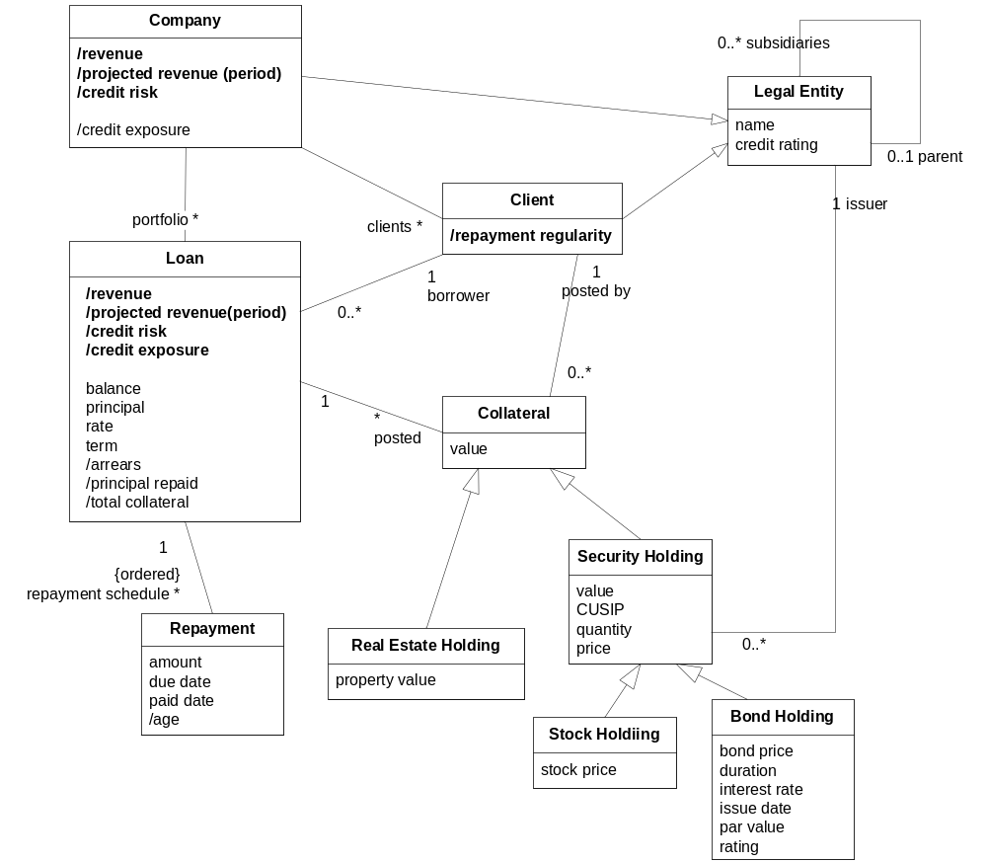
  - The top level goal may be stated in one of the following similar ways:
- Minimize credit risk while maximizing projected revenue;
- Maximize projected revenue/credit risk ratio (or some other function of revenue,risk)
- Minimize the credit risk/projected revenue ratio.
  - If we interpret “credit risk” as being specifically about the future (as opposed to being about the past, or even about our best guess about that future), then it cannot be objectively measured. While the credit exposure itself can be defined and objectively measured, the minima that might be achieved within any given future time frame cannot be predicted with certainty. Consequently, “minimize” and “maximize” goals are often called “soft goals”. Despite their “softness”, they have an important place in goal modeling. A reasonable way to refine into sub-goals would be:
    - Predict Credit Risk Based On Risk Prediction Model
    - Modify Controllable Credit Risk Parameters (collateral demanded, credit ratings, black-listed clients, etc.) To Limit Predicted Risk
    - Track Historical Performance of Risk Prediction Model
    - Improve Risk Prediction Model Over Time
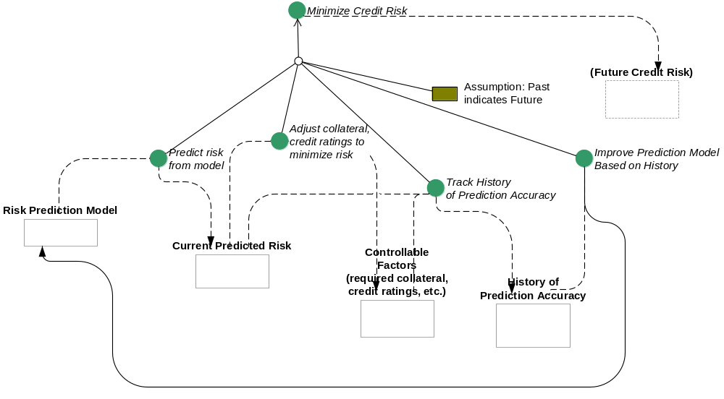
Events in the domain that we will have to react to in order to meet these subgoals “at all times”: changes in credit ratings (including due to parent/subsidiary structure), collateral value change, etc.
  - The lending activities and attributes will be fully defined once the Business Architecture (processes, roles, activities, information model) has been completed. Sometimes further detail is added in the Application Black Box Architecture (use cases and information model). Remember that models should be developed iteratively, and the activities that will be constrained from a risk perspective and the attributes cited in the constraints can be defined in a second pass over the Business and Application Black Box Architectures once both are somewhat stable.
  - The goal of optimizing lending activities is the higher level goal.
  - Answer #2 above offers a more precise statement of what might constitute optimization of lending activities: optimization of credit risk vs. projected revenue.
  - These could be reporting use cases to allow drilling up/down the loan, client and legal entity hierarchies looking at total credit exposure, revenue (actual and projected). Drill-down into collateral assets and values would also help. The use cases should support plugging in of different hypothetical values to drive results.
  - There is no magic bullet, and it may well be a true conflict. Making things clear makes it easier to recognize true conflicts, and to evaluate solutions to the conflict. The following process would yield a rational solution.
- Find out if there really is a conflict. What does “notify immediately” mean in quantitative terms?
- If more timely information truly is not available, assess the risk that would result from a less-than-immediate availability of information.
- Fashion a compromise. For example, provide daily reports that include notice of client credit downgrades, but also arrange to trigger extra reports intra-day if a downgrade occurs more than a certain amount of time earlier than end of day.
- Get explicit agreement from stakeholders to any such compromise, and document it with the original conflict within the goals model.
- Provide traceability back from use cases and information model to the conflict within the goals model so the rationale for the compromise functionality can be reviewed and validated.

5.2 Role Activity Diagram
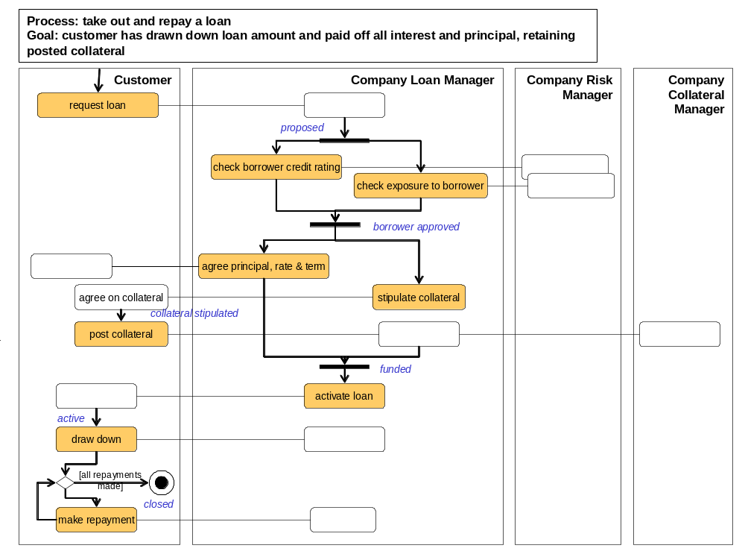Notes: the RAD above focuses on main flow, and makes some simplifying assumptions as follows.
- The full loan amount (principal) is always drawn down in a single operation.
- The case of late or absent repayments leading to foreclosure is not shown.
- Numerous other contingencies, such as variation in collateral value, loan interest rate changes, etc., have been omitted.
- This model does not deal with the lending of further amounts followed by further drawings and consequent adjustments in repayment schedule, except in the form of taking out an entirely new loan.
2. Activity Specifications
activity: post collateral
roles: Company, Client
inputs: loan: Loan, collateral: Collateral from Client
outputs: none
precondition: loan is proposed, and collateral amount has been stipulated by lender
postcondition: stipulated collateral has been posted against the loan, loan is funded

activity: draw down
roles: Company, Client
inputs: loan from Client – loan from which to draw down
outputs: cash: USD for Client
precondition: the loan is active.
postcondition: the balance equals the principal, which is unchanged from before

- Information Model
The types and attributes have business meaning and are not specific to a software system.

Client The party who borrows.
Collateral Assets belonging to the Client, which can be transferred in whole or in part to the Company in the event that a Loan is foreclosed.
Company The party who lends.
Legal Entity Any legally incorporated enterprise.
Loan The record of the funds advanced to the borrower and the history of repayment.
Repayment One of the scheduled transfers of funds from Client to Company to reduce outstanding balance and interest

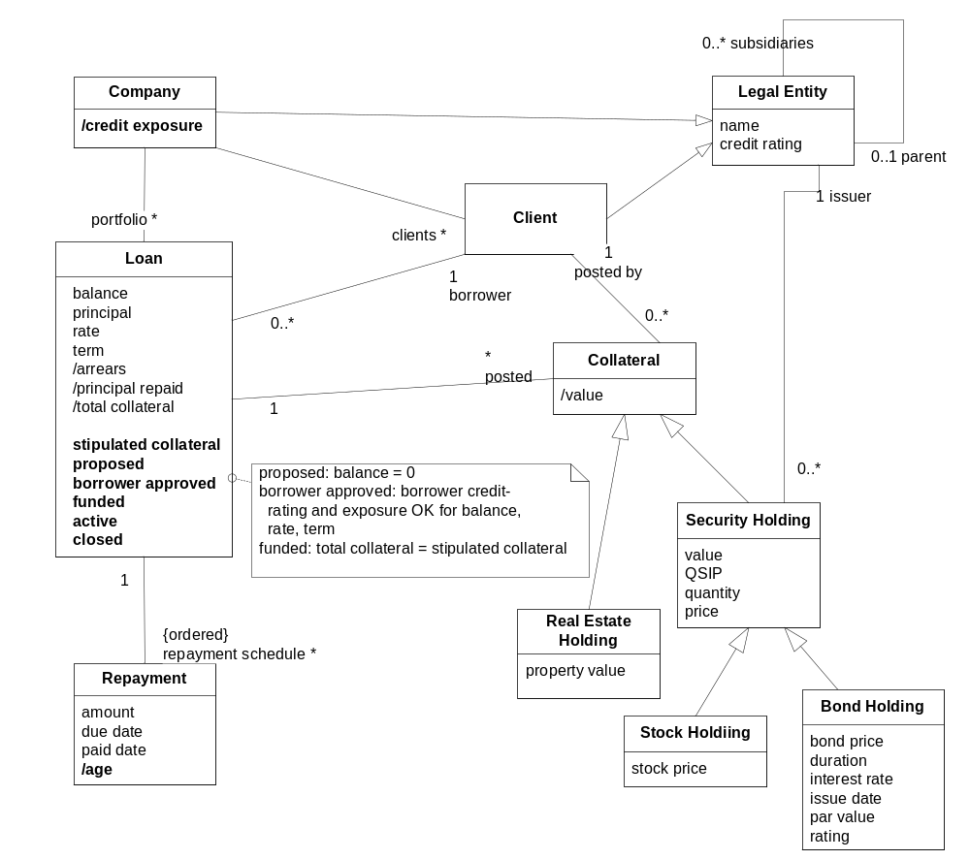.

5.3 Build a State Diagram & Definition Matrix
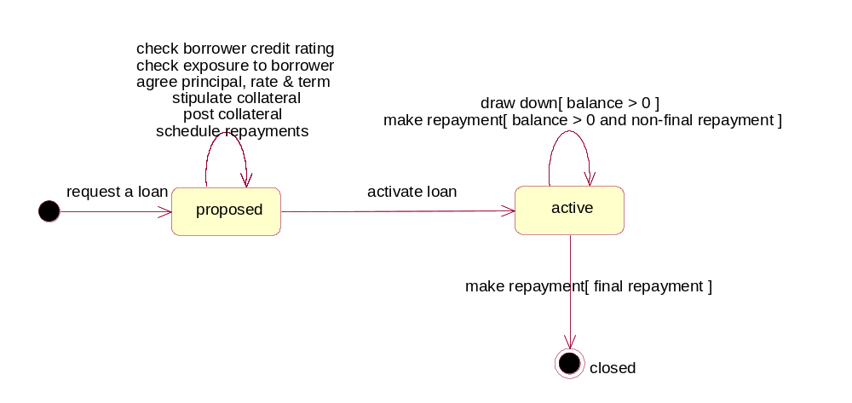
Note1: Since there are many activities that take place within state “proposed” it might be worth considering some interesting sub-states of that state e.g. borrower approved, funded, etc. This solution does not name and define those finer-grained states, but they would be straightforward.
Note2: This front-loaded complexity is typical of loans; there is a lot more work to do before a loan is activated than there is once funds are drawn down and repayments begin.

State | Definition
proposed | balance = 0 (no draw down made yet)  borrower approved: borrower rating & exposure OK for term, principal, rate  funded: total collateral = stipulated collateral
active | balance > 0 (draw down made and loan activated)
closed | balance = 0 and one or more repayments made

6.1 Mapped Black Box Assembly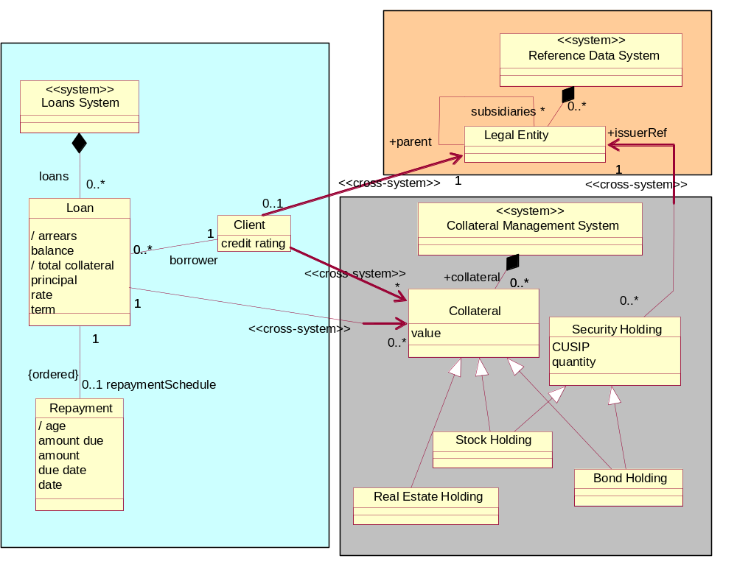

Notes:
- Some cross-system associations are necessary to relate different types, or differing views (projections) of the “same” types between systems, to ensure that they remain consistent.
- Examples given here are:
  - Loans and Reference Data occurrences of Legal Entity/Client to be kept in synch;
  - We might be able to dispense with LE and the parent-subsidiary relationship altogether in Loans and maintain only Client, synchronizing it directly with LE within Reference Data regularly; or maintain a cache for performance reasons.
  - Every Security Holding in Collateral Management to refer to an Issuer Legal Entity within Reference Data;
  - Collateral occurrences within Loans and Collateral Management to be kept in synch. (An alternative would have been to treat Collateral as being the responsibility entirely of Collateral Management.)

6.2 Use Cases

1) use case diagram
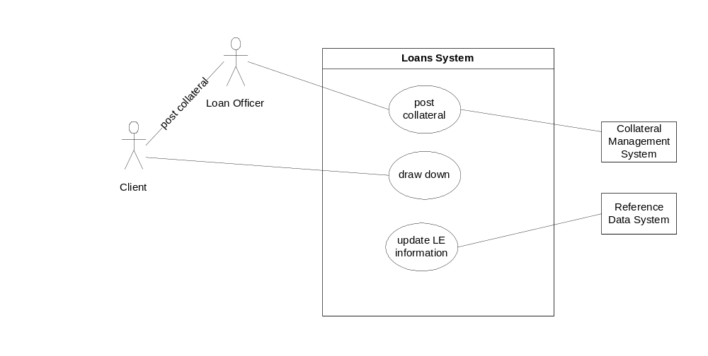

2) use case specifications

Use case: post collateral
Actors: Loan Officer, Loans System, Client, Collateral Management System
Inputs: Loan ID, Client ID, list of assets (obtained from Client) to be posted as collateral for Loan
Outputs: Confirmation of posting to Client via Loan Officer, Collateral record to CMS
Trigger: Client contacts LLC offering assets as collateral against loan
Precondition: Loan is “proposed”; Client offering collateral is borrower for Loan; collateral fulfils criteria for suitability.
Postcondition:
If the collateral offered is sufficient, the offered collateral extends the set of holdings already in use as collateral against loan (in the Collateral Management System) and the loan is funded. If collateral is insufficient, there is no change to the system.

Use case: draw down
Actors: Client, Loans System
Inputs: Loan, specified by Client
Outputs: Notice of balance [to Client], funds transfer to [Client? Missing Actor?…]
Trigger: Client initiates automated draw-down process
Precondition: Loan is “active” and balance is zero
Postcondition: Loan balance equals principal, which remains unchanged, and funds transfer has been initiated

Use case: update LE info
Actors: Loans System, Reference Data System
Inputs: Changes in reference data structure from Reference Data System.
Outputs: None.
Trigger: Daily synchronization schedule.
Precondition: true
Postcondition: Systems are synchronized such that
- every instance of Legal Entity in the Loans System has a corresponding instance in the Reference Data System.
- every instance of a parent/child link in one system has a corresponding link in the other system.

6.3 Describe Steps and Alternate Paths

Use case: post collateral
Actors: Loan Officer, Loans System, Client, Collateral Management System
Inputs: Loan, Client, list of assets (obtained from Client) to be posted as collateral for Loan
Outputs: Confirmation of posting to Client, Collateral posting to CMS
Trigger: Client contacts LLC offering assets as collateral against loan
Precondition: Loan is “proposed”; Client offering collateral is borrower for Loan; collateral fulfils general criteria for suitability.
Postcondition:
If the collateral offered is sufficient, the offered collateral extends the set of holdings already in use as collateral against loan (in the Collateral Management System) and the loan is funded. If collateral is insufficient, there is no change to the system.
Main (success) steps:
- Client sends collateral asset list to loan officer.
- Officer looks up loan in system to validate:
    - That it exists and has been proposed;
    - that client offering collateral is the client for the loan.
- System remembers loan number for use as input parameter on posting.
- For each item on the list of assets:
    - officer looks up value of asset in loan system;
    - loan system obtains asset valuation from collateral management system;
    - loan system adds value of asset to posting total.
- Officer checks that posting total is not less than total valuation claimed by client.
- Officer OKs posting of assets to the system.
- Loans system informs Collateral Management System that collateral has been posted.
- Loans System confirms posting.
Alternate paths:
1a: Collateral list fails general suitability criteria.
1a1. Officer contacts client and explains problem.
2a: Loan in incorrect state.
2a1. Officer attempts to diagnose how error arose.
2b: Client mismatched.
2a1. Officer attempts to diagnose how error arose.
4iia: Asset cannot immediately be valued (e.g., real estate, or system unavailable).
4iia1. Asset valuation request is put in queue in collateral management system.
4iia2. Use case suspended pending valuation.
4iia3. Collateral management system reports back when asset valued.
4iia4. Resume at 4iii.
5a: Collateral insufficient.
5a1. Officer saves entered data, and contacts client to explain problem.
5a2. Client offers further collateral.
5a3. Resume at 5.

6.4 Identify & Specify Use Case Operations
Use case: post collateral
Operations from steps
- ….
- Officer looks up loan in system to validate status and client
lookup loan (loan_id, client_id): Loan Record…
returns the loan record from the loan portfolio that matches loan_id, checking that the borrower has client_id
- ….
- For each item on the list of assets:
    - officer looks up value of asset in loan system;
asset_value (loan_id, asset_info): $
returns the value of the described assets
    - <<out>> loan system obtains asset valuation from collateral management system;
<<out>> asset_value (asset_info): $
    - ….
accumulate_asset_value (…)
adds the asset value to the collateral for the loan
- ….
- Officer OKs posting of assets to the system.
- <<out>> Loans system informs collateral management system that collateral has been posted.
<<event>> collateral_posted ( loan_id )
- ….

6.6 Black Box Ports and Assembly

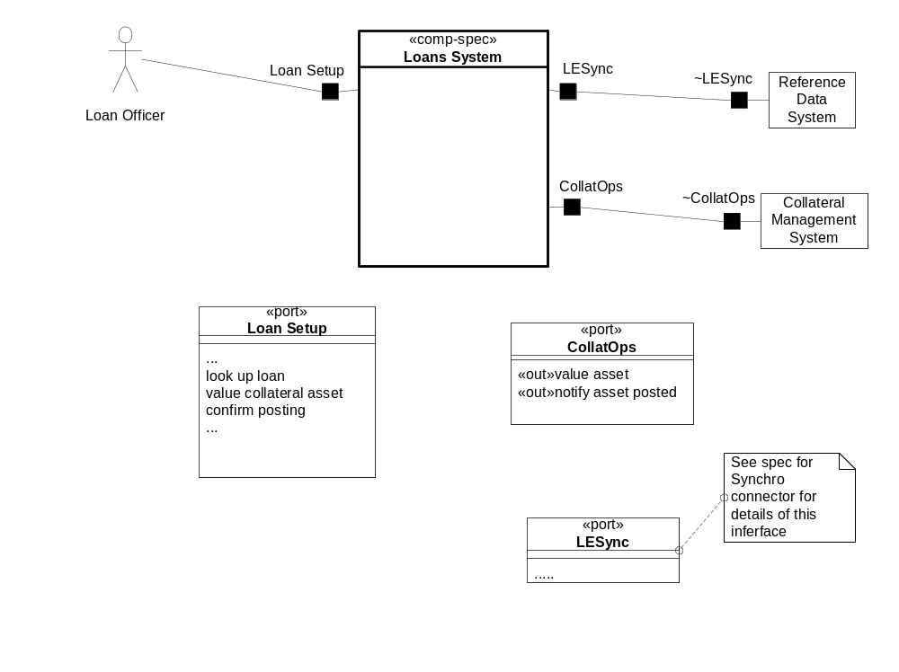

7.1 Draft Core Type & Use-Case Based Components

find core type components
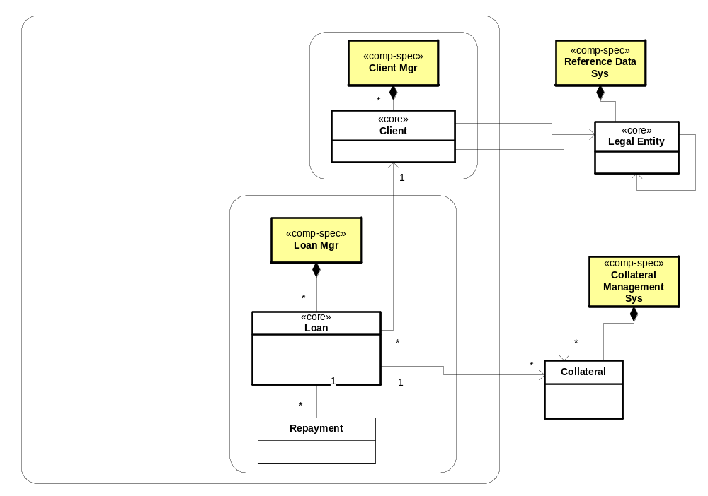

add use-case based components
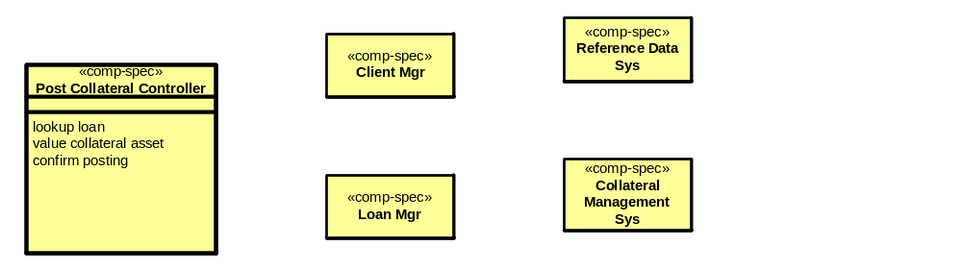

7.2 Design Collaborations across Sub-Components
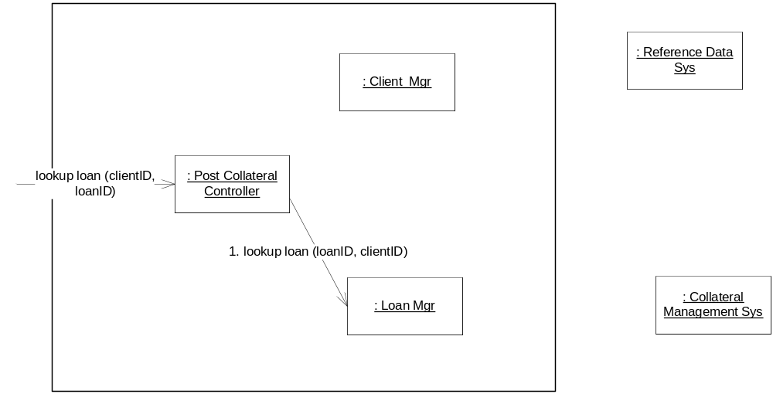

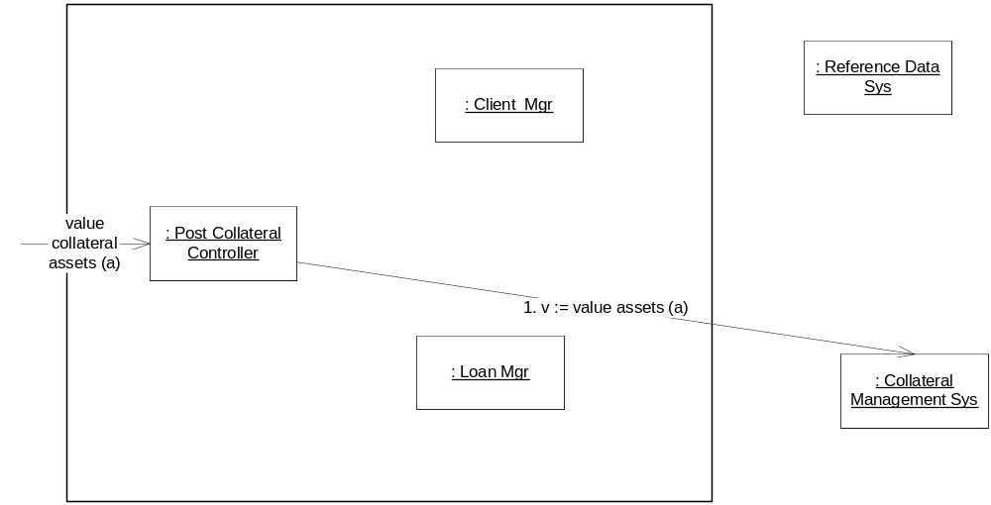

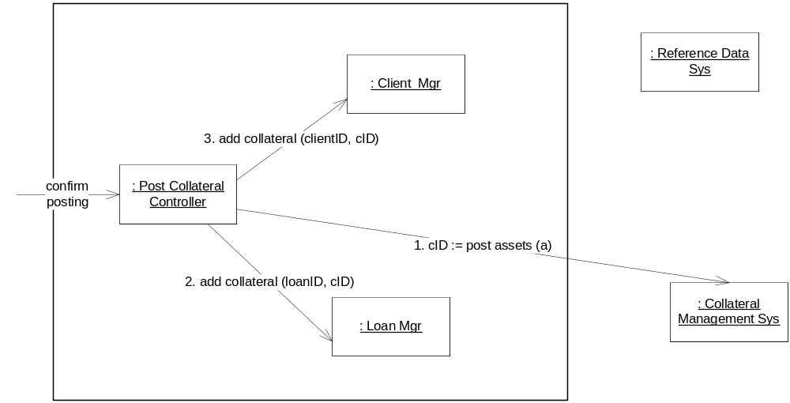

8.1 Apply a Pattern

package Loans_Manager;
interface payment_due_listener {
void notify_payment_due (T);
}
interface collateral_posted_listener {
void notify_collateral_posted (T2);
}

public class Loan_Events {
add_payment_due_listener ( payment_due_listener );
remove_payment_due_listener (payment_due_listener);
notify…
}

8.2 Extract a Pattern

