📘 Nxtfolio Documentation Guide

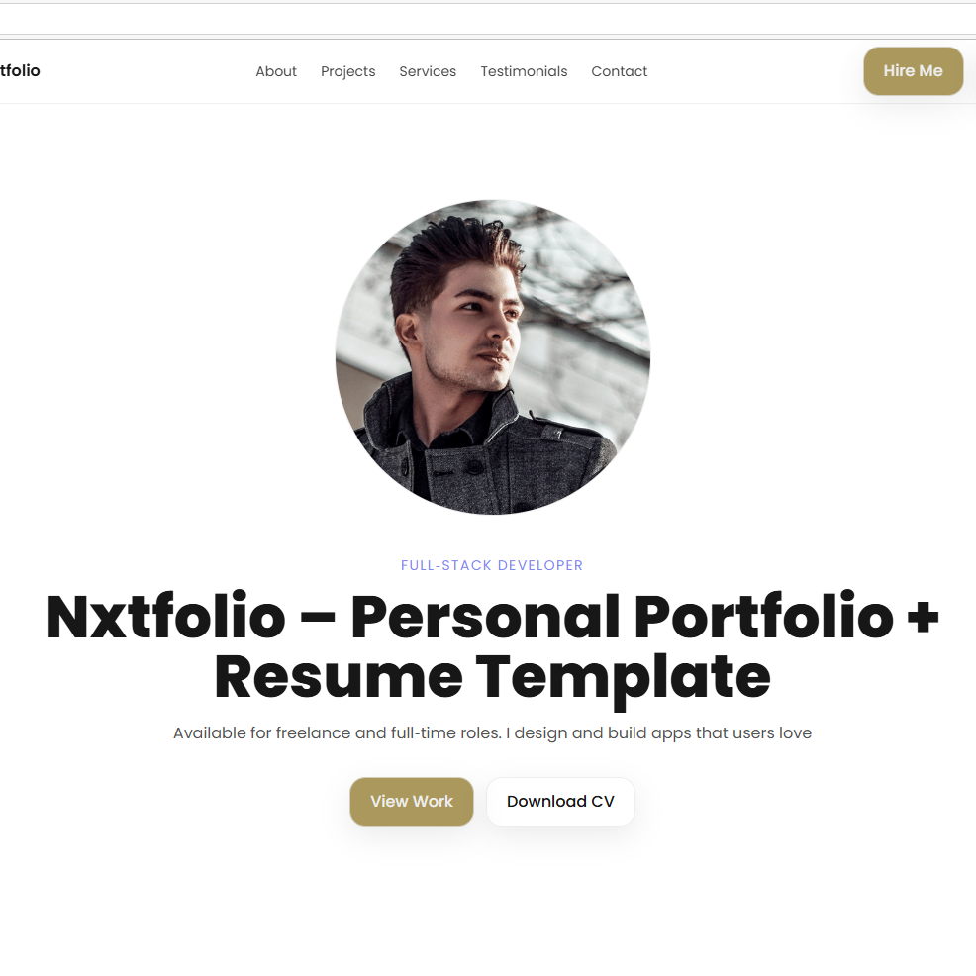A modern, customizable personal portfolio & resume template built with Next.js and Tailwind CSS.

**Demo Site: https://nxtfolio.vercel.app/**

🚀 Features

* Hero section with role, headline, and CTA
* About section with skills
* Portfolio/projects showcase
* Resume/CV download
* Services section
* Testimonials carousel or grid
* Contact form (with Mailgun integration)
* Footer with customizable variants
* Dark/light mode toggle
* Real-time LayoutSettings panel

# 🛠 Requirements

* Node.js v18+
* npm or yarn
* GitHub account (for deployment with Vercel)
* Vercel account

# 🎨 LayoutSettings Panel

1. Global Settings → update font style, brand color
2. Header → update site name, CTA label & link
3. Hero → toggle hide/show, update role, headline, tagline, upload profile/resume, choose layout variant
4. About → toggle, update title/subtitle, manage skills, choose layout variant
5. Projects → toggle, choose grid layout, manage project items
6. Services → toggle, choose grid layout, manage services with icons/images
7. Testimonials → toggle, choose variant, manage testimonials
8. Contact → toggle, update info, add location, socials, Mailgun settings
9. Footer → update text, choose layout variant, manage socials

# 💾 Saving Layouts

* All changes are saved in /config/layout.json
* This file controls the final look of your portfolio

**Deployment Guide (if you’ve already customized your layout in Demo site)**

* Extract the ZIP file (you purchased from the Gumroad).
* Copy the **layout.json** you downloaded from the demo site.
* Replace the file /config/layout.json in the extracted ZIP project you’ve purchased with your downloaded layout.json.
* Create a **GitHub account** → [https://github.com/signup](https://github.com/signup?utm_source=chatgpt.com)
* Create a **Vercel account** → https://vercel.com/ (sign up with GitHub).
* Import the project into Vercel.
* Add **environment variables** (Mailgun, etc.).
* Click **Deploy**.
* Your site will be live at https://yourname.vercel.app

✅ *Note: For first-time deployment, no coding is required — just upload & deploy.*

**🎨 Re-Customize the Layout Guide (Advanced Users)**

If you want to change the layout **after initial deployment**:

* Extract the ZIP file.
* Install dependencies:
* npm install
* Enable LayoutSettings panel locally: in .env set
* NEXT_PUBLIC_ENV=development
* Run locally:
* npm run dev
* Customize via LayoutSettings → Click **Save**.
* Replace the layout.json file in /config with the new downloaded layout.json
* Before deployment, disable the LayoutSettings panel by setting
* NEXT_PUBLIC_ENV=production
* Push to GitHub.
* Deploy again to Vercel → connect GitHub repo, add environment variables, click **Deploy**.

✅ *Note: Re-customization requires Node.js installed locally.*

# 📧 Mailgun Setup

* Sign up at mailgun.com
* Get your API key & domain
* Add to .env.local: MAILGUN_API_KEY, MAILGUN_DOMAIN, MAILGUN_FROM_EMAIL, MAILGUN_TO_EMAIL
* Deploy again → Contact form sends to your email

# ❓ Support

* For support or inquiries, contact: nxtasq@gmail.com