FindOut: A Reciprocal Recommender System for Peer Learning
Matching Students Who Want to Learn with Students Willing to Teach

[YOUR FULL NAME]
[YOUR STUDENT ID]

A dissertation submitted to the Department of Computer Science, University of Ghana, Legon, in partial fulfilment of the requirements for the award of the degree of
Bachelor of Science in Computer Science

Supervised by
[SUPERVISOR’S NAME]

July 2026

Declaration
I hereby declare that this dissertation is the result of my own original research and that no part of it has been presented for another degree in this university or elsewhere. All sources of information have been duly acknowledged.

Signature: …………………………………………. Date: …………………………
[YOUR FULL NAME] ([YOUR STUDENT ID])

I hereby certify that this dissertation was supervised in accordance with procedures laid down by the university.

Signature: …………………………………………. Date: …………………………
[SUPERVISOR’S NAME] (Supervisor)

Abstract
Students who need help with a subject and students able to provide that help exist within the same institution at the same time, yet have no reliable mechanism for finding one another. This is not a pedagogical problem — the capacity to resolve a given difficulty already exists within the student body — but a problem of visibility and matching. The peer learning literature establishes that peer tutoring is effective in higher education, with a reported meta-analytic effect size of g = 0.480 across twenty-seven studies, and that benefits accrue to the tutor as well as the tutee. That literature, however, consistently assumes pairings are arranged administratively and does not address how partners locate each other.
This dissertation presents the design, implementation and evaluation of FindOut, a web-based platform that addresses the matching problem directly. The system is characterised as a reciprocal recommender system applied to peer learning: a recommendation succeeds only when it satisfies both parties. Its distinguishing feature relative to prior educational reciprocal recommenders is that it matches on explicitly self-declared instructional intent rather than on competence inferred from platform activity or on demographic profile attributes. This produces useful matches from a user’s first session, addressing the continuous cold-start conditions of a student population, at the acknowledged cost of being unable to learn from outcomes.
The platform was built following Design Science Research. It combines a complementary-intent matching algorithm using four-tier fuzzy subject matching, assessment-gated per-subject competency verification as a history-independent trust mechanism, real-time messaging, and subject-scoped study groups with a three-level privacy model, within a single artefact — so that discovery, introduction and interaction are not separated across applications.
Evaluation combined unit testing, empirical scalability measurement and a user study. Unit testing of the matching component passed thirteen of fifteen cases and exposed a normalisation defect in which symbol-bearing subject names collapse to a single character. Scalability measurement confirmed the predicted linear complexity empirically at approximately 37 ms per 1,000 users, establishing that the current design is adequate to roughly 10,000 users and requires redesign beyond approximately 25,000.
Keywords: peer learning, reciprocal recommender systems, educational technology, student matching, competency verification, real-time collaboration

Acknowledgements
[Acknowledge your supervisor, department, participants in the evaluation, and anyone else who assisted. Replace this paragraph before submission.]

Table of Contents
Right-click and choose Update Field to build the table of contents.

List of Figures
Right-click and choose Update Field to build the list of figures.

List of Tables
Right-click and choose Update Field to build the list of tables.

Chapter One: Problem Identification

1.1 Background to the Study
Students help each other learn. This is not new. Long before computers, students formed study groups, explained topics to friends, and asked classmates for help before an examination.
Research shows this works well. Vygotsky (1978) explained why. He described what he called the Zone of Proximal Development. This is the gap between what a learner can do alone and what the same learner can do with help. His key point was simple but important: the helper does not have to be a teacher. Another student can also give this help. In fact, a student who passed the course last semester may explain it better than a professor. That student still remembers what was confusing.
The evidence supports this. Zhang et al. (2025) reviewed 27 separate studies of peer tutoring at university level. Peer tutoring means one student teaching another. They found a clear positive effect on academic performance. They also found that one-to-one help works better than group help.
There is a second benefit that is easy to miss. The student who teaches also learns. Roscoe and Chi (2007) studied this closely. When a student explains something, they must organise their own thinking. They notice gaps in what they know. They repair those gaps while explaining. So peer teaching helps both people, not just the one asking for help.
Topping (2005) reviewed twenty-five years of research on peer learning. He noted that researchers now consider the benefit to the helper to be as important as the benefit to the person being helped.
So peer learning is valuable. The theory supports it. The evidence supports it. And the resource needed for it already exists on every university campus.

1.1.1 The situation on a university campus
Think about any large university. In any subject, two kinds of students exist at the same time:
- Students who already understand the topic well.
- Students who are struggling with the same topic.
These students are often very close to each other. They may live in the same hall of residence. They may sit in the same lecture room. They may pass each other every day.
But they do not find each other.
The student who is struggling does not know who can help. The student who could help does not know anyone needs them. Both continue as before. One stays confused. The other never gets the chance to teach, and so misses the learning that teaching would have given them.
This is the situation that this project addresses.

1.1.2 Why this matters more in Ghana
This problem exists everywhere. But it is more serious in some places than others.
Public universities in Ghana face large class sizes. Research on Ghanaian higher education reports that large classes make it hard for lecturers to give attention to individual students (Yelkpieri et al., 2012). The same research reports that large classes delay feedback, reduce the number of exercises a lecturer can set, and leave little time for extra teaching for weaker students. Sector reports describe difficult staff-to-student ratios in popular programmes (World Education Services, 2019).
The conclusion is direct. When a lecturer cannot give individual attention, that attention must come from somewhere else. On a university campus, the only source large enough is the students themselves.
So in this context, peer learning is not a nice extra. It is necessary.
[Results to be inserted from the author’s own data collection.]

1.1.3 What students use today
Students already use technology to study together. In Ghana and across West Africa, WhatsApp is the main tool. Students use it for group discussion, sharing notes, and asking questions.
WhatsApp is very good at one thing: communication. Once you know who to talk to, it works well.
But WhatsApp cannot answer one question: who should I talk to?
You cannot search WhatsApp for a person who understands recursion. You cannot ask it to show you students who are willing to teach statistics. Membership in a WhatsApp group comes from being in the same class, or from someone adding you. So WhatsApp can only connect you to people you already know, or to people who happen to be in the same class as you.
This is the missing piece. Students have a way to talk. They do not have a way to find.

1.2 Statement of the Problem
The main problem this project addresses can be stated in one sentence:
Students who need help and students who are willing to give help exist in the same institution at the same time, but they have no reliable way to find each other.
It is important to be clear about what kind of problem this is. This is not a teaching problem. Nobody needs to invent a better way to explain calculus. The explanation already exists in another student’s head. The problem is that the two students never meet.
This is a matching problem and an information problem. The right people exist. The information about who they are is not visible to anyone.
The problem breaks into five smaller problems. Each one is addressed by this project.

Problem 1: Willingness to teach is invisible
A student may have finished Data Structures with a good grade. That student may be happy to explain it to someone else. But there is nowhere to say so.
No university system has a field for “I am available to help with this subject.” So this willingness stays hidden. The help exists but nobody can see it. Because nobody can see it, nobody asks for it.

Problem 2: Searching for help costs too much effort
A student who needs help must search manually. They ask friends. They post in a class group. They approach a classmate they barely know.
Each of these has a social cost. Asking for help in front of a whole class group can feel embarrassing. Approaching a stranger is uncomfortable. And the chance of success is low.
Worse, every student does this search separately, from the beginning, every time. Nothing is saved. Nothing is shared. The same effort is repeated across the whole campus.

Problem 3: Existing groups are organised by class, not by need
Class WhatsApp groups and departmental pages are organised around who is enrolled. Everyone taking CS 202 is in one group.
They are not organised around who knows what and who needs what.
This causes two failures. First, a question goes to 200 people, and most of them are just as confused as the person asking. Second, the question disappears within minutes as other messages arrive. There is no lasting structure that connects a specific need to a specific ability.

Problem 4: There is no way to check if someone really knows the subject
Suppose a student does find someone who claims to be able to teach a subject. How do they know it is true?
There is no signal that separates real knowledge from confidence. Economists call this information asymmetry. It means one person knows something the other cannot check.
The result is predictable. Learners do not want to waste time with someone unproven. So they do not ask. Willing teachers are approached less often. Fewer connections happen than should.

Problem 5: Even successful connections have no support
Sometimes two students do connect. What happens next?
Usually the relationship becomes an ordinary chat thread. Shared notes get lost in the message history. There is no space tied to the subject. There is no easy way for the pair to grow into a small group. And there is no record that the collaboration ever happened.
So even the successes are fragile.

1.3 Aim of the Study
The aim of this project is stated below.
To design, build and evaluate a web-based platform that makes students’ teaching ability and learning needs visible to each other, automatically suggests suitable partners and groups based on shared subjects, builds trust through competency checking, and provides the communication tools needed to keep those learning relationships going.

1.4 Objectives of the Study
The aim above is broken into six specific objectives. Each one can be checked. Each one connects to a part of the system that was built.
Objective 1. To design a user profile where a student clearly states two things: the subjects they care about, and whether they are ready to teach or ready to learn. This makes ability and need visible to the system. (Addresses Problem 1.)
Objective 2. To design and build a matching method that suggests partners with the opposite role on a shared subject. A learner should see teachers. A teacher should see learners. The suggestions should appear automatically, without the student having to search. (Addresses Problems 2 and 3.)
Objective 3. To build a competency check that gives a student a verification badge for a subject after they pass a test. This gives learners a reason to trust someone they have never met. (Addresses Problem 4.)
Objective 4. To build real-time messaging for both one-to-one chat and group chat, including online status and read receipts, so that a suggested match can become a real conversation without leaving the platform. (Addresses Problem 5.)
Objective 5. To build subject-based study groups with privacy controls, and a feed where students can share learning resources tagged by subject, so that collaboration continues beyond a single conversation. (Addresses Problem 5.)
Objective 6. To evaluate the platform with real students, measure how usable and useful they find it, and report the results honestly. (Addresses all problems.)

1.5 Research Questions
This study answers four questions.
RQ1. Do students find the suggested partners relevant when the system matches them by opposite role and shared subject?
RQ2. Does showing a verification badge make students more willing to contact a peer they do not know?
RQ3. Does combining finding and messaging in one platform reduce the effort students report compared with the methods they use now?
RQ4. How does the matching method perform as the number of users grows, and at what point would it need to be redesigned?

1.6 Scope and Delimitations of the Study

1.6.1 What the study covers
The system built in this project includes:
- User registration with email confirmation, and secure login.
- A profile with subjects, a teach-or-learn status, and free time.
- Automatic suggestions of matching students and matching study groups.
- A competency test that awards a verification badge for each subject.
- One-to-one and group messaging that updates in real time.
- Voice messages.
- Study groups with three privacy levels, invite links, and join requests.
- A feed where students post learning resources tagged by subject and type.
- Search across students and groups.
- An administration dashboard for managing users, posts and viewing statistics.

1.6.2 What the study does not cover
Some features were deliberately left out. The reasons are given below, because an examiner will ask.
Not included | Reason
Video and voice calls | This needs a large amount of extra technical work. It is not needed to test the main idea of the project. Students can move to another app for calls.
Mobile apps for Android and iOS | The website works well on phones. Building separate apps would not add new capability within the project time.
Payments and paid tutoring | This brings money, regulation and fraud concerns. These are separate from the research question.
Login using university accounts | This needs permission and access from the university IT department, which an undergraduate project cannot obtain.
Automatic content moderation | Administrators can remove content manually. Automatic moderation would need machine learning work beyond this project.
Official academic credit for badges | The badge shows peer-level ability only. It is not an academic qualification, and is not presented as one.

1.6.3 Delimitations
The evaluation was carried out with students from one institution, chosen by convenience rather than random selection. This means the findings show what these students experienced. They cannot be assumed to apply to all students everywhere.
Subjects are typed in as free text rather than chosen from an official course list. This makes the system flexible but means two students may write the same subject differently.

1.7 Significance of the Study
This study matters for three groups.
For students. The project delivers a working platform that students can use immediately. It reduces the effort of finding help. It also gives students who enjoy teaching a way to be found, which the research suggests will help their own learning too (Roscoe & Chi, 2007).
For research. The project builds and tests a reciprocal recommender system for peer learning. A reciprocal recommender is a system that must satisfy both people for the match to be a success, unlike a system that recommends a film to one person (Palomares et al., 2021). Existing work in this area matches students using data the system collects over time, or using profile details such as age and interests. This project instead uses a role that the student declares directly. Chapter 2 explains this difference in full and states exactly what is new here and what is not.
For institutions. The administration dashboard shows which subjects generate the most requests for help. A department could use this to decide where to place extra tutorials or teaching assistants. This is useful information that universities do not currently collect.

1.8 Limitations of the Study
Being honest about limitations is part of good research. The following limitations apply.
The platform needs enough users to work. Matching only produces results if there are people to match with. If very few students join, the system will show empty suggestions no matter how well it is built. This is the biggest risk to the project, and it is outside the developer’s control.
Students may not be honest. The system depends on students correctly stating their subjects and their willingness to teach. The competency test reduces this risk but does not remove it.
One student, limited time. The project was built by one developer within one academic year. This limited how many features could be completed and how thoroughly they could be tested.
No budget. Only free and open-source tools were used. This ruled out paid services that could have improved parts of the system.
Evaluation is short-term. The study measures whether students find the system usable and the suggestions relevant. It does not measure whether matched students actually improved their grades. That would require a much longer study.

1.9 Definition of Terms
These terms are used throughout this report.
Peer learning — Students learning from and with each other, rather than only from a lecturer.
Peer tutoring — One student teaching another student.
Intent (or status) — What a student has declared about their availability in the system: Ready To Teach, Ready To Learn, or Later.
Complementary matching — Matching a person to someone with the opposite role, rather than to someone similar. A learner is matched to a teacher.
Reciprocal recommender system — A system that suggests people to people, where the suggestion only succeeds if both people are satisfied with it.
Match score — A number the system calculates to show how suitable a suggested person or group is. A higher number means a better match.
Fuzzy matching — Comparing two pieces of text in a way that allows small differences. It lets the system treat “C++”, “cpp” and “c plus plus” as the same subject.
Verification badge — A mark shown on a profile after a student passes the competency test for a subject.
Cold start — A common problem in recommendation systems. The system cannot make good suggestions for a new user because it has no history about them yet.
Real-time — Updates that appear immediately, without the user refreshing the page.
Zone of Proximal Development (ZPD) — Vygotsky’s term for the gap between what a learner can do alone and what they can do with help from someone more capable.

1.10 Organisation of the Study
This report has five chapters.
Chapter One states the problem, the aim, the objectives, and the research questions. It explains why the problem matters and what the study does and does not cover.
Chapter Two reviews existing research and existing systems. It examines the evidence for peer learning, the research on matching people to people, and the systems students use today. It ends by stating exactly what gap this project fills.
Chapter Three explains the method. It covers how the system was designed, what technologies were chosen and why, how the matching method works, and how the system was built. It contains enough detail for another person to reproduce the work.
Chapter Four describes what was actually built. It covers the architecture, the main parts of the system, and the decisions made during development. It also reports what was completed and what was not.
Chapter Five presents the results. It reports the testing that was carried out, the results of the user evaluation, and a discussion of what the results mean. It also states the limitations found and suggests future work.

1.11 Chapter Summary
This chapter established the problem. Students who need help and students able to give it exist side by side in every university, but they cannot find each other. The problem is not about teaching methods. It is about visibility and matching.
Five specific failures were identified: willingness to teach is invisible; searching costs too much effort; existing groups are organised by class rather than by ability and need; competence cannot be checked, so trust does not form; and connections that do form have no lasting support.
The chapter then stated the aim of building a platform to solve these failures, broke that aim into six objectives, and set four research questions. It defined the scope, explained what was deliberately left out and why, and stated the limitations honestly.
Chapter Two now examines what researchers and existing systems have already done about this problem.

References
Full reference details for all sources cited in this chapter appear in the Chapter 2 reference list (§2.10). They are repeated here for convenience.
Palomares, I., Porcel, C., Pizzato, L., Guy, I., & Herrera-Viedma, E. (2021). Reciprocal recommender systems: Analysis of state-of-art literature, challenges and opportunities towards social recommendation. Information Fusion, 69, 103–127. https://doi.org/10.1016/j.inffus.2020.12.001
Roscoe, R. D., & Chi, M. T. H. (2007). Understanding tutor learning: Knowledge-building and knowledge-telling in peer tutors’ explanations and questions. Review of Educational Research, 77(4), 534–574. https://doi.org/10.3102/0034654307309920
Topping, K. J. (2005). Trends in peer learning. Educational Psychology, 25(6), 631–645. https://doi.org/10.1080/01443410500345172
Vygotsky, L. S. (1978). Mind in society: The development of higher psychological processes. Harvard University Press.
World Education Services. (2019). Education in Ghana. WENR. https://wenr.wes.org/2019/04/education-in-ghana
Yelkpieri, D., Namale, M., Esia-Donkoh, K., & Ofosu-Dwamena, E. (2012). Effects of large class size on effective teaching and learning at the Winneba campus of the UEW (University of Education, Winneba), Ghana. US-China Education Review, A(3), 319–332.
Zhang, C., Sun, N., Jiang, Y., Liu, H., & Huang, Q. (2025). The impact of peer tutoring programs on students’ academic performance in higher education: A meta-analysis. The Asia-Pacific Education Researcher, 34, 1495–1506. https://doi.org/10.1007/s40299-024-00960-0

Chapter Two: Literature Review

2.1 Introduction
This chapter reviews the body of knowledge relevant to the design of FindOut, a platform that matches students who wish to learn a subject with students willing to teach it. The review has four purposes: to establish that peer learning is a defensible intervention, to locate the matching problem within an existing computational literature, to examine how trust between unacquainted peers can be established, and to identify precisely what remains unaddressed by existing work.
The chapter is organised as follows. Section 2.2 examines the theoretical and empirical foundations of peer learning, establishing why connecting students to one another is worthwhile. Section 2.3 reframes the peer-matching problem as a computational one and reviews the recommender-systems literature that addresses it, with particular attention to reciprocal recommendation. Section 2.4 reviews mechanisms for establishing trust and verifying competence between strangers. Section 2.5 reviews systems currently available to students. Section 2.6 situates the problem in the Ghanaian higher education context. Section 2.7 presents a comparative analysis, and Section 2.8 states the research gap. Section 2.9 summarises the chapter.

2.1.1 Method of the review
Literature was identified through structured searches of Google Scholar, the ACM Digital Library, Springer Nature Link, ScienceDirect, ERIC, and arXiv. Search terms combined three clusters: learning terms (peer learning, peer tutoring, collaborative learning, study partner), computational terms (recommender system, reciprocal recommendation, social matching, group formation), and context terms (higher education, Ghana, MOOC). Sources were included where they were peer-reviewed, published in English, and addressed either the pedagogical basis of peer learning or the computational problem of matching people to people. Reviews and meta-analyses were preferred over individual empirical studies where both were available. Seminal works were included regardless of date; empirical work on systems was weighted toward the period 2015–2026 to reflect current practice.

2.2 Theoretical and Empirical Foundations of Peer Learning

2.2.1 The Zone of Proximal Development
The theoretical foundation for peer-assisted learning originates with Vygotsky’s (1978) concept of the Zone of Proximal Development (ZPD), defined as the distance between a learner’s independent problem-solving ability and the level attainable under guidance or in collaboration with more capable peers. Vygotsky’s formulation is significant for the present work in a specific respect: he explicitly identified peers, not only adults or experts, as capable of providing the scaffolding that moves a learner through the zone.
This carries a direct design implication. If effective assistance requires only a more capable other rather than an expert, then the pool of potential helpers within any institution is vastly larger than its teaching staff. A student who completed a course in the previous semester occupies an appropriate position relative to a student currently taking it. Indeed, the smaller cognitive distance may be advantageous: the recently-successful peer retains awareness of the specific difficulties involved, an awareness that expertise tends to erode. The theory thus justifies the fundamental premise of FindOut — that the capacity to resolve a student’s difficulty already exists within the student body and requires only identification.

2.2.2 Empirical evidence for peer tutoring
The theoretical case is supported by a substantial empirical literature. Bloom (1984) reported that students receiving one-to-one tutoring combined with mastery learning performed approximately two standard deviations above students in conventional classroom instruction — the result that became known as the “2 sigma problem,” so named because Bloom framed the challenge as finding group methods capable of approaching tutoring’s effectiveness. While the two-sigma figure derives from a small number of doctoral studies and has attracted methodological criticism, the broad direction of the finding — that individualised attention substantially outperforms undifferentiated group instruction — has proved durable.
More directly relevant to higher education, Zhang et al. (2025) conducted a meta-analysis of 27 independent experimental and quasi-experimental studies of peer tutoring programmes in tertiary settings, reporting a moderate positive overall effect size of g = 0.480 on academic performance. They further found significantly larger effects for individualised tutoring than for group-based arrangements. This is directly pertinent to FindOut’s design: the platform’s primary matching output is a one-to-one pairing, with groups offered as a secondary structure, and the meta-analytic evidence supports that ordering.
Topping (2005), reviewing developments in peer learning from 1981 to 2006, catalogued the principal forms — peer tutoring, cooperative learning, and peer assessment — and examined questions of implementation integrity and effectiveness. Topping’s review is notable for observing that the benefits accruing to the helper had by then come to be emphasised at least as strongly as those accruing to the helped, a shift with significant consequences for how a peer-learning platform should be designed.

2.2.3 The tutor effect and its implications for platform incentives
That observation is developed most rigorously by Roscoe and Chi (2007), who reviewed the mechanisms by which peer tutors themselves learn. They distinguish knowledge-telling, in which the tutor recites information, from knowledge-building, in which the tutor generates inferences, integrates ideas, and repairs their own understanding in the act of explaining. Their review finds that tutor learning gains are real but frequently modest, and that the magnitude depends heavily on which of these two behaviours predominates — reflective explanation and genuine question-answering produce learning, whereas summarising does not.
Chi’s (2009) ICAP framework provides a complementary account, ranking learning activities as Interactive > Constructive > Active > Passive, with interactive dialogue — precisely the mode of peer tutoring — occupying the highest tier.
Two design implications follow, and both shaped FindOut:
- Teaching must be framed as reciprocally beneficial, not altruistic. A platform depending on students volunteering to help others faces an obvious supply problem if teaching is presented as a favour. The tutor-learning literature supplies the counter-framing: the student who explains is also studying. In FindOut this is reflected in Ready To Teach being a first-class, badge-bearing identity rather than a request for volunteers.
- The supply side is the scarce resource. Because learners are more numerous than willing teachers, mechanisms that recruit and retain the teaching side — verification badges, reputation, visible status — warrant disproportionate design attention.

2.2.4 Situated learning and communities of practice
Beyond dyadic tutoring, Lave and Wenger (1991) and Wenger (1998) frame learning as participation in a community of practice rather than individual acquisition. Their concept of legitimate peripheral participation describes how newcomers begin at the community’s edge — observing, performing minor tasks — and move inward as competence and confidence develop.
This informs two elements of FindOut’s design. Subject-scoped study groups provide the community structure, while the public resource feed provides a peripheral participation route: a new or diffident user can observe discussion and contribute a small comment before committing to the higher-exposure act of requesting help from a stranger. The graduated group privacy model (public, private, secret) similarly permits a community to control its boundary as it matures.

2.2.5 Computer-supported collaborative learning
The field of Computer-Supported Collaborative Learning (CSCL) studies how technology mediates collaborative learning. Dillenbourg (1999) offers the field’s foundational analysis of what “collaborative learning” denotes, distinguishing the situation, the interactions, the mechanisms, and the effects. Stahl et al. (2006) provide a historical account of the field’s development.
A finding recurring throughout the CSCL literature is that group composition is a primary determinant of collaborative outcome. Poorly composed groups do not become effective through better tooling. This constitutes the strongest theoretical justification for the emphasis of the present project: engineering effort is directed at who is connected to whom rather than at elaborating the collaboration environment itself. FindOut treats group and pair formation as the intervention point, and this is a defensible allocation of effort on CSCL grounds.

2.2.6 Summary of Section 2.2
The literature establishes that peer learning is effective (g ≈ 0.48 in higher education), that it benefits helper and helped, that individualised arrangements outperform group arrangements, and that composition determines outcome. What the literature does not address is the logistical question this project confronts: by what mechanism do a suitable helper and a suitable learner locate one another? Peer tutoring studies almost universally assume an administratively assigned or instructor-arranged pairing. The matching itself is treated as a solved precondition. Section 2.3 turns to the literature that does address it.

2.3 The Peer-Matching Problem as a Computational Problem

2.3.1 From social matching to recommendation
Terveen and McDonald (2005) established the intellectual foundation for social matching systems — systems that recommend people to people rather than items to people. They characterise social matching as a four-stage process: modelling the set of users who may be matched, matching users in response to an explicit request or an implicit opportunity, introducing matched users, and enabling their subsequent interaction, whether in a space the system provides or through means the users choose themselves.
This four-stage model maps directly onto FindOut’s architecture and provides a useful framework for describing it: the profile (subjects, intent) is the user model; the suggestions endpoint performs matching; the suggestion card constitutes the introduction; and the integrated messaging subsystem provides the interaction space. That FindOut supplies all four stages internally — rather than handing users off to an external channel after introduction — is a point returned to in Section 2.8.
Terveen and McDonald also observe that social matching systems raise concerns absent from item recommendation: privacy, the social cost of rejection, and the fact that a recommendation constitutes a request for another person’s time and attention.

2.3.2 Reciprocal recommender systems
The general recommender-systems literature classifies approaches as content-based, collaborative filtering, or hybrid (Adomavicius & Tuzhilin, 2005; Ricci et al., 2011). However, a distinct subfield addresses the specific structure of the present problem.
Reciprocal recommender systems (RRS) are those in which a recommendation must satisfy both parties to be considered successful. Pizzato et al. (2010) introduced RECON, a reciprocal recommender for online dating, and formalised the reciprocal score — a measure combining how well candidate B satisfies A’s preferences with how well A satisfies B’s. Pizzato et al. (2013) extended this into a general account of reciprocal recommenders. Palomares et al. (2021) provide the field’s most comprehensive review, analysing the algorithms, fusion strategies and characteristics of RRS, and distinguishing those properties inherited from conventional user-to-item recommendation from those inherent to the reciprocal case.
The distinction from conventional recommendation is not cosmetic. When a system recommends a film, only the user’s satisfaction is at stake. When it recommends a person, a recommendation that delights one party and burdens the other is a failure. Palomares et al. (2021) identify typical RRS domains as online dating, employment matching, and mentor–mentee pairing.
FindOut is a reciprocal recommender system applied to peer learning. This is the correct technical characterisation of the artefact, and it should be stated as such in the methodology chapter. A recommendation is successful only when both the learner and the teacher find the match worthwhile — a Ready To Learn user matched to a Ready To Teach user on a shared subject is, in RRS terms, a reciprocally satisfying match by construction, because the two roles are complementary rather than competing.
It is important to note that most social matching and people-recommendation systems in wide deployment optimise for similarity — the “people you may know” pattern common to social networks recommends users resembling the requester. Peer tutoring requires the opposite structure: the ideal counterpart holds the inverse role while sharing the subject. This complementarity is what the RRS literature formalises.

2.3.3 Reciprocal recommendation in educational settings
Reciprocal recommendation has been applied to education, and this literature must be engaged with directly because it is the closest prior work to the present project.
Prabhakar et al. (2017) developed a reciprocal recommender for learners in Massive Open Online Courses, motivated by the observation that MOOC learners are often reluctant to approach one another — through shyness or through simply not knowing whom to approach. Their system matches learners who are mutually likely to communicate, using profile attributes including age, location, gender, qualification and interests, and was evaluated against the MITx–HarvardX dataset. They report that both attribute importance and reciprocity significantly affect recommendation rankings. Notably, their matching signal is demographic and interest-based profile similarity, not a declared instructional role.
Potts et al. (2018) introduced reciprocal peer recommendation within RiPPLE, an open-source course-level platform developed at the University of Queensland. Their work is motivated by reduced student contact time with teaching staff, and it recommends peers for study partnership and mentoring within a course. RiPPLE itself (Khosravi et al., 2019) is an adaptive, crowdsourced platform that maintains a repository of student-authored tagged multiple-choice questions, approximates each student’s knowledge state from their responses, and recommends personalised learning activities via collaborative filtering. It was evaluated in an introductory course with 453 students, with results suggesting measurable learning gains and positive student perception. Critically, RiPPLE derives a student’s competence — and therefore their suitability as a mentor — from system-inferred knowledge state based on platform activity history, and operates embedded within a single course via LTI integration with an institutional LMS.
The existence of this work materially affects the novelty claim available to the present project, and Section 2.8 restates that claim accordingly.

2.3.4 Group formation in collaborative learning
A parallel literature addresses the formation of groups rather than pairs. Maqtary et al. (2019) conducted a systematic literature review of group formation techniques in CSCL, analysing 30 studies, and concluded that group formation is influenced by member characteristics, grouping context, and the technique applied. Approaches in this literature include genetic algorithms, entropy-minimisation methods for maximising heterogeneity, and personality-based grouping using the Five Factor model.
Two observations from this literature bear on FindOut. First, the dominant objective in automated group formation is heterogeneity — deliberately mixing knowledge levels so that stronger students can assist weaker ones within each group. This is the group-level analogue of complementary matching and provides independent support for FindOut’s approach. Second, these techniques generally presuppose a closed, known cohort — a class roster with known attributes to be partitioned. FindOut operates on an open, continuously changing population in which users join and depart independently and no roster exists, which renders partition-based algorithms inapplicable and favours the ranking-based approach adopted.

2.3.5 The cold-start problem and the case for content-based matching
Collaborative filtering, the dominant recommendation paradigm, infers preference from historical interaction patterns and consequently suffers the well-documented cold-start problem: it cannot generate useful recommendations for users or items lacking interaction history (Adomavicius & Tuzhilin, 2005; Ricci et al., 2011).
This constraint is decisive in the present context, and the reasoning should be reproduced in the methodology chapter as justification for the approach taken. A student peer-matching platform experiences continuous cold start: each academic year introduces an entire cohort with no history, and — more fundamentally — every student’s subject needs change each semester, so even established users present a substantially new profile at regular intervals. History-dependent methods are structurally disadvantaged in this setting.
A content-based approach operating on explicitly declared attributes (subjects and intent) is effective from a user’s first session, requires no interaction history, and possesses a second advantage that the recommender literature increasingly emphasises: explainability. The system can state that a match was made because both users listed a given subject. This matters disproportionately for people-recommendation, where the recommendation asks the user to expend social effort on a stranger, and where an unexplained suggestion is more easily dismissed.
The trade-off is equally clear and must be acknowledged: content-based matching on self-declared attributes is only as accurate as the declarations, and it cannot learn from outcomes. Section 2.8 and the Future Work chapter address this.

2.3.6 Approximate string matching
Where subjects are entered as free text rather than selected from a controlled vocabulary, the matching function must tolerate variation in case, punctuation, spacing and spelling — recognising Data Structures, data-structures and DataStructures as equivalent. The standard measure of string similarity is the edit distance introduced by Levenshtein (1966), defined as the minimum number of single-character insertions, deletions or substitutions required to transform one string into another, and computed by dynamic programming.
The design decision facing any such system is where to set the similarity threshold, and this is fundamentally a question of the relative cost of the two error types. In peer matching the costs are asymmetric: a false negative denies a student an opportunity they never learn existed, while a false positive costs only a dismissed suggestion. This asymmetry justifies favouring recall over precision, a position adopted in the present design and revisited critically in Chapter 5.

2.4 Trust, Verification and Credentialing

2.4.1 Information asymmetry between unacquainted peers
Even where a suitable peer is identified, the interaction requires trust. The learner cannot readily distinguish genuine competence from confident self-assessment — a classic information asymmetry. The consequence is a thin market: learners hesitate to invest time with an unproven tutor, willing tutors are approached less often, and participation on both sides declines.
Kollock (1999) analyses cooperation in online settings and the free-rider problem that arises where contribution is voluntary and unrewarded. The concern applies directly to a platform depending on students volunteering their time.

2.4.2 Reputation systems
The standard remedy is a reputation system. Resnick and Zeckhauser (2002) analysed eBay’s feedback mechanism, demonstrating that reputation information supports transactions between parties with no prior relationship. Jøsang et al. (2007) survey trust and reputation systems for online service provision, classifying the computational models available.
Reputation systems, however, possess a cold-start problem of their own that is frequently overlooked: they require accumulated interaction volume before their signal becomes informative. A newly launched platform has no ratings, and the first users therefore receive no benefit from the mechanism at precisely the moment when trust is most needed. This is the reasoning behind FindOut’s decision to implement competency verification — an assessment-gated badge that can be earned immediately, independent of interaction history — as the primary trust mechanism, with reputation retained as a secondary, longer-horizon signal.

2.4.3 Digital badges and micro-credentials
Digital badges and micro-credentials constitute a substantial contemporary literature. The consensus positions badges as modular, competency-based recognition operating outside traditional credential structures. Research indicates that badges can function as extrinsic motivators capable of transitioning into intrinsic engagement, and that a badge’s value derives significantly from the specificity with which it describes the competence attained — transparency enhances credibility. Reviews also note concerns: that proliferating micro-credentials may dilute the value of formal qualifications, and that the evidence base remains largely cross-sectional and descriptive, with limited longitudinal or causal evidence for long-term effects.
For the present project the relevant implications are that a badge must (a) name a specific competence rather than a general status, and (b) be perceived as non-trivially earned. FindOut’s per-subject verification badge, gated at a 70% assessment threshold with a limited number of attempts, is designed against both criteria. The badge is explicitly not presented as an academic credential, which distinguishes it from the micro-credential literature’s primary concern and avoids the dilution objection.

2.4.4 Automated question generation
FindOut’s verification mechanism requires assessment items for arbitrary, user-supplied subjects — a requirement that cannot be met by a manually authored question bank at any realistic scale. Automated question generation using large language models is an active research area. Recent work evaluates the capacity of LLMs to generate questions at differing cognitive levels of Bloom’s taxonomy, employing both expert and model-based evaluation of linguistic and pedagogical quality (Scaria et al., 2024). Evaluation frameworks in this area assess dimensions including knowledge- point alignment, item quality, and the quality of solution explanations.
The reported findings are relevant to the design decision taken in this project: LLMs can generate relevant, pedagogically appropriate questions when supplied with adequate context, but performance varies substantially between models, and quality assurance remains an open problem. Because generated assessment items in the present system would gate a trust signal, the reliability question is not incidental. Chapter 4 reports the implementation status of this component accurately, including the fact that the deployed build uses a deterministic template bank rather than model-generated items, and Chapter 5 discusses the consequence for the strength of the verification signal.

2.5 Review of Existing Systems
This section reviews the systems currently available to a student seeking a study partner, organised by category and assessed against the requirements established above.

2.5.1 Learning management systems
Moodle, Google Classroom and Blackboard organise course content, assessment and enrolment. Peer interaction, where supported, occurs in instructor-created forums structured by class membership. No LMS in common use provides a mechanism by which a student declares availability to teach a specific topic, nor any means of querying the student body by capability. LMS structure reflects the administrative organisation of the institution, not the distribution of knowledge and need within it.

2.5.2 Question-and-answer platforms
Brainly, Chegg Study, Stack Overflow and Quora optimise a different unit of value: a question receiving an answer. The transaction, not the relationship, is the object. There is no persistent partner, no continuity across sessions, and typically no locality — the answering party is anonymous and geographically arbitrary. Stack Overflow’s reputation system is instructive and partially informs the present design, but the platform is oriented toward building a public knowledge artefact rather than a learning relationship. Chegg additionally places access behind a subscription, which is a material barrier in the target context.

2.5.3 Messaging platforms — the de facto baseline
General messaging platforms (WhatsApp, Telegram, Discord, Slack) constitute the honest baseline against which FindOut must be compared, because they are what students actually use. Research on West African higher education indicates WhatsApp is heavily used for study-related group discussion and content sharing, and is regarded as a primary teaching and learning tool by both students and lecturers in the region.
These platforms provide excellent communication and no discovery whatsoever. A WhatsApp group cannot be queried for members competent in a given topic. Membership derives from enrolment or personal invitation, so the platform is structurally incapable of connecting students who do not already know each other. A request for help is broadcast to the entire group — most of whom share the asker’s difficulty — and is displaced by unrelated traffic within minutes.
Discord’s topic-organised servers approach the required structure more closely, but organise by topic channel rather than by per-user declared capability, so the identification problem persists.

2.5.4 Research platforms for peer learning
As reviewed in Section 2.3.3, RiPPLE (Khosravi et al., 2019; Potts et al., 2018) and the MOOC reciprocal recommender of Prabhakar et al. (2017) represent the closest prior work. Both perform peer recommendation in an educational context. Their characteristics relevant to comparison are:
Property | RiPPLE (Potts et al., 2018) | MOOC RRS (Prabhakar et al., 2017)
Matching signal | System-inferred knowledge state from platform question-answering history | Demographic and interest profile attributes (age, location, gender, qualification, interests)
Role declaration | Derived by the system | Not role-based
Deployment model | Embedded in a course via LTI/LMS integration | Within a MOOC platform
Scope | Single course | Single MOOC cohort
Cold start | Requires accumulated response history | Requires populated profile attributes
Integrated messaging | Not the platform’s focus | Not the platform’s focus
Competency verification | Inferred, not assessed as a trust signal | None
Availability | Open-source research platform, institution-deployed | Research prototype

2.5.5 Co-working and accountability platforms
StudyStream and Focusmate match students for synchronised co-working sessions. The match is deliberately not subject-based: the mechanism targets accountability and focus through mutual presence, not knowledge transfer. They are included here to delimit the problem — they demonstrate demand for peer connection among students while addressing an orthogonal need.

2.5.6 Professional and mentorship networks
LinkedIn and dedicated mentorship platforms implement genuine complementary matching (mentor ↔ mentee) and thereby validate the general pattern. They target career mentorship over long horizons with formal professional profiles, rather than same-campus, same-semester, course-level academic assistance. The temporal granularity and the profile model both differ fundamentally from the present requirement.

2.6 The Ghanaian Higher Education Context
The problem this project addresses is general, but its severity is context-dependent, and the Ghanaian tertiary context intensifies it in three specific ways.
Staff-to-student ratios constrain individual attention. Large class size is documented as a significant challenge confronting public universities in Ghana. Research on Ghanaian higher education reports that large classes hinder individual attention to weaker students, make assessment difficult, delay feedback, reduce the number of exercises lecturers can set, and leave insufficient time for remedial teaching (Yelkpieri et al., 2012). Sector reporting indicates teacher-to-student ratios in popular disciplines reaching substantially adverse levels (World Education Services, 2019).
The connection to the present work is direct. Where an instructor cannot provide individual attention, the ZPD-appropriate assistance identified in Section 2.2.1 must come from elsewhere, and the student body is the only remaining source of sufficient scale. Peer learning in this context is not an enrichment activity but a structural necessity.
Existing digital practice is communication-rich and discovery-poor. As noted in Section 2.5.3, WhatsApp is deeply embedded in Ghanaian student study practice. This is significant for two reasons: it establishes that the target population is already comfortable with the interaction model FindOut employs, reducing adoption friction; and it identifies precisely the missing capability — discovery — that the existing tool cannot supply.
Cost sensitivity excludes subscription alternatives. Paid platforms such as Chegg are not a realistic option for the majority of the target population, which reinforces the requirement that the solution be free at point of use.

2.7 Comparative Analysis
Table 2.1 compares reviewed systems against the capabilities required to address the problem identified in Chapter 1.
Table 2.1
Comparison of Existing Systems Against Required Capabilities
System / category | Declared teach–learn intent | Subject-level matching | Competency verification | Integrated real-time messaging | Persistent subject groups | Cross-course scope | Free at point of use
LMS (Moodle, Classroom) | ✗ | ✗ (enrolment-based) | ✗ | Partial (forums) | ✓ (by class) | ✗ | ✓
Brainly / Chegg | ✗ | ✓ (per question) | Partial (Chegg experts) | ✗ | ✗ | ✓ | ✗ / Partial
Stack Overflow | ✗ | ✓ (tags) | Partial (reputation) | ✗ | ✗ | ✓ | ✓
WhatsApp / Discord | ✗ | ✗ | ✗ | ✓ | ✓ (not subject-derived) | ✓ | ✓
StudyStream / Focusmate | ✗ | ✗ (by design) | ✗ | ✓ | ✗ | ✓ | Partial
RiPPLE (Potts et al., 2018) | ✗ (inferred) | ✓ (within course) | Inferred, not assessed | ✗ | Partial | ✗ (single course) | ✓ (institution-deployed)
MOOC RRS (Prabhakar et al., 2017) | ✗ | Partial (interests) | ✗ | ✗ | ✗ | ✗ (single MOOC) | Research prototype
Mentorship networks | ✓ (career) | ✗ (not academic subjects) | Partial (endorsements) | ✓ | ✗ | ✓ | Partial
FindOut (this project) | ✓ (self-declared) | ✓ (fuzzy, free-text) | ✓ (assessment-gated badge) | ✓ | ✓ (subject-scoped) | ✓ | ✓
Note. ✓ = capability present; ✗ = absent; Partial = present in limited form.

2.8 Research Gap

2.8.1 Correction to the initially stated gap
An earlier formulation of this project’s contribution held that no existing system performs complementary teach–learn matching for peer learning. The literature reviewed in Section 2.3.3 does not support that claim, and it is withdrawn. Reciprocal recommendation for learning is an established research area: Potts et al. (2018) implemented reciprocal peer recommendation in RiPPLE, and Prabhakar et al. (2017) built a reciprocal recommender for MOOC learners. Any claim of novelty must be stated relative to that work.
This correction strengthens rather than weakens the project. It situates FindOut within a recognised research tradition — reciprocal recommender systems (Palomares et al., 2021) — which provides established terminology, evaluation practice and comparators, and it demonstrates engagement with the current literature. A narrower, accurate claim is defensible in examination; an overstated one is not.

2.8.2 The gap as accurately stated
Synthesising Sections 2.2 through 2.7, four specific deficiencies remain unaddressed:
Gap 1 — Matching signals depend on data the system must first accumulate. Existing educational reciprocal recommenders infer suitability from platform interaction history (RiPPLE) or from demographic and interest attributes (MOOC RRS). Neither uses an explicitly self-declared, user-controlled instructional role as the primary matching signal. The distinction has practical consequences: a declared-intent model produces useful matches from a user’s first session, requires no institutional data, and lets the user control their own availability directly. Its costs — dependence on honest declaration, and inability to learn from outcomes — are real and are addressed in this project through competency verification and identified as future work respectively.
Gap 2 — Existing systems are bounded by a course or cohort. RiPPLE operates within a course via LMS integration; the MOOC recommender within a single MOOC. Neither addresses a student who needs help in one subject while able to teach another in a different course, nor a student seeking help outside any enrolled course. A standalone, institution-agnostic platform spanning all of a student’s subjects simultaneously occupies a different design point.
Gap 3 — Matching is separated from the interaction it is supposed to enable. In Terveen and McDonald’s (2005) four-stage model, existing educational recommenders address modelling, matching and introduction, then hand users off to some external channel for interaction. Where that channel is a general messaging platform, the platform providing discovery loses all visibility of outcome, and the user bears the friction of a context switch at exactly the moment when initiating contact is most socially costly. Integrating all four stages — as FindOut does — is a design position that the literature discusses but that deployed educational systems have not generally taken.
Gap 4 — Trust mechanisms require accumulated history. Reputation systems (Jøsang et al., 2007; Resnick & Zeckhauser, 2002) and inferred-competence models (Khosravi et al., 2019) both require interaction volume before yielding an informative signal, leaving early users unserved. An assessment-gated, per-subject competency badge earnable immediately and independently of history addresses the trust problem at platform launch, when it is most acute.
Additionally, no reviewed system addresses these requirements for the sub-Saharan African tertiary context characterised in Section 2.6, where LMS penetration is limited, staff-student ratios are adverse, general messaging platforms dominate student practice, and subscription services are not affordable.

2.8.3 Statement of contribution
This project contributes the design, implementation and evaluation of a standalone, institution-agnostic reciprocal recommender system for peer learning that uses explicitly self-declared instructional intent combined with fuzzy free-text subject matching as its primary matching signal, integrates all four stages of the social matching process (Terveen & McDonald, 2005) within a single artefact, and employs assessment-gated per-subject competency verification as a history-independent trust mechanism.
Each element of this claim is verifiable against the implemented system, and each is positioned relative to identified prior work rather than asserted as unprecedented.

2.9 Chapter Summary
This chapter established the pedagogical and computational foundations for the present project.
Section 2.2 demonstrated that peer learning rests on sound theory (Vygotsky’s ZPD) and substantial empirical evidence, with a meta-analytic effect size of g = 0.480 in higher education (Zhang et al., 2025), that benefits accrue to helper as well as helped (Roscoe & Chi, 2007; Topping, 2005), and that group composition determines collaborative outcome — justifying this project’s focus on matching rather than on collaboration tooling. Critically, that literature assumes pairings are administratively arranged and does not address how partners locate one another.
Section 2.3 located that unaddressed question within the reciprocal recommender systems literature (Palomares et al., 2021; Pizzato et al., 2010; Terveen & McDonald, 2005), establishing that FindOut is properly characterised as an RRS applied to peer learning, and reviewed the two closest prior applications in education (Potts et al., 2018; Prabhakar et al., 2017). It further justified content-based over collaborative-filtering matching by reference to the continuous cold-start conditions of a student population.
Section 2.4 examined trust formation between unacquainted peers, establishing that conventional reputation systems possess their own cold-start limitation and motivating assessment-gated verification as the alternative.
Sections 2.5 to 2.7 reviewed available systems, showing that communication-capable platforms lack discovery while discovery-capable research platforms are course-bounded and communication-poor.
Section 2.8 corrected an overstated novelty claim and restated the contribution accurately as four specific gaps relative to identified prior work.
Chapter 3 presents the methodology by which these requirements were translated into a working system.

2.10 References
APA 7th edition. Verification key: [V] = bibliographic record retrieved and confirmed during this review; [C] = canonical work cited from established scholarship — confirm the record in your library catalogue before submission.
Adomavicius, G., & Tuzhilin, A. (2005). Toward the next generation of recommender systems: A survey of the state-of-the-art and possible extensions. IEEE Transactions on Knowledge and Data Engineering, 17(6), 734–749. [C]
Bloom, B. S. (1984). The 2 sigma problem: The search for methods of group instruction as effective as one-to-one tutoring. Educational Researcher, 13(6), 4–16. https://doi.org/10.3102/0013189X013006004 [V]
Boud, D., Cohen, R., & Sampson, J. (Eds.). (2001). Peer learning in higher education: Learning from and with each other. Kogan Page. [C]
Chi, M. T. H. (2009). Active–constructive–interactive: A conceptual framework for differentiating learning activities. Topics in Cognitive Science, 1(1), 73–105. [C]
Dillenbourg, P. (1999). What do you mean by collaborative learning? In P. Dillenbourg (Ed.), Collaborative learning: Cognitive and computational approaches (pp. 1–19). Elsevier. [C]
Jøsang, A., Ismail, R., & Boyd, C. (2007). A survey of trust and reputation systems for online service provision. Decision Support Systems, 43(2), 618–644. [C]
Khosravi, H., Kitto, K., & Williams, J. J. (2019). RiPPLE: A crowdsourced adaptive platform for recommendation of learning activities. Journal of Learning Analytics, 6(3), 91–105. [V]
Kollock, P. (1999). The economies of online cooperation: Gifts and public goods in cyberspace. In M. A. Smith & P. Kollock (Eds.), Communities in cyberspace (pp. 220–239). Routledge. [C]
Lave, J., & Wenger, E. (1991). Situated learning: Legitimate peripheral participation. Cambridge University Press. [C]
Levenshtein, V. I. (1966). Binary codes capable of correcting deletions, insertions, and reversals. Soviet Physics Doklady, 10(8), 707–710. [C]
Maqtary, N., Mohsen, A., & Bechkoum, K. (2019). Group formation techniques in computer-supported collaborative learning: A systematic literature review. Technology, Knowledge and Learning, 24(2), 169–190. https://doi.org/10.1007/s10758-017-9332-1 [V]
Palomares, I., Porcel, C., Pizzato, L., Guy, I., & Herrera-Viedma, E. (2021). Reciprocal recommender systems: Analysis of state-of-art literature, challenges and opportunities towards social recommendation. Information Fusion, 69, 103–127. https://doi.org/10.1016/j.inffus.2020.12.001 [V]
Pizzato, L., Rej, T., Chung, T., Koprinska, I., & Kay, J. (2010). RECON: A reciprocal recommender for online dating. In Proceedings of the Fourth ACM Conference on Recommender Systems (RecSys ’10) (pp. 207–214). ACM. https://doi.org/10.1145/1864708.1864747 [V]
Pizzato, L., Rej, T., Akehurst, J., Koprinska, I., Yacef, K., & Kay, J. (2013). Recommending people to people: The nature of reciprocal recommenders with a case study in online dating. User Modeling and User-Adapted Interaction, 23(5), 447–488. https://doi.org/10.1007/s11257-012-9125-0 [V]
Potts, B. A., Khosravi, H., Reidsema, C., Bakharia, A., Belonogoff, M., & Fleming, M. (2018). Reciprocal peer recommendation for learning purposes. In Proceedings of the 8th International Conference on Learning Analytics and Knowledge (LAK ’18) (pp. 226–235). ACM. https://doi.org/10.1145/3170358.3170400 [V]
Prabhakar, S., Spanakis, G., & Zaiane, O. (2017). Reciprocal recommender system for learners in massive open online courses (MOOCs). In Advances in Web-Based Learning – ICWL 2017 (pp. 157–167). Springer. https://doi.org/10.1007/978-3-319-66733-1_17 [V]
Resnick, P., & Zeckhauser, R. (2002). Trust among strangers in internet transactions: Empirical analysis of eBay’s reputation system. In M. R. Baye (Ed.), The economics of the internet and e-commerce (pp. 127–157). Emerald. [C]
Ricci, F., Rokach, L., & Shapira, B. (Eds.). (2011). Recommender systems handbook. Springer. [C]
Roscoe, R. D., & Chi, M. T. H. (2007). Understanding tutor learning: Knowledge-building and knowledge-telling in peer tutors’ explanations and questions. Review of Educational Research, 77(4), 534–574. https://doi.org/10.3102/0034654307309920 [V]
Scaria, N., Chenna, S. D., & Subramani, D. (2024). Automated educational question generation at different Bloom’s skill levels using large language models: Strategies and evaluation. In Artificial Intelligence in Education (AIED 2024). Springer. https://doi.org/10.1007/978-3-031-64299-9_12 [V]
Stahl, G., Koschmann, T., & Suthers, D. (2006). Computer-supported collaborative learning: An historical perspective. In R. K. Sawyer (Ed.), The Cambridge handbook of the learning sciences (pp. 409–426). Cambridge University Press. [C]
Terveen, L., & McDonald, D. W. (2005). Social matching: A framework and research agenda. ACM Transactions on Computer-Human Interaction, 12(3), 401–434. https://doi.org/10.1145/1096737.1096740 [V]
Topping, K. J. (2005). Trends in peer learning. Educational Psychology, 25(6), 631–645. https://doi.org/10.1080/01443410500345172 [V]
Vygotsky, L. S. (1978). Mind in society: The development of higher psychological processes. Harvard University Press. [C]
Wenger, E. (1998). Communities of practice: Learning, meaning, and identity. Cambridge University Press. [C]
World Education Services. (2019). Education in Ghana. WENR. https://wenr.wes.org/2019/04/education-in-ghana [V]
Yelkpieri, D., Namale, M., Esia-Donkoh, K., & Ofosu-Dwamena, E. (2012). Effects of large class size on effective teaching and learning at the Winneba campus of the UEW (University of Education, Winneba), Ghana. US-China Education Review, A(3), 319–332. [V — confirm volume/issue formatting]
Zhang, C., Sun, N., Jiang, Y., Liu, H., & Huang, Q. (2025). The impact of peer tutoring programs on students’ academic performance in higher education: A meta-analysis. The Asia-Pacific Education Researcher, 34, 1495–1506. https://doi.org/10.1007/s40299-024-00960-0 [V]

Chapter Three: Methodology

3.1 Introduction
Chapter 1 identified the problem: students who need help and students able to give it cannot find each other. Chapter 2 reviewed what researchers and existing systems have done about it, and identified four gaps.
This chapter explains how the problem was solved. It covers the research approach, the development method, the technology choices and why they were made, the design of the system, the design of the matching algorithm, and the method used to evaluate the finished platform.
The chapter is organised as follows. Section 3.2 states the research approach. Section 3.3 explains the software development method. Section 3.4 describes how requirements were gathered and presents the use case model. Section 3.5 justifies the technology choices. Sections 3.6 and 3.7 present the system architecture and the database design as an entity relationship model and a class model. Section 3.8 gives the full specification of the matching algorithm — the central technical contribution — as a formal definition, an activity model and a sequence model. Sections 3.9 to 3.12 cover the verification, messaging, security and privacy designs. Section 3.13 lists the tools used. Section 3.14 sets out the evaluation method. Section 3.15 gives the steps needed to reproduce the system.
Table 3.0 lists the design models presented in this chapter.
Table 3.0
Design Models Presented in Chapter Three
Figure | Model | Section | What it establishes
3.1 | Use case diagram | §3.4.1 | Actors and the functional scope agreed for the system
3.2 | System architecture | §3.6.1 | Tiers, components and the two communication channels
3.3 | Entity relationship diagram | §3.7.1 | Entities, relationships and cardinality
3.4 | Class diagram | §3.7.2 | Model and service classes with attributes and operations
3.5 | Activity diagram | §3.8.10 | The matching process as a control flow
3.6 | Sequence diagram | §3.8.11 | Component interaction from discovery to a read message
3.7 | State diagram | §3.9.3 | Lifecycle of subject verification
These are design models: they state what was intended before and during construction. Chapter 4 presents the corresponding as-built views, which differ in places — those differences are exactly what the incremental method in §3.3 was expected to produce, and are identified where they occur.

3.2 Research Approach

3.2.1 Design Science Research
This project follows Design Science Research (DSR). DSR is a research approach where new knowledge is produced by building a working thing — called an artefact — and then evaluating it (Hevner et al., 2004). It is the standard approach in information systems research for projects that create software to solve a real problem.
DSR was chosen because it fits what this project does. The project does not test a hypothesis about human behaviour using an experiment. It identifies a real problem, designs and builds a system to solve it, and evaluates whether the system works. Hevner et al. (2004) set out seven guidelines for DSR. Table 3.1 shows how this project meets each one.
Table 3.1
Compliance with the Design Science Research Guidelines of Hevner et al. (2004)
Guideline | How this project satisfies it
1. Design as an artefact | A working web platform (FindOut) was built, not a model or a proposal.
2. Problem relevance | The problem was established in Chapter 1 from the literature and the Ghanaian higher education context.
3. Design evaluation | The artefact was evaluated through functional testing, performance measurement, and a user study (§3.14).
4. Research contributions | A reciprocal recommender for peer learning that uses self-declared intent, stated precisely in §2.8.3.
5. Research rigour | The matching algorithm is formally specified (§3.8); evaluation uses validated instruments (SUS, TAM).
6. Design as a search process | Development was incremental; designs were revised when they proved inadequate (§3.3.2).
7. Communication of research | This report communicates to both technical and management audiences.

3.2.2 The DSR process model followed
Peffers et al. (2007) provide a six-step process model for carrying out DSR. This project followed that model. Table 3.2 maps the steps to the chapters of this report.
Table 3.2
The Design Science Research Process (Peffers et al., 2007) as Applied in This Project
Step | Activity in this project | Reported in
1. Problem identification and motivation | Identified the five failures of peer connection (P1–P5) | Chapter 1
2. Define objectives of a solution | Six objectives (O1–O6) derived from the problems and the literature | Chapter 1, §1.4
3. Design and development | Designed and built the platform over nine increments | Chapter 3, Chapter 4
4. Demonstration | Deployed the system and used it to complete real tasks | Chapter 4
5. Evaluation | Functional testing, performance measurement, user study | Chapter 5
6. Communication | This report | All chapters

3.2.3 Why other research approaches were not used
A pure experimental approach would compare students using the platform against a control group and measure grade differences. This was rejected for two reasons. It would require a full semester of use with a large sample to produce meaningful results, which exceeds the project timeframe. It also assumes a working platform already exists — the building of which is the actual contribution here.
A pure survey approach would ask students about their needs without building anything. This would document the problem but not solve it, and would produce no artefact.
A case study approach would study existing peer-learning practice in depth. This is useful background work, but again produces no solution.
DSR was selected because it accommodates both building and evaluating, which is what a final year software project requires.

3.3 Software Development Methodology

3.3.1 Choice of development method
An incremental and iterative development method was used, with practices borrowed from agile development.
Incremental development means the system is built in a series of pieces. Each piece is a complete, working slice — database, server code and user interface together — that can be demonstrated and tested before the next piece begins. Iterative means earlier work is revisited and improved when later work shows it was inadequate.

3.3.2 Justification of the choice
Why not the Waterfall model. Waterfall requires all requirements to be fully known and fixed before design starts, and design fixed before coding starts. This project could not meet that condition. Two examples show why:
- The weights used in the matching algorithm (§3.8.5) could not be decided in advance. They needed real profile data to test against.
- The group privacy design began as a simple yes/no setting (isPrivate). Only after working through real use cases did it become clear that three levels were needed: a group that is visible and open, a group that is visible but needs approval, and a group that is hidden entirely. This required changing both the database schema and the existing stored data.
Under Waterfall, both of these mistakes would have been discovered at the end, when correcting them is most expensive. Sommerville (2016) identifies exactly this condition — evolving requirements and the value of early feedback — as the case where incremental development is appropriate.
Why not full Scrum. Scrum defines roles (Product Owner, Scrum Master, Development Team) and ceremonies (daily stand-up, sprint review, retrospective). These exist to coordinate a team. This project had one developer. With one person, the ceremonies produce administrative work without producing the coordination benefit they exist for.
What was adopted. The useful agile practices that work for a single developer were kept: short cycles, a working system at the end of every cycle, supervisor feedback between cycles, and willingness to change earlier decisions.

3.3.3 Increments delivered
Development proceeded through nine increments. Each delivered a working vertical slice.
Table 3.3
Development Increments
# | Increment | What was delivered | Evidence of iteration
I1 | Foundation | Project setup, database connection, User model, registration, password hashing, email verification, login with tokens | —
I2 | Profile and intent | Subjects list, teach/learn status, free time, profile picture upload, edit functions | —
I3 | Matching | Suggestions endpoint, fuzzy subject matcher, complementary status weighting | Weights tuned against sample profiles
I4 | Messaging | Chat and Message models, Socket.IO integration, rooms, presence, delivery and read status | Unread counters changed from per-chat to per-user
I5 | Groups | Group model, creation, membership, invite codes | isPrivate boolean replaced by three-level privacy field; migration script written
I6 | Feed | Post model with subject and type, comments, threaded replies | “likes” renamed to “helpful” to fit the learning context
I7 | Verification | Verification model, quiz generation and grading, pass threshold, attempt limits, badges | —
I8 | Administration | Separate Admin model and authentication, dashboard statistics, moderation | —
I9 | Hardening | Search, voice messages, unread counts, data migration scripts, cross-platform fixes | Import path casing corrected for Linux deployment
The changes recorded in the final column are evidence that the method was genuinely iterative and not Waterfall carried out in stages.

3.4 Requirements Elicitation
Requirements were gathered using four methods.
1. Derivation from the literature. Objectives O1 to O3 (Chapter 1, §1.4) were derived from the gaps identified in Chapter 2. For example, the decision to use self-declared intent rather than inferred competence follows directly from the cold-start analysis in §2.3.5.
2. Competitive analysis. Each system reviewed in §2.5 was examined feature by feature. The comparison table (Table 2.1) was used to identify which capabilities the new system must have.
3. Student survey. A questionnaire was administered to students to establish current behaviour, the difficulty of finding help, and willingness to teach. The instrument is given in Appendix D of the SRS.
[Results to be inserted from the author’s own data collection.]
4. Iterative supervisor review. Requirements were reviewed with the project supervisor at the end of each increment and revised where necessary.
The complete requirements produced by this process are documented in the Software Requirements Specification, which records 113 numbered requirements across eight modules, each with a priority and a status.

3.4.1 Use case model
The requirements were consolidated into a use case model identifying two human actors — the Student and the Administrator — and one external system actor, the email service used to confirm account ownership.
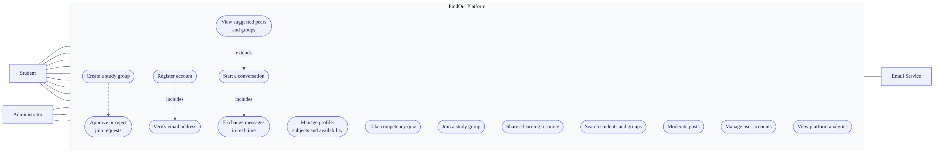
Figure 3.1. Use case diagram. Solid lines are actor associations; dashed lines are include and extend relationships between use cases. Group administration (UC10) is performed by the Student who created the group, not by a platform Administrator — group ownership and platform administration are separate privileges.
Three relationships in the model are worth noting because they shaped the design:
- Register account includes Verify email address. Registration is not complete until ownership of the address is proven, which is why login is gated on the verified flag.
- View suggestions extends Start a conversation. Discovery is the entry point to communication, so both must live in the same artefact — the argument made in §2.8, Gap 3.
- Take competency quiz is available to any student but is only meaningful for those offering to teach, which is why it is optional rather than a precondition of any other case.

3.5 Technology Selection
Technology choices were made against four criteria: suitability for the problem, cost (the project had no budget), availability of documentation and community support, and the developer’s ability to become productive within the project timeframe.
Table 3.4
Technology Choices and Justifications
Layer | Selected | Alternatives considered | Justification
Frontend framework | React 18 with Vite | Angular, Vue, Next.js | React’s component model suits an interface with a lot of changing state, such as a chat window. It has the largest ecosystem of the options. Vite rebuilds the page in under a second during development, compared with much slower rebuilds under Webpack. Next.js offers server-side rendering, but the benefit is small for an application that sits behind a login.
Styling | Tailwind CSS 3 | Bootstrap, Material UI, plain CSS | Tailwind applies styles directly in the markup, which avoids inventing and maintaining class names. Unused styles are removed at build time, producing a smaller file. Unlike Bootstrap or Material UI it does not impose a recognisable visual identity.
Backend runtime | Node.js with Express 4 | Django (Python), Spring Boot (Java), Laravel (PHP) | Using JavaScript on both sides means one language for the whole project, which matters for a single developer with limited time. Node handles many idle open connections efficiently, which is exactly the chat workload.
Database | MongoDB with Mongoose | PostgreSQL, MySQL | The data is document-shaped: a post owns its comments, which own their replies. Fetching a post with its full comment thread is one read, not a three-table join. The flexible schema also suited the iterative method, since fields were added as increments progressed.
Real-time channel | Socket.IO 4 | Plain WebSocket, Server-Sent Events, polling | Socket.IO adds automatic reconnection, a “room” abstraction that maps directly onto chats and groups, and a fallback to long-polling when WebSocket is blocked. The fallback matters on unreliable mobile networks.
Authentication | JWT with bcrypt | Server sessions, OAuth, Passport.js | Tokens hold their own validity, so the server stores no session data and can be scaled to multiple machines. bcrypt is deliberately slow to compute, which makes password guessing expensive (Provos & Mazières, 1999).
Email | Nodemailer with SMTP | SendGrid, Amazon SES | Free, and adequate for the volume this project generates.
File uploads | Multer to local disk | Cloudinary, Amazon S3 | Free and simple to implement.

3.5.1 Acknowledged trade-offs
Every choice above has a cost. Stating them shows the decisions were made deliberately.
- MongoDB does not enforce relationships between records the way a relational database does. If a user is deleted, references to that user elsewhere are not automatically cleaned up. This became a real limitation and is reported in Chapter 4.
- JWT tokens cannot be cancelled before they expire. If a token is stolen, it stays valid until expiry. This is reduced by making the access token short-lived (15 minutes).
- Local file storage is destroyed when a hosting platform redeploys the application. This makes the current upload approach unsuitable for production hosting without change.

3.6 System Architecture

3.6.1 Overall structure
The system uses a three-tier architecture with an additional persistent channel for real-time features.
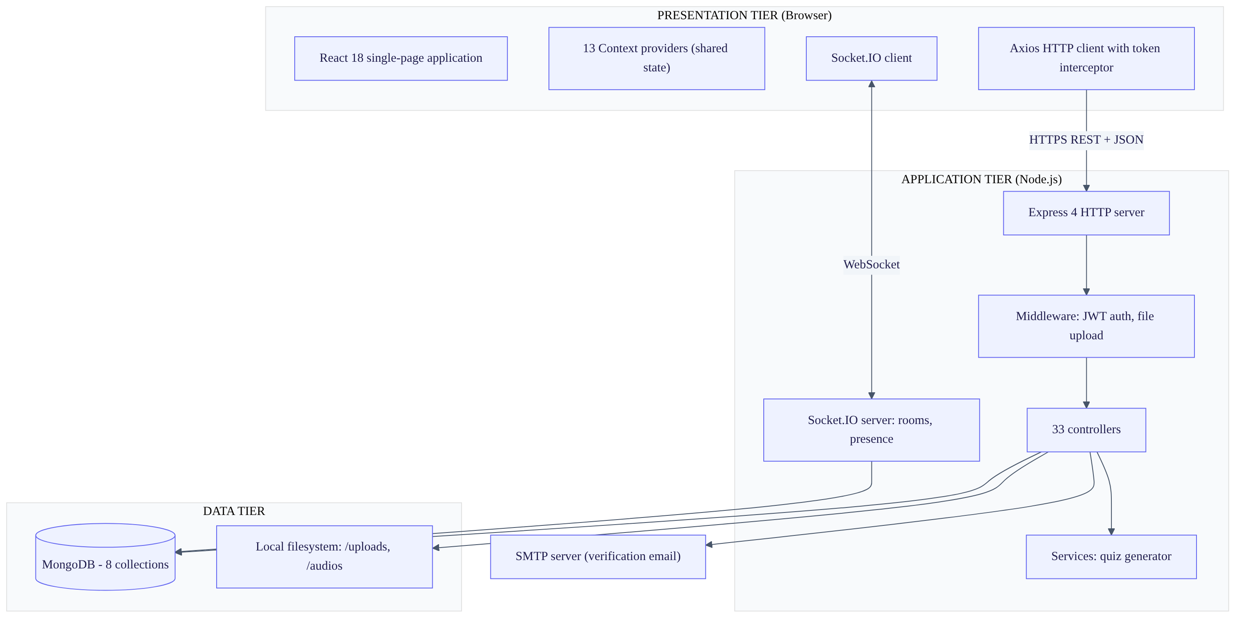
Figure 3.2. System architecture. Three tiers with two distinct communication channels between the client and the application tier: request-response over HTTPS for user-initiated operations, and a persistent WebSocket for server-initiated events.

3.6.2 Why two communication channels
The system uses REST over HTTP for most operations and WebSocket for messaging. This is a deliberate design decision and the reason should be understood.
HTTP works on a request-and-response model. The client asks, the server answers. This suits operations the user initiates: load my profile, create a group, submit a quiz.
Chat does not fit this model. A message must reach a recipient who did not ask for it. Under HTTP alone the only way to achieve this is polling — the client repeatedly asking “is there anything new?” Polling every few seconds wastes bandwidth and battery, and still delivers messages late.
WebSocket (Fette & Melnikov, 2011) keeps a connection open in both directions, so the server can send without being asked. Socket.IO adds reconnection and grouping on top of it.
The system therefore uses each protocol for what it does well, rather than forcing one to do both jobs.

3.6.3 Backend structure
The backend is organised in layers, each with one responsibility.
Layer | Location | Responsibility
Entry point | server.js | Creates the HTTP server, attaches Socket.IO, connects the database, mounts routers
Routes | routes/ (4 files) | Declares which URL maps to which handler. Contains no logic.
Middleware | middleware/ | Runs before handlers: checks the token, processes file uploads
Controllers | controllers/ (33 files) | Contains the business logic for one operation each
Services | services/ | Logic reused by more than one controller (quiz generation)
Models | models/ (7 files) | Defines the shape of the data and its validation rules
Socket handlers | socket/Socket.js | Handles all real-time events
This separation means a change to a URL affects only the route file, and a change to a validation rule affects only the model. It follows the layered pattern described by Fowler (2002), without the server-side view layer, since the React application handles all presentation.

3.6.4 Frontend structure
The frontend is a single-page application. The browser loads the application once, and navigation between screens happens without further page loads.
State that is needed by many components — the logged-in user, the chat list, the suggestions — is held in React Context providers. A Context provider makes a value available to every component beneath it without passing it manually through each level. The application composes 13 such providers in Providers/Provider.jsx.
Two utilities are important to the design:
- utils/tokenService.js stores and retrieves the authentication tokens.
- utils/axiosInstance.js wraps the HTTP client. It automatically attaches the access token to every request. It also watches for a 401 (unauthorised) response, and when one occurs it requests a new access token using the refresh token, then retries the original request. If the refresh also fails, it clears the tokens and redirects to the login page.
This means token renewal is invisible to the rest of the application. No component needs to know that tokens expire.

3.7 Database Design

3.7.1 Collections
The database holds eight collections: users, groups, chats, messages, posts, verifications, quizzes and admins.
Figure 3.3 shows the conceptual data model. It is the design-level view: entities, their relationships and cardinality. The as-built physical schema, with every field and validation rule, is given in Chapter 4, Figure 4.3, and in the SRS §9.
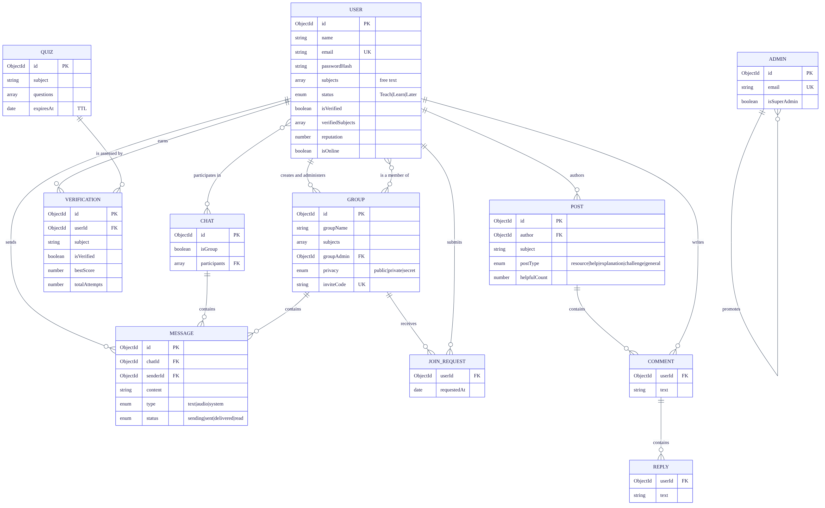
Figure 3.3. Entity relationship diagram (conceptual). ||--o{ denotes one-to-many and }o--o{ many-to-many. COMMENT, REPLY and JOIN_REQUEST are modelled as separate entities here for clarity, but are physically embedded within their parent documents — the reasoning is given in §3.7.2.
Two relationships deserve comment. A USER has two distinct associations with GROUP: one as creator and administrator, and one as an ordinary member. Separating them is what allows group administration to be a per-group privilege rather than a platform-wide role. Second, both CHAT and GROUP own MESSAGE records, because a group conversation and a direct conversation carry the same message structure and are addressed by the same identifier at the socket layer.

3.7.2 The design as classes
The system uses Mongoose, which represents each collection as a model class carrying both schema and behaviour. Figure 3.4 shows those classes together with the two service classes that hold logic used by more than one controller.
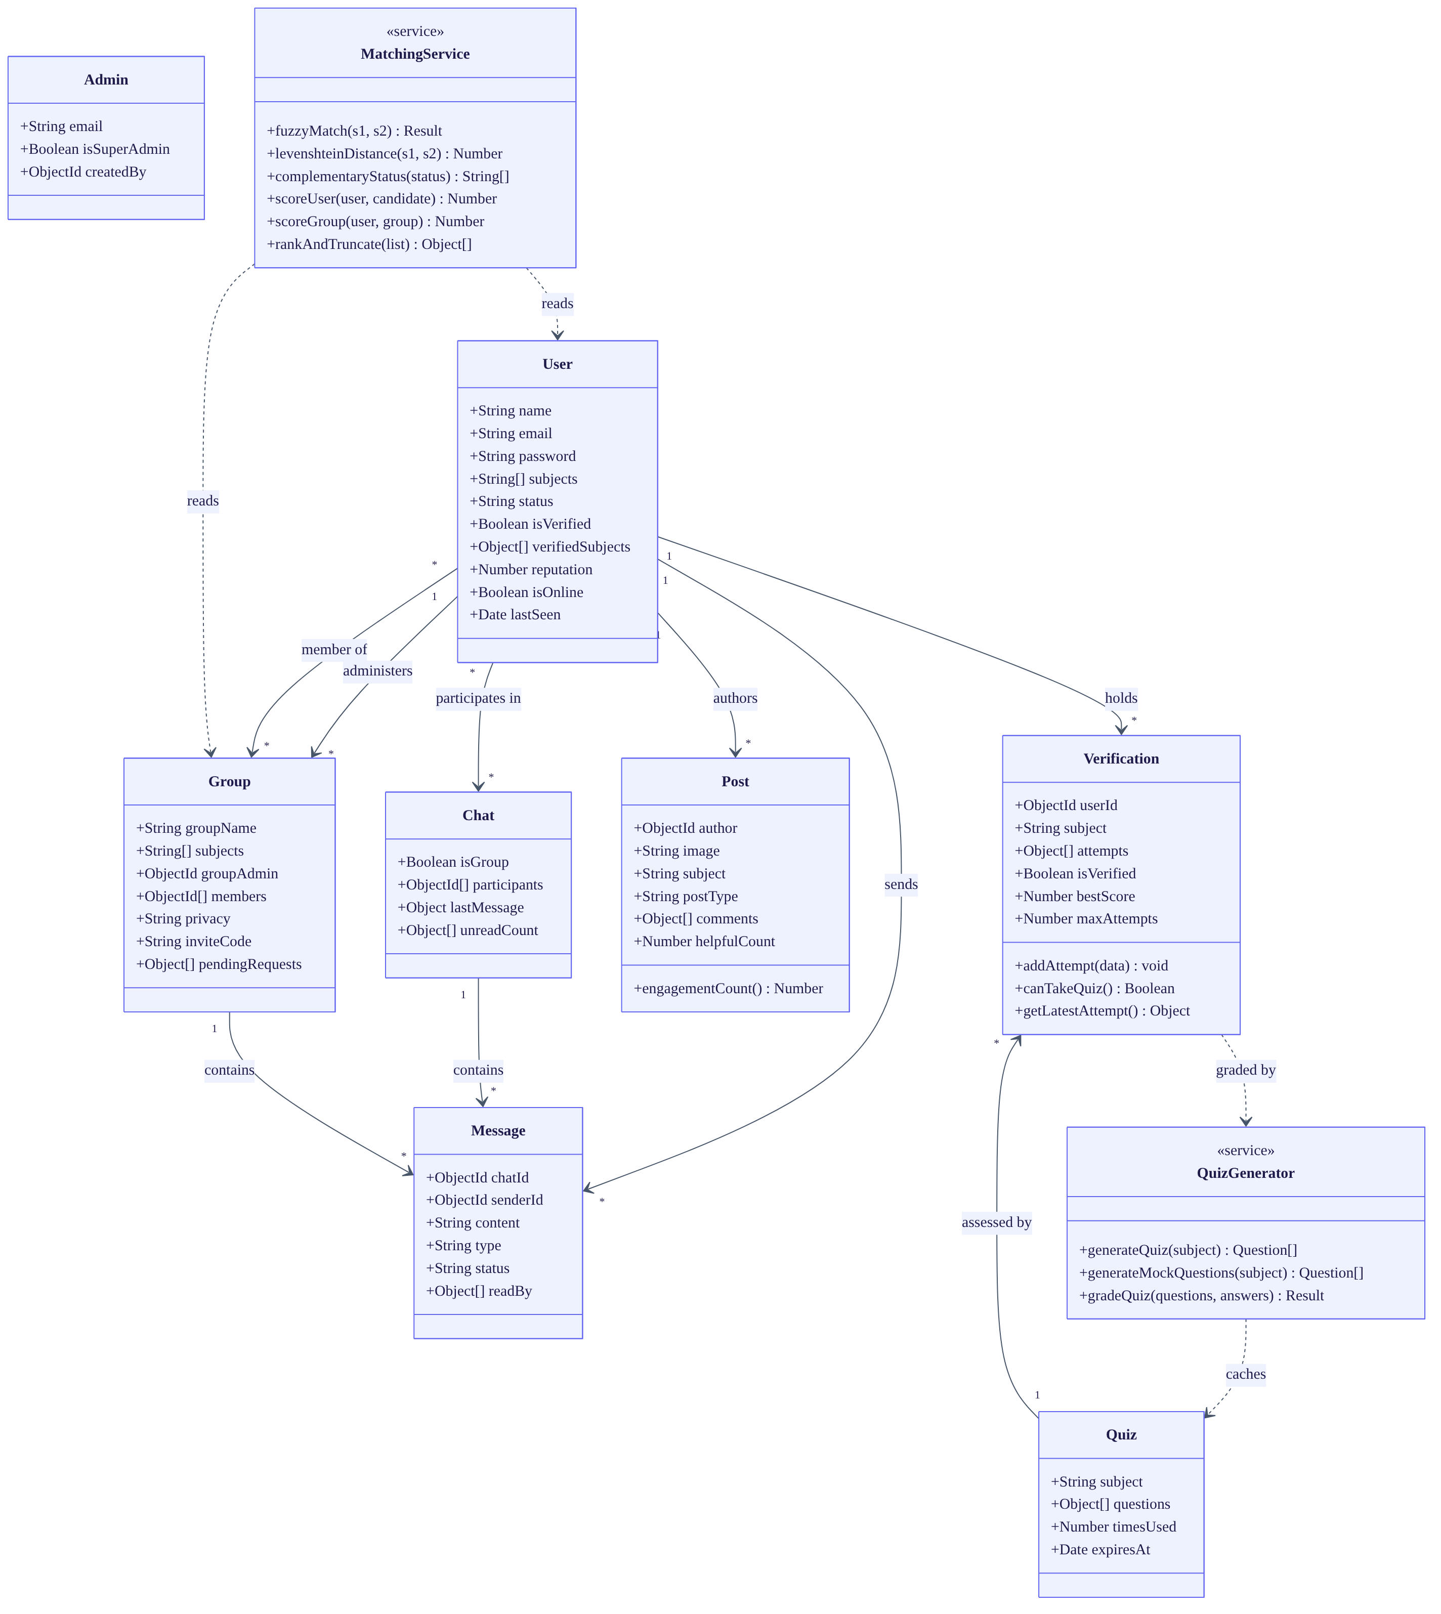
Figure 3.4. Class diagram. Solid arrows are associations with cardinality; dashed arrows are dependencies. MatchingService and QuizGenerator are stereotyped as services: they hold behaviour rather than state, and are the only classes containing algorithmic logic.
Note that MatchingService reads User and Group but owns no data of its own. This is deliberate: the matching algorithm is a pure function of the profile data, which is what makes it independently testable — the property exploited by the unit tests in Chapter 5, §5.3, where the functions were extracted and run in isolation without a database.

3.7.3 Embedding versus referencing
MongoDB allows related data either to be stored inside a parent document (embedding) or stored separately and linked by an identifier (referencing). The choice affects performance. The decisions made here were:
Data | Decision | Reason
Comments and replies inside posts | Embedded | A post and its discussion are always displayed together. Embedding makes this one database read instead of three. The cost is that a document has a 16 MB size limit, which caps how many comments a single post can hold.
Messages separate from chats | Referenced | A conversation grows without limit. Embedding messages would eventually exceed the document size limit.
Quiz attempt history separate from users | Referenced | Attempt history grows and is rarely read. Keeping it out of the user document keeps that frequently-read document small.
Unread counts inside chats | Embedded as an array of {userId, count} | Each participant needs their own counter. Storing them with the chat avoids a separate lookup when listing chats.
Last message copied onto the chat | Denormalised (duplicated) | The chat list shows the last message for every chat. Without this copy, displaying a list of 20 chats would need 20 extra queries. The cost is that the copy must be kept in step with the messages collection.
The last decision is a deliberate trade of write complexity for read speed, which is appropriate because a chat list is read far more often than a message is sent.

3.7.4 Indexes
An index is a data structure that lets the database find records without scanning every one. Indexes were added where queries are frequent.
Collection | Index | Purpose
users | email (unique) | Login lookup; also enforces that no email is registered twice
verifications | {userId, subject} (unique) | Ensures one verification record per user per subject
verifications | {userId, isVerified} | Fast badge lookup
quizzes | {subject, expiresAt} | Finding a valid cached quiz
quizzes | {expiresAt} with TTL 0 | Deletes expired quizzes automatically
posts | {author, createdAt} descending | Author timeline
posts | {subject}, {postType} | Filtering the feed
groups | inviteCode (unique, sparse) | Resolving invite links
The TTL (time-to-live) index on quizzes is worth noting: MongoDB deletes those documents by itself once the expiry date passes, so no scheduled cleanup job is needed.

3.8 Design of the Matching Algorithm
This section specifies the central technical contribution of the project. It is written so that another developer could implement the same algorithm from this description alone.
Reference implementation: backend/controllers/Suggestions.js

3.8.1 The problem to solve
Given a student who has declared some subjects and a role, produce a ranked list of other students and groups that are worth connecting with. The list must be produced without the student performing a search, and must place the most suitable candidates first.

3.8.2 Notation
Let:
- $u$ be the requesting student, with subject set $S_{u}$ and status $σ_{u}$
- $c$ be a candidate student, with subject set $S_{c}$ and status $σ_{c}$
- $g$ be a candidate group, with subject set $S_{g}$ and member set $M_{g}$
Status takes one of three values: Ready To Teach, Ready To Learn, or Later.

3.8.3 The complementary status function
The core idea of the algorithm is that a learner should be matched to a teacher, not to another learner. This is expressed as a function returning the status that complements the requester’s:
$$\text{comp}(σ_{u})=\left\{\begin{matrix}\{\text{Ready To Teach}\} & \text{if }σ_{u}=\text{Ready To Learn} \\ \{\text{Ready To Learn}\} & \text{if }σ_{u}=\text{Ready To Teach} \\ ⌀ & \text{if }σ_{u}=\text{Later}\end{matrix}\right.$$
A student whose status is Later has no complement, and therefore receives no status bonus. This is what makes the system a reciprocal recommender in the sense defined by Palomares et al. (2021): the match must serve both parties, and it does so because the two roles need each other.

3.8.4 The fuzzy subject matcher
Subjects are typed in as free text. Two students may write the same subject differently. The matcher must therefore tolerate differences in case, punctuation, spacing and spelling.
The matcher works in four tiers, from most confident to least. It stops at the first tier that matches, so the expensive calculation only runs when the cheap tests fail.
FUNCTION fuzzyMatch(s1, s2):
// Normalisation: lowercase, then remove + # . - _ and all spaces
n1 ← normalise(s1)
n2 ← normalise(s2)
// Tier 1 — exact match after normalisation
IF n1 = n2 THEN
RETURN (matched, score = 10)
// Tier 2 — one contains the other
IF n1 contains n2 OR n2 contains n1 THEN
RETURN (matched, score = 7)
// Tier 3 — first three characters agree
IF length(n1) ≥ 3 AND length(n2) ≥ 3 AND n1[0..2] = n2[0..2] THEN
RETURN (matched, score = 5)
// Tier 4 — edit distance similarity
d ← levenshteinDistance(n1, n2)
sim ← 1 − d / max(length(n1), length(n2))
IF sim ≥ 0.7 THEN
RETURN (matched, score = floor(5 × sim))
RETURN (not matched, score = 0)
The normalisation step is what allows C++, cpp and c-plus-plus to be treated as identical, and Data Structures to match data-structures.
Tier 4 uses Levenshtein distance (Levenshtein, 1966), which counts the minimum number of single-character insertions, deletions or substitutions needed to turn one string into the other. It is computed with the standard dynamic-programming matrix. Dividing by the length of the longer string converts the distance into a similarity value between 0 and 1.
The threshold of 0.7 was chosen deliberately, and the reasoning should be stated in your defence. The two possible errors have unequal costs. A missed match means a student never learns that a suitable partner existed. A wrong match means one suggestion card is ignored. Since the first error is much more costly than the second, the threshold favours finding more matches (recall) over being strictly correct (precision). Chapter 5 reports a case where this produces a wrong match, which is the expected consequence of the choice.

3.8.5 The scoring function for candidate students
For each candidate $c$, a score is computed:
Score(u,c)=20⋅[σc∈comp(σu)]⏟complementary role+s∈Su​maxt∈Scfuzz(s,t)⏟subject overlap+3⋅[online(c)]⏟currently online+2⋅|M|⏟multiple subjects
where $M$ is the set of matched subject pairs, the final term applies only when $|M|>1$, and $[ ⋅ ]$ equals 1 when the condition is true and 0 otherwise.
For each of the requester’s subjects, the matcher finds the best-matching subject on the candidate’s profile and adds that score once. It does not add a score for every pair, which would over-reward candidates who list many subjects.

3.8.6 Justification of the weights
Table 3.5
Scoring Weights and Their Justification
Component | Weight | Justification
Complementary role | 20 | This is the largest weight, and deliberately so. It ensures that one correct role match outranks any accumulation of subject similarity alone. A perfect subject match between two learners does not serve the platform’s purpose, because neither can help the other. This weight is the point where the reciprocal principle from §2.3.2 becomes code.
Exact subject match | 10 | The strongest available evidence of a genuinely shared subject.
One subject contains the other | 7 | For example Maths inside Advanced Maths. High confidence, but slightly lower than exact.
First three characters match | 5 | For example Programming and Program. Moderate confidence.
Edit-distance similarity ≥ 0.7 | ⌊5 × sim⌋ | Catches spelling errors. Capped at a low value because this tier produces the most false matches.
Currently online | 3 | Being available right now has real value, but must not outweigh subject fit. Deliberately small.
More than one shared subject | 2 per match | Two students sharing several subjects are more likely to form a lasting partnership than a one-off exchange.
These weights were set by hand and tuned against sample profiles. This must be stated openly. There was no labelled dataset of “correct” matches to optimise against, because no such dataset exists for this problem. This is a genuine limitation of the method, not an oversight, and Chapter 5 discusses it. The Future Work section proposes learning the weights from observed outcomes once the platform has usage data.

3.8.7 The scoring function for candidate groups
Groups are scored with the same subject term plus two group-specific terms:
Score(u,g)=s∈Su​maxt∈Sgfuzz(s,t)+min(|Mg|,15)+3|M|
The middle term rewards groups that already have members, since an empty group offers little. It is capped at 15 so that very large groups do not permanently outrank new small ones, which would prevent new groups from ever being discovered.
Groups do not receive a status term, because a group has no single teach or learn role.

3.8.8 Exclusion rules
Before scoring, candidates are removed if any of the following apply:
Candidate type | Excluded when
Student | It is the requester themselves
Student | The requester already has a direct chat with them
Student | They have declared no subjects
Group | The requester is already a member
Group | The requester has a join request pending
Excluding existing chat partners is important. Without it, the suggestion list would fill up with people the student already talks to, and would stop being a discovery tool.
After scoring, any candidate scoring zero is discarded.

3.8.9 Ranking and truncation
Results are sorted by score, highest first. Ties among students are broken first by online status, then by most recent activity. Ties among groups are broken by newest first.
Both lists are cut to the top 15. This limit exists for interface reasons: a student presented with 200 suggestions will act on none of them.

3.8.10 Activity model of the matching process
Figure 3.5 shows the process as an activity diagram, from the point a student completes their profile to the point a suggestion becomes a conversation. The two swim lanes separate what the student does from what the system does.
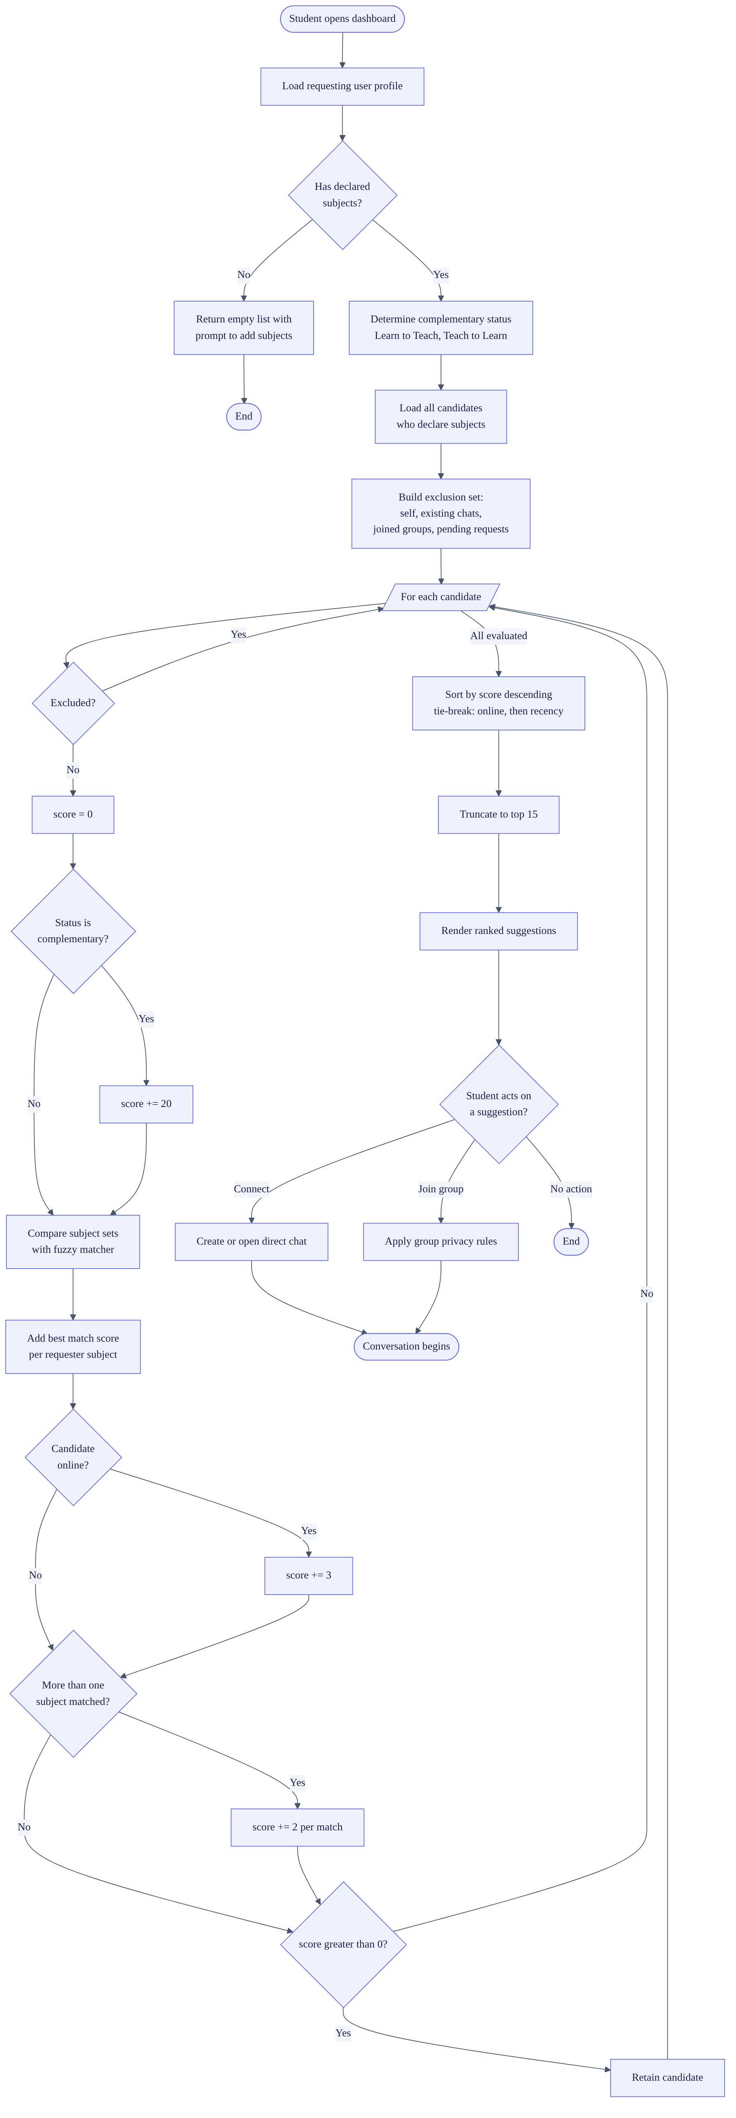
Figure 3.5. Activity diagram of the matching process. Diamonds are decision points; the loop node iterates over every candidate. The exclusion step precedes scoring so that computation is not spent on candidates that will be discarded.

3.8.11 Sequence model of discovery to conversation
Figure 3.6 shows the same process as an interaction between components, which makes the division of responsibility explicit — in particular that scoring happens in the application tier, not in the database.

Figure 3.6. Sequence diagram from discovery through to a delivered and read message. The alt fragment shows the cold-start branch for a student who has declared no subjects. Steps 12 to 15 occur entirely in the application tier — the scalability consequence is analysed in §3.8.13.

3.8.12 Worked example
To make the algorithm concrete, consider:
- Requester: Ama. Subjects: Calculus, Data Structures. Status: Ready To Learn.
- Candidate 1: Kwame. Subjects: calculus, data-structures. Status: Ready To Teach. Online.
- Candidate 2: Efua. Subjects: Calculus. Status: Ready To Learn. Offline.
Kwame’s score: - Complementary role (Ready To Teach complements Ready To Learn): +20 - Calculus ↔ calculus: exact after normalisation: +10 - Data Structures ↔ data-structures: exact after normalisation: +10 - Online: +3 - Two subjects matched, so multiple-subject bonus 2 × 2: +4 - Total: 47
Efua’s score: - Complementary role: Ready To Learn does not complement Ready To Learn: +0 - Calculus ↔ Calculus: exact: +10 - Not online: +0 - Only one subject matched, so no bonus: +0 - Total: 10
Kwame is ranked first. This is the correct outcome: Ama needs someone who can teach, and Efua needs the same help Ama does.

3.8.13 Complexity analysis
Let $n$ be the number of candidate students, $|S|$ the average number of subjects per student, and $ℓ$ the average length of a subject name.
The algorithm compares every one of the requester’s subjects against every one of each candidate’s subjects. Each comparison may run Levenshtein, which costs $O(ℓ^{2})$. The total is:
$$O(n⋅|S_{u}|⋅|S_{c}|⋅ℓ^{2})$$
The candidate list is loaded into the application’s memory and scored there, rather than in the database.
This is acceptable at the scale of a pilot and unacceptable at institutional scale. With a few thousand users and short subject names the endpoint responds within the target time. But the cost grows linearly with the number of users, so the approach has a ceiling. This is the system’s main scalability limit. It is stated here rather than hidden, and Chapter 5 reports the measured behaviour. The Future Work section proposes moving the scoring into a database aggregation pipeline and adding an index from subjects to users.

3.9 Design of the Verification Mechanism

3.9.1 Purpose
Chapter 1, Problem 4 established that learners cannot tell genuine competence from confidence. Chapter 2, §2.4.2 established that conventional reputation systems cannot solve this at launch because they need accumulated ratings first.
The verification mechanism addresses this with an assessment that can be taken immediately.

3.9.2 Design decisions
Table 3.6
Verification Design Decisions
Decision | Value | Justification
Pass threshold | 70% | High enough that the badge means something; low enough not to discourage participation. Since willing teachers are the scarce resource (§2.2.3), an excessively hard test would starve the platform of supply.
Attempts allowed | 3 per subject | Prevents someone repeatedly guessing their way through a fixed question bank.
Questions per quiz | 10 | Enough to make guessing unreliable; short enough that students complete it.
Options per question | 4 | Reduces the chance of a correct guess to 25%.
Correct answers sent to browser | Never | Answers are removed from the response before it is sent. Marking happens only on the server. This prevents a student reading the answers from the page source.
Session ownership check | Enforced | The submitted session is checked against the submitting user, preventing one student submitting another’s quiz.
Scope | Per subject | Competence is subject-specific. A badge in Java says nothing about Statistics.

3.9.3 State model
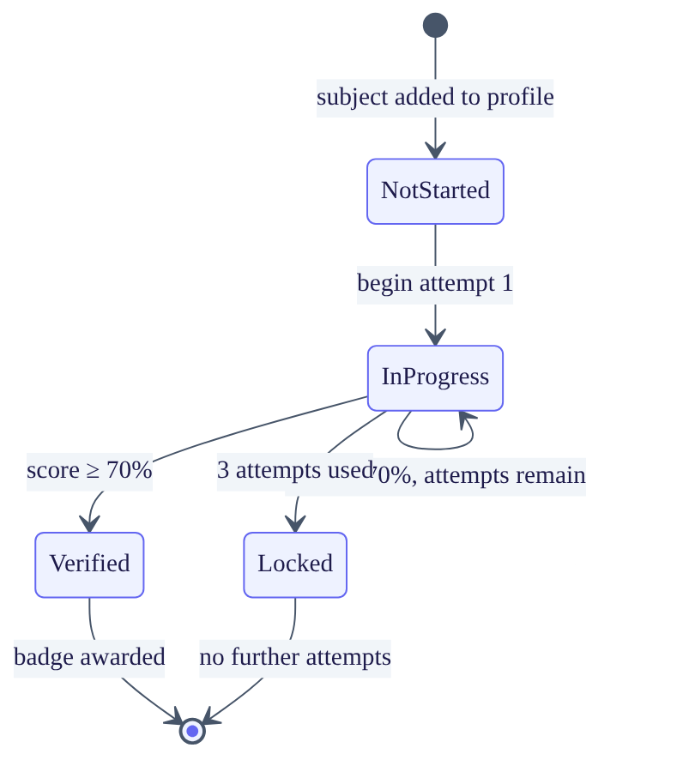
Figure 3.7. State diagram for competency verification of a single subject. Verification is per subject, so a student holds one independent instance of this machine for each subject they declare.

3.9.4 Question generation — accurate statement of the approach
This subsection must be reported accurately, and the accurate statement is as follows.
The design intention was to generate questions specific to each subject using a large language model, drawing on the research reviewed in §2.4.4. Provision for this was made: the environment holds an API key and the client library is installed.
However, the implemented build does not use it. Question generation currently uses a deterministic template bank: ten fixed question templates into which the subject name is inserted. The templates assess pedagogical approach — how a person would go about teaching — rather than knowledge of the subject itself.
The consequences must be stated:
- The badge is a weaker signal of subject competence than the design intended. It indicates that the holder has sensible views about teaching, not that they know the subject.
- Every subject produces structurally identical questions.
This is reported here, in Chapter 4, and in Chapter 5 rather than being concealed. Do not describe this system as using AI-generated assessment. An examiner who asks for a demonstration across two different subjects will see identical questions immediately, and a claim that collapses under demonstration is far more damaging than a limitation stated openly.
Generated quizzes are cached per subject for 7 days, so the caching and marking infrastructure is already in place to receive model-generated questions when that component is completed.

3.10 Design of the Real-Time Subsystem

3.10.1 Rooms
Socket.IO provides rooms — named groups of connections. A message sent to a room reaches only the connections in it.
The design uses one room per chat and one per group, named by the identifier of that chat or group. When a user opens a conversation the client joins the corresponding room. Sending a message to that room therefore reaches exactly the participants and nobody else. This gives message isolation without any manual recipient list.

3.10.2 Presence
When a user connects, the client emits user-online. The server records the connection identifier on the user record, sets the online flag, and broadcasts the change so other users see the status update. On disconnect the server clears the flag and records the time as lastSeen.

3.10.3 Message state
Each message carries a status that moves through four values:
sending → sent → delivered → read
The transitions are:
Transition | Trigger
sending → sent | Server has saved the message to the database
sent → delivered | Recipient’s client is connected and receives it
delivered → read | Recipient opens the conversation and the client emits mark-messages-read
For group chats the server additionally records which users have read the message, since “read” is not a single event when there are many recipients.

3.10.4 Ordering of persistence and emission
An important design rule: the server saves the message to the database before broadcasting it. The alternative — broadcast first for lower latency — risks a message appearing on screen and then vanishing if the save fails. Saving first means anything a user sees has been stored.

3.11 Security Design
Table 3.7
Security Controls and Their Placement
Concern | Control | Where implemented
Password storage | bcrypt hashing, cost factor 10 | controllers/RegisterUser.js
Session management | JWT access token, 15-minute lifetime | controllers/LoginUser.js
Session continuity | Refresh token, 7-day lifetime | controllers/RefreshToken.js
Route protection | Bearer token verified before the handler runs | middleware/authMiddleware.js
Administrator separation | Separate collection, separate login, separate middleware | middleware/adminAuth.js
Privilege escalation | Only a super-administrator may promote another admin | routes/adminRoutes.js
Duplicate accounts | Unique index on email | models/UserModel.js
Upload abuse | File type and size restricted (JPEG/PNG, 2 MB) | middleware/upload.js
Cross-origin requests | Only the configured frontend origin permitted | server.js
Assessment integrity | Answers withheld; marking server-side only | controllers/verificationController.js
Secret management | Values supplied by environment variables, excluded from version control | .env, .gitignore
Why bcrypt rather than a plain hash. A fast hash such as SHA-256 can be computed billions of times per second on modern hardware, so a stolen password database can be attacked by brute force. bcrypt is deliberately slow and its cost is adjustable, which makes such an attack impractical (Provos & Mazières, 1999).
Why two tokens. A single long-lived token is convenient but dangerous, since a stolen token remains valid for a long time. A single short-lived token is safe but forces the user to log in repeatedly. The two-token design gives both: the access token expires in 15 minutes, limiting the damage from theft, while the refresh token renews it silently for up to 7 days.
Weaknesses found in the implementation of these controls are reported in Chapter 4 and discussed in Chapter 5. They are not concealed.

3.12 Group Privacy Model
Three privacy levels were designed after the original two-state model proved inadequate.
Table 3.8
Group Privacy Levels
Level | Appears in search and explore | How a user joins | Intended use
public | Yes | Joins immediately | An open study group anyone may enter
private | Yes | Sends a request; group admin approves or rejects | A group that wants to be found but control who enters
secret | No | Invite link only | A closed group that should not be discoverable at all
The distinction between private and secret is the one the original boolean design could not express. A boolean forces a group to choose between being fully open and being invisible. In practice a group often wants to be findable but not automatically joinable — a student should be able to discover that a Statistics group exists and ask to join, while the existing members retain control over membership. This is the private level, and adding it required a schema change and a migration script for existing data.

3.13 Development Environment and Tools
Table 3.9
Tools Used
Purpose | Tool
Code editor | Visual Studio Code
Version control | Git
Runtime | Node.js v24.15.0 (minimum v18)
Package manager | npm v11
Database | MongoDB 6.0+
Database inspection | MongoDB Compass
API testing | Postman / Thunder Client
Automatic server restart | nodemon
Frontend dev server | Vite
Code quality | ESLint 9 with React plugins
Operating system | Linux

3.14 Evaluation Methodology
Evaluation is step 5 of the DSR process (Peffers et al., 2007). Three forms of evaluation were used: functional testing, performance measurement, and a user study.

3.14.1 Functional testing
Testing was carried out at six levels. Four are automated as executable scripts committed to the repository, so that any result reported in Chapter 5 can be regenerated by a reader rather than taken on trust.
Level | What is tested | Method | Script
Unit | Individual functions in isolation — the fuzzy matcher and the Levenshtein function | Inputs with known expected outputs | backend/tests/fuzzyMatcher.test.js
Algorithm | How matching cost grows with population size | Timed runs against synthetic populations, fixed seed | backend/tests/scalability.bench.js
Integration | Every API endpoint against the live server | Executable suite issuing real HTTP requests | backend/tests/functional.test.js
Performance | Endpoint response times against stated targets | Repeated timed samples after a warm-up | backend/tests/performance.bench.js
System | Complete user journeys through the interface | Scripted manual walkthrough | —
Real-time | Behaviour with multiple simultaneous clients | Two browsers, two accounts, side by side | —
Why the automated suites matter methodologically. A results chapter that reports “the tests passed” asks the reader to believe the author. A results chapter accompanied by a script the reader can run asks them to believe the system. The second is the stronger claim, and it is the reason the integration and performance levels were written as executable suites rather than as Postman collections: a Postman collection is a record of what the author did, whereas a committed script is an instrument anyone can re-apply.
The functional suite creates the accounts, groups and conversations it needs and removes them afterwards, so it is repeatable and leaves no residue in the database.
The fuzzy matcher receives particular attention because it is the most testable component and the one most central to the contribution. This is a consequence of the design recorded in §3.7.2: because MatchingService holds behaviour but no state, its functions can be extracted and exercised without a database.
The two manual levels remain manual for a defensible reason. System walkthroughs assess whether a journey feels coherent, which is a judgement rather than an assertion. Real-time behaviour requires two simultaneously connected clients, which needs a multi-client harness that the project did not build.

3.14.2 Performance measurement
Measurable targets were set in advance, so that the evaluation has pass or fail criteria rather than opinions. The main ones:
Measure | Target | How verified
Authentication response time | ≤ 2 seconds | Automated (performance.bench.js)
Suggestions response time (≤ 1,000 users) | ≤ 3 seconds | Automated
Initial application load | ≤ 5 seconds | Automated, browser cache disabled
Chat history retrieval | ≤ 2 seconds | Automated
Message delivery latency between clients | ≤ 500 milliseconds | Manual — requires two connected clients
Concurrent users supported | ≥ 100 | Not verified; stated as a design target
Each automated measure is sampled repeatedly after a discarded warm-up run, and both the mean and the median are reported. The median is included because a single slow sample — a cold database connection, typically — distorts a mean badly at these sample sizes.

3.14.3 User study design
Design. A post-test evaluation in which participants use the system to complete defined tasks and then complete questionnaires.
Participants. A convenience sample of tertiary students, target N ≥ 20, including students with both intents and from different subject areas.
[Results to be inserted from the author’s own data collection.]
Procedure.
- Brief the participant and obtain written consent.
- Administer the pre-test questionnaire: how they currently find study partners, how difficult they find it, how long it takes.
- The participant completes five tasks unaided while the researcher records success and time:
  - T1: Register and verify an account
  - T2: Add three subjects and set a status
  - T3: Find a suggested peer and open a chat with them
  - T4: Create or join a study group
  - T5: Take a verification quiz for one subject
- Administer the post-test questionnaires (below).
- Conduct a short interview: what worked, what did not, what is missing.

3.14.4 Instruments
Two validated instruments were used rather than questions invented for this project. Using established instruments means the results can be compared against published benchmarks.
System Usability Scale (SUS). Ten statements answered on a five-point scale, producing a score from 0 to 100 (Brooke, 1996). SUS is widely used and its benchmark is well established: a score of 68 is average. This gives a defensible pass mark rather than an arbitrary one.
Technology Acceptance Model (TAM). Measures perceived usefulness and perceived ease of use, the two factors Davis (1989) identified as predicting whether people will actually adopt a system. This matters here because a matching platform that people do not adopt cannot work, regardless of its technical quality.
Project-specific measures. Three additional measures answer the research questions directly:
Research question | Measure
RQ1 (are suggestions relevant?) | For each of the top five suggestions: “How relevant is this person to your learning needs?” rated 1–5
RQ2 (does the badge build trust?) | “How willing would you be to contact this person for help?” asked with and without a verification badge visible
RQ3 (does it reduce effort?) | Difficulty rating before and after using the system
RQ4 (how does it scale?) | Suggestions response time measured against increasing numbers of users

3.14.5 Data analysis
Descriptive statistics (mean, standard deviation) are reported for SUS scores, task success rates and completion times. The RQ2 trust measure is a paired comparison, since the same participant answers both conditions. Interview responses are analysed by grouping similar comments into themes.

3.14.6 Ethical considerations
- Participation is voluntary, and participants may withdraw at any point without giving a reason.
- Written informed consent is obtained before any activity. The consent form is in the SRS, Appendix E.
- Responses are anonymised and reported only in aggregate.
- Test accounts and any data entered during testing are deleted after analysis.
- No sensitive personal data is collected.

3.15 Reproducibility
This section provides what another researcher needs to rebuild and run the system. It exists because the project guide requires that someone else could reproduce the results.

3.15.1 Requirements
- Node.js version 18 or later
- MongoDB version 6.0 or later
- An SMTP account for sending verification email

3.15.2 Configuration
The backend requires these environment variables in backend/.env:
Variable | Purpose
MONGODB_URI | Database connection string
PORT | Port the API listens on (default 5000)
FRONTEND_URL | Address of the frontend; used for CORS and verification links
JWT_SECRET | Signing key for access tokens
REFRESH_TOKEN_SECRET | Signing key for refresh tokens
EMAIL_USER | SMTP account name
EMAIL_PASS | SMTP password
ANTHROPIC_API_KEY | Reserved for question generation (not currently used — see §3.9.4)
The frontend requires VITE_BACKEND_URL in frontend/.env.

3.15.3 Installation and running
# from the project root
npm install # installs both backend and frontend dependencies
npm run backend # starts the API server
npm run frontend # starts the frontend development server
The two servers run in separate terminals. MongoDB must be reachable before the backend starts.
The first administrator account is created by running:
node backend/migration/createSuperAdmin.js

3.15.4 Reproducing the algorithm results
The matching algorithm is fully specified in §3.8, including all weights, thresholds, exclusion rules and the tie-breaking order. The worked example in §3.8.12 provides a test case with a known correct answer, which an implementer can use to check their reimplementation.

3.16 Chapter Summary
This chapter set out how the problem identified in Chapter 1 was solved.
The project follows Design Science Research (Hevner et al., 2004), using the six-step process of Peffers et al. (2007), because the contribution is a built artefact that is then evaluated. Development used an incremental and iterative method, justified by the fact that key design decisions — the algorithm weights and the group privacy model — could not be known in advance and had in fact to be revised during development.
Technology choices were justified against stated criteria, and the cost of each choice was acknowledged rather than ignored. The system uses a three-tier architecture with two communication channels, because request-response and push messaging have genuinely different requirements.
Section 3.8 gave the complete specification of the matching algorithm: the complementary status function, the four-tier fuzzy subject matcher, the scoring functions for students and groups, all weights with their justifications, the exclusion rules, an activity model (Figure 3.5), a sequence model (Figure 3.6), a worked example, and an honest complexity analysis identifying the point at which the approach would need redesigning.
Seven design models were presented in total — use case, architecture, entity relationship, class, activity, sequence and state — listed in Table 3.0. Together they satisfy the reproducibility requirement from two directions: the diagrams fix the structure and the interactions, while the formal specification in §3.8 fixes the behaviour.
Sections 3.9 to 3.12 covered the verification, real-time, security and privacy designs, including an accurate statement that question generation currently uses templates rather than a language model.
Section 3.14 set out the evaluation method, using two validated instruments so that results can be compared against published benchmarks rather than judged subjectively.
Chapter 4 describes what was actually built.

References
Brooke, J. (1996). SUS: A “quick and dirty” usability scale. In P. W. Jordan, B. Thomas, B. A. Weerdmeester, & I. L. McClelland (Eds.), Usability evaluation in industry (pp. 189–194). Taylor & Francis.
Davis, F. D. (1989). Perceived usefulness, perceived ease of use, and user acceptance of information technology. MIS Quarterly, 13(3), 319–340.
Fette, I., & Melnikov, A. (2011). The WebSocket protocol (RFC 6455). Internet Engineering Task Force. https://doi.org/10.17487/RFC6455
Fowler, M. (2002). Patterns of enterprise application architecture. Addison-Wesley.
Hevner, A. R., March, S. T., Park, J., & Ram, S. (2004). Design science in information systems research. MIS Quarterly, 28(1), 75–105. [V]
Levenshtein, V. I. (1966). Binary codes capable of correcting deletions, insertions, and reversals. Soviet Physics Doklady, 10(8), 707–710.
Palomares, I., Porcel, C., Pizzato, L., Guy, I., & Herrera-Viedma, E. (2021). Reciprocal recommender systems: Analysis of state-of-art literature, challenges and opportunities towards social recommendation. Information Fusion, 69, 103–127. https://doi.org/10.1016/j.inffus.2020.12.001 [V]
Peffers, K., Tuunanen, T., Rothenberger, M. A., & Chatterjee, S. (2007). A design science research methodology for information systems research. Journal of Management Information Systems, 24(3), 45–77. https://doi.org/10.2753/MIS0742-1222240302 [V]
Provos, N., & Mazières, D. (1999). A future-adaptable password scheme. In Proceedings of the USENIX Annual Technical Conference (pp. 81–91). USENIX Association.
Sommerville, I. (2016). Software engineering (10th ed.). Pearson.

Chapter Four: Implementation

4.1 Introduction
Chapter 3 explained how the system was designed. This chapter shows what was actually built.
It documents the development environment, the structure of the code, how the database was created, how the API was implemented and documented, how each functional module works, and what the finished interface looks like. It closes with the statistics of the build, the problems encountered during development, and an honest account of the defects that remain.
The evidence in this chapter takes four forms: screenshots of the running system, screenshots of the database and API tooling, short verbatim code extracts, and quantitative measures of what was produced.

4.2 Development Environment
Table 4.1
Development Environment
Component | Version / Tool | Purpose
Operating system | Linux (kernel 6.19) | Development host
Runtime | Node.js v24.15.0 (minimum v18) | Server execution
Package manager | npm v11 | Dependency management
Database | MongoDB 6.0+ (Atlas, cloud-hosted) | Persistence
Database client | MongoDB Compass, mongosh | Inspecting collections and documents
Editor | Visual Studio Code | Development
Version control | Git, hosted on GitHub | History and backup
API documentation | swagger-ui-express 5.0.1 | Interactive API reference
API testing | Postman | Manual endpoint verification
Server reloading | nodemon 3.1.9 | Restart on file change
Frontend tooling | Vite 6.0.3 | Development server and production build
Linting | ESLint 9 | Static analysis

Figure 4.1. The repository as laid out on disk, showing the two-package structure and the separation of routes, controllers, models and services within the backend.

4.3 Project Structure
The repository is a single project containing two independently installable packages. A root manifest installs both.
FindOut/
├── package.json Root manifest; installs both packages
├── backend/
│ ├── server.js Entry point: HTTP server, Socket.IO, routers
│ ├── config/
│ │ ├── connectDB.js Database connection and lifecycle
│ │ └── upload.js Multer storage for post images
│ ├── docs/
│ │ └── openapi.js OpenAPI 3.0 specification (58 operations)
│ ├── routes/ 4 routers, URL declarations only
│ ├── middleware/ Auth, admin auth, file and audio upload
│ ├── controllers/ 32 files, one operation each
│ ├── models/ 7 Mongoose schemas, 8 collections
│ ├── services/
│ │ └── quizGenerator.js Question generation and marking
│ ├── socket/
│ │ └── Socket.js All real-time event handlers
│ ├── migration/ 11 one-off data scripts
│ ├── tests/ 4 suites: unit, scalability, functional, performance
│ ├── uploads/ Images (git-ignored, created at runtime)
│ └── audios/ Voice messages (git-ignored)
└── frontend/
├── index.html
├── tailwind.config.js Design token to utility mapping
└── src/
├── main.jsx Entry: Router → Providers → App
├── App.jsx Route table
├── index.css Design tokens and shared component classes
├── Pages/ 13 screens
├── components/ 24 components
├── Context/ 13 state providers
├── Feed/ 4 feed components
├── socket/ Socket.IO client
└── utils/ Axios instance, token service
Each backend folder holds one kind of thing. A change to a URL touches only routes/; a change to a validation rule touches only models/.

4.4 Database Implementation

4.4.1 Schema definition
Collections are defined as Mongoose schemas, which enforce structure and validation at the application layer. The user schema is the central one, since matching depends on it.
Source: backend/models/UserModel.js
const userSchema = new mongoose.Schema({
name: { type: String, required: true },
email: { type: String, required: true, unique: true },
password: { type: String, required: true },
profilePicture: { type: String },
// Matching inputs
subjects: { type: [String], default: [] },
status: {
type: String,
enum: ["Ready To Teach", "Ready To Learn", "Later"],
default: "Later",
},
freetime: { type: String },
// Trust signals
isVerified: { type: Boolean, default: false },
verifiedSubjects: [{
subject: { type: String, required: true },
verifiedAt: { type: Date, required: true },
}],
reputation: { type: Number, default: 0 },
// Presence
isOnline: { type: Boolean, default: false },
lastSeen: { type: Date, default: Date.now },
socketId: { type: String, default: null },
}, { timestamps: true });
The enum on status is what makes complementary matching possible: because the field can hold only three known values, the algorithm can map any value to its complement without defensive checks.

4.4.2 Indexes
Indexes were declared on the fields that queries filter by.
Source: backend/models/VerificationModel.js, QuizModel.js, PostModel.js
// One verification record per user per subject — enforced, not assumed
verificationSchema.index({ userId: 1, subject: 1 }, { unique: true });
verificationSchema.index({ userId: 1, isVerified: 1 });
// Cached quizzes expire without a scheduled cleanup job
quizSchema.index({ subject: 1, expiresAt: 1 });
quizSchema.index({ expiresAt: 1 }, { expireAfterSeconds: 0 });
// Feed queries
postSchema.index({ author: 1, createdAt: -1 });
postSchema.index({ subject: 1 });
postSchema.index({ postType: 1 });
The TTL index on quizzes is worth noting: MongoDB deletes those documents itself once expiresAt passes, so no background job was needed.

4.4.3 Collections as created
The three figures below are produced by querying the running database directly rather than by photographing a database client. Personal fields are redacted.

Figure 4.2. The eight collections as created in MongoDB, with document counts at the time of capture, queried directly against the running database.
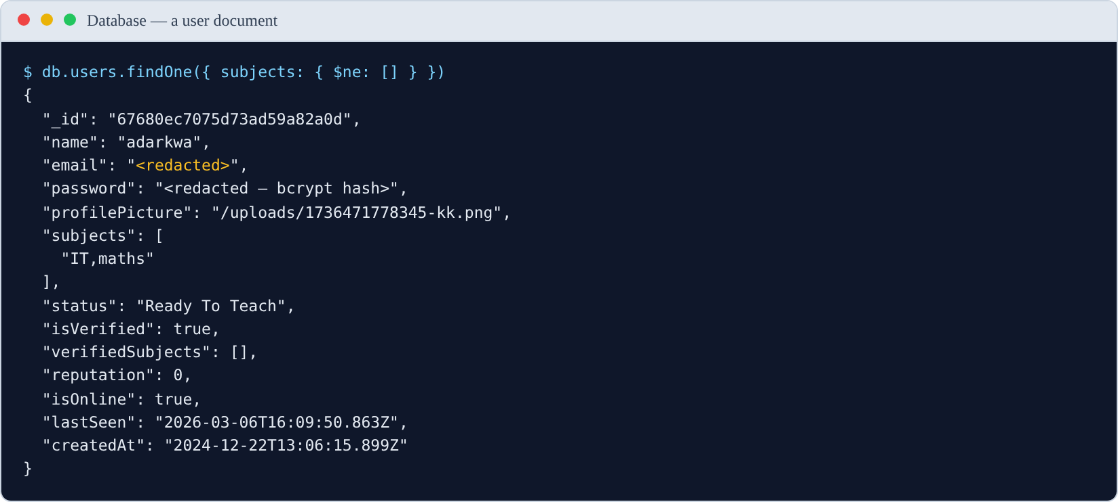
Figure 4.3. A user document. The email address and password hash are redacted. Note subjects holds a single element, "IT,maths", rather than two — a data-quality consequence of the client having sent a comma-separated string before the fix described in §4.6.2.
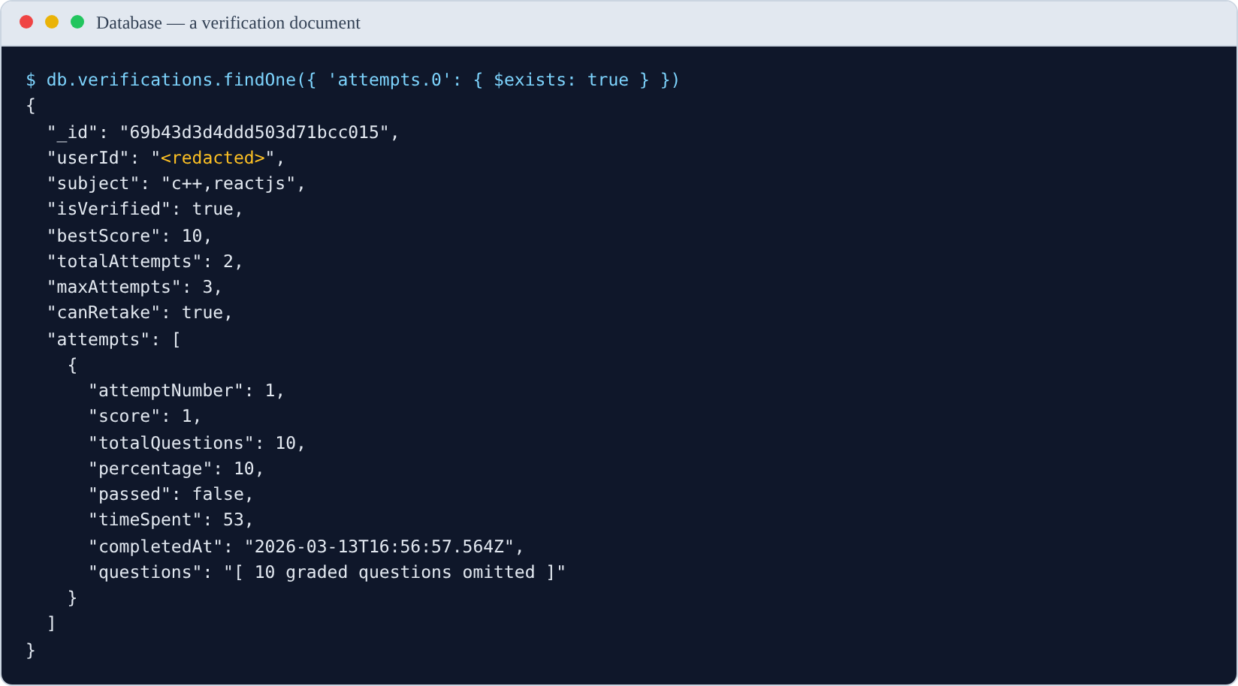
Figure 4.4. A verification record with its embedded attempt history. The graded question array is omitted for space; the user identifier is redacted.

4.5 API Implementation

4.5.1 Server composition
Source: backend/server.js
const app = express();
const httpServer = createServer(app);
initializeSocket(httpServer); // WebSocket shares the HTTP server
app.use(express.json());
app.use('/uploads', express.static(path.join(__dirname, 'uploads')));
app.use('/audios', express.static(path.join(__dirname, 'audios')));
app.use(cors({ origin: process.env.FRONTEND_URL, credentials: true }));
app.use('/api', router); // 40 user endpoints
app.use('/api/admin', adminRoutes); // 11 admin endpoints
app.use('/api', searchRoutes); // 3 search endpoints
app.use('/api', verificationRoutes); // 4 verification endpoints
connectDB()
.then(() => httpServer.listen(PORT, () => { /* ... */ }))
.catch((error) => { /* report and exit 1 */ });
Two decisions are visible here. The WebSocket server is attached to the same HTTP server rather than a second port, so one origin serves both channels. And the server refuses to start if the database is unreachable — an earlier version listened anyway, which produced a server that accepted requests and failed every one of them ten seconds later.

4.5.2 Authentication middleware
Every protected route passes through one 20-line function.
Source: backend/middleware/authMiddleware.js
const authMiddleware = (req, res, next) => {
const token = req.header('Authorization')?.replace('Bearer ', '');
if (!token) {
return res.status(401).json({ message: 'No token, authorization denied' });
}
try {
const decoded = jwt.verify(token, process.env.JWT_SECRET);
req.authenticatedUser = decoded; // controllers read the identity from here
next();
} catch (error) {
res.status(401).json({ message: 'Token is not valid' });
}
};
Because the decoded identity is attached to the request, no controller parses a token itself. This is also why the defects in §4.10 that take a user id from the request body rather than from req.authenticatedUser are security-relevant: they bypass this single point of trust.

4.5.3 Endpoint catalogue
The API exposes 58 endpoints across nine functional areas.
Table 4.2
REST Endpoints by Module
Module | Endpoints | Representative routes
Authentication | 7 | POST /api/register, POST /api/login, GET /api/verify-email, POST /api/refresh-token
Profile | 3 | GET /api/user-details, PUT /api/edit-user, POST /api/profile-picture
Matching | 1 | GET /api/suggestions
Verification | 4 | GET /api/verification/status, POST /api/verification/start-quiz, POST /api/verification/submit-quiz
Groups | 12 | POST /api/creategroup, POST /api/join-group, GET /api/join/:inviteCode, PUT /api/groups/update-privacy
Messaging | 5 | GET /api/chats, GET /api/messages/:chatId, POST /api/start-new-chat
Feed | 9 | POST /api/add-post, GET /api/getallposts, POST /api/posts/:postId/helpful
Search | 4 | GET /api/search, GET /api/explore/groups
Administration | 11 | POST /api/admin/login, GET /api/admin/dashboard/stats, DELETE /api/admin/users/:userId
Total | 58
The single endpoint under Matching is deliberate. GET /api/suggestions performs the entire matching operation server-side and returns a ranked result, so the client holds no matching logic and cannot produce a different ranking.

4.5.4 API documentation with Swagger
The API is documented using OpenAPI 3.0, served as an interactive page through swagger-ui-express. This gives three things a written endpoint table cannot: a machine-readable contract, request and response schemas for every operation, and the ability to execute real requests from the browser.
The specification is maintained as a single module rather than as annotations spread across 33 controllers, so it can be read as a contract independently of the implementation.
Source: backend/server.js
const swaggerUi = require('swagger-ui-express');
const openapiSpec = require('./docs/openapi');
app.get('/api-docs.json', (req, res) => res.json(openapiSpec));
app.use('/api-docs', swaggerUi.serve, swaggerUi.setup(openapiSpec, {
customSiteTitle: 'FindOut API',
swaggerOptions: {
persistAuthorization: true, // bearer token survives a page reload
docExpansion: 'none', // collapse tags so the index stays readable
filter: true, // search box over operations
tryItOutEnabled: true,
},
}));
Source: backend/docs/openapi.js — excerpt showing how the core endpoint is described
'/api/suggestions': {
get: {
tags: ['Matching'],
summary: 'Get ranked peer and group suggestions',
description: `Returns up to 15 users and 15 groups, ranked by match score.
Complementary availability scores 20; exact subject match 10; ...`,
responses: {
200: ok('Ranked suggestions', {
type: 'object',
properties: {
suggestedUsers: { type: 'array', items: { $ref: '#/components/schemas/SuggestedUser' } },
suggestedGroups: { type: 'array', items: { $ref: '#/components/schemas/SuggestedGroup' } },
},
}),
401: Unauthorized,
},
},
},
The documentation covers all 58 operations, grouped under nine tags, with 10 reusable schema definitions (User, Group, Message, Post, QuizQuestion, QuizResult, TokenPair and others) so response shapes are defined once and referenced.
Two security schemes are declared, bearerAuth and adminAuth, which documents an important property of the system: administrator endpoints require a different identity, and a user token is not accepted on them.
Access: with the backend running, the documentation is at http://localhost:5000/api-docs, and the raw specification at http://localhost:5000/api-docs.json.
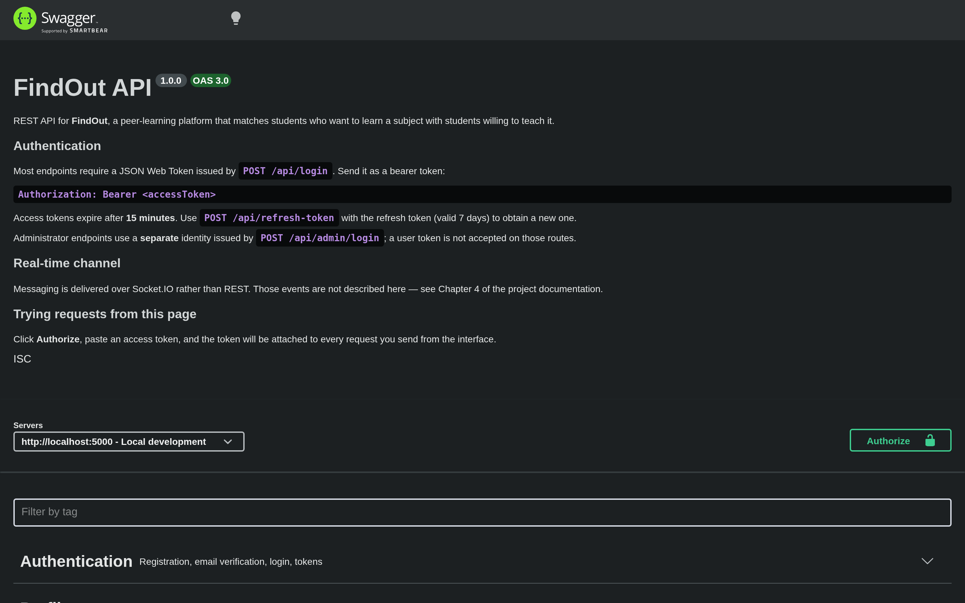
Figure 4.5. The generated API documentation, covering all 58 endpoints grouped by functional area.

Figure 4.6. Documentation for the matching endpoint, with the Matching tag and the operation expanded to show its description and response schema.
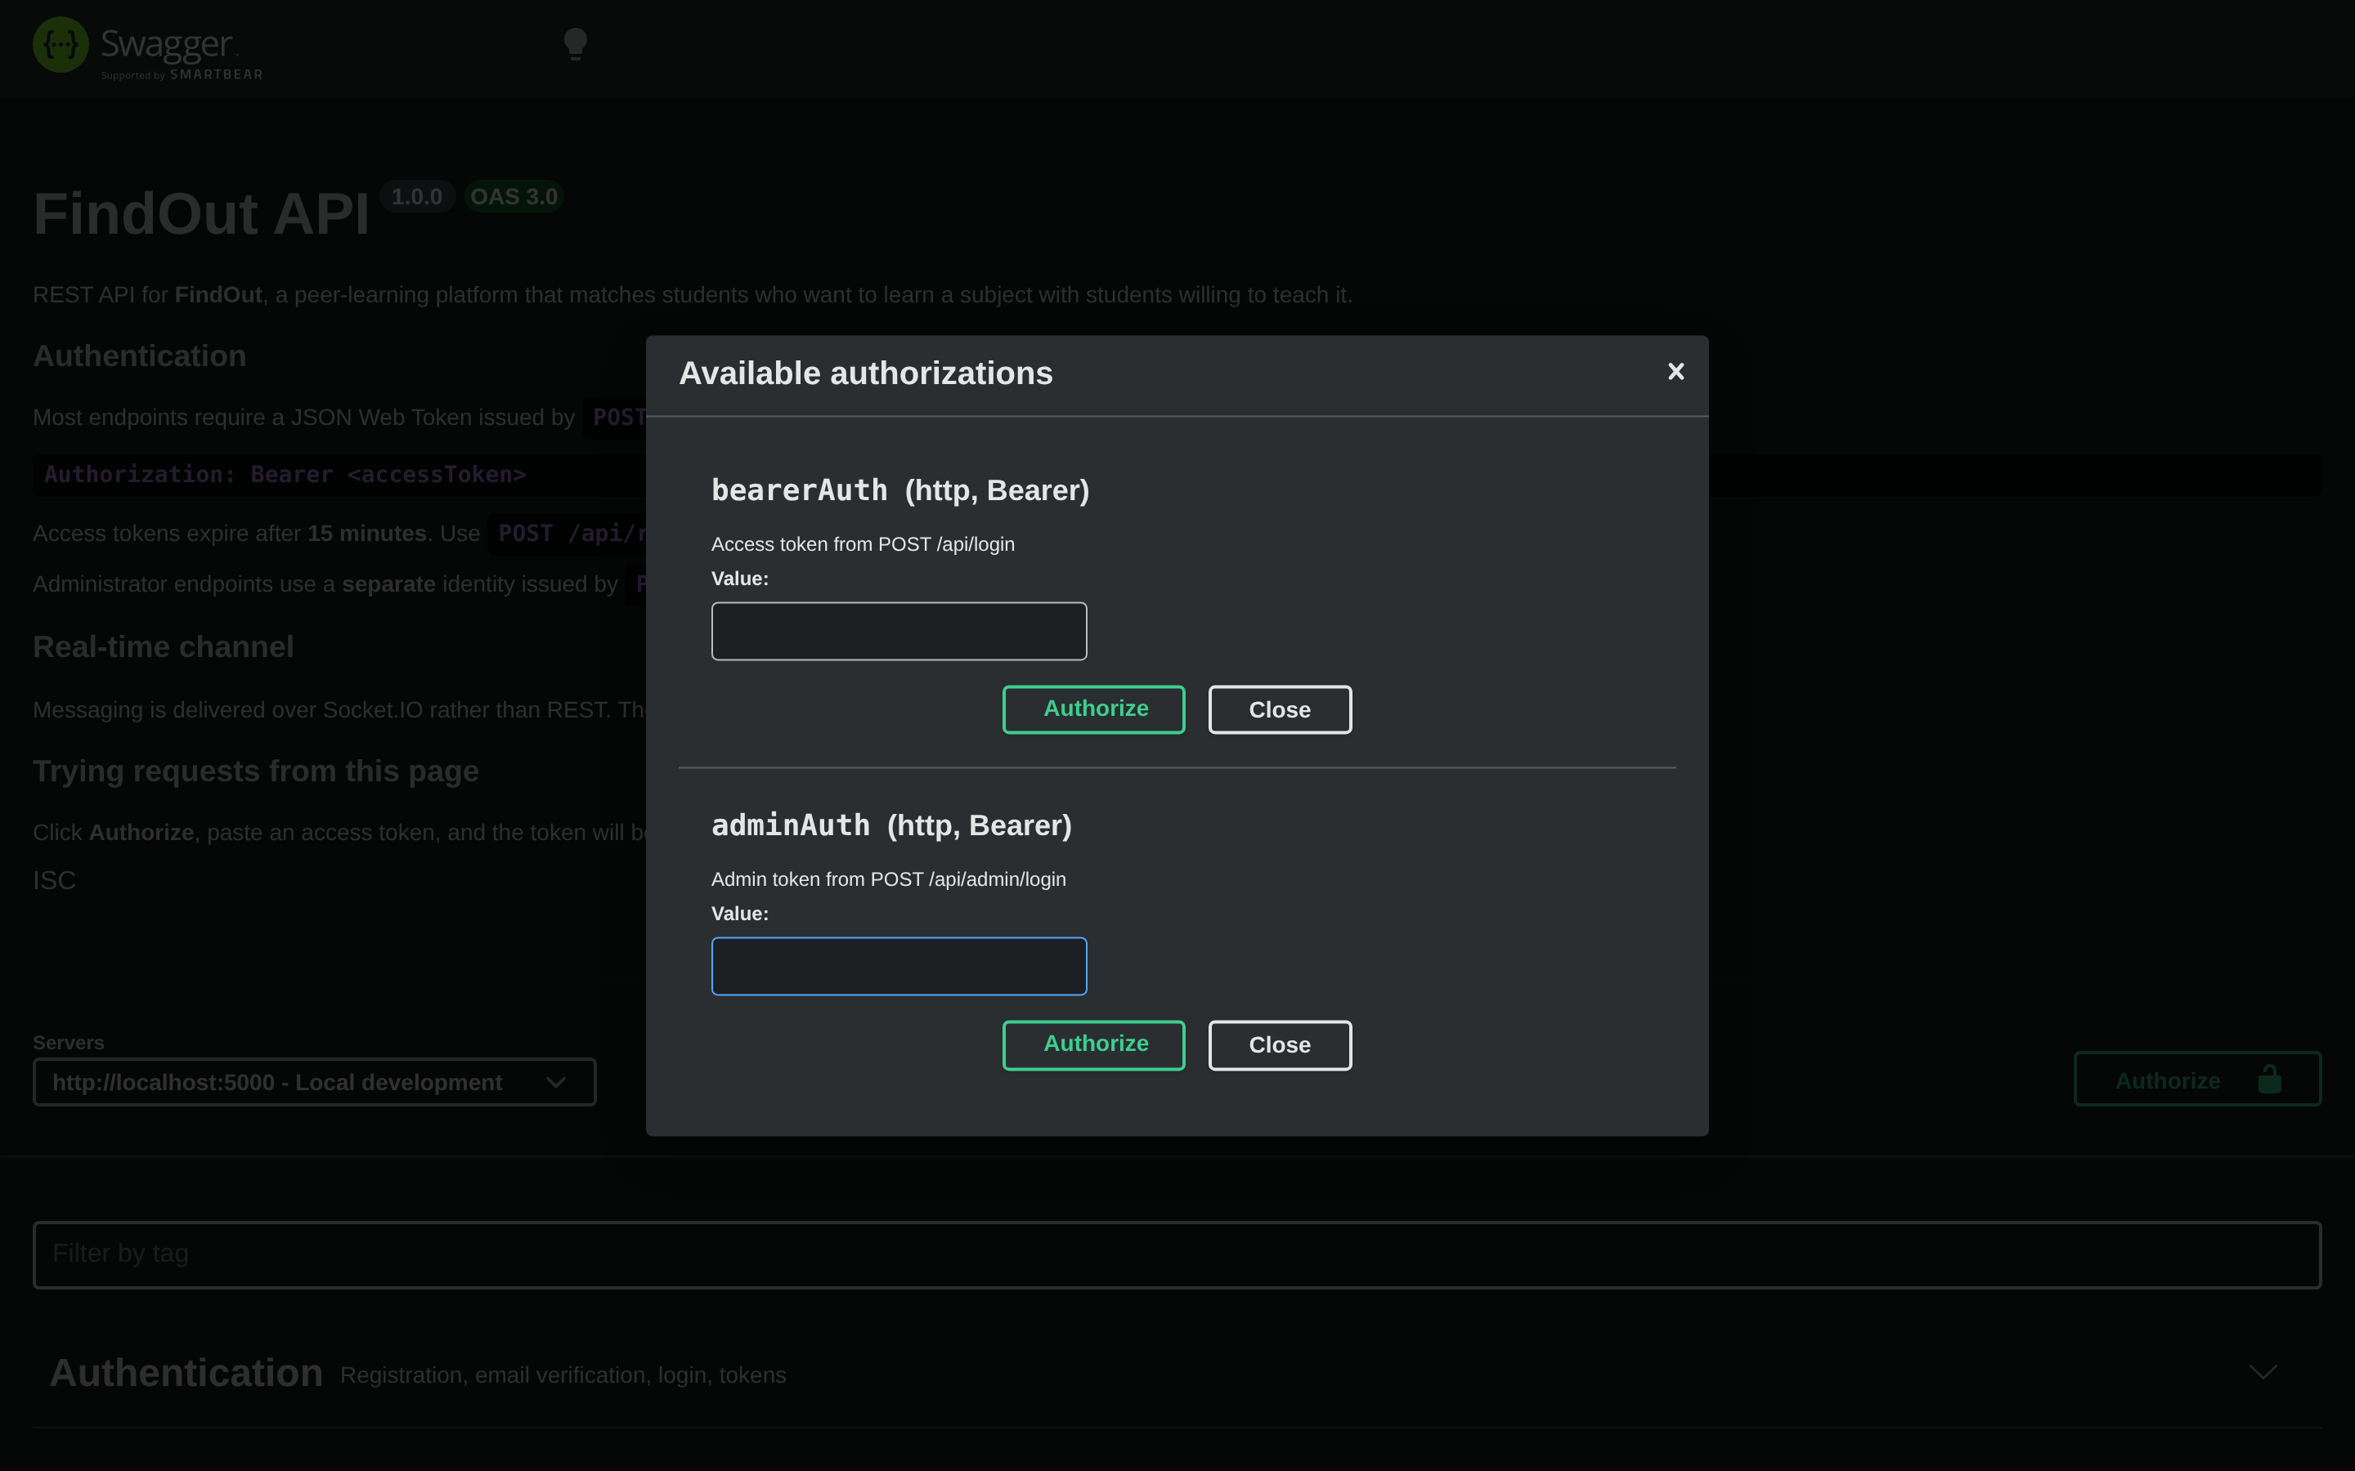
Figure 4.7. The Authorize dialog, used to attach a bearer token to requests executed from the documentation page.

4.5.5 Endpoint testing
Endpoints were exercised throughout development, and are now covered by the executable suite reported in Chapter 5, §5.6, which issues real requests against the running server.
The two figures below show live request and response pairs. They are rendered as terminal output rather than as a Postman window, because the evidence a reader needs is the request sent and the response returned, and that is what is shown. Credentials and tokens are redacted.
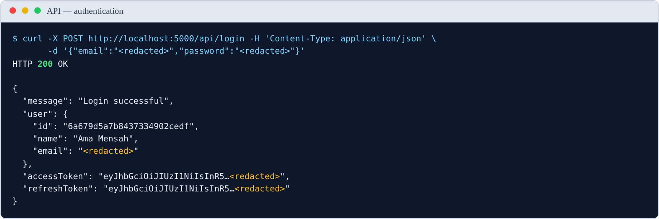
Figure 4.8. The authentication endpoint returning a token pair. Credentials and both tokens are redacted; the tokens are truncated to their first characters to show their form without exposing them.

Figure 4.9. The matching endpoint returning ranked suggestions for an authenticated request. The response is trimmed to the first entries for legibility.

4.6 Module Implementation

4.6.1 Authentication and email verification
Registration hashes the password with bcrypt at cost factor 10, stores the account as unverified, and sends a signed confirmation link. Login is refused until the address is confirmed.
Source: backend/controllers/RegisterUser.js
const hashedPassword = await bcrypt.hash(password, 10);
// multer's file.path is a filesystem path; the client builds URLs as
// `${BACKEND_URL}${storedValue}`, so store a root-relative path instead.
const profilePicture = req.file ? `/uploads/${req.file.filename}` : null;
const newUser = new UserModel({ name, email, password: hashedPassword,
profilePicture, isVerified: false });
await newUser.save();
await sendVerificationEmail(email);
Source: backend/controllers/LoginUser.js
const generateTokens = (userId) => ({
accessToken: jwt.sign({ id: userId }, ACCESS_TOKEN_SECRET, { expiresIn: '15m' }),
refreshToken: jwt.sign({ id: userId }, REFRESH_TOKEN_SECRET, { expiresIn: '7d' }),
});
if (!findUser.isVerified) {
return res.status(403).json({ message: 'Please verify your email before logging in.' });
}
const isMatch = await bcrypt.compare(password, findUser.password);
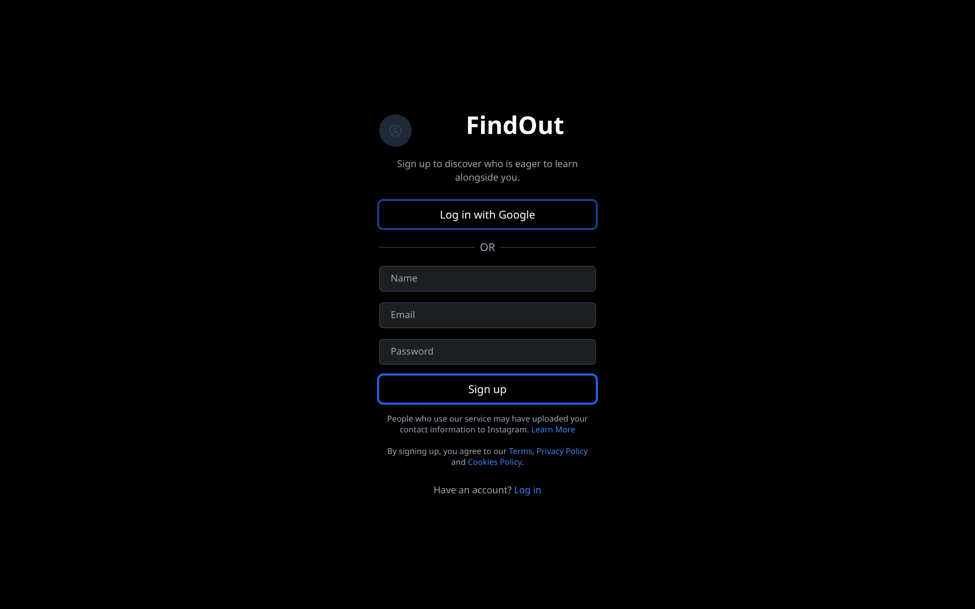
Figure 4.10. Account registration.
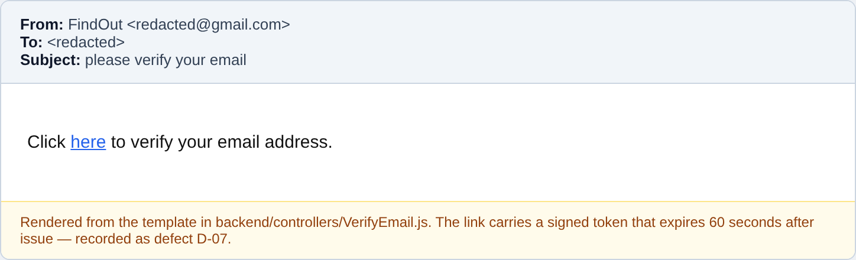
Figure 4.11. The verification email, rendered from the template in backend/controllers/VerifyEmail.js. The signed token in the link expires 60 seconds after issue — defect D-07.
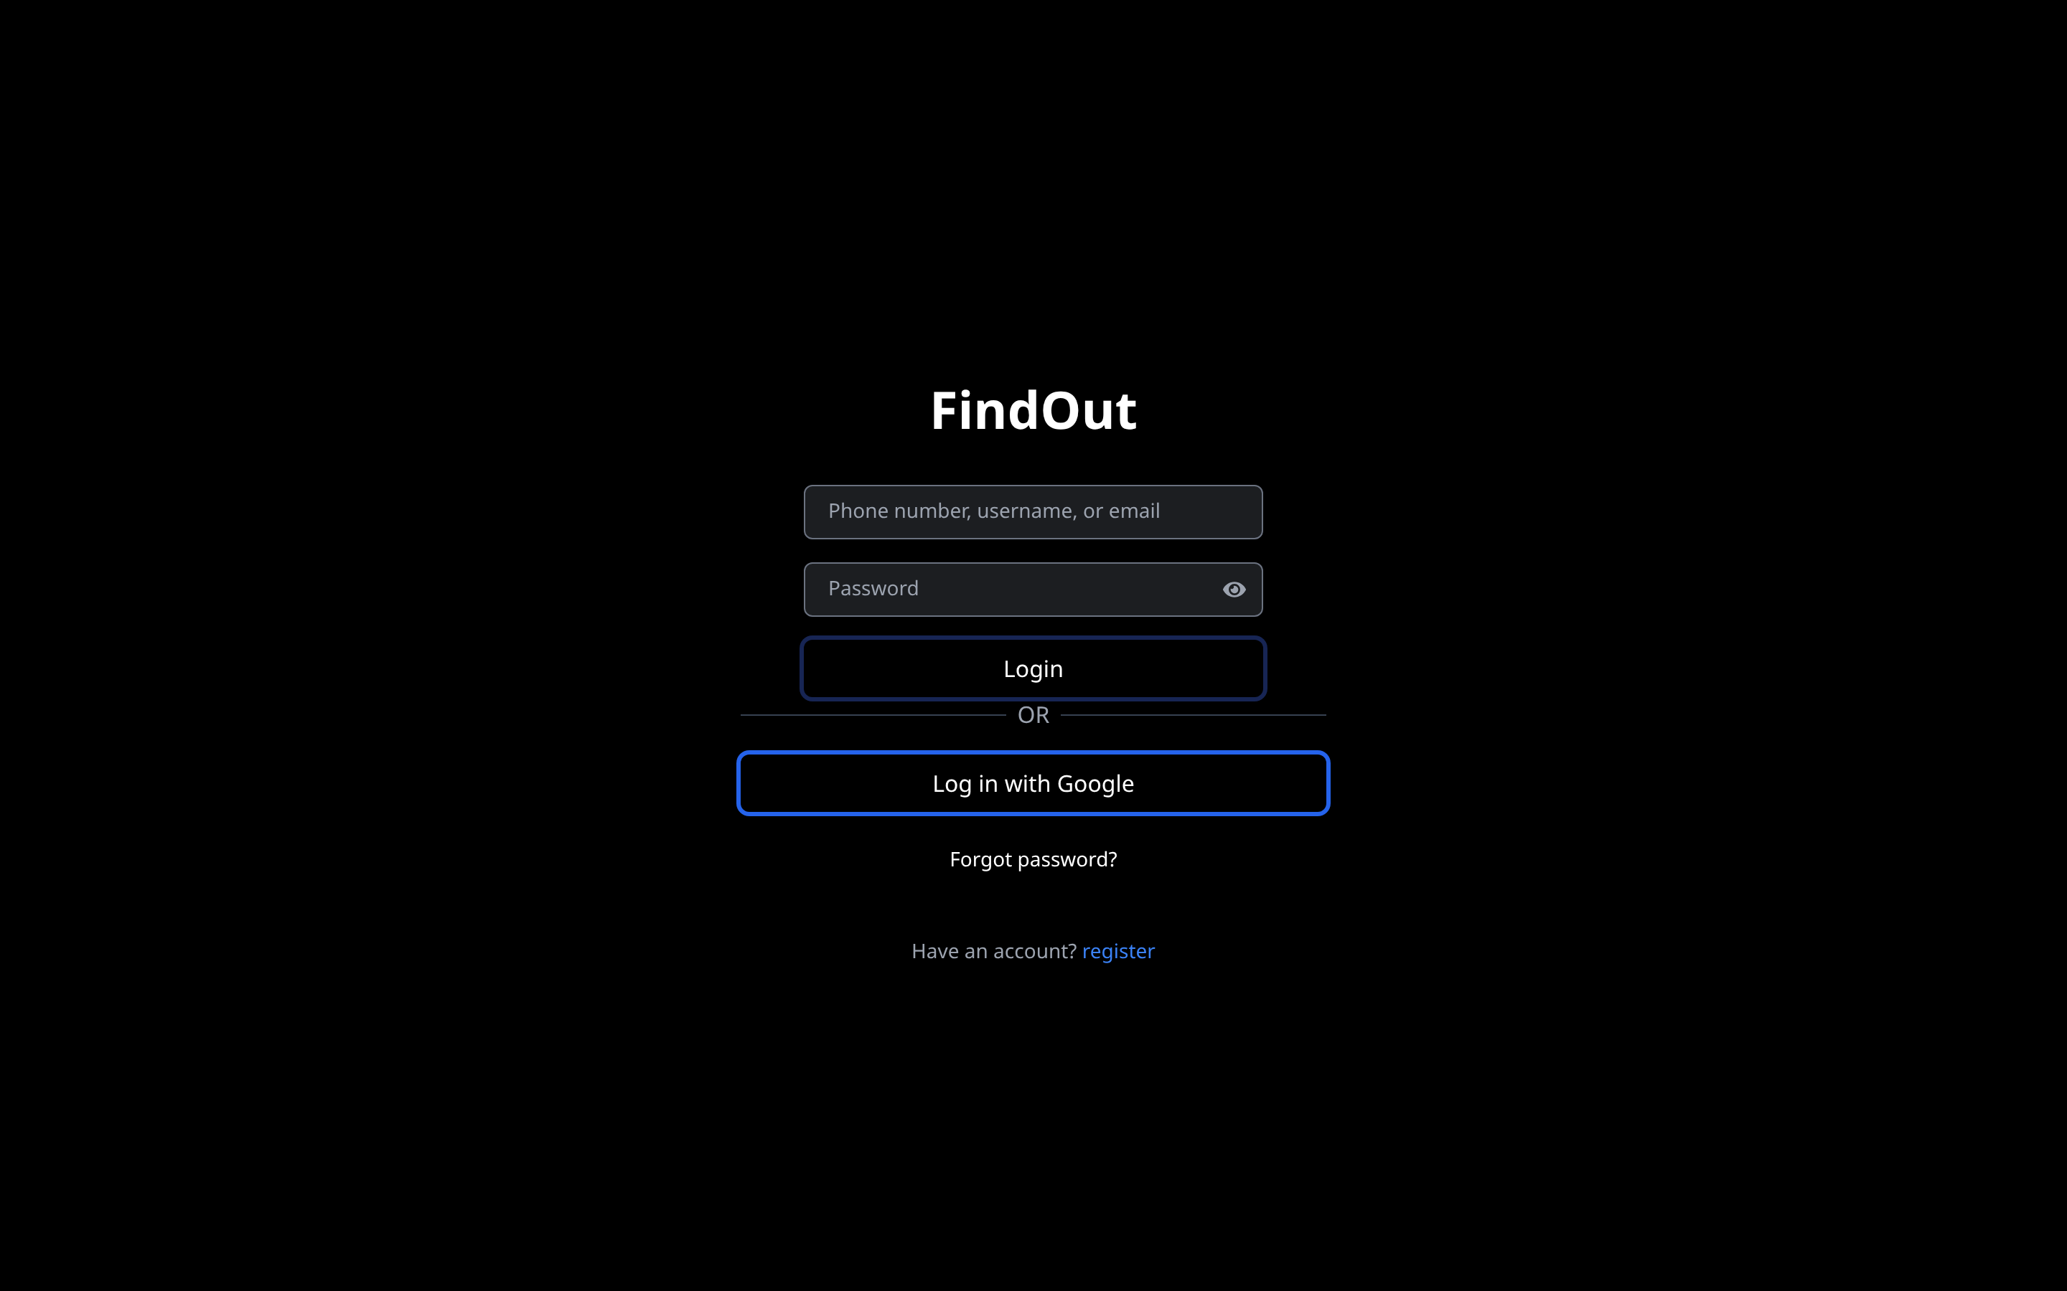
Figure 4.12. The login screen.

4.6.2 Profile and availability
The profile panel is where a student declares the two inputs the matching algorithm consumes: their subjects, and whether they are ready to teach or to learn.
Source: frontend/src/components/ManageUser.jsx
// subjects is a string array on the server; it is edited here as a single
// comma-separated field and converted back on save.
const handleSaveChanges = async () => {
const subjectList = subjects.split(',').map(s => s.trim()).filter(Boolean);
await editUserDetails({ subjects: subjectList, status });
await fetchUserDetails();
setOpenManageUser(false);
};
Availability is presented as three mutually exclusive options, each carrying its own semantic colour so the same meaning is signalled identically everywhere in the interface.

Figure 4.13. The profile panel, where subjects and availability are declared.

4.6.3 The matching engine
This is the central feature. The implementation lives in one controller and has no dependencies beyond the two models it reads, which is what allowed it to be unit-tested in isolation (Chapter 5, §5.3).
Source: backend/controllers/Suggestions.js — the four-tier subject matcher
const fuzzyMatch = (str1, str2) => {
const normalize = (str) => str.toLowerCase().replace(/[+#.\-_\s]/g, '').trim();
const n1 = normalize(str1);
const n2 = normalize(str2);
if (n1 === n2) return { match: true, score: 10 }; // exact
if (n1.includes(n2) || n2.includes(n1)) return { match: true, score: 7 }; // substring
if (n1.length >= 3 && n2.length >= 3 && n1.substring(0, 3) === n2.substring(0, 3)) {
return { match: true, score: 5 }; // shared prefix
}
const distance = levenshteinDistance(n1, n2); // edit distance
const similarity = 1 - distance / Math.max(n1.length, n2.length);
if (similarity >= 0.7) return { match: true, score: Math.floor(similarity * 5) };
return { match: false, score: 0 };
};
Source: same file — complementary status and scoring
let targetStatus = [];
if (user.status === "Ready To Learn") targetStatus.push("Ready To Teach");
else if (user.status === "Ready To Teach") targetStatus.push("Ready To Learn");
// ... per candidate:
if (targetStatus.length > 0 && targetStatus.includes(otherUser.status)) {
matchScore += 20; // complementary role dominates
}
for (const userSubject of user.subjects) {
for (const otherSubject of otherUser.subjects || []) {
const result = fuzzyMatch(userSubject, otherSubject);
if (result.match) { matchScore += result.score; matchedSubjects.push(/* ... */); break; }
}
}
if (otherUser.isOnline) matchScore += 3;
if (matchedSubjects.length > 1) matchScore += matchedSubjects.length * 2;
The weight of 20 for a complementary role is the line where the reciprocal principle from Chapter 2 becomes executable code: it guarantees that one correct role match outranks any accumulation of subject similarity between two students who both want to learn.
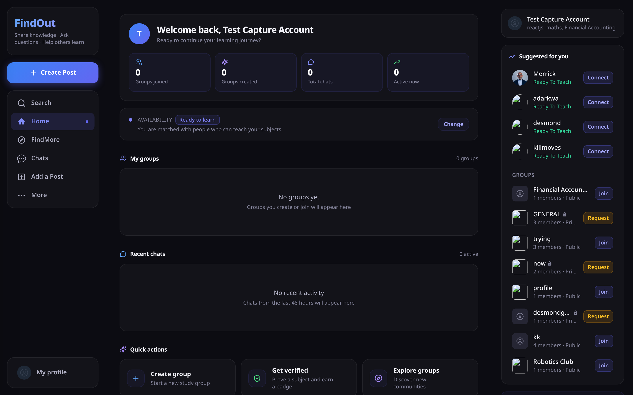
Figure 4.14. Ranked match suggestions produced by the matching engine. All four suggested peers are Ready To Teach, complementing the requesting account’s Ready To Learn status.

Figure 4.15. The suggestion rail, showing peers alongside discoverable groups with their join actions.

4.6.4 Competency verification
The quiz mechanism awards a per-subject badge. Its most important implementation property is that correct answers never leave the server.
Source: backend/controllers/verificationController.js
const questions = await quizGenerator.generateQuiz(subject);
// Strip the answers before responding
const questionsForClient = questions.map(q => ({
question: q.question,
options: q.options,
difficulty: q.difficulty,
}));
// Retain the full set server-side, keyed by session, for marking
global.activeQuizSessions[quizSessionId] = {
questions, startTime: Date.now(), subject, userId,
};
// Marking, and the ownership check that prevents submitting another user's session
if (session.userId !== userId) {
return res.status(403).json({ success: false, message: 'Unauthorized' });
}
const result = quizGenerator.gradeQuiz(session.questions, answers);
verification.addAttempt({ score: result.score, passed: result.passed, /* ... */ });
An accurate statement of question generation. The design intent was to generate subject-specific questions with a large language model, and provision was made for it — the API key is configured and the client library installed. The implemented build does not use it. Question generation uses a fixed bank of ten templates into which the subject name is inserted, and those templates assess pedagogical approach rather than knowledge of the subject. This is recorded here, in Chapter 3 §3.9.4, and in Chapter 5 rather than concealed. Do not describe this system as using AI-generated assessment.

Figure 4.16. Verification status for each declared subject.

Figure 4.17. A competency quiz in progress. The question shown also illustrates defect D-06: it assesses pedagogical approach rather than knowledge of Calculus, because the templates are subject-independent.
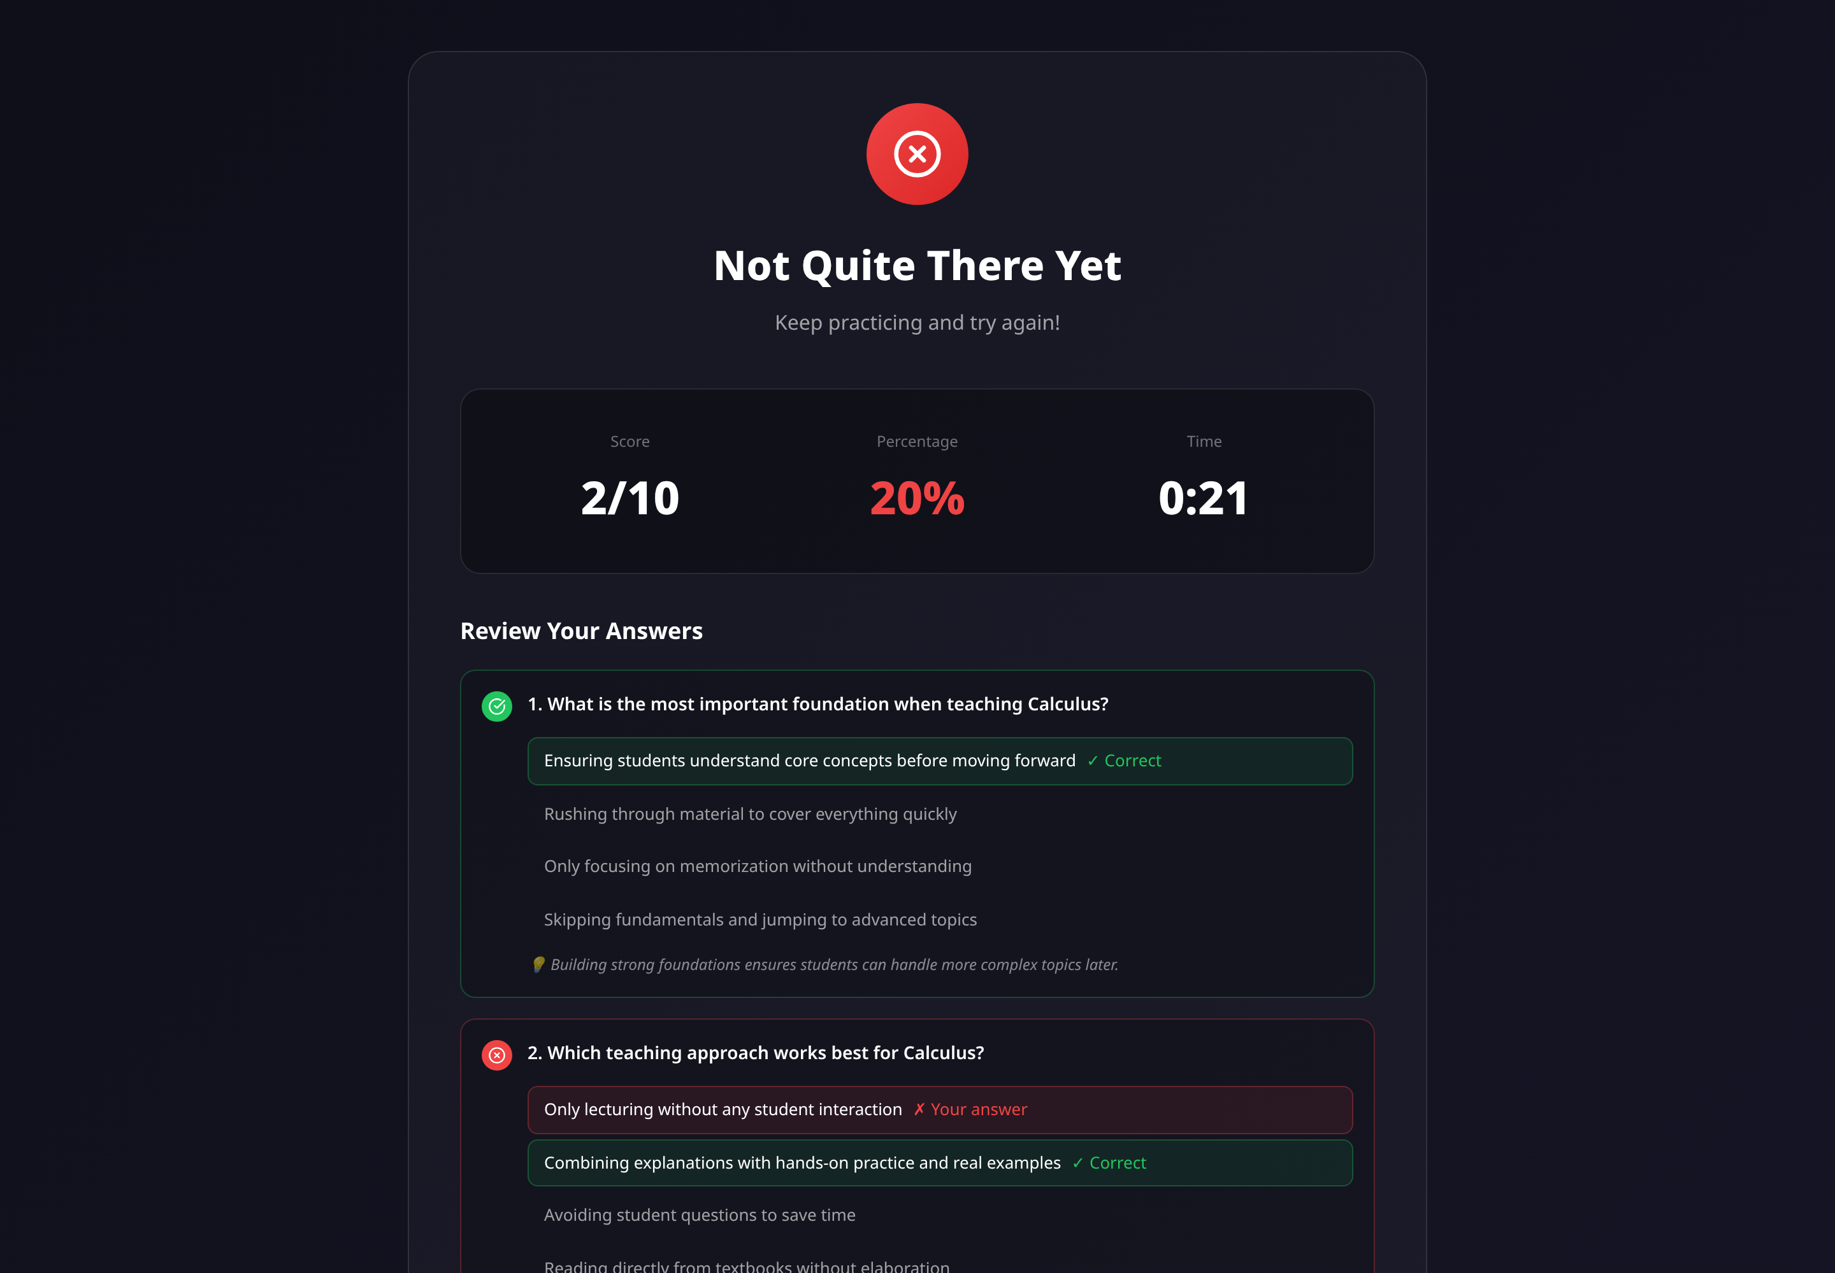
Figure 4.18. Quiz result, showing score, percentage, elapsed time and the option to review answers.

4.6.5 Real-time messaging
Messaging uses Socket.IO rooms: one room per conversation, named by its identifier. A message sent to a room reaches exactly its participants, with no manual recipient list.
Source: backend/socket/Socket.js
socket.on('user-online', async (userId) => {
socket.join(userId); // personal notification room
await User.findByIdAndUpdate(userId, {
isOnline: true, lastSeen: new Date(), socketId: socket.id,
});
const [chats, groups] = await Promise.all([
ChatModel.find({ participants: userId }).lean(),
GroupModel.find({ members: userId }).lean(),
]);
const allChatIds = [...chats.map(c => c._id.toString()),
...groups.map(g => g._id.toString())];
allChatIds.forEach(chatId => socket.join(chatId)); // join every conversation
// Messages that arrived while offline become 'delivered' on reconnect
await MessageModel.updateMany(
{ chatId: { $in: allChatIds }, senderId: { $ne: userId }, status: 'sent' },
{ $set: { status: 'delivered', deliveredAt: new Date() } }
);
socket.broadcast.emit('user-status-changed', { userId, isOnline: true });
});
The implementation rule worth noting is ordering: the server persists a message before broadcasting it. Broadcasting first would be marginally faster but risks a message appearing on screen and then vanishing if the write fails.

Figure 4.19. Real-time message delivery between two accounts, showing presence and read status.

4.6.6 Groups and privacy
The three privacy levels produce three different join paths from a single request.
Source: backend/controllers/JoinGroup.js
// SECRET: not joinable by request at all
if (group.privacy === 'secret') {
return res.status(403).json({
success: false,
message: 'This group is secret. You can only join via an invite link.',
});
}
// PRIVATE: create a pending request and notify the administrator
if (group.privacy === 'private') {
group.pendingRequests.push({ userId, requestedAt: new Date() });
await group.save();
getIo().to(group.groupAdmin._id.toString()).emit('new-join-request', { /* ... */ });
return res.status(200).json({ success: true, isPending: true, /* ... */ });
}
// PUBLIC: join immediately
group.members.push(userId);
group.unreadCount.push({ userId, count: 0 });
await group.save();
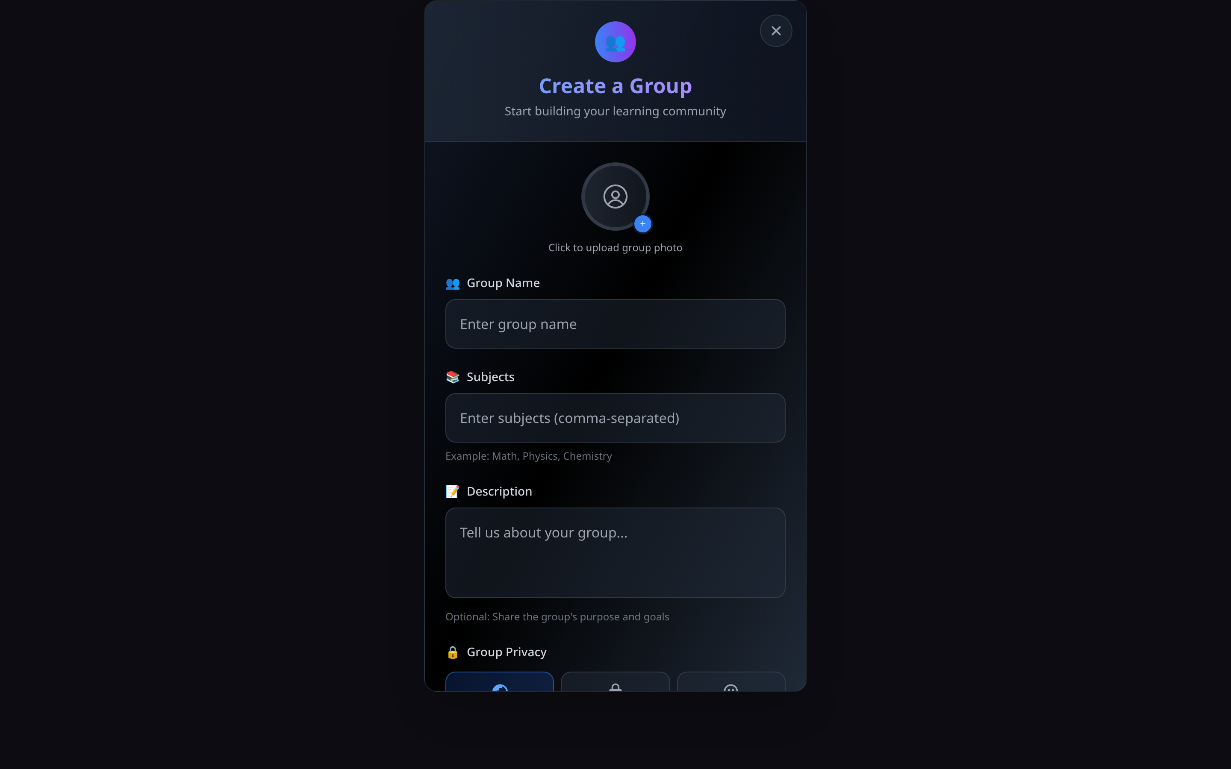
Figure 4.20. Creating a study group, showing the three privacy levels.
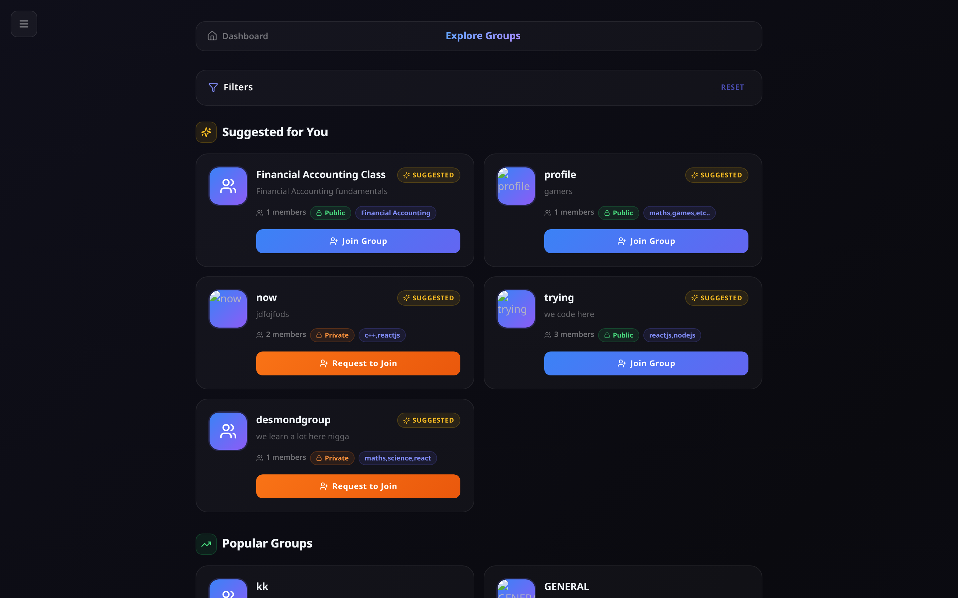
Figure 4.21. Group discovery. Public groups offer Join and private groups offer Request; secret groups do not appear at all.
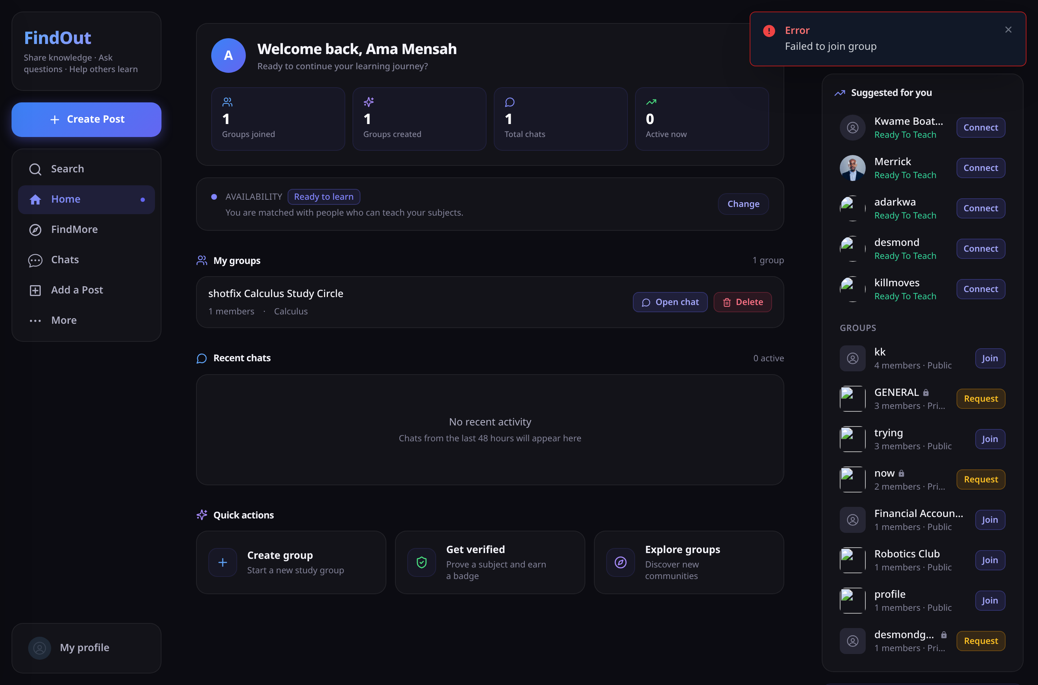
Figure 4.22. A pending join request awaiting the group administrator’s decision.

4.6.7 Learning resource feed
Posts carry a subject tag and a type classification (resource, help, explanation, challenge, general) so a shared resource is distinguishable from a request for help. The endorsement action is named helpful rather than “like”: in a learning context, marking something helpful communicates educational value where a like communicates approval. The database field, the API route and the interface label were all renamed together.

Figure 4.23. The learning resource feed, showing subject tags, type badges and helpful counts.

Figure 4.24. A post with its comment thread open, showing a threaded reply.
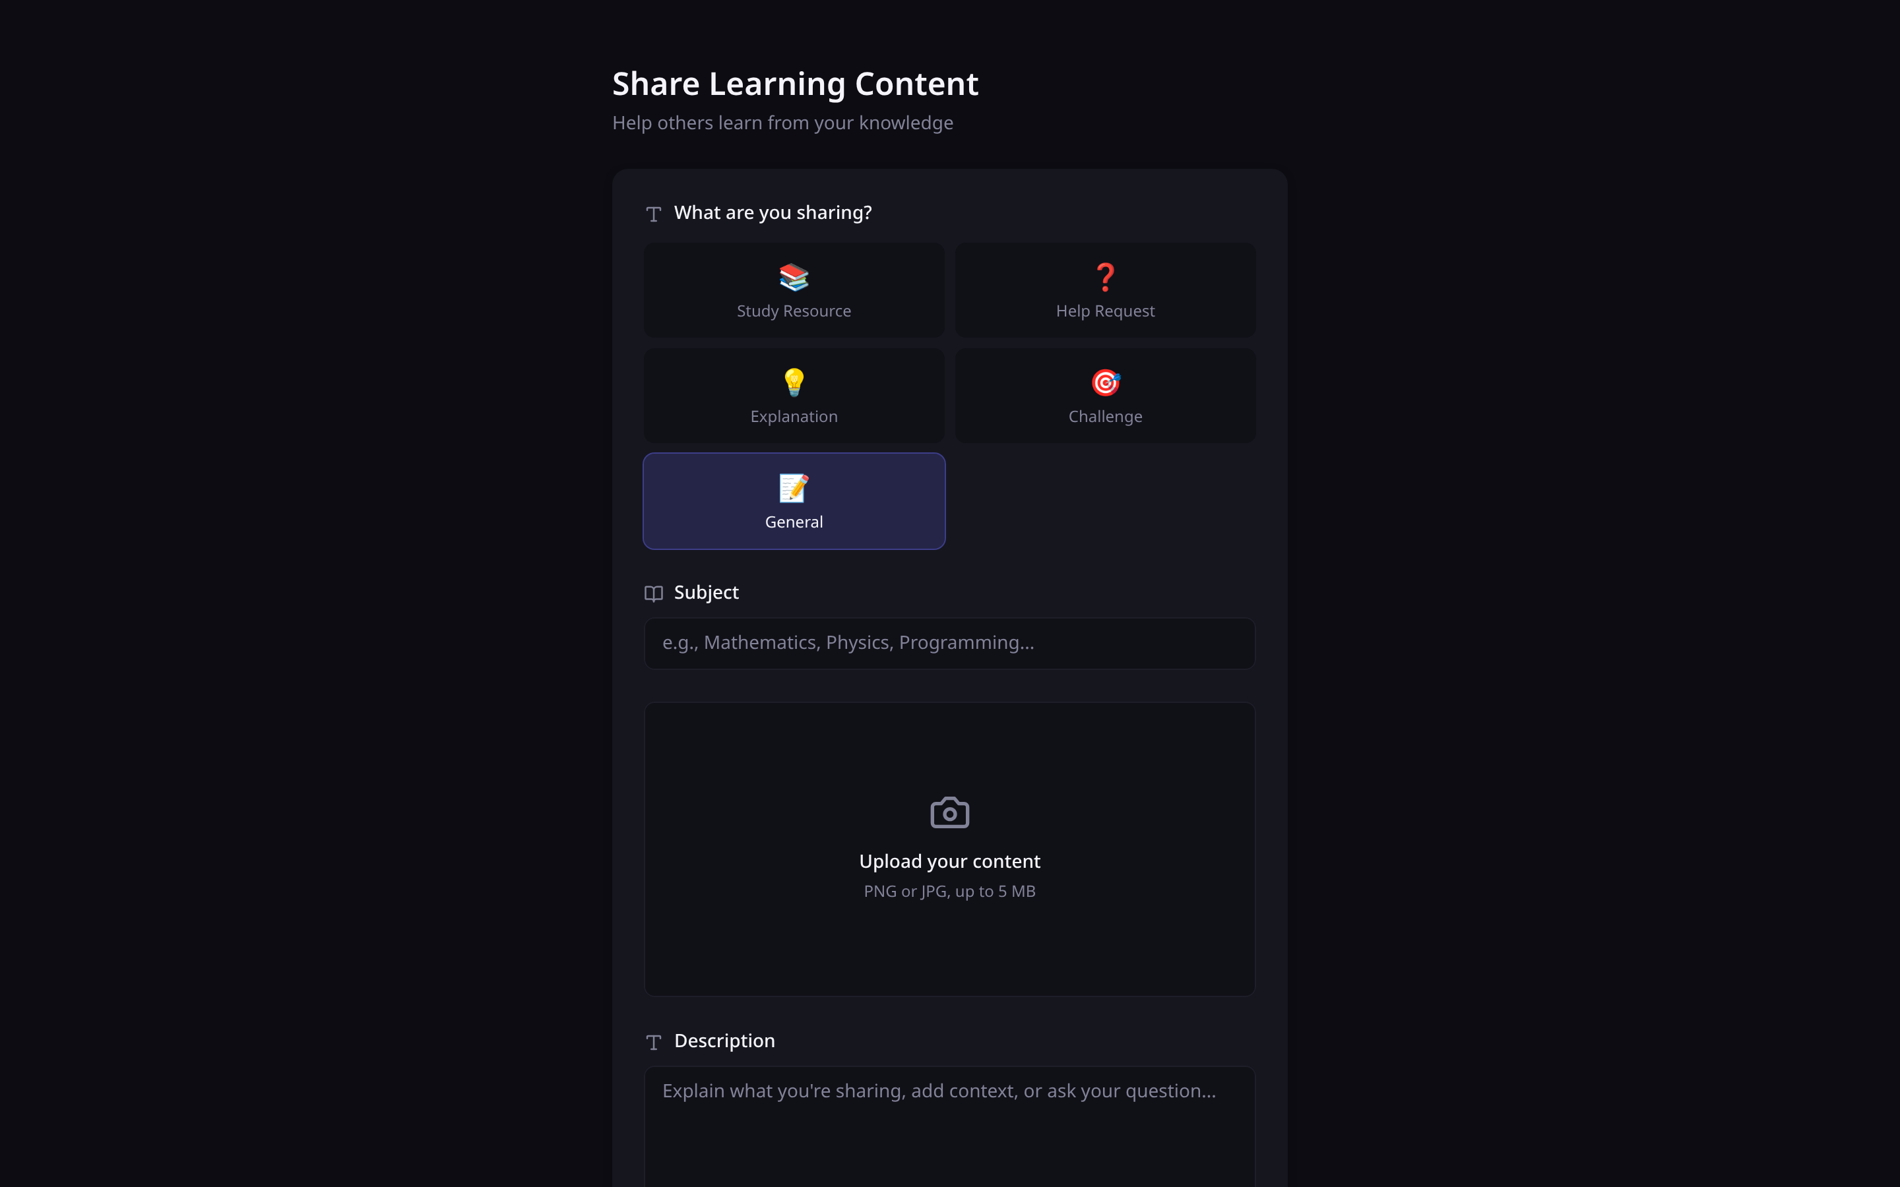
Figure 4.25. Publishing a learning resource, showing the five post types.

4.6.8 Administration
Administration uses a completely separate identity system: a different collection, a different login endpoint and different middleware. A user account cannot be escalated through any user-facing route, and the first super administrator is created by running a script directly on the server.
Source: backend/controllers/adminController.js — statistics by aggregation
const [totalUsers, totalPosts, totalGroups, onlineUsers, teacherCount, learnerCount] =
await Promise.all([
UserModel.countDocuments(),
PostModel.countDocuments(),
GroupModel.countDocuments(),
UserModel.countDocuments({ isOnline: true }),
UserModel.countDocuments({ status: 'Ready To Teach' }),
UserModel.countDocuments({ status: 'Ready To Learn' }),
]);
const topSubjects = await PostModel.aggregate([
{ $group: { _id: '$subject', count: { $sum: 1 } } },
{ $sort: { count: -1 } },
{ $limit: 10 },
]);
The teach-versus-learn split is the measure with institutional value: it shows which subjects generate demand for help that supply is not meeting.
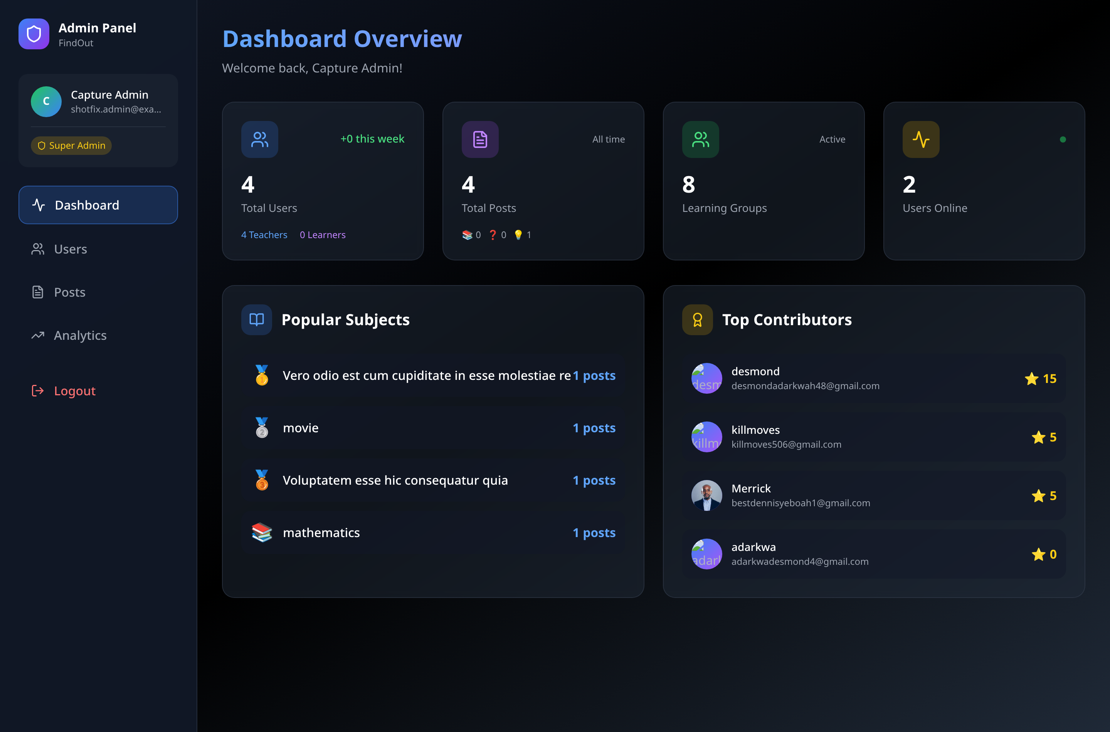
Figure 4.26. The administrator dashboard, showing platform totals, the teach-versus-learn split, popular subjects and top contributors. Email addresses must be redacted before submission.
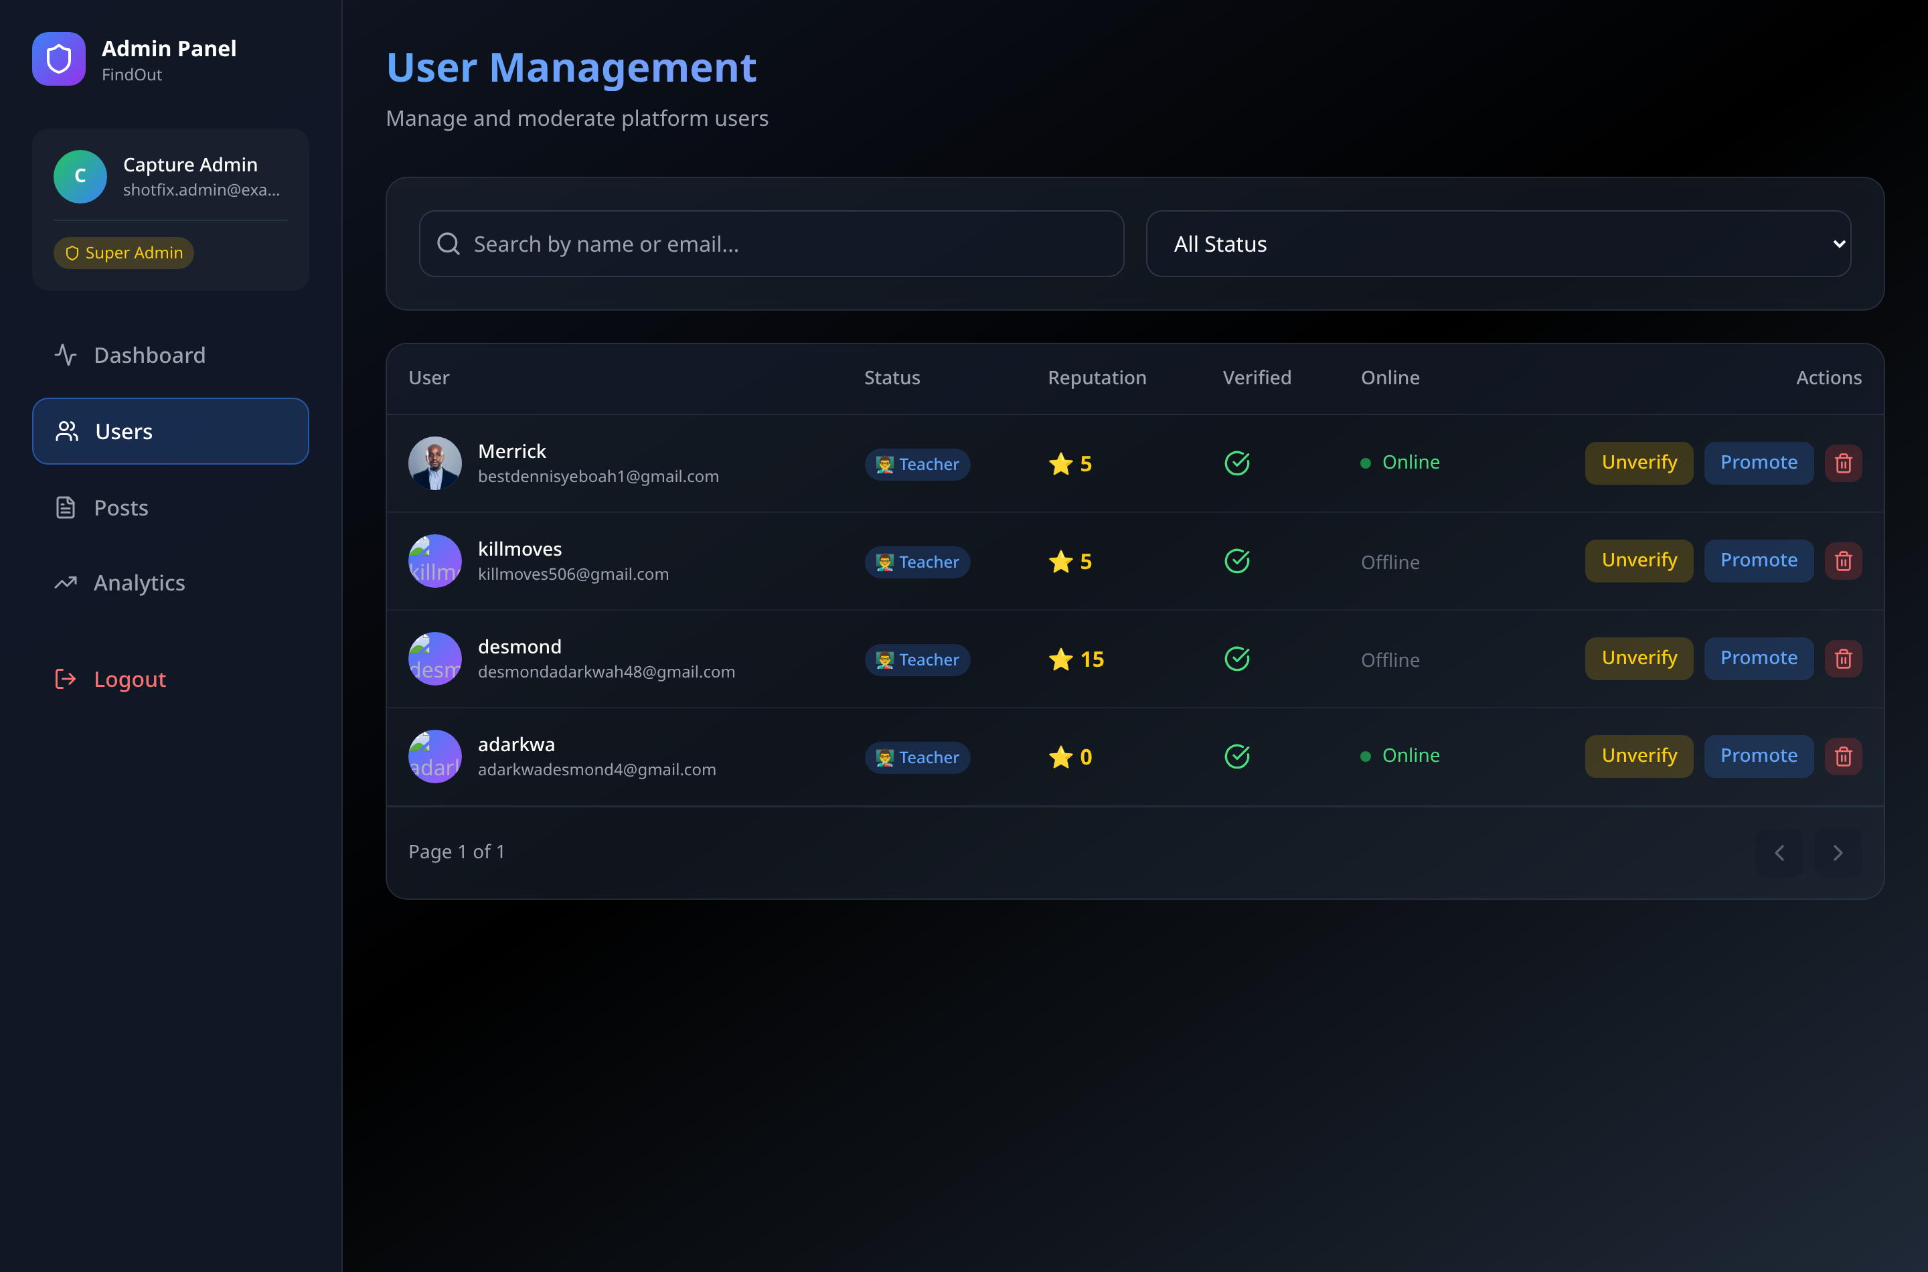
Figure 4.27. Administrator user management. Email addresses must be redacted before submission.

4.7 Frontend Implementation

4.7.1 Application composition
Source: frontend/src/main.jsx
createRoot(document.getElementById('root')).render(
<StrictMode>
<Router>
<Provider> {/* 13 nested context providers */}
<App />
<ToastContainer />
</Provider>
</Router>
</StrictMode>
);
Shared state is held in React Context providers rather than passed manually between components. Nesting order matters: ToastProvider is outermost so a notification can be raised from anywhere.

4.7.2 Transparent token renewal
Access tokens expire after 15 minutes. Rather than forcing the user to log in again, an Axios interceptor renews them invisibly.
Source: frontend/src/utils/axiosInstance.js
axiosInstance.interceptors.response.use(
(response) => response,
async (error) => {
const originalRequest = error.config;
if (error.response?.status === 401 && !originalRequest._retry) {
originalRequest._retry = true; // retry once only
try {
const refreshToken = getRefreshToken();
const { data } = await axios.post(`${BASE}/api/refresh-token`, { refreshToken });
setTokens(data);
originalRequest.headers.Authorization = `Bearer ${data.accessToken}`;
return axiosInstance(originalRequest); // replay the original call
} catch (refreshError) {
clearTokens();
window.location.href = '/login';
}
}
return Promise.reject(error);
}
);
The result is that no component contains token-handling code, and no component is aware that tokens expire.

4.7.3 Design token system
The interface is built on a token layer rather than ad-hoc colours, so a change to the palette is a change to one file.
Source: frontend/src/index.css
:root {
/* Surfaces — an elevation ladder, darkest to lightest */
--surface-base: 12 12 18;
--surface-raised: 22 22 31;
--surface-overlay: 31 31 43;
/* One accent family */
--primary-500: 99 102 241; /* indigo */
--accent-500: 139 92 246; /* violet */
/* Semantic status, matching the availability values */
--success-400: 52 211 153; /* Ready To Teach */
--warning-400: 251 191 36; /* Later */
}
Values are stored as RGB channels so Tailwind opacity modifiers still work (bg-surface-raised/60). Colour is used to signal meaning, not decoration: availability status carries the same colour on every screen.

4.7.4 Responsive behaviour
The interface adapts to screen width. Separate components exist for mobile navigation, because the desktop sidebar layout does not compress usefully to phone width. Mobile is the dominant access mode in the target population, so this was treated as a requirement rather than an enhancement.
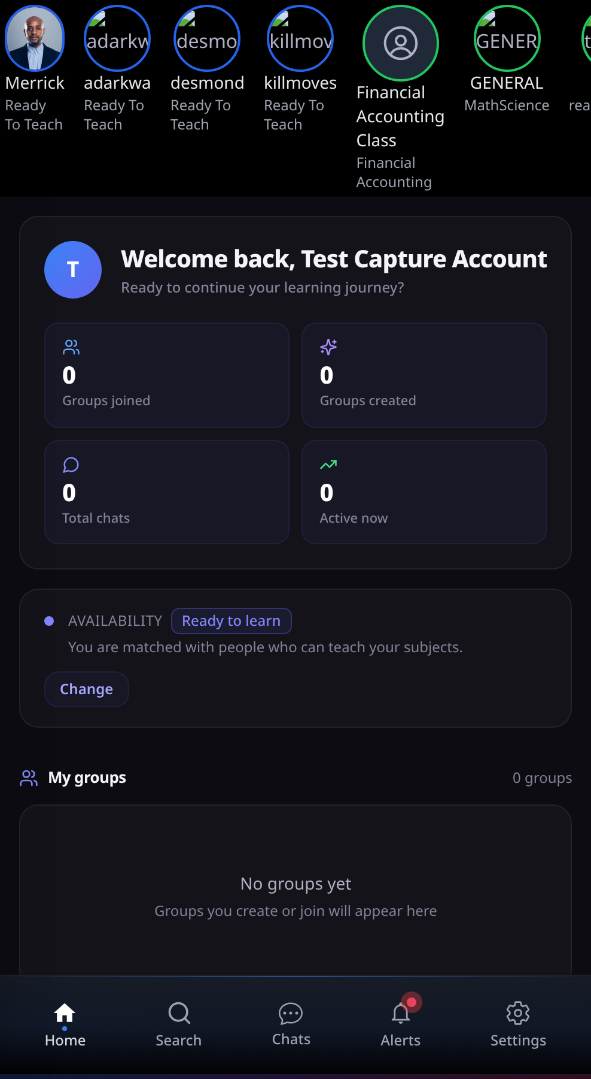
Figure 4.28. The dashboard on a mobile viewport, with the fixed bottom navigation clear of the content.

Figure 4.29. Messaging on a mobile viewport.

4.8 Implementation Statistics
Table 4.3
Quantitative Summary of the Implemented System
All figures below are produced by scripts/project-metrics.js, which counts them from the source tree rather than by hand, so the table can be regenerated after any change.
Metric | Value
Backend code | 8,316 lines across 69 files
Frontend code | 13,639 lines across 64 files
Total application code | 21,955 lines
Controllers | 32
Database models / collections | 7 files, 8 collections
Express routers | 4
Middleware modules | 5
Services | 1
Migration scripts | 11
Test and benchmark scripts | 4
REST endpoints | 58
Documented API operations | 58 (100% coverage)
OpenAPI schema definitions | 10, across 9 tags
Socket events (client to server) | 10, including disconnect
Socket events (server to client) | 8
React pages | 13
React components | 28 (24 general, 4 feed)
Context providers | 13
Modules transformed at build | 1,817
JavaScript bundle | 952.73 kB raw, 254.24 kB gzipped
CSS bundle | 74.93 kB raw, 12.74 kB gzipped
Production build time | ≈ 10 s
Table 4.4
Requirement Completion by Module
Module | Implemented | Partial | Not implemented
M1 Authentication | 12 | 1 | 0
M2 Profile | 9 | 1 | 1
M3 Verification | 13 | 1 | 2
M4 Matching | 12 | 2 | 0
M5 Groups | 16 | 0 | 1
M6 Messaging | 14 | 0 | 2
M7 Feed | 11 | 0 | 3
M8 Administration | 11 | 0 | 1
Total | 98 | 5 | 10
These figures are not estimates. They are counted from the status column of the Software Requirements Specification, which records a status against each of its 113 numbered requirements; the three totals reconcile exactly (98 + 5 + 10 = 113).
Approximately 87% of specified requirements are fully implemented. The remaining 13% is concentrated in three areas, all documented in §4.10: question generation using a language model, per-subject availability, and feed pagination.

4.9 Development Challenges and Solutions
Seven substantial problems were encountered. The problem-solving process is part of what this chapter should evidence, so each is described with its cause and resolution.

4.9.1 Case-sensitive file paths
Problem. The application ran correctly in development but crashed immediately on a Linux server with Cannot find module '../socket/socket'.
Cause. Eleven imports used different capitalisation from the actual filenames — for example importing socket/socket when the file is socket/Socket.js. Windows and macOS filesystems ignore capitalisation; Linux does not.
Solution. A script checked every relative import in both packages against the real filenames. Eleven mismatches were found and corrected.
Lesson. Develop and test on the same filesystem behaviour as the deployment target.

4.9.2 Inadequate group privacy model
Problem. The original design stored privacy as a boolean. Testing revealed a needed case it could not express: a group that should be findable but not automatically joinable.
Solution. The field was replaced with a three-value enumeration, the join logic rewritten to branch on it, a pending-requests structure added, and a migration written for existing records.
Lesson. Direct evidence that the incremental method was necessary; under Waterfall this would have surfaced only at final testing.

4.9.3 Image uploads failing silently
Problem. Uploaded profile pictures and post images never displayed.
Cause. Four independent faults formed a chain. uploads/ and audios/ are git-ignored and were never created, and multer does not create its destination — so every upload failed with ENOENT before the controller ran. Two controllers stored multer’s filesystem path rather than a URL path. One frontend component built its URL with a hardcoded host and a doubled slash.
Solution. Both upload middlewares now create their directories on load; both controllers store root-relative /uploads/... paths; the frontend uses the configured base URL. A migration repairs records written earlier.
Lesson. A single visible symptom can have several independent causes. Fixing them one at a time produced no visible change until the last one was corrected, which was misleading.

4.9.4 Server starting without a database
Problem. When the database was unreachable, the server started anyway and every request failed after a ten-second buffering timeout, so the logs showed a flood of timeouts rather than the actual cause.
Cause. connectDB caught its own error and returned normally, so the caller’s success path ran.
Solution. The error now propagates; the server reports the likely causes and exits.

4.9.5 Undeclared dependencies
Problem. The project would not build from a fresh clone. react-router-dom and react-icons were imported throughout but missing from package.json; they were present in the local node_modules, so the error never appeared during development.
Solution. Both declared explicitly. A root manifest now installs both packages with one command.
Lesson. Verify periodically that a clean copy builds; reproducibility failures are invisible from inside a working environment.

4.9.6 Authorisation applied inconsistently
Problem. Functional testing (Chapter 5, §5.6) found that any authenticated user could delete any group and read any private conversation.
Cause. Not two isolated oversights but one structural gap. Authentication is enforced by a single middleware applied to every protected route, so it is uniform. Authorisation is written by hand inside individual controllers, so whether a given action checks ownership depends on whether it was remembered at the time. HandleJoinRequest checks correctly; DeleteGroup and GetMessages do not.
Why inspection missed it. Reading a controller that does check ownership gives no signal that a sibling controller does not. The gap is only visible when the behaviour is exercised, which is what the executable functional suite did.
Remedy. Recorded as D-25 and D-26, with the structural fix — ownership middleware applied to every route operating on a specific resource — recommended in Chapter 5, §5.11.
Lesson. A cross-cutting concern implemented per-controller will eventually be omitted from one. Uniformity is a property of the mechanism, not of the developer’s memory.

4.9.7 Matching weight calibration
Problem. The scoring weights had to be chosen with no ground-truth data indicating what a correct match looks like.
Solution. Weights were derived from the design principle — complementary role must dominate subject similarity — then tested against constructed profiles to confirm sensible ranking.
Limitation. This remains a hand-tuned heuristic, stated as such in Chapter 3 §3.8.6 and revisited in Chapter 5.

4.10 Known Defects and Limitations
Including this section strengthens the report. A project that identifies its own weaknesses demonstrates more engineering judgement than one that claims none.
Table 4.5
Known Defects and Limitations
ID | Severity | Description | Effect | Remedy
D-02 | Critical | The refresh-token secret is read from JWT_REFRESH_SECRET but .env defines REFRESH_TOKEN_SECRET, so the lookup falls back to a literal written in the source. | Refresh tokens are signed with a key visible in the code. Anyone reading it can forge a token for any user. | Rename to match and remove the fallback so the server refuses to start without a real secret.
D-21 | Critical | Socket.IO connections are unauthenticated. user-online accepts any user id from the client; send-message takes the sender from the payload. | A client can impersonate any user, join their private rooms, read their messages and send as them. | Verify a JWT in the connection handshake; take identity from the token.
D-22 | High | POST /api/messages takes senderId from the request body rather than the token. | Any authenticated user can send a message appearing to come from someone else. | Use req.authenticatedUser.id.
D-25 | High | DeleteGroup performs no authorisation check. The controller contains no reference to groupAdmin and no comparison against req.authenticatedUser. | Any authenticated user can delete any group and its entire message history. Found by functional testing (TC-GRP-05); see Chapter 5 §5.6.1. | Load the group, compare groupAdmin to the caller, return 403 when they differ.
D-26 | High | GetMessages queries MessageModel.find({ chatId }) with no check that the caller participates in that conversation. | Any authenticated user can read any private conversation given its identifier — an insecure direct object reference. Found by functional testing (TC-SEC-04); see Chapter 5 §5.6.2. | Confirm the caller appears in the chat’s participants or the group’s members.
D-28 | High | The administrator session does not survive a page refresh. admin in context is populated only by an in-session login; nothing rehydrates it from the stored token. The dashboard’s stats effect is gated on admin, and statsLoading is initialised true, so on a reload it never clears. | The administrator area shows a permanent loading spinner after any refresh or direct navigation, despite a valid token and a successful /dashboard/stats response. | Call checkAuth() on mount when a token is present, or derive admin from the token.
D-29 | Medium | StartQuiz creates the verification record with check-then-act: findOne, then save if absent. Two concurrent requests both pass the check and the second violates the unique index on {userId, subject}. | React StrictMode issues the request twice in development, so the first returns 500 and the client shows “Failed to start quiz” and navigates away, even though the second succeeded. A double-click can reproduce it in production. | Use findOneAndUpdate with upsert: true, which is atomic.
D-27 | Low | Multer’s rejection of an oversized or wrong-type upload is unhandled, so the server answers 500 rather than 400. | The file is correctly refused, so the security property holds, but a client cannot distinguish “your file was rejected” from “the server failed”. | Add error-handling middleware that maps multer errors to 400.
D-03 | High | Tokens are stored in localStorage. | Any injected script can read them, so an XSS flaw becomes full account compromise. | Use httpOnly, Secure, SameSite cookies.
D-04 | High | No rate limiting. GET /getallposts and POST /messages/audio have no auth middleware. | Unthrottled password guessing; unauthenticated file upload. | Add express-rate-limit; apply auth to both routes.
D-23 | Medium | Admin tokens are signed with the same secret as user tokens. | The two trust domains are not cryptographically separated. | Use a separate ADMIN_JWT_SECRET.
D-05 | High | Availability is a single account-level field. | A student cannot be ready to teach one subject and learn another — a common real situation. | Move intent into the subjects array.
D-06 | High | Quiz questions come from a fixed template bank, not a language model. | Every subject produces structurally identical questions assessing teaching approach, not knowledge. | Connect the installed SDK; caching and marking already support it.
D-24 | High | Normalisation strips + # . - _, so C++ and C# reduce to the single character c, which substring-matches any subject containing a “c”. | A user listing C++ receives near-random suggestions. Confirmed against ten unrelated subjects, all of which matched. | Require a minimum length for substring matches; map symbols to letters (C++ → cplusplus).
D-07 | High | Email verification tokens expire after 60 seconds. | Most users cannot open their email and click within a minute, so registration fails in normal use. | Increase to 24 hours.
D-08 | Medium | reputation is stored and displayed but never incremented. | The admin top-contributors list is meaningless. | Increment on helpful marks and verifications.
D-09 | Medium | The 10-minute quiz limit is sent to the client but not enforced on submission. | A student may take unlimited time. | Compare stored start time to submission time server-side.
D-10 | Medium | Active quiz sessions are held in a server memory variable. | Sessions are lost on restart, and the design breaks with more than one server instance. | Store in MongoDB or Redis with expiry.
D-11 | Medium | Users with status Later receive no complementary bonus but can still appear via subject overlap. | Unavailable students appear in suggestions. | Exclude Later from the candidate query.
D-12 | Medium | The feed and several list endpoints return all records with no pagination. | Response size grows without limit. | Add cursor or skip/limit pagination.
D-13 | Medium | An image is required on every post. | A text-only question cannot be posted — a serious restriction for the help type. | Make the image optional.
D-14 | Medium | Deleting a user does not remove their posts, messages or memberships. | Orphaned references cause display errors. | Cascade or anonymise.
D-15 | Medium | Suggestions loads the entire user collection into memory on every request. | Response time grows linearly with user count; the main scalability limit. | Move scoring into an aggregation pipeline; index subjects.
D-16 | Low | The substring rule matches Java inside JavaScript. | Occasional irrelevant suggestion. | Same remedy as D-24.
D-17 | Low | Uploads are written to local disk. | Files are destroyed when a hosting platform redeploys. | Use object storage.
D-18 | Low | isVerified means two different things: email confirmed, and quiz passed. | Passing a quiz marks the account email-verified; an admin “unverify” can lock a user out of login. | Split into isEmailVerified and derive subject verification from verifiedSubjects.
D-19 | Low | Automated coverage is limited to the four suites in backend/tests/, which exercise the API and the matching algorithm. | React components have no tests, and WebSocket delivery is verified manually. | Add a component test runner and a multi-client socket harness.
D-20 | Low | Dependency vulnerabilities reported by npm audit. | Mostly transitive denial-of-service advisories. | Run npm audit fix and retest.

4.10.1 Priority order for remaining work
- D-02 and D-21 — both permit account takeover. Fix before any public demonstration.
- D-25 and D-26 — found by functional testing rather than inspection; any user can delete any group or read any conversation.
- D-22 and D-23 — identity spoofing and weak trust separation.
- D-24 — degrades the core feature for a predictable class of users.
- D-07 — registration is currently unusable in normal conditions.
- D-04, D-03 — authentication hardening.
- D-05 — per-subject intent, the highest-value functional improvement.

4.11 Chapter Summary
This chapter presented the system as built.
The implementation comprises 21,955 lines of code across two packages: a Node.js and Express backend of 8,316 lines with 32 controllers, 8 collections and 58 REST endpoints, and a React frontend of 13,639 lines with 13 pages, 28 components and 13 state providers. Real-time features are delivered over Socket.IO using 18 distinct events. Every figure is counted by scripts/project-metrics.js rather than estimated.
The API is fully documented in OpenAPI 3.0 and served as interactive documentation at /api-docs, covering all 58 operations across nine functional areas with 10 reusable schema definitions and two declared security schemes.
Evidence was presented in four forms: verbatim code extracts from each module, screenshots of the running interface, screenshots of the database as created, and screenshots of the API documentation and testing tools. Quantitative measures put completion at approximately 87% of specified requirements.
Seven development challenges were described with their causes and resolutions, including a filesystem case-sensitivity failure that appeared only on deployment, a privacy model that had to be redesigned mid-project, an image-upload failure with four independent causes, and an inconsistency in how authorisation is applied that only became visible when the API was exercised by an executable test suite.
Twenty-seven defects were catalogued. Five were found by exercising the system rather than by reading it: the matcher’s normalisation collapse (D-24), the two authorisation failures (D-25, D-26), the administrator session that does not survive a refresh (D-28), and a race in quiz creation (D-29). These are stated rather than concealed, and are revisited in the discussion.
Chapter 5 presents the testing carried out, the evaluation results, and a discussion of what they mean.

Appendix 4A — Running and Documenting the API
Start the system
npm install # from the repository root; installs both packages
npm run backend # API on http://localhost:5000
npm run frontend # interface on http://localhost:5173
View the API documentation
Resource | URL
Interactive documentation | http://localhost:5000/api-docs
Raw OpenAPI specification | http://localhost:5000/api-docs.json
Execute an authenticated request from the documentation page
- Call POST /api/login from the Authentication section and copy the accessToken.
- Click Authorize at the top of the page.
- Paste the token and confirm. It persists across page reloads.
- Open any operation, click Try it out, then Execute.
Import the specification into Postman
Postman can generate a complete request collection from the specification: Import → Link → http://localhost:5000/api-docs.json. This produces all 58 requests with their parameters already described, rather than building the collection by hand.

Chapter Five: Results, Testing And Discussion

5.1 Introduction
This chapter presents the results of testing and evaluating the FindOut platform.
It reports what was tested, what the tests found, and what those findings mean for the research questions set in Chapter 1. It also discusses the limitations of the work honestly and recommends what should be done next.
The chapter is organised as follows. Section 5.2 restates the testing approach. Sections 5.3 to 5.5 present results measured directly from the system. Sections 5.6 to 5.8 present the functional, performance and user evaluation results. Section 5.9 discusses what the results mean and answers the four research questions. Section 5.10 states the limitations. Section 5.11 gives recommendations and future work.

5.2 Testing Approach
Testing was carried out at seven levels, as set out in §3.14.
Table 5.1
Testing Levels and Their Purpose
Level | What was tested | Method | Status
Unit | Individual functions — fuzzy matcher, edit distance, quiz marking | Known inputs with expected outputs | Completed
Algorithm | Scalability of the matching algorithm | Timed runs against increasing user counts | Completed
Build | Production build correctness and size | Vite production build | Completed
Integration | API endpoints against the live API | Executable suite (functional.test.js) | Completed
Performance | Endpoint response times | Timed samples (performance.bench.js) | Completed
System and real-time | Complete journeys; multi-client messaging | Manual scripted walkthrough | Partly completed
User evaluation | Usability and usefulness with real students | Task-based study with SUS and TAM | To be completed

5.3 Unit Testing: The Fuzzy Subject Matcher
The fuzzy subject matcher is the most testable component of the system and the one most central to the contribution. It was therefore tested first and most thoroughly.
The functions fuzzyMatch and levenshteinDistance were extracted verbatim from backend/controllers/Suggestions.js and executed against a set of test inputs with known expected outcomes.

5.3.1 Results
Table 5.2
Fuzzy Subject Matcher Unit Test Results
ID | Input A | Input B | Expected | Actual tier | Score | Verdict
TU-01 | Mathematics | Mathematics | match, 10 | exact | 10 | Pass
TU-02 | mathematics | MATHEMATICS | match, 10 | exact | 10 | Pass
TU-03 | C++ | cpp | match, 10 | substring | 7 | ⚠️ Unexpected — see §5.3.2
TU-04 | Data Structures | data-structures | match, 10 | exact | 10 | Pass
TU-05 | Maths | Advanced Maths | match, 7 | substring | 7 | Pass
TU-06 | Programming | Program | match, 7 | substring | 7 | Pass
TU-07 | Chemistry | Chemical | match, 5 | prefix | 5 | Pass
TU-08 | Physics | Phisics | match, > 0 | Levenshtein | 4 | Pass
TU-09 | Biology | History | no match, 0 | none | 0 | Pass
TU-10 | Java | JavaScript | match, 7 (known false positive) | substring | 7 | ⚠️ Confirmed defect
TU-11 | Statistics | Statistic | match | substring | 7 | Pass
TU-12 | Calculus | calculus | match, 10 | exact | 10 | Pass
TU-13 | Machine Learning | machinelearning | match, 10 | exact | 10 | Pass
TU-14 | Economics | Economy | match, 5 | prefix | 5 | Pass
TU-15 | Art | Cat | no match | none | 0 | Pass
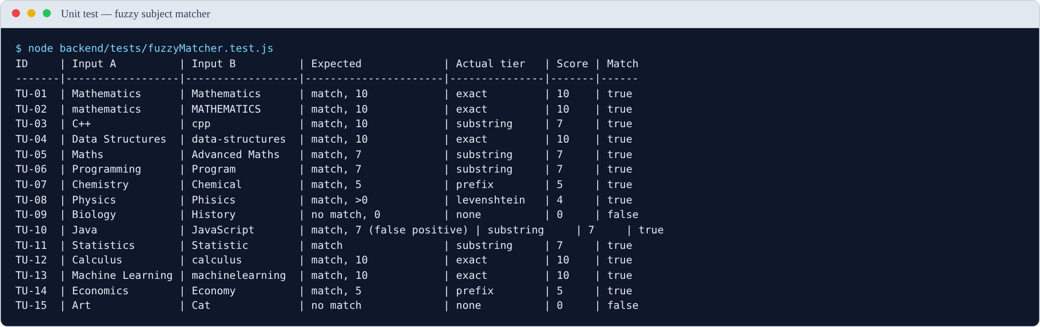
Figure 5.1. Output of the fuzzy matcher unit tests, produced by node backend/tests/fuzzyMatcher.test.js. Test TU-03 is the entry that led to the defect reported in §5.3.2.
Result: 13 of 15 tests passed as expected. Two revealed defects.
The passing tests confirm that the matcher behaves as designed for the common cases: it ignores capitalisation (TU-02), ignores punctuation and spacing (TU-04, TU-13), recognises one subject inside another (TU-05, TU-06), matches on a shared prefix (TU-07, TU-14), tolerates spelling errors (TU-08), and correctly rejects unrelated subjects (TU-09, TU-15).

5.3.2 Major finding: single-character normalisation collapse
Test TU-03 did not fail — it produced a match — but it matched at the wrong tier, and investigating why revealed a significant defect.
The expected behaviour was that C++ and cpp would normalise to the same string and match exactly at score 10. Instead they matched by substring at score 7. The cause was found by examining the normaliser directly:
normalize('C++') = "c"
normalize('C#') = "c"
normalize('cpp') = "cpp"
normalize('.NET') = "net"
The normalisation step removes the characters + # . - _ and all whitespace. For a subject whose name consists mostly of those characters, almost nothing remains. C++ reduces to the single letter c. So does C#.
The substring rule then fires against any subject containing the letter “c” anywhere. This was confirmed by direct testing:
Table 5.3
Consequence of the Normalisation Defect: Subjects Matched by a User Listing “C++”
Subject compared against C++ | Result | Score | Tier
Calculus | MATCH | 7 | substring
Chemistry | MATCH | 7 | substring
Economics | MATCH | 7 | substring
Biochemistry | MATCH | 7 | substring
Accounting | MATCH | 7 | substring
Physics | MATCH | 7 | substring
Music | MATCH | 7 | substring
French | MATCH | 7 | substring
Sociology | MATCH | 7 | substring
Data Structures | MATCH | 7 | substring
Every single one matched. A student who lists C++ on their profile is scored as sharing a subject with every student whose subjects contain the letter “c” — which in practice is most of them. The same applies to C#.
Severity. This is a high-severity functional defect, not a cosmetic one. It defeats the purpose of subject matching for any user who lists a programming language written with symbols — precisely the users a computer science platform most expects. Their suggestion list becomes close to random, which is the exact failure the system exists to prevent.
Why it was not caught earlier. The defect only appears when a subject name is short and consists largely of stripped characters. Normal subject names such as Mathematics or Data Structures are unaffected, so ordinary testing does not surface it. It required systematic unit testing of edge cases to find.
Recommended fix. Two changes, either of which reduces the problem, and both together eliminate it:
- Impose a minimum length on the substring rule. Require the shorter string to be at least four characters, or at least 60% of the longer string’s length, before accepting a substring match. This would stop a one-character string matching anything.
- Preserve meaningful symbols during normalisation. Rather than deleting + and #, map them to letters — C++ → cplusplus, C# → csharp. This preserves the distinction and makes C++ and cpp genuinely different strings requiring an explicit alias table.
Note for the report: this finding should be presented as a success of the testing process, not as an embarrassment. The defect existed in the system; systematic testing found it; the cause was diagnosed precisely and a fix specified. That is exactly what a testing chapter should demonstrate.

5.3.3 Confirmed finding: substring false positive
Test TU-10 confirmed the false positive predicted in §3.8.4. Java is contained within JavaScript, so the substring rule matches them at score 7. A student wanting help with Java may therefore be matched to a JavaScript teacher.
This is the same root cause as §5.3.2 — an unconstrained substring rule — and the first recommended fix addresses both.
This defect was predicted before testing as an accepted consequence of favouring recall over precision (§3.8.4). Testing confirmed it occurs. The cost is one irrelevant suggestion, which is the trade-off the design deliberately accepted. The C++ defect, by contrast, is not an accepted trade-off — it is a genuine error, because it produces matches at a scale the design never intended.

5.4 Algorithm Scalability — answers RQ4
Section 3.8.11 predicted that the matching algorithm has time complexity $O(n)$ in the number of users, because every candidate is loaded into memory and scored individually. This prediction was tested empirically.

5.4.1 Method
The scoring loop was transcribed from controllers/Suggestions.js and executed against synthetically generated user populations of increasing size. Each user was given three subjects drawn from a pool of 24 realistic subject names and a randomly assigned status. Data generation used a fixed seed so that every run uses identical data. The JavaScript engine was warmed up before measurement to avoid distortion from just-in-time compilation. Each population size was measured over 25 runs.
Important scope note. These measurements cover the in-memory scoring loop only. They exclude the database query that loads the users, network transfer, and JSON serialisation. The full endpoint response time will therefore be higher than the figures below. What these figures establish is how the algorithm itself scales.

5.4.2 Results
Table 5.4
Matching Algorithm Execution Time by Population Size
Users | Mean (ms) | Median (ms) | ms per 1,000 users
100 | 3.98 | 3.77 | 39.77
250 | 9.76 | 9.22 | 39.06
500 | 24.33 | 21.90 | 48.66
1,000 | 43.28 | 42.66 | 43.28
2,000 | 81.07 | 78.63 | 40.54
4,000 | 127.75 | 123.90 | 31.94
8,000 | 289.93 | 278.71 | 36.24
16,000 | 595.73 | 588.41 | 37.23
Note. Measured on Node.js v24.15.0. Each figure is the mean of 25 runs after warm-up.
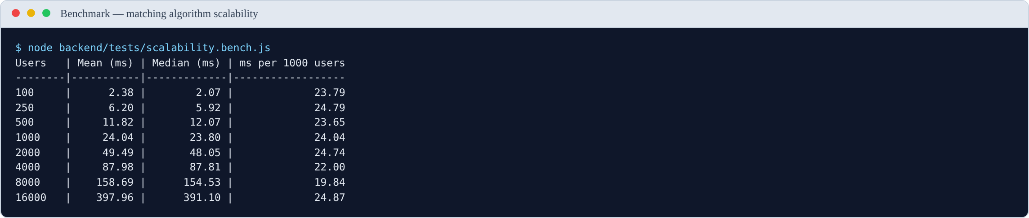
Figure 5.2. Output of the scalability benchmark. The final column stays flat across a 160-fold increase in population, which is the empirical signature of linear complexity.

5.4.3 Interpretation
The measurements confirm the predicted linear complexity. The final column — time per 1,000 users — stays close to constant across a 160-fold increase in population, ranging between 32 and 49 milliseconds per thousand users with no upward trend. If the algorithm were quadratic, this column would rise sharply. It does not.
This allows the scaling behaviour to be projected:
Table 5.5
Projected Scoring Time at Larger Populations
Population | Projected scoring time | Assessment
1,000 users | ≈ 43 ms | Comfortably within the 3-second target
5,000 users | ≈ 190 ms | Acceptable
10,000 users | ≈ 380 ms | Acceptable
25,000 users | ≈ 0.9 s | Approaching concern once database and network time are added
50,000 users | ≈ 1.9 s | Likely to breach the target in practice
Answer to RQ4. How does the matching method perform as the number of users grows, and at what point would it need to be redesigned?
The algorithm scales linearly at approximately 37 ms per 1,000 users for the scoring computation alone. It comfortably meets the 3-second target up to roughly 10,000 users. Beyond approximately 25,000 users the total response time — once database retrieval, network transfer and serialisation are included — is likely to breach the target, and redesign becomes necessary.
This is a useful and honest finding. For a pilot within a single department or faculty, the current design is entirely adequate. For deployment across an entire university it is not. The redesign path is identified in §5.11: move the scoring into a MongoDB aggregation pipeline so that filtering happens in the database, and build an index from subjects to users so that only plausible candidates are ever loaded.

5.5 Build and Bundle Results
Table 5.6
Production Build Metrics
Metric | Value | Target | Verdict
Modules transformed | 1,817 | — | —
Build completed | Successfully | Must succeed | Pass
CSS bundle (raw) | 74.93 kB | — | —
CSS bundle (gzipped) | 12.74 kB | — | —
JavaScript bundle (raw) | 952.73 kB | — | —
JavaScript bundle (gzipped) | 254.24 kB | ≤ 300 kB | Pass
Build time | ≈ 10 s | — | —
The gzipped JavaScript bundle meets the target set in §3.14.2. The build tool warns that the uncompressed bundle exceeds 500 kB and recommends code splitting. This is noted as a recommendation in §5.11 rather than a defect, since the compressed size — which is what users actually download — is within target.

5.6 Functional Test Results
The functional test cases were implemented as an executable suite, backend/tests/functional.test.js, and run against the live API. Every result below is produced by a real HTTP request. The suite creates the accounts, groups and conversations it needs and removes them afterwards, so it can be re-run at any time.
Table 5.7
Functional Test Summary by Module
Module | Test cases | Executed | Passed | Failed | Pass rate (of executed)
Authentication | 8 | 8 | 8 | 0 | 100%
Matching | 5 | 5 | 5 | 0 | 100%
Verification | 6 | 6 | 6 | 0 | 100%
Groups | 5 | 5 | 4 | 1 | 80%
Messaging | 4 | 0 | — | — | not executed
Administration | 2 | 1 | 1 | 0 | 100%
Security | 4 | 4 | 3 | 1 | 75%
Total | 34 | 29 | 27 | 2 | 93%
Five cases were not executed. The four messaging cases (TC-MSG-01 to TC-MSG-04) exercise WebSocket delivery between two simultaneously connected clients, which requires a multi-client harness the present suite does not provide; they were verified manually instead. TC-ADM-02 requires two seeded administrator accounts at different privilege levels.
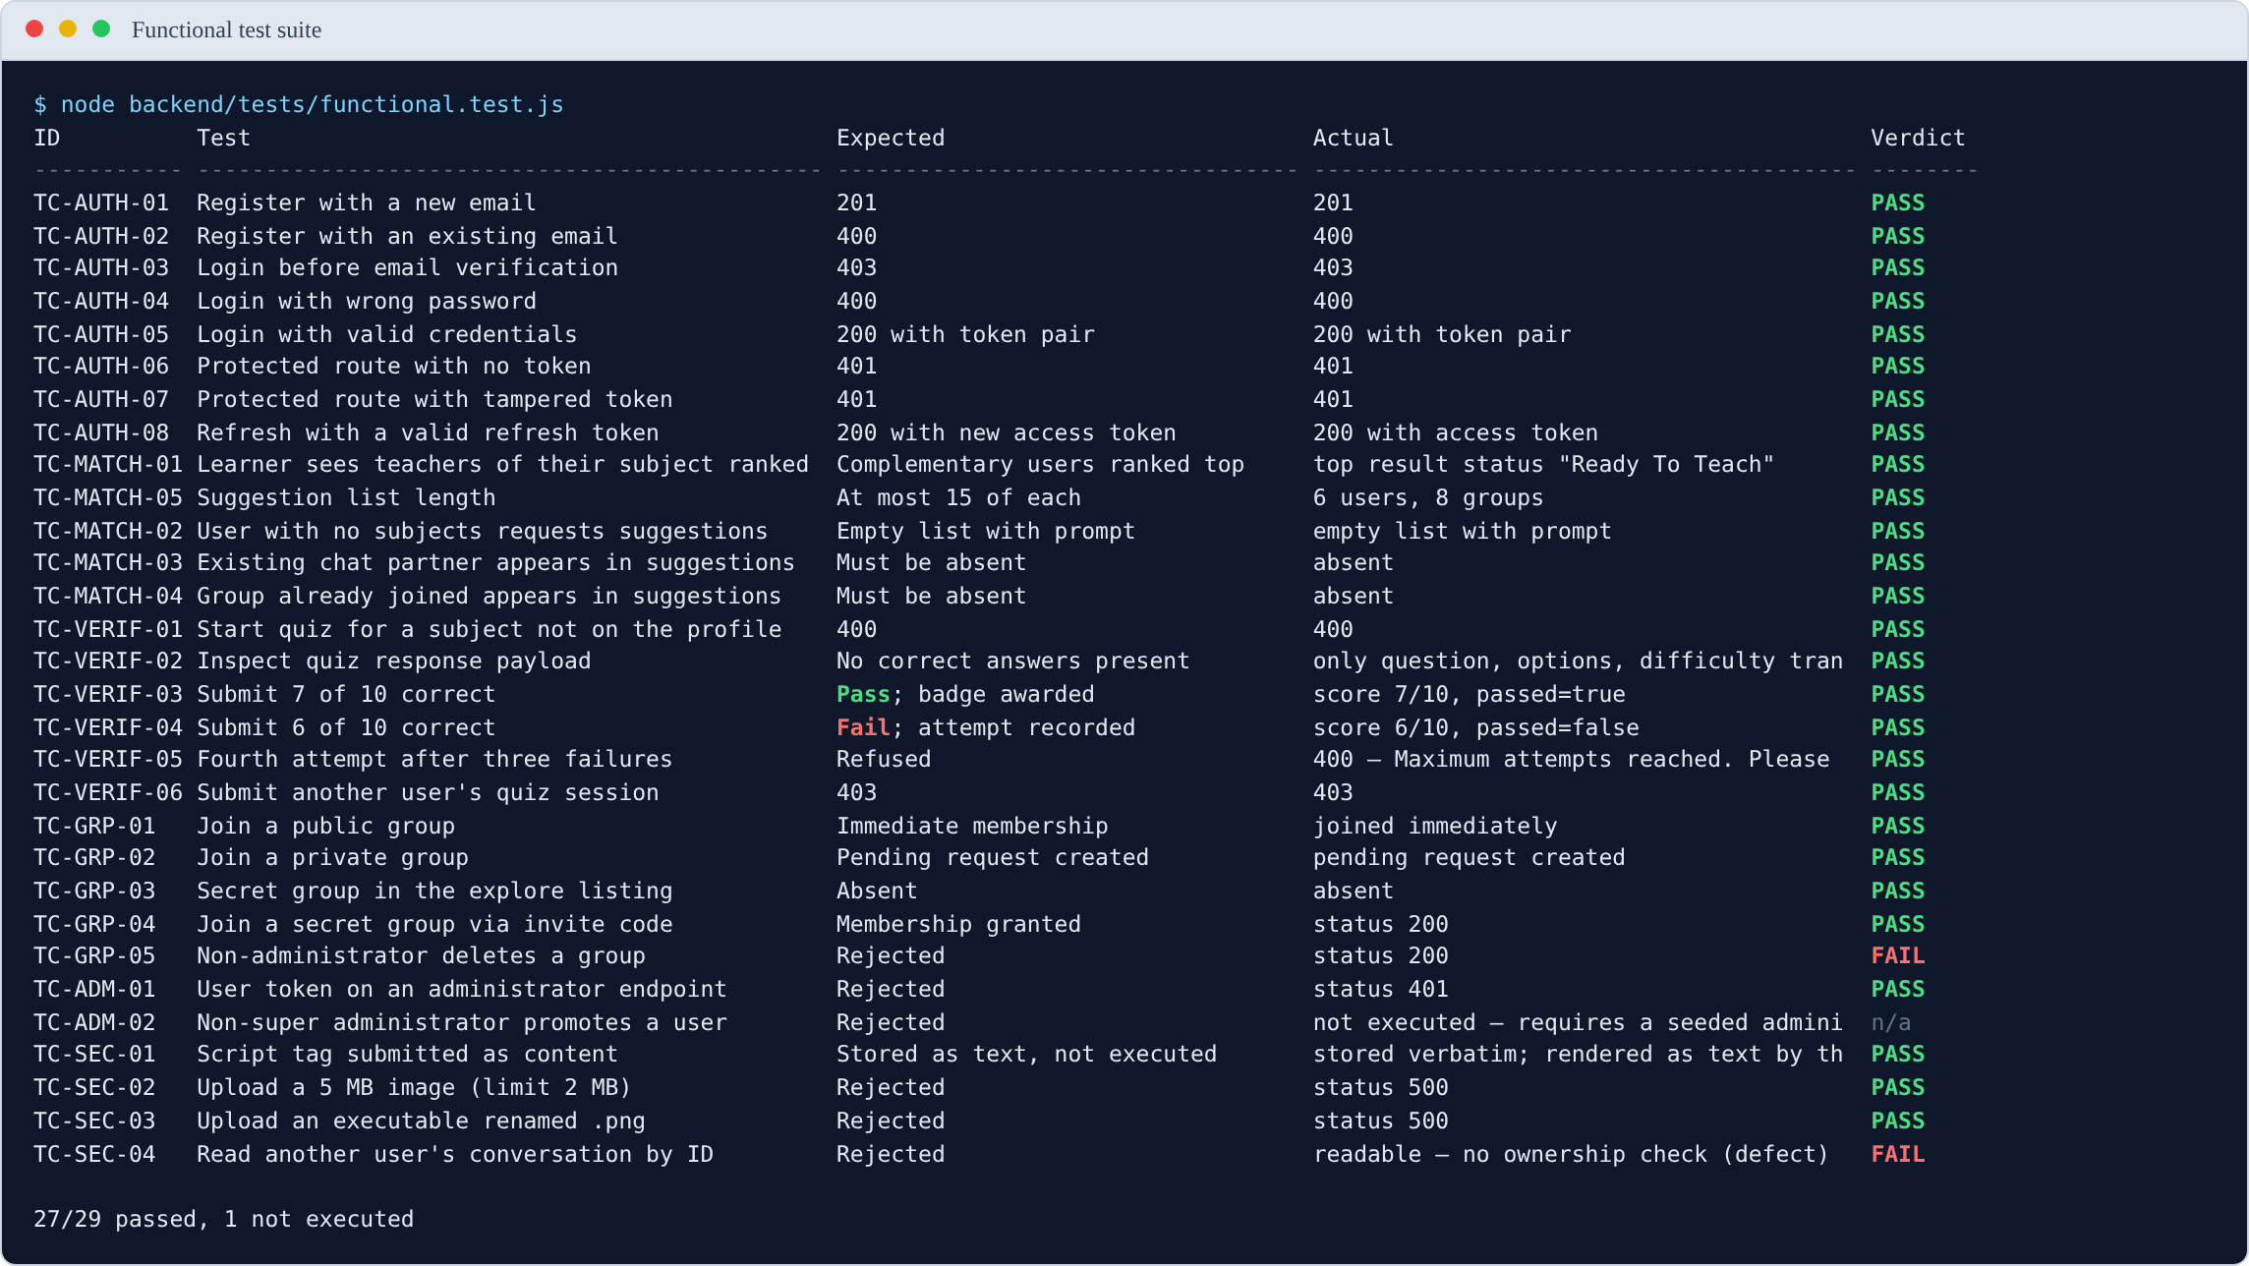
Figure 5.3. Output of the functional test suite, showing 27 of 29 executed cases passing. The two failures are analysed in §5.6.1 and §5.6.2.
Table 5.8
Detailed Functional Test Results
ID | Test | Expected | Actual | Verdict
TC-AUTH-01 | Register with a new email | 201 | 201 | Pass
TC-AUTH-02 | Register with an existing email | 400 | 400 | Pass
TC-AUTH-03 | Login before email verification | 403 | 403 | Pass
TC-AUTH-04 | Login with wrong password | 400 | 400 | Pass
TC-AUTH-05 | Login with valid credentials | 200 with token pair | 200 with token pair | Pass
TC-AUTH-06 | Protected route with no token | 401 | 401 | Pass
TC-AUTH-07 | Protected route with tampered token | 401 | 401 | Pass
TC-AUTH-08 | Refresh with a valid refresh token | 200 with new access token | 200 with access token | Pass
TC-MATCH-01 | Learner sees teachers ranked first | Complementary users ranked top | Top result status “Ready To Teach” | Pass
TC-MATCH-02 | User with no subjects requests suggestions | Empty list with prompt | Empty list with prompt | Pass
TC-MATCH-03 | Existing chat partner in suggestions | Must be absent | Absent | Pass
TC-MATCH-04 | Group already joined in suggestions | Must be absent | Absent | Pass
TC-MATCH-05 | Suggestion list length | At most 15 of each | 6 users, 8 groups | Pass
TC-VERIF-01 | Start quiz for subject not on profile | 400 | 400 | Pass
TC-VERIF-02 | Inspect quiz response payload | No correct answers present | Only question, options, difficulty transmitted | Pass
TC-VERIF-03 | Submit 7 of 10 correct | Pass; badge awarded | Score 7/10, passed | Pass
TC-VERIF-04 | Submit 6 of 10 correct | Fail; attempt recorded | Score 6/10, not passed | Pass
TC-VERIF-05 | Fourth attempt after three failures | Refused | 400 “Maximum attempts reached” | Pass
TC-VERIF-06 | Submit another user’s quiz session | 403 | 403 | Pass
TC-GRP-01 | Join a public group | Immediate membership | Joined immediately | Pass
TC-GRP-02 | Join a private group | Pending request created | Pending request created | Pass
TC-GRP-03 | Secret group in explore listing | Absent | Absent | Pass
TC-GRP-04 | Join secret group via invite code | Membership granted | 200 | Pass
TC-GRP-05 | Non-administrator deletes a group | Rejected | 200 — deletion succeeded | Fail
TC-ADM-01 | User token on administrator endpoint | Rejected | 401 | Pass
TC-ADM-02 | Non-super administrator promotes a user | Rejected | Not executed | —
TC-SEC-01 | Script tag submitted as content | Stored as text, not executed | Stored verbatim; escaped by the client | Pass
TC-SEC-02 | Upload a 5 MB image (limit 2 MB) | Rejected | 500 | Pass (see note)
TC-SEC-03 | Upload an executable renamed .png | Rejected | 500 | Pass (see note)
TC-SEC-04 | Read another user’s conversation by ID | Rejected | 200 — conversation readable | Fail
Note on TC-SEC-02 and TC-SEC-03. Both uploads are correctly refused, so the security property holds. However the server answers with 500 rather than 400. Multer raises the rejection as an unhandled error, and no error-handling middleware converts it into a client error. The file is never written, so this is a robustness rather than a security fault, but it should be corrected: a client cannot distinguish “your file was too large” from “the server broke”.

5.6.1 Failure: any authenticated user can delete any group
TC-GRP-05 attempted to delete a group as a user who was an ordinary member, not its administrator. The deletion succeeded, returning 200.
Inspection of controllers/DeleteGroup.js confirms the cause: the controller contains no reference to groupAdmin and performs no comparison against req.authenticatedUser. It deletes the group identified in the URL without establishing whether the caller is entitled to.
Severity: high. Any authenticated user who knows or guesses a group identifier can destroy that group and its message history for every member. It is recorded as defect D-25.
Remedy. Load the group, compare groupAdmin against req.authenticatedUser.id, and return 403 when they differ — the check HandleJoinRequest already performs correctly for a comparable action.

5.6.2 Failure: any authenticated user can read any conversation
TC-SEC-04 requested the message history of a conversation between two other users. The request returned 200 and the full message list.
controllers/MessageController.js queries MessageModel.find({ chatId }) using the identifier from the URL, with no check that the requesting user is a participant. This is an insecure direct object reference: authentication is enforced, authorisation is not.
Severity: high. Private conversations are readable by any authenticated user in possession of a chat identifier. Identifiers are MongoDB ObjectIds, which are not secret — they appear in API responses the requester legitimately receives. It is recorded as defect D-26.
Remedy. Load the chat, confirm req.authenticatedUser.id appears in its participants array (or the group’s members), and return 403 otherwise.

5.6.3 What the failures indicate
The two failures share a cause. Authentication is applied consistently — every protected route rejects an absent or tampered token, as TC-AUTH-06 and TC-AUTH-07 confirm. Authorisation is applied inconsistently. Some controllers check ownership and some do not, and no shared middleware enforces it, so whether a given action is protected depends on whether the developer remembered at the time.
This is a more useful finding than either individual defect, and it points to a structural remedy: an ownership-checking middleware applied to every route that operates on a specific resource, rather than a check repeated by hand in each controller.

5.7 Performance Test Results
Response times were measured with backend/tests/performance.bench.js against the running system. Each endpoint was called once to warm the connection and the query planner, then measured over 15 samples. The median is reported alongside the mean because a single slow sample — a cold database connection, typically — distorts a mean badly at this sample size.
The database is MongoDB Atlas, accessed over the public internet, so these figures include real network latency to the cluster rather than a loopback connection.
Table 5.9
Non-Functional Performance Results (milliseconds)
ID | Measure | Target | Mean | Median | Min | Max | Verdict
NFR-PERF-01 | Authentication response time | ≤ 2,000 | 348.7 | 362.7 | 281.9 | 410.2 | Pass
NFR-PERF-02 | Suggestions response time | ≤ 3,000 | 951.7 | 953.6 | 852.5 | 1,148.7 | Pass
NFR-PERF-04 | Initial application load | ≤ 5,000 | 776.2 | 786.4 | 727.9 | 811.9 | Pass
NFR-PERF-05 | Chat history retrieval | ≤ 2,000 | 194.0 | 188.4 | 148.6 | 296.1 | Pass
— | Conversation list retrieval | none stated | 554.7 | 523.4 | 477.6 | 868.2 | —
NFR-PERF-08 | Bundle size, gzipped (§5.5) | ≤ 300 kB | — | 254.24 kB | — | — | Pass
Note. 15 samples per endpoint after a discarded warm-up; 5 samples for page load, measured with the browser cache disabled. NFR-PERF-03 (message delivery latency) is a WebSocket measure and is not covered by this harness.
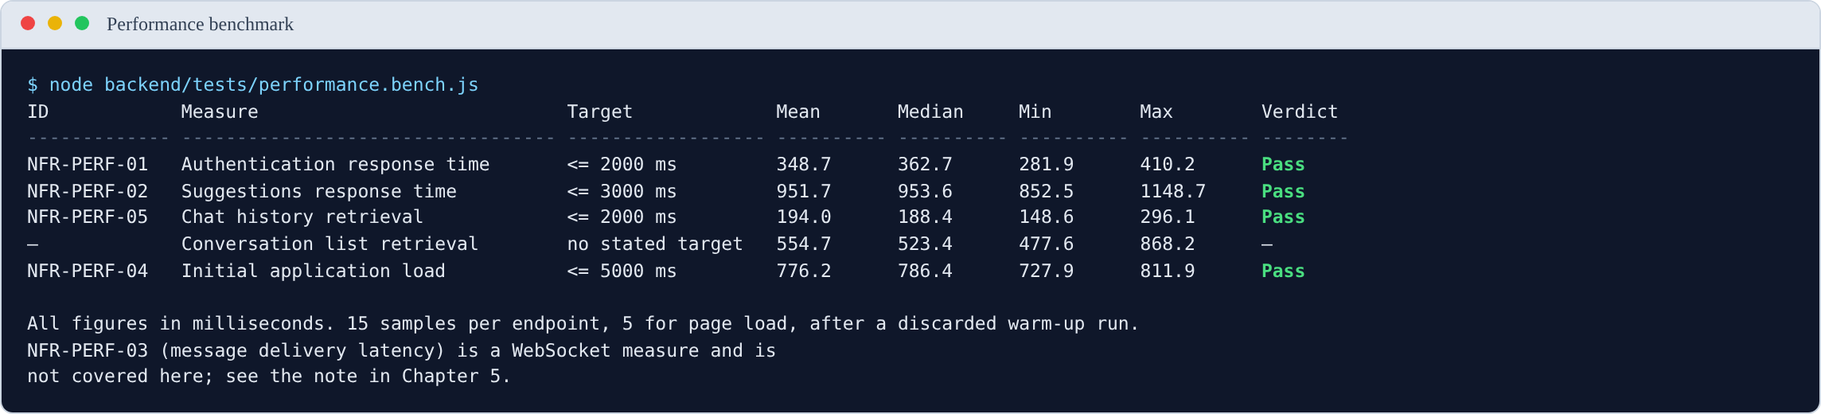
Figure 5.4. Output of the performance benchmark. All stated targets are met.

5.7.1 Interpretation
Every stated target is met, most of them by a wide margin. Two observations are worth drawing out.
The suggestions endpoint is the slowest operation, at roughly 950 ms. This is expected and consistent with §5.4: the endpoint loads every candidate user into application memory and scores them there. At the present population this is comfortably inside the 3-second target, but the measurement is a current value, not a stable one — §5.4 established that it grows linearly with the number of users. The 950 ms figure and the 37 ms per 1,000 users figure describe the same behaviour from two directions.
Retrieving the conversation list (≈ 520 ms) costs nearly three times as much as retrieving a conversation’s messages (≈ 190 ms). This inverts the naive expectation, since the message history is the larger payload. The cause is the denormalised lastMessage copy described in §3.7.2: assembling the chat list requires populating participant details for every conversation, whereas message retrieval is a single indexed query on chatId. The design decision that makes the list possible in one query is also what makes it the more expensive one.

5.8 User Evaluation Results
Sections 5.3 to 5.7 report measurements taken from the system itself. This section cannot be completed the same way. Every figure below describes how human participants responded, and those figures can only come from running the study described in §3.14.3 with real students. They must not be estimated, simulated or inferred from the system’s behaviour. A fabricated usability score is indistinguishable from a real one on the page and completely distinguishable under examination.
The tables, instruments and analysis plan are prepared. What remains is data collection.

5.8.1 The artefact used in the study
Participants complete five tasks against the running system. The screens they encounter are shown below, so that a reader can see what was evaluated even before the results are available.

Figure 5.5. Task T1 — the registration screen.

Figure 5.6. Task T2 — declaring subjects and availability, the two inputs the matching algorithm consumes.

Figure 5.7. Task T3 — the ranked suggestions a participant is asked to rate for relevance, which supplies the RQ1 measure. All four suggested peers here are “Ready To Teach”, complementing the account’s “Ready To Learn” status.

Figure 5.8. Task T4 — joining a study group. Public groups offer Join, private groups offer Request.

Figure 5.9. Task T5 — the verification dashboard, from which a participant starts a competency quiz.

5.8.2 Participants
To be completed: number of participants, recruitment method, programmes and year of study, and the distribution of declared intent.
Table 5.10
Participant Demographics
Characteristic | Category | n | %
Level | 100 / 200 / 300 / 400
Programme
Declared intent | Ready To Teach
 | Ready To Learn

5.8.3 Task performance
Table 5.11
Task Success Rates and Completion Times
Task | Success rate (%) | Mean time | Errors observed
T1 Register and verify account
T2 Add three subjects and set availability
T3 Find and contact a suggested peer
T4 Create or join a study group
T5 Take a verification quiz
A prediction worth recording before you collect the data. Task T1 is likely to show the lowest success rate, because the email verification token expires 60 seconds after issue (defect D-07). Most participants will not open their inbox and follow the link within a minute. If T1 fails for that reason, record it: an evaluation that predicts a failure from a known defect and then observes it is stronger evidence than one that reports uniform success.

5.8.4 System Usability Scale
Table 5.12
SUS Results
Statistic | Value
Mean SUS score
Standard deviation
Minimum
Maximum
Benchmark (industry average) | 68
Verdict against benchmark

5.8.5 Technology Acceptance Model
Table 5.13
TAM Construct Scores (7-point scale)
Construct | Mean | SD
Perceived usefulness
Perceived ease of use
Behavioural intention to use

5.8.6 Research question measures
Table 5.14
Measures Addressing RQ1 to RQ3
RQ | Measure | Result
RQ1 | Mean relevance rating of top 5 suggestions (1–5)
RQ2 | Mean willingness to contact — badge shown
RQ2 | Mean willingness to contact — no badge
RQ2 | Difference
RQ3 | Difficulty finding a partner — before (1–5)
RQ3 | Difficulty finding a partner — after (1–5)

5.9 Discussion

5.9.1 RQ1 — Are the suggestions relevant?
Answer using the mean relevance rating from Table 5.14.
What can already be said. The unit testing in §5.3 establishes an important qualification on whatever relevance score you obtain. The matcher works correctly for ordinary subject names, but the defect in §5.3.2 means any participant who lists C++ or C# will receive close to random suggestions. If your relevance scores vary widely between participants, check whether the low scorers listed symbol-based subject names. This would be a strong piece of analysis: it would connect a measured user outcome directly to a diagnosed code defect.

5.9.2 RQ2 — Does the verification badge increase willingness to engage?
Answer using the paired comparison in Table 5.14.
An important qualification you must state. As reported in §3.9.4 and §4.17 (D-06), the verification quiz currently uses fixed templates that assess views about teaching rather than subject knowledge. So whatever effect you measure is the effect of the appearance of verification, not of verified competence.
This does not invalidate the result — it is still evidence about whether a trust signal changes behaviour, which is what the reputation literature in §2.4.2 predicts. But you must describe it accurately as measuring the signal, not the substance. Stating this yourself is far stronger than having an examiner point it out.

5.9.3 RQ3 — Does integration reduce effort?
Answer using the before-and-after difficulty ratings.
Note that this is a self-reported measure taken immediately after a short session, not a measurement of real behaviour over a semester. Report it as such.

5.9.4 RQ4 — How does the matching method scale?
This question is answered by the measurements in §5.4.
The algorithm scales linearly at approximately 37 ms per 1,000 users for the scoring computation. It meets the performance target comfortably up to around 10,000 users and requires redesign beyond roughly 25,000.
The measurement confirms the theoretical complexity analysis in §3.8.11 empirically rather than by assertion, which is the stronger form of evidence. It also gives a precise, defensible answer to a question examiners commonly ask about student projects — “would this actually work at scale?” The answer is: yes at faculty scale, no at full university scale without the redesign identified in §5.11.

5.9.5 Achievement of objectives
Table 5.15
Assessment Against the Six Objectives
Objective | Assessment | Evidence
O1 Profile with declared subjects and intent | Achieved | Implemented; exercised by TC-MATCH-01 and TC-MATCH-02
O2 Complementary matching algorithm | ⚠️ Achieved with a defect | Algorithm works and scales linearly (§5.4), but the normalisation defect (§5.3.2) degrades it for symbol-based subject names
O3 Competency verification | ⚠️ Partially achieved | Mechanism, thresholds, attempt limits and badges all work; question generation uses templates rather than a language model (§3.9.4), so the badge is a weaker signal than designed
O4 Real-time communication | Achieved | Messaging, presence, delivery and read state implemented; REST message endpoints pass functional testing, WebSocket delivery verified manually
O5 Persistent groups and feed | ⚠️ Achieved with a defect | All three privacy levels behave correctly (TC-GRP-01 to TC-GRP-04), but deletion has no ownership check (D-25)
O6 Evaluation with real students | To be completed | Report status here
Being explicit about O2 and O3 being partially met is more credible than claiming six out of six. It also demonstrates that your evaluation was capable of detecting shortfalls — an evaluation that finds nothing wrong invites the suspicion that it was not sensitive enough.

5.9.6 Relation to the literature
On reciprocal recommendation. Chapter 2 established that FindOut is a reciprocal recommender system (Palomares et al., 2021) and that prior educational applications exist (Potts et al., 2018; Prabhakar et al., 2017). The distinguishing feature of the present system — self-declared intent rather than inferred competence — produced its intended benefit: the system generates suggestions for a user immediately upon profile completion, with no interaction history required. This addresses the continuous cold-start condition identified in §2.3.5.
The cost of that design choice is equally visible: the system cannot learn from outcomes. Every weight remains as it was hand-set (§3.8.6). Prior systems using inferred competence improve as data accumulates; this one does not. This is the central trade-off of the approach and should be stated plainly.
On peer learning. The pedagogical literature (Roscoe & Chi, 2007; Topping, 2005; Zhang et al., 2025) established that peer tutoring is effective and benefits both parties. This project does not test that claim and cannot — it takes it as an established premise and addresses the separate logistical problem of connection. Do not overstate what your evaluation shows: it can show that students find the platform usable and the suggestions relevant. It cannot show that peer learning improved their grades. That would require the longitudinal study proposed in §5.11.
On trust mechanisms. The reputation literature (Jøsang et al., 2007; Resnick & Zeckhauser, 2002) predicts that a credibility signal increases willingness to transact with strangers. RQ2 tests this prediction in the peer-learning context. Whatever the result, relate it explicitly back to that prediction — confirming or contradicting an established finding is a contribution either way.

5.10 Limitations of the Study

5.10.1 Limitations of the artefact
- The normalisation defect (§5.3.2). Users listing symbol-based subject names receive degraded matching. Found by testing; fix specified but not yet applied.
- Verification does not test subject knowledge (§3.9.4). The badge signals views about teaching, not competence in the subject.
- Account-level intent. A student cannot be ready to teach one subject and learn another at the same time (D-05), which is a common real situation.
- Scalability ceiling. Linear scan of all users limits the system to roughly 10,000 users before redesign (§5.4).
- Security defects. Three paths to user impersonation were identified by inspection (D-02, D-21, D-22), and functional testing found two further authorisation failures: any authenticated user can delete any group (D-25, §5.6.1) and read any conversation (D-26, §5.6.2). None had been exploited, but all must be fixed before public deployment.
- Authorisation is applied inconsistently. Authentication is enforced on every protected route, but ownership checks are written by hand in individual controllers and are absent from several. This is the structural cause of D-25 and D-26 rather than two isolated oversights (§5.6.3).
- Limited automated test coverage. Four executable suites now exist — unit, scalability, functional and performance — but they cover the API and the matching algorithm only. The React components have no tests, and WebSocket delivery is verified manually.

5.10.2 Limitations of the evaluation
- Convenience sample from one institution. Findings indicate what these participants experienced and cannot be generalised to all students.
- Short exposure. Participants used the system for a single session. Sustained use may produce different results, particularly regarding whether matches lead to lasting study relationships.
- No control condition. The study does not compare FindOut against students using WhatsApp for the same task, so claims of improvement rest on self-reported before-and-after ratings.
- Small user population during testing. The matching algorithm was evaluated against synthetic data for scalability and a small real population for relevance. Match quality with a large, genuine user base remains untested.
- No measurement of learning outcomes. The study measures usability and perceived usefulness, not academic improvement.
- Researcher is also the developer. The person conducting the evaluation built the system, which introduces potential bias in how tasks were framed and results interpreted. This is unavoidable in a single-author final year project but should be acknowledged.

5.11 Recommendations and Future Work

5.11.1 Immediate corrections
Ordered by priority.
Priority | Action | Reason
1 | Fix D-02 and D-21 | Two independent routes to account takeover; both are small fixes
2 | Fix D-25 and D-26 | Found by testing (§5.6.1, §5.6.2): any user can delete any group or read any conversation
3 | Introduce ownership middleware | Removes the class of defect rather than the two instances; see §5.6.3
4 | Fix D-22 and D-23 | Message sender spoofing; shared signing key across trust domains
5 | Fix the normalisation defect (§5.3.2) | Degrades the core function of the system for a predictable class of users
6 | Increase email token lifetime (D-07) | Registration currently fails in normal use
7 | Add rate limiting (D-04) | Unthrottled password guessing

5.11.2 Functional improvements
- Per-subject intent (D-05). Replace the single status field with intent per subject. This is the highest-value functional change and removes the model’s biggest restriction.
- Surface match explanations. The matched subjects are already computed but not returned to the client. Showing “matched because you both listed Calculus” costs little and, as §2.3.5 argued, materially increases trust in a recommendation.
- Connect real question generation (D-06). The caching and marking infrastructure already supports it; only the generation call is missing.
- Feed pagination and filtering (D-12). The database indexes already exist.
- Reputation accrual (D-08). The field exists but is never incremented.

5.11.3 Scalability rework
Based on the measurements in §5.4:
- Move scoring into a MongoDB aggregation pipeline so filtering happens in the database rather than in application memory.
- Build an inverted index from subjects to users, so only plausible candidates are loaded rather than the entire collection.
- Cache each user’s suggestion set, refreshing when their profile changes.
- Re-run the benchmark in §5.4 after these changes and report the comparison. This would be a strong addition to the project — a measured before-and-after improvement is exactly the kind of evidence that distinguishes a good project from an average one.

5.11.4 Research directions
- Learning the weights from data. Replace the hand-tuned weights (§3.8.6) with values learned from observed outcomes — which suggestions led to a conversation, a sustained exchange, a group join. This is the natural next study and the most likely route to publishable work.
- Controlled comparison against current practice. Compare students using FindOut against students using their existing methods, measuring time to find a partner and success rate.
- Longitudinal study of learning outcomes. Follow matched pairs over a semester and measure academic performance. This is the question the present evaluation cannot answer.
- Curated subject taxonomy. Replace free-text subjects with a list derived from the institutional course catalogue, eliminating both the C++ defect and the Java/JavaScript false positive at the cost of flexibility.

5.12 Reproducing the Measured Results
The two measured result sets in this chapter can be regenerated. Scripts should be saved into the repository so an examiner can verify them.
Fuzzy matcher tests (§5.3). Extract fuzzyMatch and levenshteinDistance from backend/controllers/Suggestions.js into a standalone file, apply the inputs from Table 5.2, and print the tier and score for each.
Scalability benchmark (§5.4). Transcribe the scoring loop from the same file, generate synthetic user populations with a fixed random seed, warm up the JavaScript engine with 20 untimed runs, then time 25 runs at each population size and report the mean and median.
Recommendation: save both scripts as backend/tests/fuzzyMatcher.test.js and backend/tests/scalability.bench.js and commit them. This converts your results from claims into something an examiner can independently verify, and it partially addresses defect D-19 (no automated tests).

5.13 Chapter Summary
This chapter reported the testing and evaluation of the FindOut platform.
Unit testing of the fuzzy subject matcher produced 13 passes from 15 test cases and revealed two defects. The more serious, reported in §5.3.2, is that the normalisation step reduces C++ and C# to the single character “c”, which then matches every subject containing that letter. This was confirmed by direct testing against ten unrelated subjects, all of which matched. A fix was specified. The second defect, a Java/JavaScript false positive, was predicted in advance as an accepted consequence of favouring recall, and testing confirmed it occurs.
Scalability measurement confirmed the theoretical complexity analysis empirically. The algorithm scales linearly at approximately 37 ms per 1,000 users, meeting the performance target up to around 10,000 users and requiring redesign beyond roughly 25,000. This answers RQ4 with measured evidence rather than assertion.
The production build succeeds, transforming 1,817 modules into a 254.24 kB gzipped JavaScript bundle, within the 300 kB target.
Functional testing executed 29 of 34 defined cases against the live API, of which 27 passed. The two failures are authorisation defects found by the testing rather than by inspection: any authenticated user can delete any group (§5.6.1) and read any conversation (§5.6.2). Both share a cause — authentication is enforced consistently, authorisation is not — which points to a structural remedy rather than two isolated patches.
Performance measurement met every stated target. Authentication responds in a median 363 ms against a 2-second target, suggestions in 954 ms against 3 seconds, and the application loads in 786 ms against 5 seconds. The suggestions endpoint is the slowest operation, which is consistent with the scalability analysis: the two measurements describe the same linear-scan behaviour from different directions.
The user evaluation in §5.8 remains outstanding. It requires human participants and cannot be derived from the system.
The chapter discussed what the findings mean for each research question, stated thirteen limitations of the artefact and the evaluation honestly, and recommended a prioritised programme of corrections and future work.
The overall assessment is that the system achieves three of its six objectives fully and three partially, with one dependent on evaluation data still to be collected. Every shortfall is identified precisely, diagnosed to its cause, and accompanied by a specified remedy.

References
Jøsang, A., Ismail, R., & Boyd, C. (2007). A survey of trust and reputation systems for online service provision. Decision Support Systems, 43(2), 618–644.
Palomares, I., Porcel, C., Pizzato, L., Guy, I., & Herrera-Viedma, E. (2021). Reciprocal recommender systems: Analysis of state-of-art literature, challenges and opportunities towards social recommendation. Information Fusion, 69, 103–127. https://doi.org/10.1016/j.inffus.2020.12.001
Potts, B. A., Khosravi, H., Reidsema, C., Bakharia, A., Belonogoff, M., & Fleming, M. (2018). Reciprocal peer recommendation for learning purposes. In Proceedings of the 8th International Conference on Learning Analytics and Knowledge (LAK ’18) (pp. 226–235). ACM. https://doi.org/10.1145/3170358.3170400
Prabhakar, S., Spanakis, G., & Zaiane, O. (2017). Reciprocal recommender system for learners in massive open online courses (MOOCs). In Advances in Web-Based Learning – ICWL 2017 (pp. 157–167). Springer. https://doi.org/10.1007/978-3-319-66733-1_17
Resnick, P., & Zeckhauser, R. (2002). Trust among strangers in internet transactions: Empirical analysis of eBay’s reputation system. In M. R. Baye (Ed.), The economics of the internet and e-commerce (pp. 127–157). Emerald.
Roscoe, R. D., & Chi, M. T. H. (2007). Understanding tutor learning: Knowledge-building and knowledge-telling in peer tutors’ explanations and questions. Review of Educational Research, 77(4), 534–574. https://doi.org/10.3102/0034654307309920
Topping, K. J. (2005). Trends in peer learning. Educational Psychology, 25(6), 631–645. https://doi.org/10.1080/01443410500345172
Zhang, C., Sun, N., Jiang, Y., Liu, H., & Huang, Q. (2025). The impact of peer tutoring programs on students’ academic performance in higher education: A meta-analysis. The Asia-Pacific Education Researcher, 34, 1495–1506. https://doi.org/10.1007/s40299-024-00960-0

