FindOut: A Reciprocal Recommender System for Peer Learning
Matching Students Who Want to Learn with Students Willing to Teach

Chapter Three: Methodology

[YOUR FULL NAME] · [YOUR STUDENT ID]
Department of Computer Science, University of Ghana, Legon
Supervisor: [SUPERVISOR’S NAME]
July 2026

Contents
Right-click and choose Update Field to build the contents.

Chapter Three: Methodology

3.1 Introduction
Chapter 1 identified the problem: students who need help and students able to give it cannot find each other. Chapter 2 reviewed what researchers and existing systems have done about it, and identified four gaps.
This chapter explains how the problem was solved. It covers the research approach, the development method, the technology choices and why they were made, the design of the system, the design of the matching algorithm, and the method used to evaluate the finished platform.
The chapter is organised as follows. Section 3.2 states the research approach. Section 3.3 explains the software development method. Section 3.4 describes how requirements were gathered and presents the use case model. Section 3.5 justifies the technology choices. Sections 3.6 and 3.7 present the system architecture and the database design as an entity relationship model and a class model. Section 3.8 gives the full specification of the matching algorithm — the central technical contribution — as a formal definition, an activity model and a sequence model. Sections 3.9 to 3.12 cover the verification, messaging, security and privacy designs. Section 3.13 lists the tools used. Section 3.14 sets out the evaluation method. Section 3.15 gives the steps needed to reproduce the system.
Table 3.0 lists the design models presented in this chapter.
Table 3.0
Design Models Presented in Chapter Three
Figure | Model | Section | What it establishes
3.1 | Use case diagram | §3.4.1 | Actors and the functional scope agreed for the system
3.2 | System architecture | §3.6.1 | Tiers, components and the two communication channels
3.3 | Entity relationship diagram | §3.7.1 | Entities, relationships and cardinality
3.4 | Class diagram | §3.7.2 | Model and service classes with attributes and operations
3.5 | Activity diagram | §3.8.10 | The matching process as a control flow
3.6 | Sequence diagram | §3.8.11 | Component interaction from discovery to a read message
3.7 | State diagram | §3.9.3 | Lifecycle of subject verification
These are design models: they state what was intended before and during construction. Chapter 4 presents the corresponding as-built views, which differ in places — those differences are exactly what the incremental method in §3.3 was expected to produce, and are identified where they occur.

3.2 Research Approach

3.2.1 Design Science Research
This project follows Design Science Research (DSR). DSR is a research approach where new knowledge is produced by building a working thing — called an artefact — and then evaluating it (Hevner et al., 2004). It is the standard approach in information systems research for projects that create software to solve a real problem.
DSR was chosen because it fits what this project does. The project does not test a hypothesis about human behaviour using an experiment. It identifies a real problem, designs and builds a system to solve it, and evaluates whether the system works. Hevner et al. (2004) set out seven guidelines for DSR. Table 3.1 shows how this project meets each one.
Table 3.1
Compliance with the Design Science Research Guidelines of Hevner et al. (2004)
Guideline | How this project satisfies it
1. Design as an artefact | A working web platform (FindOut) was built, not a model or a proposal.
2. Problem relevance | The problem was established in Chapter 1 from the literature and the Ghanaian higher education context.
3. Design evaluation | The artefact was evaluated through functional testing, performance measurement, and a user study (§3.14).
4. Research contributions | A reciprocal recommender for peer learning that uses self-declared intent, stated precisely in §2.8.3.
5. Research rigour | The matching algorithm is formally specified (§3.8); evaluation uses validated instruments (SUS, TAM).
6. Design as a search process | Development was incremental; designs were revised when they proved inadequate (§3.3.2).
7. Communication of research | This report communicates to both technical and management audiences.

3.2.2 The DSR process model followed
Peffers et al. (2007) provide a six-step process model for carrying out DSR. This project followed that model. Table 3.2 maps the steps to the chapters of this report.
Table 3.2
The Design Science Research Process (Peffers et al., 2007) as Applied in This Project
Step | Activity in this project | Reported in
1. Problem identification and motivation | Identified the five failures of peer connection (P1–P5) | Chapter 1
2. Define objectives of a solution | Six objectives (O1–O6) derived from the problems and the literature | Chapter 1, §1.4
3. Design and development | Designed and built the platform over nine increments | Chapter 3, Chapter 4
4. Demonstration | Deployed the system and used it to complete real tasks | Chapter 4
5. Evaluation | Functional testing, performance measurement, user study | Chapter 5
6. Communication | This report | All chapters

3.2.3 Why other research approaches were not used
A pure experimental approach would compare students using the platform against a control group and measure grade differences. This was rejected for two reasons. It would require a full semester of use with a large sample to produce meaningful results, which exceeds the project timeframe. It also assumes a working platform already exists — the building of which is the actual contribution here.
A pure survey approach would ask students about their needs without building anything. This would document the problem but not solve it, and would produce no artefact.
A case study approach would study existing peer-learning practice in depth. This is useful background work, but again produces no solution.
DSR was selected because it accommodates both building and evaluating, which is what a final year software project requires.

3.3 Software Development Methodology

3.3.1 Choice of development method
An incremental and iterative development method was used, with practices borrowed from agile development.
Incremental development means the system is built in a series of pieces. Each piece is a complete, working slice — database, server code and user interface together — that can be demonstrated and tested before the next piece begins. Iterative means earlier work is revisited and improved when later work shows it was inadequate.

3.3.2 Justification of the choice
Why not the Waterfall model. Waterfall requires all requirements to be fully known and fixed before design starts, and design fixed before coding starts. This project could not meet that condition. Two examples show why:
- The weights used in the matching algorithm (§3.8.5) could not be decided in advance. They needed real profile data to test against.
- The group privacy design began as a simple yes/no setting (isPrivate). Only after working through real use cases did it become clear that three levels were needed: a group that is visible and open, a group that is visible but needs approval, and a group that is hidden entirely. This required changing both the database schema and the existing stored data.
Under Waterfall, both of these mistakes would have been discovered at the end, when correcting them is most expensive. Sommerville (2016) identifies exactly this condition — evolving requirements and the value of early feedback — as the case where incremental development is appropriate.
Why not full Scrum. Scrum defines roles (Product Owner, Scrum Master, Development Team) and ceremonies (daily stand-up, sprint review, retrospective). These exist to coordinate a team. This project had one developer. With one person, the ceremonies produce administrative work without producing the coordination benefit they exist for.
What was adopted. The useful agile practices that work for a single developer were kept: short cycles, a working system at the end of every cycle, supervisor feedback between cycles, and willingness to change earlier decisions.

3.3.3 Increments delivered
Development proceeded through nine increments. Each delivered a working vertical slice.
Table 3.3
Development Increments
# | Increment | What was delivered | Evidence of iteration
I1 | Foundation | Project setup, database connection, User model, registration, password hashing, email verification, login with tokens | —
I2 | Profile and intent | Subjects list, teach/learn status, free time, profile picture upload, edit functions | —
I3 | Matching | Suggestions endpoint, fuzzy subject matcher, complementary status weighting | Weights tuned against sample profiles
I4 | Messaging | Chat and Message models, Socket.IO integration, rooms, presence, delivery and read status | Unread counters changed from per-chat to per-user
I5 | Groups | Group model, creation, membership, invite codes | isPrivate boolean replaced by three-level privacy field; migration script written
I6 | Feed | Post model with subject and type, comments, threaded replies | “likes” renamed to “helpful” to fit the learning context
I7 | Verification | Verification model, quiz generation and grading, pass threshold, attempt limits, badges | —
I8 | Administration | Separate Admin model and authentication, dashboard statistics, moderation | —
I9 | Hardening | Search, voice messages, unread counts, data migration scripts, cross-platform fixes | Import path casing corrected for Linux deployment
The changes recorded in the final column are evidence that the method was genuinely iterative and not Waterfall carried out in stages.

3.4 Requirements Elicitation
Requirements were gathered using four methods.
1. Derivation from the literature. Objectives O1 to O3 (Chapter 1, §1.4) were derived from the gaps identified in Chapter 2. For example, the decision to use self-declared intent rather than inferred competence follows directly from the cold-start analysis in §2.3.5.
2. Competitive analysis. Each system reviewed in §2.5 was examined feature by feature. The comparison table (Table 2.1) was used to identify which capabilities the new system must have.
3. Student survey. A questionnaire was administered to students to establish current behaviour, the difficulty of finding help, and willingness to teach. The instrument is given in Appendix D of the SRS.
[Results to be inserted from the author’s own data collection.]
4. Iterative supervisor review. Requirements were reviewed with the project supervisor at the end of each increment and revised where necessary.
The complete requirements produced by this process are documented in the Software Requirements Specification, which records 113 numbered requirements across eight modules, each with a priority and a status.

3.4.1 Use case model
The requirements were consolidated into a use case model identifying two human actors — the Student and the Administrator — and one external system actor, the email service used to confirm account ownership.
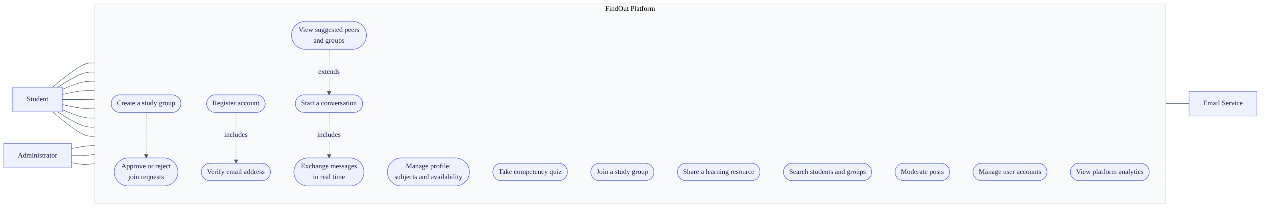
Figure 3.1. Use case diagram. Solid lines are actor associations; dashed lines are include and extend relationships between use cases. Group administration (UC10) is performed by the Student who created the group, not by a platform Administrator — group ownership and platform administration are separate privileges.
Three relationships in the model are worth noting because they shaped the design:
- Register account includes Verify email address. Registration is not complete until ownership of the address is proven, which is why login is gated on the verified flag.
- View suggestions extends Start a conversation. Discovery is the entry point to communication, so both must live in the same artefact — the argument made in §2.8, Gap 3.
- Take competency quiz is available to any student but is only meaningful for those offering to teach, which is why it is optional rather than a precondition of any other case.

3.5 Technology Selection
Technology choices were made against four criteria: suitability for the problem, cost (the project had no budget), availability of documentation and community support, and the developer’s ability to become productive within the project timeframe.
Table 3.4
Technology Choices and Justifications
Layer | Selected | Alternatives considered | Justification
Frontend framework | React 18 with Vite | Angular, Vue, Next.js | React’s component model suits an interface with a lot of changing state, such as a chat window. It has the largest ecosystem of the options. Vite rebuilds the page in under a second during development, compared with much slower rebuilds under Webpack. Next.js offers server-side rendering, but the benefit is small for an application that sits behind a login.
Styling | Tailwind CSS 3 | Bootstrap, Material UI, plain CSS | Tailwind applies styles directly in the markup, which avoids inventing and maintaining class names. Unused styles are removed at build time, producing a smaller file. Unlike Bootstrap or Material UI it does not impose a recognisable visual identity.
Backend runtime | Node.js with Express 4 | Django (Python), Spring Boot (Java), Laravel (PHP) | Using JavaScript on both sides means one language for the whole project, which matters for a single developer with limited time. Node handles many idle open connections efficiently, which is exactly the chat workload.
Database | MongoDB with Mongoose | PostgreSQL, MySQL | The data is document-shaped: a post owns its comments, which own their replies. Fetching a post with its full comment thread is one read, not a three-table join. The flexible schema also suited the iterative method, since fields were added as increments progressed.
Real-time channel | Socket.IO 4 | Plain WebSocket, Server-Sent Events, polling | Socket.IO adds automatic reconnection, a “room” abstraction that maps directly onto chats and groups, and a fallback to long-polling when WebSocket is blocked. The fallback matters on unreliable mobile networks.
Authentication | JWT with bcrypt | Server sessions, OAuth, Passport.js | Tokens hold their own validity, so the server stores no session data and can be scaled to multiple machines. bcrypt is deliberately slow to compute, which makes password guessing expensive (Provos & Mazières, 1999).
Email | Nodemailer with SMTP | SendGrid, Amazon SES | Free, and adequate for the volume this project generates.
File uploads | Multer to local disk | Cloudinary, Amazon S3 | Free and simple to implement.

3.5.1 Acknowledged trade-offs
Every choice above has a cost. Stating them shows the decisions were made deliberately.
- MongoDB does not enforce relationships between records the way a relational database does. If a user is deleted, references to that user elsewhere are not automatically cleaned up. This became a real limitation and is reported in Chapter 4.
- JWT tokens cannot be cancelled before they expire. If a token is stolen, it stays valid until expiry. This is reduced by making the access token short-lived (15 minutes).
- Local file storage is destroyed when a hosting platform redeploys the application. This makes the current upload approach unsuitable for production hosting without change.

3.6 System Architecture

3.6.1 Overall structure
The system uses a three-tier architecture with an additional persistent channel for real-time features.
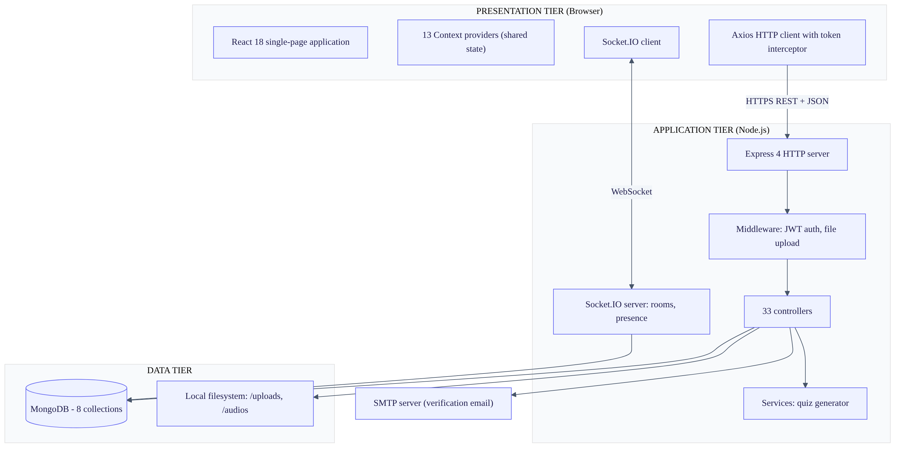
Figure 3.2. System architecture. Three tiers with two distinct communication channels between the client and the application tier: request-response over HTTPS for user-initiated operations, and a persistent WebSocket for server-initiated events.

3.6.2 Why two communication channels
The system uses REST over HTTP for most operations and WebSocket for messaging. This is a deliberate design decision and the reason should be understood.
HTTP works on a request-and-response model. The client asks, the server answers. This suits operations the user initiates: load my profile, create a group, submit a quiz.
Chat does not fit this model. A message must reach a recipient who did not ask for it. Under HTTP alone the only way to achieve this is polling — the client repeatedly asking “is there anything new?” Polling every few seconds wastes bandwidth and battery, and still delivers messages late.
WebSocket (Fette & Melnikov, 2011) keeps a connection open in both directions, so the server can send without being asked. Socket.IO adds reconnection and grouping on top of it.
The system therefore uses each protocol for what it does well, rather than forcing one to do both jobs.

3.6.3 Backend structure
The backend is organised in layers, each with one responsibility.
Layer | Location | Responsibility
Entry point | server.js | Creates the HTTP server, attaches Socket.IO, connects the database, mounts routers
Routes | routes/ (4 files) | Declares which URL maps to which handler. Contains no logic.
Middleware | middleware/ | Runs before handlers: checks the token, processes file uploads
Controllers | controllers/ (33 files) | Contains the business logic for one operation each
Services | services/ | Logic reused by more than one controller (quiz generation)
Models | models/ (7 files) | Defines the shape of the data and its validation rules
Socket handlers | socket/Socket.js | Handles all real-time events
This separation means a change to a URL affects only the route file, and a change to a validation rule affects only the model. It follows the layered pattern described by Fowler (2002), without the server-side view layer, since the React application handles all presentation.

3.6.4 Frontend structure
The frontend is a single-page application. The browser loads the application once, and navigation between screens happens without further page loads.
State that is needed by many components — the logged-in user, the chat list, the suggestions — is held in React Context providers. A Context provider makes a value available to every component beneath it without passing it manually through each level. The application composes 13 such providers in Providers/Provider.jsx.
Two utilities are important to the design:
- utils/tokenService.js stores and retrieves the authentication tokens.
- utils/axiosInstance.js wraps the HTTP client. It automatically attaches the access token to every request. It also watches for a 401 (unauthorised) response, and when one occurs it requests a new access token using the refresh token, then retries the original request. If the refresh also fails, it clears the tokens and redirects to the login page.
This means token renewal is invisible to the rest of the application. No component needs to know that tokens expire.

3.7 Database Design

3.7.1 Collections
The database holds eight collections: users, groups, chats, messages, posts, verifications, quizzes and admins.
Figure 3.3 shows the conceptual data model. It is the design-level view: entities, their relationships and cardinality. The as-built physical schema, with every field and validation rule, is given in Chapter 4, Figure 4.3, and in the SRS §9.
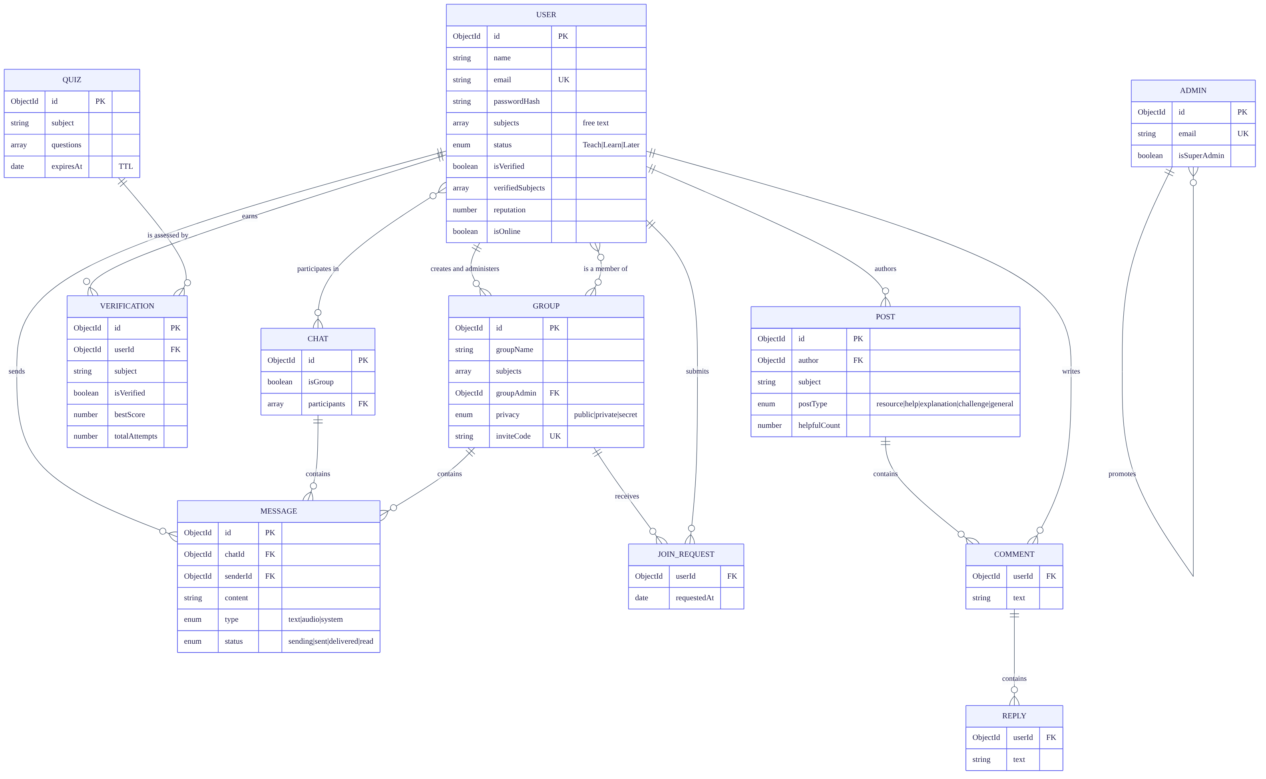
Figure 3.3. Entity relationship diagram (conceptual). ||--o{ denotes one-to-many and }o--o{ many-to-many. COMMENT, REPLY and JOIN_REQUEST are modelled as separate entities here for clarity, but are physically embedded within their parent documents — the reasoning is given in §3.7.2.
Two relationships deserve comment. A USER has two distinct associations with GROUP: one as creator and administrator, and one as an ordinary member. Separating them is what allows group administration to be a per-group privilege rather than a platform-wide role. Second, both CHAT and GROUP own MESSAGE records, because a group conversation and a direct conversation carry the same message structure and are addressed by the same identifier at the socket layer.

3.7.2 The design as classes
The system uses Mongoose, which represents each collection as a model class carrying both schema and behaviour. Figure 3.4 shows those classes together with the two service classes that hold logic used by more than one controller.
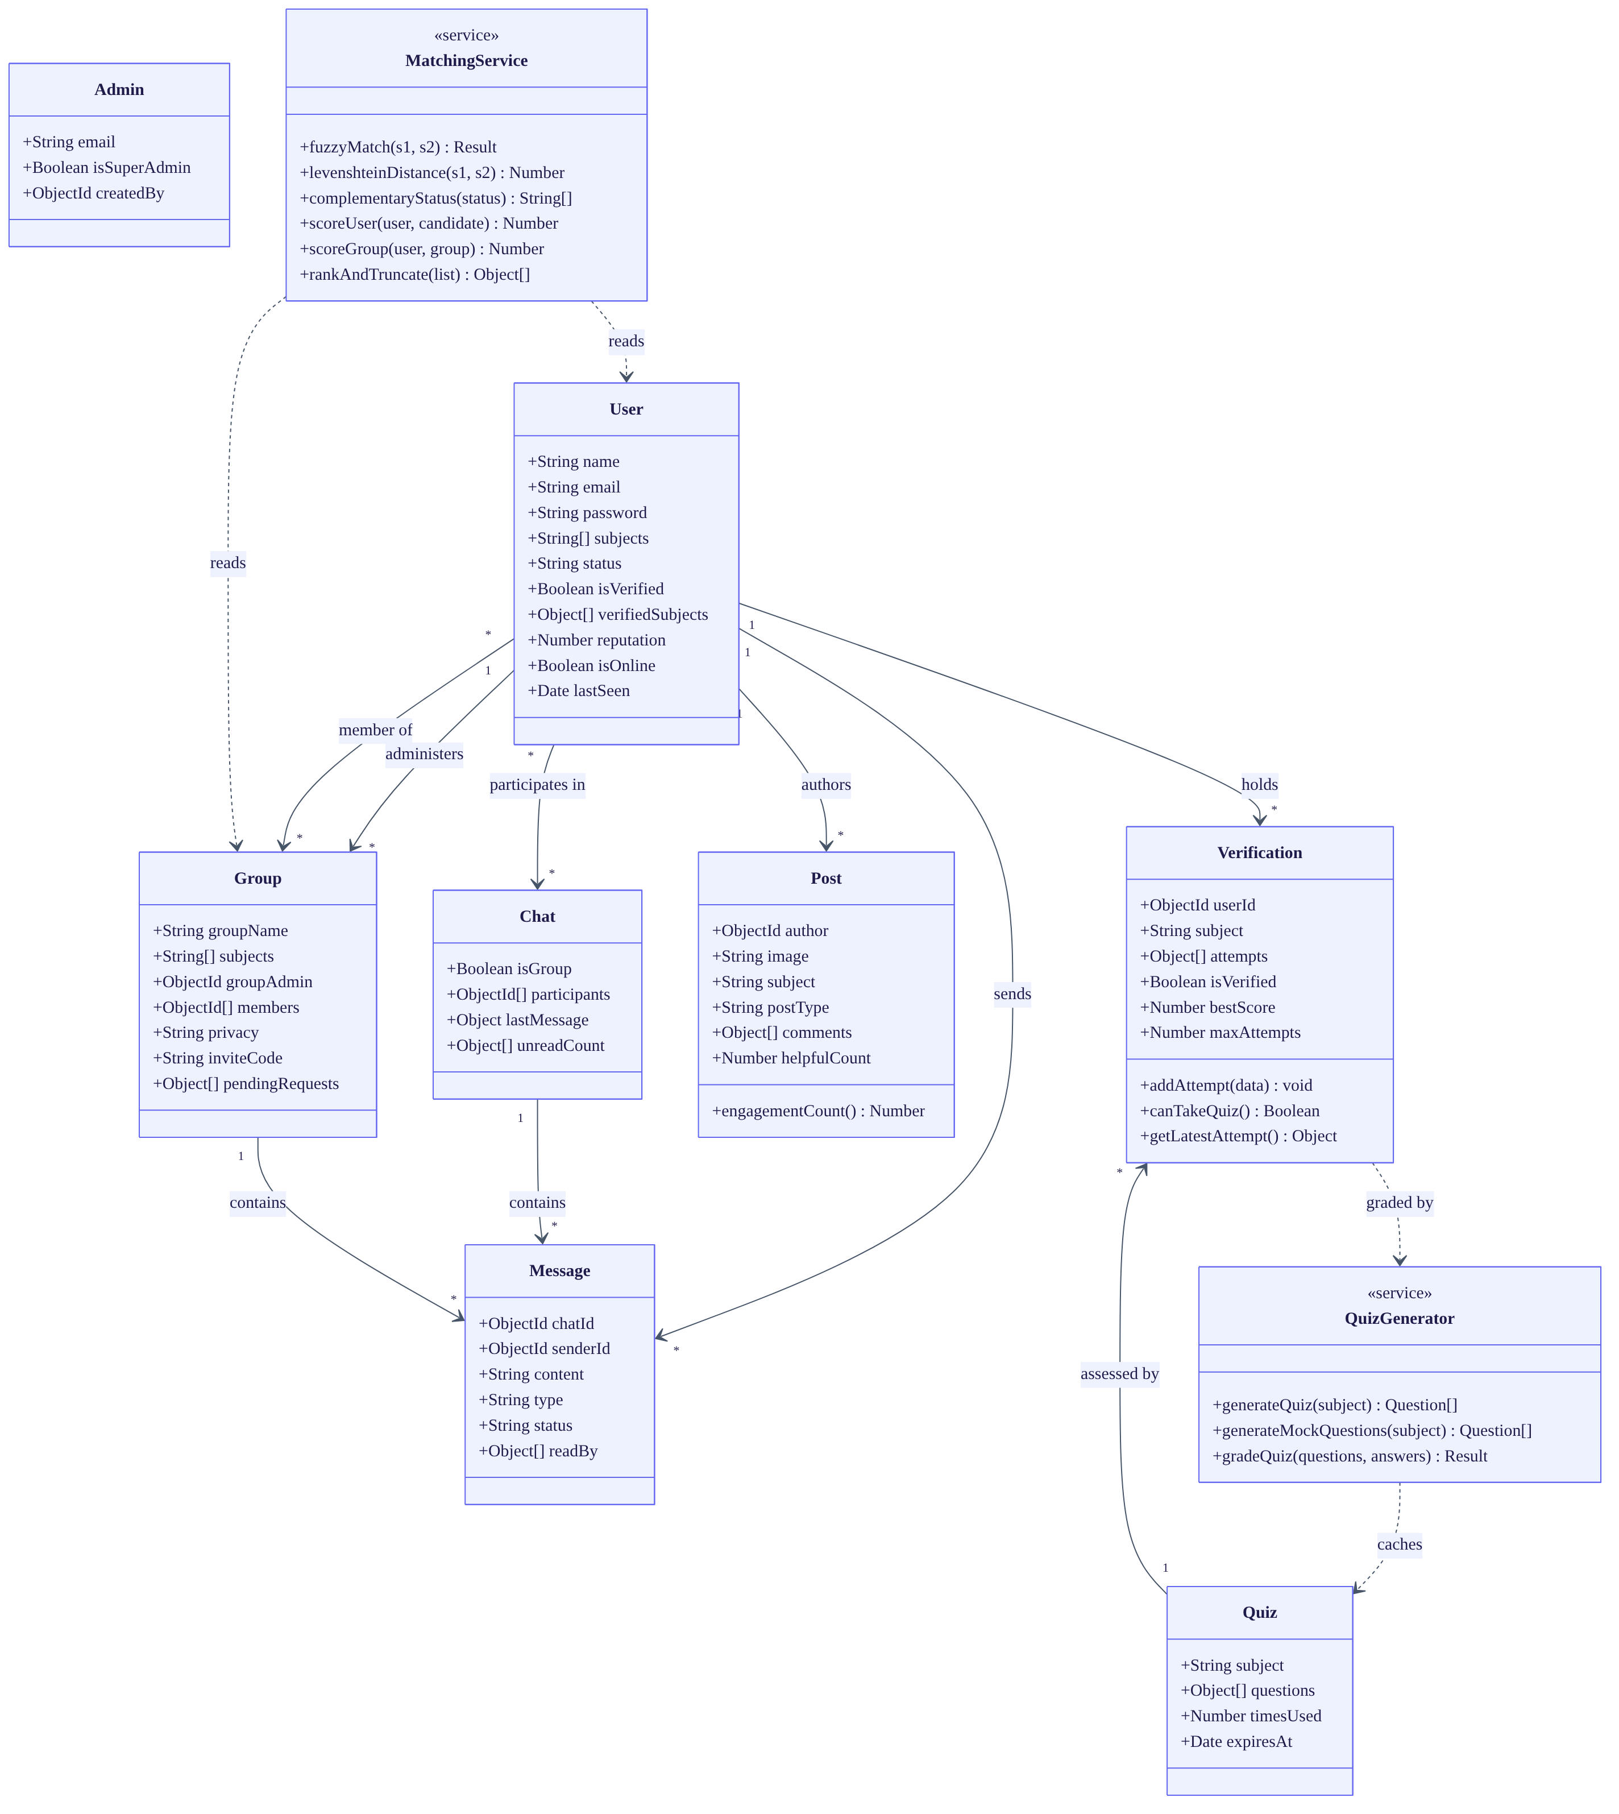
Figure 3.4. Class diagram. Solid arrows are associations with cardinality; dashed arrows are dependencies. MatchingService and QuizGenerator are stereotyped as services: they hold behaviour rather than state, and are the only classes containing algorithmic logic.
Note that MatchingService reads User and Group but owns no data of its own. This is deliberate: the matching algorithm is a pure function of the profile data, which is what makes it independently testable — the property exploited by the unit tests in Chapter 5, §5.3, where the functions were extracted and run in isolation without a database.

3.7.3 Embedding versus referencing
MongoDB allows related data either to be stored inside a parent document (embedding) or stored separately and linked by an identifier (referencing). The choice affects performance. The decisions made here were:
Data | Decision | Reason
Comments and replies inside posts | Embedded | A post and its discussion are always displayed together. Embedding makes this one database read instead of three. The cost is that a document has a 16 MB size limit, which caps how many comments a single post can hold.
Messages separate from chats | Referenced | A conversation grows without limit. Embedding messages would eventually exceed the document size limit.
Quiz attempt history separate from users | Referenced | Attempt history grows and is rarely read. Keeping it out of the user document keeps that frequently-read document small.
Unread counts inside chats | Embedded as an array of {userId, count} | Each participant needs their own counter. Storing them with the chat avoids a separate lookup when listing chats.
Last message copied onto the chat | Denormalised (duplicated) | The chat list shows the last message for every chat. Without this copy, displaying a list of 20 chats would need 20 extra queries. The cost is that the copy must be kept in step with the messages collection.
The last decision is a deliberate trade of write complexity for read speed, which is appropriate because a chat list is read far more often than a message is sent.

3.7.4 Indexes
An index is a data structure that lets the database find records without scanning every one. Indexes were added where queries are frequent.
Collection | Index | Purpose
users | email (unique) | Login lookup; also enforces that no email is registered twice
verifications | {userId, subject} (unique) | Ensures one verification record per user per subject
verifications | {userId, isVerified} | Fast badge lookup
quizzes | {subject, expiresAt} | Finding a valid cached quiz
quizzes | {expiresAt} with TTL 0 | Deletes expired quizzes automatically
posts | {author, createdAt} descending | Author timeline
posts | {subject}, {postType} | Filtering the feed
groups | inviteCode (unique, sparse) | Resolving invite links
The TTL (time-to-live) index on quizzes is worth noting: MongoDB deletes those documents by itself once the expiry date passes, so no scheduled cleanup job is needed.

3.8 Design of the Matching Algorithm
This section specifies the central technical contribution of the project. It is written so that another developer could implement the same algorithm from this description alone.
Reference implementation: backend/controllers/Suggestions.js

3.8.1 The problem to solve
Given a student who has declared some subjects and a role, produce a ranked list of other students and groups that are worth connecting with. The list must be produced without the student performing a search, and must place the most suitable candidates first.

3.8.2 Notation
Let:
- $u$ be the requesting student, with subject set $S_{u}$ and status $σ_{u}$
- $c$ be a candidate student, with subject set $S_{c}$ and status $σ_{c}$
- $g$ be a candidate group, with subject set $S_{g}$ and member set $M_{g}$
Status takes one of three values: Ready To Teach, Ready To Learn, or Later.

3.8.3 The complementary status function
The core idea of the algorithm is that a learner should be matched to a teacher, not to another learner. This is expressed as a function returning the status that complements the requester’s:
$$\text{comp}(σ_{u})=\left\{\begin{matrix}\{\text{Ready To Teach}\} & \text{if }σ_{u}=\text{Ready To Learn} \\ \{\text{Ready To Learn}\} & \text{if }σ_{u}=\text{Ready To Teach} \\ ⌀ & \text{if }σ_{u}=\text{Later}\end{matrix}\right.$$
A student whose status is Later has no complement, and therefore receives no status bonus. This is what makes the system a reciprocal recommender in the sense defined by Palomares et al. (2021): the match must serve both parties, and it does so because the two roles need each other.

3.8.4 The fuzzy subject matcher
Subjects are typed in as free text. Two students may write the same subject differently. The matcher must therefore tolerate differences in case, punctuation, spacing and spelling.
The matcher works in four tiers, from most confident to least. It stops at the first tier that matches, so the expensive calculation only runs when the cheap tests fail.
FUNCTION fuzzyMatch(s1, s2):
// Normalisation: lowercase, then remove + # . - _ and all spaces
n1 ← normalise(s1)
n2 ← normalise(s2)
// Tier 1 — exact match after normalisation
IF n1 = n2 THEN
RETURN (matched, score = 10)
// Tier 2 — one contains the other
IF n1 contains n2 OR n2 contains n1 THEN
RETURN (matched, score = 7)
// Tier 3 — first three characters agree
IF length(n1) ≥ 3 AND length(n2) ≥ 3 AND n1[0..2] = n2[0..2] THEN
RETURN (matched, score = 5)
// Tier 4 — edit distance similarity
d ← levenshteinDistance(n1, n2)
sim ← 1 − d / max(length(n1), length(n2))
IF sim ≥ 0.7 THEN
RETURN (matched, score = floor(5 × sim))
RETURN (not matched, score = 0)
The normalisation step is what allows C++, cpp and c-plus-plus to be treated as identical, and Data Structures to match data-structures.
Tier 4 uses Levenshtein distance (Levenshtein, 1966), which counts the minimum number of single-character insertions, deletions or substitutions needed to turn one string into the other. It is computed with the standard dynamic-programming matrix. Dividing by the length of the longer string converts the distance into a similarity value between 0 and 1.
The threshold of 0.7 was chosen deliberately, and the reasoning should be stated in your defence. The two possible errors have unequal costs. A missed match means a student never learns that a suitable partner existed. A wrong match means one suggestion card is ignored. Since the first error is much more costly than the second, the threshold favours finding more matches (recall) over being strictly correct (precision). Chapter 5 reports a case where this produces a wrong match, which is the expected consequence of the choice.

3.8.5 The scoring function for candidate students
For each candidate $c$, a score is computed:
Score(u,c)=20⋅[σc∈comp(σu)]⏟complementary role+s∈Su​maxt∈Scfuzz(s,t)⏟subject overlap+3⋅[online(c)]⏟currently online+2⋅|M|⏟multiple subjects
where $M$ is the set of matched subject pairs, the final term applies only when $|M|>1$, and $[ ⋅ ]$ equals 1 when the condition is true and 0 otherwise.
For each of the requester’s subjects, the matcher finds the best-matching subject on the candidate’s profile and adds that score once. It does not add a score for every pair, which would over-reward candidates who list many subjects.

3.8.6 Justification of the weights
Table 3.5
Scoring Weights and Their Justification
Component | Weight | Justification
Complementary role | 20 | This is the largest weight, and deliberately so. It ensures that one correct role match outranks any accumulation of subject similarity alone. A perfect subject match between two learners does not serve the platform’s purpose, because neither can help the other. This weight is the point where the reciprocal principle from §2.3.2 becomes code.
Exact subject match | 10 | The strongest available evidence of a genuinely shared subject.
One subject contains the other | 7 | For example Maths inside Advanced Maths. High confidence, but slightly lower than exact.
First three characters match | 5 | For example Programming and Program. Moderate confidence.
Edit-distance similarity ≥ 0.7 | ⌊5 × sim⌋ | Catches spelling errors. Capped at a low value because this tier produces the most false matches.
Currently online | 3 | Being available right now has real value, but must not outweigh subject fit. Deliberately small.
More than one shared subject | 2 per match | Two students sharing several subjects are more likely to form a lasting partnership than a one-off exchange.
These weights were set by hand and tuned against sample profiles. This must be stated openly. There was no labelled dataset of “correct” matches to optimise against, because no such dataset exists for this problem. This is a genuine limitation of the method, not an oversight, and Chapter 5 discusses it. The Future Work section proposes learning the weights from observed outcomes once the platform has usage data.

3.8.7 The scoring function for candidate groups
Groups are scored with the same subject term plus two group-specific terms:
Score(u,g)=s∈Su​maxt∈Sgfuzz(s,t)+min(|Mg|,15)+3|M|
The middle term rewards groups that already have members, since an empty group offers little. It is capped at 15 so that very large groups do not permanently outrank new small ones, which would prevent new groups from ever being discovered.
Groups do not receive a status term, because a group has no single teach or learn role.

3.8.8 Exclusion rules
Before scoring, candidates are removed if any of the following apply:
Candidate type | Excluded when
Student | It is the requester themselves
Student | The requester already has a direct chat with them
Student | They have declared no subjects
Group | The requester is already a member
Group | The requester has a join request pending
Excluding existing chat partners is important. Without it, the suggestion list would fill up with people the student already talks to, and would stop being a discovery tool.
After scoring, any candidate scoring zero is discarded.

3.8.9 Ranking and truncation
Results are sorted by score, highest first. Ties among students are broken first by online status, then by most recent activity. Ties among groups are broken by newest first.
Both lists are cut to the top 15. This limit exists for interface reasons: a student presented with 200 suggestions will act on none of them.

3.8.10 Activity model of the matching process
Figure 3.5 shows the process as an activity diagram, from the point a student completes their profile to the point a suggestion becomes a conversation. The two swim lanes separate what the student does from what the system does.
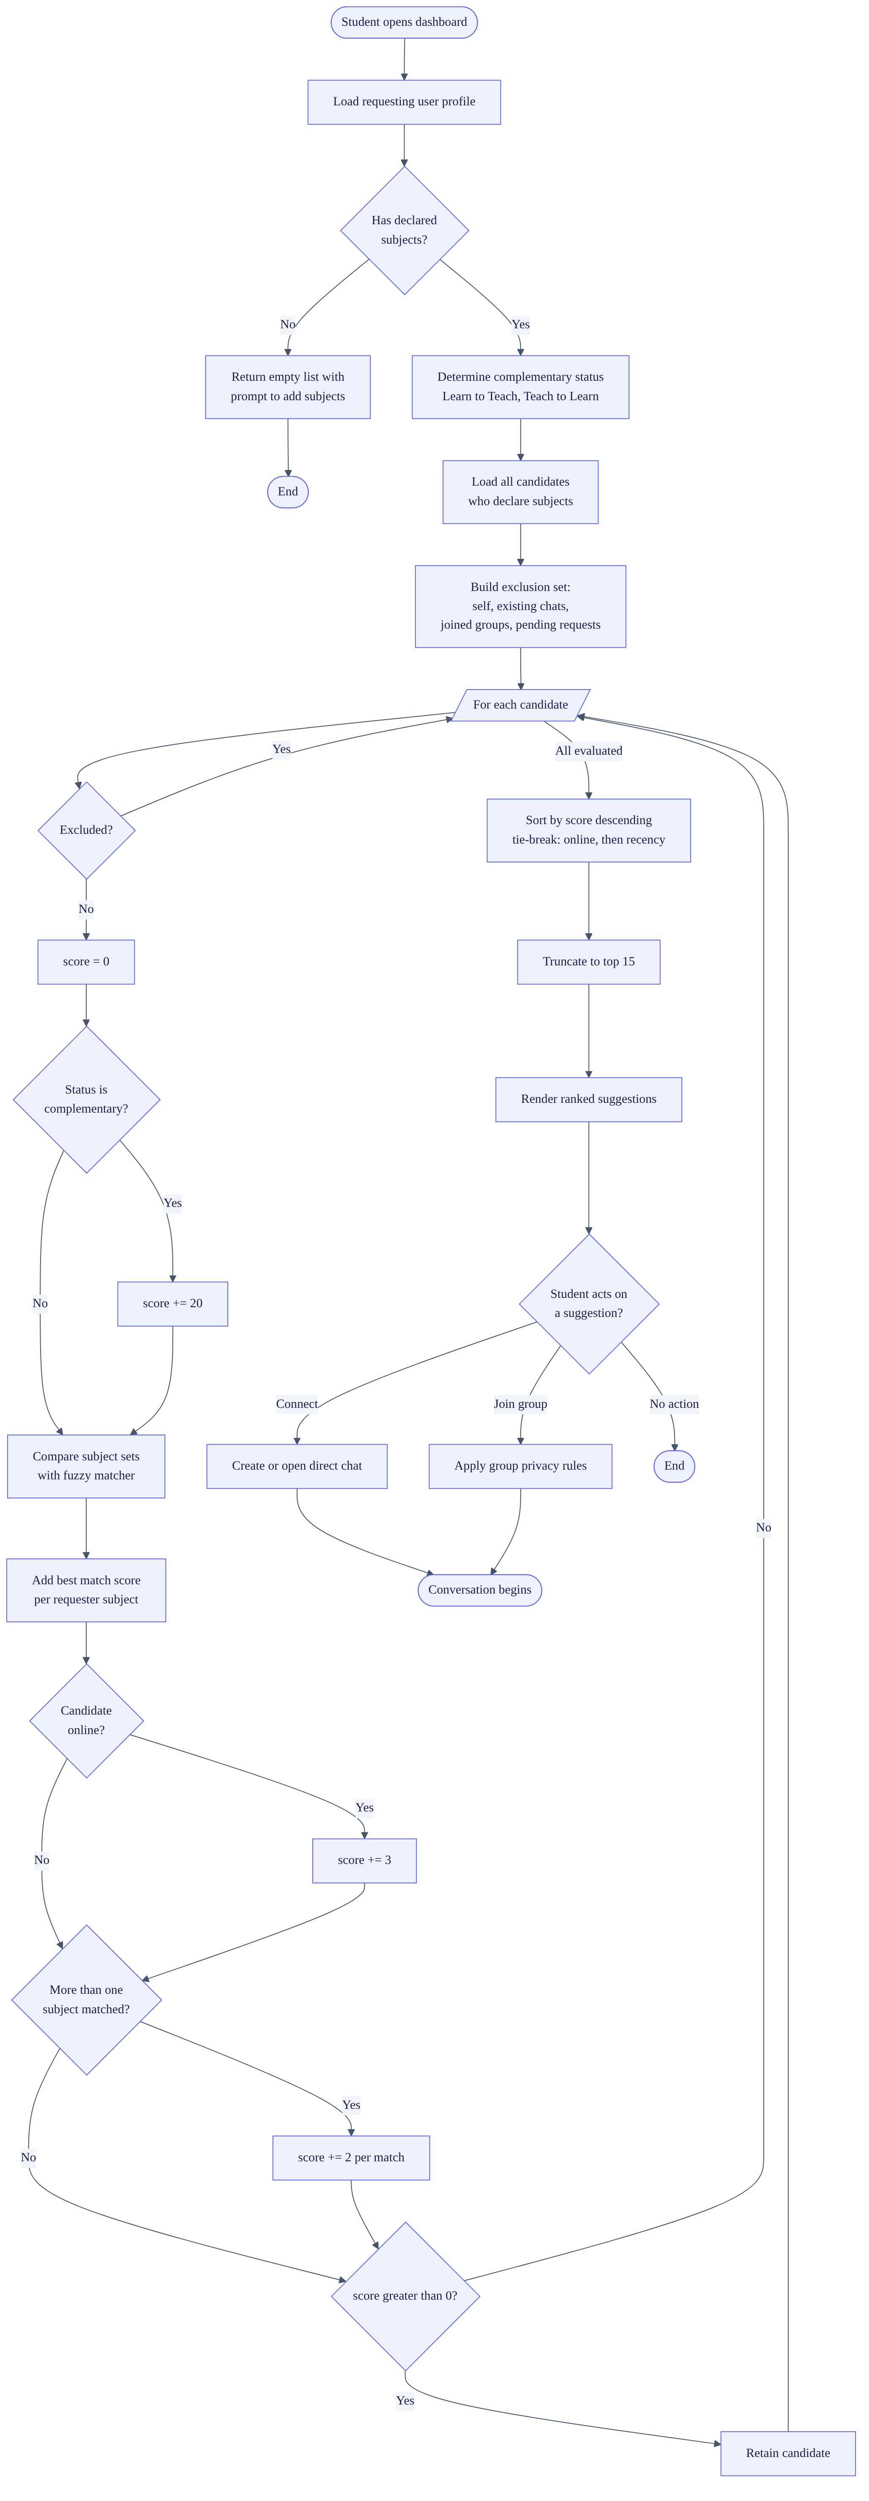
Figure 3.5. Activity diagram of the matching process. Diamonds are decision points; the loop node iterates over every candidate. The exclusion step precedes scoring so that computation is not spent on candidates that will be discarded.

3.8.11 Sequence model of discovery to conversation
Figure 3.6 shows the same process as an interaction between components, which makes the division of responsibility explicit — in particular that scoring happens in the application tier, not in the database.
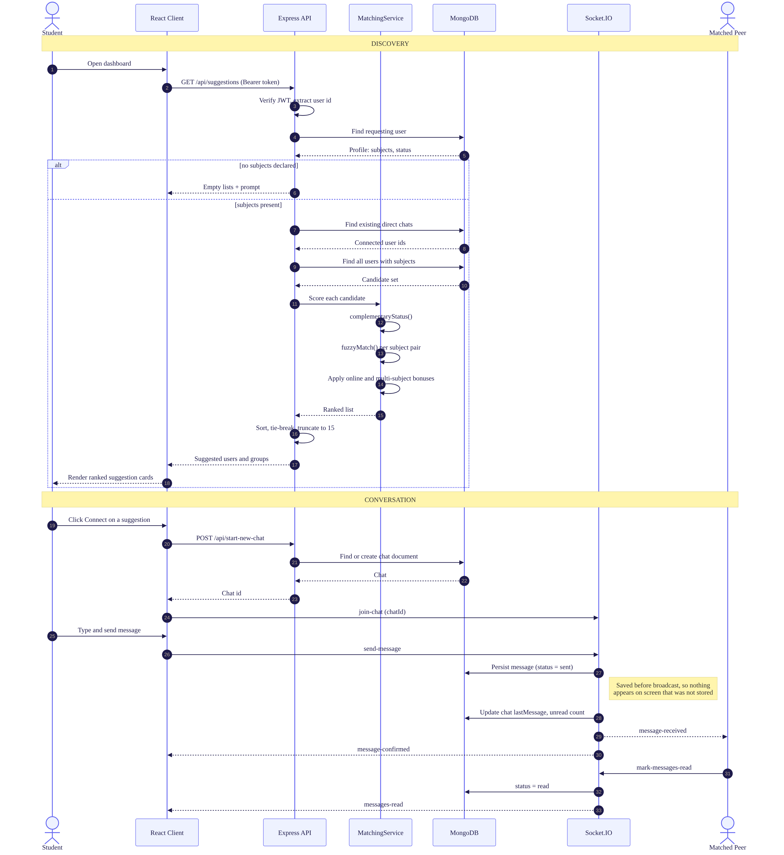
Figure 3.6. Sequence diagram from discovery through to a delivered and read message. The alt fragment shows the cold-start branch for a student who has declared no subjects. Steps 12 to 15 occur entirely in the application tier — the scalability consequence is analysed in §3.8.13.

3.8.12 Worked example
To make the algorithm concrete, consider:
- Requester: Ama. Subjects: Calculus, Data Structures. Status: Ready To Learn.
- Candidate 1: Kwame. Subjects: calculus, data-structures. Status: Ready To Teach. Online.
- Candidate 2: Efua. Subjects: Calculus. Status: Ready To Learn. Offline.
Kwame’s score: - Complementary role (Ready To Teach complements Ready To Learn): +20 - Calculus ↔ calculus: exact after normalisation: +10 - Data Structures ↔ data-structures: exact after normalisation: +10 - Online: +3 - Two subjects matched, so multiple-subject bonus 2 × 2: +4 - Total: 47
Efua’s score: - Complementary role: Ready To Learn does not complement Ready To Learn: +0 - Calculus ↔ Calculus: exact: +10 - Not online: +0 - Only one subject matched, so no bonus: +0 - Total: 10
Kwame is ranked first. This is the correct outcome: Ama needs someone who can teach, and Efua needs the same help Ama does.

3.8.13 Complexity analysis
Let $n$ be the number of candidate students, $|S|$ the average number of subjects per student, and $ℓ$ the average length of a subject name.
The algorithm compares every one of the requester’s subjects against every one of each candidate’s subjects. Each comparison may run Levenshtein, which costs $O(ℓ^{2})$. The total is:
$$O(n⋅|S_{u}|⋅|S_{c}|⋅ℓ^{2})$$
The candidate list is loaded into the application’s memory and scored there, rather than in the database.
This is acceptable at the scale of a pilot and unacceptable at institutional scale. With a few thousand users and short subject names the endpoint responds within the target time. But the cost grows linearly with the number of users, so the approach has a ceiling. This is the system’s main scalability limit. It is stated here rather than hidden, and Chapter 5 reports the measured behaviour. The Future Work section proposes moving the scoring into a database aggregation pipeline and adding an index from subjects to users.

3.9 Design of the Verification Mechanism

3.9.1 Purpose
Chapter 1, Problem 4 established that learners cannot tell genuine competence from confidence. Chapter 2, §2.4.2 established that conventional reputation systems cannot solve this at launch because they need accumulated ratings first.
The verification mechanism addresses this with an assessment that can be taken immediately.

3.9.2 Design decisions
Table 3.6
Verification Design Decisions
Decision | Value | Justification
Pass threshold | 70% | High enough that the badge means something; low enough not to discourage participation. Since willing teachers are the scarce resource (§2.2.3), an excessively hard test would starve the platform of supply.
Attempts allowed | 3 per subject | Prevents someone repeatedly guessing their way through a fixed question bank.
Questions per quiz | 10 | Enough to make guessing unreliable; short enough that students complete it.
Options per question | 4 | Reduces the chance of a correct guess to 25%.
Correct answers sent to browser | Never | Answers are removed from the response before it is sent. Marking happens only on the server. This prevents a student reading the answers from the page source.
Session ownership check | Enforced | The submitted session is checked against the submitting user, preventing one student submitting another’s quiz.
Scope | Per subject | Competence is subject-specific. A badge in Java says nothing about Statistics.

3.9.3 State model
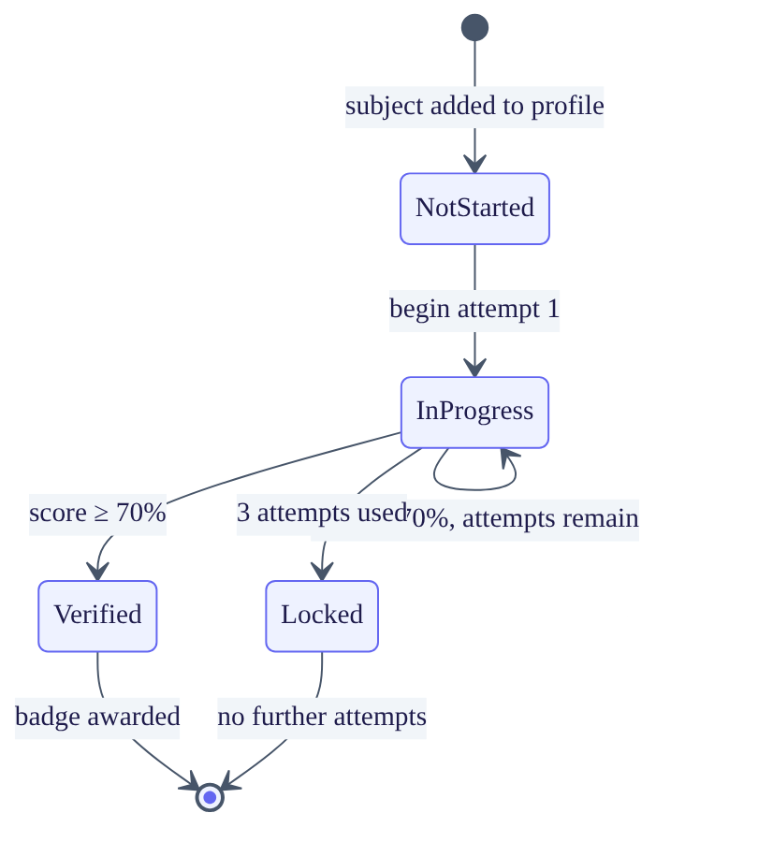
Figure 3.7. State diagram for competency verification of a single subject. Verification is per subject, so a student holds one independent instance of this machine for each subject they declare.

3.9.4 Question generation — accurate statement of the approach
This subsection must be reported accurately, and the accurate statement is as follows.
The design intention was to generate questions specific to each subject using a large language model, drawing on the research reviewed in §2.4.4. Provision for this was made: the environment holds an API key and the client library is installed.
However, the implemented build does not use it. Question generation currently uses a deterministic template bank: ten fixed question templates into which the subject name is inserted. The templates assess pedagogical approach — how a person would go about teaching — rather than knowledge of the subject itself.
The consequences must be stated:
- The badge is a weaker signal of subject competence than the design intended. It indicates that the holder has sensible views about teaching, not that they know the subject.
- Every subject produces structurally identical questions.
This is reported here, in Chapter 4, and in Chapter 5 rather than being concealed. Do not describe this system as using AI-generated assessment. An examiner who asks for a demonstration across two different subjects will see identical questions immediately, and a claim that collapses under demonstration is far more damaging than a limitation stated openly.
Generated quizzes are cached per subject for 7 days, so the caching and marking infrastructure is already in place to receive model-generated questions when that component is completed.

3.10 Design of the Real-Time Subsystem

3.10.1 Rooms
Socket.IO provides rooms — named groups of connections. A message sent to a room reaches only the connections in it.
The design uses one room per chat and one per group, named by the identifier of that chat or group. When a user opens a conversation the client joins the corresponding room. Sending a message to that room therefore reaches exactly the participants and nobody else. This gives message isolation without any manual recipient list.

3.10.2 Presence
When a user connects, the client emits user-online. The server records the connection identifier on the user record, sets the online flag, and broadcasts the change so other users see the status update. On disconnect the server clears the flag and records the time as lastSeen.

3.10.3 Message state
Each message carries a status that moves through four values:
sending → sent → delivered → read
The transitions are:
Transition | Trigger
sending → sent | Server has saved the message to the database
sent → delivered | Recipient’s client is connected and receives it
delivered → read | Recipient opens the conversation and the client emits mark-messages-read
For group chats the server additionally records which users have read the message, since “read” is not a single event when there are many recipients.

3.10.4 Ordering of persistence and emission
An important design rule: the server saves the message to the database before broadcasting it. The alternative — broadcast first for lower latency — risks a message appearing on screen and then vanishing if the save fails. Saving first means anything a user sees has been stored.

3.11 Security Design
Table 3.7
Security Controls and Their Placement
Concern | Control | Where implemented
Password storage | bcrypt hashing, cost factor 10 | controllers/RegisterUser.js
Session management | JWT access token, 15-minute lifetime | controllers/LoginUser.js
Session continuity | Refresh token, 7-day lifetime | controllers/RefreshToken.js
Route protection | Bearer token verified before the handler runs | middleware/authMiddleware.js
Administrator separation | Separate collection, separate login, separate middleware | middleware/adminAuth.js
Privilege escalation | Only a super-administrator may promote another admin | routes/adminRoutes.js
Duplicate accounts | Unique index on email | models/UserModel.js
Upload abuse | File type and size restricted (JPEG/PNG, 2 MB) | middleware/upload.js
Cross-origin requests | Only the configured frontend origin permitted | server.js
Assessment integrity | Answers withheld; marking server-side only | controllers/verificationController.js
Secret management | Values supplied by environment variables, excluded from version control | .env, .gitignore
Why bcrypt rather than a plain hash. A fast hash such as SHA-256 can be computed billions of times per second on modern hardware, so a stolen password database can be attacked by brute force. bcrypt is deliberately slow and its cost is adjustable, which makes such an attack impractical (Provos & Mazières, 1999).
Why two tokens. A single long-lived token is convenient but dangerous, since a stolen token remains valid for a long time. A single short-lived token is safe but forces the user to log in repeatedly. The two-token design gives both: the access token expires in 15 minutes, limiting the damage from theft, while the refresh token renews it silently for up to 7 days.
Weaknesses found in the implementation of these controls are reported in Chapter 4 and discussed in Chapter 5. They are not concealed.

3.12 Group Privacy Model
Three privacy levels were designed after the original two-state model proved inadequate.
Table 3.8
Group Privacy Levels
Level | Appears in search and explore | How a user joins | Intended use
public | Yes | Joins immediately | An open study group anyone may enter
private | Yes | Sends a request; group admin approves or rejects | A group that wants to be found but control who enters
secret | No | Invite link only | A closed group that should not be discoverable at all
The distinction between private and secret is the one the original boolean design could not express. A boolean forces a group to choose between being fully open and being invisible. In practice a group often wants to be findable but not automatically joinable — a student should be able to discover that a Statistics group exists and ask to join, while the existing members retain control over membership. This is the private level, and adding it required a schema change and a migration script for existing data.

3.13 Development Environment and Tools
Table 3.9
Tools Used
Purpose | Tool
Code editor | Visual Studio Code
Version control | Git
Runtime | Node.js v24.15.0 (minimum v18)
Package manager | npm v11
Database | MongoDB 6.0+
Database inspection | MongoDB Compass
API testing | Postman / Thunder Client
Automatic server restart | nodemon
Frontend dev server | Vite
Code quality | ESLint 9 with React plugins
Operating system | Linux

3.14 Evaluation Methodology
Evaluation is step 5 of the DSR process (Peffers et al., 2007). Three forms of evaluation were used: functional testing, performance measurement, and a user study.

3.14.1 Functional testing
Testing was carried out at six levels. Four are automated as executable scripts committed to the repository, so that any result reported in Chapter 5 can be regenerated by a reader rather than taken on trust.
Level | What is tested | Method | Script
Unit | Individual functions in isolation — the fuzzy matcher and the Levenshtein function | Inputs with known expected outputs | backend/tests/fuzzyMatcher.test.js
Algorithm | How matching cost grows with population size | Timed runs against synthetic populations, fixed seed | backend/tests/scalability.bench.js
Integration | Every API endpoint against the live server | Executable suite issuing real HTTP requests | backend/tests/functional.test.js
Performance | Endpoint response times against stated targets | Repeated timed samples after a warm-up | backend/tests/performance.bench.js
System | Complete user journeys through the interface | Scripted manual walkthrough | —
Real-time | Behaviour with multiple simultaneous clients | Two browsers, two accounts, side by side | —
Why the automated suites matter methodologically. A results chapter that reports “the tests passed” asks the reader to believe the author. A results chapter accompanied by a script the reader can run asks them to believe the system. The second is the stronger claim, and it is the reason the integration and performance levels were written as executable suites rather than as Postman collections: a Postman collection is a record of what the author did, whereas a committed script is an instrument anyone can re-apply.
The functional suite creates the accounts, groups and conversations it needs and removes them afterwards, so it is repeatable and leaves no residue in the database.
The fuzzy matcher receives particular attention because it is the most testable component and the one most central to the contribution. This is a consequence of the design recorded in §3.7.2: because MatchingService holds behaviour but no state, its functions can be extracted and exercised without a database.
The two manual levels remain manual for a defensible reason. System walkthroughs assess whether a journey feels coherent, which is a judgement rather than an assertion. Real-time behaviour requires two simultaneously connected clients, which needs a multi-client harness that the project did not build.

3.14.2 Performance measurement
Measurable targets were set in advance, so that the evaluation has pass or fail criteria rather than opinions. The main ones:
Measure | Target | How verified
Authentication response time | ≤ 2 seconds | Automated (performance.bench.js)
Suggestions response time (≤ 1,000 users) | ≤ 3 seconds | Automated
Initial application load | ≤ 5 seconds | Automated, browser cache disabled
Chat history retrieval | ≤ 2 seconds | Automated
Message delivery latency between clients | ≤ 500 milliseconds | Manual — requires two connected clients
Concurrent users supported | ≥ 100 | Not verified; stated as a design target
Each automated measure is sampled repeatedly after a discarded warm-up run, and both the mean and the median are reported. The median is included because a single slow sample — a cold database connection, typically — distorts a mean badly at these sample sizes.

3.14.3 User study design
Design. A post-test evaluation in which participants use the system to complete defined tasks and then complete questionnaires.
Participants. A convenience sample of tertiary students, target N ≥ 20, including students with both intents and from different subject areas.
[Results to be inserted from the author’s own data collection.]
Procedure.
- Brief the participant and obtain written consent.
- Administer the pre-test questionnaire: how they currently find study partners, how difficult they find it, how long it takes.
- The participant completes five tasks unaided while the researcher records success and time:
  - T1: Register and verify an account
  - T2: Add three subjects and set a status
  - T3: Find a suggested peer and open a chat with them
  - T4: Create or join a study group
  - T5: Take a verification quiz for one subject
- Administer the post-test questionnaires (below).
- Conduct a short interview: what worked, what did not, what is missing.

3.14.4 Instruments
Two validated instruments were used rather than questions invented for this project. Using established instruments means the results can be compared against published benchmarks.
System Usability Scale (SUS). Ten statements answered on a five-point scale, producing a score from 0 to 100 (Brooke, 1996). SUS is widely used and its benchmark is well established: a score of 68 is average. This gives a defensible pass mark rather than an arbitrary one.
Technology Acceptance Model (TAM). Measures perceived usefulness and perceived ease of use, the two factors Davis (1989) identified as predicting whether people will actually adopt a system. This matters here because a matching platform that people do not adopt cannot work, regardless of its technical quality.
Project-specific measures. Three additional measures answer the research questions directly:
Research question | Measure
RQ1 (are suggestions relevant?) | For each of the top five suggestions: “How relevant is this person to your learning needs?” rated 1–5
RQ2 (does the badge build trust?) | “How willing would you be to contact this person for help?” asked with and without a verification badge visible
RQ3 (does it reduce effort?) | Difficulty rating before and after using the system
RQ4 (how does it scale?) | Suggestions response time measured against increasing numbers of users

3.14.5 Data analysis
Descriptive statistics (mean, standard deviation) are reported for SUS scores, task success rates and completion times. The RQ2 trust measure is a paired comparison, since the same participant answers both conditions. Interview responses are analysed by grouping similar comments into themes.

3.14.6 Ethical considerations
- Participation is voluntary, and participants may withdraw at any point without giving a reason.
- Written informed consent is obtained before any activity. The consent form is in the SRS, Appendix E.
- Responses are anonymised and reported only in aggregate.
- Test accounts and any data entered during testing are deleted after analysis.
- No sensitive personal data is collected.

3.15 Reproducibility
This section provides what another researcher needs to rebuild and run the system. It exists because the project guide requires that someone else could reproduce the results.

3.15.1 Requirements
- Node.js version 18 or later
- MongoDB version 6.0 or later
- An SMTP account for sending verification email

3.15.2 Configuration
The backend requires these environment variables in backend/.env:
Variable | Purpose
MONGODB_URI | Database connection string
PORT | Port the API listens on (default 5000)
FRONTEND_URL | Address of the frontend; used for CORS and verification links
JWT_SECRET | Signing key for access tokens
REFRESH_TOKEN_SECRET | Signing key for refresh tokens
EMAIL_USER | SMTP account name
EMAIL_PASS | SMTP password
ANTHROPIC_API_KEY | Reserved for question generation (not currently used — see §3.9.4)
The frontend requires VITE_BACKEND_URL in frontend/.env.

3.15.3 Installation and running
# from the project root
npm install # installs both backend and frontend dependencies
npm run backend # starts the API server
npm run frontend # starts the frontend development server
The two servers run in separate terminals. MongoDB must be reachable before the backend starts.
The first administrator account is created by running:
node backend/migration/createSuperAdmin.js

3.15.4 Reproducing the algorithm results
The matching algorithm is fully specified in §3.8, including all weights, thresholds, exclusion rules and the tie-breaking order. The worked example in §3.8.12 provides a test case with a known correct answer, which an implementer can use to check their reimplementation.

3.16 Chapter Summary
This chapter set out how the problem identified in Chapter 1 was solved.
The project follows Design Science Research (Hevner et al., 2004), using the six-step process of Peffers et al. (2007), because the contribution is a built artefact that is then evaluated. Development used an incremental and iterative method, justified by the fact that key design decisions — the algorithm weights and the group privacy model — could not be known in advance and had in fact to be revised during development.
Technology choices were justified against stated criteria, and the cost of each choice was acknowledged rather than ignored. The system uses a three-tier architecture with two communication channels, because request-response and push messaging have genuinely different requirements.
Section 3.8 gave the complete specification of the matching algorithm: the complementary status function, the four-tier fuzzy subject matcher, the scoring functions for students and groups, all weights with their justifications, the exclusion rules, an activity model (Figure 3.5), a sequence model (Figure 3.6), a worked example, and an honest complexity analysis identifying the point at which the approach would need redesigning.
Seven design models were presented in total — use case, architecture, entity relationship, class, activity, sequence and state — listed in Table 3.0. Together they satisfy the reproducibility requirement from two directions: the diagrams fix the structure and the interactions, while the formal specification in §3.8 fixes the behaviour.
Sections 3.9 to 3.12 covered the verification, real-time, security and privacy designs, including an accurate statement that question generation currently uses templates rather than a language model.
Section 3.14 set out the evaluation method, using two validated instruments so that results can be compared against published benchmarks rather than judged subjectively.
Chapter 4 describes what was actually built.

References
Brooke, J. (1996). SUS: A “quick and dirty” usability scale. In P. W. Jordan, B. Thomas, B. A. Weerdmeester, & I. L. McClelland (Eds.), Usability evaluation in industry (pp. 189–194). Taylor & Francis.
Davis, F. D. (1989). Perceived usefulness, perceived ease of use, and user acceptance of information technology. MIS Quarterly, 13(3), 319–340.
Fette, I., & Melnikov, A. (2011). The WebSocket protocol (RFC 6455). Internet Engineering Task Force. https://doi.org/10.17487/RFC6455
Fowler, M. (2002). Patterns of enterprise application architecture. Addison-Wesley.
Hevner, A. R., March, S. T., Park, J., & Ram, S. (2004). Design science in information systems research. MIS Quarterly, 28(1), 75–105. [V]
Levenshtein, V. I. (1966). Binary codes capable of correcting deletions, insertions, and reversals. Soviet Physics Doklady, 10(8), 707–710.
Palomares, I., Porcel, C., Pizzato, L., Guy, I., & Herrera-Viedma, E. (2021). Reciprocal recommender systems: Analysis of state-of-art literature, challenges and opportunities towards social recommendation. Information Fusion, 69, 103–127. https://doi.org/10.1016/j.inffus.2020.12.001 [V]
Peffers, K., Tuunanen, T., Rothenberger, M. A., & Chatterjee, S. (2007). A design science research methodology for information systems research. Journal of Management Information Systems, 24(3), 45–77. https://doi.org/10.2753/MIS0742-1222240302 [V]
Provos, N., & Mazières, D. (1999). A future-adaptable password scheme. In Proceedings of the USENIX Annual Technical Conference (pp. 81–91). USENIX Association.
Sommerville, I. (2016). Software engineering (10th ed.). Pearson.

