FindOut: A Reciprocal Recommender System for Peer Learning
Matching Students Who Want to Learn with Students Willing to Teach

Chapter Four: Implementation

[YOUR FULL NAME] · [YOUR STUDENT ID]
Department of Computer Science, University of Ghana, Legon
Supervisor: [SUPERVISOR’S NAME]
July 2026

Contents
Right-click and choose Update Field to build the contents.

Chapter Four: Implementation

4.1 Introduction
Chapter 3 explained how the system was designed. This chapter shows what was actually built.
It documents the development environment, the structure of the code, how the database was created, how the API was implemented and documented, how each functional module works, and what the finished interface looks like. It closes with the statistics of the build, the problems encountered during development, and an honest account of the defects that remain.
The evidence in this chapter takes four forms: screenshots of the running system, screenshots of the database and API tooling, short verbatim code extracts, and quantitative measures of what was produced.

4.2 Development Environment
Table 4.1
Development Environment
Component | Version / Tool | Purpose
Operating system | Linux (kernel 6.19) | Development host
Runtime | Node.js v24.15.0 (minimum v18) | Server execution
Package manager | npm v11 | Dependency management
Database | MongoDB 6.0+ (Atlas, cloud-hosted) | Persistence
Database client | MongoDB Compass | Inspecting collections and documents
Editor | Visual Studio Code | Development
Version control | Git, hosted on GitHub | History and backup
API documentation | swagger-ui-express 5.0.1 | Interactive API reference
API testing | Postman | Manual endpoint verification
Server reloading | nodemon 3.1.9 | Restart on file change
Frontend tooling | Vite 6.0.3 | Development server and production build
Linting | ESLint 9 | Static analysis
[ FIGURE 4.1 — SCREENSHOT TO BE INSERTED ]
Figure 4.1. The FindOut repository in the development environment, showing the > two-package structure.

4.3 Project Structure
The repository is a single project containing two independently installable packages. A root manifest installs both.
FindOut/
├── package.json Root manifest; installs both packages
├── backend/
│ ├── server.js Entry point: HTTP server, Socket.IO, routers
│ ├── config/
│ │ ├── connectDB.js Database connection and lifecycle
│ │ └── upload.js Multer storage for post images
│ ├── docs/
│ │ └── openapi.js OpenAPI 3.0 specification (58 operations)
│ ├── routes/ 4 routers, URL declarations only
│ ├── middleware/ Auth, admin auth, file and audio upload
│ ├── controllers/ 33 files, one operation each
│ ├── models/ 7 Mongoose schemas, 8 collections
│ ├── services/
│ │ └── quizGenerator.js Question generation and marking
│ ├── socket/
│ │ └── Socket.js All real-time event handlers
│ ├── migration/ 11 one-off data scripts
│ ├── tests/ 4 suites: unit, scalability, functional, performance
│ ├── uploads/ Images (git-ignored, created at runtime)
│ └── audios/ Voice messages (git-ignored)
└── frontend/
├── index.html
├── tailwind.config.js Design token to utility mapping
└── src/
├── main.jsx Entry: Router → Providers → App
├── App.jsx Route table
├── index.css Design tokens and shared component classes
├── Pages/ 13 screens
├── components/ 25 components
├── Context/ 13 state providers
├── Feed/ 4 feed components
├── socket/ Socket.IO client
└── utils/ Axios instance, token service
Each backend folder holds one kind of thing. A change to a URL touches only routes/; a change to a validation rule touches only models/.

4.4 Database Implementation

4.4.1 Schema definition
Collections are defined as Mongoose schemas, which enforce structure and validation at the application layer. The user schema is the central one, since matching depends on it.
Source: backend/models/UserModel.js
const userSchema = new mongoose.Schema({
name: { type: String, required: true },
email: { type: String, required: true, unique: true },
password: { type: String, required: true },
profilePicture: { type: String },
// Matching inputs
subjects: { type: [String], default: [] },
status: {
type: String,
enum: ["Ready To Teach", "Ready To Learn", "Later"],
default: "Later",
},
freetime: { type: String },
// Trust signals
isVerified: { type: Boolean, default: false },
verifiedSubjects: [{
subject: { type: String, required: true },
verifiedAt: { type: Date, required: true },
}],
reputation: { type: Number, default: 0 },
// Presence
isOnline: { type: Boolean, default: false },
lastSeen: { type: Date, default: Date.now },
socketId: { type: String, default: null },
}, { timestamps: true });
The enum on status is what makes complementary matching possible: because the field can hold only three known values, the algorithm can map any value to its complement without defensive checks.

4.4.2 Indexes
Indexes were declared on the fields that queries filter by.
Source: backend/models/VerificationModel.js, QuizModel.js, PostModel.js
// One verification record per user per subject — enforced, not assumed
verificationSchema.index({ userId: 1, subject: 1 }, { unique: true });
verificationSchema.index({ userId: 1, isVerified: 1 });
// Cached quizzes expire without a scheduled cleanup job
quizSchema.index({ subject: 1, expiresAt: 1 });
quizSchema.index({ expiresAt: 1 }, { expireAfterSeconds: 0 });
// Feed queries
postSchema.index({ author: 1, createdAt: -1 });
postSchema.index({ subject: 1 });
postSchema.index({ postType: 1 });
The TTL index on quizzes is worth noting: MongoDB deletes those documents itself once expiresAt passes, so no background job was needed.

4.4.3 Collections as created
[ FIGURE 4.2 — SCREENSHOT TO BE INSERTED ]
Figure 4.2. The eight collections as created in MongoDB, with document counts at > the time of capture.
[ FIGURE 4.3 — SCREENSHOT TO BE INSERTED ]
Figure 4.3. A user document, showing the stored subjects and availability that > drive the matching algorithm.
[ FIGURE 4.4 — SCREENSHOT TO BE INSERTED ]
Figure 4.4. A verification record with its embedded attempt history.

4.5 API Implementation

4.5.1 Server composition
Source: backend/server.js
const app = express();
const httpServer = createServer(app);
initializeSocket(httpServer); // WebSocket shares the HTTP server
app.use(express.json());
app.use('/uploads', express.static(path.join(__dirname, 'uploads')));
app.use('/audios', express.static(path.join(__dirname, 'audios')));
app.use(cors({ origin: process.env.FRONTEND_URL, credentials: true }));
app.use('/api', router); // 40 user endpoints
app.use('/api/admin', adminRoutes); // 11 admin endpoints
app.use('/api', searchRoutes); // 3 search endpoints
app.use('/api', verificationRoutes); // 4 verification endpoints
connectDB()
.then(() => httpServer.listen(PORT, () => { /* ... */ }))
.catch((error) => { /* report and exit 1 */ });
Two decisions are visible here. The WebSocket server is attached to the same HTTP server rather than a second port, so one origin serves both channels. And the server refuses to start if the database is unreachable — an earlier version listened anyway, which produced a server that accepted requests and failed every one of them ten seconds later.

4.5.2 Authentication middleware
Every protected route passes through one 20-line function.
Source: backend/middleware/authMiddleware.js
const authMiddleware = (req, res, next) => {
const token = req.header('Authorization')?.replace('Bearer ', '');
if (!token) {
return res.status(401).json({ message: 'No token, authorization denied' });
}
try {
const decoded = jwt.verify(token, process.env.JWT_SECRET);
req.authenticatedUser = decoded; // controllers read the identity from here
next();
} catch (error) {
res.status(401).json({ message: 'Token is not valid' });
}
};
Because the decoded identity is attached to the request, no controller parses a token itself. This is also why the defects in §4.10 that take a user id from the request body rather than from req.authenticatedUser are security-relevant: they bypass this single point of trust.

4.5.3 Endpoint catalogue
The API exposes 58 endpoints across nine functional areas.
Table 4.2
REST Endpoints by Module
Module | Endpoints | Representative routes
Authentication | 7 | POST /api/register, POST /api/login, GET /api/verify-email, POST /api/refresh-token
Profile | 3 | GET /api/user-details, PUT /api/edit-user, POST /api/profile-picture
Matching | 1 | GET /api/suggestions
Verification | 4 | GET /api/verification/status, POST /api/verification/start-quiz, POST /api/verification/submit-quiz
Groups | 12 | POST /api/creategroup, POST /api/join-group, GET /api/join/:inviteCode, PUT /api/groups/update-privacy
Messaging | 5 | GET /api/chats, GET /api/messages/:chatId, POST /api/start-new-chat
Feed | 9 | POST /api/add-post, GET /api/getallposts, POST /api/posts/:postId/helpful
Search | 4 | GET /api/search, GET /api/explore/groups
Administration | 11 | POST /api/admin/login, GET /api/admin/dashboard/stats, DELETE /api/admin/users/:userId
Total | 58
The single endpoint under Matching is deliberate. GET /api/suggestions performs the entire matching operation server-side and returns a ranked result, so the client holds no matching logic and cannot produce a different ranking.

4.5.4 API documentation with Swagger
The API is documented using OpenAPI 3.0, served as an interactive page through swagger-ui-express. This gives three things a written endpoint table cannot: a machine-readable contract, request and response schemas for every operation, and the ability to execute real requests from the browser.
The specification is maintained as a single module rather than as annotations spread across 33 controllers, so it can be read as a contract independently of the implementation.
Source: backend/server.js
const swaggerUi = require('swagger-ui-express');
const openapiSpec = require('./docs/openapi');
app.get('/api-docs.json', (req, res) => res.json(openapiSpec));
app.use('/api-docs', swaggerUi.serve, swaggerUi.setup(openapiSpec, {
customSiteTitle: 'FindOut API',
swaggerOptions: {
persistAuthorization: true, // bearer token survives a page reload
docExpansion: 'none', // collapse tags so the index stays readable
filter: true, // search box over operations
tryItOutEnabled: true,
},
}));
Source: backend/docs/openapi.js — excerpt showing how the core endpoint is described
'/api/suggestions': {
get: {
tags: ['Matching'],
summary: 'Get ranked peer and group suggestions',
description: `Returns up to 15 users and 15 groups, ranked by match score.
Complementary availability scores 20; exact subject match 10; ...`,
responses: {
200: ok('Ranked suggestions', {
type: 'object',
properties: {
suggestedUsers: { type: 'array', items: { $ref: '#/components/schemas/SuggestedUser' } },
suggestedGroups: { type: 'array', items: { $ref: '#/components/schemas/SuggestedGroup' } },
},
}),
401: Unauthorized,
},
},
},
The documentation covers all 58 operations, grouped under nine tags, with 10 reusable schema definitions (User, Group, Message, Post, QuizQuestion, QuizResult, TokenPair and others) so response shapes are defined once and referenced.
Two security schemes are declared, bearerAuth and adminAuth, which documents an important property of the system: administrator endpoints require a different identity, and a user token is not accepted on them.
Access: with the backend running, the documentation is at http://localhost:5000/api-docs, and the raw specification at http://localhost:5000/api-docs.json.
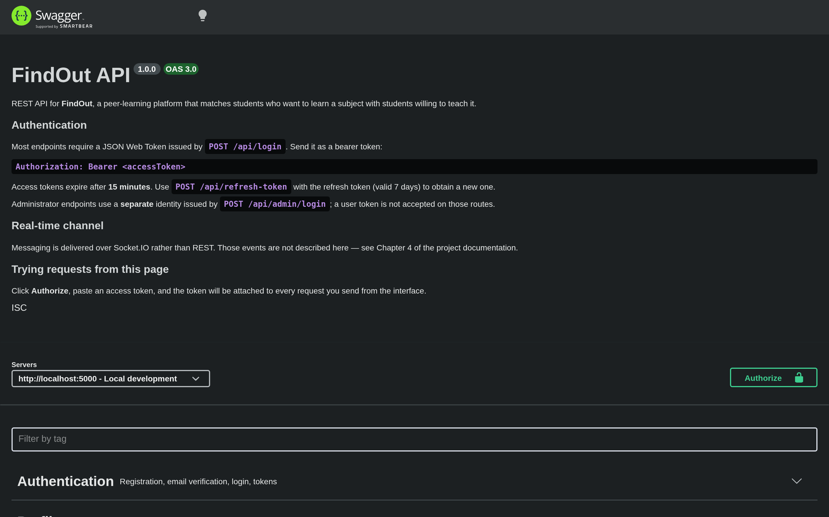
Figure 4.5
Figure 4.5. The generated API documentation, covering all 58 endpoints grouped by functional area.
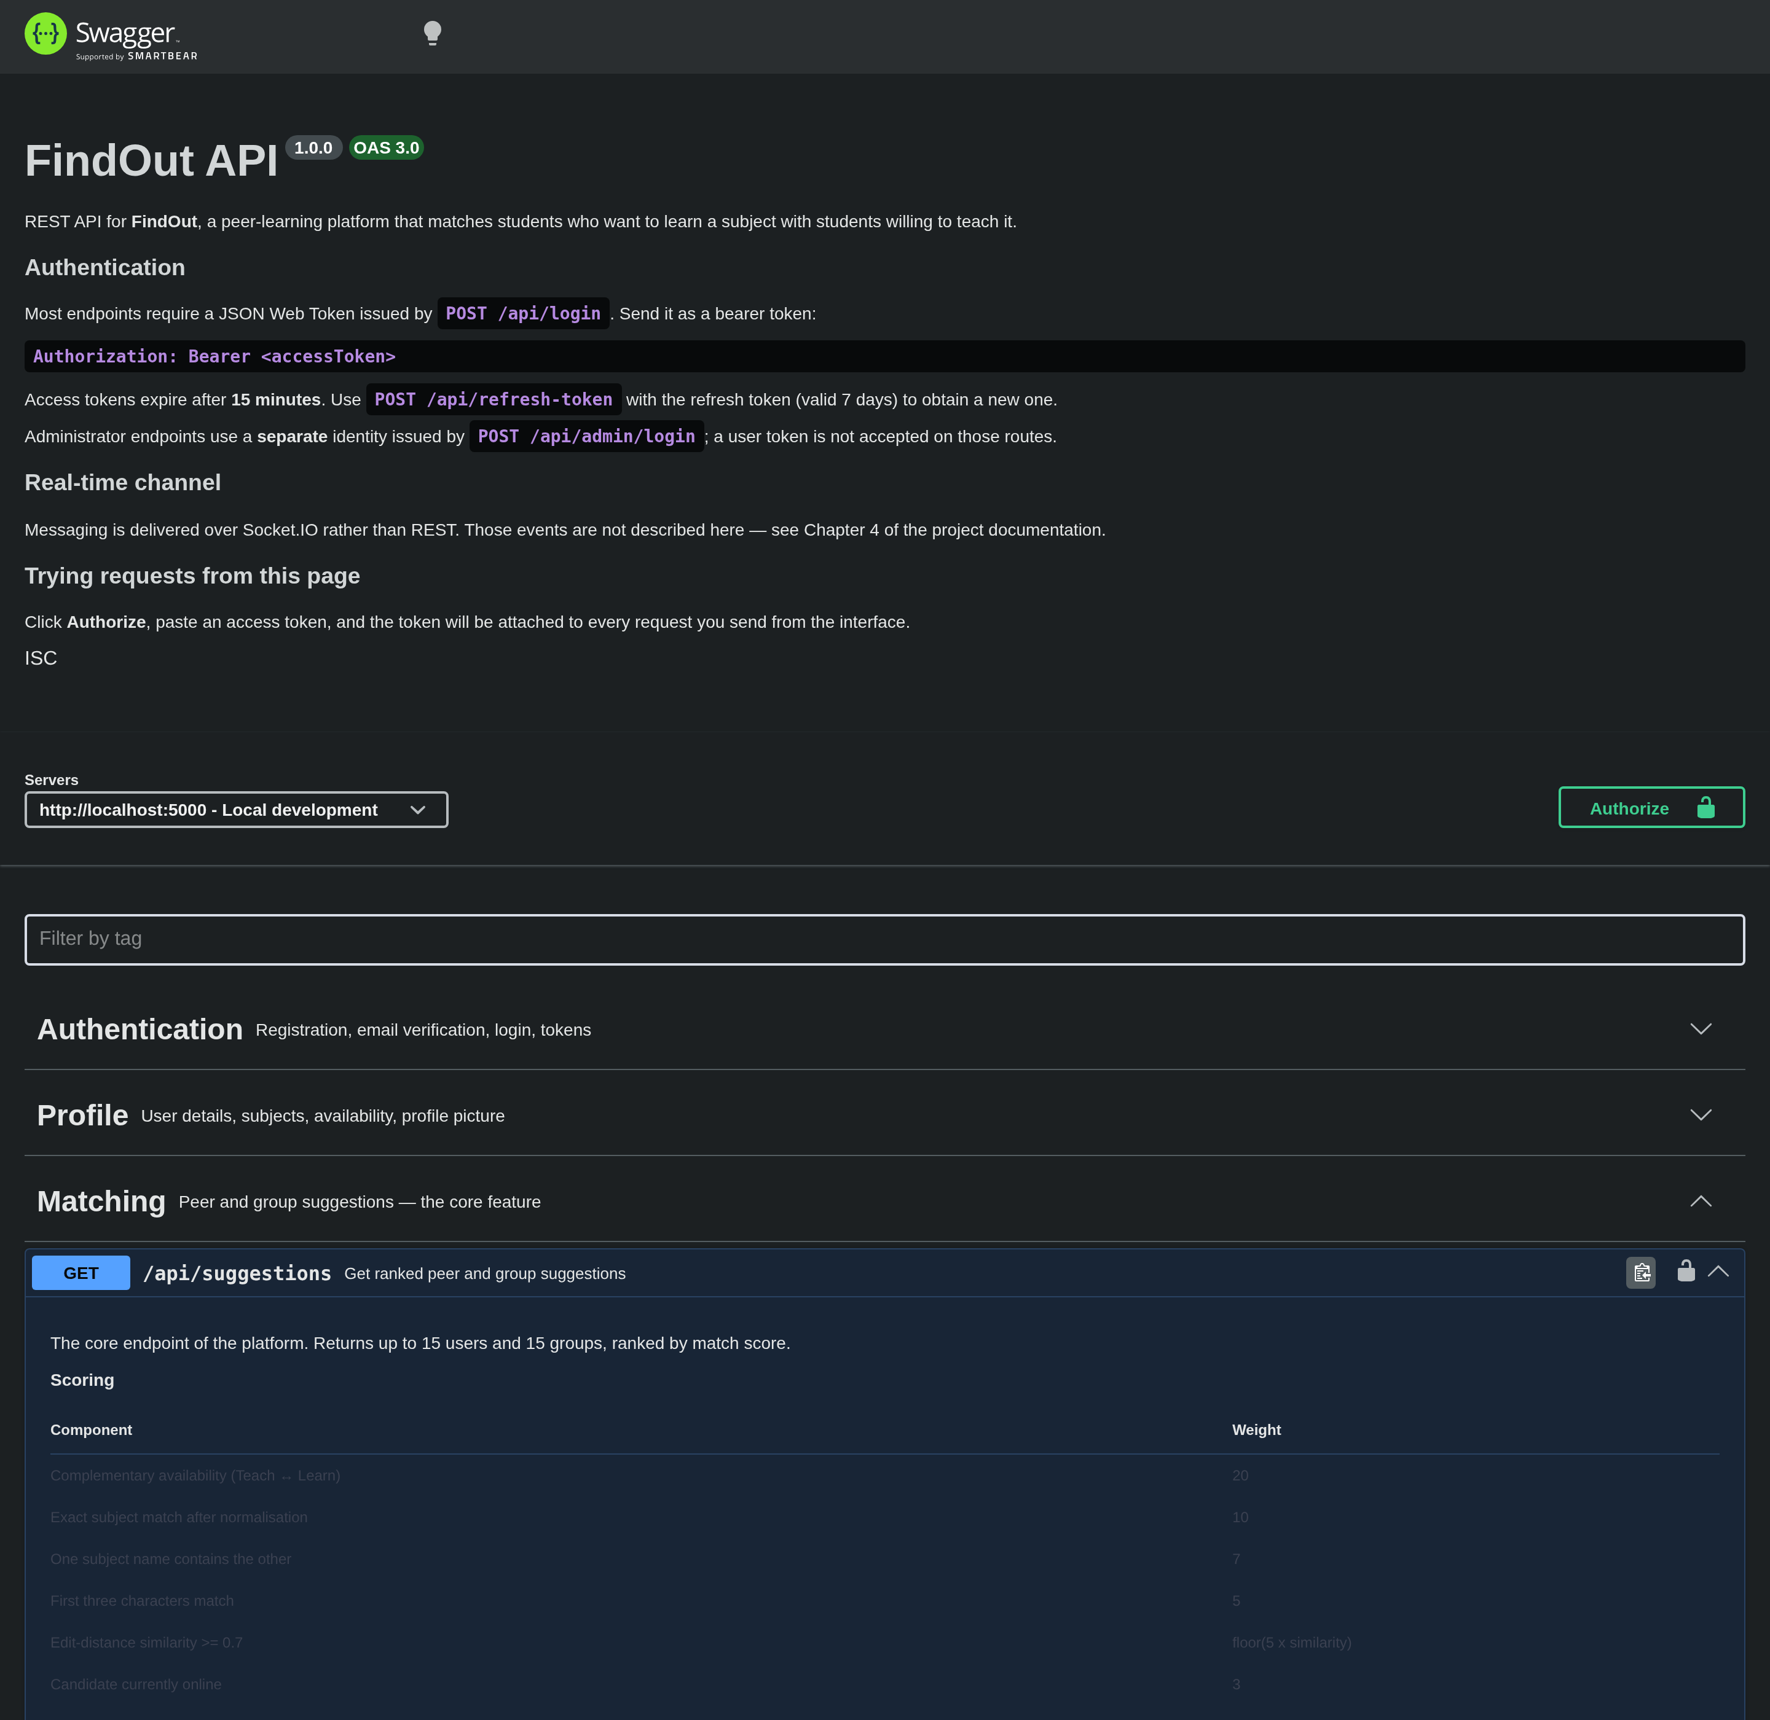
Figure 4.6
Figure 4.6. Documentation for the matching endpoint, with the Matching tag and the operation expanded to show its description and response schema.
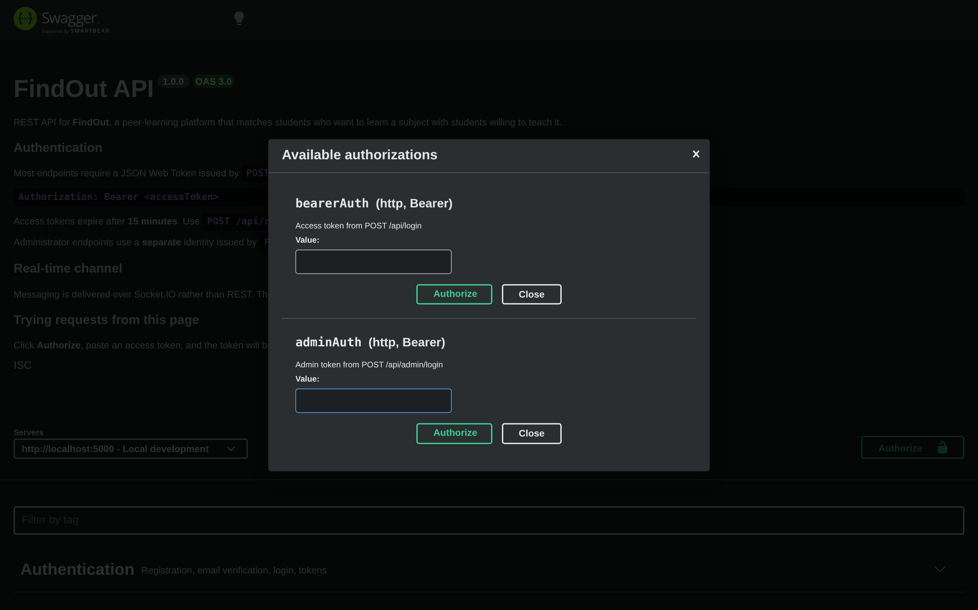
Figure 4.7
Figure 4.7. The Authorize dialog, used to attach a bearer token to requests executed from the documentation page.

4.5.5 Endpoint testing
Endpoints were additionally exercised with Postman during development, which allows saved collections and variable reuse across requests.
[ FIGURE 4.8 — SCREENSHOT TO BE INSERTED ]
Figure 4.8. Verifying the login endpoint and the issued token pair in Postman.
[ FIGURE 4.9 — SCREENSHOT TO BE INSERTED ]
Figure 4.9. The matching endpoint returning ranked suggestions.

4.6 Module Implementation

4.6.1 Authentication and email verification
Registration hashes the password with bcrypt at cost factor 10, stores the account as unverified, and sends a signed confirmation link. Login is refused until the address is confirmed.
Source: backend/controllers/RegisterUser.js
const hashedPassword = await bcrypt.hash(password, 10);
// multer's file.path is a filesystem path; the client builds URLs as
// `${BACKEND_URL}${storedValue}`, so store a root-relative path instead.
const profilePicture = req.file ? `/uploads/${req.file.filename}` : null;
const newUser = new UserModel({ name, email, password: hashedPassword,
profilePicture, isVerified: false });
await newUser.save();
await sendVerificationEmail(email);
Source: backend/controllers/LoginUser.js
const generateTokens = (userId) => ({
accessToken: jwt.sign({ id: userId }, ACCESS_TOKEN_SECRET, { expiresIn: '15m' }),
refreshToken: jwt.sign({ id: userId }, REFRESH_TOKEN_SECRET, { expiresIn: '7d' }),
});
if (!findUser.isVerified) {
return res.status(403).json({ message: 'Please verify your email before logging in.' });
}
const isMatch = await bcrypt.compare(password, findUser.password);
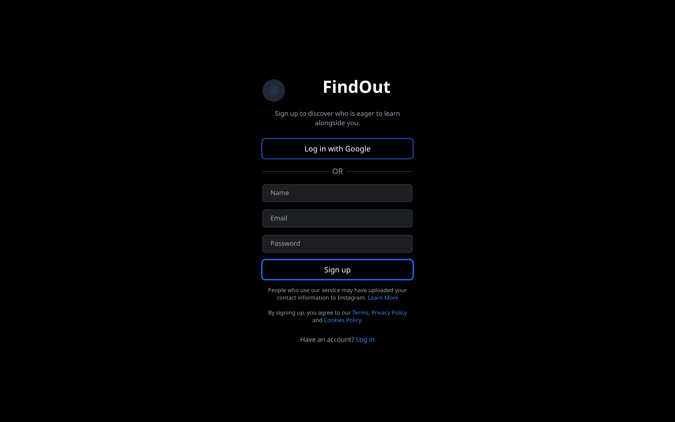
Figure 4.10
Figure 4.10. Account registration.
[ FIGURE 4.11 — SCREENSHOT TO BE INSERTED ]
Figure 4.11. The email verification message.
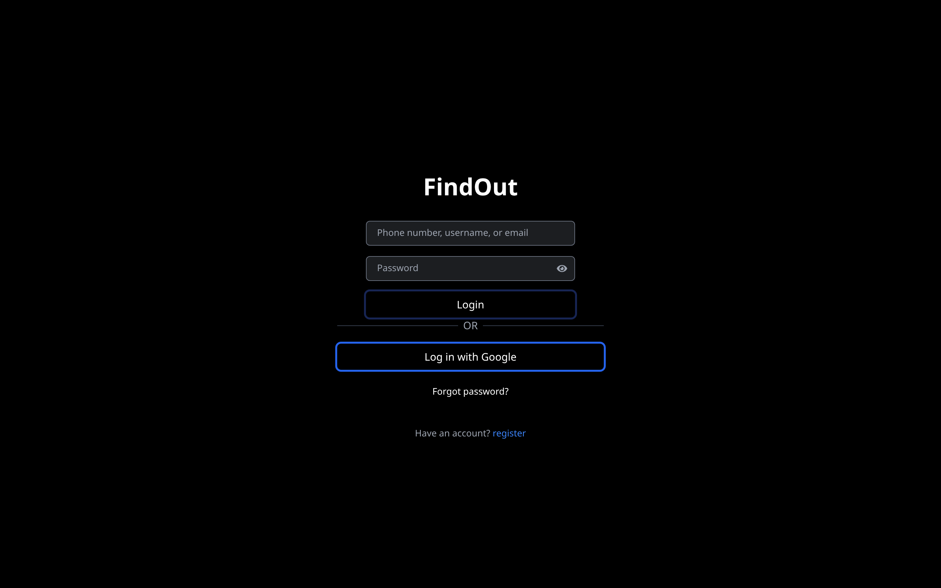
Figure 4.12
Figure 4.12. The login screen.

4.6.2 Profile and availability
The profile panel is where a student declares the two inputs the matching algorithm consumes: their subjects, and whether they are ready to teach or to learn.
Source: frontend/src/components/ManageUser.jsx
// subjects is a string array on the server; it is edited here as a single
// comma-separated field and converted back on save.
const handleSaveChanges = async () => {
const subjectList = subjects.split(',').map(s => s.trim()).filter(Boolean);
await editUserDetails({ subjects: subjectList, status });
await fetchUserDetails();
setOpenManageUser(false);
};
Availability is presented as three mutually exclusive options, each carrying its own semantic colour so the same meaning is signalled identically everywhere in the interface.

Figure 4.13
Figure 4.13. The profile panel, where subjects and availability are declared.

4.6.3 The matching engine
This is the central feature. The implementation lives in one controller and has no dependencies beyond the two models it reads, which is what allowed it to be unit-tested in isolation (Chapter 5, §5.3).
Source: backend/controllers/Suggestions.js — the four-tier subject matcher
const fuzzyMatch = (str1, str2) => {
const normalize = (str) => str.toLowerCase().replace(/[+#.\-_\s]/g, '').trim();
const n1 = normalize(str1);
const n2 = normalize(str2);
if (n1 === n2) return { match: true, score: 10 }; // exact
if (n1.includes(n2) || n2.includes(n1)) return { match: true, score: 7 }; // substring
if (n1.length >= 3 && n2.length >= 3 && n1.substring(0, 3) === n2.substring(0, 3)) {
return { match: true, score: 5 }; // shared prefix
}
const distance = levenshteinDistance(n1, n2); // edit distance
const similarity = 1 - distance / Math.max(n1.length, n2.length);
if (similarity >= 0.7) return { match: true, score: Math.floor(similarity * 5) };
return { match: false, score: 0 };
};
Source: same file — complementary status and scoring
let targetStatus = [];
if (user.status === "Ready To Learn") targetStatus.push("Ready To Teach");
else if (user.status === "Ready To Teach") targetStatus.push("Ready To Learn");
// ... per candidate:
if (targetStatus.length > 0 && targetStatus.includes(otherUser.status)) {
matchScore += 20; // complementary role dominates
}
for (const userSubject of user.subjects) {
for (const otherSubject of otherUser.subjects || []) {
const result = fuzzyMatch(userSubject, otherSubject);
if (result.match) { matchScore += result.score; matchedSubjects.push(/* ... */); break; }
}
}
if (otherUser.isOnline) matchScore += 3;
if (matchedSubjects.length > 1) matchScore += matchedSubjects.length * 2;
The weight of 20 for a complementary role is the line where the reciprocal principle from Chapter 2 becomes executable code: it guarantees that one correct role match outranks any accumulation of subject similarity between two students who both want to learn.
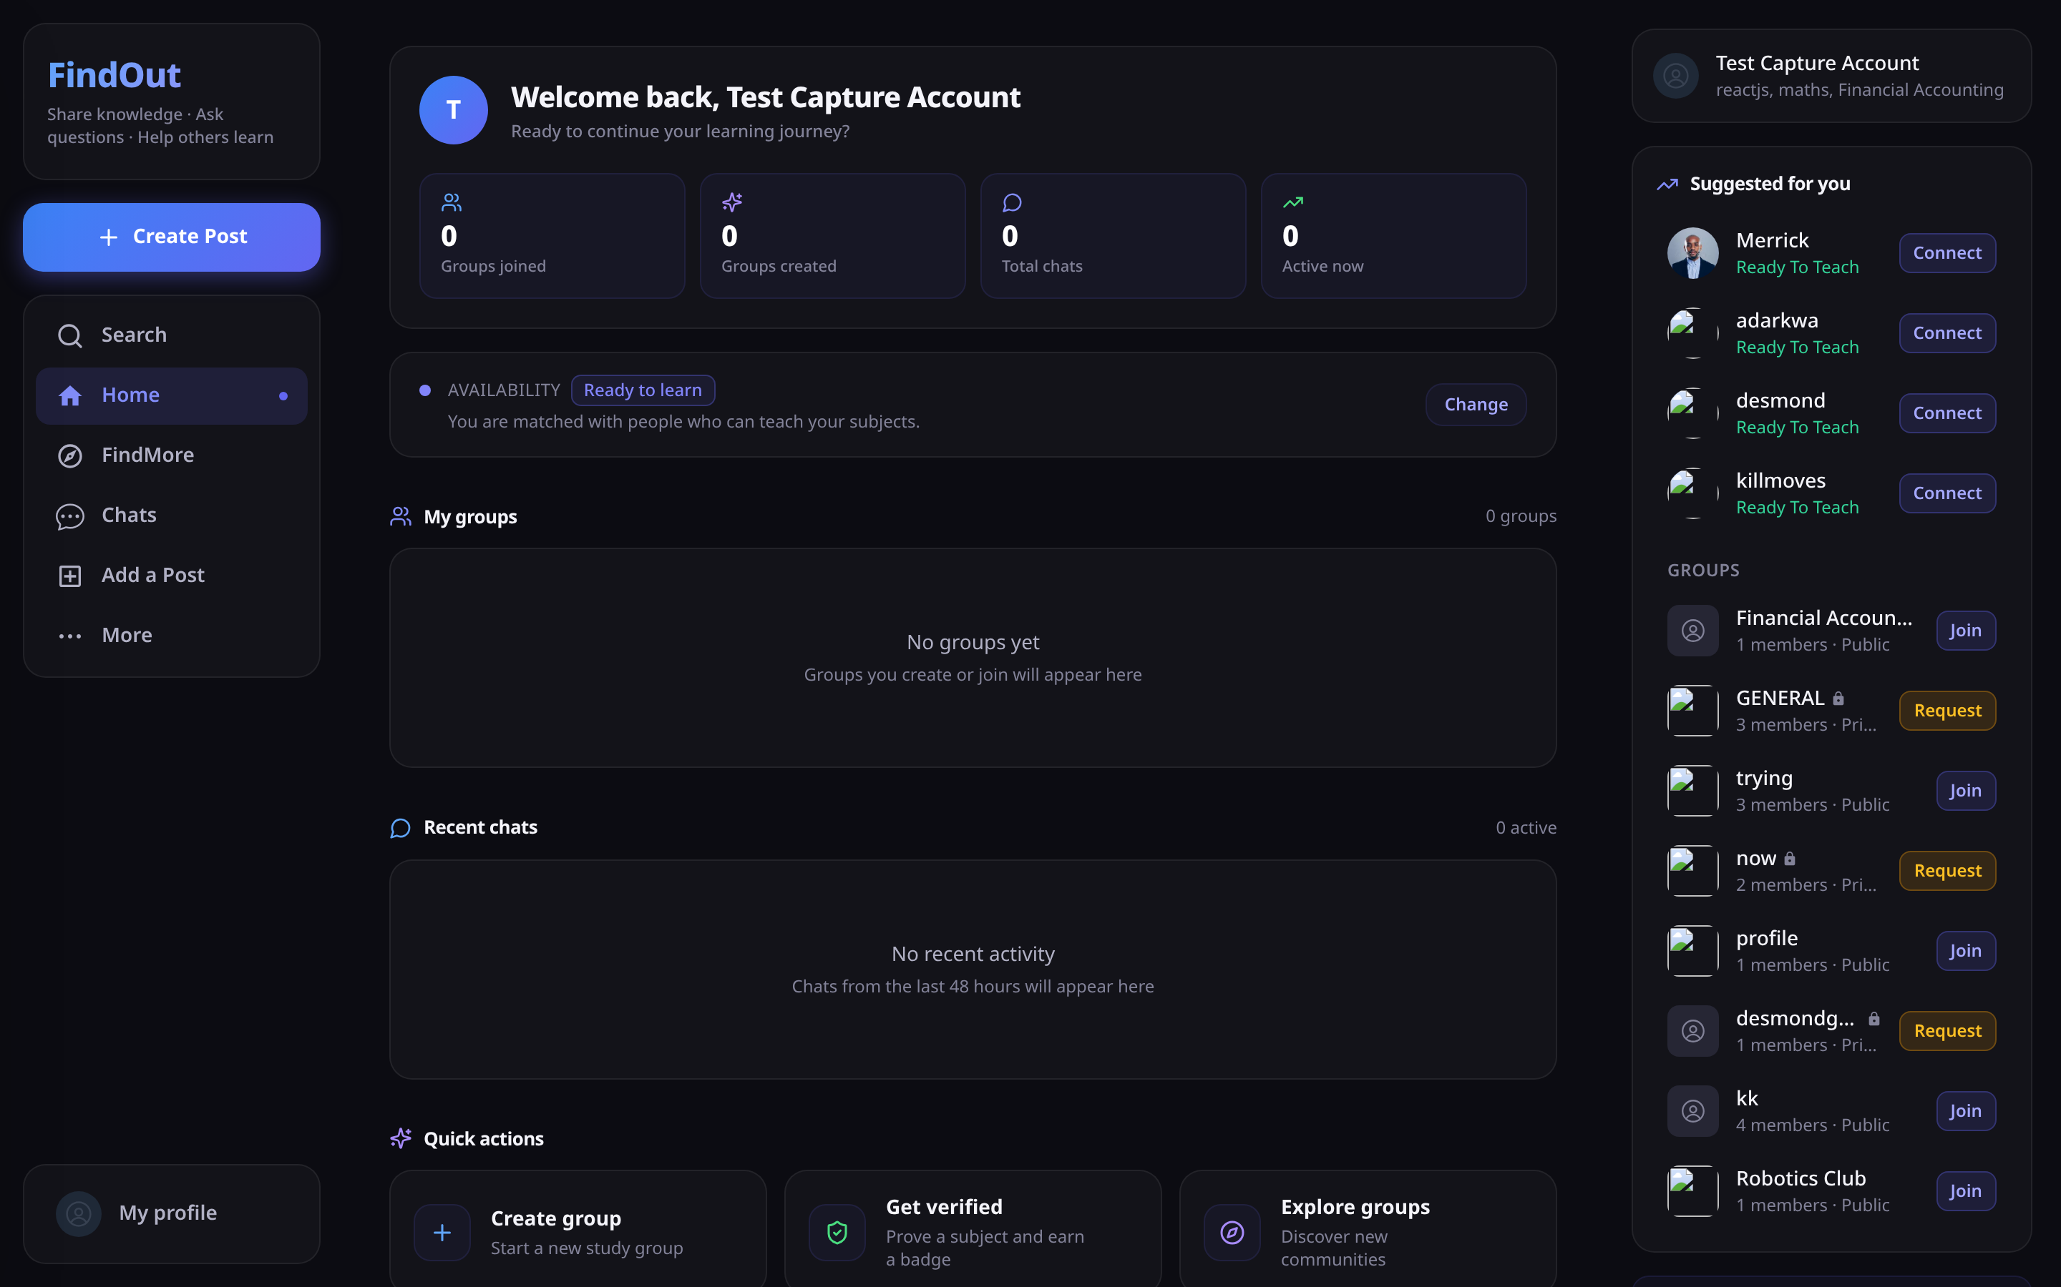
Figure 4.14
Figure 4.14. Ranked match suggestions produced by the matching engine. All four suggested peers are Ready To Teach, complementing the requesting account’s Ready To Learn status.

Figure 4.15
Figure 4.15. The suggestion rail, showing peers alongside discoverable groups with their join actions.

4.6.4 Competency verification
The quiz mechanism awards a per-subject badge. Its most important implementation property is that correct answers never leave the server.
Source: backend/controllers/verificationController.js
const questions = await quizGenerator.generateQuiz(subject);
// Strip the answers before responding
const questionsForClient = questions.map(q => ({
question: q.question,
options: q.options,
difficulty: q.difficulty,
}));
// Retain the full set server-side, keyed by session, for marking
global.activeQuizSessions[quizSessionId] = {
questions, startTime: Date.now(), subject, userId,
};
// Marking, and the ownership check that prevents submitting another user's session
if (session.userId !== userId) {
return res.status(403).json({ success: false, message: 'Unauthorized' });
}
const result = quizGenerator.gradeQuiz(session.questions, answers);
verification.addAttempt({ score: result.score, passed: result.passed, /* ... */ });
An accurate statement of question generation. The design intent was to generate subject-specific questions with a large language model, and provision was made for it — the API key is configured and the client library installed. The implemented build does not use it. Question generation uses a fixed bank of ten templates into which the subject name is inserted, and those templates assess pedagogical approach rather than knowledge of the subject. This is recorded here, in Chapter 3 §3.9.4, and in Chapter 5 rather than concealed. Do not describe this system as using AI-generated assessment.
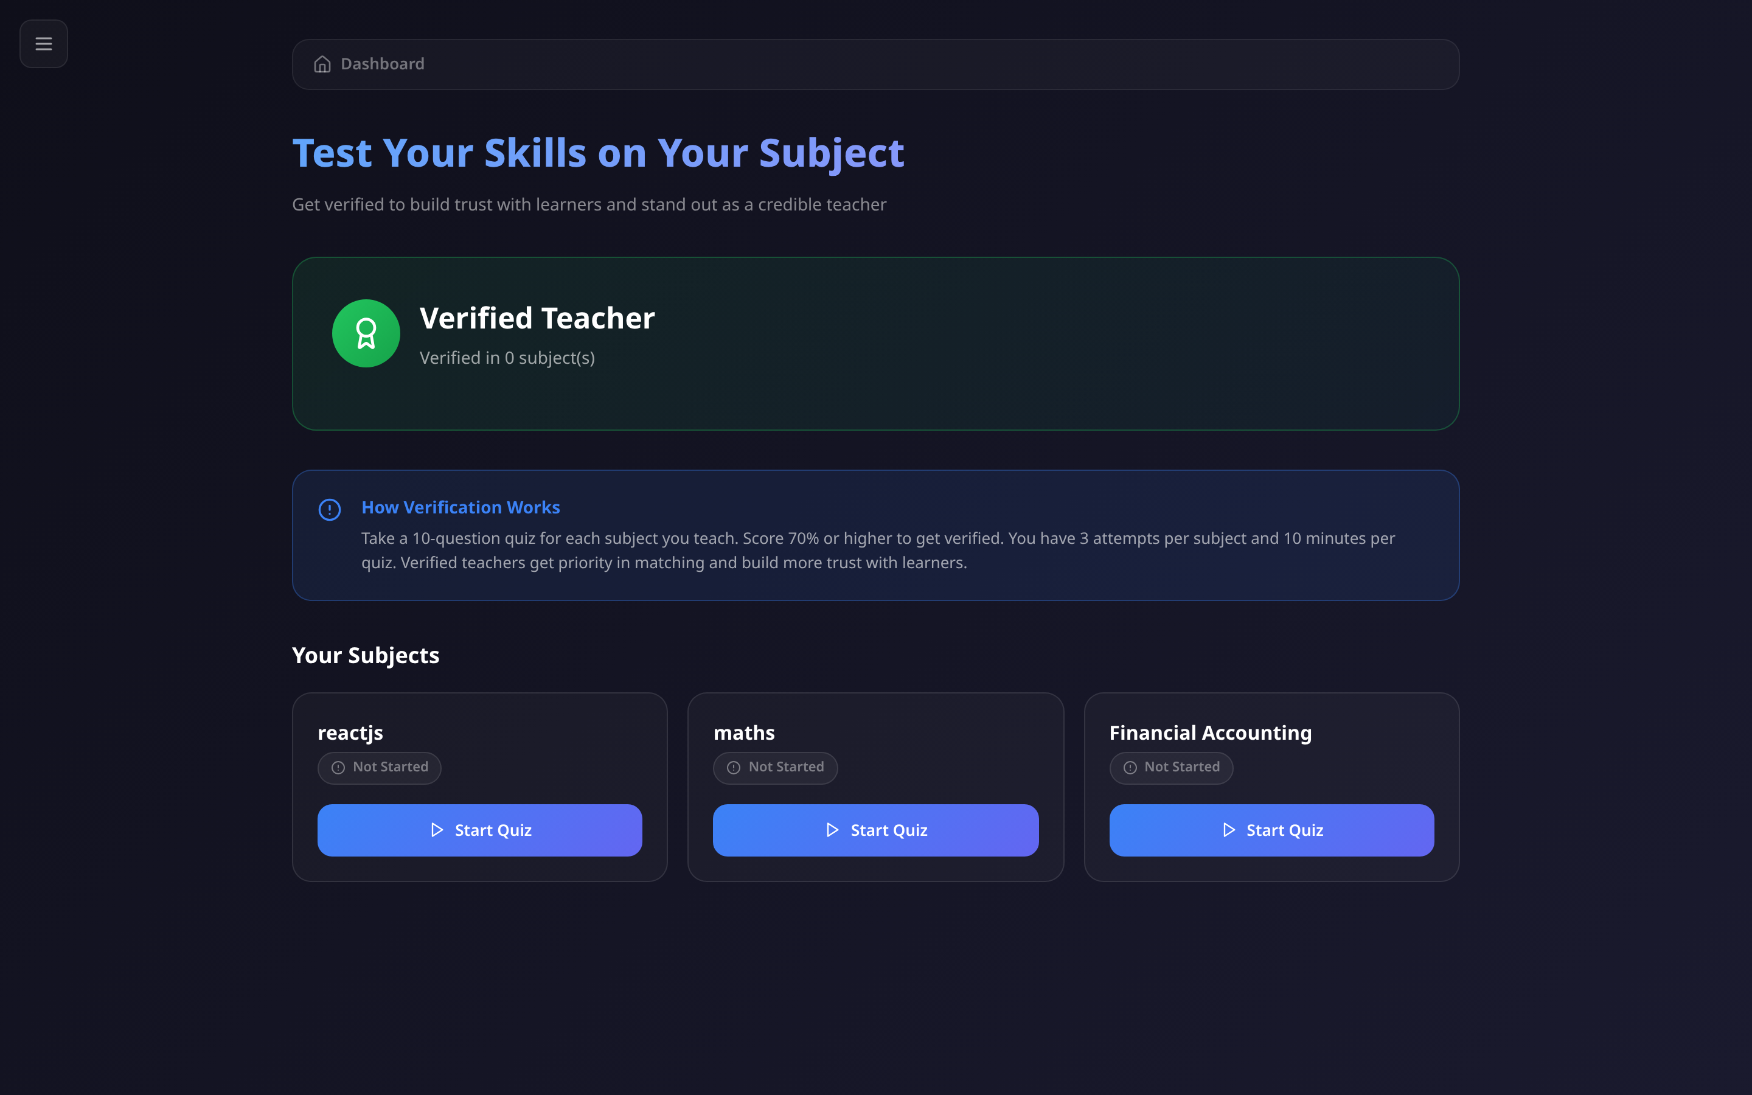
Figure 4.16
Figure 4.16. Verification status for each declared subject.
[ FIGURE 4.17 — SCREENSHOT TO BE INSERTED ]
Figure 4.17. A competency quiz in progress.
[ FIGURE 4.18 — SCREENSHOT TO BE INSERTED ]
Figure 4.18. Quiz result and awarded badge.

4.6.5 Real-time messaging
Messaging uses Socket.IO rooms: one room per conversation, named by its identifier. A message sent to a room reaches exactly its participants, with no manual recipient list.
Source: backend/socket/Socket.js
socket.on('user-online', async (userId) => {
socket.join(userId); // personal notification room
await User.findByIdAndUpdate(userId, {
isOnline: true, lastSeen: new Date(), socketId: socket.id,
});
const [chats, groups] = await Promise.all([
ChatModel.find({ participants: userId }).lean(),
GroupModel.find({ members: userId }).lean(),
]);
const allChatIds = [...chats.map(c => c._id.toString()),
...groups.map(g => g._id.toString())];
allChatIds.forEach(chatId => socket.join(chatId)); // join every conversation
// Messages that arrived while offline become 'delivered' on reconnect
await MessageModel.updateMany(
{ chatId: { $in: allChatIds }, senderId: { $ne: userId }, status: 'sent' },
{ $set: { status: 'delivered', deliveredAt: new Date() } }
);
socket.broadcast.emit('user-status-changed', { userId, isOnline: true });
});
The implementation rule worth noting is ordering: the server persists a message before broadcasting it. Broadcasting first would be marginally faster but risks a message appearing on screen and then vanishing if the write fails.
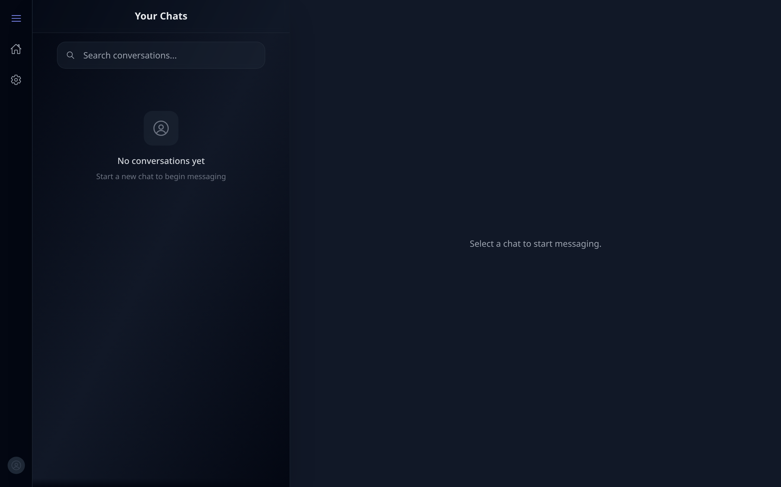
Figure 4.19
Figure 4.19. Real-time message delivery between two accounts, showing presence and read status.

4.6.6 Groups and privacy
The three privacy levels produce three different join paths from a single request.
Source: backend/controllers/JoinGroup.js
// SECRET: not joinable by request at all
if (group.privacy === 'secret') {
return res.status(403).json({
success: false,
message: 'This group is secret. You can only join via an invite link.',
});
}
// PRIVATE: create a pending request and notify the administrator
if (group.privacy === 'private') {
group.pendingRequests.push({ userId, requestedAt: new Date() });
await group.save();
getIo().to(group.groupAdmin._id.toString()).emit('new-join-request', { /* ... */ });
return res.status(200).json({ success: true, isPending: true, /* ... */ });
}
// PUBLIC: join immediately
group.members.push(userId);
group.unreadCount.push({ userId, count: 0 });
await group.save();
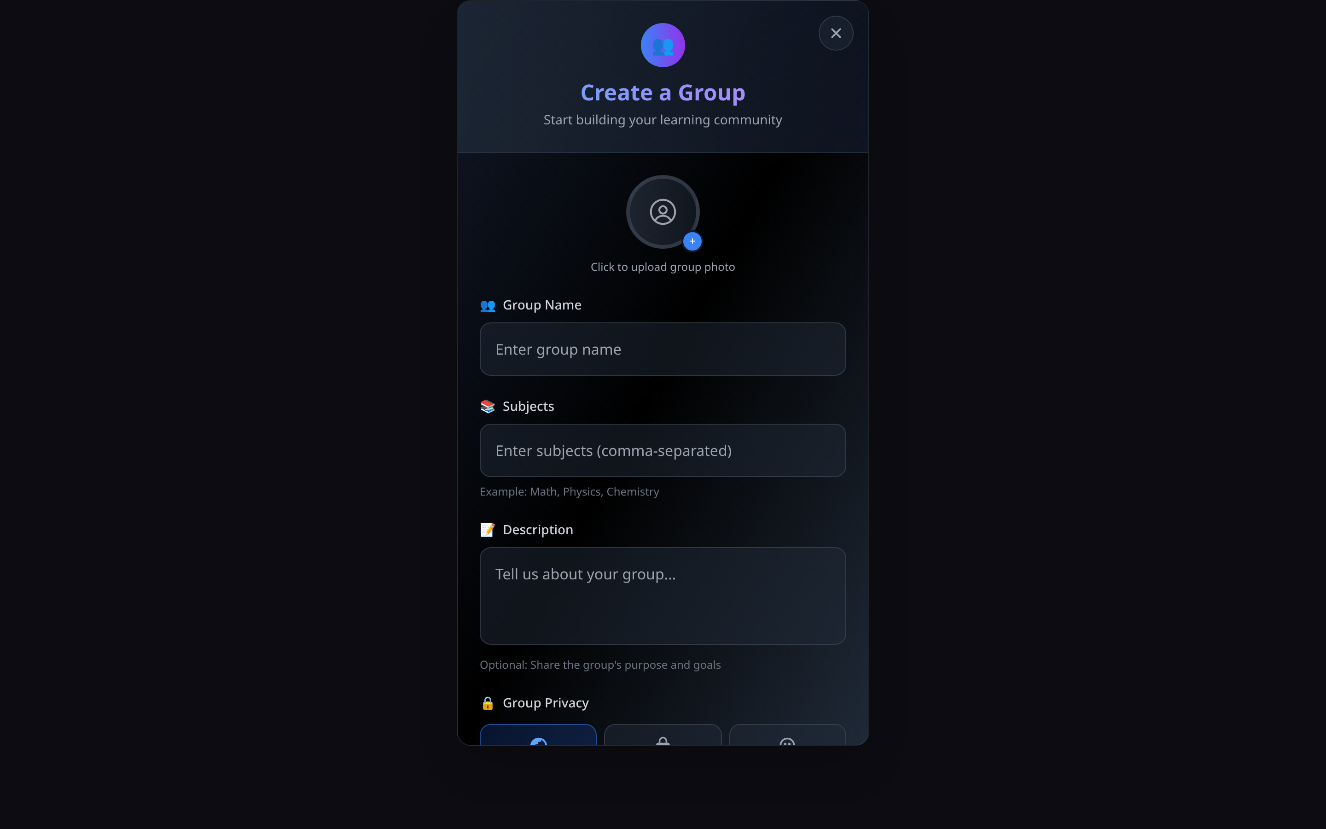
Figure 4.20
Figure 4.20. Creating a study group, showing the three privacy levels.
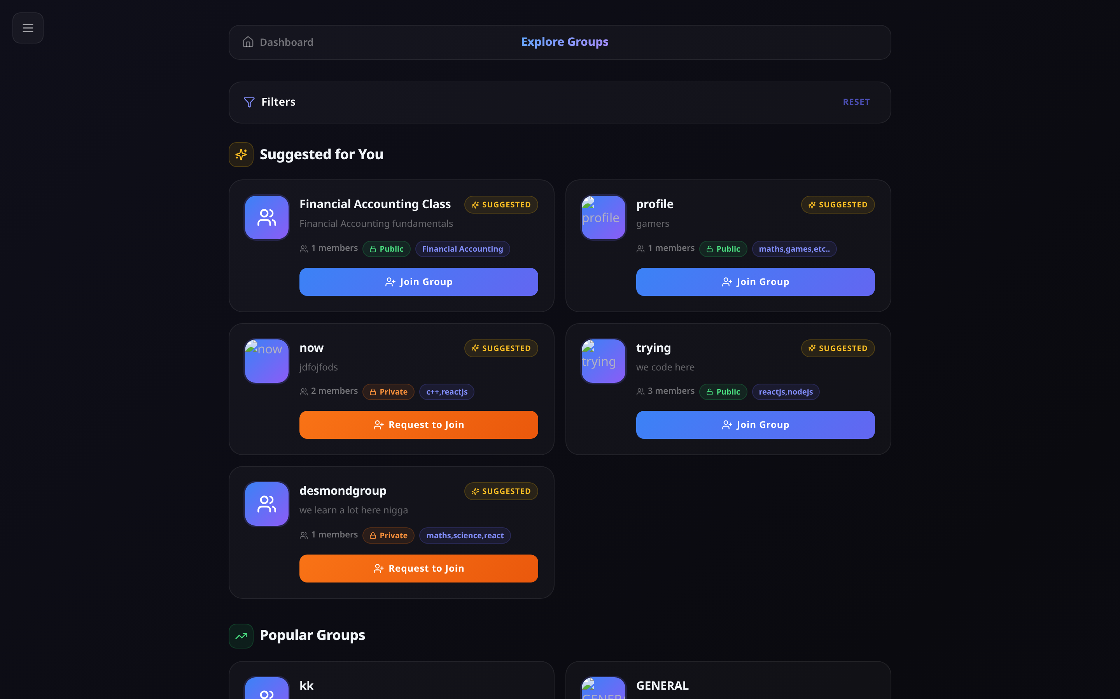
Figure 4.21
Figure 4.21. Group discovery. Public groups offer Join and private groups offer Request; secret groups do not appear at all.
[ FIGURE 4.22 — SCREENSHOT TO BE INSERTED ]
Figure 4.22. A pending join request awaiting approval.

4.6.7 Learning resource feed
Posts carry a subject tag and a type classification (resource, help, explanation, challenge, general) so a shared resource is distinguishable from a request for help. The endorsement action is named helpful rather than “like”: in a learning context, marking something helpful communicates educational value where a like communicates approval. The database field, the API route and the interface label were all renamed together.
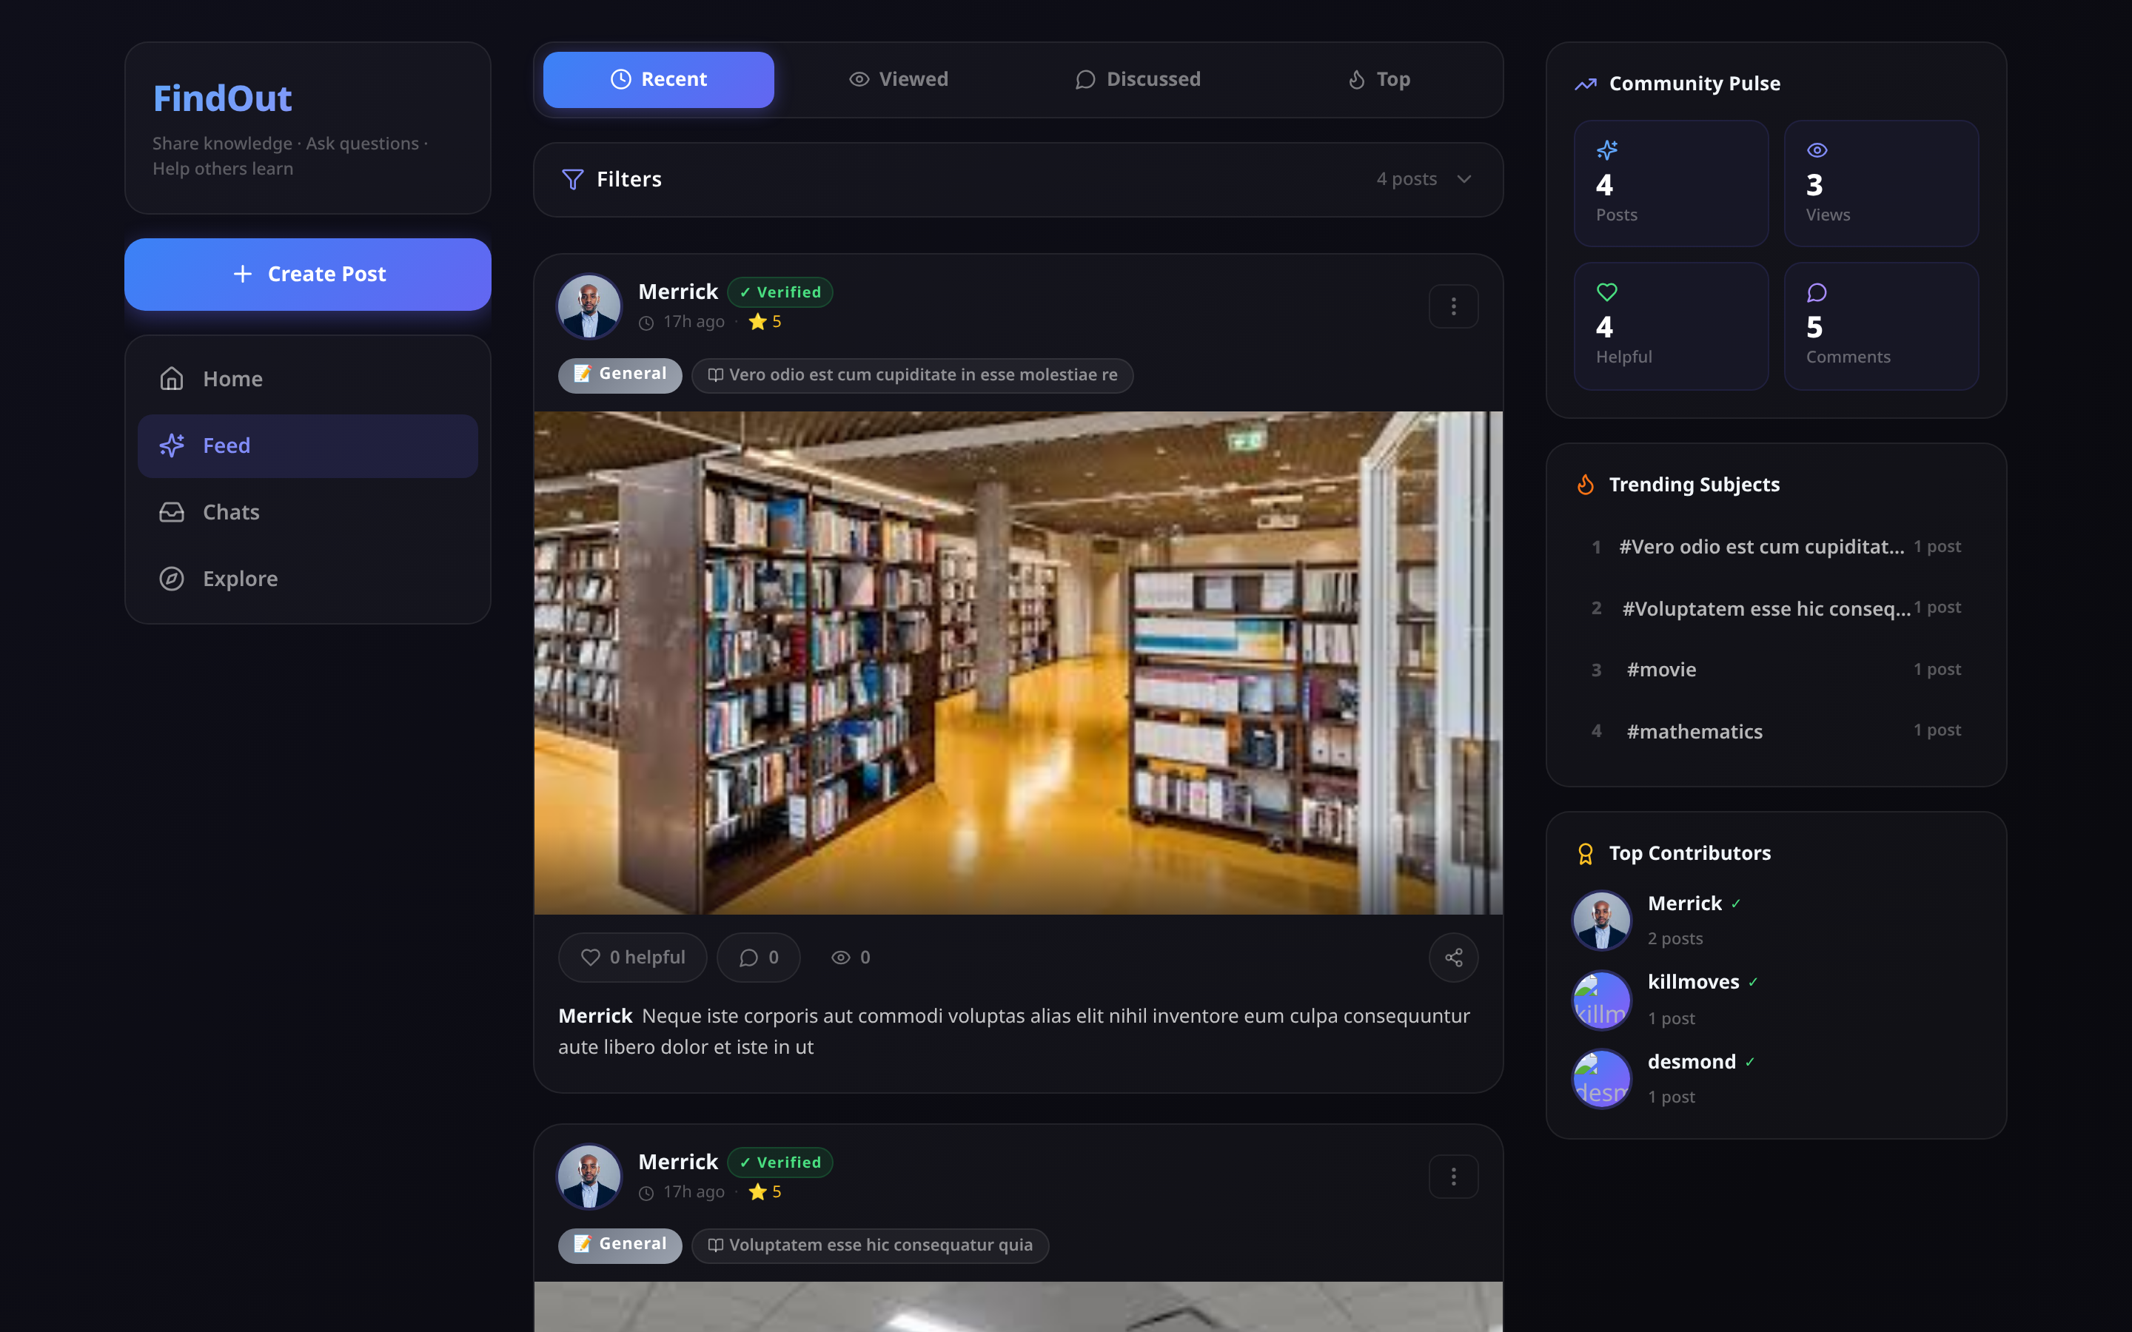
Figure 4.23
Figure 4.23. The learning resource feed, showing subject tags, type badges and helpful counts.
[ FIGURE 4.24 — SCREENSHOT TO BE INSERTED ]
Figure 4.24. Threaded discussion on a post.
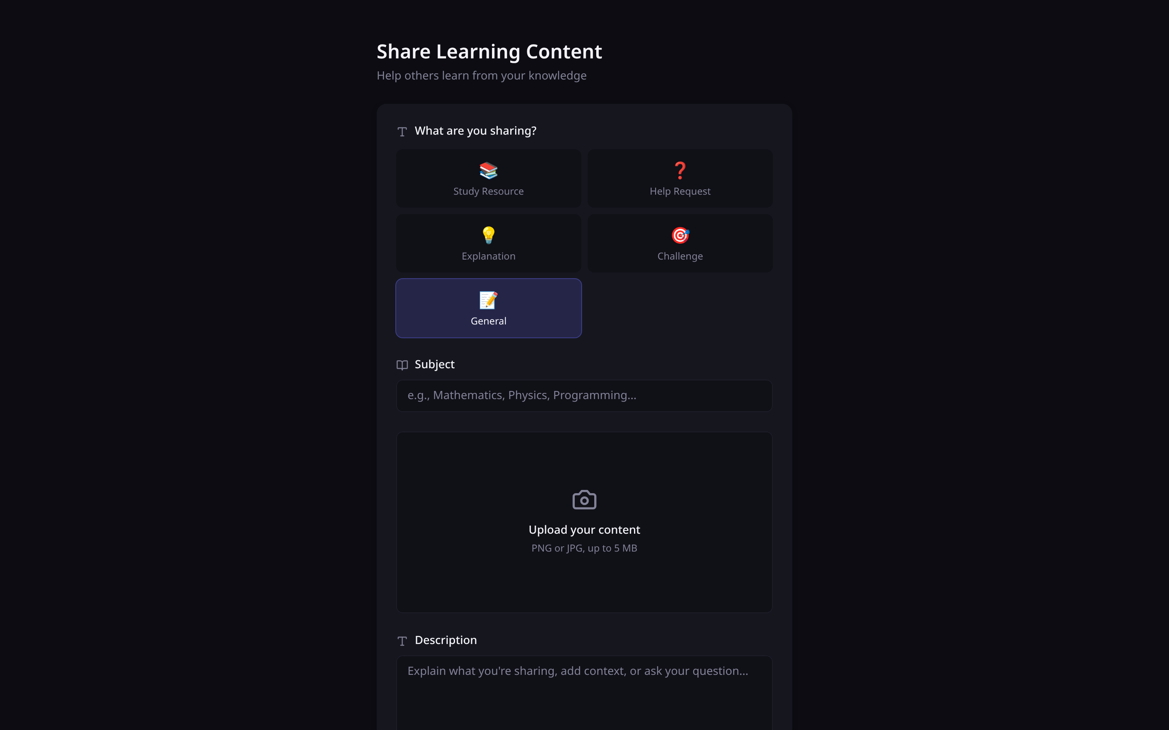
Figure 4.25
Figure 4.25. Publishing a learning resource, showing the five post types.

4.6.8 Administration
Administration uses a completely separate identity system: a different collection, a different login endpoint and different middleware. A user account cannot be escalated through any user-facing route, and the first super administrator is created by running a script directly on the server.
Source: backend/controllers/adminController.js — statistics by aggregation
const [totalUsers, totalPosts, totalGroups, onlineUsers, teacherCount, learnerCount] =
await Promise.all([
UserModel.countDocuments(),
PostModel.countDocuments(),
GroupModel.countDocuments(),
UserModel.countDocuments({ isOnline: true }),
UserModel.countDocuments({ status: 'Ready To Teach' }),
UserModel.countDocuments({ status: 'Ready To Learn' }),
]);
const topSubjects = await PostModel.aggregate([
{ $group: { _id: '$subject', count: { $sum: 1 } } },
{ $sort: { count: -1 } },
{ $limit: 10 },
]);
The teach-versus-learn split is the measure with institutional value: it shows which subjects generate demand for help that supply is not meeting.
[ FIGURE 4.26 — SCREENSHOT TO BE INSERTED ]
Figure 4.26. Administrator dashboard.
[ FIGURE 4.27 — SCREENSHOT TO BE INSERTED ]
Figure 4.27. User management and moderation.

4.7 Frontend Implementation

4.7.1 Application composition
Source: frontend/src/main.jsx
createRoot(document.getElementById('root')).render(
<StrictMode>
<Router>
<Provider> {/* 13 nested context providers */}
<App />
<ToastContainer />
</Provider>
</Router>
</StrictMode>
);
Shared state is held in React Context providers rather than passed manually between components. Nesting order matters: ToastProvider is outermost so a notification can be raised from anywhere.

4.7.2 Transparent token renewal
Access tokens expire after 15 minutes. Rather than forcing the user to log in again, an Axios interceptor renews them invisibly.
Source: frontend/src/utils/axiosInstance.js
axiosInstance.interceptors.response.use(
(response) => response,
async (error) => {
const originalRequest = error.config;
if (error.response?.status === 401 && !originalRequest._retry) {
originalRequest._retry = true; // retry once only
try {
const refreshToken = getRefreshToken();
const { data } = await axios.post(`${BASE}/api/refresh-token`, { refreshToken });
setTokens(data);
originalRequest.headers.Authorization = `Bearer ${data.accessToken}`;
return axiosInstance(originalRequest); // replay the original call
} catch (refreshError) {
clearTokens();
window.location.href = '/login';
}
}
return Promise.reject(error);
}
);
The result is that no component contains token-handling code, and no component is aware that tokens expire.

4.7.3 Design token system
The interface is built on a token layer rather than ad-hoc colours, so a change to the palette is a change to one file.
Source: frontend/src/index.css
:root {
/* Surfaces — an elevation ladder, darkest to lightest */
--surface-base: 12 12 18;
--surface-raised: 22 22 31;
--surface-overlay: 31 31 43;
/* One accent family */
--primary-500: 99 102 241; /* indigo */
--accent-500: 139 92 246; /* violet */
/* Semantic status, matching the availability values */
--success-400: 52 211 153; /* Ready To Teach */
--warning-400: 251 191 36; /* Later */
}
Values are stored as RGB channels so Tailwind opacity modifiers still work (bg-surface-raised/60). Colour is used to signal meaning, not decoration: availability status carries the same colour on every screen.

4.7.4 Responsive behaviour
The interface adapts to screen width. Separate components exist for mobile navigation, because the desktop sidebar layout does not compress usefully to phone width. Mobile is the dominant access mode in the target population, so this was treated as a requirement rather than an enhancement.
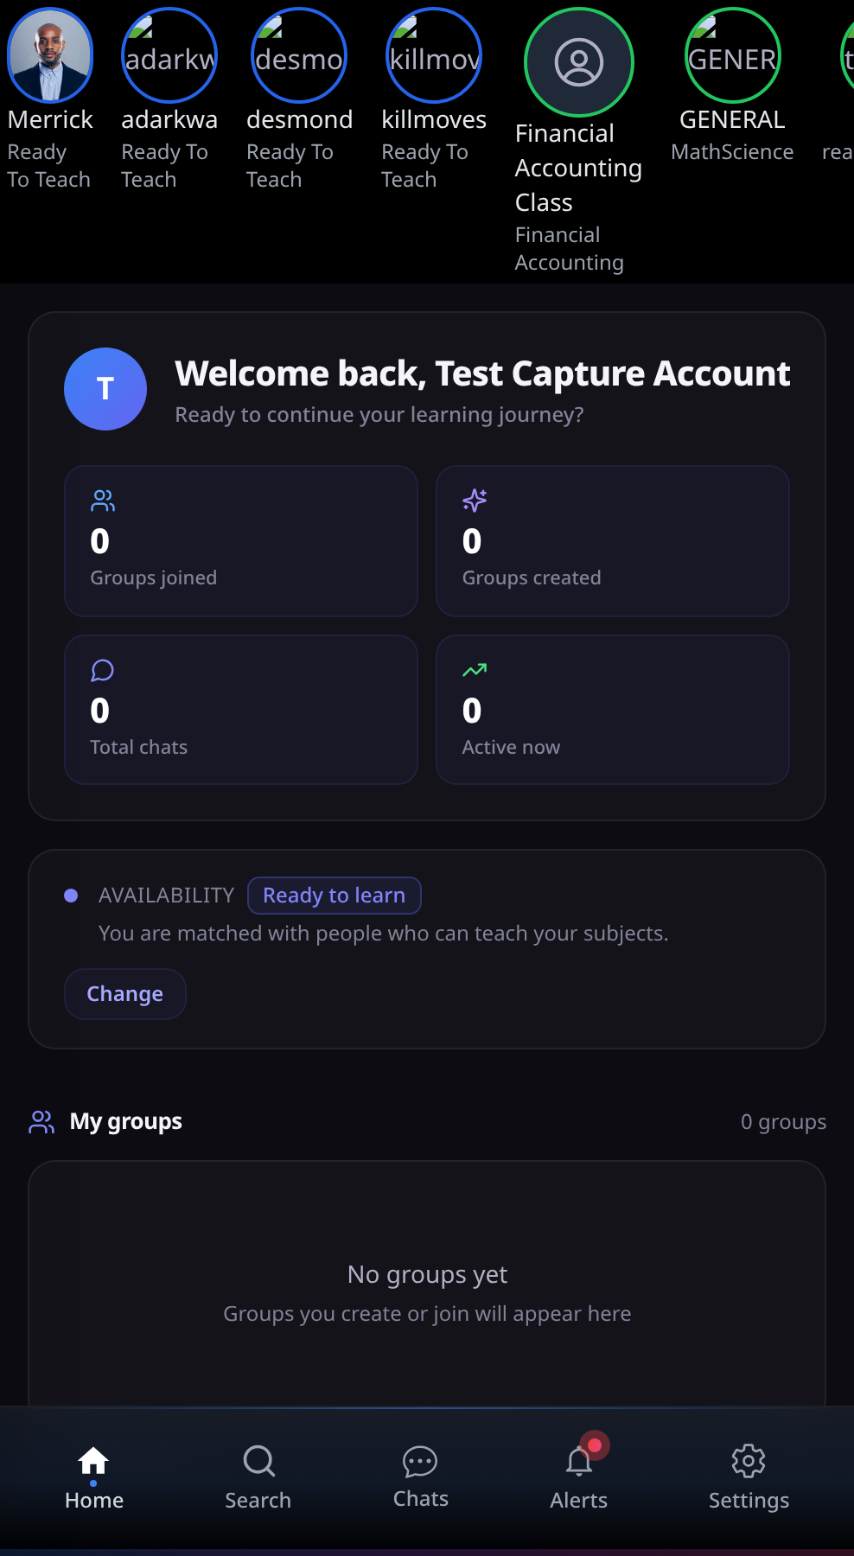
Figure 4.28
Figure 4.28. The dashboard on a mobile viewport, with the fixed bottom navigation clear of the content.

Figure 4.29
Figure 4.29. Messaging on a mobile viewport.

4.8 Implementation Statistics
Table 4.3
Quantitative Summary of the Implemented System
All figures below are produced by scripts/project-metrics.js, which counts them from the source tree rather than by hand, so the table can be regenerated after any change.
Metric | Value
Backend code | 8,316 lines across 69 files
Frontend code | 13,639 lines across 64 files
Total application code | 21,955 lines
Controllers | 32
Database models / collections | 7 files, 8 collections
Express routers | 4
Middleware modules | 5
Services | 1
Migration scripts | 11
Test and benchmark scripts | 4
REST endpoints | 58
Documented API operations | 58 (100% coverage)
OpenAPI schema definitions | 10, across 9 tags
Socket events (client to server) | 10, including disconnect
Socket events (server to client) | 8
React pages | 13
React components | 28 (24 general, 4 feed)
Context providers | 13
Modules transformed at build | 1,817
JavaScript bundle | 952.73 kB raw, 254.24 kB gzipped
CSS bundle | 74.93 kB raw, 12.74 kB gzipped
Production build time | ≈ 10 s
Table 4.4
Requirement Completion by Module
Module | Implemented | Partial | Not implemented
M1 Authentication | 12 | 1 | 0
M2 Profile | 9 | 1 | 1
M3 Verification | 13 | 1 | 2
M4 Matching | 12 | 2 | 0
M5 Groups | 16 | 0 | 1
M6 Messaging | 14 | 0 | 2
M7 Feed | 11 | 0 | 3
M8 Administration | 11 | 0 | 1
Total | 98 | 5 | 10
These figures are not estimates. They are counted from the status column of the Software Requirements Specification, which records a status against each of its 113 numbered requirements; the three totals reconcile exactly (98 + 5 + 10 = 113).
Approximately 87% of specified requirements are fully implemented. The remaining 13% is concentrated in three areas, all documented in §4.10: question generation using a language model, per-subject availability, and feed pagination.

4.9 Development Challenges and Solutions
Seven substantial problems were encountered. The problem-solving process is part of what this chapter should evidence, so each is described with its cause and resolution.

4.9.1 Case-sensitive file paths
Problem. The application ran correctly in development but crashed immediately on a Linux server with Cannot find module '../socket/socket'.
Cause. Eleven imports used different capitalisation from the actual filenames — for example importing socket/socket when the file is socket/Socket.js. Windows and macOS filesystems ignore capitalisation; Linux does not.
Solution. A script checked every relative import in both packages against the real filenames. Eleven mismatches were found and corrected.
Lesson. Develop and test on the same filesystem behaviour as the deployment target.

4.9.2 Inadequate group privacy model
Problem. The original design stored privacy as a boolean. Testing revealed a needed case it could not express: a group that should be findable but not automatically joinable.
Solution. The field was replaced with a three-value enumeration, the join logic rewritten to branch on it, a pending-requests structure added, and a migration written for existing records.
Lesson. Direct evidence that the incremental method was necessary; under Waterfall this would have surfaced only at final testing.

4.9.3 Image uploads failing silently
Problem. Uploaded profile pictures and post images never displayed.
Cause. Four independent faults formed a chain. uploads/ and audios/ are git-ignored and were never created, and multer does not create its destination — so every upload failed with ENOENT before the controller ran. Two controllers stored multer’s filesystem path rather than a URL path. One frontend component built its URL with a hardcoded host and a doubled slash.
Solution. Both upload middlewares now create their directories on load; both controllers store root-relative /uploads/... paths; the frontend uses the configured base URL. A migration repairs records written earlier.
Lesson. A single visible symptom can have several independent causes. Fixing them one at a time produced no visible change until the last one was corrected, which was misleading.

4.9.4 Server starting without a database
Problem. When the database was unreachable, the server started anyway and every request failed after a ten-second buffering timeout, so the logs showed a flood of timeouts rather than the actual cause.
Cause. connectDB caught its own error and returned normally, so the caller’s success path ran.
Solution. The error now propagates; the server reports the likely causes and exits.

4.9.5 Undeclared dependencies
Problem. The project would not build from a fresh clone. react-router-dom and react-icons were imported throughout but missing from package.json; they were present in the local node_modules, so the error never appeared during development.
Solution. Both declared explicitly. A root manifest now installs both packages with one command.
Lesson. Verify periodically that a clean copy builds; reproducibility failures are invisible from inside a working environment.

4.9.6 Authorisation applied inconsistently
Problem. Functional testing (Chapter 5, §5.6) found that any authenticated user could delete any group and read any private conversation.
Cause. Not two isolated oversights but one structural gap. Authentication is enforced by a single middleware applied to every protected route, so it is uniform. Authorisation is written by hand inside individual controllers, so whether a given action checks ownership depends on whether it was remembered at the time. HandleJoinRequest checks correctly; DeleteGroup and GetMessages do not.
Why inspection missed it. Reading a controller that does check ownership gives no signal that a sibling controller does not. The gap is only visible when the behaviour is exercised, which is what the executable functional suite did.
Remedy. Recorded as D-25 and D-26, with the structural fix — ownership middleware applied to every route operating on a specific resource — recommended in Chapter 5, §5.11.
Lesson. A cross-cutting concern implemented per-controller will eventually be omitted from one. Uniformity is a property of the mechanism, not of the developer’s memory.

4.9.7 Matching weight calibration
Problem. The scoring weights had to be chosen with no ground-truth data indicating what a correct match looks like.
Solution. Weights were derived from the design principle — complementary role must dominate subject similarity — then tested against constructed profiles to confirm sensible ranking.
Limitation. This remains a hand-tuned heuristic, stated as such in Chapter 3 §3.8.6 and revisited in Chapter 5.

4.10 Known Defects and Limitations
Including this section strengthens the report. A project that identifies its own weaknesses demonstrates more engineering judgement than one that claims none.
Table 4.5
Known Defects and Limitations
ID | Severity | Description | Effect | Remedy
D-02 | Critical | The refresh-token secret is read from JWT_REFRESH_SECRET but .env defines REFRESH_TOKEN_SECRET, so the lookup falls back to a literal written in the source. | Refresh tokens are signed with a key visible in the code. Anyone reading it can forge a token for any user. | Rename to match and remove the fallback so the server refuses to start without a real secret.
D-21 | Critical | Socket.IO connections are unauthenticated. user-online accepts any user id from the client; send-message takes the sender from the payload. | A client can impersonate any user, join their private rooms, read their messages and send as them. | Verify a JWT in the connection handshake; take identity from the token.
D-22 | High | POST /api/messages takes senderId from the request body rather than the token. | Any authenticated user can send a message appearing to come from someone else. | Use req.authenticatedUser.id.
D-25 | High | DeleteGroup performs no authorisation check. The controller contains no reference to groupAdmin and no comparison against req.authenticatedUser. | Any authenticated user can delete any group and its entire message history. Found by functional testing (TC-GRP-05); see Chapter 5 §5.6.1. | Load the group, compare groupAdmin to the caller, return 403 when they differ.
D-26 | High | GetMessages queries MessageModel.find({ chatId }) with no check that the caller participates in that conversation. | Any authenticated user can read any private conversation given its identifier — an insecure direct object reference. Found by functional testing (TC-SEC-04); see Chapter 5 §5.6.2. | Confirm the caller appears in the chat’s participants or the group’s members.
D-27 | Low | Multer’s rejection of an oversized or wrong-type upload is unhandled, so the server answers 500 rather than 400. | The file is correctly refused, so the security property holds, but a client cannot distinguish “your file was rejected” from “the server failed”. | Add error-handling middleware that maps multer errors to 400.
D-03 | High | Tokens are stored in localStorage. | Any injected script can read them, so an XSS flaw becomes full account compromise. | Use httpOnly, Secure, SameSite cookies.
D-04 | High | No rate limiting. GET /getallposts and POST /messages/audio have no auth middleware. | Unthrottled password guessing; unauthenticated file upload. | Add express-rate-limit; apply auth to both routes.
D-23 | Medium | Admin tokens are signed with the same secret as user tokens. | The two trust domains are not cryptographically separated. | Use a separate ADMIN_JWT_SECRET.
D-05 | High | Availability is a single account-level field. | A student cannot be ready to teach one subject and learn another — a common real situation. | Move intent into the subjects array.
D-06 | High | Quiz questions come from a fixed template bank, not a language model. | Every subject produces structurally identical questions assessing teaching approach, not knowledge. | Connect the installed SDK; caching and marking already support it.
D-24 | High | Normalisation strips + # . - _, so C++ and C# reduce to the single character c, which substring-matches any subject containing a “c”. | A user listing C++ receives near-random suggestions. Confirmed against ten unrelated subjects, all of which matched. | Require a minimum length for substring matches; map symbols to letters (C++ → cplusplus).
D-07 | High | Email verification tokens expire after 60 seconds. | Most users cannot open their email and click within a minute, so registration fails in normal use. | Increase to 24 hours.
D-08 | Medium | reputation is stored and displayed but never incremented. | The admin top-contributors list is meaningless. | Increment on helpful marks and verifications.
D-09 | Medium | The 10-minute quiz limit is sent to the client but not enforced on submission. | A student may take unlimited time. | Compare stored start time to submission time server-side.
D-10 | Medium | Active quiz sessions are held in a server memory variable. | Sessions are lost on restart, and the design breaks with more than one server instance. | Store in MongoDB or Redis with expiry.
D-11 | Medium | Users with status Later receive no complementary bonus but can still appear via subject overlap. | Unavailable students appear in suggestions. | Exclude Later from the candidate query.
D-12 | Medium | The feed and several list endpoints return all records with no pagination. | Response size grows without limit. | Add cursor or skip/limit pagination.
D-13 | Medium | An image is required on every post. | A text-only question cannot be posted — a serious restriction for the help type. | Make the image optional.
D-14 | Medium | Deleting a user does not remove their posts, messages or memberships. | Orphaned references cause display errors. | Cascade or anonymise.
D-15 | Medium | Suggestions loads the entire user collection into memory on every request. | Response time grows linearly with user count; the main scalability limit. | Move scoring into an aggregation pipeline; index subjects.
D-16 | Low | The substring rule matches Java inside JavaScript. | Occasional irrelevant suggestion. | Same remedy as D-24.
D-17 | Low | Uploads are written to local disk. | Files are destroyed when a hosting platform redeploys. | Use object storage.
D-18 | Low | isVerified means two different things: email confirmed, and quiz passed. | Passing a quiz marks the account email-verified; an admin “unverify” can lock a user out of login. | Split into isEmailVerified and derive subject verification from verifiedSubjects.
D-19 | Low | Automated coverage is limited to the four suites in backend/tests/, which exercise the API and the matching algorithm. | React components have no tests, and WebSocket delivery is verified manually. | Add a component test runner and a multi-client socket harness.
D-20 | Low | Dependency vulnerabilities reported by npm audit. | Mostly transitive denial-of-service advisories. | Run npm audit fix and retest.

4.10.1 Priority order for remaining work
- D-02 and D-21 — both permit account takeover. Fix before any public demonstration.
- D-25 and D-26 — found by functional testing rather than inspection; any user can delete any group or read any conversation.
- D-22 and D-23 — identity spoofing and weak trust separation.
- D-24 — degrades the core feature for a predictable class of users.
- D-07 — registration is currently unusable in normal conditions.
- D-04, D-03 — authentication hardening.
- D-05 — per-subject intent, the highest-value functional improvement.

4.11 Chapter Summary
This chapter presented the system as built.
The implementation comprises 21,955 lines of code across two packages: a Node.js and Express backend of 8,316 lines with 32 controllers, 8 collections and 58 REST endpoints, and a React frontend of 13,639 lines with 13 pages, 28 components and 13 state providers. Real-time features are delivered over Socket.IO using 18 distinct events. Every figure is counted by scripts/project-metrics.js rather than estimated.
The API is fully documented in OpenAPI 3.0 and served as interactive documentation at /api-docs, covering all 58 operations across nine functional areas with 10 reusable schema definitions and two declared security schemes.
Evidence was presented in four forms: verbatim code extracts from each module, screenshots of the running interface, screenshots of the database as created, and screenshots of the API documentation and testing tools. Quantitative measures put completion at approximately 87% of specified requirements.
Seven development challenges were described with their causes and resolutions, including a filesystem case-sensitivity failure that appeared only on deployment, a privacy model that had to be redesigned mid-project, an image-upload failure with four independent causes, and an inconsistency in how authorisation is applied that only became visible when the API was exercised by an executable test suite.
Twenty-five defects were catalogued. Three were found by testing rather than by inspection: the matcher’s normalisation collapse (D-24) and the two authorisation failures (D-25, D-26). These are stated rather than concealed, and are revisited in the discussion.
Chapter 5 presents the testing carried out, the evaluation results, and a discussion of what they mean.

Appendix 4A — Running and Documenting the API
Start the system
npm install # from the repository root; installs both packages
npm run backend # API on http://localhost:5000
npm run frontend # interface on http://localhost:5173
View the API documentation
Resource | URL
Interactive documentation | http://localhost:5000/api-docs
Raw OpenAPI specification | http://localhost:5000/api-docs.json
Execute an authenticated request from the documentation page
- Call POST /api/login from the Authentication section and copy the accessToken.
- Click Authorize at the top of the page.
- Paste the token and confirm. It persists across page reloads.
- Open any operation, click Try it out, then Execute.
Import the specification into Postman
Postman can generate a complete request collection from the specification: Import → Link → http://localhost:5000/api-docs.json. This produces all 58 requests with their parameters already described, rather than building the collection by hand.

