FindOut: A Reciprocal Recommender System for Peer Learning
Matching Students Who Want to Learn with Students Willing to Teach

Chapter Five: Results, Testing and Discussion

[YOUR FULL NAME] · [YOUR STUDENT ID]
Department of Computer Science, University of Ghana, Legon
Supervisor: [SUPERVISOR’S NAME]
July 2026

Contents
Right-click and choose Update Field to build the contents.

Chapter Five: Results, Testing And Discussion

5.1 Introduction
This chapter presents the results of testing and evaluating the FindOut platform.
It reports what was tested, what the tests found, and what those findings mean for the research questions set in Chapter 1. It also discusses the limitations of the work honestly and recommends what should be done next.
The chapter is organised as follows. Section 5.2 restates the testing approach. Sections 5.3 to 5.5 present results measured directly from the system. Sections 5.6 to 5.8 present the functional, performance and user evaluation results. Section 5.9 discusses what the results mean and answers the four research questions. Section 5.10 states the limitations. Section 5.11 gives recommendations and future work.

5.2 Testing Approach
Testing was carried out at seven levels, as set out in §3.14.
Table 5.1
Testing Levels and Their Purpose
Level | What was tested | Method | Status
Unit | Individual functions — fuzzy matcher, edit distance, quiz marking | Known inputs with expected outputs | Completed
Algorithm | Scalability of the matching algorithm | Timed runs against increasing user counts | Completed
Build | Production build correctness and size | Vite production build | Completed
Integration | API endpoints against the live API | Executable suite (functional.test.js) | Completed
Performance | Endpoint response times | Timed samples (performance.bench.js) | Completed
System and real-time | Complete journeys; multi-client messaging | Manual scripted walkthrough | Partly completed
User evaluation | Usability and usefulness with real students | Task-based study with SUS and TAM | To be completed

5.3 Unit Testing: The Fuzzy Subject Matcher
The fuzzy subject matcher is the most testable component of the system and the one most central to the contribution. It was therefore tested first and most thoroughly.
The functions fuzzyMatch and levenshteinDistance were extracted verbatim from backend/controllers/Suggestions.js and executed against a set of test inputs with known expected outcomes.

5.3.1 Results
Table 5.2
Fuzzy Subject Matcher Unit Test Results
ID | Input A | Input B | Expected | Actual tier | Score | Verdict
TU-01 | Mathematics | Mathematics | match, 10 | exact | 10 | Pass
TU-02 | mathematics | MATHEMATICS | match, 10 | exact | 10 | Pass
TU-03 | C++ | cpp | match, 10 | substring | 7 | ⚠️ Unexpected — see §5.3.2
TU-04 | Data Structures | data-structures | match, 10 | exact | 10 | Pass
TU-05 | Maths | Advanced Maths | match, 7 | substring | 7 | Pass
TU-06 | Programming | Program | match, 7 | substring | 7 | Pass
TU-07 | Chemistry | Chemical | match, 5 | prefix | 5 | Pass
TU-08 | Physics | Phisics | match, > 0 | Levenshtein | 4 | Pass
TU-09 | Biology | History | no match, 0 | none | 0 | Pass
TU-10 | Java | JavaScript | match, 7 (known false positive) | substring | 7 | ⚠️ Confirmed defect
TU-11 | Statistics | Statistic | match | substring | 7 | Pass
TU-12 | Calculus | calculus | match, 10 | exact | 10 | Pass
TU-13 | Machine Learning | machinelearning | match, 10 | exact | 10 | Pass
TU-14 | Economics | Economy | match, 5 | prefix | 5 | Pass
TU-15 | Art | Cat | no match | none | 0 | Pass
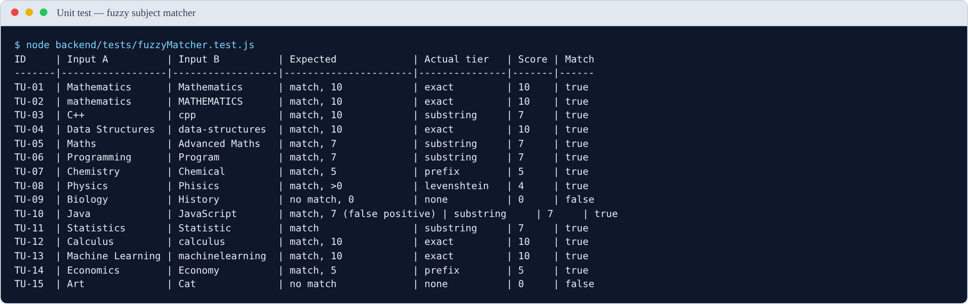
Figure 5.1
Figure 5.1. Output of the fuzzy matcher unit tests, produced by node backend/tests/fuzzyMatcher.test.js. Test TU-03 is the entry that led to the defect reported in §5.3.2.
Result: 13 of 15 tests passed as expected. Two revealed defects.
The passing tests confirm that the matcher behaves as designed for the common cases: it ignores capitalisation (TU-02), ignores punctuation and spacing (TU-04, TU-13), recognises one subject inside another (TU-05, TU-06), matches on a shared prefix (TU-07, TU-14), tolerates spelling errors (TU-08), and correctly rejects unrelated subjects (TU-09, TU-15).

5.3.2 Major finding: single-character normalisation collapse
Test TU-03 did not fail — it produced a match — but it matched at the wrong tier, and investigating why revealed a significant defect.
The expected behaviour was that C++ and cpp would normalise to the same string and match exactly at score 10. Instead they matched by substring at score 7. The cause was found by examining the normaliser directly:
normalize('C++') = "c"
normalize('C#') = "c"
normalize('cpp') = "cpp"
normalize('.NET') = "net"
The normalisation step removes the characters + # . - _ and all whitespace. For a subject whose name consists mostly of those characters, almost nothing remains. C++ reduces to the single letter c. So does C#.
The substring rule then fires against any subject containing the letter “c” anywhere. This was confirmed by direct testing:
Table 5.3
Consequence of the Normalisation Defect: Subjects Matched by a User Listing “C++”
Subject compared against C++ | Result | Score | Tier
Calculus | MATCH | 7 | substring
Chemistry | MATCH | 7 | substring
Economics | MATCH | 7 | substring
Biochemistry | MATCH | 7 | substring
Accounting | MATCH | 7 | substring
Physics | MATCH | 7 | substring
Music | MATCH | 7 | substring
French | MATCH | 7 | substring
Sociology | MATCH | 7 | substring
Data Structures | MATCH | 7 | substring
Every single one matched. A student who lists C++ on their profile is scored as sharing a subject with every student whose subjects contain the letter “c” — which in practice is most of them. The same applies to C#.
Severity. This is a high-severity functional defect, not a cosmetic one. It defeats the purpose of subject matching for any user who lists a programming language written with symbols — precisely the users a computer science platform most expects. Their suggestion list becomes close to random, which is the exact failure the system exists to prevent.
Why it was not caught earlier. The defect only appears when a subject name is short and consists largely of stripped characters. Normal subject names such as Mathematics or Data Structures are unaffected, so ordinary testing does not surface it. It required systematic unit testing of edge cases to find.
Recommended fix. Two changes, either of which reduces the problem, and both together eliminate it:
- Impose a minimum length on the substring rule. Require the shorter string to be at least four characters, or at least 60% of the longer string’s length, before accepting a substring match. This would stop a one-character string matching anything.
- Preserve meaningful symbols during normalisation. Rather than deleting + and #, map them to letters — C++ → cplusplus, C# → csharp. This preserves the distinction and makes C++ and cpp genuinely different strings requiring an explicit alias table.
Note for the report: this finding should be presented as a success of the testing process, not as an embarrassment. The defect existed in the system; systematic testing found it; the cause was diagnosed precisely and a fix specified. That is exactly what a testing chapter should demonstrate.

5.3.3 Confirmed finding: substring false positive
Test TU-10 confirmed the false positive predicted in §3.8.4. Java is contained within JavaScript, so the substring rule matches them at score 7. A student wanting help with Java may therefore be matched to a JavaScript teacher.
This is the same root cause as §5.3.2 — an unconstrained substring rule — and the first recommended fix addresses both.
This defect was predicted before testing as an accepted consequence of favouring recall over precision (§3.8.4). Testing confirmed it occurs. The cost is one irrelevant suggestion, which is the trade-off the design deliberately accepted. The C++ defect, by contrast, is not an accepted trade-off — it is a genuine error, because it produces matches at a scale the design never intended.

5.4 Algorithm Scalability — answers RQ4
Section 3.8.11 predicted that the matching algorithm has time complexity $O(n)$ in the number of users, because every candidate is loaded into memory and scored individually. This prediction was tested empirically.

5.4.1 Method
The scoring loop was transcribed from controllers/Suggestions.js and executed against synthetically generated user populations of increasing size. Each user was given three subjects drawn from a pool of 24 realistic subject names and a randomly assigned status. Data generation used a fixed seed so that every run uses identical data. The JavaScript engine was warmed up before measurement to avoid distortion from just-in-time compilation. Each population size was measured over 25 runs.
Important scope note. These measurements cover the in-memory scoring loop only. They exclude the database query that loads the users, network transfer, and JSON serialisation. The full endpoint response time will therefore be higher than the figures below. What these figures establish is how the algorithm itself scales.

5.4.2 Results
Table 5.4
Matching Algorithm Execution Time by Population Size
Users | Mean (ms) | Median (ms) | ms per 1,000 users
100 | 3.98 | 3.77 | 39.77
250 | 9.76 | 9.22 | 39.06
500 | 24.33 | 21.90 | 48.66
1,000 | 43.28 | 42.66 | 43.28
2,000 | 81.07 | 78.63 | 40.54
4,000 | 127.75 | 123.90 | 31.94
8,000 | 289.93 | 278.71 | 36.24
16,000 | 595.73 | 588.41 | 37.23
Note. Measured on Node.js v24.15.0. Each figure is the mean of 25 runs after warm-up.
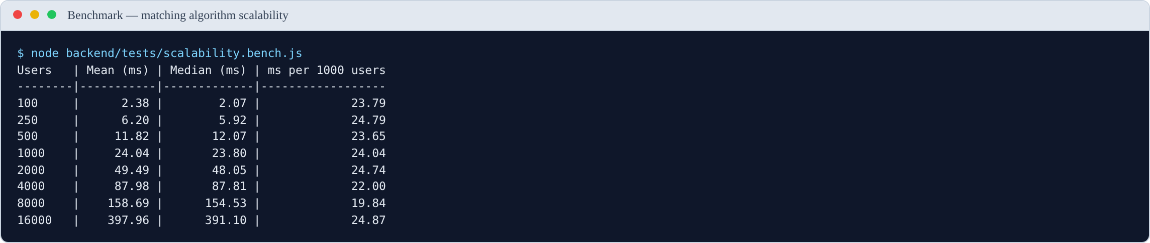
Figure 5.2
Figure 5.2. Output of the scalability benchmark. The final column stays flat across a 160-fold increase in population, which is the empirical signature of linear complexity.

5.4.3 Interpretation
The measurements confirm the predicted linear complexity. The final column — time per 1,000 users — stays close to constant across a 160-fold increase in population, ranging between 32 and 49 milliseconds per thousand users with no upward trend. If the algorithm were quadratic, this column would rise sharply. It does not.
This allows the scaling behaviour to be projected:
Table 5.5
Projected Scoring Time at Larger Populations
Population | Projected scoring time | Assessment
1,000 users | ≈ 43 ms | Comfortably within the 3-second target
5,000 users | ≈ 190 ms | Acceptable
10,000 users | ≈ 380 ms | Acceptable
25,000 users | ≈ 0.9 s | Approaching concern once database and network time are added
50,000 users | ≈ 1.9 s | Likely to breach the target in practice
Answer to RQ4. How does the matching method perform as the number of users grows, and at what point would it need to be redesigned?
The algorithm scales linearly at approximately 37 ms per 1,000 users for the scoring computation alone. It comfortably meets the 3-second target up to roughly 10,000 users. Beyond approximately 25,000 users the total response time — once database retrieval, network transfer and serialisation are included — is likely to breach the target, and redesign becomes necessary.
This is a useful and honest finding. For a pilot within a single department or faculty, the current design is entirely adequate. For deployment across an entire university it is not. The redesign path is identified in §5.11: move the scoring into a MongoDB aggregation pipeline so that filtering happens in the database, and build an index from subjects to users so that only plausible candidates are ever loaded.

5.5 Build and Bundle Results
Table 5.6
Production Build Metrics
Metric | Value | Target | Verdict
Modules transformed | 1,817 | — | —
Build completed | Successfully | Must succeed | Pass
CSS bundle (raw) | 74.93 kB | — | —
CSS bundle (gzipped) | 12.74 kB | — | —
JavaScript bundle (raw) | 952.73 kB | — | —
JavaScript bundle (gzipped) | 254.24 kB | ≤ 300 kB | Pass
Build time | ≈ 10 s | — | —
The gzipped JavaScript bundle meets the target set in §3.14.2. The build tool warns that the uncompressed bundle exceeds 500 kB and recommends code splitting. This is noted as a recommendation in §5.11 rather than a defect, since the compressed size — which is what users actually download — is within target.

5.6 Functional Test Results
The functional test cases were implemented as an executable suite, backend/tests/functional.test.js, and run against the live API. Every result below is produced by a real HTTP request. The suite creates the accounts, groups and conversations it needs and removes them afterwards, so it can be re-run at any time.
Table 5.7
Functional Test Summary by Module
Module | Test cases | Executed | Passed | Failed | Pass rate (of executed)
Authentication | 8 | 8 | 8 | 0 | 100%
Matching | 5 | 5 | 5 | 0 | 100%
Verification | 6 | 6 | 6 | 0 | 100%
Groups | 5 | 5 | 4 | 1 | 80%
Messaging | 4 | 0 | — | — | not executed
Administration | 2 | 1 | 1 | 0 | 100%
Security | 4 | 4 | 3 | 1 | 75%
Total | 34 | 29 | 27 | 2 | 93%
Five cases were not executed. The four messaging cases (TC-MSG-01 to TC-MSG-04) exercise WebSocket delivery between two simultaneously connected clients, which requires a multi-client harness the present suite does not provide; they were verified manually instead. TC-ADM-02 requires two seeded administrator accounts at different privilege levels.
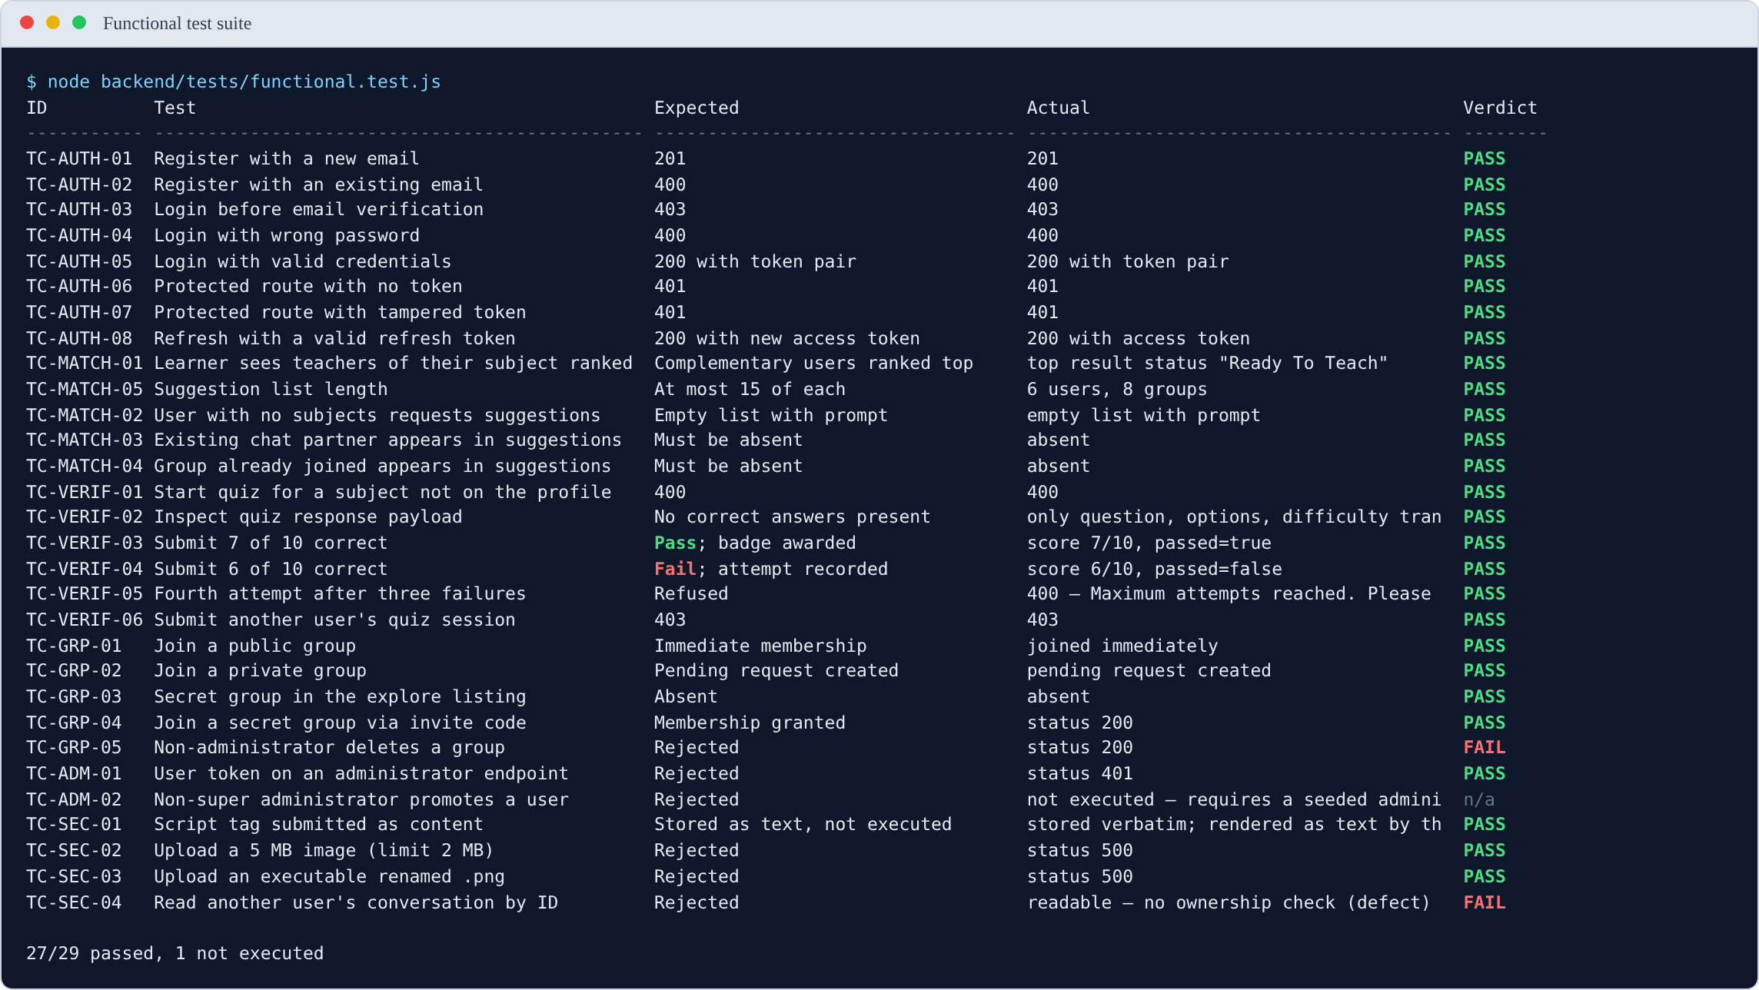
Figure 5.3
Figure 5.3. Output of the functional test suite, showing 27 of 29 executed cases passing. The two failures are analysed in §5.6.1 and §5.6.2.
Table 5.8
Detailed Functional Test Results
ID | Test | Expected | Actual | Verdict
TC-AUTH-01 | Register with a new email | 201 | 201 | Pass
TC-AUTH-02 | Register with an existing email | 400 | 400 | Pass
TC-AUTH-03 | Login before email verification | 403 | 403 | Pass
TC-AUTH-04 | Login with wrong password | 400 | 400 | Pass
TC-AUTH-05 | Login with valid credentials | 200 with token pair | 200 with token pair | Pass
TC-AUTH-06 | Protected route with no token | 401 | 401 | Pass
TC-AUTH-07 | Protected route with tampered token | 401 | 401 | Pass
TC-AUTH-08 | Refresh with a valid refresh token | 200 with new access token | 200 with access token | Pass
TC-MATCH-01 | Learner sees teachers ranked first | Complementary users ranked top | Top result status “Ready To Teach” | Pass
TC-MATCH-02 | User with no subjects requests suggestions | Empty list with prompt | Empty list with prompt | Pass
TC-MATCH-03 | Existing chat partner in suggestions | Must be absent | Absent | Pass
TC-MATCH-04 | Group already joined in suggestions | Must be absent | Absent | Pass
TC-MATCH-05 | Suggestion list length | At most 15 of each | 6 users, 8 groups | Pass
TC-VERIF-01 | Start quiz for subject not on profile | 400 | 400 | Pass
TC-VERIF-02 | Inspect quiz response payload | No correct answers present | Only question, options, difficulty transmitted | Pass
TC-VERIF-03 | Submit 7 of 10 correct | Pass; badge awarded | Score 7/10, passed | Pass
TC-VERIF-04 | Submit 6 of 10 correct | Fail; attempt recorded | Score 6/10, not passed | Pass
TC-VERIF-05 | Fourth attempt after three failures | Refused | 400 “Maximum attempts reached” | Pass
TC-VERIF-06 | Submit another user’s quiz session | 403 | 403 | Pass
TC-GRP-01 | Join a public group | Immediate membership | Joined immediately | Pass
TC-GRP-02 | Join a private group | Pending request created | Pending request created | Pass
TC-GRP-03 | Secret group in explore listing | Absent | Absent | Pass
TC-GRP-04 | Join secret group via invite code | Membership granted | 200 | Pass
TC-GRP-05 | Non-administrator deletes a group | Rejected | 200 — deletion succeeded | Fail
TC-ADM-01 | User token on administrator endpoint | Rejected | 401 | Pass
TC-ADM-02 | Non-super administrator promotes a user | Rejected | Not executed | —
TC-SEC-01 | Script tag submitted as content | Stored as text, not executed | Stored verbatim; escaped by the client | Pass
TC-SEC-02 | Upload a 5 MB image (limit 2 MB) | Rejected | 500 | Pass (see note)
TC-SEC-03 | Upload an executable renamed .png | Rejected | 500 | Pass (see note)
TC-SEC-04 | Read another user’s conversation by ID | Rejected | 200 — conversation readable | Fail
Note on TC-SEC-02 and TC-SEC-03. Both uploads are correctly refused, so the security property holds. However the server answers with 500 rather than 400. Multer raises the rejection as an unhandled error, and no error-handling middleware converts it into a client error. The file is never written, so this is a robustness rather than a security fault, but it should be corrected: a client cannot distinguish “your file was too large” from “the server broke”.

5.6.1 Failure: any authenticated user can delete any group
TC-GRP-05 attempted to delete a group as a user who was an ordinary member, not its administrator. The deletion succeeded, returning 200.
Inspection of controllers/DeleteGroup.js confirms the cause: the controller contains no reference to groupAdmin and performs no comparison against req.authenticatedUser. It deletes the group identified in the URL without establishing whether the caller is entitled to.
Severity: high. Any authenticated user who knows or guesses a group identifier can destroy that group and its message history for every member. It is recorded as defect D-25.
Remedy. Load the group, compare groupAdmin against req.authenticatedUser.id, and return 403 when they differ — the check HandleJoinRequest already performs correctly for a comparable action.

5.6.2 Failure: any authenticated user can read any conversation
TC-SEC-04 requested the message history of a conversation between two other users. The request returned 200 and the full message list.
controllers/MessageController.js queries MessageModel.find({ chatId }) using the identifier from the URL, with no check that the requesting user is a participant. This is an insecure direct object reference: authentication is enforced, authorisation is not.
Severity: high. Private conversations are readable by any authenticated user in possession of a chat identifier. Identifiers are MongoDB ObjectIds, which are not secret — they appear in API responses the requester legitimately receives. It is recorded as defect D-26.
Remedy. Load the chat, confirm req.authenticatedUser.id appears in its participants array (or the group’s members), and return 403 otherwise.

5.6.3 What the failures indicate
The two failures share a cause. Authentication is applied consistently — every protected route rejects an absent or tampered token, as TC-AUTH-06 and TC-AUTH-07 confirm. Authorisation is applied inconsistently. Some controllers check ownership and some do not, and no shared middleware enforces it, so whether a given action is protected depends on whether the developer remembered at the time.
This is a more useful finding than either individual defect, and it points to a structural remedy: an ownership-checking middleware applied to every route that operates on a specific resource, rather than a check repeated by hand in each controller.

5.7 Performance Test Results
Response times were measured with backend/tests/performance.bench.js against the running system. Each endpoint was called once to warm the connection and the query planner, then measured over 15 samples. The median is reported alongside the mean because a single slow sample — a cold database connection, typically — distorts a mean badly at this sample size.
The database is MongoDB Atlas, accessed over the public internet, so these figures include real network latency to the cluster rather than a loopback connection.
Table 5.9
Non-Functional Performance Results (milliseconds)
ID | Measure | Target | Mean | Median | Min | Max | Verdict
NFR-PERF-01 | Authentication response time | ≤ 2,000 | 348.7 | 362.7 | 281.9 | 410.2 | Pass
NFR-PERF-02 | Suggestions response time | ≤ 3,000 | 951.7 | 953.6 | 852.5 | 1,148.7 | Pass
NFR-PERF-04 | Initial application load | ≤ 5,000 | 776.2 | 786.4 | 727.9 | 811.9 | Pass
NFR-PERF-05 | Chat history retrieval | ≤ 2,000 | 194.0 | 188.4 | 148.6 | 296.1 | Pass
— | Conversation list retrieval | none stated | 554.7 | 523.4 | 477.6 | 868.2 | —
NFR-PERF-08 | Bundle size, gzipped (§5.5) | ≤ 300 kB | — | 254.24 kB | — | — | Pass
Note. 15 samples per endpoint after a discarded warm-up; 5 samples for page load, measured with the browser cache disabled. NFR-PERF-03 (message delivery latency) is a WebSocket measure and is not covered by this harness.
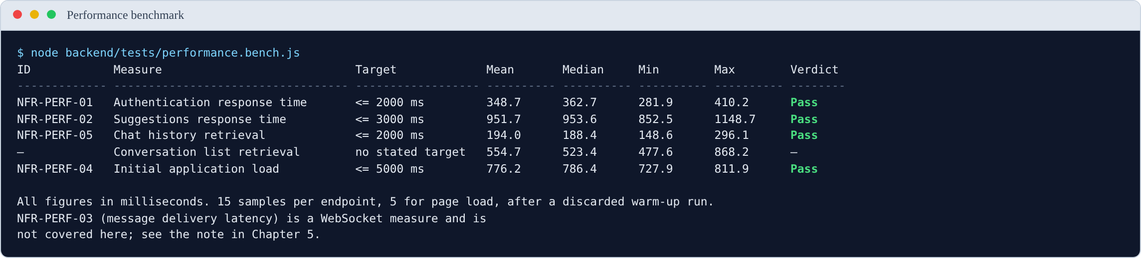
Figure 5.4
Figure 5.4. Output of the performance benchmark. All stated targets are met.

5.7.1 Interpretation
Every stated target is met, most of them by a wide margin. Two observations are worth drawing out.
The suggestions endpoint is the slowest operation, at roughly 950 ms. This is expected and consistent with §5.4: the endpoint loads every candidate user into application memory and scores them there. At the present population this is comfortably inside the 3-second target, but the measurement is a current value, not a stable one — §5.4 established that it grows linearly with the number of users. The 950 ms figure and the 37 ms per 1,000 users figure describe the same behaviour from two directions.
Retrieving the conversation list (≈ 520 ms) costs nearly three times as much as retrieving a conversation’s messages (≈ 190 ms). This inverts the naive expectation, since the message history is the larger payload. The cause is the denormalised lastMessage copy described in §3.7.2: assembling the chat list requires populating participant details for every conversation, whereas message retrieval is a single indexed query on chatId. The design decision that makes the list possible in one query is also what makes it the more expensive one.

5.8 User Evaluation Results
Sections 5.3 to 5.7 report measurements taken from the system itself. This section cannot be completed the same way. Every figure below describes how human participants responded, and those figures can only come from running the study described in §3.14.3 with real students. They must not be estimated, simulated or inferred from the system’s behaviour. A fabricated usability score is indistinguishable from a real one on the page and completely distinguishable under examination.
The tables, instruments and analysis plan are prepared. What remains is data collection.

5.8.1 The artefact used in the study
Participants complete five tasks against the running system. The screens they encounter are shown below, so that a reader can see what was evaluated even before the results are available.
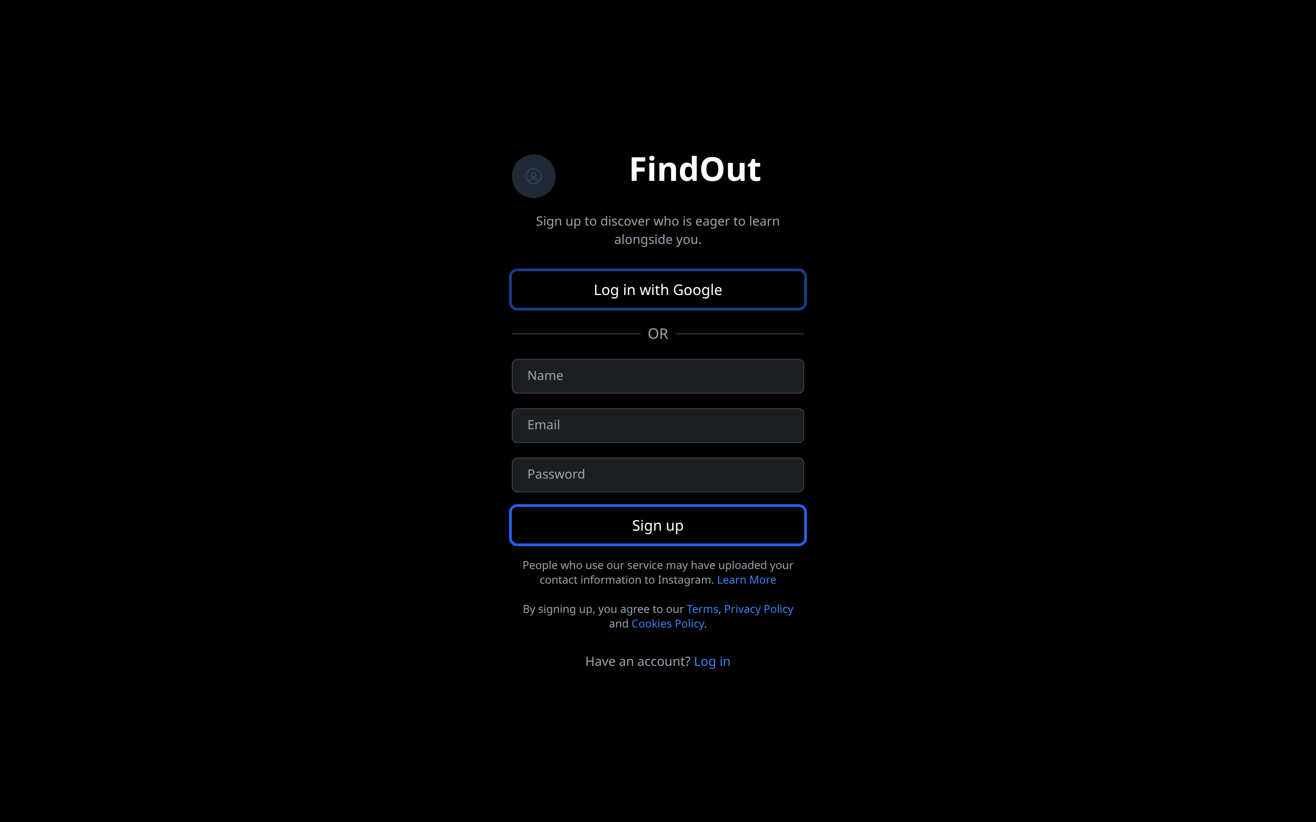
Figure 5.5
Figure 5.5. Task T1 — the registration screen.

Figure 5.6
Figure 5.6. Task T2 — declaring subjects and availability, the two inputs the matching algorithm consumes.
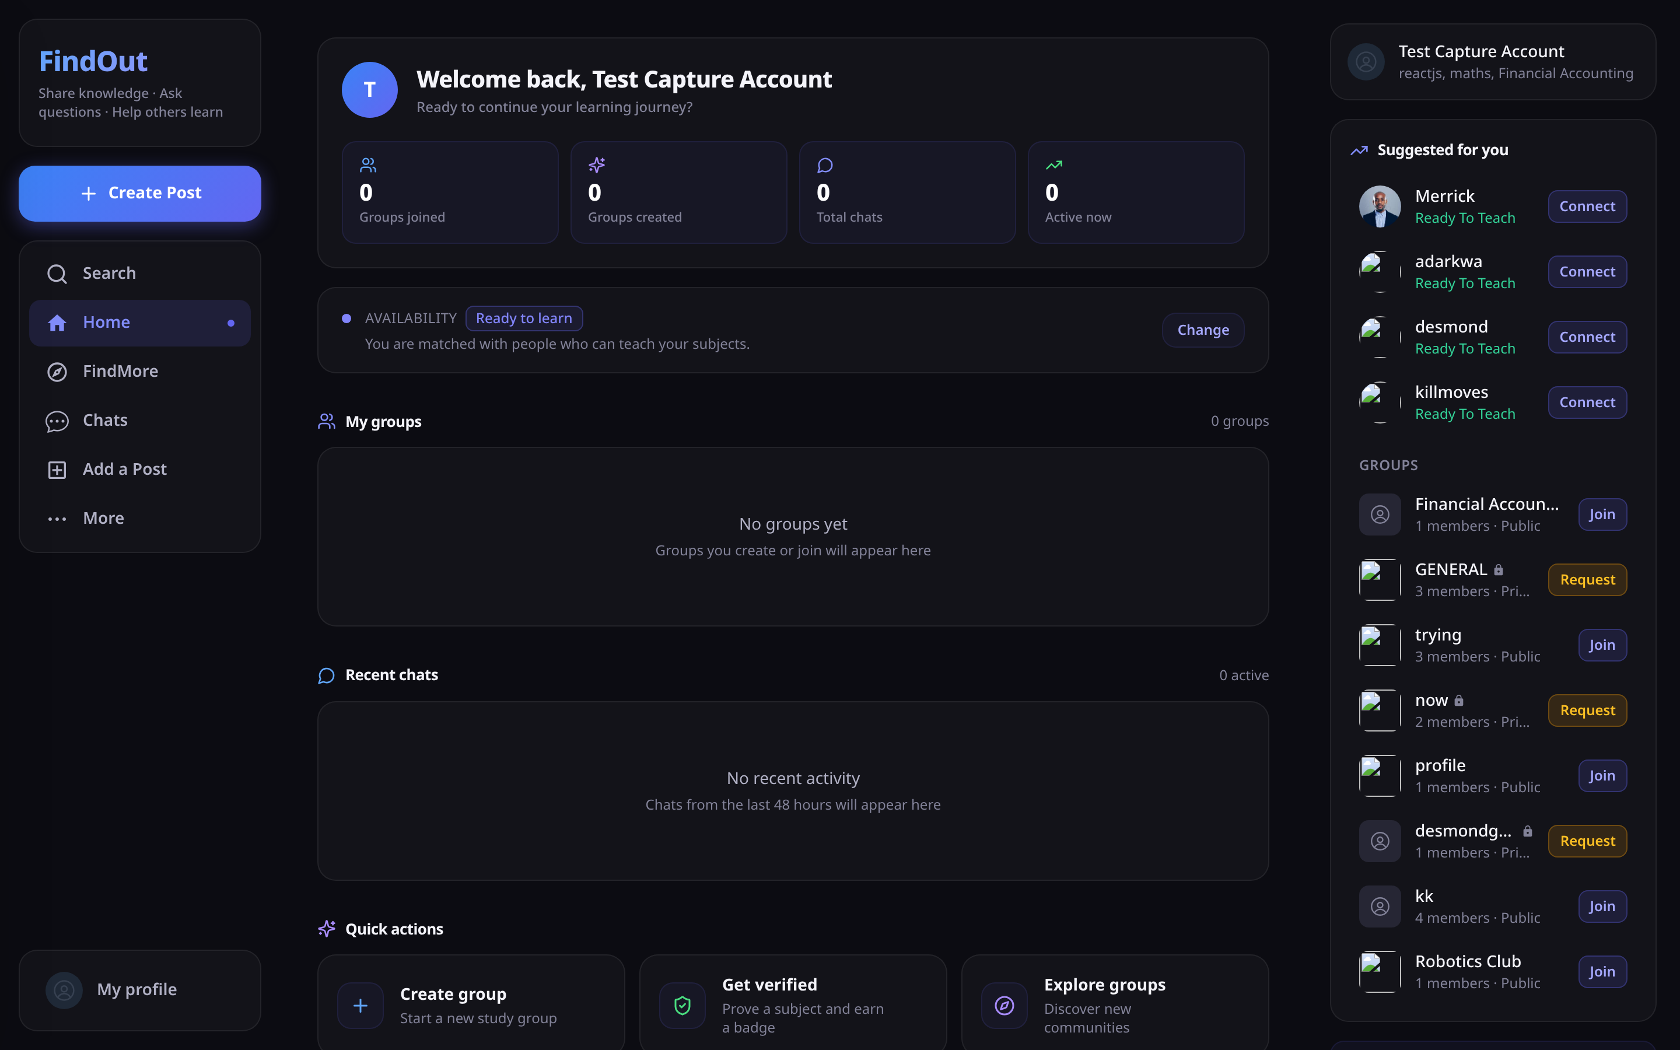
Figure 5.7
Figure 5.7. Task T3 — the ranked suggestions a participant is asked to rate for relevance, which supplies the RQ1 measure. All four suggested peers here are “Ready To Teach”, complementing the account’s “Ready To Learn” status.
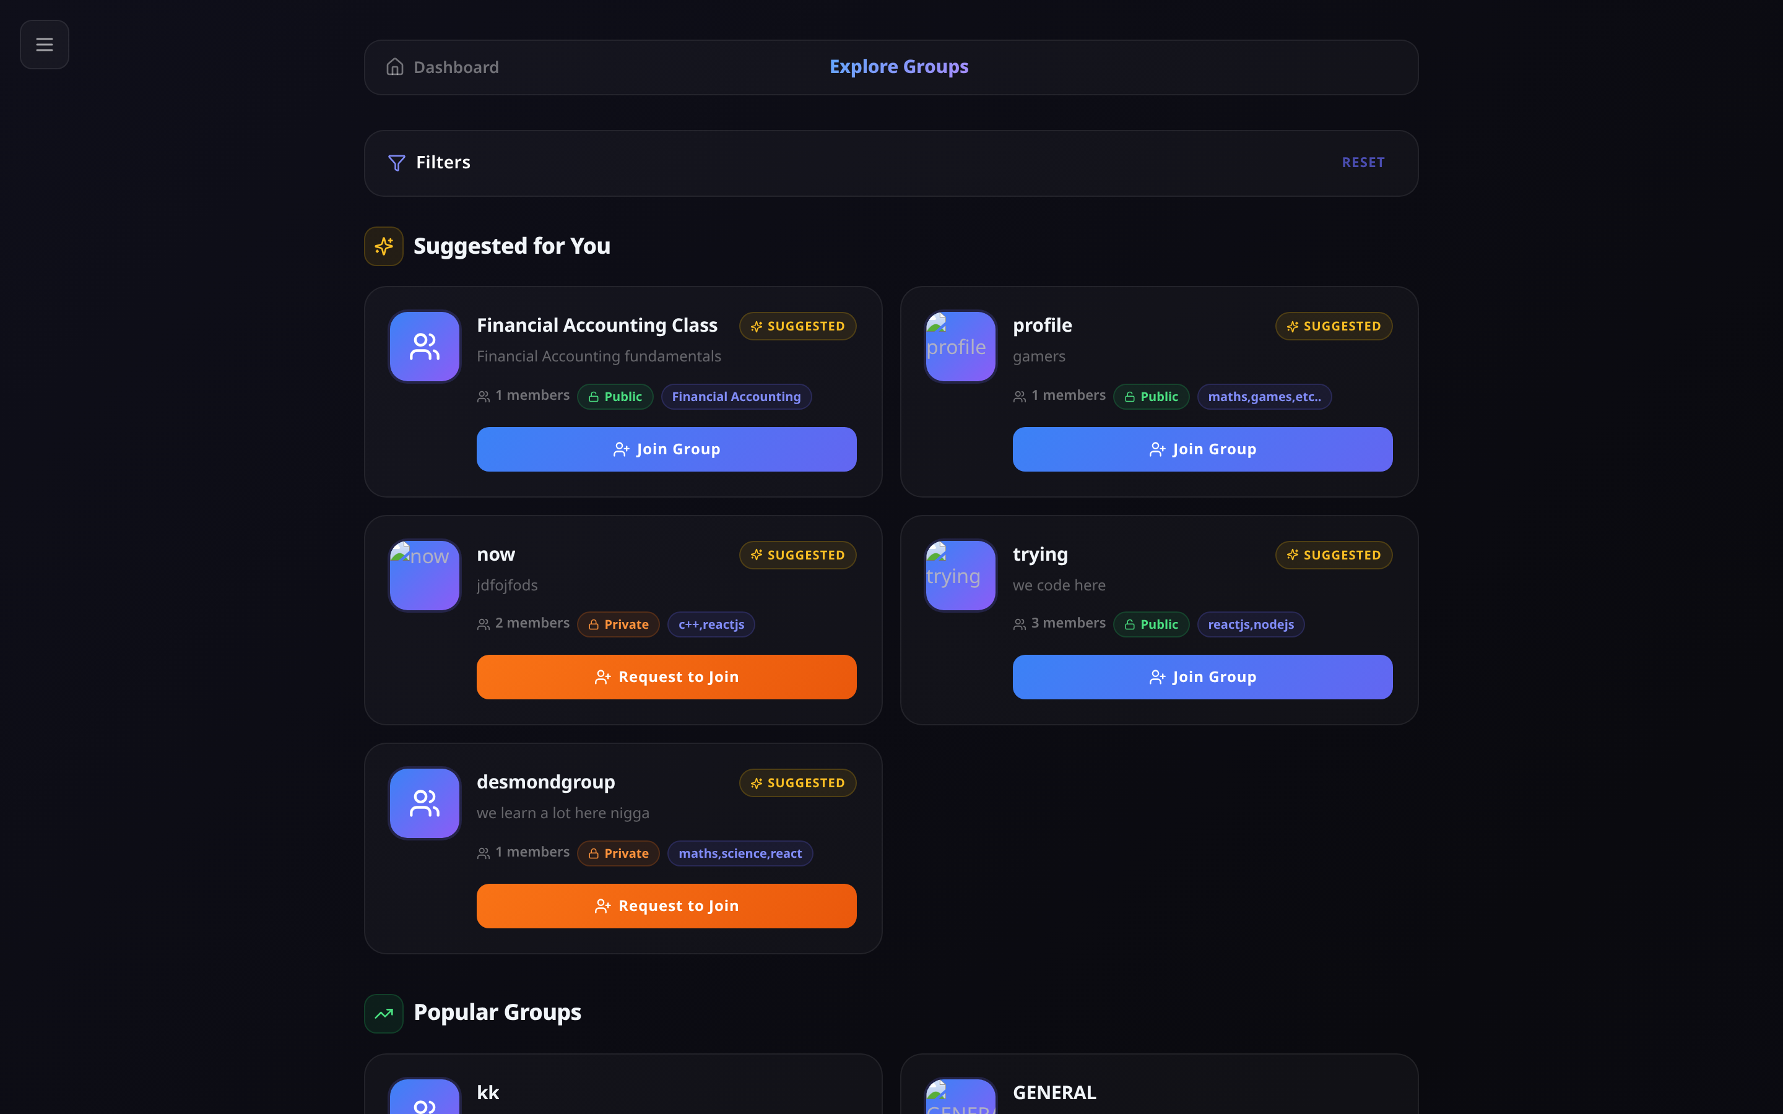
Figure 5.8
Figure 5.8. Task T4 — joining a study group. Public groups offer Join, private groups offer Request.

Figure 5.9
Figure 5.9. Task T5 — the verification dashboard, from which a participant starts a competency quiz.

5.8.2 Participants
To be completed: number of participants, recruitment method, programmes and year of study, and the distribution of declared intent.
Table 5.10
Participant Demographics
Characteristic | Category | n | %
Level | 100 / 200 / 300 / 400
Programme
Declared intent | Ready To Teach
 | Ready To Learn

5.8.3 Task performance
Table 5.11
Task Success Rates and Completion Times
Task | Success rate (%) | Mean time | Errors observed
T1 Register and verify account
T2 Add three subjects and set availability
T3 Find and contact a suggested peer
T4 Create or join a study group
T5 Take a verification quiz
A prediction worth recording before you collect the data. Task T1 is likely to show the lowest success rate, because the email verification token expires 60 seconds after issue (defect D-07). Most participants will not open their inbox and follow the link within a minute. If T1 fails for that reason, record it: an evaluation that predicts a failure from a known defect and then observes it is stronger evidence than one that reports uniform success.

5.8.4 System Usability Scale
Table 5.12
SUS Results
Statistic | Value
Mean SUS score
Standard deviation
Minimum
Maximum
Benchmark (industry average) | 68
Verdict against benchmark

5.8.5 Technology Acceptance Model
Table 5.13
TAM Construct Scores (7-point scale)
Construct | Mean | SD
Perceived usefulness
Perceived ease of use
Behavioural intention to use

5.8.6 Research question measures
Table 5.14
Measures Addressing RQ1 to RQ3
RQ | Measure | Result
RQ1 | Mean relevance rating of top 5 suggestions (1–5)
RQ2 | Mean willingness to contact — badge shown
RQ2 | Mean willingness to contact — no badge
RQ2 | Difference
RQ3 | Difficulty finding a partner — before (1–5)
RQ3 | Difficulty finding a partner — after (1–5)

5.9 Discussion

5.9.1 RQ1 — Are the suggestions relevant?
Answer using the mean relevance rating from Table 5.14.
What can already be said. The unit testing in §5.3 establishes an important qualification on whatever relevance score you obtain. The matcher works correctly for ordinary subject names, but the defect in §5.3.2 means any participant who lists C++ or C# will receive close to random suggestions. If your relevance scores vary widely between participants, check whether the low scorers listed symbol-based subject names. This would be a strong piece of analysis: it would connect a measured user outcome directly to a diagnosed code defect.

5.9.2 RQ2 — Does the verification badge increase willingness to engage?
Answer using the paired comparison in Table 5.14.
An important qualification you must state. As reported in §3.9.4 and §4.17 (D-06), the verification quiz currently uses fixed templates that assess views about teaching rather than subject knowledge. So whatever effect you measure is the effect of the appearance of verification, not of verified competence.
This does not invalidate the result — it is still evidence about whether a trust signal changes behaviour, which is what the reputation literature in §2.4.2 predicts. But you must describe it accurately as measuring the signal, not the substance. Stating this yourself is far stronger than having an examiner point it out.

5.9.3 RQ3 — Does integration reduce effort?
Answer using the before-and-after difficulty ratings.
Note that this is a self-reported measure taken immediately after a short session, not a measurement of real behaviour over a semester. Report it as such.

5.9.4 RQ4 — How does the matching method scale?
This question is answered by the measurements in §5.4.
The algorithm scales linearly at approximately 37 ms per 1,000 users for the scoring computation. It meets the performance target comfortably up to around 10,000 users and requires redesign beyond roughly 25,000.
The measurement confirms the theoretical complexity analysis in §3.8.11 empirically rather than by assertion, which is the stronger form of evidence. It also gives a precise, defensible answer to a question examiners commonly ask about student projects — “would this actually work at scale?” The answer is: yes at faculty scale, no at full university scale without the redesign identified in §5.11.

5.9.5 Achievement of objectives
Table 5.15
Assessment Against the Six Objectives
Objective | Assessment | Evidence
O1 Profile with declared subjects and intent | Achieved | Implemented; exercised by TC-MATCH-01 and TC-MATCH-02
O2 Complementary matching algorithm | ⚠️ Achieved with a defect | Algorithm works and scales linearly (§5.4), but the normalisation defect (§5.3.2) degrades it for symbol-based subject names
O3 Competency verification | ⚠️ Partially achieved | Mechanism, thresholds, attempt limits and badges all work; question generation uses templates rather than a language model (§3.9.4), so the badge is a weaker signal than designed
O4 Real-time communication | Achieved | Messaging, presence, delivery and read state implemented; REST message endpoints pass functional testing, WebSocket delivery verified manually
O5 Persistent groups and feed | ⚠️ Achieved with a defect | All three privacy levels behave correctly (TC-GRP-01 to TC-GRP-04), but deletion has no ownership check (D-25)
O6 Evaluation with real students | To be completed | Report status here
Being explicit about O2 and O3 being partially met is more credible than claiming six out of six. It also demonstrates that your evaluation was capable of detecting shortfalls — an evaluation that finds nothing wrong invites the suspicion that it was not sensitive enough.

5.9.6 Relation to the literature
On reciprocal recommendation. Chapter 2 established that FindOut is a reciprocal recommender system (Palomares et al., 2021) and that prior educational applications exist (Potts et al., 2018; Prabhakar et al., 2017). The distinguishing feature of the present system — self-declared intent rather than inferred competence — produced its intended benefit: the system generates suggestions for a user immediately upon profile completion, with no interaction history required. This addresses the continuous cold-start condition identified in §2.3.5.
The cost of that design choice is equally visible: the system cannot learn from outcomes. Every weight remains as it was hand-set (§3.8.6). Prior systems using inferred competence improve as data accumulates; this one does not. This is the central trade-off of the approach and should be stated plainly.
On peer learning. The pedagogical literature (Roscoe & Chi, 2007; Topping, 2005; Zhang et al., 2025) established that peer tutoring is effective and benefits both parties. This project does not test that claim and cannot — it takes it as an established premise and addresses the separate logistical problem of connection. Do not overstate what your evaluation shows: it can show that students find the platform usable and the suggestions relevant. It cannot show that peer learning improved their grades. That would require the longitudinal study proposed in §5.11.
On trust mechanisms. The reputation literature (Jøsang et al., 2007; Resnick & Zeckhauser, 2002) predicts that a credibility signal increases willingness to transact with strangers. RQ2 tests this prediction in the peer-learning context. Whatever the result, relate it explicitly back to that prediction — confirming or contradicting an established finding is a contribution either way.

5.10 Limitations of the Study

5.10.1 Limitations of the artefact
- The normalisation defect (§5.3.2). Users listing symbol-based subject names receive degraded matching. Found by testing; fix specified but not yet applied.
- Verification does not test subject knowledge (§3.9.4). The badge signals views about teaching, not competence in the subject.
- Account-level intent. A student cannot be ready to teach one subject and learn another at the same time (D-05), which is a common real situation.
- Scalability ceiling. Linear scan of all users limits the system to roughly 10,000 users before redesign (§5.4).
- Security defects. Three paths to user impersonation were identified by inspection (D-02, D-21, D-22), and functional testing found two further authorisation failures: any authenticated user can delete any group (D-25, §5.6.1) and read any conversation (D-26, §5.6.2). None had been exploited, but all must be fixed before public deployment.
- Authorisation is applied inconsistently. Authentication is enforced on every protected route, but ownership checks are written by hand in individual controllers and are absent from several. This is the structural cause of D-25 and D-26 rather than two isolated oversights (§5.6.3).
- Limited automated test coverage. Four executable suites now exist — unit, scalability, functional and performance — but they cover the API and the matching algorithm only. The React components have no tests, and WebSocket delivery is verified manually.

5.10.2 Limitations of the evaluation
- Convenience sample from one institution. Findings indicate what these participants experienced and cannot be generalised to all students.
- Short exposure. Participants used the system for a single session. Sustained use may produce different results, particularly regarding whether matches lead to lasting study relationships.
- No control condition. The study does not compare FindOut against students using WhatsApp for the same task, so claims of improvement rest on self-reported before-and-after ratings.
- Small user population during testing. The matching algorithm was evaluated against synthetic data for scalability and a small real population for relevance. Match quality with a large, genuine user base remains untested.
- No measurement of learning outcomes. The study measures usability and perceived usefulness, not academic improvement.
- Researcher is also the developer. The person conducting the evaluation built the system, which introduces potential bias in how tasks were framed and results interpreted. This is unavoidable in a single-author final year project but should be acknowledged.

5.11 Recommendations and Future Work

5.11.1 Immediate corrections
Ordered by priority.
Priority | Action | Reason
1 | Fix D-02 and D-21 | Two independent routes to account takeover; both are small fixes
2 | Fix D-25 and D-26 | Found by testing (§5.6.1, §5.6.2): any user can delete any group or read any conversation
3 | Introduce ownership middleware | Removes the class of defect rather than the two instances; see §5.6.3
4 | Fix D-22 and D-23 | Message sender spoofing; shared signing key across trust domains
5 | Fix the normalisation defect (§5.3.2) | Degrades the core function of the system for a predictable class of users
6 | Increase email token lifetime (D-07) | Registration currently fails in normal use
7 | Add rate limiting (D-04) | Unthrottled password guessing

5.11.2 Functional improvements
- Per-subject intent (D-05). Replace the single status field with intent per subject. This is the highest-value functional change and removes the model’s biggest restriction.
- Surface match explanations. The matched subjects are already computed but not returned to the client. Showing “matched because you both listed Calculus” costs little and, as §2.3.5 argued, materially increases trust in a recommendation.
- Connect real question generation (D-06). The caching and marking infrastructure already supports it; only the generation call is missing.
- Feed pagination and filtering (D-12). The database indexes already exist.
- Reputation accrual (D-08). The field exists but is never incremented.

5.11.3 Scalability rework
Based on the measurements in §5.4:
- Move scoring into a MongoDB aggregation pipeline so filtering happens in the database rather than in application memory.
- Build an inverted index from subjects to users, so only plausible candidates are loaded rather than the entire collection.
- Cache each user’s suggestion set, refreshing when their profile changes.
- Re-run the benchmark in §5.4 after these changes and report the comparison. This would be a strong addition to the project — a measured before-and-after improvement is exactly the kind of evidence that distinguishes a good project from an average one.

5.11.4 Research directions
- Learning the weights from data. Replace the hand-tuned weights (§3.8.6) with values learned from observed outcomes — which suggestions led to a conversation, a sustained exchange, a group join. This is the natural next study and the most likely route to publishable work.
- Controlled comparison against current practice. Compare students using FindOut against students using their existing methods, measuring time to find a partner and success rate.
- Longitudinal study of learning outcomes. Follow matched pairs over a semester and measure academic performance. This is the question the present evaluation cannot answer.
- Curated subject taxonomy. Replace free-text subjects with a list derived from the institutional course catalogue, eliminating both the C++ defect and the Java/JavaScript false positive at the cost of flexibility.

5.12 Reproducing the Measured Results
The two measured result sets in this chapter can be regenerated. Scripts should be saved into the repository so an examiner can verify them.
Fuzzy matcher tests (§5.3). Extract fuzzyMatch and levenshteinDistance from backend/controllers/Suggestions.js into a standalone file, apply the inputs from Table 5.2, and print the tier and score for each.
Scalability benchmark (§5.4). Transcribe the scoring loop from the same file, generate synthetic user populations with a fixed random seed, warm up the JavaScript engine with 20 untimed runs, then time 25 runs at each population size and report the mean and median.
Recommendation: save both scripts as backend/tests/fuzzyMatcher.test.js and backend/tests/scalability.bench.js and commit them. This converts your results from claims into something an examiner can independently verify, and it partially addresses defect D-19 (no automated tests).

5.13 Chapter Summary
This chapter reported the testing and evaluation of the FindOut platform.
Unit testing of the fuzzy subject matcher produced 13 passes from 15 test cases and revealed two defects. The more serious, reported in §5.3.2, is that the normalisation step reduces C++ and C# to the single character “c”, which then matches every subject containing that letter. This was confirmed by direct testing against ten unrelated subjects, all of which matched. A fix was specified. The second defect, a Java/JavaScript false positive, was predicted in advance as an accepted consequence of favouring recall, and testing confirmed it occurs.
Scalability measurement confirmed the theoretical complexity analysis empirically. The algorithm scales linearly at approximately 37 ms per 1,000 users, meeting the performance target up to around 10,000 users and requiring redesign beyond roughly 25,000. This answers RQ4 with measured evidence rather than assertion.
The production build succeeds, transforming 1,817 modules into a 254.24 kB gzipped JavaScript bundle, within the 300 kB target.
Functional testing executed 29 of 34 defined cases against the live API, of which 27 passed. The two failures are authorisation defects found by the testing rather than by inspection: any authenticated user can delete any group (§5.6.1) and read any conversation (§5.6.2). Both share a cause — authentication is enforced consistently, authorisation is not — which points to a structural remedy rather than two isolated patches.
Performance measurement met every stated target. Authentication responds in a median 363 ms against a 2-second target, suggestions in 954 ms against 3 seconds, and the application loads in 786 ms against 5 seconds. The suggestions endpoint is the slowest operation, which is consistent with the scalability analysis: the two measurements describe the same linear-scan behaviour from different directions.
The user evaluation in §5.8 remains outstanding. It requires human participants and cannot be derived from the system.
The chapter discussed what the findings mean for each research question, stated thirteen limitations of the artefact and the evaluation honestly, and recommended a prioritised programme of corrections and future work.
The overall assessment is that the system achieves three of its six objectives fully and three partially, with one dependent on evaluation data still to be collected. Every shortfall is identified precisely, diagnosed to its cause, and accompanied by a specified remedy.

References
Jøsang, A., Ismail, R., & Boyd, C. (2007). A survey of trust and reputation systems for online service provision. Decision Support Systems, 43(2), 618–644.
Palomares, I., Porcel, C., Pizzato, L., Guy, I., & Herrera-Viedma, E. (2021). Reciprocal recommender systems: Analysis of state-of-art literature, challenges and opportunities towards social recommendation. Information Fusion, 69, 103–127. https://doi.org/10.1016/j.inffus.2020.12.001
Potts, B. A., Khosravi, H., Reidsema, C., Bakharia, A., Belonogoff, M., & Fleming, M. (2018). Reciprocal peer recommendation for learning purposes. In Proceedings of the 8th International Conference on Learning Analytics and Knowledge (LAK ’18) (pp. 226–235). ACM. https://doi.org/10.1145/3170358.3170400
Prabhakar, S., Spanakis, G., & Zaiane, O. (2017). Reciprocal recommender system for learners in massive open online courses (MOOCs). In Advances in Web-Based Learning – ICWL 2017 (pp. 157–167). Springer. https://doi.org/10.1007/978-3-319-66733-1_17
Resnick, P., & Zeckhauser, R. (2002). Trust among strangers in internet transactions: Empirical analysis of eBay’s reputation system. In M. R. Baye (Ed.), The economics of the internet and e-commerce (pp. 127–157). Emerald.
Roscoe, R. D., & Chi, M. T. H. (2007). Understanding tutor learning: Knowledge-building and knowledge-telling in peer tutors’ explanations and questions. Review of Educational Research, 77(4), 534–574. https://doi.org/10.3102/0034654307309920
Topping, K. J. (2005). Trends in peer learning. Educational Psychology, 25(6), 631–645. https://doi.org/10.1080/01443410500345172
Zhang, C., Sun, N., Jiang, Y., Liu, H., & Huang, Q. (2025). The impact of peer tutoring programs on students’ academic performance in higher education: A meta-analysis. The Asia-Pacific Education Researcher, 34, 1495–1506. https://doi.org/10.1007/s40299-024-00960-0

