# Activity diagram

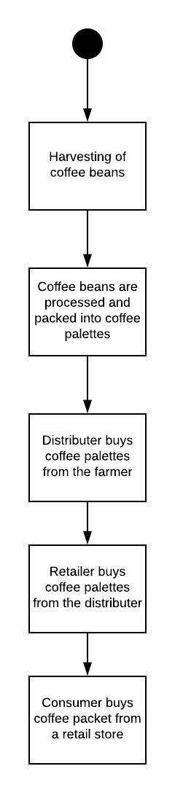

# Sequence Diagram

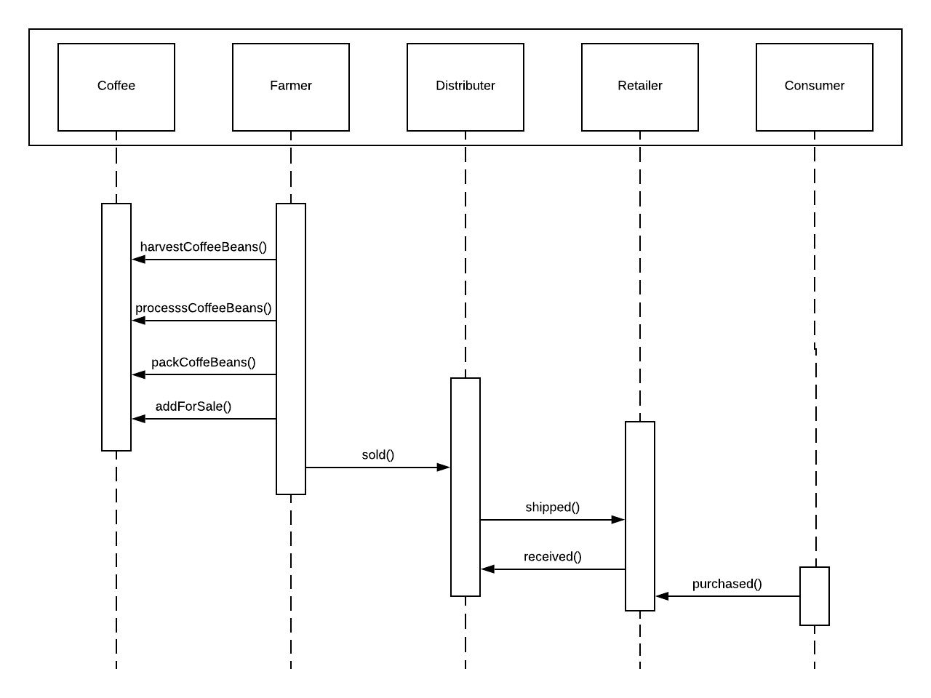

# State Diagram

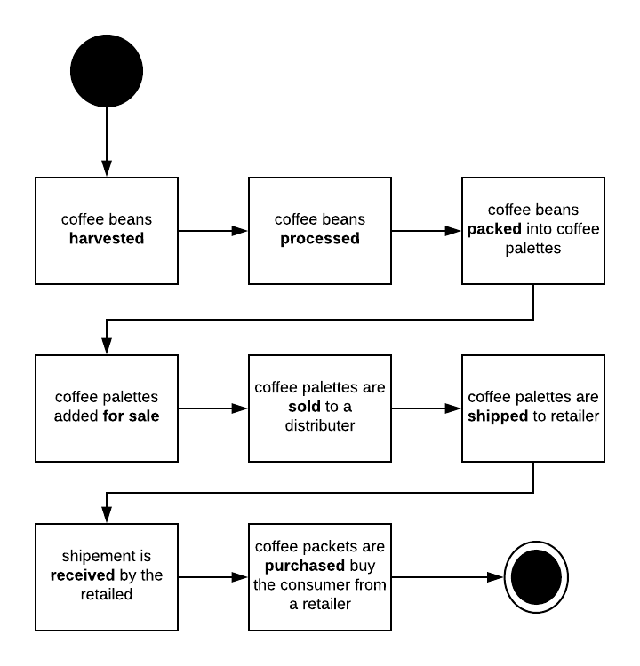

# Class Diagram

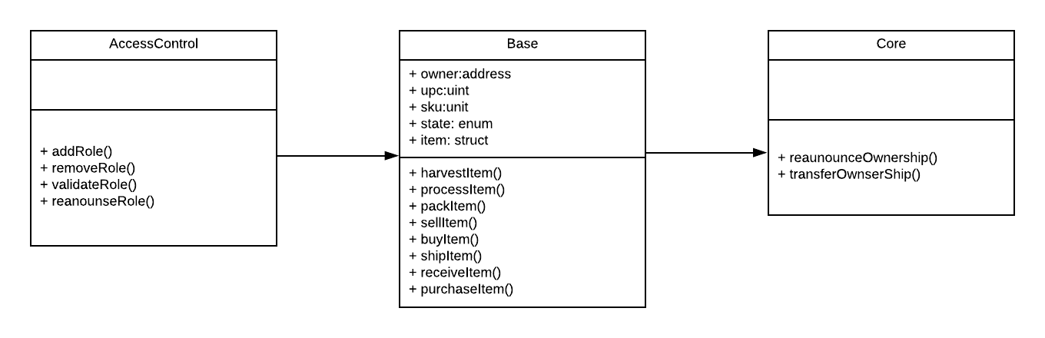

# Libraries used

* Truffle-hdwallet-provider

Used for linking the wallet , while deploying the smart contracts.

* Web3

Web3 is used for interacting with locan and remote ethereum nodes.

# Test cases

The project passes all the test cases except for the follwing one

// assert.equal(eventEmitted, true, 'Invalid event emitted') .

This is because the code provided is for an older version and is actually depricated.

*// var event = supplyChain.Harvested();*

*// await event.watch((err, res) => {*

*// eventEmitted = true*

*// })*

<https://github.com/trufflesuite/truffle/issues/1254>

I have used the new function to watch for events

await supplyChain.Harvested().on('data',event=>{

eventEmitted = true;

});

The events do get emited while the test’s are running but it does not enter this perticular block of code .

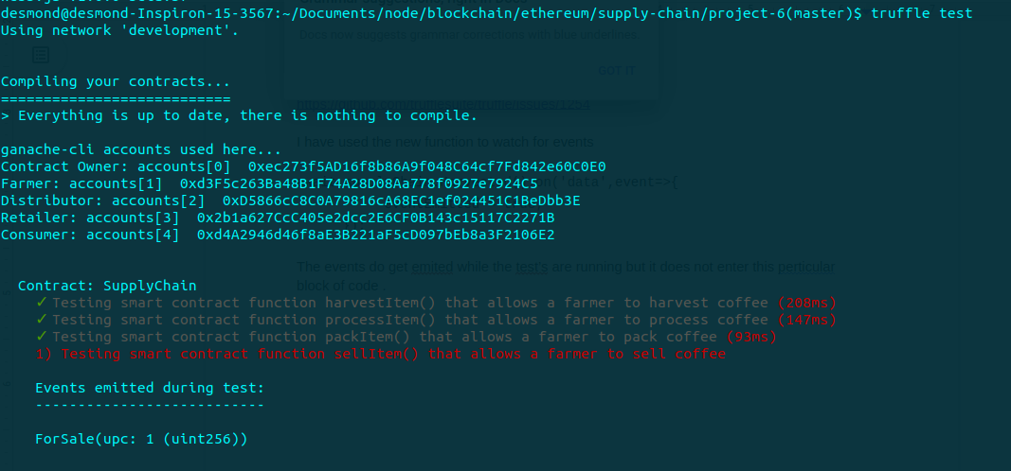

# Deployment

Transaction hash: 0xaa00acc7635e1f03e63dfb9f25e2f4a4e50792faca6509740b8ea67b3c57825f

Contract address: 0x9d628c790ea94Ad0f2Db195aF55924a100AD46d4

Truffle v5.0.26 (core: 5.0.26)

Solidity - ^0.4.24 (solc-js)

Node v8.12.0

Web3.js v1.0.0-beta.37