/**************************************************************************

ITC5202 – Project 2

I declare that this assignment is my own work in accordance with Humber Academic Policy.

No part of this assignment has been copied manually or electronically from any other source

(including web sites) or distributed to other students.

Group member Names: Giovanny Avillaneda, Kexin Zhu,

Student IDs: n01604159, n01621302

Date: 2024-04-04

**************************************************************************/

# Phase 1

## Step 1 Choose group partners and a group in BB

Screenshot here

## Step 2 List all the students’ information

Group Name: Group 6

|  |  |
| --- | --- |
| Name | N number |
| Giovanny Avillaneda | n01604159 |
| Kexin Zhu | n01621302 |
| Tbd | Tbd |

## Step 3 Create a Spotify dev account

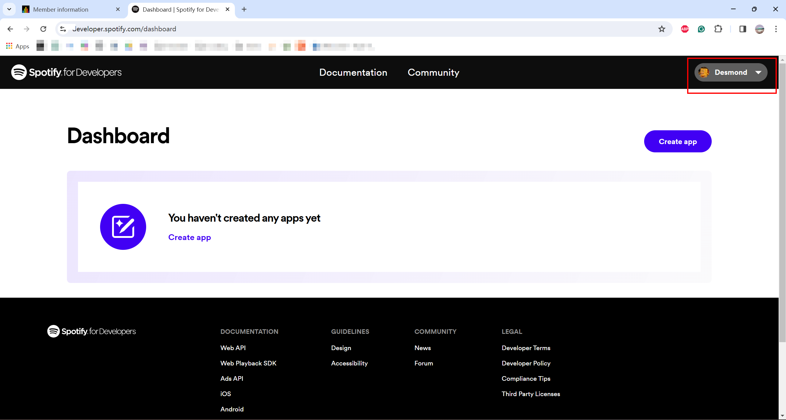

## Step 4 Go to dashboard and create app

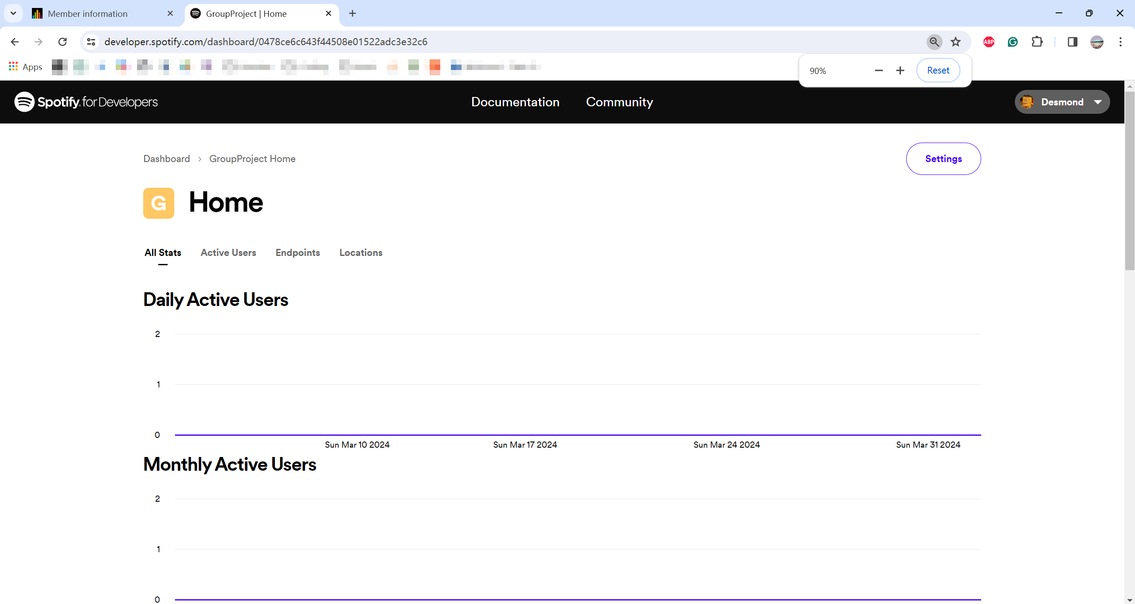

## Step 5 Copy client id and client secret

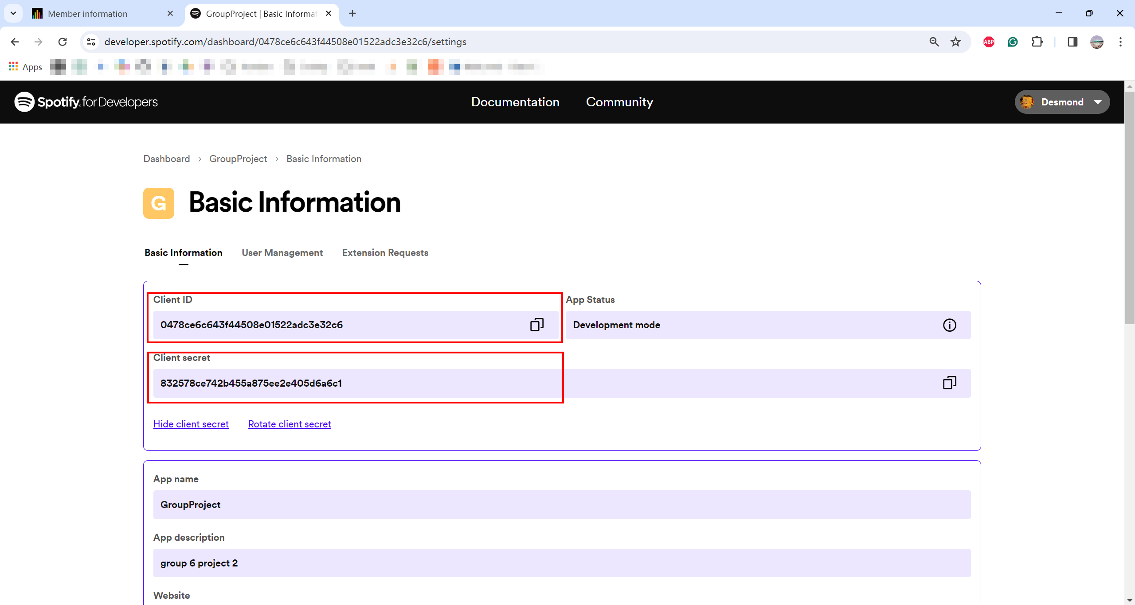

## Step 6 Create a HTML page with proper styling to display genres