/**************************************************************************

ITC5202 – Project 2

I declare that this assignment is my own work in accordance with Humber Academic Policy. No part of this assignment has been copied manually or electronically from any other source (including web sites) or distributed to other students.

Group member Names: Giovanny Avillaneda, Kexin Zhu

Student IDs: N01604159, N01621302

Date: 2024-04-04

**************************************************************************/

# Phase 1

## Step 1 Choose group partners and a group in BB

## Step 2 List all the students’ information

Group Name: Group 6

|  |  |
| --- | --- |
| Name | N number |
| Giovanny Avillaneda | n01604159 |
| Kexin Zhu | n01621302 |

## Step 3 Create a Spotify dev account.

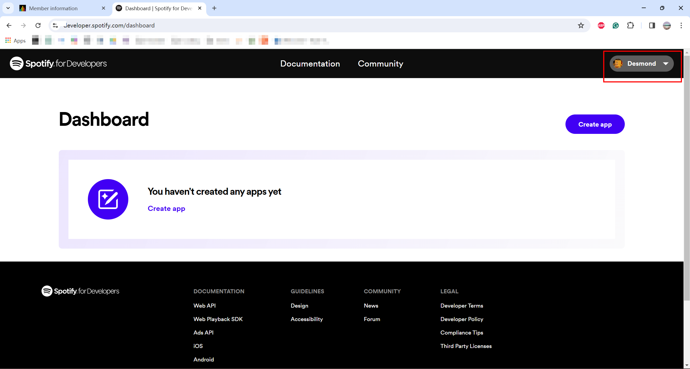

## Step 4 Go to dashboard and create app.

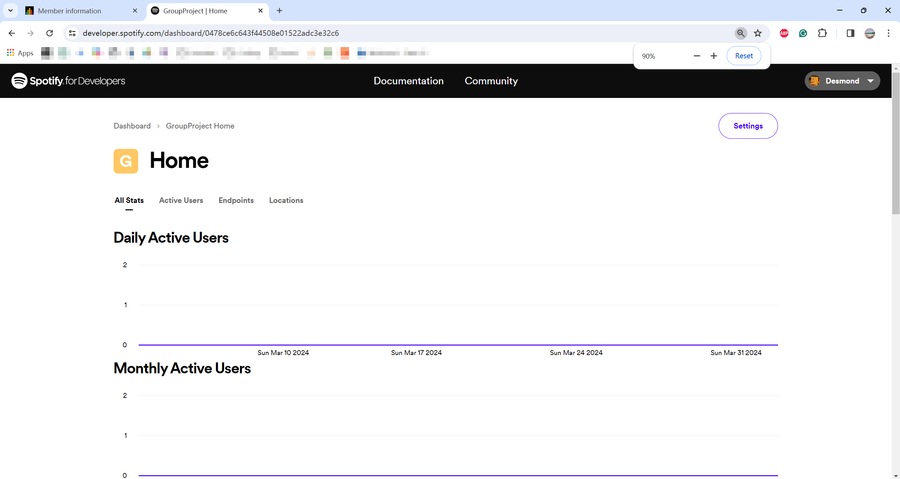

## Step 5 Copy client id and client secret

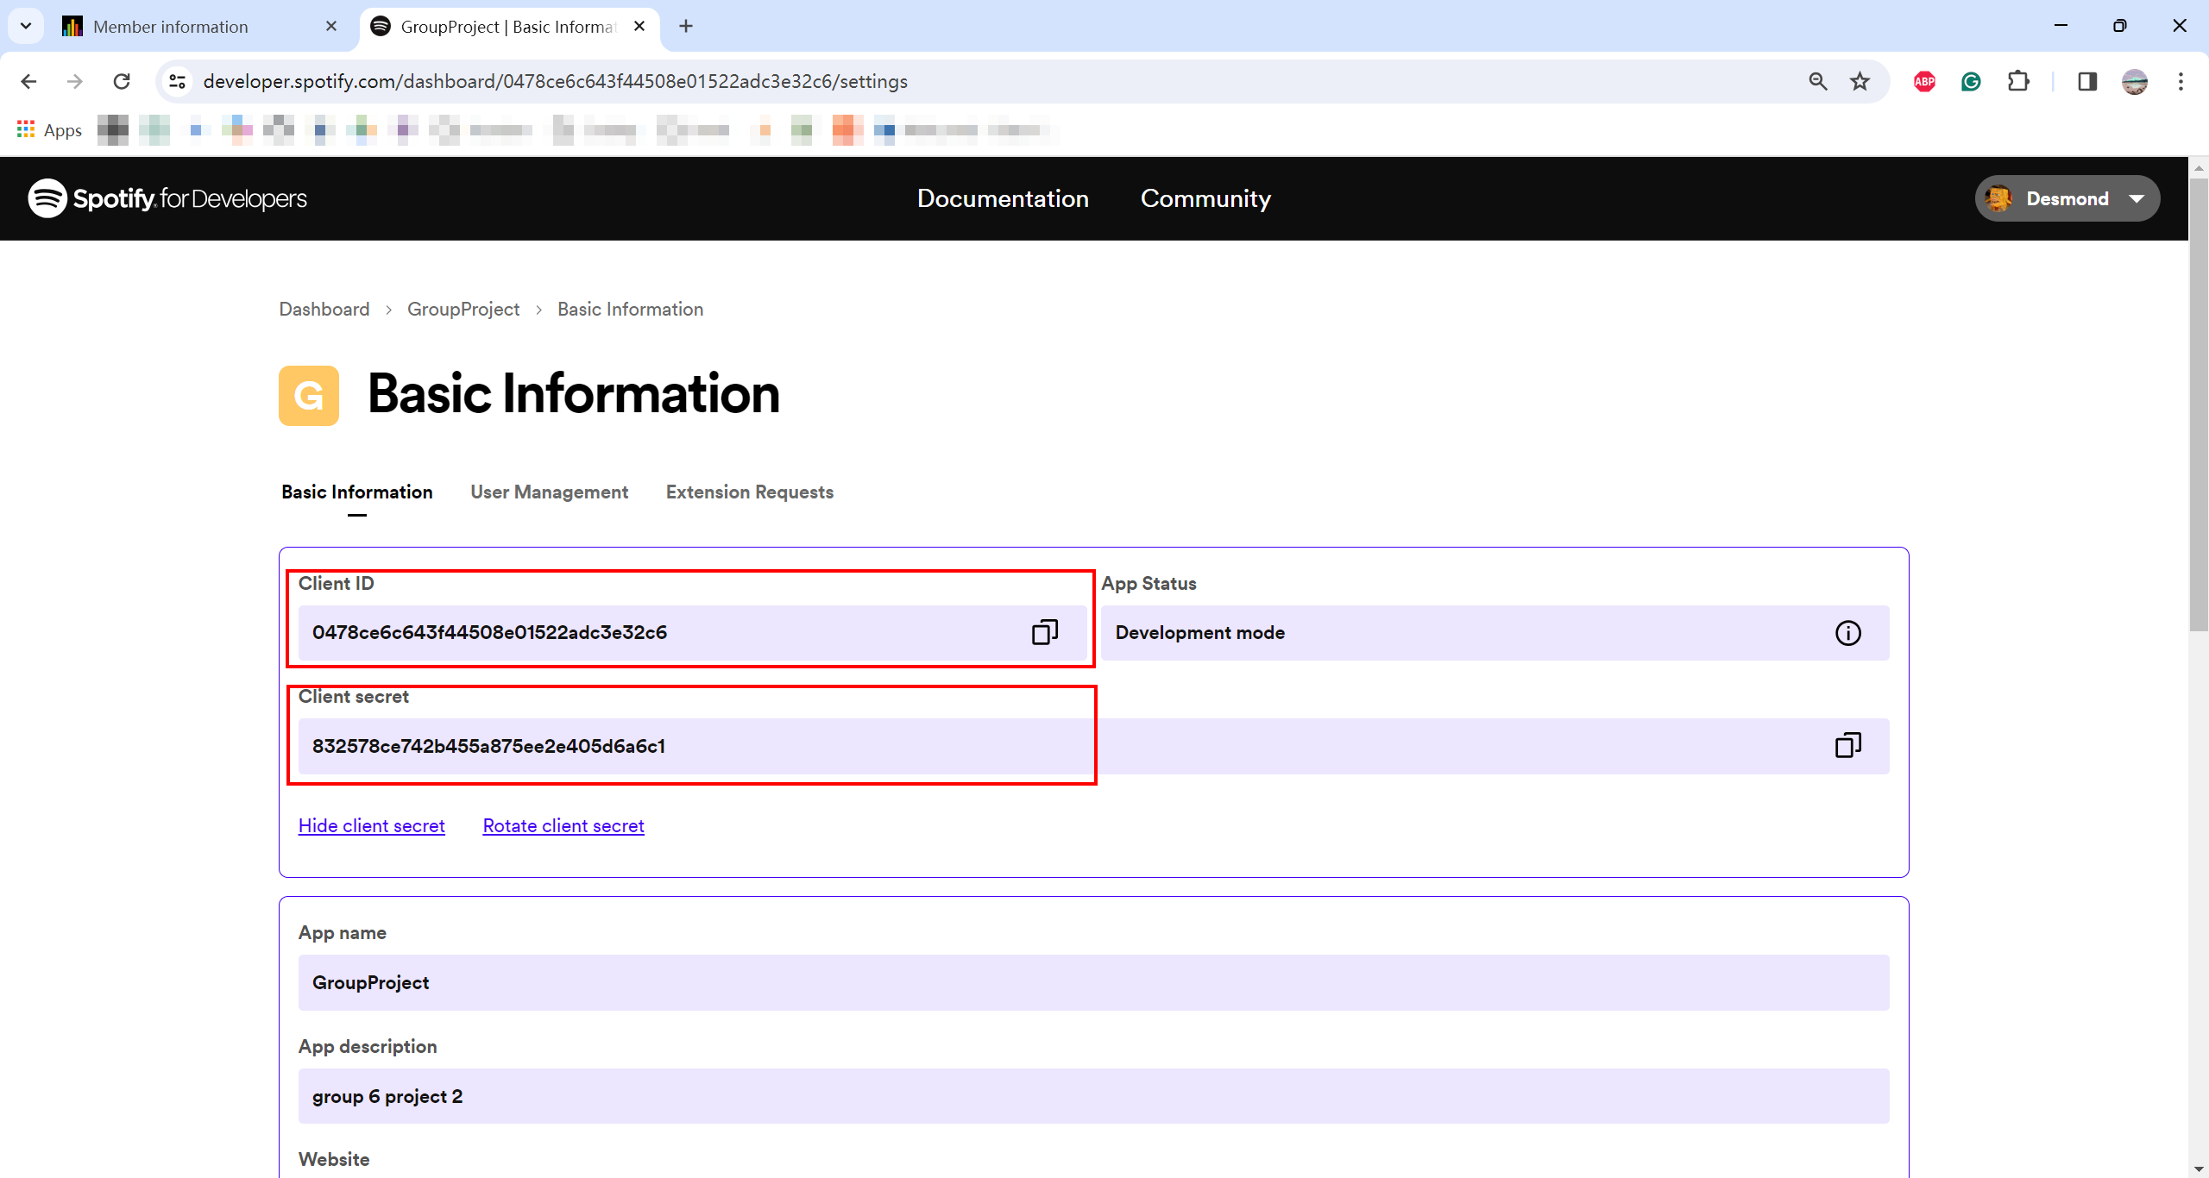

## Step 6 Create a HTML page with proper styling to display genres.

Every time you refresh the page, the colors will change automatically.

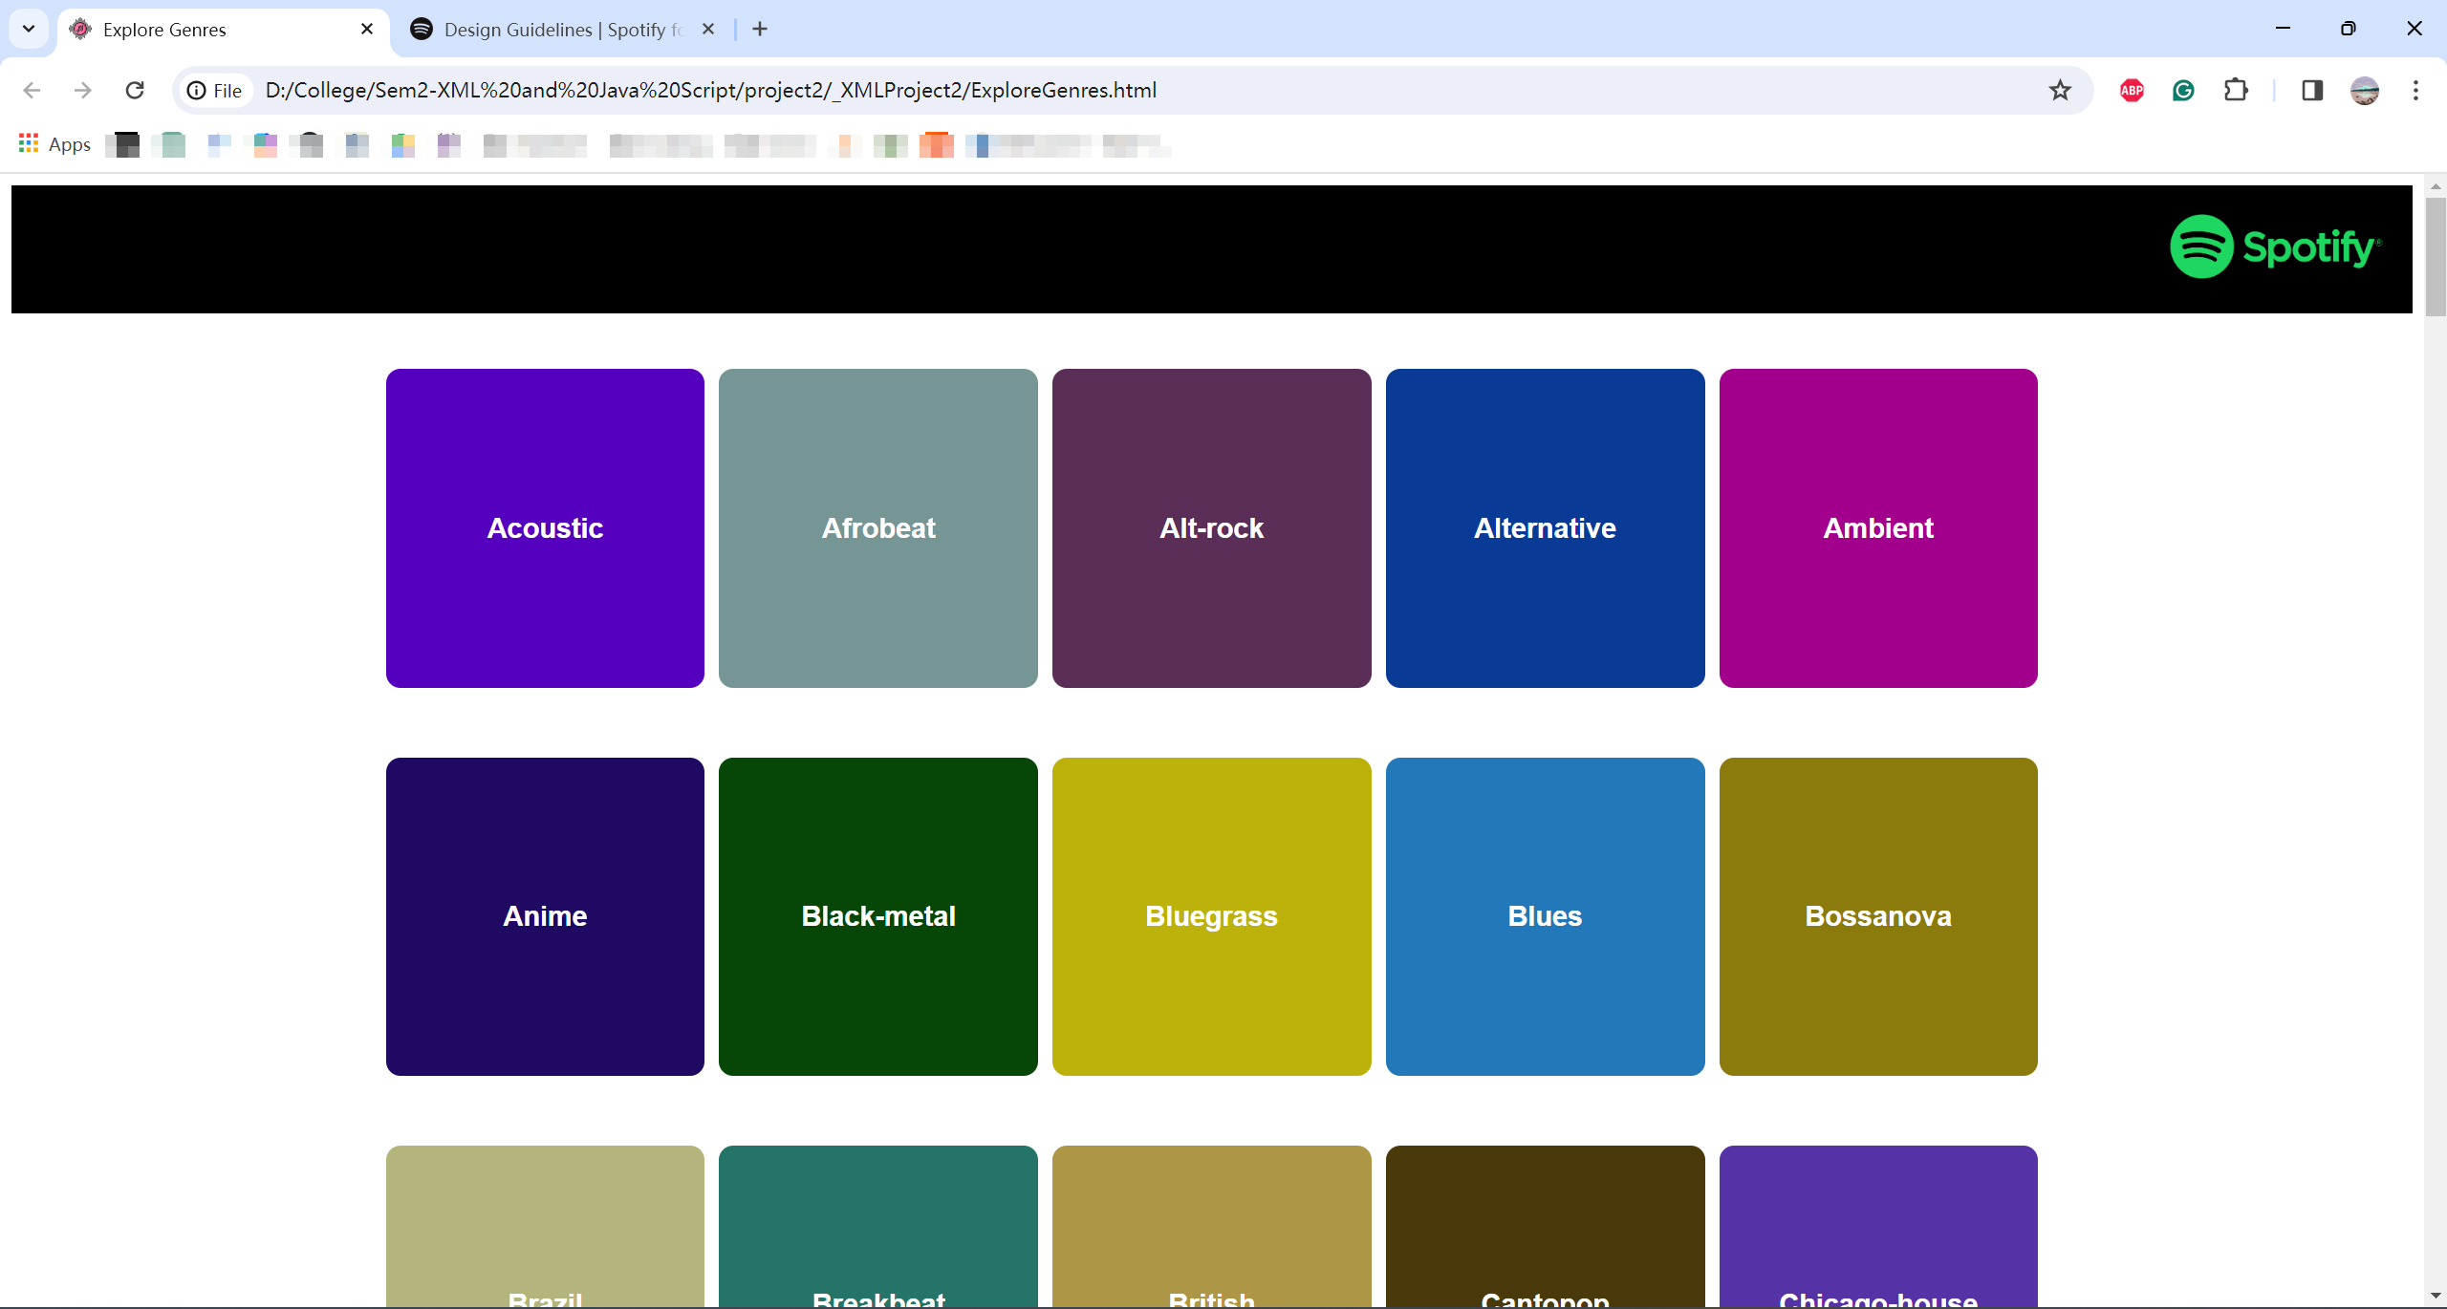

# Phase 2

## Step 1 Update your code and a checkbox “Show Playlist” to show the playlists.

When check the checkbox, show playlists of all genres.

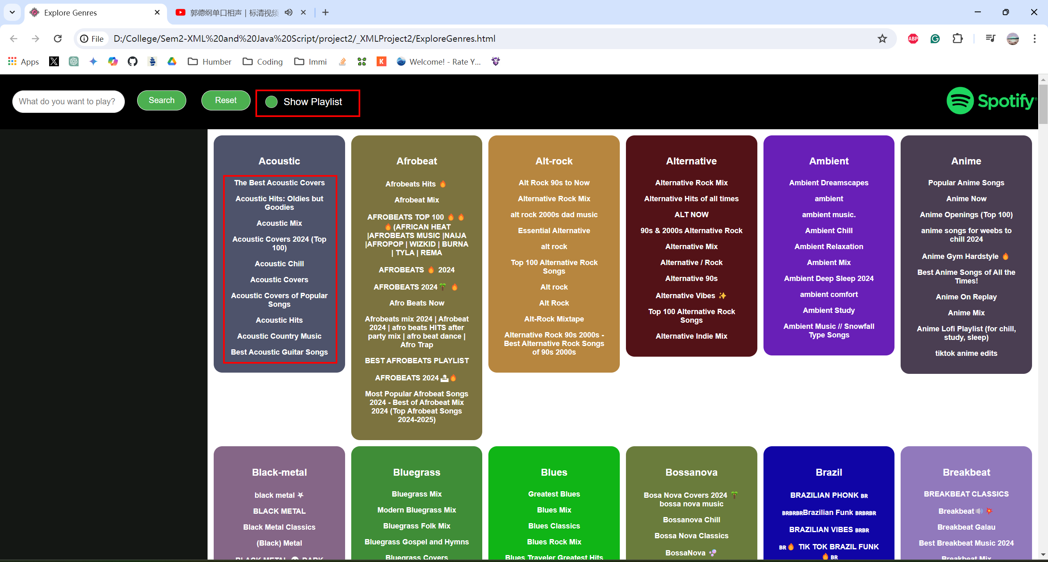

When uncheck the checkbox, hide all playlists.

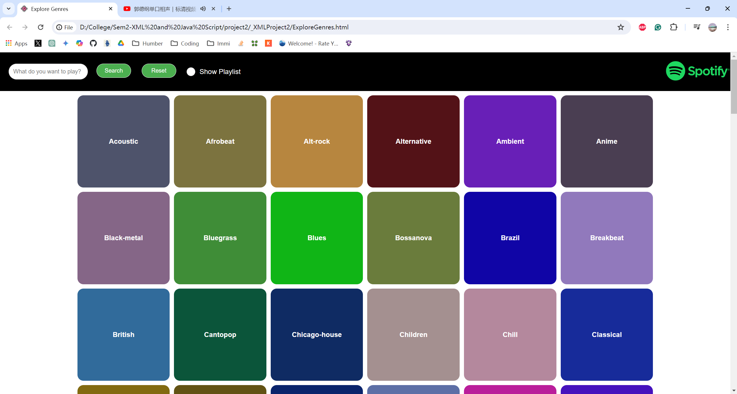

## Step 2 Update your code to show tracks for each playlist

When click a playlist, show all the tracks of that playlist.

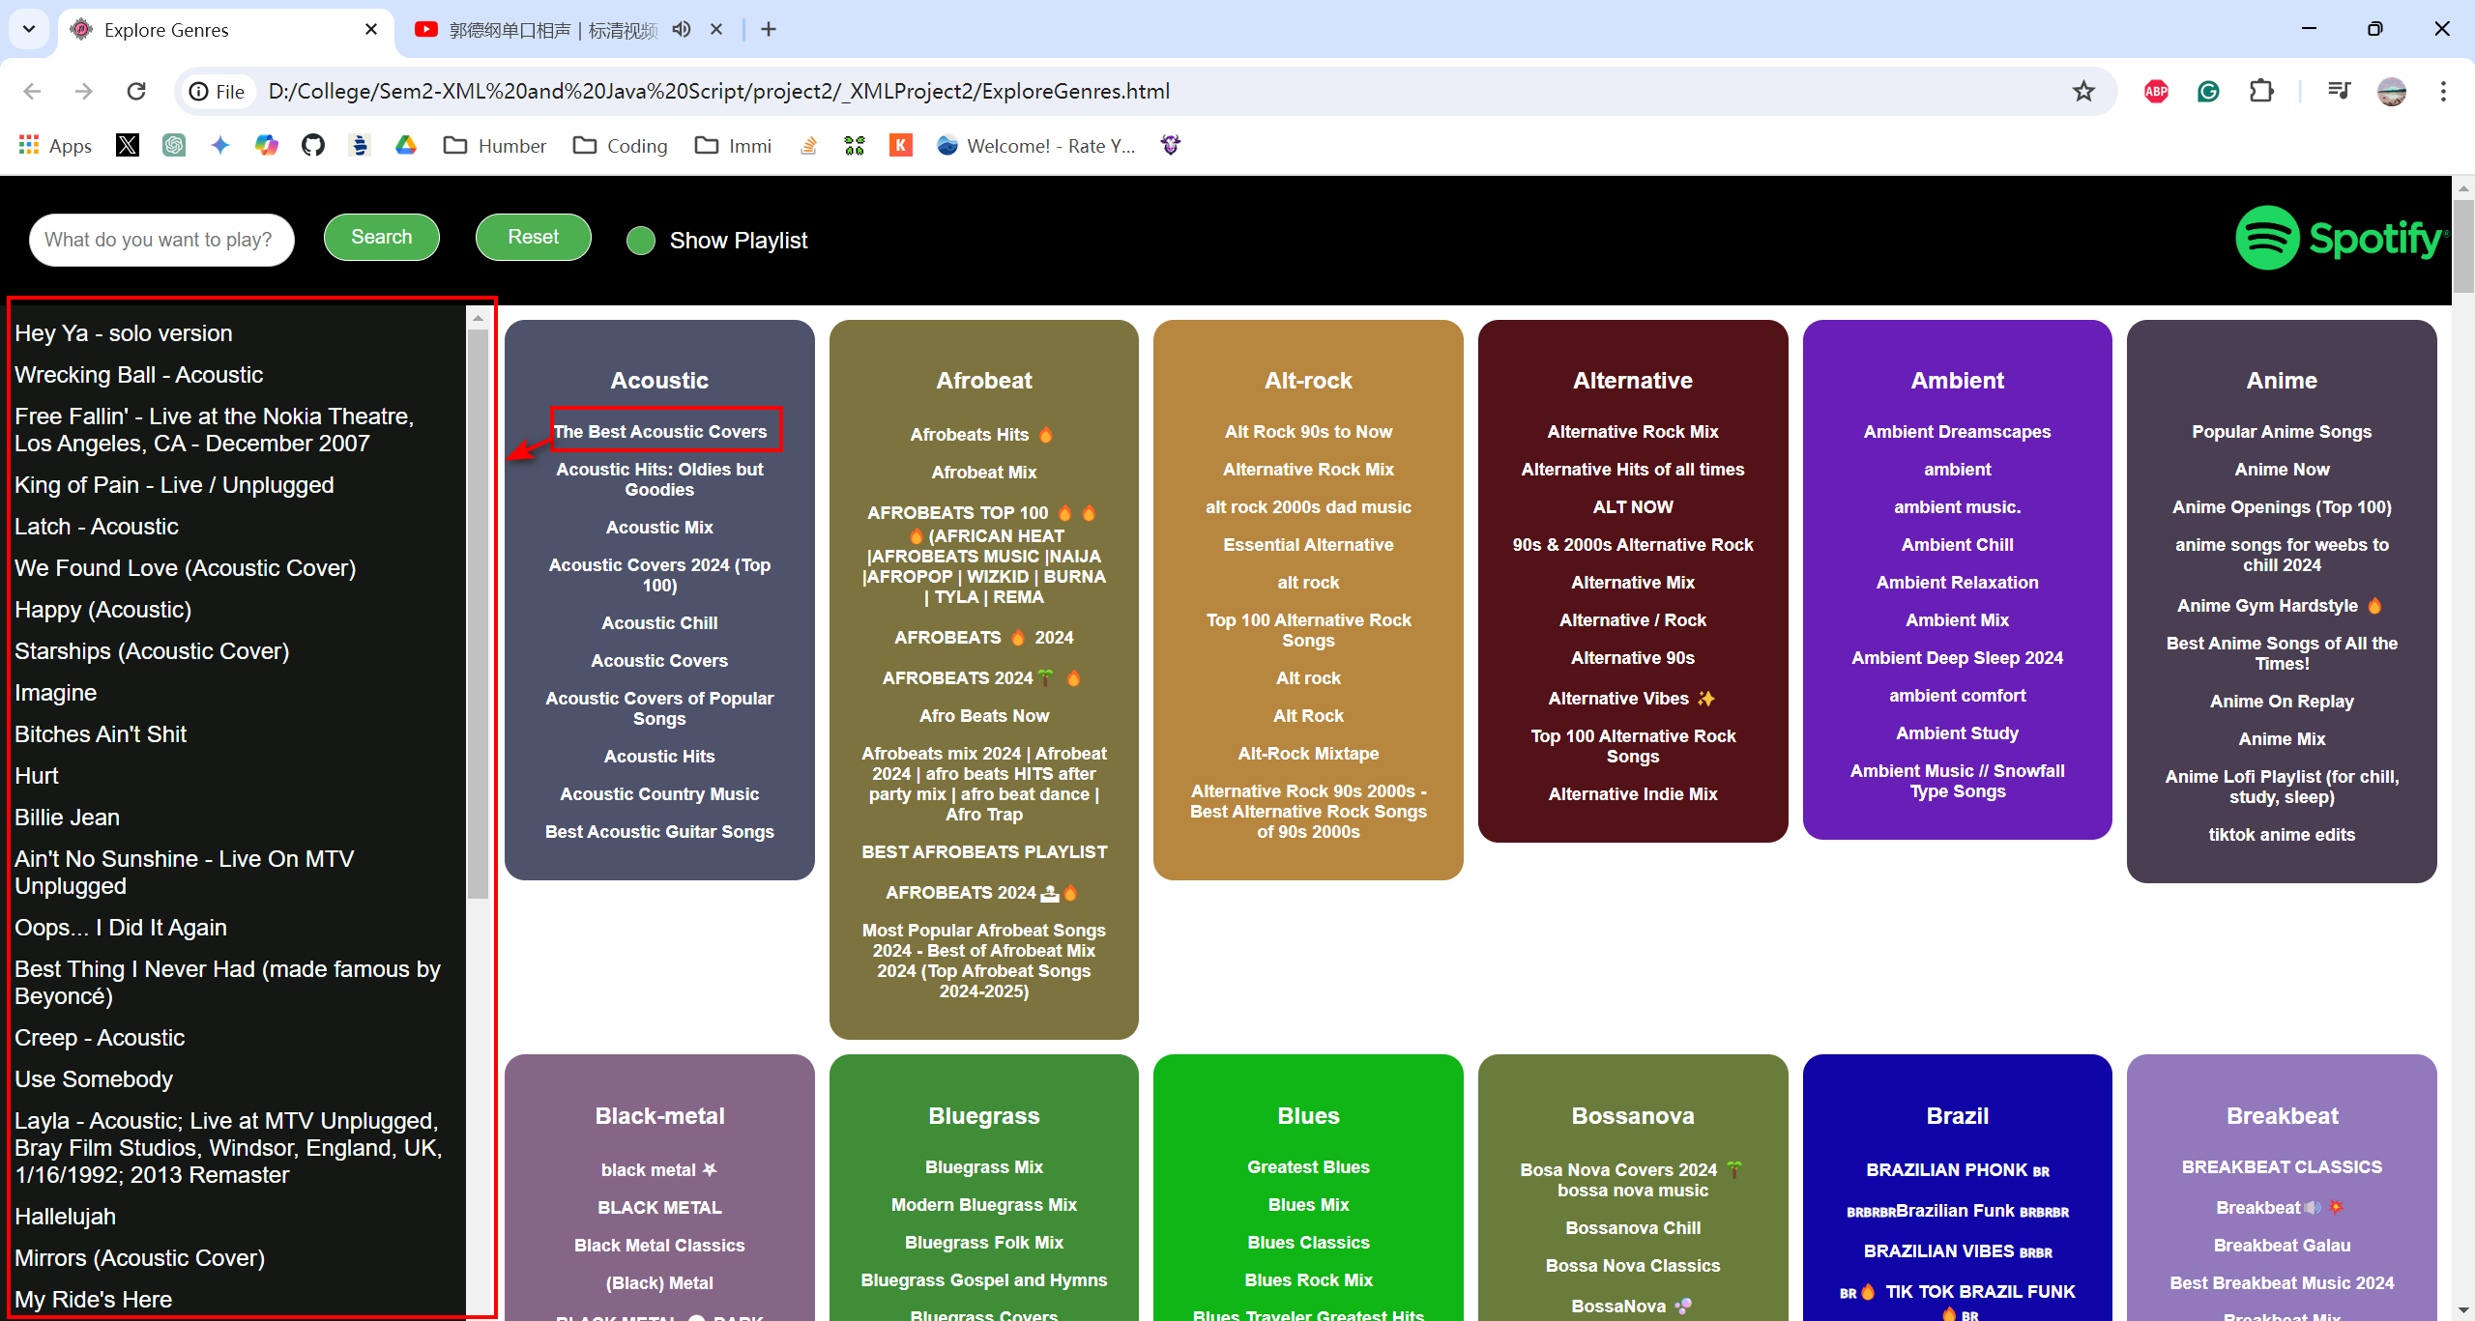

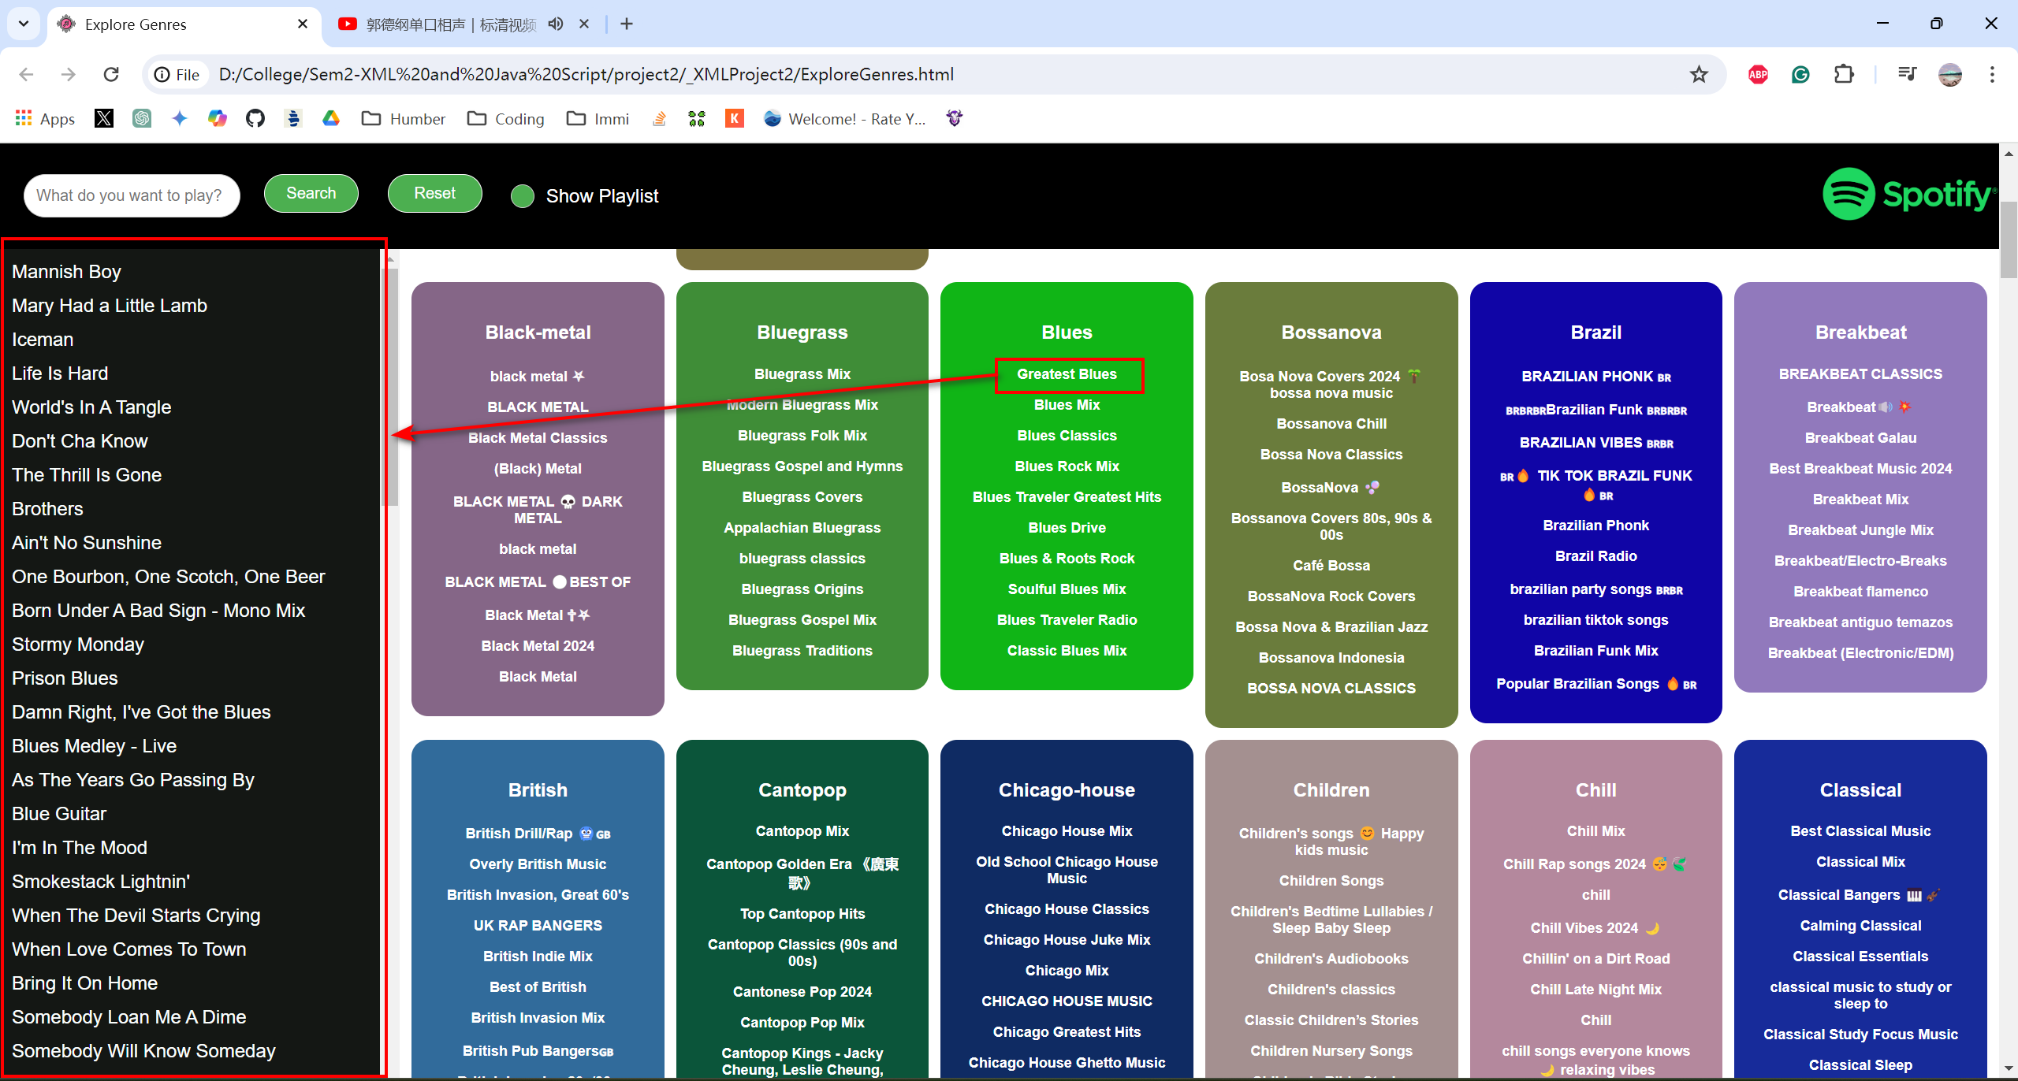

## Step 3 Add a Search input bar and a Search button

The search is partial and case insensitive.

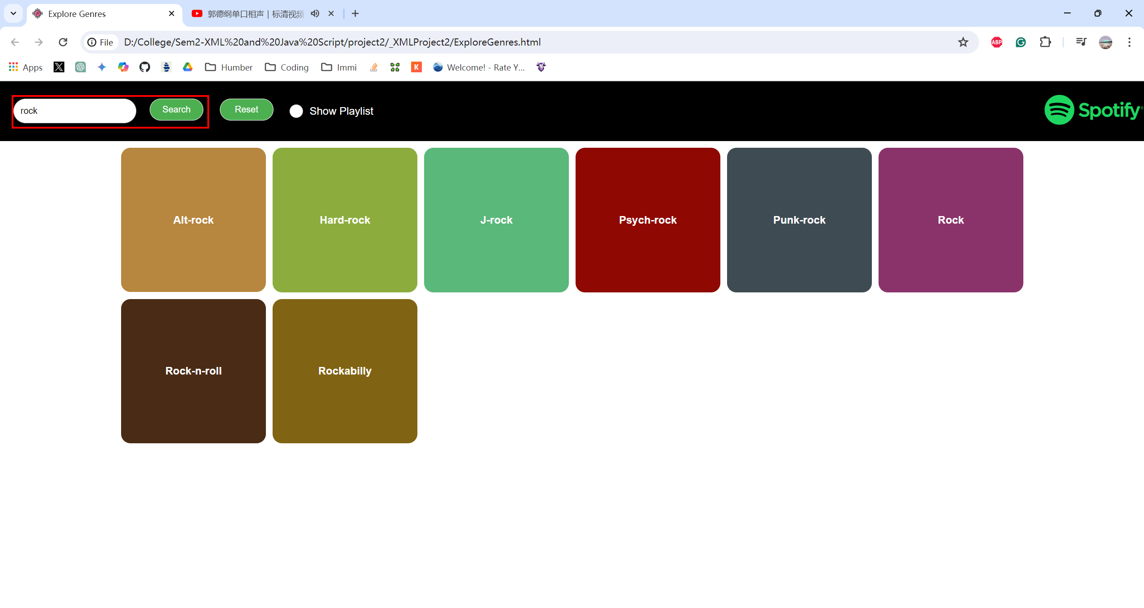

And could search when showing playlist.

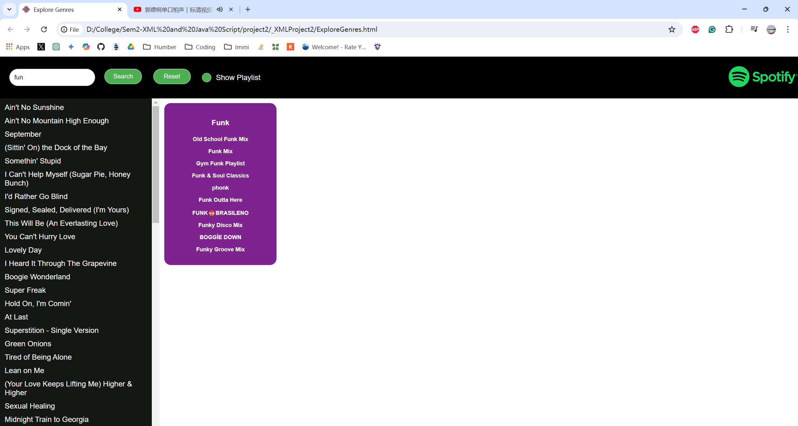

## Step 4 Add a “Reset” button

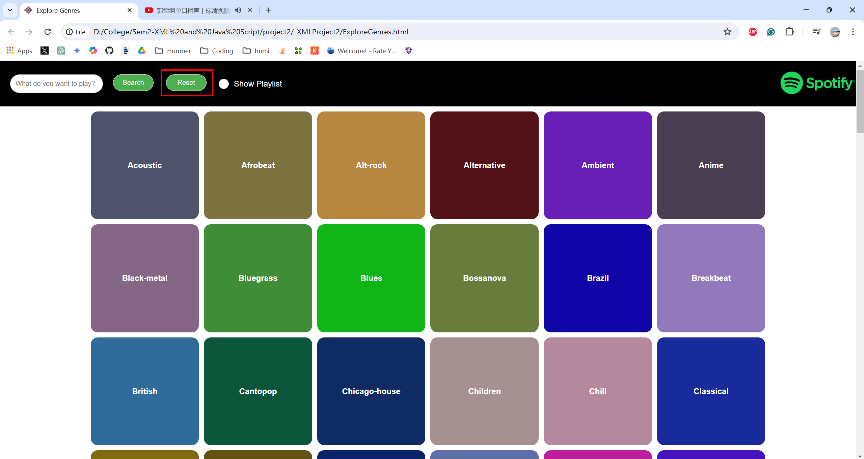

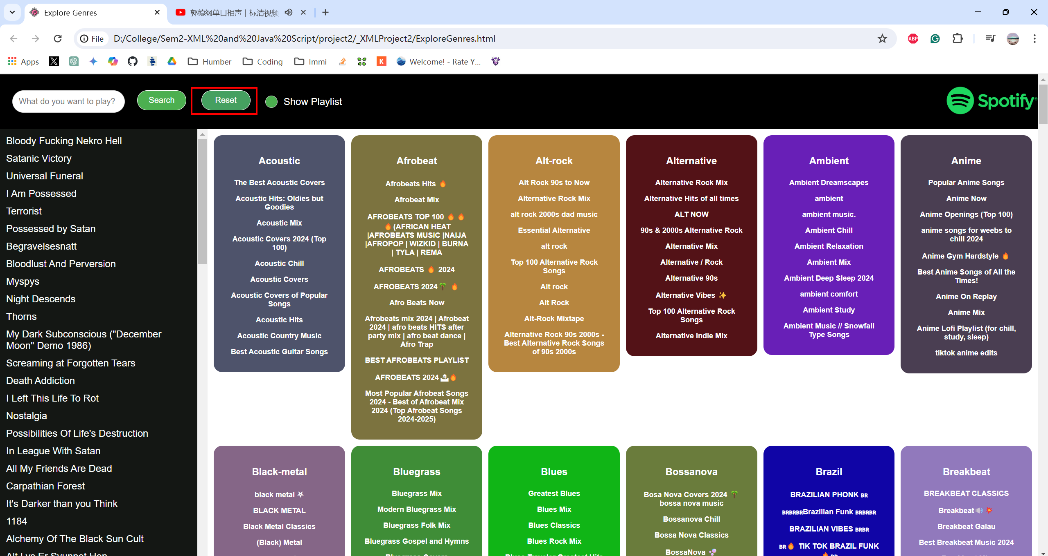

## Step 5 Add appropriate styling

Please refer to the website.

