# JavascriptBonusQuiz

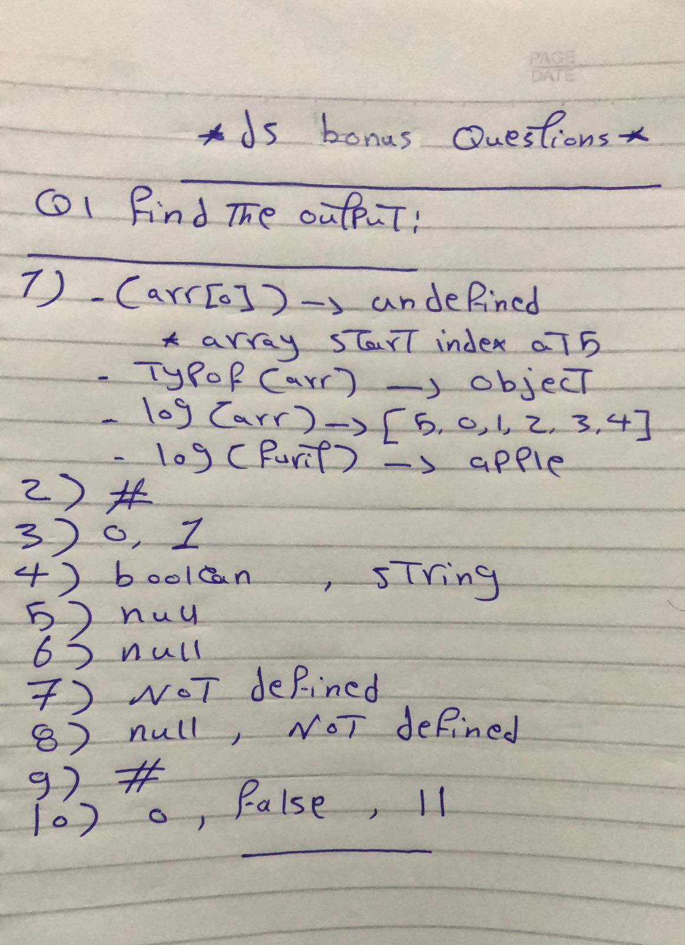

## Q2

1. Reverse String For Example => Welcome => emocleW

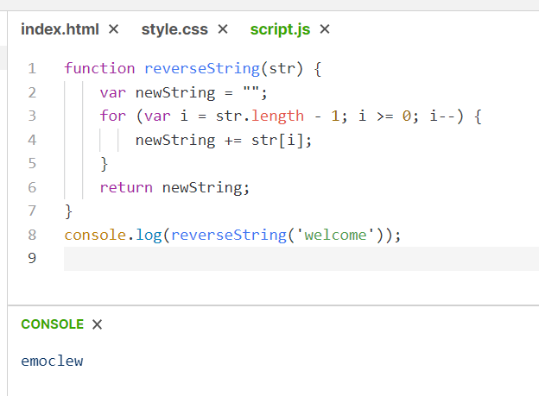

1. FizzBuzz Game

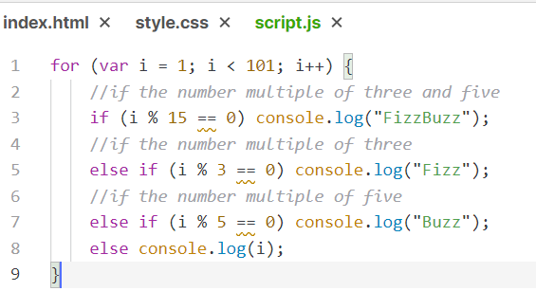

1. Using Recursion Compute The Factorial Of 5

