# JsBasicsExam

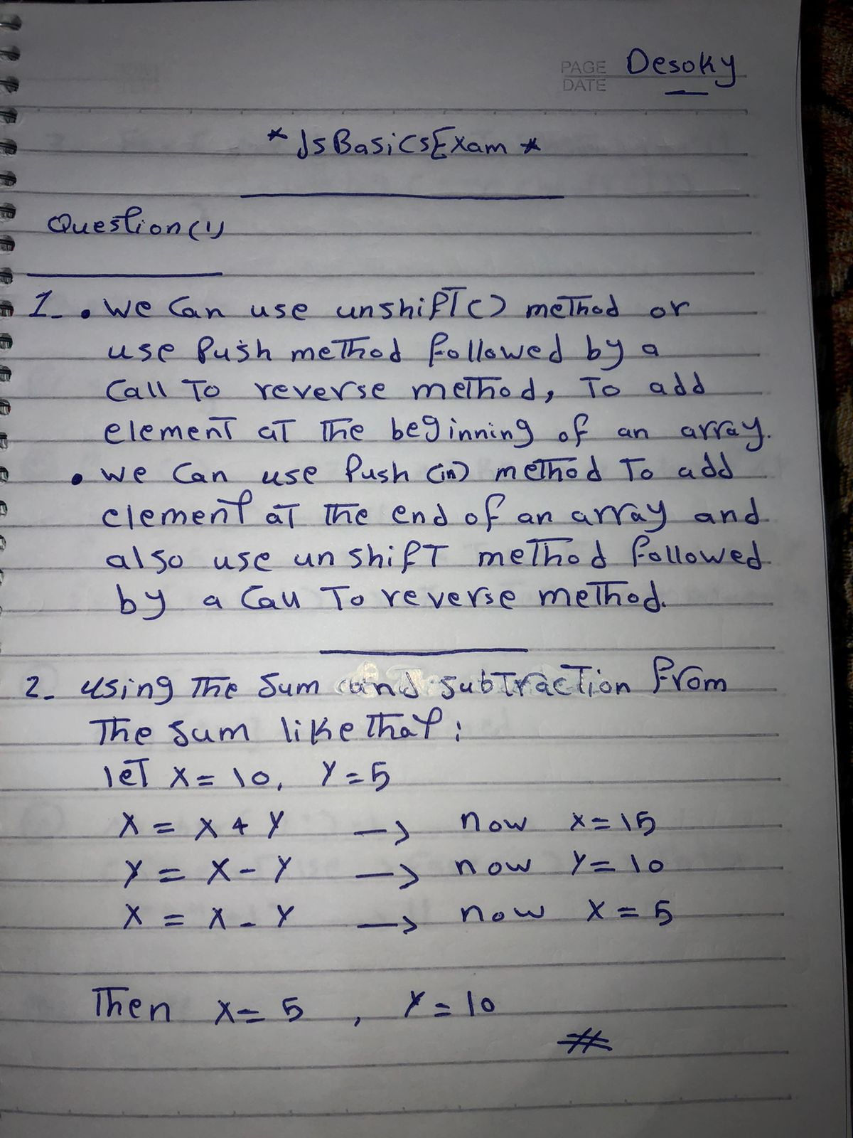

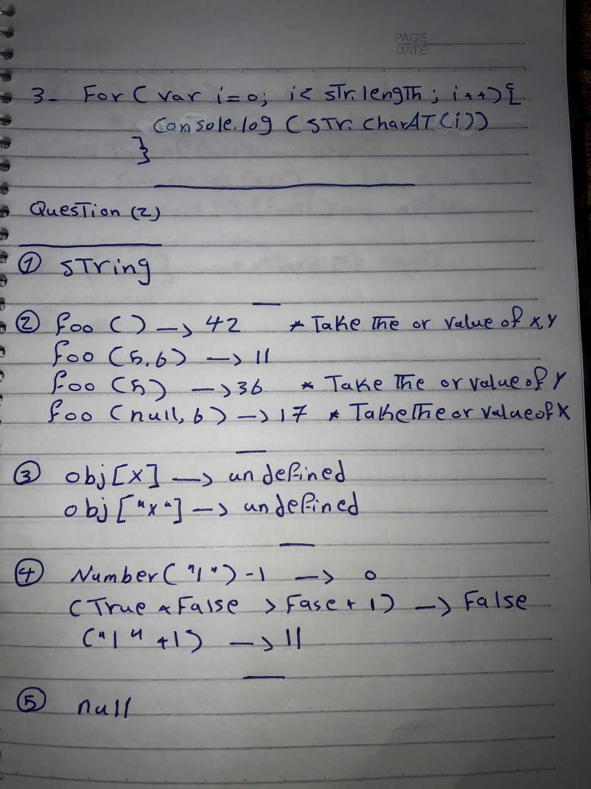

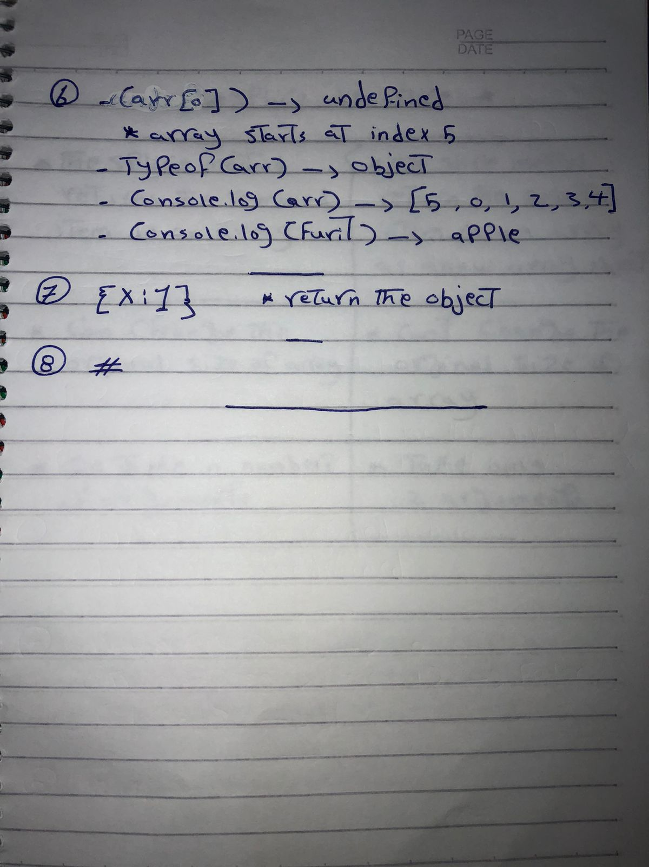

## Question ( 3 ) :

1. Write a program to append and prepend, single or multiple

values in to an array

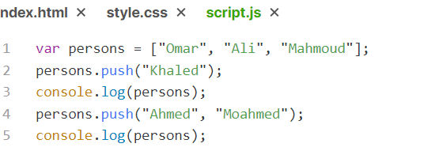

1. Write a function that converts an object into an array, where

each element represents a key-value pair in the form of an

array.

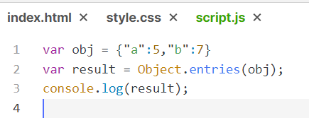

1. JS Calculator interface HTML Code

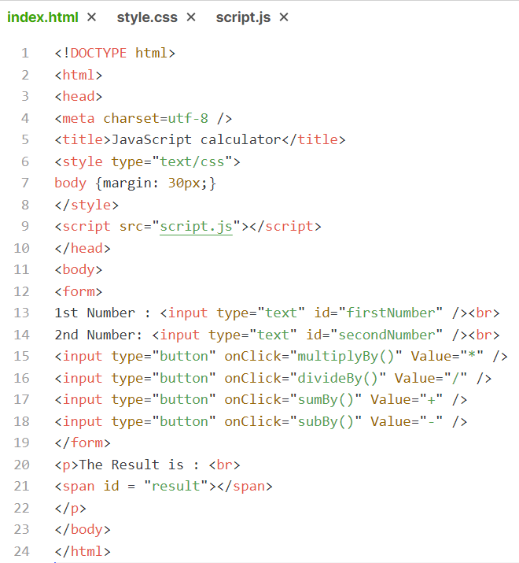

3- JS Code

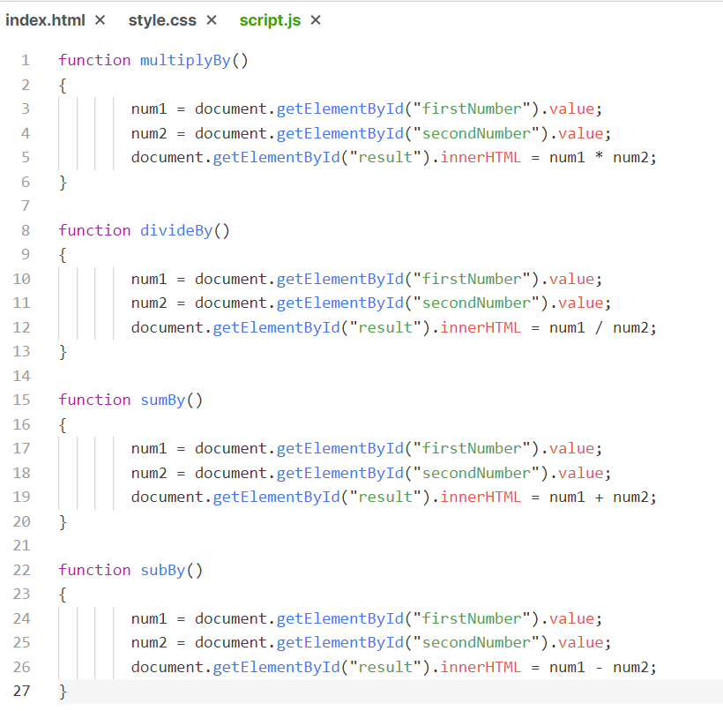

3- Output

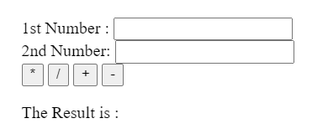

1. Get the Minimum value from a numbers array along with its

index

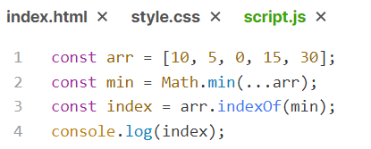

1. Compute The Factorial Of 5

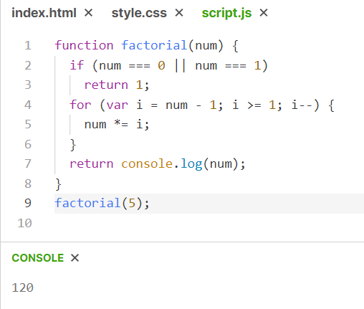

1. Write a function which can return multiple values from a

function

