# JsSampleExam

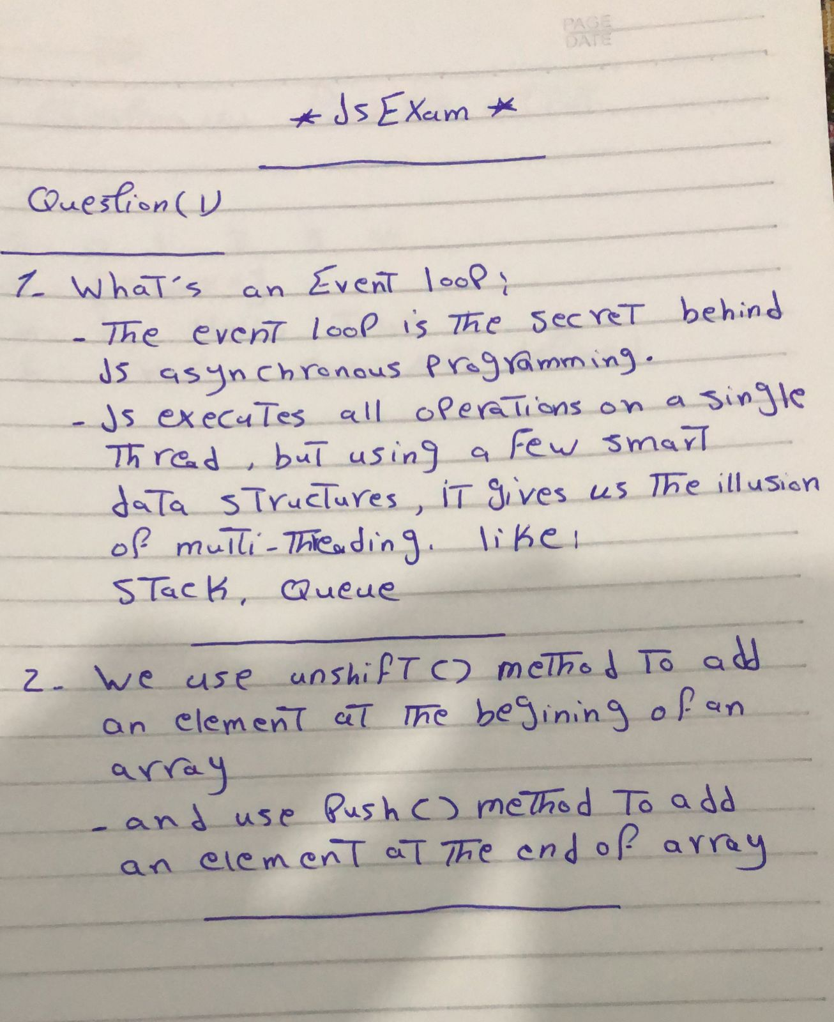

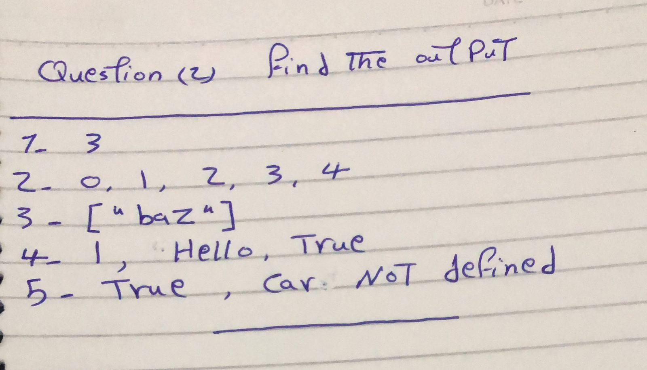

## Questions ( 3 ) :

1. Create Function sumObjectValues() that will sum all values of

the fields that contain numbers

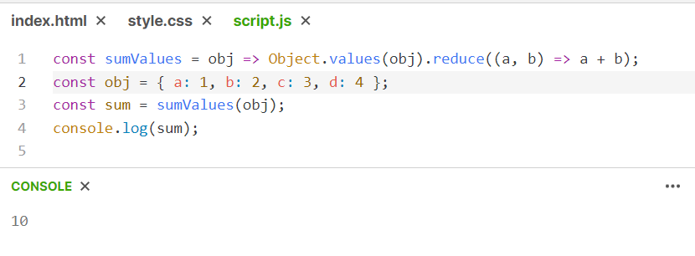

1. Show the execution of 3 asynchronous block of code, one after

the other in sequence

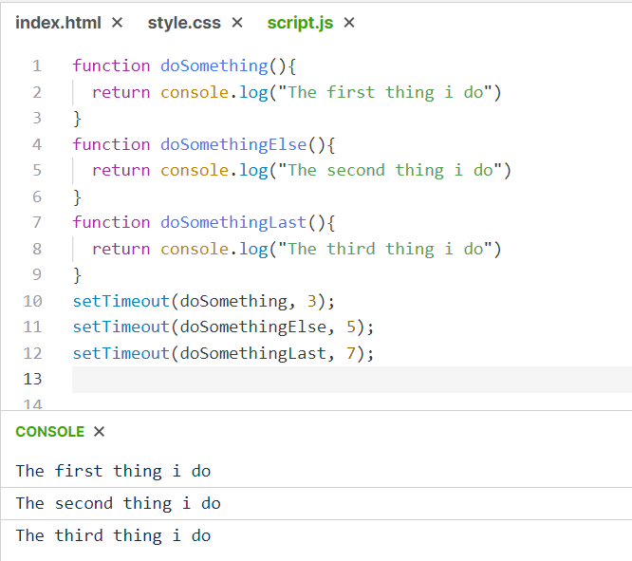

1. Get the maximum value from a numbers array along with its index

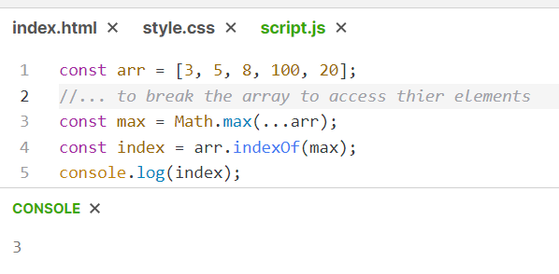

1. Write a function which accepts two valid dates and returns the

difference between them as number of days

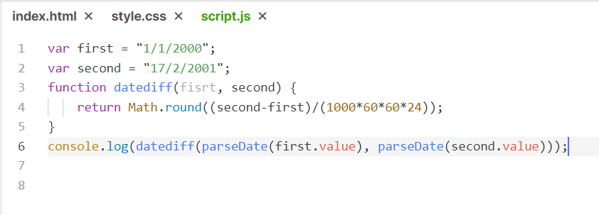

1. Design a Calulator interface

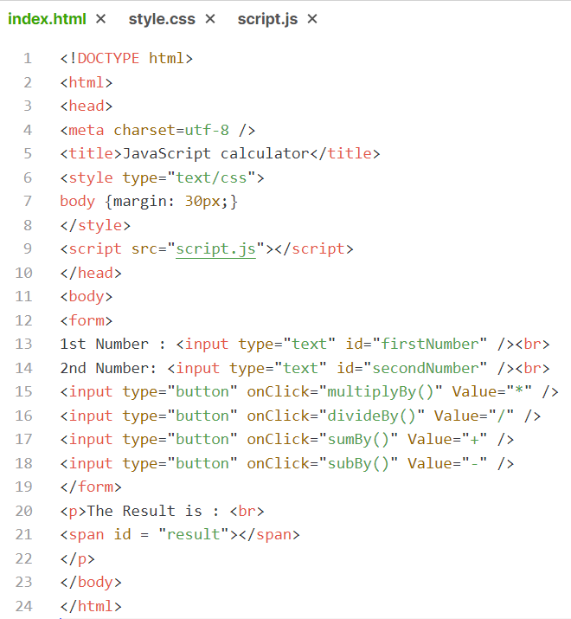

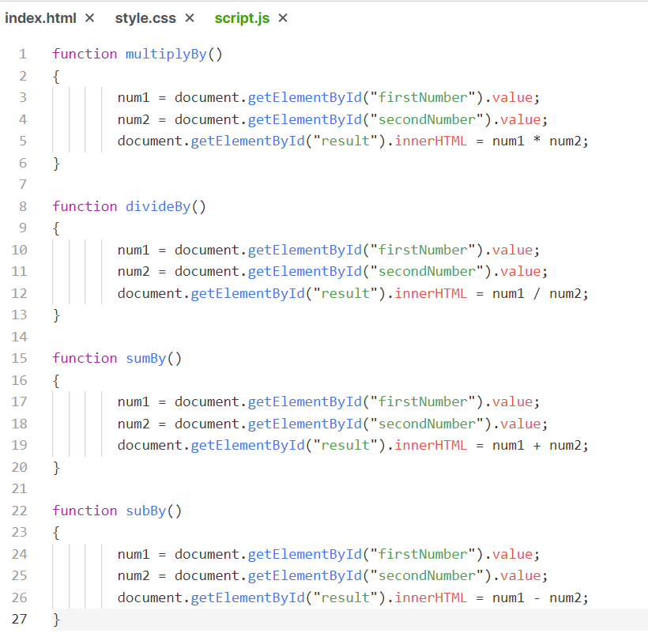

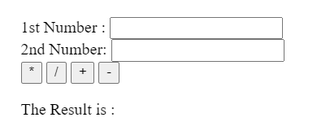

1. Write a function which can return multiple values from a function

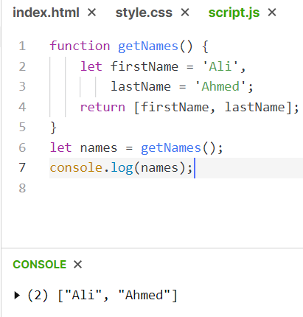

1. Write a function to reverse an array.

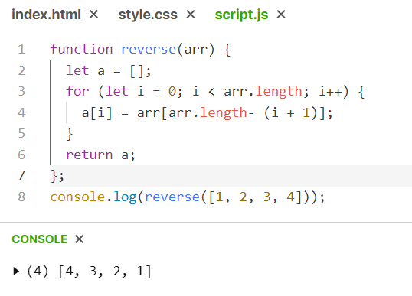

1. Write a function that converts an object into an array, where each

element represents a key-value pair in the form of an array.

