数据结构课程设计报告
（2019-2020第一学期）

姓 名 陈楚燚
学 号 161830218

任课教师 黄元元

南京航空航天大学
2020年 1月 1日

目录
一、 学生成绩管理 1
1. 任务简述 1
2. 算法描述 1
3. 源代码 1
二、 算术表达式求值 15
三、 字符串 20
四、 Huffman编码 21
五、 最小生成树 21
六、 关键路径问题 22
七、 最短路径问题 22

学生成绩管理

- 任务简述
要求使用带头的双向链式线性表。每个结点存储的信息包括姓名、学号、成绩，并按照 姓名升序排序；另外，将成绩不及格的学生单独存成一个链表。设计操作界面的菜单项， 包括：创建链表、显示信息、查询记录、插入记录、删除记录、输入补考成绩。
- 算法描述
利用A链表存储所有学生成绩，B链表存储所有不及格学生成绩。
创建链表：从文件中读取数据，然后判断成绩是否及格，并通过插入法存入相对应链表。
显示信息：遍历AB链表，打印信息
查询记录：遍历AB链表，找到符合name的结点输出
插入记录：获取用户输入，根据成绩遍历A或B链表，并找到相关位置，判断是否有重复结点，然后插入
删除记录：遍历AB链表，寻找名字符合输入的结点，询问用户是否删除
输入补考成绩：获取用户输入，遍历B表，找到结点更新成绩，如果及格将其转移到A表
- 源代码
- #include <cstdio>
- #include <cstdlib>
- #include <cstring>
- #include <iostream>
- #include <fstream>
- #include <string>
- #include <sstream>

- using namespace std;
- char sbuf[1024]; //存储缓冲区输入

- typedef struct student
- {
- char name[20];
- char number[20];
- int score;
- struct student* next;
- struct student* pre;
- }ST;

- int menu_select();
- void CreateST(ST* A, ST* B);
- void Print(ST* A, ST *B);
- void Search(ST* A, ST *B);
- void Insert(ST* A, ST* B);
- void Delete(ST* A, ST* B);
- void Retest(ST* A, ST* B);
- void close(ST* A, ST *B);

- int menu_select()
- {
- char i;
- do {
- system("cls");
- printf("1.创建纪录（从文件读入）\n");
- printf("2.显示所有记录\n");
- printf("3.插入一条记录\n");
- printf("4.删除一条记录\n");
- printf("5.输入补考成绩\n");
- printf("6.查询\n");
- printf("0.退出\n");
- printf("请输入选择序号(0-6):");
- i = getchar();
- } while (i<'0' || i>'6');
- return (i - '0');
- }

- void CreateST(ST* A, ST *B)
- {
- A->next = NULL;
- B->next = NULL;
- ifstream infile;
- ST* t, * p, * p1;
- infile.open("01.txt");
- if (!infile)
- {
- cout << "error" << endl;
- system("pause");
- exit(0);
- }
- while (!infile.eof())
- {
- if (infile.fail()) break;
- char score[3], name[20], number[20];
- stringstream ss;
- t = (ST *)malloc(sizeof(ST));
- infile >> name;
- infile >> score;
- infile >> number;
- memcpy(t->name, name, 20);
- memcpy(t->number, number, 20);
- ss << score; //利用流将字符串转为数字
- ss >> t->score;
- if (t->score >= 60) p = A;
- else p = B;
- while (p->next != NULL)
- {
- if (strcmp(t->name, p->next->name) < 0)
- {
- break;
- }
- else if (strcmp(t->name, p->next->name) == 0)
- {
- if (t->score < p->next->score)
- {
- break;
- }
- else if (t->score == p->next->score)
- {
- if (strcmp(t->number, p->number) < 0)
- {
- break;
- }
- }

- }
- p = p->next;
- }
- if (p->next == NULL)
- {
- p->next = t;
- t->pre = p;
- t->next = NULL;
- }
- else
- {
- p1 = p->next;
- p->next = t;
- t->pre = p;
- t->next = p1;
- p1->pre = t;
- }

- //cout << t->name << " " << t->score<<" "<<t->number<<endl;
- }
- infile.close();

- cout << "创建成功" << endl;
- return;
- }

- void Print(ST* A, ST* B)
- {
- int cnt = 0;
- ST* p1 = A->next, * p2 = B->next;
- if (p1 == NULL && p2 == NULL)
- {
- cout << "数据为空" << endl;
- return;
- }
- printf("%8s\t%20s\t%8s\t%20s\n","序号","姓名","成绩","学号");
- while (p1!= NULL)
- {
- cnt++;
- printf("%8d\t%20s\t%8d\t%20s\n", cnt, p1->name, p1->score, p1->number);
- p1 = p1->next;
- if (cnt % 10 == 0) system("pause");
- }
- while (p2 != NULL)
- {
- cnt++;
- printf("%8d\t%20s\t%8d\t%20s\n", cnt, p2->name, p2->score, p2->number);
- p2 = p2->next;
- if (cnt % 10 == 0) system("pause");
- }
- }

- void Search(ST* A, ST* B)
- {
- char name[20];
- fgets(sbuf, 1024, stdin); //清除输入流缓冲区
- cout << "请输入待查找的学生姓名：" << endl;
- cin.getline(name, 20);
- int cnt = 0;
- ST* p1 = A->next, * p2 = B->next;
- if (p1 == NULL && p2 == NULL)
- {
- cout << "数据为空" << endl;
- return;
- }
- while (p1 != NULL)
- {
- if (strcmp(name, p1->name) == 0)
- {
- cnt++;
- if (cnt == 1)
- {
- printf("%8s\t%20s\t%8s\t%20s\n", "序号", "姓名", "成绩", "学号");
- }
- printf("%8d\t%20s\t%8d\t%20s\n", cnt, p1->name, p1->score, p1->number);
- if (cnt % 10 == 0) system("pause");
- }
- p1 = p1->next;
- }
- while (p2 != NULL)
- {
- if (strcmp(name, p2->name) == 0)
- {
- cnt++;
- if (cnt == 1)
- {
- printf("%8s\t%20s\t%8s\t%20s\n", "序号", "姓名", "成绩", "学号");
- }
- printf("%8d\t%20s\t%8d\t%20s\n", cnt, p2->name, p2->score, p2->number);
- if (cnt % 10 == 0) system("pause");
- }
- p2 = p2->next;
- }

- if (!cnt)
- cout << "未找到此人" << endl;
- }

- void Insert(ST* A, ST* B)
- {
- fgets(sbuf, 1024, stdin); //清除输入流缓冲区
- char name[20], score1[20], number[20];
- int score;
- bool flag = 0;

- //输入姓名
- cout << "请输入学生姓名：" << endl;
- cin.getline(name,20);

- //输入成绩
- while (1)
- {
- flag = 0;
- cout << "请输入学生成绩：" << endl;
- cin.getline(score1, 20);
- for (int i = 0; i < strlen(score1); i++)
- {
- if (score1[i] > '9' && score1[i] < '0')
- {
- flag = 1;
- break;
- }
- }
- if (flag == 0)
- {
- stringstream ss;
- ss << score1; //利用流重新以整型存储
- ss >> score;
- if (score <= 100 && score >= 0) break;
- }
- cout << "格式错误，应为不超过100的自然数" << endl;
- }

- //输入学号
- while (1)
- {
- flag = 0;
- cout << "请输入学生学号：" << endl;
- cin.getline(number, 20);
- if (strlen(number) != 9)
- {
- cout << "格式错误" << endl;
- continue;
- }
- for (int i = 0; i < strlen(number); i++)
- {
- if (number[i] > '9' && number[i] < '0')
- {
- flag = 1;
- break;
- }
- }
- if (flag == 0) break;
- cout << "格式错误，应为9位数字" << endl;
- }

- //插入
- ST* p1, * p;
- p1 = A, p = A->next;
- while (p != NULL)
- {
- if (strcmp(number, p->number) == 0)
- {
- //判断是否相同学号
- cout << "插入失败,有相同学号信息" << endl;
- return;
- }
- p1 = p;
- p = p->next;
- }

- p1 = B, p = B->next;
- while (p != NULL)
- {
- if (strcmp(number, p->number) == 0)
- {
- //判断是否相同学号
- cout << "插入失败,有相同学号信息" << endl;
- return;
- }
- p1 = p;
- p = p->next;
- }

- char c[20];
- cout << "可插入，是否插入(y/n)" << endl;
- cin.getline(c, 20);
- if (c[0] == 'y' || c[0]=='Y')
- {
- ST* t = (ST*)malloc(sizeof(ST));
- memcpy(t->name, name, 20);
- memcpy(t->number, number, 20);
- t->score = score;
- if (score >= 60)
- p = A;
- else
- p = B;
- while (p->next != NULL)
- {
- if (strcmp(t->name, p->next->name) < 0)
- {
- break;
- }
- else if (strcmp(t->name, p->next->name) == 0)
- {
- if (t->score < p->next->score)
- {
- break;
- }
- else if (t->score == p->next->score)
- {
- if (strcmp(t->number, p->number) < 0)
- {
- break;
- }
- }

- }
- p = p->next;
- }
- p1 = p->next;
- p->next = t;
- t->pre = p;
- t->next = p1;
- if (p1 != NULL)
- {
- p1->pre = t;
- }
- cout << "插入成功" << endl;
- }
- else
- {
- return;
- }
- }

- void Delete(ST* A, ST* B)
- {
- bool flag = 0;
- char name[20], ch[20];
- fgets(sbuf, 1024, stdin); //清除输入流缓冲区
- cout << "请输入待删除的学生姓名：" << endl;
- cin.getline(name, 20);
- ST* p = A->next, * p1 = A;
- ST* pB = B->next, * p2 = B;

- if (p == NULL && pB == NULL)
- {
- cout << "数据为空" << endl;
- return;
- }
- while (p != NULL)
- {
- if (strcmp(name, p->name) == 0)
- {
- flag = 1;
- cout << p->name << " " << p->score << " " << p->number << endl;
- cout << "此条信息是否要删除？(y/n)" << endl;
- cin.getline(ch, 20);
- if (ch[0] == 'y' || ch[0] == 'Y')
- {
- p1->next = p->next;
- if(p->next != NULL)
- p->next->pre = p1;
- free(p);
- p = p1;
- }
- }
- p1 = p;
- p = p->next;
- }

- while (pB != NULL)
- {
- if (strcmp(name, pB->name) == 0)
- {
- flag = 1;
- cout << pB->name << " " << pB->score << " " << pB->number << endl;
- cout << "此条信息是否要删除？(y/n)" << endl;
- cin.getline(ch, 20);
- if (ch[0] == 'y' || ch[0] == 'Y')
- {
- p2->next = pB->next;
- if(pB->next != NULL)
- pB->next->pre = p2;
- free(pB);
- pB = p2;
- }
- }
- p2 = pB;
- pB = pB->next;
- }
- if (!flag)
- cout << "未找到此人" << endl;
- }

- void Retest(ST* A, ST* B)
- {
- fgets(sbuf, 1024, stdin); //清除输入流缓冲区
- char name[20], score1[20], number[20];
- int score;
- bool flag = 0;

- //输入姓名
- cout << "请输入补考学生姓名：" << endl;
- cin.getline(name, 20);

- //输入成绩
- while (1)
- {
- flag = 0;
- cout << "请输入补考学生成绩：" << endl;
- cin.getline(score1, 20);
- for (int i = 0; i < strlen(score1); i++)
- {
- if (score1[i] > '9' && score1[i] < '0')
- {
- flag = 1;
- break;
- }
- }
- if (flag == 0)
- {
- stringstream ss;
- ss << score1; //利用流重新以整型存储
- ss >> score;
- if (score <= 100 && score >= 0) break;
- }
- cout << "格式错误，应为不超过100的自然数" << endl;
- }

- //输入学号
- while (1)
- {
- flag = 0;
- cout << "请输入补考学生学号：" << endl;
- cin.getline(number, 20);
- if (strlen(number) != 9)
- {
- cout << "格式错误" << endl;
- continue;
- }
- for (int i = 0; i < strlen(number); i++)
- {
- if (number[i] > '9' && number[i] < '0')
- {
- flag = 1;
- break;
- }
- }
- if (flag == 0) break;
- cout << "格式错误，应为9位数字" << endl;
- }

- ST* pa, * pb, * t;

- //进行查找
- flag = 0;
- pb = B->next;
- while (pb != NULL)
- {
- if (strcmp(pb->name, name) == 0 && strcmp(pb->number, number) == 0)
- {
- flag = 1;
- break;
- }
- pb = pb->next;
- }
- t = pb;
- t->score = score;
- //更改操作
- if (flag)
- {
- //补考通过需删除其信息
- if (score >= 60)
- {
- ST* pb1;
- pb1 = pb->pre;
- pb1->next = pb->next;
- if (pb->next != NULL)
- pb->next->pre = pb1;
- //对A链进行更改
- pa = A;
- while (pa->next != NULL)
- {
- if (strcmp(t->name, pa->next->name) < 0)
- {
- break;
- }
- else if (strcmp(t->name, pa->next->name) == 0)
- {
- if (t->score < pa->next->score)
- {
- break;
- }
- else if (t->score == pa->next->score)
- {
- if (strcmp(t->number, pa->number) < 0)
- {
- break;
- }
- }

- }
- pa = pa->next;
- }
- ST* p1 = pa->next;
- pa->next = t;
- t->pre = pa;
- t->next = p1;
- if (p1 != NULL)
- {
- p1->pre = t;
- }
- }
- cout << "修改成功" << endl;
- }
- else
- {
- cout << "未在需补考人员中找到此人" << endl;
- return;
- }
- }

- void close(ST* A, ST* B)
- {
- //对操作进行存储
- ST* p = A->next, * p2 = B->next;
- ofstream outfile;
- outfile.open("01.txt");
- while (p->next != NULL)
- {
- outfile << p->name << " " << p->score << " " << p->number << endl;
- p = p->next;
- }
- outfile << p->name << " " << p->score << " " << p->number;
- if (p2 != NULL)
- outfile << endl;
- while (p2->next != NULL)
- {
- outfile << p2->name << " " << p2->score << " " << p2->number << endl;
- p2 = p2->next;
- }
- outfile << p2->name << " " << p2->score << " " << p2->number;
- free(A);
- free(B);
- outfile.close();
- }

- int main()
- {
- ST* A, * B;
- A = (ST*)malloc(sizeof(ST));
- B = (ST*)malloc(sizeof(ST));
- A->next = B->next = NULL;
- for (;;)
- {
- switch (menu_select())
- {
- case 1:
- printf("调用创建链表函数\n");
- CreateST(A, B);
- system("pause");
- break;
- case 2:
- printf("调用显示函数\n");
- Print(A, B);
- system("pause");
- break;
- case 3:
- printf("调用插入函数\n");
- Insert(A, B);
- system("pause");
- break;
- case 4:
- printf("调用删除函数 :\n");
- Delete(A, B);
- system("pause");
- break;
- case 5:
- printf("调用输入补考成绩函数:\n");
- Retest(A, B);
- system("pause");
- break;
- case 6:
- printf("调用查找函数 :\n");
- Search(A, B);
- system("pause");
- break;
- case 0:
- printf("再见\n");
- close(A, B);
- system("pause");
- exit(0);

- }
- }
- return 0;
- }

- 结果分析
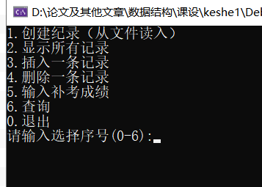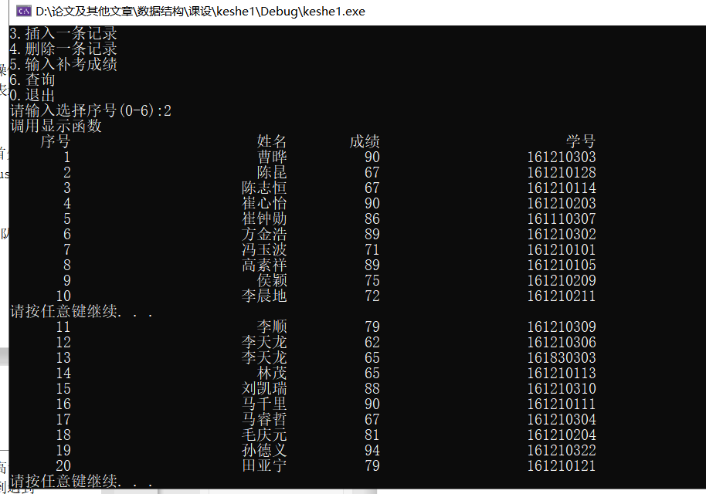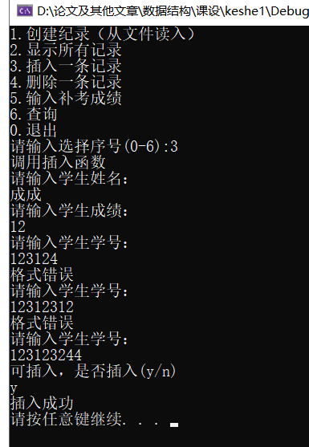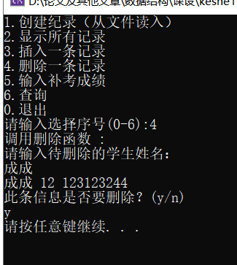
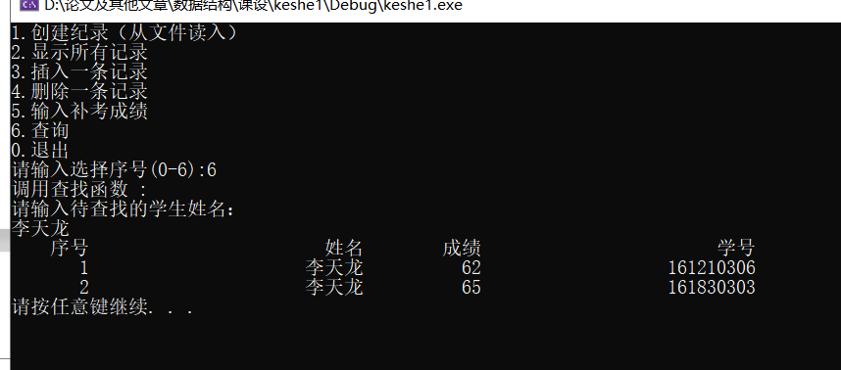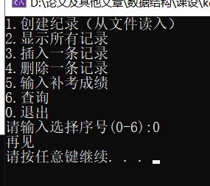
- 总结
将单向链表转换成双向循环链表极大地加快了遍历链表的效率。在做合法性验证时，可将验证函数封装，减少代码重复率。

算术表达式求值
- 任务简述
一个算术表达式是由操作数(operand)、运算符(operator)和括号组成的。假设操作数 均是正实数，运算符只含加减乘除四种运算符。编程利用“算符优先法”求算术表达式 的值。
- 算法描述
先将算术表达式由中缀表达式转变为后缀表达式。其中转变的原理大致为，首先规定 ( 为最低级操作符，建立后缀表达式队列，遍历中缀表达式，遇到数字直接push进队列，若是运算符：
（1）该运算符是左括号 ( , 则直接存入操作符栈。
（2）该运算符是右括号 )，则将操作符栈中 ( 前的所有运算符出栈，push进队列。
（3）若该运算符为非括号，则将该运算符和操作符栈顶运算符作比较：若高于栈顶运算符，则直接存入操作符栈，否则将栈顶运算符出栈 ( 从栈中弹出元素直到遇到发现更低优先级的元素(或者栈为空)为止），push进队列。
（4）当遍历完后，操作栈中还有运算符时，则将所有运算符出栈，push进队列。
再将后缀表达式进行计算，定义一个数字栈，遍历队列，遇到数字存入栈中，遇到操作符取出栈顶两个元素进行计算，将结果存入栈中，当遍历完后，数字栈中的唯一元素就是结果。
关于合法性检测：
- 非法数字：类似12.12.12，不符合现实数字规定
- 非法字符：除+-*/.0-9之外均为非法字符
- 表达式合法性：遵循这一规则即可，操作符数一定比操作数少1
- 源代码
- #include <cstdio>
- #include <iostream>
- #include <cstdlib>
- #include <string>
- #include <sstream>

- using namespace std;

- struct node1{
- double a[100];
- int top;
- };
- struct node2{
- char a[100];
- int top;
- };

- bool cmp(char a, char b)
- {
- if (a == '(') return 1;
- if (a == '+' || a == '-')
- {
- if (b == '+' || b == '-')
- {
- return 0;
- }
- else
- return 1;
- }
- else
- return 0;
- }

- int main()
- {
- node1 num; //操作数栈
- node2 ope; //操作符栈
- char ans[100][100];
- for (int i = 0; i < 100; i++)
- for (int j = 0; j < 100; j++)
- ans[i][j] = '\0';
- int anslen = -1;
- string test;
- int pos = 0;
- ope.top = -1;
- num.top = -1;
- cout << "请输入要计算的算式" << endl;
- cin >> test;
- for(int i=0;i<test.length()-1;i++)
- if (test[i] != '+' && test[i] != '-' && test[i] != '*' && test[i] != '/' && test[i] != '(' && test[i] != ')' && test[i] != '.' && (test[i] > '9' || test[i] < '0'))
- {
- cout << "格式出错" << endl;
- return main();
- }
- test.append("#"); //添加结尾标志
- bool flag = 0;
- int numcnt = 0;
- int optcnt = 0;
- while (1)
- {
- char t = test[pos];
- switch (t)
- {
- case '(':
- ope.a[++ope.top] = '(';
- break;
- case ')':
- while (ope.a[ope.top] != '(' && ope.top != -1)
- {
- ans[++anslen][0] = ope.a[ope.top--];
- }
- if(ope.top == -1)
- {
- cout << "格式出错" << endl;
- return main();
- }
- ope.top--;
- break;
- case '*':
- optcnt++;
- while (!cmp(ope.a[ope.top], '*') && ope.top != -1)
- {
- ans[++anslen][0] = ope.a[ope.top--];
- }
- ope.a[++ope.top] = '*';
- break;
- case '/':
- optcnt++;
- while (!cmp(ope.a[ope.top], '/') && ope.top != -1)
- {
- ans[++anslen][0] = ope.a[ope.top--];
- }
- ope.a[++ope.top] = '/';
- break;
- case '+':
- optcnt++;
- while (!cmp(ope.a[ope.top], '+') && ope.top != -1)
- {
- ans[++anslen][0] = ope.a[ope.top--];
- }
- ope.a[++ope.top] = '+';
- break;
- case '-':
- optcnt++;
- while (!cmp(ope.a[ope.top], '-') && ope.top != -1)
- {
- ans[++anslen][0] = ope.a[ope.top--];
- }
- ope.a[++ope.top] = '-';
- break;
- case '#':
- flag = 1;
- while (ope.top != -1)
- {
- if (ope.a[ope.top] == '(')
- {
- cout << "格式出错" << endl;
- return main();
- }
- ans[++anslen][0] = ope.a[ope.top--];
- }
- break;
- default:
- numcnt++;
- anslen++;
- int len = -1;
- int cnt = -1;
- while ((test[pos + 1] <= '9' && test[pos + 1] >= '0') || test[pos + 1] == '.')
- {
- if (test[pos] == '.') cnt++;
- if (cnt > 0) { cout << "格式错误" << endl; return main(); }
- ans[anslen][++len] = test[pos];
- pos++;
- }
- ans[anslen][++len] = test[pos];
- break;
- }
- if (flag) break;
- pos++;
- }
- if(optcnt+1!=numcnt) { cout << "格式错误" << endl; return main(); }
- for (int i = 0; i <= anslen; i++)
- {
- for (int j = 0; j < strlen(ans[i]); j++)
- cout << ans[i][j];
- cout << " ";
- }
- cout << endl;
- //计算后缀表达式

- for (int i = 0; i <= anslen; i++)
- {
- if (ans[i][0] == '+')
- {
- double tmp,a,b;
- a = num.a[num.top--];
- b = num.a[num.top--];
- tmp = b + a;
- //cout << b << "+" << a << "=" << tmp << endl;
- num.a[++num.top] = tmp;
- }
- else if (ans[i][0] == '-')
- {
- double tmp, a, b;
- a = num.a[num.top--];
- b = num.a[num.top--];
- tmp = b - a;
- //cout << b << "-" << a << "=" << tmp << endl;
- num.a[++num.top] = tmp;
- }
- else if (ans[i][0] == '*')
- {
- double tmp, a, b;
- a = num.a[num.top--];
- b = num.a[num.top--];
- tmp = b * a;
- //cout << b << "*" << a << "=" << tmp << endl;
- num.a[++num.top] = tmp;
- }
- else if (ans[i][0] == '/')
- {
- double tmp, a, b;
- a = num.a[num.top--];
- b = num.a[num.top--];
- tmp = b / a;
- //cout << b << "/" << a << "=" << tmp << endl;
- num.a[++num.top] = tmp;
- }
- else
- {
- double tmp;
- stringstream ss;
- ss << ans[i];
- ss >> tmp;
- ss.clear();
- num.a[++num.top] = tmp;
- }
- }
- printf("%.2lf\n", num.a[num.top]);
- return 0;
- }

- 结果分析
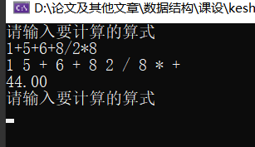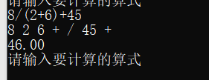
时间复杂度：O(N)
- 总结
这条题目主要考察了栈的基本应用以及中缀后缀表达式，学会求解波兰表达式和逆波兰表达式。在实现过程中字符串合法性校验对我来说是个难题，我应在以后的学习中更加注意。

字符串

1. 任务简述
一从键盘输入一串由数字组成的字符串，例如“234567910”，设计一个高效算法，输 出字符串中的升序序列，该升序序列中的数字要么是差值为1的等差序列，要么只允许 有一对相邻的数字差值为2，此时将该漏掉的数字找到并输出。
- 算法描述
穷举第一个数的位数，根据前一个数的值判断下一个数的值，下一个数只可能是前一个 数+1或+2，分四种情况讨论分析：+1进位，+1不进位，+2不进位，+2进位，并记录 +2的次数仅能为1次。
- 源代码
- #include <cstdio>
- #include <iostream>
- #include <cstdlib>
- #include <string>
- #define N 1000

- using namespace std;

- //指定长度字符串转化为整型
- int charToInt(char *s,int len)
- {
- int ans = 0;
- for (int i = 0; i < len; i++)
- {
- ans *= 10;
- ans = ans + (s[i] - '0');
- }
- return ans;
- }

- void solve(char *s,int len)
- {
- int cnt = 0, lost = -1;
- bool flag = 0;
- for (int i = 0; i < len/2; i++)
- {
- int ans[N];
- lost = -1;
- cnt = 0;
- int j;
- int l = i + 1;
- int num = 0;
- for (j = 0; j < len; j += l)
- {
- if (j == 0)
- {
- num = charToInt(s, l);
- ans[cnt++] = num;
- }
- else
- {
- int a = charToInt(s + j, l); //下一位不进位
- int b = charToInt(s + j, l + 1); //下一位进位
- if (flag) //已经有过一对相邻数字差值为2
- {
- if (num + 1 == a)
- {
- ans[cnt++] = a;
- num = a;
- }else if(num+1==b)
- {
- ans[cnt++] = b;
- num = b;
- l++;
- }else
- {
- break;
- }
- }
- else //没有一对相邻数字差值为2
- {
- if (num + 1 == a)
- {
- ans[cnt++] = a;
- num = a;
- }else if (num + 1 == b)
- {
- ans[cnt++] = b;
- num = b;
- l++;
- }else if (num + 2 == a)
- {
- flag = 1;
- ans[cnt++] = a;
- lost = num + 1;
- num = a;
- }else if (num + 2 == b)
- {
- flag = 1;
- ans[cnt++] = b;
- lost = num + 1;
- num = b;
- l++;
- }else
- {
- break;
- }
- }
- }
- }
- if (j == len)
- {
- for (int k = 0; k < cnt; k++)
- {
- cout << ans[k] << " ";
- }
- if (lost == -1)
- {
- cout << "没有漏掉的数字" << endl;
- }
- else {
- cout << "漏掉的数字为" << lost << endl;
- }
- return;
- }
- }
- cout << "字符串不合法，请重试" << endl;
- return;
- }
- int main()
- {
- while (1)
- {
- cout << "请输入字符串： ";
- char s[N];
- cin >> s;
- if (s[0] == '#')
- return 0;
- bool flag = 0;
- int l = strlen(s);
- for (int i = 0; i < l; i++)
- {
- if (s[i] > '9' || s[i] < '0')
- {
- flag = 1;
- }
- }
- if (flag)
- {
- cout << "输入不合法，请重试" << endl;
- continue;
- }
- solve(s,l);
- }
- return 0;
- }

- 结果分析
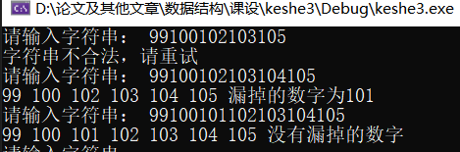
时间复杂度：O(N^2)
- 总结
枚举数字长度时，注意边界，以防数组越界，导致程序出错。另外在判断数字时要考虑到进位后读取的字符串长度也会变更。

Huffman编码
- 任务简述
对一篇英文文章，统计各字符（仅限于26个小写字母）出现的次数，实现Huffman编 码。
- 算法描述
利用桶统计26个字母的数量，构造出二叉树集合F（堆）。
* 选取与合并：在F中选取根节点的权值最小的两颗二叉树分别作为左右子树构造一棵新的二叉树（一般情况下将权值大的结点作为右子树。），这棵新二叉树的根节点的权值为其左、右子树根节点的权值之和。
* 删除与加入：在F中删除作为左、右子树的两棵二叉树，并将新建立的二叉树加入到F中。
重复上述两个步骤，当集合F中只剩下一棵二叉树时，这棵二叉树便是哈夫曼树。
- 源代码
- #include <iostream>
- #include <cstdio>
- #include <cstdlib>
- #include <fstream>

- using namespace std;

- typedef struct tree {
- char c;
- int pos;
- tree* left, * right;
- }tree;

- typedef struct node {
- int pos;
- int cnt;
- tree* treenode;
- }node;

- class Heap {
- public:
- node a[26];
- int tail;
- Heap()
- {
- tail = 0;
- for (int i = 0; i < 26; i++)
- a[i].pos = i, a[i].cnt = 0, a[i].treenode = NULL;
- }
- bool isempty()
- {
- if (tail == 1)
- return 1;
- else
- return 0;
- }
- void push(node x)
- {
- a[tail++] = x;
- int pa = (tail - 1) / 2;
- int child = tail - 1;
- while (pa >= 0)
- {
- if (a[pa].cnt > a[child].cnt)
- {
- node t = a[child];
- a[child] = a[pa];
- a[pa] = t;
- child = pa;
- pa = (pa - 1) / 2;
- }
- else
- {
- break;
- }
- }
- }
- node pop()
- {
- node t = a[0];
- a[0] = a[--tail];
- int pa = 0;
- int child = 1;
- while (child <= tail - 1)
- {
- if ((child != tail - 1) && (a[child].cnt) > a[child + 1].cnt)
- {
- child = child + 1;
- }
- if (a[child].cnt < a[pa].cnt)
- {
- node tmp = a[pa];
- a[pa] = a[child];
- a[child] = tmp;
- pa = child;
- child = 2 * child + 1;
- }
- else
- {
- break;
- }
- }
- return t;
- }
- };

- void preorder(tree* T, char (&encode)[26][100])
- {
- if (!T) return;
- tree* stack[100];
- int top = 0;
- tree* p, * p1;
- p = T;
- do
- {
- while (p)
- {
- stack[top++] = p;
- p = p->left;
- }
- p1 = NULL;
- while (top)
- {
- p = stack[top - 1];
- if (p->right == p1) //无右节点或者已经被访问出栈
- {
- int i;
- if (!p->left && !p->right)
- {
- for (i = 1; i < top; i++)
- {
- encode[p->pos][i - 1] = stack[i]->c;
- }
- encode[p->pos][top - 1] = p->c;
- }
- top--;
- p1 = p;
- }
- else
- {
- p = p->right;
- break;
- }

- }
- } while (top);
- }

- void huffman(tree* T, Heap* heap, int cnt[], char (&encode)[26][100])
- {
- for (int i = 0; i < 26; i++)
- {
- if (!cnt[i]) continue;
- node t;
- t.pos = i;
- t.cnt = cnt[i];
- t.treenode = (tree*)malloc(sizeof(tree));
- t.treenode->c = '2';
- t.treenode->pos = i;
- t.treenode->left = NULL;
- t.treenode->right = NULL;
- heap->push(t);
- }
- while (!heap->isempty())
- {
- node t1 = heap->pop();
- node t2 = heap->pop();
- node t;
- t.cnt = t1.cnt + t2.cnt;
- t.pos = -1;
- t.treenode = (tree*)malloc(sizeof(tree));
- t.treenode->left = t1.treenode;
- t1.treenode->c = '0';
- t.treenode->right = t2.treenode;
- t2.treenode->c = '1';
- t.treenode->c = '2';
- T = t.treenode;
- heap->push(t);
- }
- preorder(T, encode);
- }
- int main()
- {
- Heap heap;
- int cnt[26];
- char encode[26][100];
- tree* T = NULL;
- memset(cnt, 0, sizeof(int) * 26);
- memset(encode, 0, sizeof(char) * 2600);
- char str[100], c[1000];
- cout << "请输入你想要读取的文件路径：";
- cin >> str;
- fstream file(str);
- if (!file)
- {
- cout << "文件读取失败" << endl;
- return 0;
- }
- while (!file.eof())
- {
- file.getline(c, 1000);
- for (int i = 0; i < strlen(c); i++)
- {
- if (c[i] >= 'a' && c[i] <= 'z')
- {
- cnt[c[i]-'a']++;
- }
- if (c[i] == ' ') cout << " ";
- else cout << c[i];
- }
- cout << endl;
- }
- huffman(T, &heap, cnt, encode);
- for (int i = 0; i < 26; i++)
- {
- char ch = 'a' + i;
- cout << ch << ":";
- cout << encode[i] << endl;
- }
- file.close();
- return 0;
- }
- 结果分析
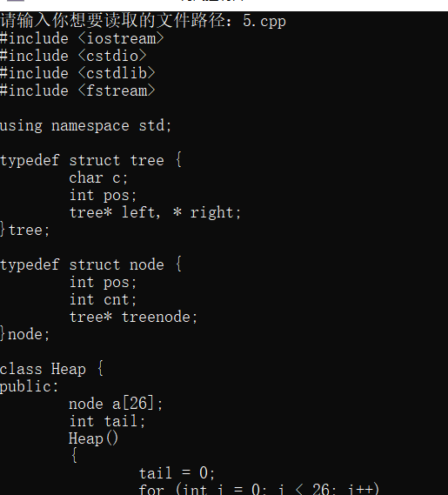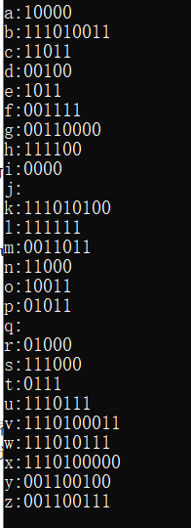
时间复杂度：O(nlogn)
- 总结
利用堆处理Huffman编码，要对只有一个字母的情况进行特判，不然程序并不会对一个字母进行编码。

最小生成树
- 任务简述
利用普利姆算法和克鲁斯卡尔算法实现最小生成树问题。
- 算法描述

Prim：
假设N=（V,{E}）是连通图，TE是N上最小生成树中边的集合。算法从U={u0}（u0∈V）， TE={}开始，
重复执行下述操作：
在所有u∈U，v∈V-U的边（u，v）∈E中找一条代价最小的边（u0，v0）并入集合 TE，同时v0 并入U，直至U=V为止。
此时TE中必有n-1条边，则T=（V，{TE}）为N的最小生成树。

Kruscal：
1).记Graph中有v个顶点，e个边
2).将Graph中所有e个边按权值从小到大排序
3).循环：从权值最小的边开始遍历每条边直至图Graph中所有的节点都在同一个连通 分量中（如果这条边连接的两个节点于图Graphnew中不在同一个连通分量中，则 添加这条边到图Graphnew中）
- 源代码
- #pragma warning( disable : 4996)
- #include <iostream>
- #include <cstdio>
- #include <cstdlib>
- #include <cstring>
- #define MAXN 200
- #define mmax 999999

- using namespace std;

- typedef struct node
- {
- int v1, v2;
- float val;
- }node;
- typedef struct node2
- {
- int pre;
- float val;
- }node2;
- typedef struct arcnode
- {
- int index;
- float val;
- struct arcnode* next;
- }AR;
- typedef struct MyGraph
- {
- int type;
- int arcnum, vexnum;
- char** vexname;
- AR* N;
- }GH;

- int findvex(char* s, GH* G)
- {
- int i;
- for (i = 0; i < G->vexnum; i++)
- {
- if (strcmp(s, G->vexname[i]) == 0)
- return i;
- }
- printf("read file erro\n");
- exit(-1);
- }

- void creatgraph(GH* G)
- {
- FILE* fp;
- AR* p;
- int i, j, k;
- float w;
- char c1[4], c2[4], c3[40];
- char filename[] = "6.txt";
- fp = fopen(filename, "rb");
- if (fp == NULL)
- {
- printf("read file erro\n");
- exit(-1);
- }
- fscanf(fp, "%d", &k);
- G->arcnum = 0;
- G->type = 0;
- G->vexnum = k;
- G->vexname = (char**)malloc(k * sizeof(char*));
- G->N = (AR*)malloc(k * sizeof(AR));
- for (i = 0; i < k; i++)
- {
- fscanf(fp, "%s", c1);
- G->vexname[i] = (char*)malloc(strlen(c1) * sizeof(char));
- strcpy(G->vexname[i], c1);
- G->N[i].next = NULL;
- }

- while (fscanf(fp, "%s%s%s", c1, c2, c3) != EOF)
- {
- w = atof(c3);
- (G->arcnum)++;
- i = findvex(c1, G);
- j = findvex(c2, G);
- p = (AR*)malloc(sizeof(AR));
- p->index = j;
- p->val = w;
- p->next = G->N[i].next;
- G->N[i].next = p;
- if (G->type == 0)
- {
- p = (AR*)malloc(sizeof(AR));
- p->index = i;
- p->val = w;
- p->next = G->N[j].next;
- G->N[j].next = p;
- }
- }
- fclose(fp);
- }

- void showgraph(GH* G)
- {
- int i;
- AR* p;
- for (i = 0; i < G->vexnum; i++)
- {
- cout << endl << G->vexname[i];
- p = G->N[i].next;
- while (p)
- {
- cout << "--" << G->vexname[p->index] << "(" << p->val << ")";
- p = p->next;
- }
- }
- cout << endl;
- }

- void init(GH* G, GH* T)
- {
- int k = G->vexnum;
- T->arcnum = 0;
- T->type = 0;
- T->vexnum = k;
- T->vexname = (char**)malloc(k * sizeof(char*));
- T->N = (AR*)malloc(k * sizeof(AR));
- for (int i = 0; i < k; i++)
- {
- T->vexname[i] = (char*)malloc(strlen(G->vexname[i]) * sizeof(char));
- strcpy(T->vexname[i], G->vexname[i]);
- T->N[i].next = NULL;
- }
- }

- void prim(GH* G, GH* T)
- {
- AR* p;
- int i, j;
- bool v[MAXN];
- node2 d[MAXN];
- init(G, T);
- for (i = 0; i < G->vexnum; i++)
- d[i].val = mmax, v[i] = 0;
- d[0].val = 0;
- p = G->N[0].next;
- while (p)
- {
- d[p->index].pre = 0;
- d[p->index].val = p->val;
- p = p->next;
- }

- for (i = 0; i < G->vexnum; i++)
- {
- int x = 1;
- for (j = 1; j < G->vexnum; j++)
- {
- if (!v[j] && (x == 1 || d[j].val < d[x].val))
- x = j;
- }
- v[x] = 1;
- AR* p1;
- p1 = (AR*)malloc(sizeof(AR));
- p1->index = x;
- p1->val = d[x].val;
- p1->next = T->N[d[x].pre].next;
- T->N[d[x].pre].next = p1;
- p1 = (AR*)malloc(sizeof(AR));
- p1->index = d[x].pre;
- p1->val = d[x].val;
- p1->next = T->N[x].next;
- T->N[x].next = p1;

- p = G->N[x].next;
- while (p)
- {
- if (!v[p->index])
- {
- if (p->val < d[p->index].val)
- {
- d[p->index].pre = x;
- d[p->index].val = p->val;
- }
- }
- p = p->next;
- }
- }

- }

- int pa[MAXN];
- node E[MAXN * MAXN];
- int findpa(int v)
- {
- if (pa[v] == v)
- return v;
- else return findpa(pa[v]);
- }

- void unionVex(int v1, int v2)
- {
- pa[findpa(v2)] = findpa(v1);
- }

- void kruscal(GH* G, GH* T)
- {
- int i, j, cnt = 0, k = 0;
- //init
- for (i = 0; i < G->vexnum; i++)
- pa[i] = i;
- init(G, T);
- for (i = 0; i < G->vexnum; i++)
- {
- AR* p;
- p = G->N[i].next;
- while (p)
- {
- E[cnt].v1 = i;
- E[cnt].v2 = p->index;
- E[cnt].val = p->val;
- cnt++;
- p = p->next;
- }
- }
- for (i = 0; i < G->vexnum; i++)
- for (j = 0; j < G->vexnum - i - 1; j++)
- {
- if (E[j].val > E[j + 1].val)
- {
- node t;
- t = E[j];
- E[j] = E[j + 1];
- E[j + 1] = E[j];
- }
- }
- //每个边重复了两次
- for (i = 0; i < cnt; i += 2)
- {
- if (k == G->vexnum - 1) break;
- if (findpa(E[i].v1) != findpa(E[i].v2))
- {
- unionVex(E[i].v1, E[i].v2);
- AR* p;
- p = (AR*)malloc(sizeof(AR));
- p->index = E[i].v1;
- p->val = E[i].val;
- p->next = T->N[E[i].v2].next;
- T->N[E[i].v2].next = p;
- p = (AR*)malloc(sizeof(AR));
- p->index = E[i].v2;
- p->val = E[i].val;
- p->next = T->N[E[i].v1].next;
- T->N[E[i].v1].next = p;
- k++;

- }
- }
- }

- int main()
- {
- GH G, T1, T2;
- creatgraph(&G);
- showgraph(&G);
- prim(&G, &T1);
- kruscal(&G, &T2);
- showgraph(&T1);
- showgraph(&T2);
- return 0;
- }

- 结果分析
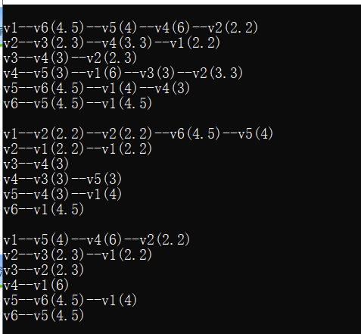
Prim：O(nlogn)
Kruskal：O(nlogn)
- 总结
使用Kruskal算法要存边，prim算法存点。以及Kruskal算法维护并查集时可以使用路径压缩优化时间复杂度。

关键路径问题
- 任务简述
设计实现AOE网的关键活动与关键路径问题。
- 算法描述
使用两个数组，etv：最早开始时间数组，ltv：最迟开始时间数组。
1.从源点V0出发，令etv[0]（源点）=0，按拓扑有序求其余各顶点的最早发生时间etv[i] （1 ≤ i ≤ n-1）。
2.从汇点Vn出发，令ltv[n-1] = etv[n-1]，按拓扑排序求各个其余各顶点的最迟发生时 间ltv[i]（n-2 ≥ i ≥ 2）;
3.根据各顶点的etv和ltv数组的值，求出弧（活动）的最早开工时间和最迟开工时间， 求每条弧的最早开工时间和最迟开工时间是否相等，若相等，则是关键活动。
- 源代码
- #pragma warning( disable : 4996)
- #include <iostream>
- #include <cstdio>
- #include <cstdlib>
- #include <cstring>
- #define MAXN 2000

- using namespace std;

- typedef struct arcnode
- {
- int index;
- int val;
- struct arcnode* next;
- }AR;
- typedef struct MyGraph
- {
- int type;
- int arcnum, vexnum;
- char** vexname;
- AR* N;
- AR* R;
- }GH;

- int start[MAXN], End[MAXN];
- int startCnt, endCnt;
- int findvex(char* s, GH* G)
- {
- int i;
- for (i = 0; i < G->vexnum; i++)
- {
- if (strcmp(s, G->vexname[i]) == 0)
- return i;
- }
- printf("read file erro\n");
- exit(-1);
- }

- void creatgraph(GH* G)
- {
- FILE* fp;
- AR* p;
- int i, j, k;
- int w;
- char c1[4], c2[4], c3[40];
- char filename[] = "有向图.txt";
- fp = fopen(filename, "rb");
- if (fp == NULL)
- {
- printf("read file erro\n");
- exit(-1);
- }
- fscanf(fp, "%d", &k);
- G->arcnum = 0;
- G->type = 1;
- G->vexnum = k;
- G->vexname = (char**)malloc(k * sizeof(char*));
- G->N = (AR*)malloc(k * sizeof(AR));
- G->R = (AR*)malloc(k * sizeof(AR));
- for (i = 0; i < k; i++)
- {
- fscanf(fp, "%s", c1);
- G->vexname[i] = (char*)malloc(strlen(c1) * sizeof(char));
- strcpy(G->vexname[i], c1);
- G->N[i].next = NULL;
- G->R[i].next = NULL;
- }

- while (fscanf(fp, "%s%s%s", c1, c2, c3) != EOF)
- {
- w = atoi(c3);
- (G->arcnum)++;
- i = findvex(c1, G);
- j = findvex(c2, G);
- p = (AR*)malloc(sizeof(AR));
- p->index = j;
- p->val = w;
- p->next = G->N[i].next;
- G->N[i].next = p;
- p = (AR*)malloc(sizeof(AR));
- p->index = i;
- p->val = w;
- p->next = G->R[j].next;
- G->R[j].next = p;
- }
- fclose(fp);
- }

- void showgraph(GH* G)
- {
- int i;
- AR* p;
- for (i = 0; i < G->vexnum; i++)
- {
- cout << G->vexname[i];
- p = G->N[i].next;
- while (p)
- {
- cout << "--" << G->vexname[p->index] << "(" << p->val << ")";
- p = p->next;
- }
- cout << endl;
- }
- cout << endl;
- }

- void TopologicalSort(GH* G, int* ve)
- {
- int i, top = 0;
- AR* p;
- int in[MAXN], stack[MAXN];
- for (i = 0; i < G->vexnum; i++)
- {
- in[i] = 0, ve[i] = 0;
- }
- for (i = 0; i < G->vexnum; i++)
- {
- p = G->N[i].next;
- while (p)
- {
- in[p->index]++;
- p = p->next;
- }
- }
- for (i = 0; i < G->vexnum; i++)
- if (!in[i])
- stack[top++] = i, start[startCnt++] = i;
- while (top)
- {
- int x = stack[--top];
- AR* p;
- p = G->N[x].next;
- while (p)
- {
- in[p->index]--;
- ve[p->index] = (ve[x] + p->val) > ve[p->index] ? (ve[x] + p->val) : ve[p->index];
- if (!in[p->index]) stack[top++] = p->index;
- p = p->next;
- }
- }

- }

- void ReTopologicalSort(GH* G, int* vl)
- {
- int i, top = 0;
- AR* p;
- int out[MAXN], stack[MAXN];
- for (i = 0; i < G->vexnum; i++)
- {
- out[i] = 0, vl[i] = 0;
- }
- for (i = 0; i < G->vexnum; i++)
- {
- p = G->N[i].next;
- while (p)
- {
- out[i]++;
- p = p->next;
- }
- }
- for (i = 0; i < G->vexnum; i++)
- if (!out[i])
- stack[top++] = i, End[endCnt++] = i;
- while (top)
- {
- int x = stack[--top];
- AR* p;
- p = G->R[x].next;
- while (p)
- {
- out[p->index]--;
- vl[p->index] = (vl[x] + p->val) > vl[p->index] ? (vl[x] + p->val) : vl[p->index];
- if (!out[p->index]) stack[top++] = p->index;
- p = p->next;
- }
- }

- }

- void init(GH* G, GH* ANS, int* vl, int* ve)
- {
- AR* p, * p1;
- int k = G->vexnum;
- ANS->arcnum = 0;
- ANS->type = 0;
- ANS->vexnum = k;
- ANS->vexname = (char**)malloc(k * sizeof(char*));
- ANS->N = (AR*)malloc(k * sizeof(AR));
- for (int i = 0; i < k; i++)
- {
- ANS->vexname[i] = (char*)malloc(strlen(G->vexname[i]) * sizeof(char));
- strcpy(ANS->vexname[i], G->vexname[i]);
- ANS->N[i].next = NULL;
- }
- for (int i = 0; i < k; i++)
- {
- if (vl[i] != ve[i]) continue;
- p1 = G->N[i].next;
- while (p1)
- {
- if (vl[p1->index] == ve[p1->index])
- {
- p = (AR*)malloc(sizeof(AR));
- p->index = p1->index;
- p->val = p1->val;
- p->next = ANS->N[i].next;
- ANS->N[i].next = p;
- }
- p1 = p1->next;
- }
- }
- }
- void dfs(GH* ANS, int* route, int* top, int v, int end)
- {
- AR* p;
- if (v == end)
- {
- for (int i = 0; i < *top; i++)
- cout << ANS->vexname[route[i]] << " -- ";
- cout << ANS->vexname[v] << endl;
- return;
- }
- route[(*top)++] = v;
- p = ANS->N[v].next;
- while (p)
- {
- dfs(ANS, route, top, p->index, end);
- p = p->next;
- }
- (*top)--;
- }

- void CriticalPathSolution(GH* G, GH* ANS)
- {
- int vl[MAXN],ve[MAXN];
- int route[MAXN], top = 0;
- TopologicalSort(G, ve); //拓扑排序
- ReTopologicalSort(G, vl); //反拓扑排序
- for (int i = 0; i < G->vexnum; i++)
- vl[i] = ve[G->vexnum - 1] - vl[i];
- //构造关键路径图
- init(G, ANS, vl, ve);
- printf("\n%12s", "vexname");
- for (int i = 0; i < G->vexnum; i++)
- printf("%8s ", G->vexname[i]);
- cout << endl;
- printf("%12s", "ve");
- for (int i = 0; i < G->vexnum; i++)
- printf("%8d ", ve[i]);
- cout << endl;
- printf("%12s", "vl");
- for (int i = 0; i < G->vexnum; i++)
- printf("%8d ", vl[i]);
- cout << endl << endl;
- cout << "有如下关键路径" << endl;
- //遍历关键路径
- for (int i = 0; i < startCnt; i++)
- for (int j = 0; j < endCnt; j++)
- dfs(ANS, route, &top, start[i], End[j]);
- }

- int main()
- {
- GH G, ANS;
- creatgraph(&G);
- cout << "原图如下" << endl;
- showgraph(&G);
- CriticalPathSolution(&G, &ANS);
- return 0;
- }
- 结果分析
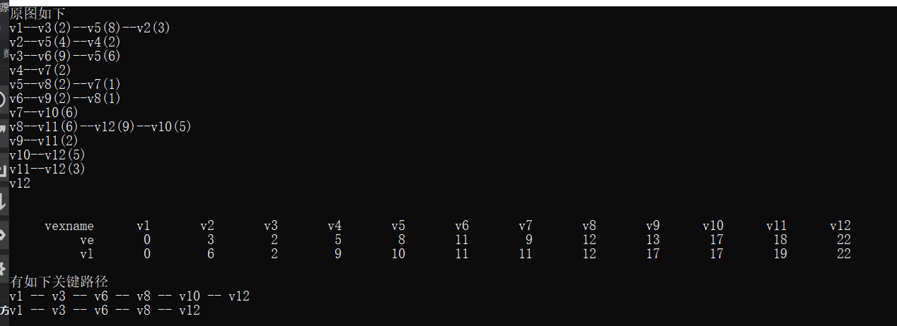
时间复杂度：O(n+e)
- 总结
关键路径的关键在于处理每个点的vl和ve的值。这道题让我学习了拓扑排序和拓扑逆排序以及对原图重新建图等操作。

最短路径问题
- 任务简述
设计Floyd和Dijkstra实现最短路径问题。
- 算法描述

Floyd：
a.从任意一条单边路径开始。所有两点之间的距离 是边的权，如果两点之间没有边相 连，则权为无穷大。
b.对于每一对顶点 u 和 v，看看是否存在一个顶点 w 使得从 u 到 w 再到 v 比己知 的路径更短。如果是更新它。

Dijkstra：
dis[v]表示s到v的距离，pre[v]为v的前驱结点，用以输出路径,vis[v]表示该点最短路 径是否已经确认。执行n次，在没有确定的点中找到一个路径最短的，并修改为已经确 认，通过这个点修改其他所有没有确定的点，直到所有点已经确认为最短路径，退出循 环。
- 源代码
- #pragma warning( disable : 4996)
- #include <iostream>
- #include <cstdio>
- #include <cstdlib>
- #include <cstring>
- #define MAXN 200
- #define mmax 0x3ffffff

- using namespace std;

- typedef struct arcnode
- {
- int index;
- int val;
- struct arcnode* next;
- }AR;
- typedef struct MyGraph
- {
- int type;
- int arcnum, vexnum;
- char** vexname;
- AR* N;
- }GH;

- int findvex(char* s, GH* G)
- {
- int i;
- for (i = 0; i < G->vexnum; i++)
- {
- if (strcmp(s, G->vexname[i]) == 0)
- return i;
- }
- printf("read file erro\n");
- exit(-1);
- }

- void creatgraph(GH* G)
- {
- FILE* fp;
- AR* p;
- int i, j, k;
- int w;
- char c1[4], c2[4], c3[40];
- char filename[] = "8.txt";
- fp = fopen(filename, "rb");
- if (fp == NULL)
- {
- printf("read file erro\n");
- exit(-1);
- }
- fscanf(fp, "%d", &k);
- G->arcnum = 0;
- G->type = 1;
- G->vexnum = k;
- G->vexname = (char**)malloc(k * sizeof(char*));
- G->N = (AR*)malloc(k * sizeof(AR));
- for (i = 0; i < k; i++)
- {
- fscanf(fp, "%s", c1);
- G->vexname[i] = (char*)malloc(strlen(c1) * sizeof(char));
- strcpy(G->vexname[i], c1);
- G->N[i].next = NULL;
- }

- while (fscanf(fp, "%s%s%s", c1, c2, c3) != EOF)
- {
- w = atoi(c3);
- (G->arcnum)++;
- i = findvex(c1, G);
- j = findvex(c2, G);
- p = (AR*)malloc(sizeof(AR));
- p->index = j;
- p->val = w;
- p->next = G->N[i].next;
- G->N[i].next = p;
- }
- fclose(fp);
- }

- void showgraph(GH* G)
- {
- int i;
- AR* p;
- for (i = 0; i < G->vexnum; i++)
- {
- cout << G->vexname[i];
- p = G->N[i].next;
- while (p)
- {
- cout << "--" << G->vexname[p->index] << "(" << p->val << ")";
- p = p->next;
- }
- cout << endl;
- }
- cout << endl;
- }

- void showRoute(GH* G, int(*p)[200], int i, int j)
- {
- if (p[i][j] == i)
- {
- cout << G->vexname[i];
- return;
- }
- showRoute(G, p, i, p[i][j]);
- cout << "--" << G->vexname[p[i][j]];
- }
- void showRouteD(GH* G, int* pre, int i, int j)
- {
- if (pre[j] == i)
- {
- cout << G->vexname[i];
- return;
- }
- showRouteD(G, pre, i, pre[j]);
- cout << "--" << G->vexname[pre[j]];
- }

- void floyd(GH* G)
- {
- int d[MAXN][MAXN], p[MAXN][MAXN];
- int i, j, k, l;
- l = G->vexnum;

- for (i = 0; i < l; i++)
- for (j = 0; j < l; j++)
- {
- if (i == j) d[i][j] = 0;
- else d[i][j] = mmax;
- p[i][j] = i;
- }
- for (i = 0; i < l; i++)
- {
- AR* p;
- p = G->N[i].next;
- while (p)
- {
- d[i][p->index] = p->val;
- p = p->next;
- }
- }
- for (k = 0; k < l; k++)
- for (i = 0; i < l; i++)
- for (j = 0; j < l; j++)
- if (d[i][j] > d[i][k] + d[k][j])
- {
- d[i][j] = d[i][k] + d[k][j];
- p[i][j] = p[k][j];
- }
- for (i = 0; i < l; i++)
- for (j = 0; j < l; j++)
- {
- if (d[i][j] == mmax || i == j) continue;
- cout << G->vexname[i] << "到" << G->vexname[j] << "的最短路径长度为" << d[i][j] << endl;
- cout << "其最短路径为：";
- k = p[i][j];
- showRoute(G, p, i, j);
- cout << "--" << G->vexname[j] << endl;
- }
- }

- void dijkstra(GH* G)
- {
- int d[MAXN][MAXN], pre[MAXN];
- bool vis[MAXN];
- int i, j, k, l, m;
- l = G->vexnum;

- for (i = 0; i < l; i++)
- for (j = 0; j < l; j++)
- {
- if (i == j) d[i][j] = 0;
- else d[i][j] = mmax;
- vis[i] = 0;
- }
- for (i = 0; i < l; i++)
- {
- for (int a = 0; a < l; a++)
- pre[a] = a, vis[a] = 0;
- for (j = 0; j < l; j++)
- {
- int k = 0, mmin = mmax;
- for (m = 0; m < l; m++)
- if (mmin > d[i][m] && !vis[m])
- {
- mmin = d[m][i];
- k = m;
- }
- vis[k] = 1;
- AR* p;
- p = G->N[k].next;
- while (p)
- {
- if (!vis[p->index] && d[i][p->index] > d[i][k] + p->val)
- {
- d[i][p->index] = d[i][k] + p->val;
- pre[p->index] = k;
- }
- p = p->next;
- }
- }
- for (j = 0; j < l; j++)
- {
- if (d[i][j] == mmax || i == j) continue;
- cout << G->vexname[i] << "到" << G->vexname[j] << "的最短路径长度为" << d[i][j] << endl;
- cout << "其最短路径为：";
- showRouteD(G, pre, i, j);
- cout << "--" << G->vexname[j] << endl;
- }
- }
- }

- int main()
- {
- GH G;
- creatgraph(&G);
- showgraph(&G);
- system("pause");
- system("cls");
- cout << "如下为floyd算法求解结果：" << endl;
- floyd(&G);
- system("pause");
- system("cls");
- cout << "如下为dijkstra算法求解结果：" << endl;
- dijkstra(&G);
- return 0;
- }
- 结果分析
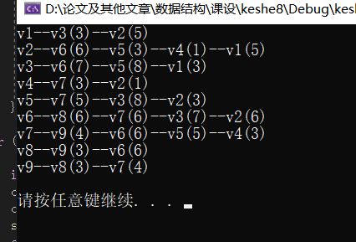
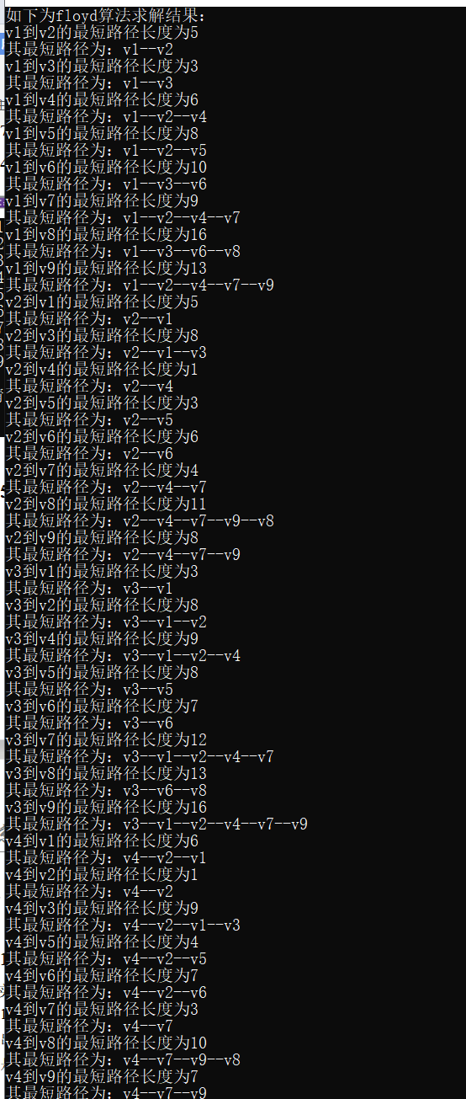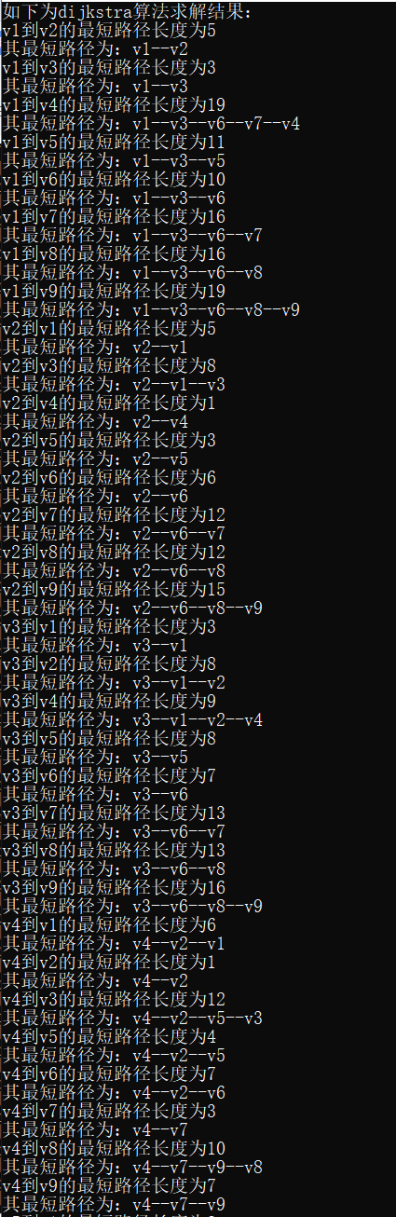
时间复杂度：
Dijkstra：O(nlogn)
Floyd：O(n^3)
- 总结
Dijsktra算法的时间复杂度在计算其他点到一点最短路径时，速度较快。但是在处理任意两点间最短路径时，Floyd的算法效率反而更高。原有在于Dijstra在优化时并没有对其中间态进行存储。

家谱管理系统
- 任务简述
实现具有下列功能的家谱管理系统。
1）输入文件以存放最初家谱中各成员的信息，成员的信息中均应包含以下内容：姓名、 出生日期、婚否、地址、健在否、死亡日期（若其已死亡），也可附加其它信息、但不 是必需的。
（2）实现数据的文件存储和读取。
（3）以图形方式显示家谱。
（4）显示第n 代所有人的信息。
（5）按照姓名查询，输出成员信息（包括其本人、父亲、孩子的信息）。
（6）按照出生日期查询成员名单。
（7）输入两人姓名，确定其关系。
（8）某成员添加孩子。
（9）删除某成员（若其还有后代，则一并删除）。
（10）修改某成员信息。
- 算法描述
使用孩子-兄弟树存储数据，配偶信息另作一个指针单独存储。
- 采用先序遍历的方式存储数据。
- 利用easyx的图形库来实现图形显示家谱
- 层次遍历
- 先序遍历树，查到名字相符的结点打印。
- 先序遍历树，查到生日相符的结点打印。
- 利用LCA算法，查找他们的最近公共祖先，然后计算他们距离祖先的深度差，然后输出结果。
- 添加成员，就是结点的插入操作
- 结点的删除操作
- 结点的信息修改
- 源代码
- #include <cstdio>
- #include <iostream>
- #include <cstdlib>
- #include <cstring>
- #include <fstream>
- #include <graphics.h>
- #include <ctime>
- #include <conio.h>
- #include <windows.h>
- #define N 2000

- using namespace std;

- typedef struct member
- {
- char name[20];
- char birth[12];
- bool isMarried;
- char address[100];
- char death[12];
- bool isdeath;
- }member;
- typedef struct familytree
- {
- member info;
- struct familytree* bro, * fir, * fa, * prebro, * spouse;
- }FT;
- typedef struct node
- {
- FT* p;
- int sx;
- int sy;
- int ex;
- int ey;
- }widget;
- typedef struct node2
- {
- FT* node;
- int deep;
- }QUE;
- char filename[20];

- int menu_select()
- {
- char i;
- do {
- system("cls");
- printf("1.创建最初家谱（从文件读入）\n");
- printf("2.打印家谱\n");
- printf("3.显示第n代人所有记录\n");
- printf("4.按姓名查询成员信息\n");
- printf("5.按出生日期查询成员信息\n");
- printf("6.查询两人关系\n");
- printf("7.为成员添加孩子\n");
- printf("8.删除某成员\n");
- printf("9.修改某成员信息\n");
- printf("0.退出\n");
- printf("请输入选择序号(0-9):");
- i = getchar();
- } while (i < '0' || i>'9');
- return (i - '0');
- }

- FT* create(FT* A, FT* fa, FT* prebro, fstream& file)
- {
- char t[20];
- FT* p, * pre;
- p = A, pre = NULL;
- if (!file.eof())
- {
- file.getline(t, 20);
- if (t[0] == '#' || t[0] == '\0')
- {
- return NULL;
- }
- A->fa = fa;
- A->prebro = prebro;
- strcpy_s(A->info.name, t);
- file.getline(A->info.birth, 12);
- file.getline(t, 20);
- if (t[0] == '1')
- A->info.isMarried = 1;
- else
- A->info.isMarried = 0;
- file.getline(A->info.address, 100);
- file.getline(t, 20);
- if (t[0] == '1')
- A->info.isdeath = 1;
- else
- A->info.isdeath = 0;
- file.getline(A->info.death, 12);
- A->fir = (FT*)malloc(sizeof(FT));
- A->bro = (FT*)malloc(sizeof(FT));
- if (A->info.isMarried)
- {
- A->spouse = (FT*)malloc(sizeof(FT));
- file.getline(t, 20);
- strcpy(A->spouse->info.name, t);
- file.getline(A->spouse->info.birth, 12);
- A->spouse->info.isMarried = 1;
- file.getline(A->spouse->info.address, 100);
- file.getline(t, 20);
- if (t[0] == '1')
- A->spouse->info.isdeath = 1;
- else
- A->spouse->info.isdeath = 0;
- file.getline(A->spouse->info.death, 12);
- }
- else
- {
- A->spouse = NULL;
- }
- A->fir = create(A->fir, A, NULL, file);
- A->bro = create(A->bro, A->fa, A, file);
- return A;
- }
- return NULL;
- }

- void CreateFT(FT* A)
- {
- cout << "请输入文件名：";
- cin >> filename;
- fstream file(filename);
- if (!file)
- {
- cout << "文件打开失败" << endl;
- exit(1);
- }
- //递归建树
- create(A, NULL, NULL, file);
- file.close();
- cout << "创建成功" << endl;
- }

- void save(FT* A, fstream& file)
- {
- if (!A)
- {
- file << '#' << endl;
- return;
- }
- file << A->info.name << endl;
- file << A->info.birth << endl;
- if (A->info.isMarried)
- file << '1' << endl;
- else
- file << '0' << endl;
- file << A->info.address << endl;
- if (A->info.isdeath)
- {
- file << '1' << endl;
- file << A->info.death << endl;
- }
- else
- {
- file << '0' << endl;
- file << "0000-00-00" << endl;
- }
- if (A->info.isMarried)
- {
- file << A->spouse->info.name << endl;
- file << A->spouse->info.birth << endl;
- file << A->spouse->info.address << endl;
- if (A->spouse->info.isdeath)
- {
- file << '1' << endl;
- file << A->spouse->info.death << endl;
- }
- else
- {
- file << '0' << endl;
- file << "0000-00-00" << endl;
- }
- }
- save(A->fir, file);
- save(A->bro, file);
- return;
- }

- void Close(FT* A)
- {
- fstream file(filename);
- //递归存储
- //先序遍历
- save(A, file);
- file.close();
- }

- void subPrint(FT* A, widget* data, int* cnt)
- {
- //清空画布
- cleardevice();
- *cnt = 0;
- wchar_t name[20];

- //画出退出按钮
- RECT r_exit = { 535,405,600,440 };
- rectangle(535, 405, 600, 440);
- drawtext(_T("退出"), &r_exit, DT_CENTER | DT_VCENTER | DT_SINGLELINE);

- //画出返回按钮
- RECT r_return = { 430, 405, 495, 440 };
- rectangle(430, 405, 495, 440);
- drawtext(_T("返回"), &r_return, DT_CENTER | DT_VCENTER | DT_SINGLELINE);
- rectangle(260, 100, 380, 180);
- //画出父亲结点
- //信息转换，utf-8转为Unicode，char转为wchar
- if (A->info.isMarried)
- {
- RECT r_pa = { 260,100,380,143 };
- RECT r_pas = { 260,137,380,180 };
- int nRet = MultiByteToWideChar(CP_ACP, 0, A->info.name, 20, name, 20);
- drawtext(name, &r_pa, DT_CENTER | DT_VCENTER | DT_SINGLELINE);
- setlinestyle(PS_DOT, 2, NULL);
- line(260, 140, 380, 140);
- setlinestyle(PS_SOLID, 2, NULL);
- nRet = MultiByteToWideChar(CP_ACP, 0, A->spouse->info.name, 20, name, 20);
- drawtext(name, &r_pas, DT_CENTER | DT_VCENTER | DT_SINGLELINE);
- }
- else
- {
- RECT r_pa = { 260,100,380,180 };
- int nRet = MultiByteToWideChar(CP_ACP, 0, A->info.name, 20, name, 20);
- drawtext(name, &r_pa, DT_CENTER | DT_VCENTER | DT_SINGLELINE);
- }

- //画出所有子结点
- FT* p = A->fir;
- while (p)
- {
- data[*cnt].p = p;
- (*cnt)++;
- p = p->bro;
- }
- int x = (640 - 60 * (*cnt)) / ((*cnt) + 1);
- int i, sx = x;
- for (i = (*cnt) - 1; i >= 0; i--)
- {
- data[i].sx = sx;
- data[i].sy = 270;
- data[i].ex = sx + 60;
- data[i].ey = 330;
- rectangle(sx, 270, sx + 60, 330);
- line(sx + 30, 270, 320, 180);
- if (data[i].p->info.isMarried)
- {
- RECT r_son = { sx,270,sx + 60,297 };
- RECT r_sons = { sx,303,sx + 60,330 };
- int nRet = MultiByteToWideChar(CP_ACP, 0, data[i].p->info.name, 20, name, 20);
- drawtext(name, &r_son, DT_CENTER | DT_VCENTER | DT_SINGLELINE);
- setlinestyle(PS_DOT, 2, NULL);
- line(sx, 300, sx + 60, 300);
- setlinestyle(PS_SOLID, 2, NULL);
- nRet = MultiByteToWideChar(CP_ACP, 0, data[i].p->spouse->info.name, 20, name, 20);
- drawtext(name, &r_sons, DT_CENTER | DT_VCENTER | DT_SINGLELINE);
- }
- else
- {
- RECT r_son = { sx,270,sx + 60,330 };
- int nRet = MultiByteToWideChar(CP_ACP, 0, data[i].p->info.name, 20, name, 20);
- drawtext(name, &r_son, DT_CENTER | DT_VCENTER | DT_SINGLELINE);
- }
- sx += x + 60;
- }
- }

- void Print(FT* A)
- {
- if (!strlen(filename))
- {
- cout << "未导入初始家谱" << endl;
- return;
- }
- // 设置随机函数种子
- srand((unsigned)time(NULL));

- // 初始化图形模式
- initgraph(640, 480);

- // 设置字体
- settextstyle(16, 8, _T("Courier"));

- // 设置颜色
- COLORREF color = RGB(252, 253, 248);
- setbkcolor(color);
- settextcolor(BLACK);
- setlinecolor(BLACK);

- // 定义鼠标参数
- MOUSEMSG m;

- FT* tree = A;
- widget data[20];
- int cnt = 0, i;
- subPrint(A, data, &cnt);
- while (1)
- {
- m = GetMouseMsg();
- if (m.uMsg == WM_LBUTTONDOWN)
- {
- //退出
- if (m.x <= 600 && m.x >= 535 && m.y >= 405 && m.y <= 440)
- {
- break;
- }
- //返回
- if ((m.x <= 495 && m.x >= 430 && m.y >= 405 && m.y <= 440) || (m.x <= 380 && m.x >= 260) && m.y <= 180 && m.y >= 100)
- {
- if (tree->fa != NULL)
- {
- subPrint(tree->fa, data, &cnt);
- tree = tree->fa;
- }
- }
- //选择子结点
- for (i = 0; i < cnt; i++)
- {
- if (m.x >= data[i].sx && m.x <= data[i].ex && m.y >= data[i].sy && m.y <= data[i].ey)
- {
- tree = data[i].p;
- subPrint(tree, data, &cnt);
- }
- }
- }
- }

- // 关闭图形模式
- closegraph();

- }

- void printInfo(FT* A)
- {
- cout << "姓名：" << A->info.name << endl;
- cout << "生日：" << A->info.birth << endl;
- cout << "婚否：";
- if (A->info.isMarried)
- {
- cout << "是" << endl;
- }
- else
- {
- cout << "否" << endl;
- }
- cout << "地址：" << A->info.address << endl;
- cout << "健在否：";
- if (A->info.isdeath)
- {
- cout << "否" << endl;
- cout << "死亡日期：" << A->info.death << endl;
- }
- else
- {
- cout << "是" << endl;
- }
- cout << endl;
- }

- void PrintN(FT* A)
- {
- if (!strlen(filename))
- {
- cout << "未导入初始家谱" << endl;
- return;
- }
- int n;
- cout << "请输入要查询的代数n：";
- cin >> n;
- if (n == 0)
- {
- cout << "n不为0！" << endl;
- return;
- }
- int head = 0, tail = 0;
- QUE c[N];
- c[tail].node = A;
- c[tail++].deep = 1;
- while (head != tail)
- {
- QUE t = c[head++];
- if (t.deep == n)
- {
- printInfo(t.node);
- if (t.node->info.isMarried)
- printInfo(t.node->spouse);
- }
- FT* tmp = t.node;
- if (t.node->fir)
- {
- c[tail].node = t.node->fir;
- c[tail++].deep = t.deep + 1;
- }
- while (tmp->bro)
- {
- tmp = tmp->bro;
- if (t.deep == n)
- {
- printInfo(tmp);
- printInfo(tmp->spouse);
- }
- if (tmp->fir)
- {
- c[tail].node = tmp->fir;
- c[tail++].deep = t.deep + 1;
- }
- }
- }
- }

- void dfsSearchByName(FT* A, char* name)
- {
- if (!strcmp(A->info.name, name))
- {
- cout << "本人：" << endl;
- printInfo(A);
- cout << "其父亲：" << endl;
- if (A->fa)
- printInfo(A->fa);
- else
- cout << "族谱中无其父亲信息" << endl << endl;
- cout << "其母亲：" << endl;
- if (A->fa && A->fa->spouse)
- printInfo(A->fa->spouse);
- else
- cout << "族谱中无其母亲信息" << endl << endl;
- cout << "其孩子：" << endl;
- if (A->fir)
- {
- FT* p = A->fir;
- printInfo(p);
- while (p->bro)
- {
- p = p->bro;
- printInfo(p);
- }
- }
- else
- cout << "族谱中无其孩子信息" << endl;
- cout << "==========================================" << endl;
- system("pause");
- }
- if (A->spouse)
- if (!strcmp(A->spouse->info.name, name))
- {
- cout << "本人：" << endl;
- printInfo(A->spouse);
- cout << "其父亲：" << endl;
- if (A->fa)
- printInfo(A->fa);
- else
- cout << "族谱中无其父亲信息" << endl;
- cout << "其母亲：" << endl;
- if (A->fa && A->fa->spouse)
- printInfo(A->fa->spouse);
- else
- cout << "族谱中无其母亲信息" << endl;
- cout << "其孩子：" << endl;
- if (A->fir)
- {
- FT* p = A->fir;
- printInfo(p);
- while (p->bro)
- {
- p = p->bro;
- printInfo(p);
- }
- }
- else
- cout << "族谱中无其孩子信息" << endl;
- cout << "==========================================" << endl;
- system("pause");
- }
- if (A->fir)
- dfsSearchByName(A->fir, name);
- if (A->bro)
- dfsSearchByName(A->bro, name);
- }

- void SearchByName(FT* A)
- {
- if (!strlen(filename))
- {
- cout << "未导入初始家谱" << endl;
- return;
- }
- char name[20];
- cout << "请输入要查询的成员姓名：";
- cin >> name;
- dfsSearchByName(A, name);
- cout << "查询完毕" << endl;
- }

- void dfsSearchByDate(FT* A, char* name)
- {
- if (!strcmp(A->info.birth, name))
- {
- cout << "本人：" << endl;
- printInfo(A);
- cout << "其父亲：" << endl;
- if (A->fa)
- printInfo(A->fa);
- else
- cout << "族谱中无其父亲信息" << endl << endl;
- cout << "其母亲：" << endl;
- if (A->fa && A->fa->spouse)
- printInfo(A->fa->spouse);
- else
- cout << "族谱中无其母亲信息" << endl << endl;
- cout << "其孩子：" << endl;
- if (A->fir)
- {
- FT* p = A->fir;
- printInfo(p);
- while (p->bro)
- {
- p = p->bro;
- printInfo(p);
- }
- }
- else
- cout << "族谱中无其孩子信息" << endl;
- cout << "==========================================" << endl;
- system("pause");
- }
- if (A->spouse)
- if (!strcmp(A->spouse->info.birth, name))
- {
- cout << "本人：" << endl;
- printInfo(A->spouse);
- cout << "其父亲：" << endl;
- if (A->fa)
- printInfo(A->fa);
- else
- cout << "族谱中无其父亲信息" << endl;
- cout << "其母亲：" << endl;
- if (A->fa && A->fa->spouse)
- printInfo(A->fa->spouse);
- else
- cout << "族谱中无其母亲信息" << endl;
- cout << "其孩子：" << endl;
- if (A->fir)
- {
- FT* p = A->fir;
- printInfo(p);
- while (p->bro)
- {
- p = p->bro;
- printInfo(p);
- }
- }
- else
- cout << "族谱中无其孩子信息" << endl;
- cout << "==========================================" << endl;
- system("pause");
- }
- if (A->fir)
- dfsSearchByDate(A->fir, name);
- if (A->bro)
- dfsSearchByDate(A->bro, name);
- }

- void SearchByDate(FT* A)
- {
- if (!strlen(filename))
- {
- cout << "未导入初始家谱" << endl;
- return;
- }
- char data[12];
- int year, month, day;
- cout << "请输入要查询的出生日期：";
- while (1)
- {
- cout << "输入年份：";
- cin >> year;
- if (year < 10000 && year >= 0)
- break;
- else
- cout << "格式错误!" << endl;
- }
- while (1)
- {
- cout << "输入月份：";
- cin >> month;
- if (month <= 12 && month >= 1)
- break;
- else
- cout << "格式错误!" << endl;
- }
- while (1)
- {
- cout << "输入日数：";
- cin >> day;
- if (day <= 31 && day >= 1)
- break;
- else
- cout << "格式错误!" << endl;
- }
- _itoa(year, data, 10);
- data[4] = '-';
- if (month / 10)
- _itoa(month, data + 5, 10);
- else
- {
- data[5] = '0';
- _itoa(month, data + 6, 10);
- }
- data[7] = '-';
- if (day / 10)
- _itoa(day, data + 8, 10);
- else
- {
- data[8] = '0';
- _itoa(day, data + 9, 10);
- }
- cout << "查询的生日为" << data << endl;
- dfsSearchByDate(A, data);
- cout << "查询完毕" << endl;
- }

- int Finds(FT* A, FT* S)
- {
- int a = -1, b = -1;
- if (A == S || A->spouse == S)
- return 0;
- else
- {
- if (A->fir)
- {
- a = Finds(A->fir, S) + 1;
- }
- if (A->bro)
- {
- b = Finds(A->bro, S);
- }
- }
- if (a <= 0 && b < 0)
- return -1;
- else
- return a > b ? a : b;
- }

- int LCA(FT* A, FT* T1, FT* T2, FT* fa)
- {
- if (A == T1 || A == T2)
- {
- if (A == T1) fa = T1;
- else fa = T2;
- return Finds(A, T1) - Finds(A, T2);
- }
- int pos1 = 0;
- int pos2 = 0;
- if (A->fir)
- {
- pos1 = Finds(A->fir, T1) + 1;
- pos2 = Finds(A->fir, T2) + 1;
- }
- if (pos1 == 0 && pos2 == 0)
- {
- return LCA(A->bro, T1, T2, fa);
- }
- else if (pos1 == 0 && pos2 > 0)
- {
- fa = A;
- pos1 = Finds(A->bro, T1);
- return pos1 - pos2;
- }
- else if (pos2 == 0 && pos1 > 0)
- {
- fa = A;
- pos2 = Finds(A->bro, T2);
- return pos1 - pos2;
- }
- else
- {
- return LCA(A->fir, T1, T2, fa);
- }
- }

- FT* dfsRelation(FT* A, char* name)
- {
- if (!strcmp(A->info.name, name))
- {
- printInfo(A);
- cout << "是否为查询对象？(Y/N):";
- cin.ignore();
- char c = getchar();
- if (c == 'y' || c == 'Y') return A;
- }
- if (A->spouse)
- if (!strcmp(A->spouse->info.name, name))
- {
- printInfo(A->spouse);
- cout << "是否为查询对象？(Y/N):";
- cin.ignore();
- char c = getchar();
- if (c == 'y' || c == 'Y') return A->spouse;
- }
- FT* p1 = NULL, * p2 = NULL;
- if (A->fir) p1 = dfsRelation(A->fir, name);
- if (p1) return p1;
- if (A->bro) p2 = dfsRelation(A->bro, name);
- if (p2) return p2;
- return NULL;
- }

- void Relation(FT* A)
- {
- if (!strlen(filename))
- {
- cout << "未导入初始家谱" << endl;
- return;
- }
- char Seniority[8][20] = { "兄弟","父亲","祖父","曾祖","玄祖","高祖","太祖","元祖" };
- char name1[20], name2[20];
- FT* T1, * T2, * fa = A;
- cout << "输入你要查找的两人姓名" << endl;
- cout << "输入第一个人的姓名：";
- cin.ignore();
- cin >> name1;
- T1 = dfsRelation(A, name1);
- if (!T1)
- {
- cout << "查无此人" << endl;
- return;
- }
- cout << "输入第二个人的姓名：";
- cin.ignore();
- cin >> name2;
- T2 = dfsRelation(A, name2);
- if (!T2)
- {
- cout << "查无此人" << endl;
- return;
- }
- cout << "=========================================" << endl;
- cout << "结果如下" << endl;
- int ans = LCA(A, T1, T2, fa);
- cout << "他们相差" << abs(ans) << "代" << endl;
- if (!ans)
- {
- cout << name1 << "和" << name2 << "是兄弟关系" << endl;
- }
- else if (ans < 0)
- {
- ans = -1 * ans;
- int i = ans > 7 ? 7 : ans;
- cout << name1 << "是" << name2 << "的" << Seniority[i] << "辈" << endl;
- }
- else
- {
- int i = ans > 7 ? 7 : ans;
- cout << name2 << "是" << name1 << "的" << Seniority[i] << "辈" << endl;
- }
- }

- FT* dfsInsert(FT* A, char* name)
- {
- if (!strcmp(A->info.name, name))
- {
- printInfo(A);
- cout << "是否为插入对象？(Y/N):";
- cin.ignore();
- char c = getchar();
- if (c == 'y' || c == 'Y') return A;
- }
- if (A->spouse)
- if (!strcmp(A->spouse->info.name, name))
- {
- printInfo(A->spouse);
- cout << "是否为插入对象？(Y/N):";
- cin.ignore();
- char c = getchar();
- if (c == 'y' || c == 'Y') return A;
- }
- FT* p1 = NULL, * p2 = NULL;
- if (A->fir) p1 = dfsInsert(A->fir, name);
- if (p1) return p1;
- if (A->bro) p2 = dfsInsert(A->bro, name);
- if (p2) return p2;
- return NULL;
- }

- void Insert(FT* A)
- {
- char c;
- if (!strlen(filename))
- {
- cout << "未导入初始家谱" << endl;
- return;
- }
- char name[20];
- cout << "输入要插入孩子的成员名字：";
- cin >> name;
- FT* fa = dfsInsert(A, name);
- if (!fa)
- {
- cout << "未找到此人" << endl;
- return;
- }
- FT* t = (FT*)malloc(sizeof(FT));
- if (fa->fir)
- {
- t->bro = fa->fir;
- t->fa = fa;
- t->fir = NULL;
- fa->fir = t;
- fa->prebro = NULL;
- }
- else
- {
- fa->fir = t;
- t->fa = fa;
- t->prebro = NULL;
- t->bro = NULL;
- t->fir = NULL;
- }
- cout << "==============================================================" << endl;
- cout << "开始添加新成员" << endl;
- cout << "输入该成员的姓名：";
- cin >> t->info.name;
- cout << "输入该成员的生日" << endl;
- char data[12];
- int year, month, day;
- while (1)
- {
- cout << "输入年份：";
- cin >> year;
- if (year < 10000 && year >= 0)
- break;
- else
- cout << "格式错误!" << endl;
- }
- while (1)
- {
- cout << "输入月份：";
- cin >> month;
- if (month <= 12 && month >= 1)
- break;
- else
- cout << "格式错误!" << endl;
- }
- while (1)
- {
- cout << "输入日数：";
- cin >> day;
- if (day <= 31 && day >= 1)
- break;
- else
- cout << "格式错误!" << endl;
- }
- _itoa(year, data, 10);
- data[4] = '-';
- if (month / 10)
- _itoa(month, data + 5, 10);
- else
- {
- data[5] = '0';
- _itoa(month, data + 6, 10);
- }
- data[7] = '-';
- if (day / 10)
- _itoa(day, data + 8, 10);
- else
- {
- data[8] = '0';
- _itoa(day, data + 9, 10);
- }
- cout << "输入的生日为" << data << endl;
- strcpy(t->info.birth, data);
- cout << "是否已婚(Y/N)：";
- cin.ignore();
- c = getchar();
- if (c == 'y' || c == 'Y') t->info.isMarried = 1;
- else t->info.isMarried = 0;
- cout << "输入地址：";
- cin >> t->info.address;
- cout << "是否健在(Y/N)：";
- cin.ignore();
- c = getchar();
- if (c == 'y' || c == 'Y')
- {
- t->info.isdeath = 0;
- }
- else
- {
- t->info.isdeath = 1;
- char death[12];
- cout << "输入其死亡日期" << endl;
- while (1)
- {
- cout << "输入年份：";
- cin >> year;
- if (year < 10000 && year >= 0)
- break;
- else
- cout << "格式错误!" << endl;
- }
- while (1)
- {
- cout << "输入月份：";
- cin >> month;
- if (month <= 12 && month >= 1)
- break;
- else
- cout << "格式错误!" << endl;
- }
- while (1)
- {
- cout << "输入日数：";
- cin >> day;
- if (day <= 31 && day >= 1)
- break;
- else
- cout << "格式错误!" << endl;
- }
- _itoa(year, death, 10);
- death[4] = '-';
- if (month / 10)
- _itoa(month, death + 5, 10);
- else
- {
- death[5] = '0';
- _itoa(month, death + 6, 10);
- }
- death[7] = '-';
- if (day / 10)
- _itoa(day, death + 8, 10);
- else
- {
- death[8] = '0';
- _itoa(day, death + 9, 10);
- }
- cout << "输入的日期为" << death << endl;
- strcpy(t->info.death, death);
- }
- if (t->info.isMarried)
- {
- t->spouse = (FT*)malloc(sizeof(FT));
- cout << "==============================================================" << endl;
- cout << "开始添加其配偶信息" << endl;
- cout << "输入该成员的姓名：";
- cin >> t->spouse->info.name;
- cout << "输入该成员的生日" << endl;
- char data[12];
- int year, month, day;
- while (1)
- {
- cout << "输入年份：";
- cin >> year;
- if (year < 10000 && year >= 0)
- break;
- else
- cout << "格式错误!" << endl;
- }
- while (1)
- {
- cout << "输入月份：";
- cin >> month;
- if (month <= 12 && month >= 1)
- break;
- else
- cout << "格式错误!" << endl;
- }
- while (1)
- {
- cout << "输入日数：";
- cin >> day;
- if (day <= 31 && day >= 1)
- break;
- else
- cout << "格式错误!" << endl;
- }
- _itoa(year, data, 10);
- data[4] = '-';
- if (month / 10)
- _itoa(month, data + 5, 10);
- else
- {
- data[5] = '0';
- _itoa(month, data + 6, 10);
- }
- data[7] = '-';
- if (day / 10)
- _itoa(day, data + 8, 10);
- else
- {
- data[8] = '0';
- _itoa(day, data + 9, 10);
- }
- cout << "输入的生日为" << data << endl;
- strcpy(t->spouse->info.birth, data);
- t->spouse->info.isMarried = 1;
- cout << "输入地址：";
- cin >> t->spouse->info.address;
- cout << "是否健在(Y/N)：";
- cin.ignore();
- c = getchar();
- if (c == 'y' || c == 'Y')
- {
- t->spouse->info.isdeath = 0;
- }
- else
- {
- t->spouse->info.isdeath = 1;
- char death[12];
- cout << "输入其死亡日期" << endl;
- while (1)
- {
- cout << "输入年份：";
- cin >> year;
- if (year < 10000 && year >= 0)
- break;
- else
- cout << "格式错误!" << endl;
- }
- while (1)
- {
- cout << "输入月份：";
- cin >> month;
- if (month <= 12 && month >= 1)
- break;
- else
- cout << "格式错误!" << endl;
- }
- while (1)
- {
- cout << "输入日数：";
- cin >> day;
- if (day <= 31 && day >= 1)
- break;
- else
- cout << "格式错误!" << endl;
- }
- _itoa(year, death, 10);
- death[4] = '-';
- if (month / 10)
- _itoa(month, death + 5, 10);
- else
- {
- death[5] = '0';
- _itoa(month, death + 6, 10);
- }
- death[7] = '-';
- if (day / 10)
- _itoa(day, death + 8, 10);
- else
- {
- death[8] = '0';
- _itoa(day, death + 9, 10);
- }
- cout << "输入的日期为" << death << endl;
- strcpy(t->spouse->info.death, death);
- }
- }
- }

- void deleteTree(FT* A)
- {
- if (!A->fir && !A->bro)
- {
- free(A);
- return;
- }
- else
- {
- if (A->fir)
- deleteTree(A->fir);
- if (A->bro)
- deleteTree(A->bro);
- free(A);
- }
- }

- void dfsdelete(FT* A, char* name)
- {
- if (!strcmp(A->info.name, name))
- {
- printInfo(A);
- cout << "是否为删除对象？(Y/N):";
- cin.ignore();
- char c = getchar();
- if (c == 'y' || c == 'Y')
- {
- if (A->prebro)
- {
- A->prebro->bro = A->bro;
- }
- else
- {
- A->fa->fir = A->bro;
- }
- if (A->fir)
- deleteTree(A->fir);
- free(A);
- return;
- }
- }
- if (A->spouse)
- if (!strcmp(A->spouse->info.name, name))
- {
- printInfo(A->spouse);
- cout << "是否为删除对象？(Y/N):";
- cin.ignore();
- char c = getchar();
- if (c == 'y' || c == 'Y')
- {
- if (A->prebro)
- {
- A->prebro->bro = A->bro;
- }
- else
- {
- A->fa->fir = A->bro;
- }
- if (A->fir)
- deleteTree(A->fir);
- free(A);
- return;
- }
- }
- if (A->fir) dfsdelete(A->fir, name);
- if (A->bro) dfsdelete(A->bro, name);
- }

- void Delete(FT* A)
- {
- if (!strlen(filename))
- {
- cout << "未导入初始家谱" << endl;
- return;
- }
- char name[20];
- cout << "输入要删除的成员姓名：";
- cin >> name;
- dfsdelete(A, name);
- cout << "删除完毕" << endl;
- }

- FT* dfschange(FT* A, char* name)
- {
- if (!strcmp(A->info.name, name))
- {
- printInfo(A);
- cout << "是否为修改对象？(Y/N):";
- cin.ignore();
- char c = getchar();
- if (c == 'y' || c == 'Y')
- return A;
- }
- if (A->spouse)
- if (!strcmp(A->spouse->info.name, name))
- {
- printInfo(A->spouse);
- cout << "是否为修改对象？(Y/N):";
- cin.ignore();
- char c = getchar();
- if (c == 'y' || c == 'Y')
- return A->spouse;
- }
- FT* p1 = NULL, * p2 = NULL;
- if (A->fir) p1 = dfschange(A->fir, name);
- if (p1) return p1;
- if (A->bro) p2 = dfschange(A->bro, name);
- if (p2) return p2;
- return NULL;
- }

- void Change(FT* A)
- {
- char c;
- if (!strlen(filename))
- {
- cout << "未导入初始家谱" << endl;
- return;
- }
- char name[20];
- cout << "输入要修改的成员姓名：";
- cin >> name;
- FT* t = dfschange(A, name);
- if (!t)
- {
- cout << "未找到此人" << endl;
- return;
- }
- cout << "==============================================================" << endl;
- cout << "开始修改成员信息" << endl;
- cout << "输入该成员的姓名：";
- cin >> t->info.name;
- cout << "输入该成员的生日" << endl;
- char data[12];
- int year, month, day;
- while (1)
- {
- cout << "输入年份：";
- cin >> year;
- if (year < 10000 && year >= 0)
- break;
- else
- cout << "格式错误!" << endl;
- }
- while (1)
- {
- cout << "输入月份：";
- cin >> month;
- if (month <= 12 && month >= 1)
- break;
- else
- cout << "格式错误!" << endl;
- }
- while (1)
- {
- cout << "输入日数：";
- cin >> day;
- if (day <= 31 && day >= 1)
- break;
- else
- cout << "格式错误!" << endl;
- }
- _itoa(year, data, 10);
- data[4] = '-';
- if (month / 10)
- _itoa(month, data + 5, 10);
- else
- {
- data[5] = '0';
- _itoa(month, data + 6, 10);
- }
- data[7] = '-';
- if (day / 10)
- _itoa(day, data + 8, 10);
- else
- {
- data[8] = '0';
- _itoa(day, data + 9, 10);
- }
- cout << "输入的生日为" << data << endl;
- strcpy(t->info.birth, data);
- cout << "是否已婚(Y/N)：";
- cin.ignore();
- c = getchar();
- if (c == 'y' || c == 'Y') t->info.isMarried = 1;
- else t->info.isMarried = 0;
- cout << "输入地址：";
- cin >> t->info.address;
- cout << "是否健在(Y/N)：";
- cin.ignore();
- c = getchar();
- if (c == 'y' || c == 'Y')
- {
- t->info.isdeath = 0;
- }
- else
- {
- t->info.isdeath = 1;
- char death[12];
- cout << "输入其死亡日期" << endl;
- while (1)
- {
- cout << "输入年份：";
- cin >> year;
- if (year < 10000 && year >= 0)
- break;
- else
- cout << "格式错误!" << endl;
- }
- while (1)
- {
- cout << "输入月份：";
- cin >> month;
- if (month <= 12 && month >= 1)
- break;
- else
- cout << "格式错误!" << endl;
- }
- while (1)
- {
- cout << "输入日数：";
- cin >> day;
- if (day <= 31 && day >= 1)
- break;
- else
- cout << "格式错误!" << endl;
- }
- _itoa(year, death, 10);
- death[4] = '-';
- if (month / 10)
- _itoa(month, death + 5, 10);
- else
- {
- death[5] = '0';
- _itoa(month, death + 6, 10);
- }
- death[7] = '-';
- if (day / 10)
- _itoa(day, death + 8, 10);
- else
- {
- death[8] = '0';
- _itoa(day, death + 9, 10);
- }
- cout << "输入的日期为" << death << endl;
- strcpy(t->info.death, death);
- }
- cout << "修改完毕" << endl;
- }

- int main()
- {
- FT* A;
- A = (FT*)malloc(sizeof(FT));
- for (;;)
- {
- switch (menu_select())
- {
- case 1:
- printf("调用创建家谱函数\n");
- CreateFT(A);
- system("pause");
- break;
- case 2:
- printf("调用显示家谱函数\n");
- Print(A);
- system("pause");
- break;
- case 3:
- printf("调用显示第n代函数\n");
- PrintN(A);
- system("pause");
- break;
- case 4:
- printf("调用查询名字函数\n");
- SearchByName(A);
- system("pause");
- break;
- case 5:
- printf("调用查询生日函数\n");
- SearchByDate(A);
- system("pause");
- break;
- case 6:
- printf("调用关系函数\n");
- Relation(A);
- system("pause");
- break;
- case 7:
- printf("调用添加成员函数\n");
- Insert(A);
- system("pause");
- break;
- case 8:
- printf("调用删除成员函数\n");
- Delete(A);
- system("pause");
- break;
- case 9:
- printf("调用修改成员函数\n");
- Change(A);
- system("pause");
- break;
- case 0:
- printf("再见\n");
- Close(A);
- system("pause");
- exit(0);

- }
- }
- return 0;
- }
- 结果分析
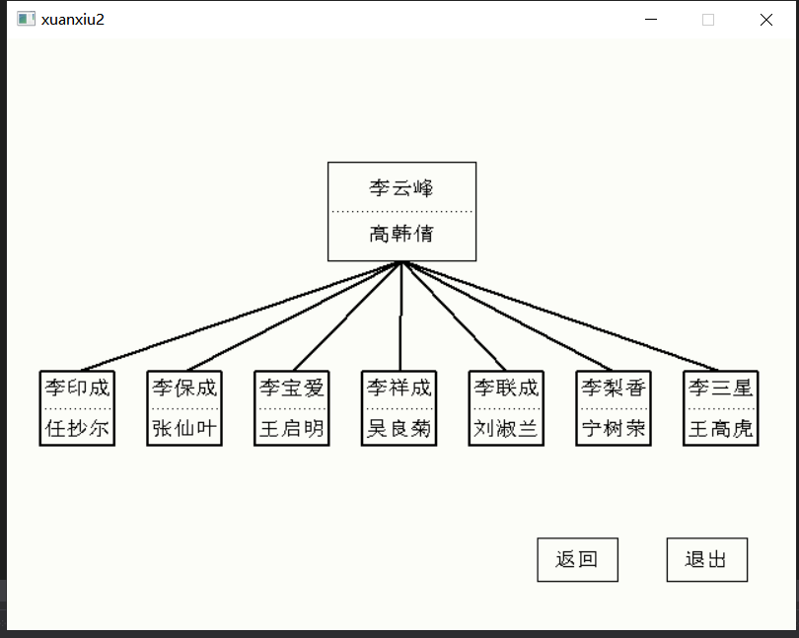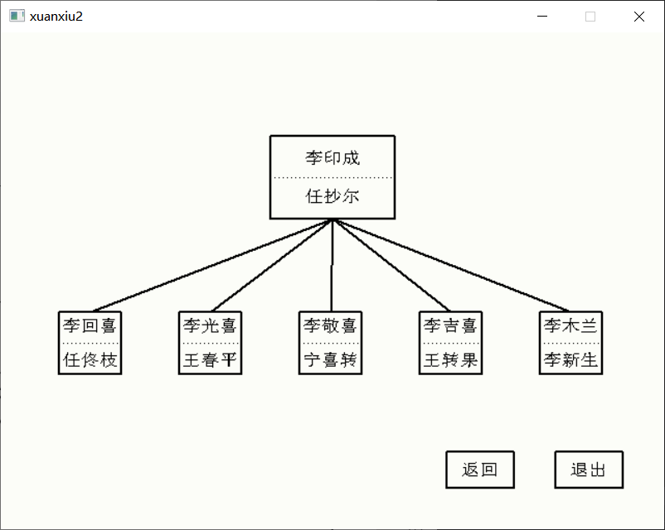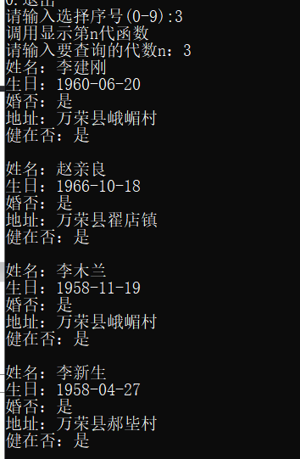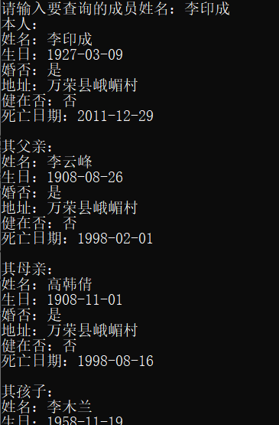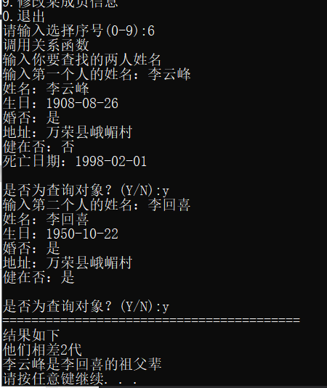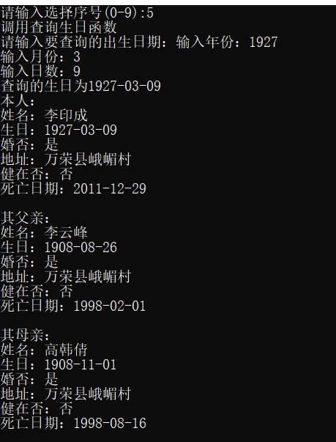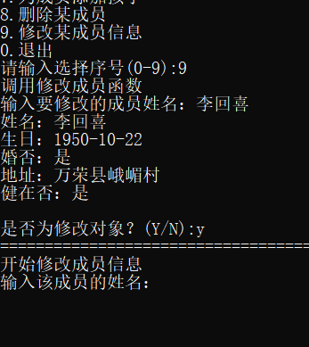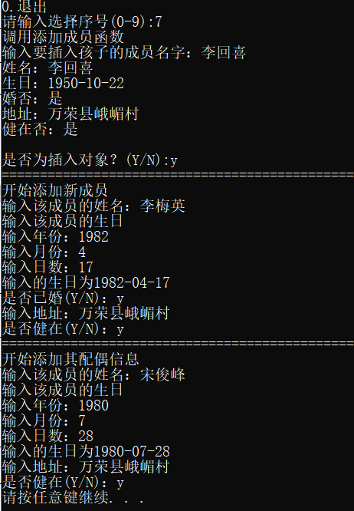

- 总结
族谱是我第二个使用图形界面的程序，但这次仅仅是调用了一个简单的easyX图形库，学会了如何快速上手一个新事物，即读官方文档。easyX也有很多不足的地方，比如它使用Unicode作为编码，而VS使用GBK编码，这边就需要将单字节char转换为宽字节char。easyX还无法将多行文本居中，总之，easyX虽然易安装使用，但其健全性而不行。

公交线路提示
- 任务简述
上网下载真实南京公交线路图，建立南京主要公交线路图的存储结构。
- 算法描述
- 经过站点最少，将两个相邻站点距离记作1，即可将问题转化为求最短路问题。利用Dijkstra算法，求出最短路径。
2）转站最少，利用Dijkstra算法，更新结点，判断待更新结点和之前结点的路线是否一致，一致则两点距离为0，否则距离为1。如此求出最少转站。
- 源代码
- #include <iostream>
- #include <cstdio>
- #include <cstdlib>
- #include <cstring>
- #define MAXN 8000

- using namespace std;

- typedef struct stack
- {
- int top;
- int stack[1000];
- }ST;
- typedef struct arcnode
- {
- int index;
- struct arcnode* next;
- }AR;
- typedef struct MyGraph
- {
- int type;
- int arcnum, vexnum;
- char** vexname;
- AR* N;
- ST* S;
- }GH;

- int findvex(char* s, GH* G)
- {
- int i;
- for (i = 0; i < G->vexnum; i++)
- {
- if (strcmp(s, G->vexname[i]) == 0)
- return i;
- }
- return -1;
- }

- void creatgraph(GH* G)
- {
- FILE* fp;
- AR* p;
- int i, j, k,m,n;
- int w;
- char c1[100],c3[200], c4[200],c2[8000];
- char filename[] = "路线.txt";
- fp = fopen(filename, "r");
- if (fp == NULL)
- {
- printf("read file erro\n");
- exit(-1);
- }
- G->type = 0;
- G->arcnum = 0;
- G->vexnum = 0;
- G->vexname = (char**)malloc(MAXN * sizeof(char*));
- G->N = (AR*)malloc(MAXN * sizeof(AR));
- G->S = (ST*)malloc(MAXN * sizeof(ST));
- for (i = 0; i < MAXN; i++)
- {
- G->S[i].top = 0;
- }
- while (fscanf(fp, "%s%s", c1, c2) != EOF)
- {
- w = atoi(c1);
- for (i = 0; i < strlen(c2);)
- {
- j = 0;
- while (c2[i] != ',')
- c3[j++] = c2[i++];
- c3[j]='\0',i++;
- j = 0, k = i;
- while (c2[k] != ','&&c2[k]!='\0')
- c4[j++] = c2[k++];
- c4[j] = '\0';
- m = findvex(c3, G);
- if (m == -1)
- {
- m = G->vexnum;
- G->vexname[m] = (char*)malloc(strlen(c3) * sizeof(char));
- strcpy(G->vexname[G->vexnum++], c3);
- G->N[m].next = NULL;
- }
- n = findvex(c4, G);
- if (n == -1)
- {
- n = G->vexnum;
- G->vexname[n] = (char*)malloc(strlen(c4) * sizeof(char));
- strcpy(G->vexname[G->vexnum++], c4);
- G->N[n].next = NULL;
- }
- G->S[m].stack[G->S[m].top++] = w;
- G->S[n].stack[G->S[n].top++] = w;
- p = (AR*)malloc(sizeof(AR));
- p->index = n;
- p->next = G->N[m].next;
- G->N[m].next = p;
- p = (AR*)malloc(sizeof(AR));
- p->index = m;
- p->next = G->N[n].next;
- G->N[n].next = p;
- G->arcnum++;
- if (k == strlen(c2)) break;
- }
- }
- fclose(fp);
- }

- void showroute(GH* G, int* pre, int i,int j)
- {
- if (pre[j] == i)
- {
- cout << G->vexname[i];
- return;
- }
- showroute(G, pre, i, pre[j]);
- cout << "--" << G->vexname[pre[j]];
- }

- int dis[MAXN], pre[MAXN], lu[MAXN];
- bool vis[MAXN];
- void find1(GH* G,int start,int end)
- {
- int n = G->vexnum;
- for (int i = 0; i < n; i++)
- {
- dis[i] = 999999;
- vis[i] = 0;
- pre[i] = i;
- }
- dis[start] = 0;
- for (int i = 0; i < n; i++)
- {
- int k = -1, mmin = 999999;
- for (int j = 0; j < n; j++)
- {
- if (mmin>dis[j]&&!vis[j])
- {
- mmin = dis[j];
- k = j;
- }
- }
- if (k == -1) break;
- vis[k] = 1;
- AR *p = G->N[k].next;
- while (p)
- {
- if (!vis[p->index] && dis[p->index] > dis[k] + 1)
- {
- dis[p->index] = dis[k] + 1;
- pre[p->index] = k;
- }
- p = p->next;
- }
- }
- if (dis[end] == 999999)
- {
- cout << "两站点不通车" << endl;
- return;
- }
- cout << "经过站点最少次数为" << dis[end] << "。乘车路线如下:" << endl;
- showroute(G,pre,start, end);
- cout << "--"<<G->vexname[end] << endl;
- }

- void find2(GH* G, int start, int end)
- {
- int n = G->vexnum;
- for (int i = 0; i < n; i++)
- {
- dis[i] = 999999;
- vis[i] = 0;
- pre[i] = i;
- lu[i] = 0;
- }
- dis[start] = 0;
- for (int i = 0; i < n; i++)
- {
- int k = -1, mmin = 999999;
- for (int j = 0; j < n; j++)
- {
- if (mmin > dis[j] && !vis[j])
- {
- mmin = dis[j];
- k = j;
- }
- }
- if (k == -1) break;
- vis[k] = 1;
- AR* p = G->N[k].next;
- while (p)
- {
- if (!vis[p->index]&&dis[p->index]>dis[k])
- {
- bool flag=0;
- if (!lu[k])
- {
- for (int j = 0; j < G->S[p->index].top; j++)
- {
- for (int l = 0; l < G->S[k].top; l++)
- if (G->S[p->index].stack[j] == G->S[k].stack[l])
- {
- dis[p->index] = dis[k];
- pre[p->index] = k;
- lu[p->index] = G->S[k].stack[l];
- flag = 1;
- break;
- }
- if (flag) break;
- }
- continue;
- }
- for (int j = 0; j < G->S[p->index].top; j++)
- {
- if (G->S[p->index].stack[j] == lu[k])
- {
- dis[p->index] = dis[k];
- pre[p->index] = k;
- lu[p->index] = G->S[i].stack[j];
- flag = 1;
- break;
- }
- }
- if (dis[p->index] > dis[k] + 1)
- {
- dis[p->index] = dis[k] + 1;
- pre[p->index] = k;
- for (int j = 0; j < G->S[p->index].top; j++)
- {
- for (int l = 0; l < G->S[k].top; l++)
- if (G->S[p->index].stack[j] == G->S[k].stack[l])
- {
- lu[p->index] = G->S[k].stack[l];
- flag = 1;
- break;
- }
- if (flag) break;
- }
- }
- }
- p = p->next;
- }
- }
- if (dis[end] == 999999)
- {
- cout << "两站点不通车" << endl;
- return;
- }
- cout << "转车次数最少次数为" << dis[end] << "。乘车路线如下:" << endl;
- showroute(G, pre, start, end);
- cout << "--" << G->vexname[end] << endl;
- }

- void busLine(GH *G)
- {
- char a[100], b[100];
- cout << "请输入起始站：";
- cin >> a;
- int x = findvex(a, G);
- cout << "请输入终点站：";
- cin >> b;
- int y = findvex(b, G);
- if (x == -1 || y == -1)
- {
- cout << "未查到站点信息" << endl;
- return;
- }
- find1(G,x,y);
- find2(G,x, y);
- }

- void showgraph(GH* G)
- {
- for (int i = 0; i < G->vexnum; i++)
- {
- AR* p = G->N[i].next;
- cout << G->vexname[i];
- while (p)
- {
- cout << "--" << G->vexname[p->index];
- p = p->next;
- }
- cout << endl;
- }
- }

- int main()
- {
- GH G;
- creatgraph(&G);
- busLine(&G);
- //showgraph(&G);
- return 0;
- }
- 结果分析
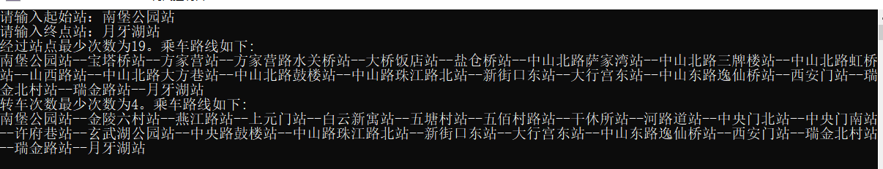
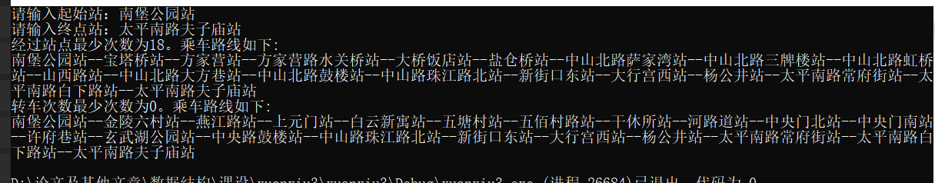
时间复杂度(nlogn)
- 总结
我觉得这个题目的主要难点在于数据结构的设计，算法直接套用Dijkstra就可以了。我一开始设计的结构没有专门存储边的数组，所以导致在查找路线的时候代码冗余丑陋。以后在思考问题时一定得设计好数据结构。

用扑克牌计算24点
- 任务简述
一副扑克牌的每张牌表示一个数（J、Q、K分别表示11、12、13，两个司令不用）。任取4张牌，即得到1-13的数，请添加运算符（规定为加、减、乘、除四种）使之成为运算式。每个数只能参与一次运算，4个数顺序可以任意组合，4个运算符任意取3个且可以重复取。运算遵从一定有限级别，可加括号控制，最终使运算结果为24.请输出一种解决方案的表达式，用括号表示运算优先。如果没有解决方案，则输出-1表示无解。
- 算法描述
四个数字计算总共五种顺序，即
((a+b)+c)+d,(a+(b+c))+d,a+((b+c)+d),a+(b+(c+d)),(a+b)+(c+d)。然后穷举这四个数的排列顺序，然后代入求值，若正确，则打印出相应计算法则。
- 源代码
- #include <cstdio>
- #include <cstdlib>
- #include <iostream>
- #include <ctime>

- using namespace std;

- double compute(double a, double b, char c)
- {
- if (c == '+') return a + b;
- if (c == '-') return a - b;
- if (c == '*') return a * b;
- if (c == '/') return a / b;
- }

- double solve1(double a, double b, double c, double d, char e, char f, char g)
- {
- double r1, r2, r3;
- r1 = compute(a, b, e);
- r2 = compute(r1, c, f);
- r3 = compute(r2, d, g);
- return r3;
- }

- double solve2(double a, double b, double c, double d, char e, char f, char g)
- {
- double r1, r2, r3;
- r1 = compute(b, c, f);
- r2 = compute(a, r1, e);
- r3 = compute(r2, d, g);
- return r3;
- }

- double solve3(double a, double b, double c, double d, char e, char f, char g)
- {
- double r1, r2, r3;
- r1 = compute(c, d, g);
- r2 = compute(b, r1, f);
- r3 = compute(a, r2, e);
- return r3;
- }

- double solve4(double a, double b, double c, double d, char e, char f, char g)
- {
- double r1, r2, r3;
- r1 = compute(b, c, f);
- r2 = compute(r1, d, g);
- r3 = compute(a, r2, e);
- return r3;
- }

- double solve5(double a, double b, double c, double d, char e, char f, char g)
- {
- double r1, r2, r3;
- r1 = compute(a, b, e);
- r2 = compute(c, d, g);
- r3 = compute(r1, r2, f);
- return r3;
- }

- bool Calculate24(double a, double b, double c, double d)
- {
- int i, j, k;
- double sum;
- char op[4] = { '+','-','*','/' };
- for (i = 0; i < 4; i++)
- {
- for (j = 0; j < 4; j++)
- {
- for (k = 0; k < 4; k++)
- {
- sum = solve1(a, b, c, d, op[i], op[j], op[k]);
- if (sum == 24)
- {
- printf("((%.0lf%c%.0lf)%c%.0lf)%c%.0lf\n", a, op[i], b, op[j], c, op[k], d);
- return 1;
- }
- sum = solve2(a, b, c, d, op[i], op[j], op[k]);
- if (sum == 24)
- {
- printf("(%.0lf%c(%.0lf%c%.0lf))%c%.0lf\n", a, op[i], b, op[j], c, op[k], d);
- return 1;
- }
- sum = solve3(a, b, c, d, op[i], op[j], op[k]);
- if (sum == 24)
- {
- printf("%.0lf%c(%.0lf%c(%.0lf%c%.0lf))\n", a, op[i], b, op[j], c, op[k], d);
- return 1;
- }
- sum = solve4(a, b, c, d, op[i], op[j], op[k]);
- if (sum == 24)
- {
- printf("%.0lf%c((%.0lf%c%.0lf)%c%.0lf)\n", a, op[i], b, op[j], c, op[k], d);
- return 1;
- }
- sum = solve5(a, b, c, d, op[i], op[j], op[k]);
- if (sum == 24)
- {
- printf("(%.0lf%c%.0lf)%c(%.0lf%c%.0lf)\n", a, op[i], b, op[j], c, op[k], d);
- return 1;
- }
- }
- }
- }
- return 0;
- }

- int main()
- {
- int i, j, k, l;
- srand((unsigned)time(0));
- double num[4];
- bool flag = false;
- num[0] = (double)((int)rand() % 13 + 1);
- num[1] = (double)((int)rand() % 13 + 1);
- num[2] = (double)((int)rand() % 13 + 1);
- num[3] = (double)((int)rand() % 13 + 1);
- cout << "生成的四个数为：" << num[0] << "," << num[1] << "," << num[2] << "," << num[3] << endl;
- for (i = 0; i < 4; i++)
- {
- for (j = 0; j < 4; j++)
- {
- if (i == j) continue;
- for (k = 0; k < 4; k++)
- {
- if (k == i || k == j) continue;
- for (l = 0; l < 4; l++)
- {
- if (l == k || l == i || l == j) continue;
- if (Calculate24(num[i], num[j], num[k], num[l]))
- flag = 1;
- }
- }
- }
- }
- if (!flag)
- cout << "无结果" << endl;
- return 0;
- }
- 结果分析
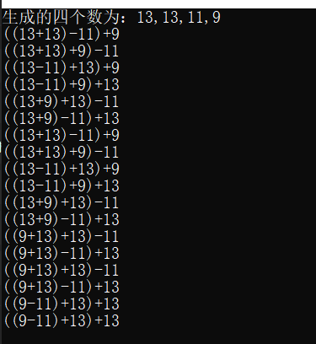
时间复杂度：O(1)
- 总结
一个简单的穷举，但我并没在代码里实现对相同公式的筛选删除。所以我想在这里写一下思路。将得到的正确结果存储在数组里，每当有一个新结果时，对数组进行遍历，若已有，则不进行添加。

朋友圈
- 任务简述
某学校有N个学生，形成M个俱乐部。每个俱乐部里的学生有着相似的兴趣爱好，形成一个朋友圈。一个学生可以同时属于若干个不同的俱乐部。根据“我的朋友的朋友也是我的朋友”这个推论可以得出，如果A和B是朋友，且B和C是朋友，则A和C也是朋友。请编写程序计算最大朋友圈中有多少人。
- 算法描述
运用并查集思想，将每个俱乐部的人员都合并到各自集合里，再根据每个集合中拥有的相同元素进行合并，最后统计最大的集合元素个数。
- 源代码
- #include <cstdio>
- #include <cstdlib>
- #include <iostream>
- #include <ctime>

- using namespace std;

- double compute(double a, double b, char c)
- {
- if (c == '+') return a + b;
- if (c == '-') return a - b;
- if (c == '*') return a * b;
- if (c == '/') return a / b;
- }

- double solve1(double a, double b, double c, double d, char e, char f, char g)
- {
- double r1, r2, r3;
- r1 = compute(a, b, e);
- r2 = compute(r1, c, f);
- r3 = compute(r2, d, g);
- return r3;
- }

- double solve2(double a, double b, double c, double d, char e, char f, char g)
- {
- double r1, r2, r3;
- r1 = compute(b, c, f);
- r2 = compute(a, r1, e);
- r3 = compute(r2, d, g);
- return r3;
- }

- double solve3(double a, double b, double c, double d, char e, char f, char g)
- {
- double r1, r2, r3;
- r1 = compute(c, d, g);
- r2 = compute(b, r1, f);
- r3 = compute(a, r2, e);
- return r3;
- }

- double solve4(double a, double b, double c, double d, char e, char f, char g)
- {
- double r1, r2, r3;
- r1 = compute(b, c, f);
- r2 = compute(r1, d, g);
- r3 = compute(a, r2, e);
- return r3;
- }

- double solve5(double a, double b, double c, double d, char e, char f, char g)
- {
- double r1, r2, r3;
- r1 = compute(a, b, e);
- r2 = compute(c, d, g);
- r3 = compute(r1, r2, f);
- return r3;
- }

- bool Calculate24(double a, double b, double c, double d)
- {
- int i, j, k;
- double sum;
- char op[4] = { '+','-','*','/' };
- for (i = 0; i < 4; i++)
- {
- for (j = 0; j < 4; j++)
- {
- for (k = 0; k < 4; k++)
- {
- sum = solve1(a, b, c, d, op[i], op[j], op[k]);
- if (sum == 24)
- {
- printf("((%.0lf%c%.0lf)%c%.0lf)%c%.0lf\n", a, op[i], b, op[j], c, op[k], d);
- return 1;
- }
- sum = solve2(a, b, c, d, op[i], op[j], op[k]);
- if (sum == 24)
- {
- printf("(%.0lf%c(%.0lf%c%.0lf))%c%.0lf\n", a, op[i], b, op[j], c, op[k], d);
- return 1;
- }
- sum = solve3(a, b, c, d, op[i], op[j], op[k]);
- if (sum == 24)
- {
- printf("%.0lf%c(%.0lf%c(%.0lf%c%.0lf))\n", a, op[i], b, op[j], c, op[k], d);
- return 1;
- }
- sum = solve4(a, b, c, d, op[i], op[j], op[k]);
- if (sum == 24)
- {
- printf("%.0lf%c((%.0lf%c%.0lf)%c%.0lf)\n", a, op[i], b, op[j], c, op[k], d);
- return 1;
- }
- sum = solve5(a, b, c, d, op[i], op[j], op[k]);
- if (sum == 24)
- {
- printf("(%.0lf%c%.0lf)%c(%.0lf%c%.0lf)\n", a, op[i], b, op[j], c, op[k], d);
- return 1;
- }
- }
- }
- }
- return 0;
- }

- int main()
- {
- int i, j, k, l;
- srand((unsigned)time(0));
- double num[4];
- bool flag = false;
- num[0] = (double)((int)rand() % 13 + 1);
- num[1] = (double)((int)rand() % 13 + 1);
- num[2] = (double)((int)rand() % 13 + 1);
- num[3] = (double)((int)rand() % 13 + 1);
- cout << "生成的四个数为：" << num[0] << "," << num[1] << "," << num[2] << "," << num[3] << endl;
- for (i = 0; i < 4; i++)
- {
- for (j = 0; j < 4; j++)
- {
- if (i == j) continue;
- for (k = 0; k < 4; k++)
- {
- if (k == i || k == j) continue;
- for (l = 0; l < 4; l++)
- {
- if (l == k || l == i || l == j) continue;
- if (Calculate24(num[i], num[j], num[k], num[l]))
- flag = 1;
- }
- }
- }
- }
- if (!flag)
- cout << "无结果" << endl;
- return 0;
- }
- 结果分析
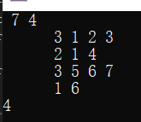
O(N)
- 总结
这题让我对并查集的理解更进一层，并且学会使用路径压缩来减小查询时的耗时。

