An Android Application of a Canteen Ordering System

**Plan**

* Definition:

The main purpose of the project is to develop an Android application which will be used by students and staff, so they can purchase food from the university’s canteen fast and easy.

By using the application, users will be able to see a list of menu options of the day and recommendations based on their order history. Also, they will be able to search for a meal either by its ingredients or by a type of food and set their dietary and cost constraints.

Once the users choose their meal, they will be able to pay for it in advance through the application (debit /credit card) or at the collection point (cash).

After placing their order, the users will be informed about their order’s status by notifications and for a limited time they will be able to update or delete their order.

* Aims:

My main goal for this project is to make a user-friendly and helpful Android application of a canteen ordering system.

I want to learn as many new things as possible about designing, implementing and testing an Android application, as well as making a secure application for payments.

I aim to improve my problem-solving skills by tackling any new possible challenges that might come up during the project and my time management skill since it is a project that is going to take a limited time, and there are many challenges that need to be accomplished during that period.

* Objectives:

To achieve my goals, first I need to acquire familiarity with Android SDK which it will entail understanding concepts of Android and using said concepts programmatically with Java. Also, I need to improve my knowledge regarding XML for the app design.

Secondly, I must do a market research, collect valuable information to help me find out if there is a market for the product/service (application) that I am about to develop during this project and help me to make some wise business decisions. Also, I need to do a research on similar applications, get some ideas, find out how they work, what things should I do or avoid.

Thirdly, I need to be able to make correct decisions on challenges that may come up while doing the project.

And finally, I want to make my application easy to use with many helpful and functional features, so every student and staff of the university want to have it on his /her phone.

* Requirements & deliverables:

1. **User:**

* : The user will be able to create an account if he /she is student or staff of the university. (Can sign up only with the university address)
* : The user must login into his /her account.
* : The user will be able to see a list of the menu options for the day.
* : The user will be able to see daily /weekly offers.
* : The user will be able to see recommendations by the application based on his/her order history.
* : The user will be able to see what products are trending at the time.
* : The user will be able to see the availability of the items.
* : The user will be able to see a description of the items including their ingredients.
* : The user will be able to see his /her order history.
* : The user will be able to search through a list of options based on the ingredients.
* : The user will be able to search for meals under different food categories.
* : The user will be able to set dietary constraints. (vegan, vegetarian etc.)
* : The user will be able to set cost constraints.
* : The user will be able to add items in the basket.
* : The user will be able to remove items from the basket.
* : The user will be able to change the quantity of an item in the basket.
* : The user will be able to pay for their order with credit /debit card through the app.
* : The user will be able to select the cash option at the checkout.
* : The user will be able to add items in his /her order, after the checkout, for a limited time.
* : The user will be able to remove items from his /her order, after the checkout, for a limited time.
* : The user will be able to delete his /her order, after the checkout, for a limited time.
* : The user will be able to receive a confirmation of his /her order.
* : The user will be able to receive a notification saying that his /her order is been processing and he /she cannot make any changes.
* : The user will be able to receive a notification, if he /she updated his /her order after checkout, saying that the changes he /she made are approved.
* : The user will be able to receive a notification saying that his /her order is finished and a unique order number.
* : The user will be able to add ranking on the items.
* : The user will be able to add a review with his /her ranking on the items.

1. **Administrator:**

* : The admin won’t have to sign up, his /her account will be given.
* : The admin will be able to login into the application but with different user permissions.
* : The admin will be able to see some edit buttons in the application that users cannot see.
* : The admin will be able to add new items.
* : The admin will be able to delete items.
* : The admin will be able to update the description of the items.
* : The admin will be able to update the price of the items.
* : The admin will be able to add offers for the day /week.
* : The admin will be able to remove offers for the day /week.
* 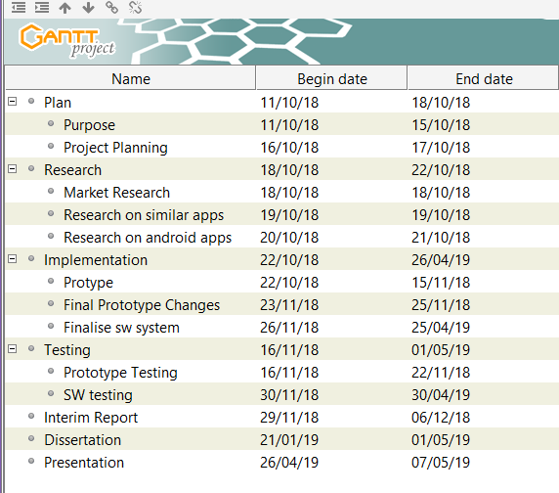Work breakdown (Gantt Chart)
* Prototype task consists of application design, database connection and some core features such as login, signup, add / remove / update items, search and checkout.
* Finalise SW system task consists of completion of the already existing features, security and some more features such as rating, offers, notifications etc.

