Decreasing TCP Latency by Increasing Initial Window Size

More information on TCP Initial Window here: https://tools.ietf.org/html/rfc6928, here https://developers.google.com/speed/articles/tcp_initcwnd_paper.pdf and here https://en.wikipedia.org/wiki/Slow-start
Argument: We should increase our TCP Initial window to 10 segments on our Microsoft Windows Servers to decrease our download times. Our applications are large (90+ initial requests on page load) with continual XHR requests made by the user. Because most of our requests are small (<200kb), it makes sense to limit the number of round trips. Latency seems to be a bigger factor in slowing down our application, rather than bandwidth.
Test Environment:
- Microsoft Windows Server 2008 R2 hosted on AWS in Oregon
- Hotfix KB 2472264 installed. https://support.microsoft.com/en-us/kb/2472264
- Test data: 180kb PNG image.

Distribution of Download Times
Initial Window set to 2 (default Windows Server 2008 R2 setting) 500 separate downloads
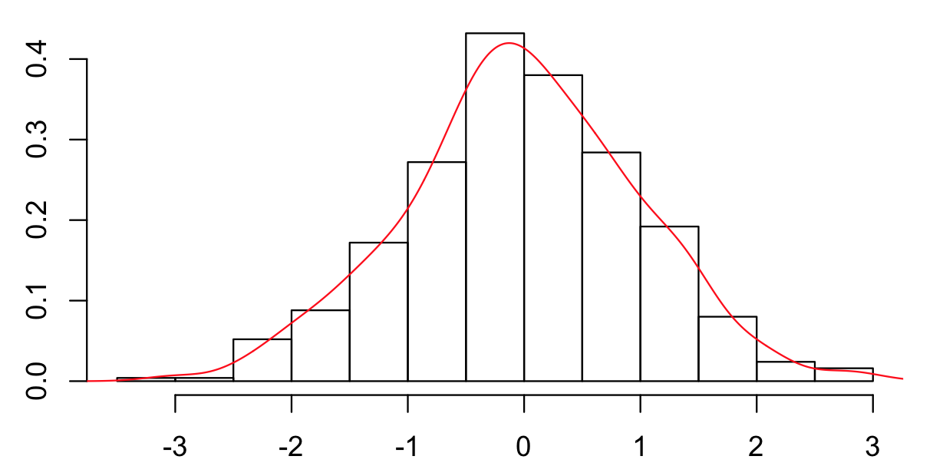
Min. 1st Qu. Median Mean 3rd Qu. Max.
0.7160 0.7550 0.7970 0.8161 0.8180 2.2850
Initial Window set to 10, 500 separate downloads
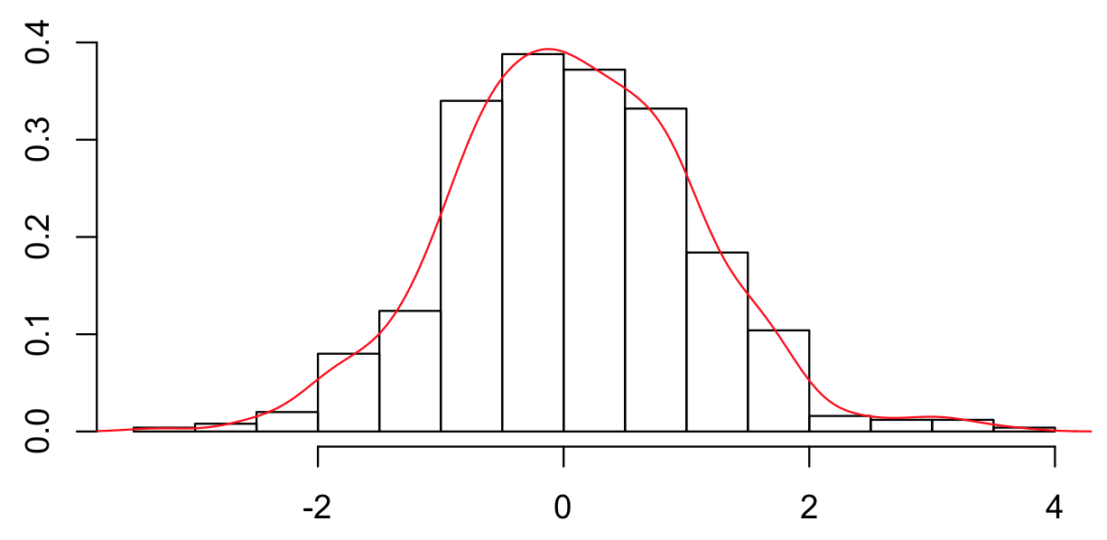
Min. 1st Qu. Median Mean 3rd Qu. Max.
0.5270 0.5550 0.5900 0.6004 0.6070 1.5330

Below is a CDF of total download time. I've eliminated a few download times >1.3 seconds because I've assumed they aren't necessarily demonstrative of average times.
10 = red, 2 = green
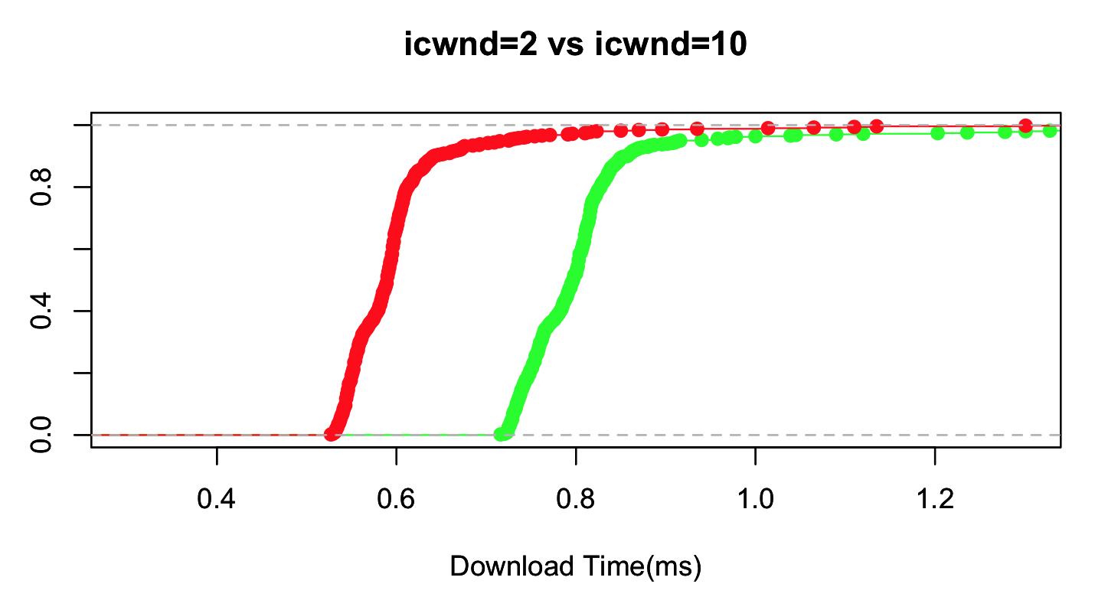
Correction: The above graph should show download time in seconds, not milliseconds.
Conclusion: During a test of 500 downloads, I observed a roughly 25% decrease in response times. This increases inversely to download size as the number of round trips decreases. On larger files (>5mb), the improvement is not as great because the window reaches its upper bound fairly quickly before finishing the request.

