UNIVERSITY OF GHANA
DEPARTMENT OF COMPUTER SCIENCE

UG CAMPUS MAINTENANCE SERVICE OPTIMIZER

A Project Report submitted in partial fulfilment of the requirements
for the course DCIT 204 & 308 — Data Structures and Algorithms

GROUP 17 — ONE STACK

Group Members

Name | Student ID
Desmond Sedem Kojo Dedzoe | 22101911
Emmanuel Nunoo Mensah | 22068431
Cheryl Abena Asantewaa Kwakye | 22081315
Dartey Natasha | 22125001
Natasha Cobblah | 22013436
ODAMTTEN, ISAIAH NII AMARH | 22272606
ABIAW, SYDELLE EDINAM | 22385260
OBENG, CHRISTIAN AMOAH | 22382197
KORANTENG, NATHANIEL BOATENG | 22411959
ACKAH, LORRAINE SEDEM | 22378275
KUMI, DELLIS ABOAGYEWAA | 22368740
ABINGA, DENNIS | 22393937

Dr. Kofi Sarpong
________________________________

August 2026

Contents
CHAPTER ONE 3
INTRODUCTION 3
1.1 Background of the Study 3
1.2 Problem Statement 3
1.3 Aim of the Project 5
1.4 Objectives 5
1.5 Scope of the Study 5
1.6 Significance of the Study 6
CHAPTER TWO 8
LITERATURE REVIEW 8
2.1 Campus Maintenance Management Systems 8
2.2 Service Request Management 8
2.3 Priority-Based Scheduling 8
2.4 Route Optimization 8
2.5 Data Structures in Management Systems 9
2.6 Graph Algorithms for Route Optimization 9
2.7 Review of Existing Systems 9
2.8 Research Gap 9
CHAPTER THREE 11
SYSTEM ANALYSIS AND DESIGN 11
3.1 Requirements Analysis 11
3.1.1 Functional Requirements 11
3.1.2 Non-Functional Requirements 11
3.2 System Architecture 11
3.3 Use Case Diagram 12
3.4 Database Design 13
3.5 System Workflow 13
CHAPTER FOUR 14
IMPLEMENTATION 14
4.1 Frontend 14
4.2 Backend 14
4.3 Custom Data Structures 14
4.4 Algorithms 15
CHAPTER FIVE 17
TESTING AND RESULTS 17
5.1 Unit Testing 17
5.2 Algorithm Testing 17
5.3 Integration and API Testing 18
5.4 Results Summary 18
CHAPTER SIX 19
CONCLUSION AND RECOMMENDATIONS 19
6.1 Conclusion 19
6.2 Limitations 19
6.3 Future Work 19
REFERENCES 21
APPENDICES 22
Appendix A: Group Members 22
Appendix B: Project Repository 22
Appendix C: Sample Test Outputs 22
Appendix D: Use Case / Architecture Diagrams 22

CHAPTER ONE

INTRODUCTION

1.1 Background of the Study
Managing maintenance activities across a large university campus presents significant operational challenges. The University of Ghana (UG) campus comprises numerous facilities including lecture halls, hostels, libraries, laboratories, administrative offices, and recreational spaces. These facilities require continuous upkeep to support academic and administrative functions effectively.
Campus users students, staff, and faculty frequently report maintenance problems ranging from plumbing leaks and electrical faults to broken furniture and infrastructure defects. These service requests vary widely in urgency: a burst pipe in a hostel bathroom demands immediate attention, whereas a flickering light in a corridor may be deferred. Technicians responsible for resolving these issues possess different specializations (electrical, plumbing, carpentry, HVAC, and general maintenance), and assigning the wrong technician to a request leads to delays and inefficient use of skilled labour.
Furthermore, campus locations are interconnected through a network of roads and pathways with measurable distances. When a technician must travel from one work site to another, the choice of route directly affects response time and fuel or time costs. Manually managing the prioritization of requests, matching technicians to jobs by category, tracking request status, and planning travel routes is time-consuming and prone to human error.
This project proposes a Campus Maintenance Service Optimizer that applies data structures and algorithms to improve three core processes: (1) prioritization of maintenance requests according to urgency, (2) assignment of suitable technicians based on service category and availability, and (3) calculation of efficient routes between campus locations using graph algorithms. By combining a structured software system with carefully chosen data structures (priority queues, graphs, hash maps, trees, and others) and algorithms (Dijkstra, Prim, Kruskal, searching, and sorting), the system aims to make maintenance operations more organized, transparent, and efficient.

1.2 Problem Statement
The existing maintenance process at many university campuses, including aspects of practice at the University of Ghana, often relies on informal channels (phone calls, walk-ins, or paper forms) and manual coordination. This approach makes it difficult to efficiently prioritize service requests according to urgency, assign appropriate technicians with the correct specialization, track the status of requests from submission to resolution, and determine efficient travel routes between dispersed campus locations.
Without systematic prioritization, urgent issues may remain unaddressed while lower-priority work is performed. Without category-based assignment, technicians may be sent to jobs outside their expertise. Without route optimization, technicians waste time navigating suboptimal paths across campus. Without centralized tracking, administrators lack visibility into workload, backlog, and performance.
The proposed solution is a software system—the UG Campus Maintenance Service Optimizer—that digitizes request submission and tracking, applies priority-queue-based prioritization, matches requests to technicians by service category, models the campus as a weighted graph, and computes shortest paths and related connectivity metrics using established graph algorithms. The system is implemented primarily in Java with custom data structures and algorithms, supported by a MySQL database and a web-based frontend for user interaction.

1.3 Aim of the Project
To design and implement a campus maintenance management system that uses data structures and algorithms to prioritize maintenance requests, assign suitable technicians, and optimize technician routes across the University of Ghana campus.

1.4 Objectives
The specific objectives of this project are:
- To develop a system that enables campus users to submit and track maintenance requests.
- To prioritize maintenance requests according to their urgency using priority-based data structures.
- To assign maintenance requests to available technicians based on service category and specialization.
- To determine efficient routes between campus locations using graph algorithms such as Dijkstra’s shortest-path algorithm.
- To provide administrators and technicians with dashboards and interfaces for managing, monitoring, and updating maintenance activities.

1.5 Scope of the Study
The system covers the following stakeholders and capabilities:
Campus Users
- Create and submit maintenance requests with description, category, location, and urgency level.
- View their submitted requests and track request status (pending, assigned, in progress, completed).
Technicians
- Log in and view assigned maintenance requests.
- Accept or update the status of assigned requests.
- View calculated routes from their current or base location to maintenance sites.
Administrators
- View and monitor all service requests and their priority order.
- Monitor technicians’ workloads and availability.
- Manage maintenance operations, service categories, and campus locations.
System Capabilities
- Request prioritization using priority queues and related structures.
- Technician assignment based on category matching.
- Route calculation over a campus road network modelled as a weighted graph.
- Database persistence for users, technicians, requests, locations, and roads.
- Custom implementations of data structures and algorithms for educational demonstration and performance analysis.
The project focuses on the University of Ghana campus as the application domain. It does not include real-time GPS tracking, mobile-native applications, or predictive maintenance models in the current version.

1.6 Significance of the Study
The project is significant for several groups:
Campus Users:
They gain a clearer, more accessible way to report maintenance problems and to track the progress of their requests without repeated physical visits or phone calls.
Technicians:
They receive clearer assignments matched to their specialization and can obtain suggested routes to maintenance locations, reducing uncertainty and travel time.
Administrators:
They obtain better visibility into the volume, priority, and status of requests, as well as technician utilization, supporting more informed operational decisions.
The University:
More organized and efficient maintenance operations can improve facility condition, reduce downtime of critical spaces, and demonstrate the practical application of computer science principles (data structures and algorithms) to real institutional problems.
Academically, the project serves as a concrete demonstration of how classic data structures and graph algorithms can be applied to a domain-relevant problem, aligning with the learning outcomes of DCIT 308.

CHAPTER TWO

LITERATURE REVIEW

2.1 Campus Maintenance Management Systems
Campus and facilities maintenance management systems (often implemented as Computerized Maintenance Management Systems—CMMS) are used by universities and other large institutions to track assets, schedule preventive and corrective maintenance, manage work orders, and report on performance. Literature and industry practice emphasize the shift from purely reactive maintenance (fix after failure) toward planned and priority-driven approaches. Studies of higher education institutions in Ghana and elsewhere note that many campuses still rely heavily on reactive strategies and lack formalized digital workflows, leading to deferred maintenance backlogs and inefficient resource allocation.
Modern CMMS platforms offer work-order management, asset registers, and reporting dashboards. However, many commercial systems are general-purpose and do not specifically model campus road networks for technician routing or expose the underlying prioritization and assignment algorithms for educational study. This project sits at the intersection of practical request management and explicit application of data structures and algorithms.

2.2 Service Request Management
Service request (or work-order) management typically involves intake, categorization, prioritization, assignment, execution, and closure. Research and practice highlight the importance of clear categories (e.g., electrical, plumbing), status workflows (pending → assigned → in progress → completed), and audit trails. Web-based portals that allow end users to submit requests and view status reduce informal channels and improve transparency. Systems that support role-based access (requester, technician, administrator) align with the multi-stakeholder nature of campus operations.

2.3 Priority-Based Scheduling
Priority-based scheduling ensures that higher-urgency work is considered before lower-urgency work. Priority queues (often implemented with heaps) are a natural data structure for this purpose: each request is associated with a priority key, and extraction always yields the highest-priority pending item. In maintenance contexts, priority may be derived from urgency level, impact on safety or teaching, time since submission, or a composite score. Academic treatments of priority queues and heaps provide the theoretical foundation for efficient prioritization used in this project.

2.4 Route Optimization
Route optimization for field technicians is a classic application of graph algorithms. Campus locations can be modelled as vertices and roads (or walkways) as weighted edges, with weights representing distance or estimated travel time. Shortest-path algorithms such as Dijkstra’s algorithm compute the minimum-cost path between a technician’s location and a maintenance site. Minimum spanning tree algorithms (Prim, Kruskal) can be used to analyse overall campus connectivity or to design efficient inspection tours under certain assumptions. Literature on facilities maintenance has applied shortest-path and related optimization methods to multi-building campuses and asset networks.

2.5 Data Structures in Management Systems
Management systems rely on a variety of data structures: dynamic arrays and linked lists for collections of records; hash tables for fast key-based lookup (e.g., by request ID or technician ID); binary search trees and balanced trees (e.g., red-black trees, B-trees) for ordered storage and range queries; queues and stacks for sequential processing; and graphs for relational and spatial structure. Implementing these structures from first principles, as required in a data structures and algorithms course, deepens understanding of time and space complexity and of when each structure is appropriate.

2.6 Graph Algorithms for Route Optimization
Dijkstra’s algorithm computes single-source shortest paths in graphs with non-negative edge weights and is widely used for road networks. Prim’s and Kruskal’s algorithms construct minimum spanning trees; Kruskal’s uses a disjoint-set (union-find) structure, which is itself an important data structure. Breadth-first search (BFS) and depth-first search (DFS) support connectivity analysis and traversal. This project implements and applies these algorithms to a campus road graph so that technicians can obtain shortest-route guidance and administrators can reason about campus connectivity.

2.7 Review of Existing Systems
Existing campus maintenance or facilities systems include commercial CMMS products, institutional portals for submitting facilities requests, and research prototypes that combine building information models with path optimization. Many commercial systems provide strong workflow and reporting features but treat prioritization and routing as black-box or configurable rules rather than explicit algorithmic components. Academic projects often focus either on request ticketing (without graph-based routing) or on routing/optimization (without full multi-role request management). Few educational projects combine custom data-structure implementations, priority-based request handling, technician assignment by category, and graph-based campus routing in a single coherent system with a database and user interface.

2.8 Research Gap
The gap addressed by this project is the lack of an integrated, educationally transparent campus maintenance system that: (1) allows users to submit and track requests; (2) prioritizes requests using an explicit priority-queue implementation; (3) assigns technicians by service category; (4) models the campus as a weighted graph and computes shortest routes with Dijkstra (and related algorithms such as Prim and Kruskal); and (5) implements a broad set of custom data structures and algorithms for study and performance analysis. By filling this gap, the project both supports more efficient maintenance operations conceptually and serves as a rich vehicle for learning data structures and algorithms in a realistic domain.

CHAPTER THREE

SYSTEM ANALYSIS AND DESIGN

3.1 Requirements Analysis

3.1.1 Functional Requirements
The system shall support the following functional requirements:
- User registration and login for campus users, technicians, and administrators.
- Submission of maintenance requests with description, category, location, and urgency.
- Viewing and tracking of requests by the submitting user.
- Prioritization of pending requests according to urgency (priority queue behaviour).
- Assignment of requests to technicians based on service category and availability.
- Technician login, viewing of assigned requests, acceptance, and status updates.
- Calculation of shortest routes between campus locations using graph algorithms.
- Administrative monitoring of requests, technicians, categories, and locations.
- Persistence of data in a relational database and retrieval via repositories/services.

3.1.2 Non-Functional Requirements
- Performance: Core operations (priority extraction, shortest-path computation, lookups) should complete in acceptable time for campus-scale data.
- Reliability: Data should persist correctly; algorithms should produce correct results for valid inputs.
- Security: Access should be role-based; authentication should protect sensitive operations.
- Usability: Interfaces for users, technicians, and administrators should be clear and task-oriented.
- Maintainability: Code should be modular (models, services, repositories, data structures, algorithms) to support extension and academic review.

3.2 System Architecture
The system follows a layered architecture:
React Web Application (Frontend)
↓
REST API / HTTP Interface
↓
Java Backend (Maven project; Spring Boot or equivalent service layer where applicable)
↓
Service Layer (business logic, prioritization, assignment, routing)
↓
Custom Data Structures & Algorithms
↓
Repository / Data Access Layer
↓
MySQL Database
The frontend provides dashboards and forms for campus users, technicians, and administrators. It communicates with the backend via REST-style endpoints. The backend hosts the domain models, services that orchestrate prioritization, assignment, and routing, and the custom data structure and algorithm implementations. The repository layer abstracts persistence, and MySQL stores users, technicians, service requests, categories, locations, and road segments. This separation allows the algorithmic core to be tested independently and demonstrated clearly for academic assessment.

3.3 Use Case Diagram
Primary actors and their main use cases are:
Campus User
- Register / Login
- Submit maintenance request
- View and track own requests
Technician
- Login
- View assigned requests
- Accept / update request status
- View route to maintenance location
Administrator
- Login
- View and manage all requests
- Monitor technicians
- Manage categories, locations, and system configuration
(A formal UML use-case diagram can be included in the appendix or presentation slides.)

3.4 Database Design
Major tables and their roles include:
Table | Purpose
users | Campus users and administrators (credentials, role, contact).
technicians | Technician profiles, specialization/category, availability.
service_requests | Requests with description, urgency, status, location, category, assignee.
service_categories | Categories such as electrical, plumbing, carpentry, general.
locations | Campus locations (buildings, halls, landmarks) as graph vertices.
roads | Road/path segments between locations with distance (edge weights).

Additional supporting tables may store status history, route results, or performance metrics. Relationships enforce that each request has a category and location, and may be assigned to one technician.
Schema:
CREATE TABLE campus_users (
id INT UNSIGNED AUTO_INCREMENT PRIMARY KEY,
full_name VARCHAR(100) NOT NULL,
email VARCHAR(100) NOT NULL UNIQUE,
phone_number VARCHAR(20),
role ENUM(
'Student',
'Lecturer',
'Maintenance Officer',
'ICT Staff',
'Security Officer',
'Administrator'
) NOT NULL,
created_at TIMESTAMP NOT NULL DEFAULT CURRENT_TIMESTAMP,
updated_at TIMESTAMP NULL ON UPDATE CURRENT_TIMESTAMP
);

CREATE TABLE locations (
id INT UNSIGNED AUTO_INCREMENT PRIMARY KEY,
location_name VARCHAR(100) NOT NULL,
location_type ENUM(
'Department',
'Hall',
'Library',
'Office',
'Laboratory',
'Lecture Hall'
) NOT NULL,
description TEXT,
x_coordinate DECIMAL(18, 15) DEFAULT NULL,
y_coordinate DECIMAL(18, 15) DEFAULT NULL,
created_at TIMESTAMP NOT NULL DEFAULT CURRENT_TIMESTAMP
);
CREATE TABLE roads (
id INT UNSIGNED AUTO_INCREMENT PRIMARY KEY,
from_location_id INT UNSIGNED NOT NULL,
to_location_id INT UNSIGNED NOT NULL,
distance_km DECIMAL(5,2) NOT NULL,
travel_time_minutes INT NOT NULL,
road_condition ENUM('Excellent', 'Good', 'Fair', 'Poor') NOT NULL,
created_at TIMESTAMP NOT NULL DEFAULT CURRENT_TIMESTAMP,

CONSTRAINT fk_roads_from_location
FOREIGN KEY (from_location_id) REFERENCES locations (id)
ON UPDATE CASCADE ON DELETE RESTRICT,

CONSTRAINT fk_roads_to_location
FOREIGN KEY (to_location_id) REFERENCES locations (id)
ON UPDATE CASCADE ON DELETE RESTRICT
);
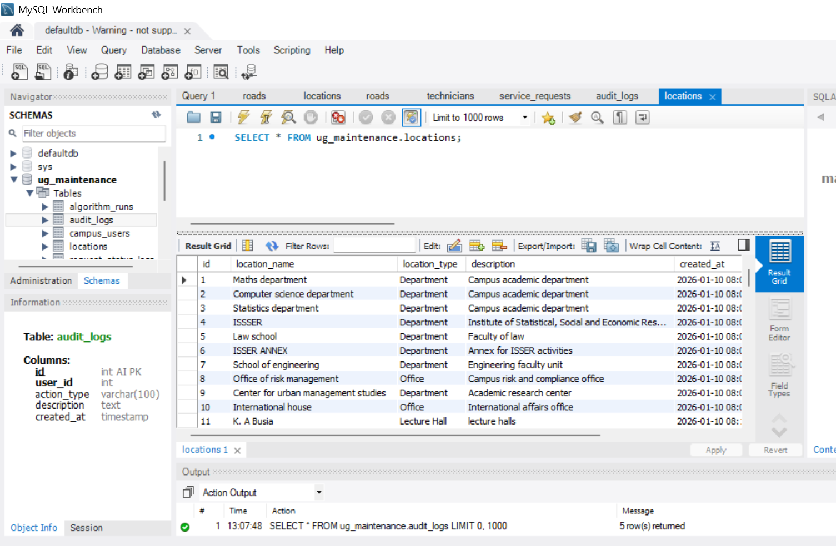

3.5 System Workflow
The end-to-end workflow is as follows:
- Campus user creates a maintenance request (description, category, location, urgency).
- Request is stored in the database and entered into the prioritization structure.
- Request is prioritized according to urgency (priority queue).
- Service category is identified from the request.
- A suitable available technician with matching specialization is identified.
- Technician receives the assignment (via dashboard / notification of assigned list).
- Shortest route from technician’s location (or base) to the request location is calculated using Dijkstra’s algorithm on the campus graph.
- Technician accepts the request and proceeds to the site.
- Work is performed; request status is updated (in progress → completed).
- User and administrator can observe the final status; metrics may be recorded for reporting.

CHAPTER FOUR

IMPLEMENTATION

4.1 Frontend
The frontend is implemented as a React web application. It provides role-specific interfaces:
- Components for login, request submission forms, request lists, and status displays for campus users.
- Technician dashboard for assigned jobs, status updates, and route display.
- Administrator views for all requests, technicians, categories, and locations.
- Client-side routing to navigate between pages without full reloads.
- API communication (HTTP requests to backend endpoints) to create, read, and update resources.
Dashboards emphasize clarity: pending vs. completed counts, priority indicators, and simple route or distance information where applicable.

4.2 Backend
The backend is a Java 17 project managed with Maven. Key packages include:
- models — domain entities (User, Technician, ServiceRequest, Location, Road, etc.).
- services — business logic for request management, prioritization, assignment, and routing.
- repositories / database — data access and persistence to MySQL.
- datastructures — custom implementations of arrays, lists, stacks, queues, priority queues, trees, hash tables, graphs, and disjoint sets.
- algorithms — searching, sorting, BFS, DFS, Dijkstra, Prim, Kruskal, and related utilities.
- api / config — endpoints and configuration for integration with the frontend and database.
REST-style APIs expose operations such as create request, list requests, assign technician, compute route, and update status. Services invoke the custom data structures and algorithms rather than relying solely on library collections, fulfilling the educational goals of the course.

4.3 Custom Data Structures
The following custom data structures were implemented and used:
Data Structure | Purpose
Dynamic Array | Dynamic storage of collections that grow as needed.
Linked List | Sequential data management and flexible insertion/deletion.
Stack | LIFO operations (e.g., undo or traversal support).
Queue / Circular Queue / Deque | FIFO and double-ended processing of tasks or events.
Priority Queue / Heap | Prioritizing maintenance requests by urgency.
HashMap / Hash Table | Key-value lookup (e.g., by ID or category).
HashSet | Unique element sets (e.g., visited nodes in graph algorithms).
Binary Search Tree (BST) | Ordered searching and ordered storage of records.
Red-Black Tree | Balanced ordered map with guaranteed logarithmic operations.
B-Tree | Efficient hierarchical searching suited to large ordered data.
Graph | Campus road network (vertices = locations, edges = roads with weights).
Disjoint Set (Union-Find) | Support for Kruskal’s minimum spanning tree algorithm.

These structures are used both in the operational flow (priority queue for requests, graph for routing) and in supporting modules (searching, sorting, connectivity analysis, performance measurement).

4.4 Algorithms
Key algorithms and their purposes:
Algorithm | Purpose
Linear / Binary Search | Finding records by key or ordered position.
Selection / Insertion / Merge / Quick Sort | Organizing requests or other data for display or analysis.
BFS / DFS | Graph traversal and connectivity analysis.
Dijkstra | Shortest path (route) for a technician to a maintenance location.
Prim | Minimum spanning tree of the campus network.
Kruskal | Minimum spanning tree using disjoint-set structure.
BST / B-Tree / Red-Black operations | Ordered insert, search, and related hierarchical operations.

Justification for Dijkstra’s algorithm
We used Dijkstra’s algorithm because the campus is represented as a weighted graph where locations are vertices and roads are edges with distances (non-negative weights). Dijkstra’s algorithm allows us to determine the shortest distance (and path) between a technician’s current or base location and the maintenance location. This supports efficient routing and reduces unnecessary travel time across campus.
Justification for Priority Queue
A priority queue (heap-based) is used so that the next request selected for assignment is always the highest-urgency pending request, ensuring that critical issues are addressed before lower-priority ones.
5. Pseudocode
Offer Operation

OFFER(request)
Add request to the end of the heap
Set index to the position of the new request
WHILE index is not the root
Find the parent of the current index
IF request has higher priority than its parent
Swap request with its parent
Update index to the parent's position
ELSE
STOP
END IF
END WHILE

Poll Operation

POLL()
IF the queue is empty
Return null
END IF
Save the root as the highest-priority request
Replace the root with the last request
Remove the last position
Set index to the root
WHILE the current request has a lower priority than a child
Find the higher-priority child
Swap the current request with that child
Update index to the child's position
END WHILE
Return the saved highest-priority request

Priority Calculation

CALCULATE_SCORE(request)
Limit urgency to a value between 1 and 5
Calculate the number of hours the request has waited
Score = (4 × Urgency) + (3 × WaitHours)
IF urgency is 5
Add CriticalBonus
END IF
Return Score

6. Priority Calculation

Priority scores are calculated using:

Priority Score = (4 × Urgency) + (3 × WaitHours) + CriticalBonus

Critical requests receive an additional bonus score.
Justification for Prim and Kruskal
Prim’s and Kruskal’s algorithms are applied to compute a minimum spanning tree of the campus graph. This supports analysis of campus connectivity and demonstrates classic MST algorithms and the use of the disjoint-set structure (for Kruskal) in a practical setting.

CHAPTER FIVE

TESTING AND RESULTS

5.1 Unit Testing
Unit tests (JUnit 5) were written for core data structures and services. Tests verify correct behaviour of insertion, deletion, search, and order properties for priority queues, trees, graphs, and related structures. Service-level tests check request creation, prioritization order, assignment logic, and route computation for valid and edge-case inputs (e.g., same location, invalid location).

5.2 Algorithm Testing
Illustrative test outcomes include:
Priority Queue
Requests inserted with priorities 5, 4, 3, 2, 1 (higher number = higher urgency in the test setup) were polled in descending order:
Polled: 5
Polled: 4
Polled: 3
Polled: 2
Polled: 1
Priority order test passed.
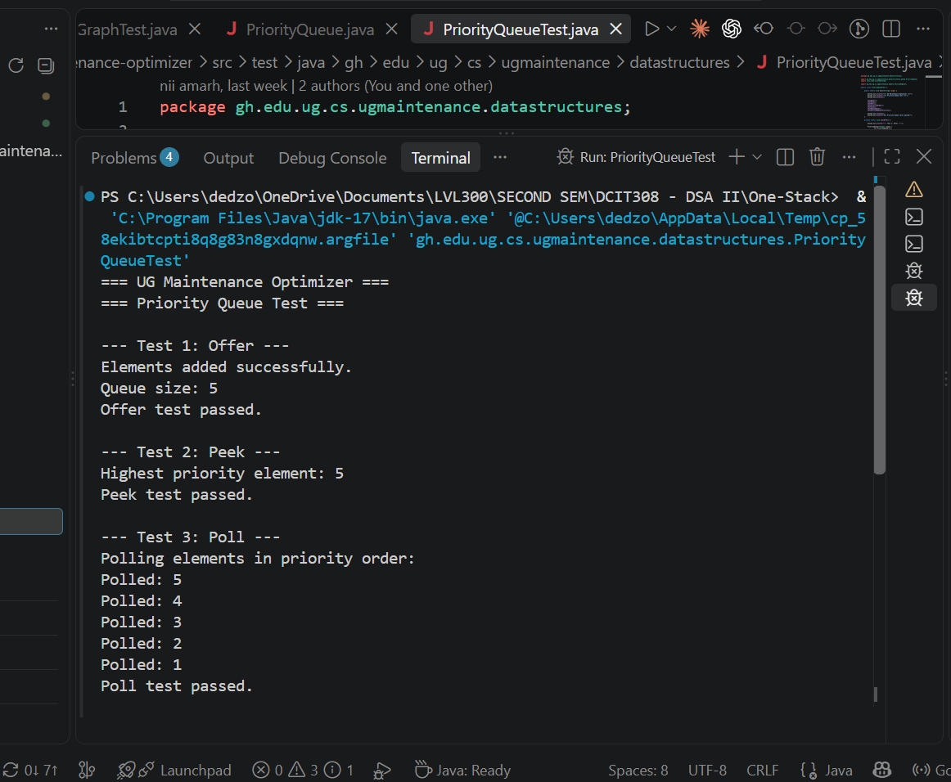
Dijkstra
For a sample campus graph, the shortest distance from location 1 to location 4 was computed as 900.0 m. Shortest-distance test passed.
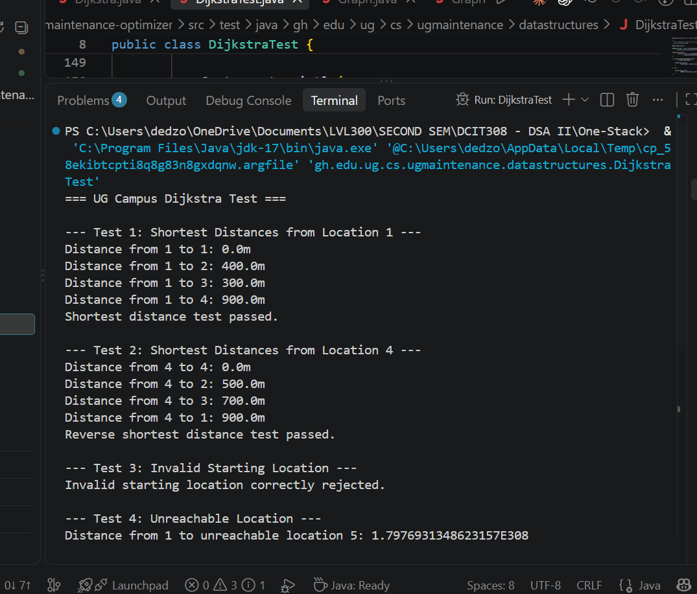
RouteService
Route distance test passed.
Invalid location test passed (appropriate error or empty result).
Same location test passed (distance 0).
These results confirm that the prioritization and routing components behave as specified.
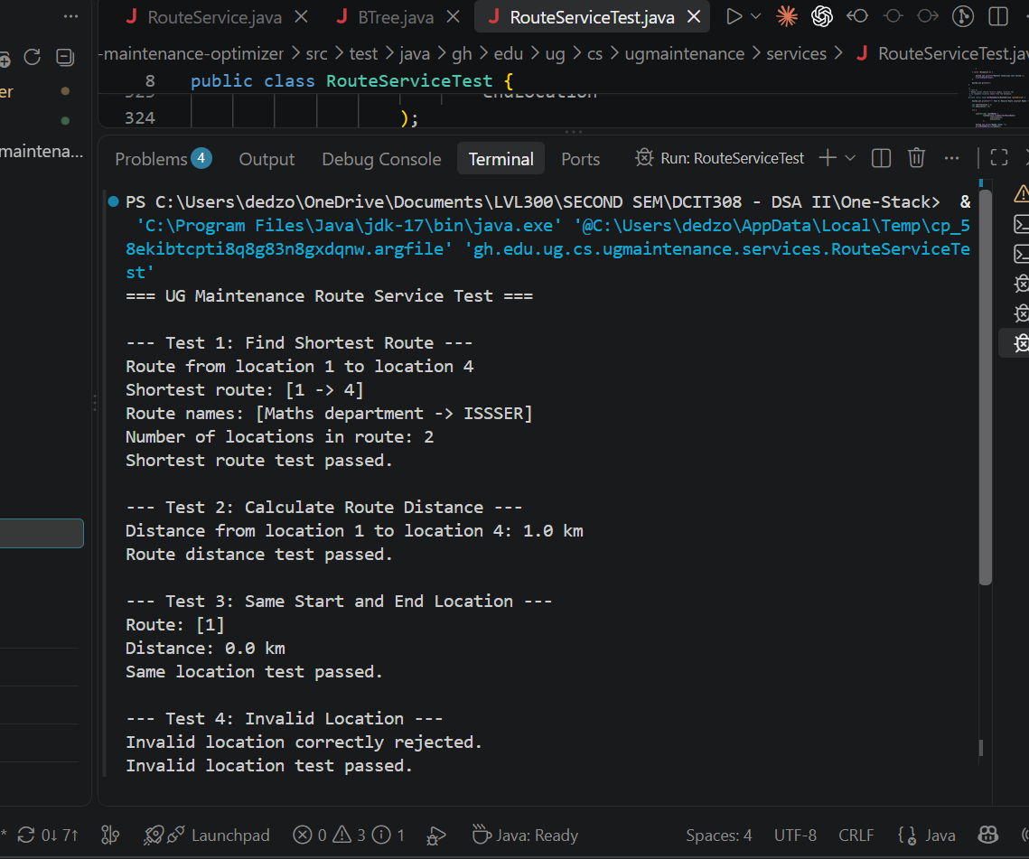

5.3 Integration and API Testing
Integration tests exercise the flow from API (or service entry points) through repositories to the database and back. Frontend testing includes form submission, list rendering, and status updates against a running or mocked backend. Database testing verifies that entities are persisted and retrieved correctly and that foreign-key relationships (request → category, location, technician) are maintained.

5.4 Results Summary
Testing demonstrated that:
- Priority queue correctly orders requests by urgency.
- Dijkstra’s algorithm correctly computes shortest paths on the campus graph.
- Route service handles normal, same-location, and invalid-location cases.
- Custom data structures support the required operations for the maintenance workflow.
- End-to-end request submission, prioritization, assignment, and status update can be demonstrated through the system interfaces.
Performance measurements (e.g., for red-black tree or other structures) can be reported from CSV or console output generated during testing, as available in the project repository.
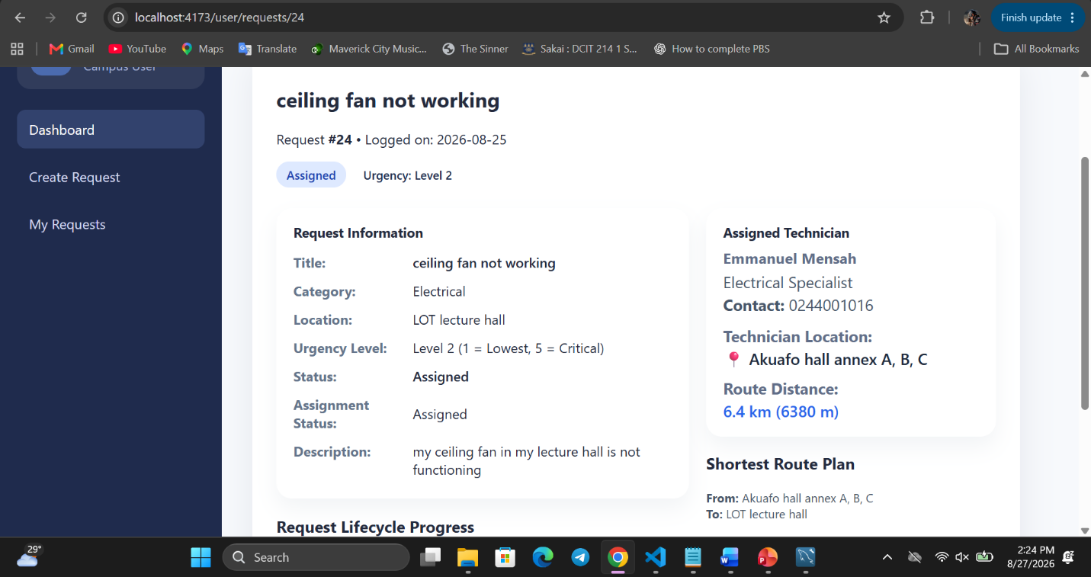

CHAPTER SIX

CONCLUSION AND RECOMMENDATIONS

6.1 Conclusion
This project designed and implemented the UG Campus Maintenance Service Optimizer, a system that applies data structures and algorithms to the management of maintenance requests across the University of Ghana campus. The system enables campus users to submit and track requests, prioritizes requests by urgency using a priority queue, assigns technicians by service category, and computes efficient routes over a campus road network using Dijkstra’s algorithm and related graph algorithms. Custom implementations of dynamic arrays, linked lists, stacks, queues, priority queues, hash tables, trees, graphs, and disjoint sets, together with searching, sorting, and graph algorithms, fulfil both operational and educational objectives.
Through layered architecture, database persistence, and role-based interfaces, the project demonstrates how theoretical constructs from a data structures and algorithms course can be applied to a realistic institutional problem. Testing confirmed correct prioritization order, shortest-path results, and handling of edge cases, supporting the claim that the system meets its stated aim and objectives.

6.2 Limitations
The current system has the following limitations:
- Dependence on database connectivity; offline operation is not supported.
- Campus location and road data may need continuous updating to remain accurate.
- Route accuracy depends on the completeness and correctness of the road network data.
- Real-world factors such as traffic, one-way restrictions, or temporary closures are not modelled.
- Live GPS tracking of technicians and real-time re-routing are outside the current scope.

6.3 Future Work
Possible improvements and extensions include:
- GPS / live location tracking of technicians and dynamic route updates.
- Real-time technician movement visualization on a campus map.
- Native mobile application for users and technicians.
- Real-time notifications (e.g., push or SMS) for assignment and status changes.
- More advanced route optimization (multi-stop, capacity, or time-window constraints).
- Predictive maintenance models based on historical request and asset data.
- Cloud deployment for broader access and scalability.

REFERENCES
Cormen, T. H., Leiserson, C. E., Rivest, R. L., & Stein, C. (2009). Introduction to Algorithms (3rd ed.). MIT Press.
University of Ghana. (n.d.). Campus facilities and Physical Development and Municipal Services Directorate (PDMSD) materials.
Project repository: https://github.com/dessy0905/ug-campus-maintenance-service-optimizer
Additional literature on CMMS, facilities management in higher education, and graph algorithms for routing as cited in Chapter Two.

APPENDICES

Appendix A: Project Repository
GitHub: https://github.com/dessy0905/ug-campus-maintenance-service-optimizer
Development Team: Group 17 — One Stack

Appendix B: Sample Test Outputs

