**W3D3 – Homework Assignment 11 – Working with JQuery and the DOM**

**Implement code solutions for the following and be sure to use "use strict":**

1. Refer to your work on Lab Assignment 4. Add Javascript and JQuery code to work with your 2 HTML forms as follows:
   1. Login Form: Add code such that when the Form is submitted by clicking on the Submit button, the values entered in the input fields are printed to the Console. Do this using mostly JQuery API. Note: Prevent the form submission operation from doing a post-back/page reload.
   2. New Product Form: Add code such that when the form is submitted by a click on the Submit button, the values entered in the input fields are displayed in a <div> block that appears below of the form. Note: Prevent the form submission operation from doing a post-back/page reload.
2. Obtain/Load the source code for the **CS472 – MiniBanking webapp** into your IDE, e.g. VSCode (if you do not already have it, download it from here - <https://mum0.sharepoint.com/sites/CS472-2021-03E-04C/Shared%20Documents/Revision-Prep%20for%20Exams/minibankapp.zip>). And do the following tasks:
   1. Re-write the application to use JQuery instead of the existing plain-vanilla DOM Web API.
   2. In your re-write of the webapp, implement the following enhancements (still using JQuery instead of DOM Web API):
      1. Add a “Savings only” Checkbox control above the List of Customer Accounts table, and add code such that if the user selects/checks the Checkbox, the List of Customer Accounts will be filtered to display only the Accounts that are of type, Savings. And if they unselect/uncheck the checkbox, the List will then display all the Customer Accounts, once again.

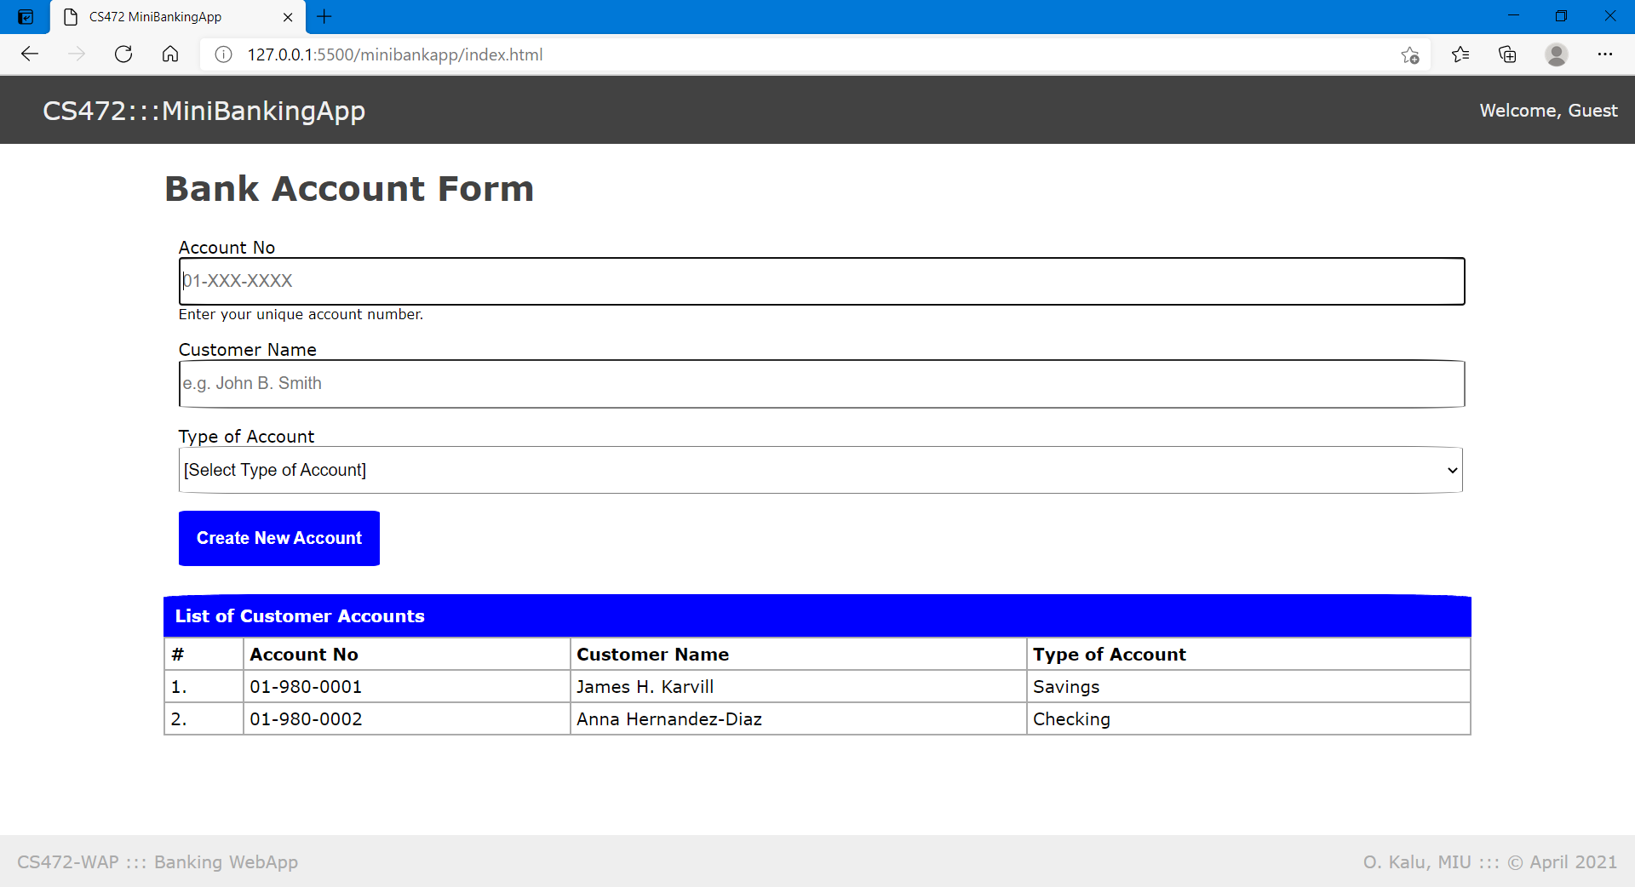

Please submit your code as a single zip file attachment to Sakai and/or push it to your github repository.

**//-- Enjoy! --//**