Configure a Development Environment

Destiny Delle

Rasmussen College

Author note:

This activity assignment is being submitted on October 5, 2018 for Kris Jamsa’s Fundamentals of Mobile Web Application Development online course.

Configure a Development Environment

Created storage

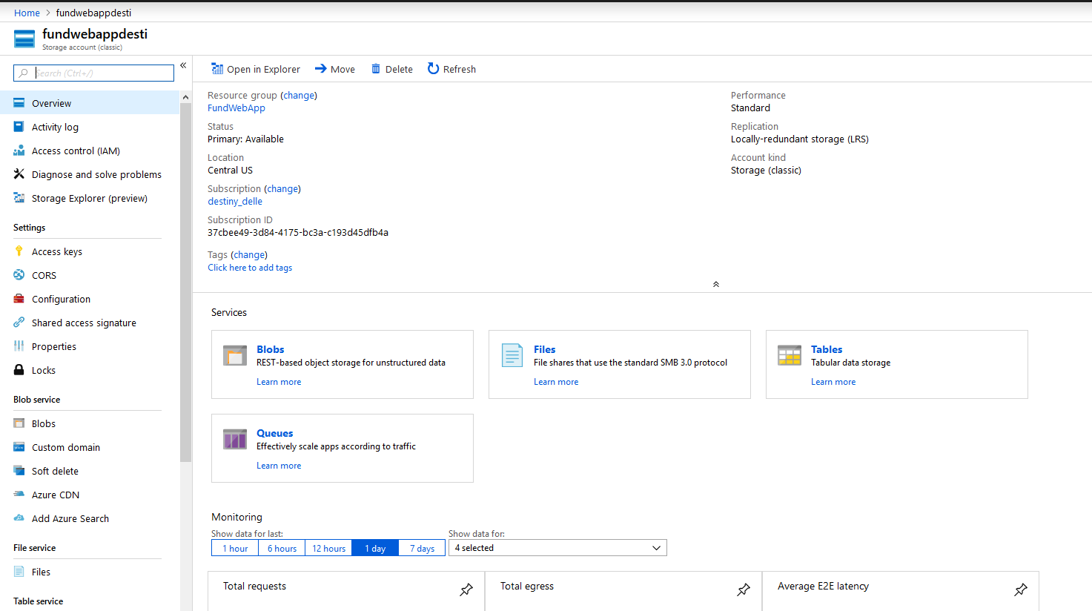

Created a LAMP:

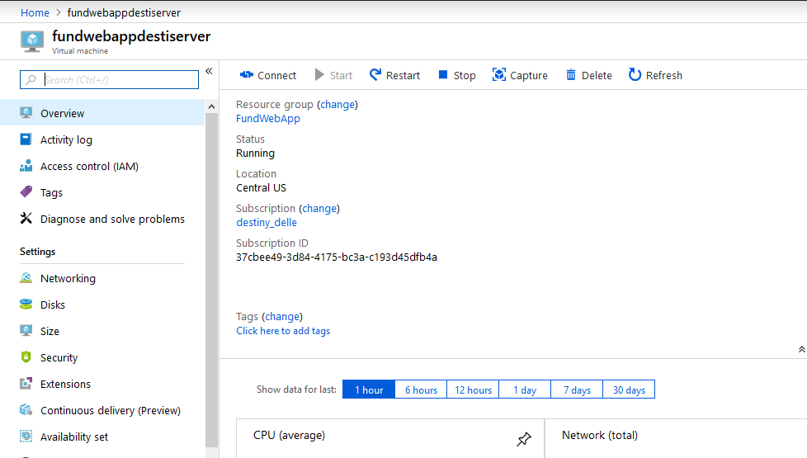

Set up DNS Name:

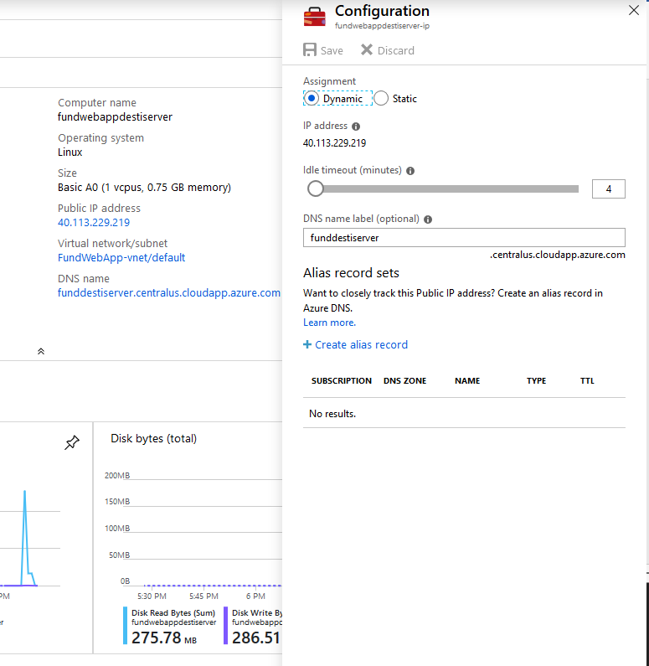

Logged into Bitnami through SSH:

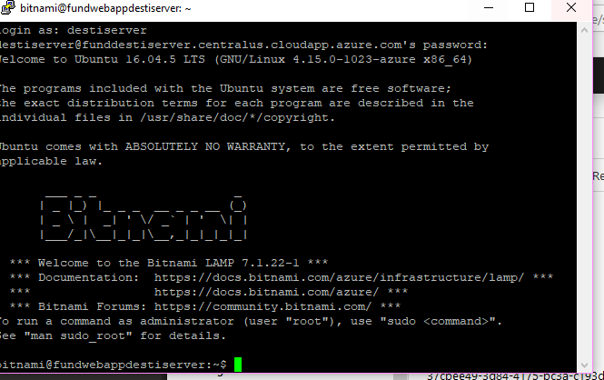

Downloading AdventureWorks:

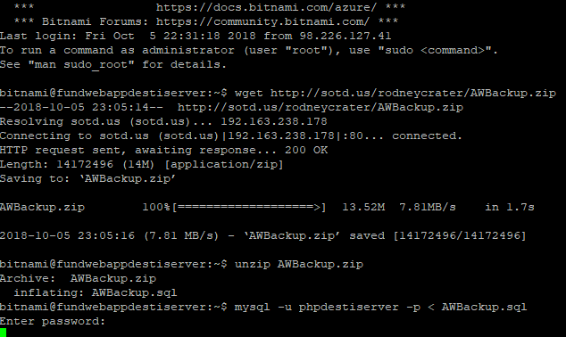

Finished downloading AW:

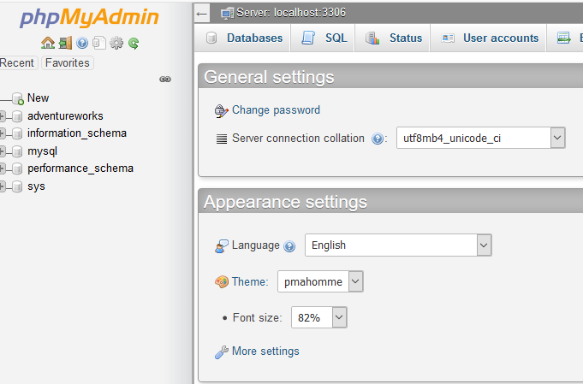

Already had Atom downloaded for previous classes:

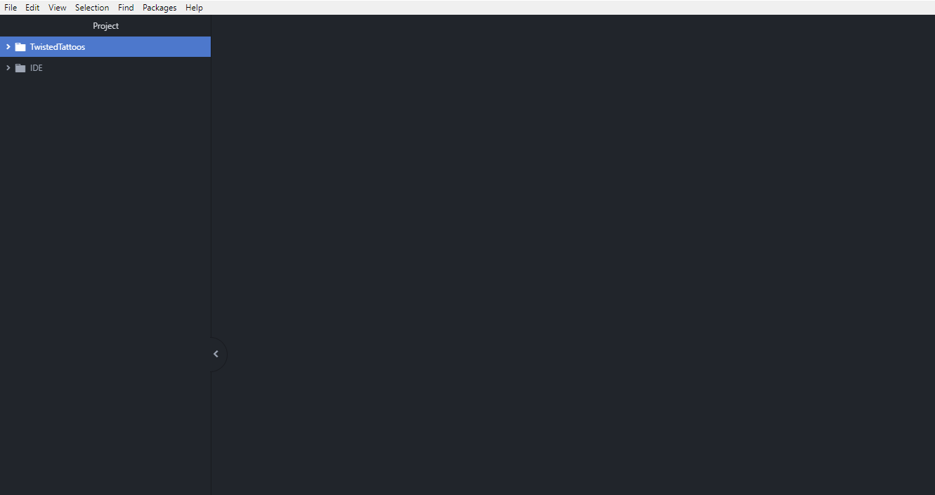

Downloaded GITHUB and created first sample.txt as instructed:

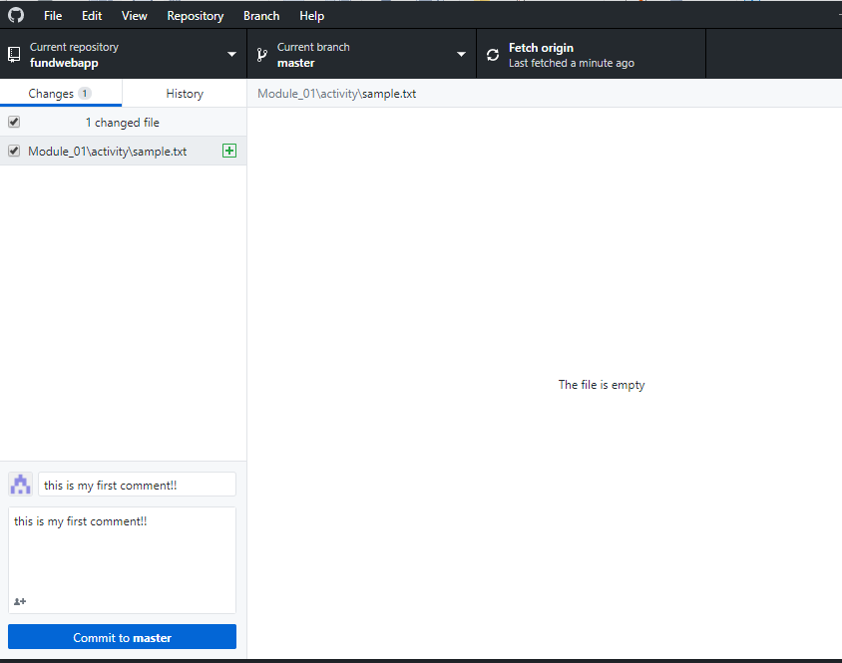

I’m not quite sure what the description of the site is so I’m going to explain to you that the LAMP Virtual Server is a server created and hosted within Azure. It also is connected to a resource group and a storage database so any and all files are stored within that. As far as the HTML webpage as described, it is a sample “Hello World” website that contains Lorem Ipsum writing to show content within on the page. It also has a navigation bar that is not currently working. As directed in the live lecture, we were able to use the sample code for this assignment.

URL for sample Hello World uploaded in FileZilla:

<https://funddestiserver.centralus.cloudapp.azure.com/module1/activity/mod1_activity.html>

GitHub URL:

<https://github.com/destidelle/fundwebapp/blob/master/Module_01/activity/mod1_activity/mod1_activity.html>