Simple Sitemap

Destiny Delle

Rasmussen College

Author’s Note:

This activity assignment is being submitted on October 22, 2018 for Kris Jamsa’s Fundamentals of Mobile Web Application Development online course.

Simple Sitemap

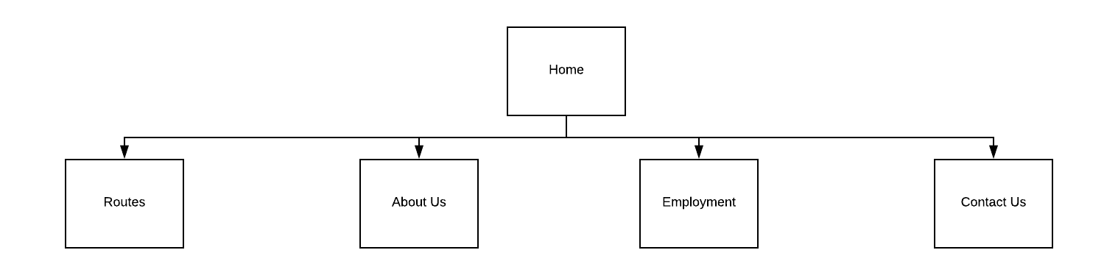

My sitemap is extremely simple as I do not have additional pages more than what is navigated to through the navigation bar. All options are part of the navigation menu and are able to be accessed from any page. All pages interlink together to one another.