Testing Display Screen Sizes

Destiny Delle

Rasmussen College

Author’s Note:

This activity assignment is being submitted on November 2, 2018 for Kris Jamsa’s Fundamentals of Mobile Web Application Development online course.

Galaxy S5 vertical:



\*\*HTML is not centered properly with the header and footer of the page. Overall, looks centered on page/screen.

Pixel 2 XL Vertical:



\*\* Not centered on screen/page and the header and footer are not centered, either.

iPhone 6/7/8 horizontal:

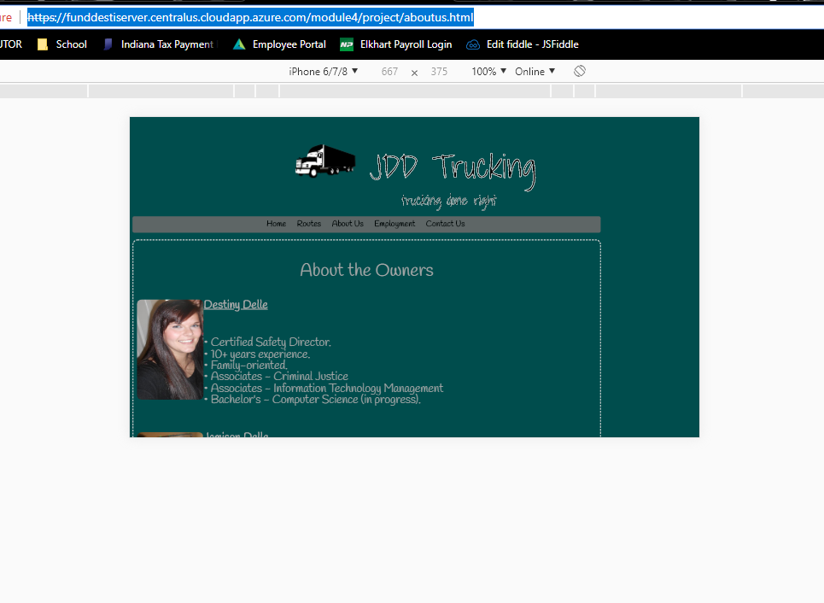

\*\*Not centered with the header and footer as well as not centered on the page(screen).

I would like to go through and make the page a bit more responsive than it currently is. By doing this, I want to make it fit nicely on a mobile device, versus just on the internet. I’ve look into viewpoint and including responsive text, but that has not quite worked for my mobile version yet. I’m still working on it, but I feel once I get that in place and get it to work with automatically making the adjustments it needs to, it will work perfectly! After I get it to work, it should look nice, regardless of what view it is on (horizontal/vertical). This will better help me get to a point where my website is ideally the way I want it to look and overall nice for the audience to view, without scaring them away.