Editing CSS Using Developers’ Tools

Destiny Delle

Rasmussen College

Author’s Note:

This course project is being submitted on November 2, 2018 for Kris Jamsa’s Fundamentals of Mobile Web Development online course.

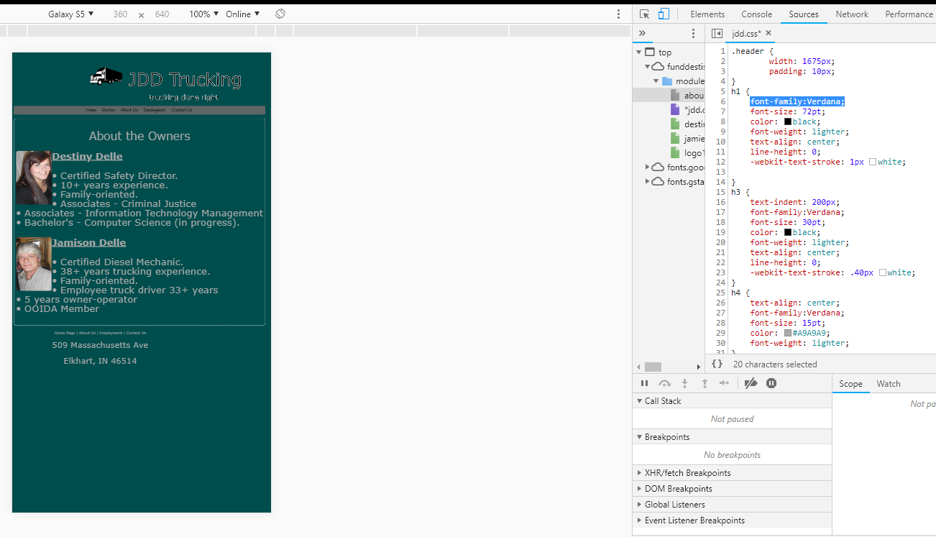

In this screen shot I decided to change the font style to something that is not “fancy” writing. I realized that by doing this, I am making my page look cleaner and overall more uniform. This will help with the user-interface usability and help allow my audience to clearly read the writing. Additionally, by changing the font in the title, it makes it much more visible what the company is. The way I have my header formatted (font colors), having that fancy font can sometimes make it a little difficult to read.

(Next page)

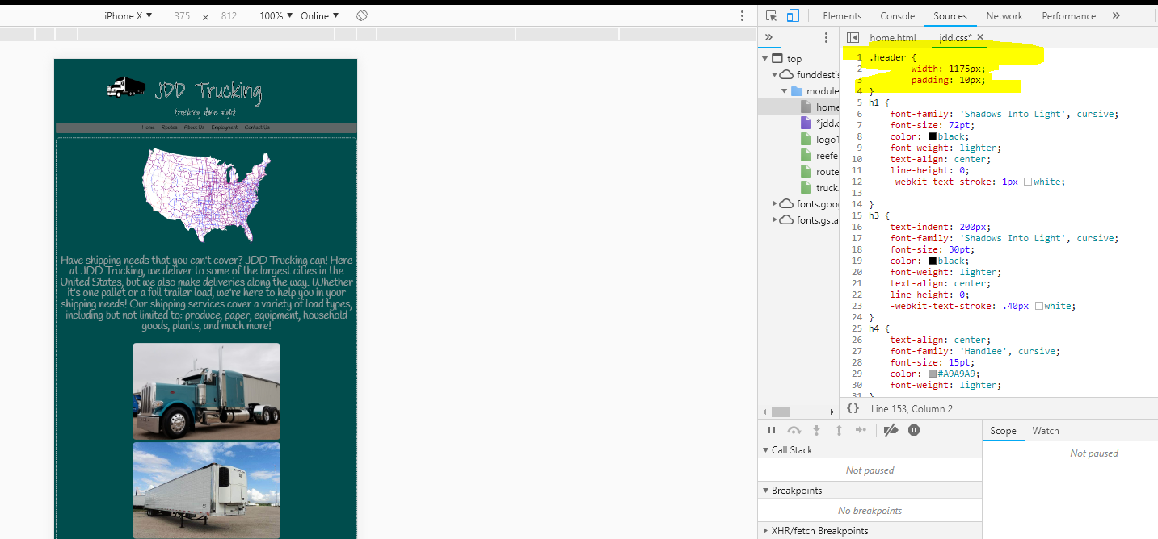

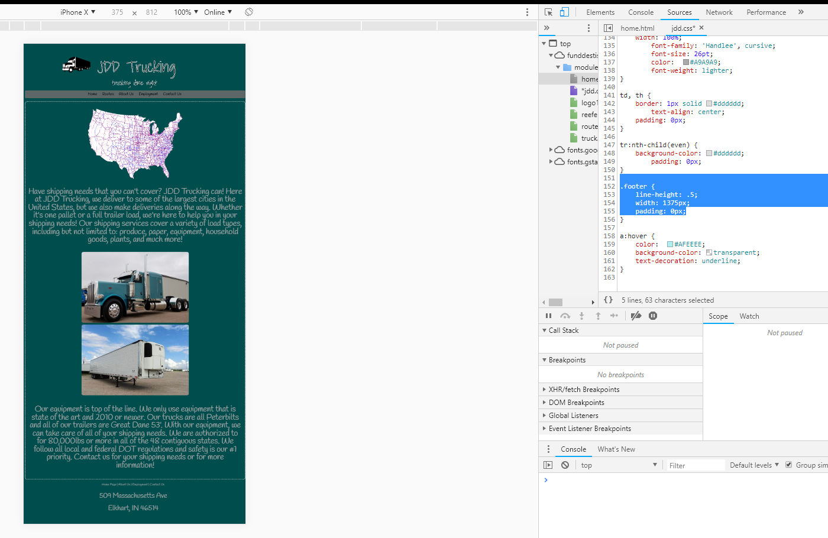

By changing the width of my header, I made it where my title (when viewing in a mobile view) can be centered more evenly with the navigation bar, making the overall design sharper. Also, I did the same thing to my footer, by making the change in the width to match it and make it look more centered and overall making it mobile ready. (NEXT PAGE)

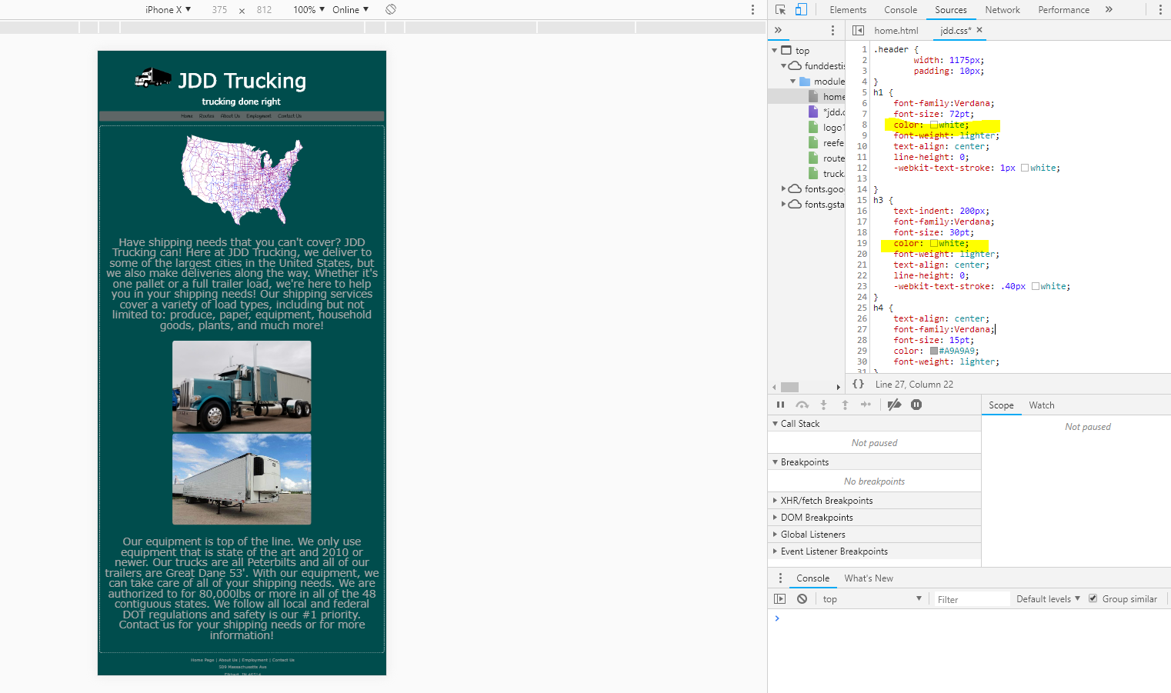

In this change, I went in and made a change to my header by making my h1 and h3 to be all white rather than white and black. I find that this really cleans up the header area a lot! It helps make it pop more rather than hiding behind the black with a white highlight. In this case, I find that this will help the audience understand what company they’re at and overall help with the appealing look to the website. It also makes the letters more visible, letting the audience know what it says, versus fighting to figure out what they are looking at.

\*\*Although it was said to change it to view ISSUES, I find that my page already had issues before that needed to be cleaned up. Below are a few that could REALLY cause issues with the page usability:

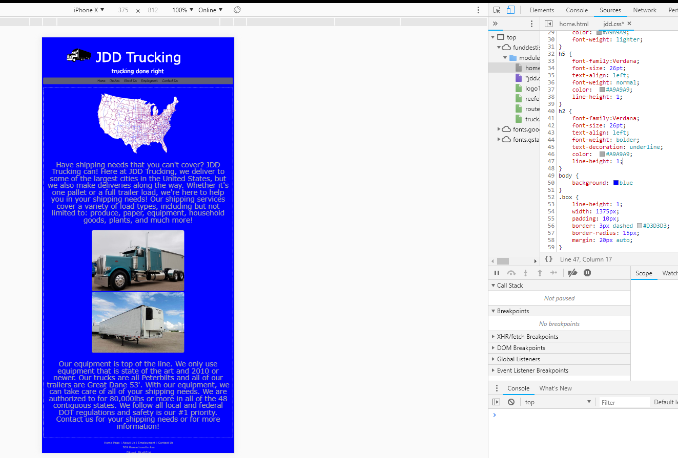

Changing the background to blue can really irritate the user’s eyes, making the page not as usable as it was before with a mild teal/turquoise. This honestly gives me a headache and would seriously cause traffic issues for the website.

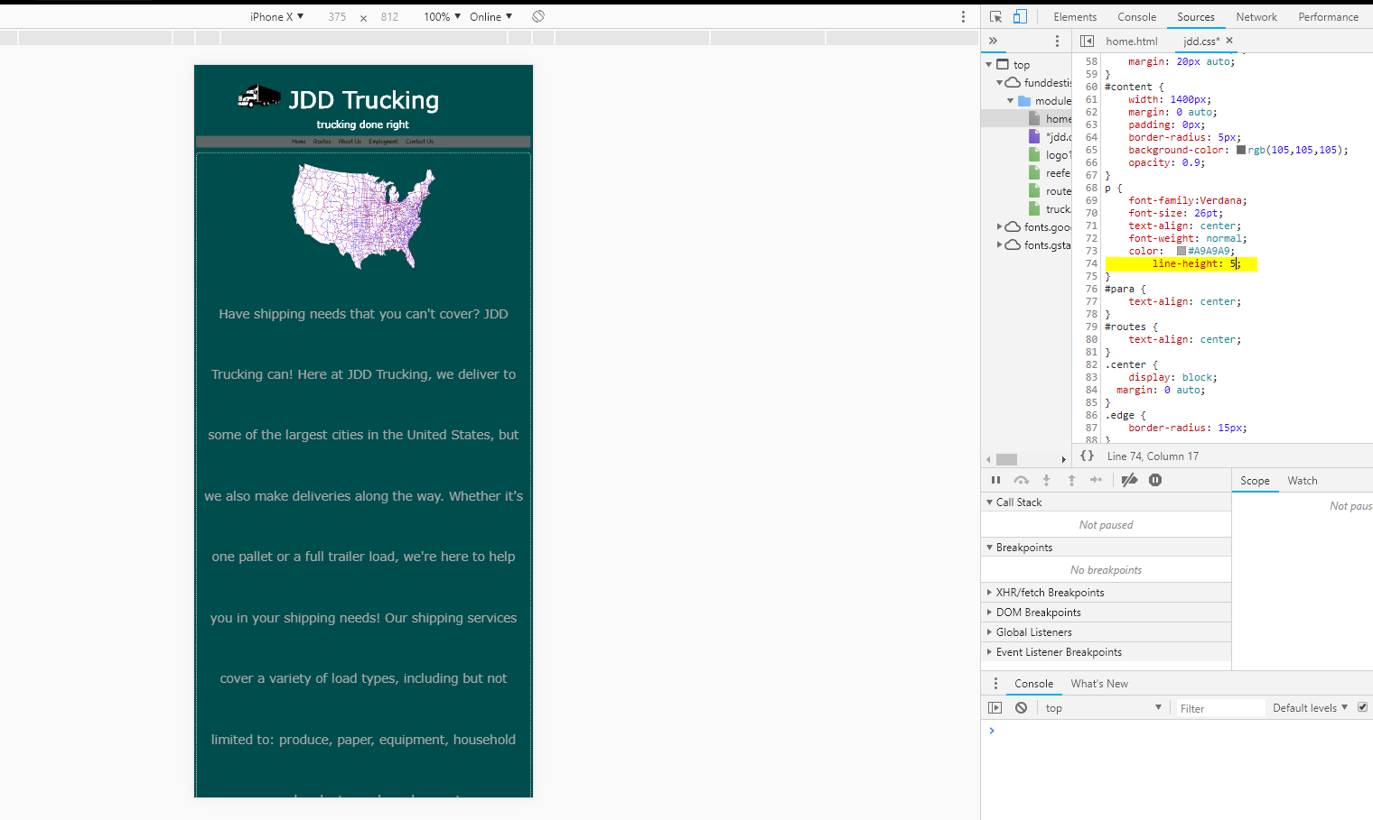changing the line height of the paragraphs can really mess with the layout of the page. This causes the lines to have much more space between then, forcing the viewer to scroll constantly just to view the content.

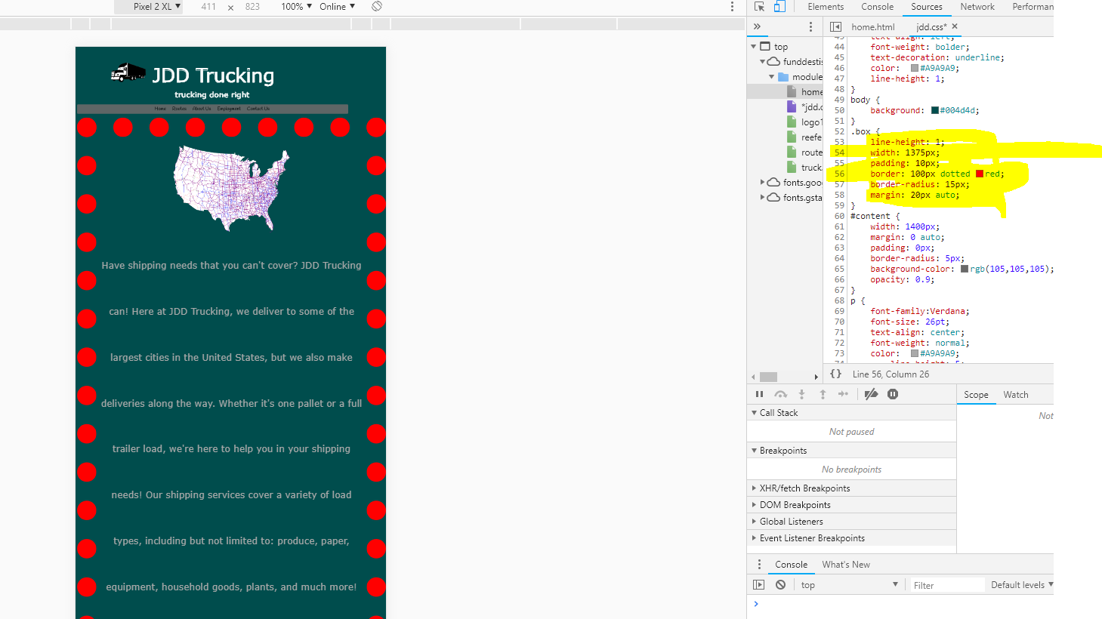

By overdoing the border of the box, changing the thickness of the design makes it look really “ugly” and unappealing. Also, changing the color to red makes it look non-uniform, taking the presentation of the webpage to a lower standard; not attracting viewers to look much further than what they see on the first page (home page).