MOOC

DRE Quiz

**Completion Badge**

1. **From two different locations (Location A & Location B) the field of wind speed at a height of interest produces the Weibull curves shown in the following figure:**

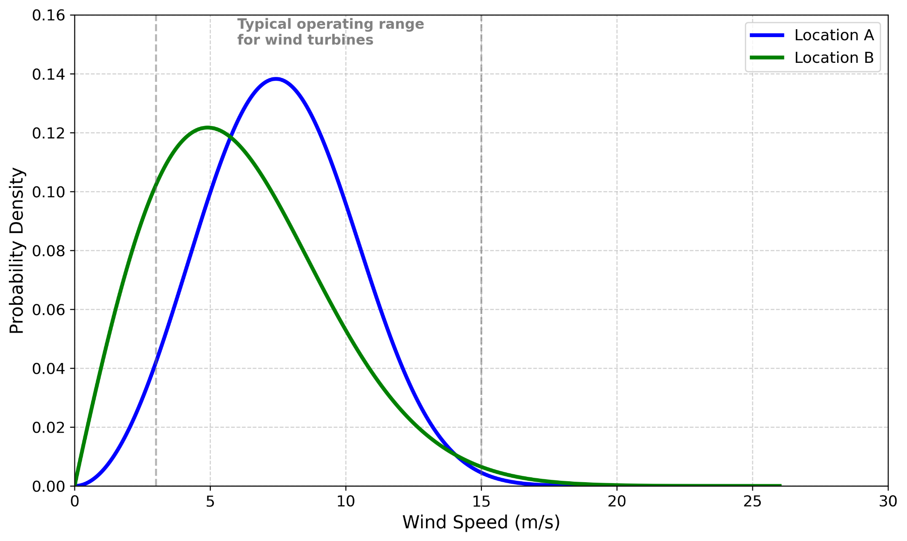

**Which location do you think is more suitable for installing a wind turbine?**

a. Location A

b. Location B

1. From two different locations (Location A & Location B) the wind speed field at a height of interest presents the following statistical results:

|  |  |  |
| --- | --- | --- |
|  | Location A | Location B |
| Mean Wind Speed | 10.22 m/s | 8.16 m/s |
| 95th Percentile of Wind Speed | 22.63 m/s | 17.85 m/s |
| 97th Percentile of Wind Speed | 24.42 m/s | 21.26 m/s |
| 99th Percentile of Wind Speed | 26.75 m/s | 23.36 m/s |

**For a wind turbine with a power curve characterized with a cut-in wind speed of 3m/s, rated wind speed of 10m/s and cut-out wind speed of 25m/s, which location is more suitable for installation, in terms of operation in moderate range, life expectancy and safety?**

a. Location A

b. Location B

1. **A Numerical Weather Prediction (NWP) model outputs wind speed at 10 m and 100 m. You need the wind speed at hub height (80 m). What should you do?**

a. Follow an interpolation process such as extrapolate using the logarithmic wind profile or power law profile

b. Take the average of 10 m and 100 m

c. Use the 100 m value as a proxy

d. Apply a smoothing function

1. **In** **the provided 2-day forecast chart, why do both solar power and irradiation drop to near-zero during the night hours?**

a. Solar panels are turned off automatically at night

b. The forecast model is not active at night

c. There is no solar radiation at night to generate power

d. The system resets each night to recalibrate

1. **According to the service description, what is the benefit of uploading historical power production data (in kW)?**

a. It activates real-time tracking

b. It reduces the need for weather forecasts

c. It enhances forecast accuracy using a machine learning model

d. It allows for monthly billing customization

1. **Why might the machine learning model generate more accurate forecasts for a specific solar park?**

a. It uses high-resolution satellite imagery only

b. It learns from local historical performance patterns and weather forecasts

c. It tracks panel temperature in real time

d. It assumes constant clear-sky conditions

1. **What type of service would be best suited for a solar company wanting to optimize performance and cut down on daily costs for the entire year?**

a. Forecast - One-off

b. Forecast - Annual

c. Assessment - Basic

d. Assessment - Premium