JAMICON
ENGINEERING

QUOTATION.
HEAD OFFICE: Along Kangundo rd. Opp Red Square Hotel, Kayole Jnctn. P.O .BOX 20137 –00100 Nairobi, Kenya.Cell:+254
722 819 349,+254 720 467 217
E-m ail: jamiconengineering@ yahoo.com

Mechanical Building & Construction Contract

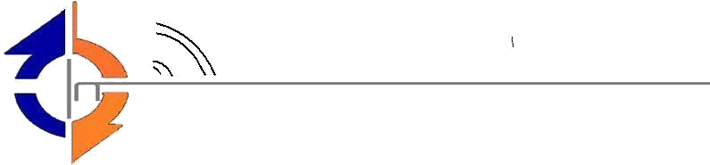

Bill To : Charles | Date :28/06/2025
Phone No.: | Quotation No:433/25
Address: | Site :
Email:
PROPOSED STEEL WORK AT 360 PETROL STATION KAYOLE JUNCTION.
5 x1.2 x15 Gas cage
Description [Product/Service] | Q ty | Rate | Amount
50 x50 x15mm tube | 8 pcs | 4,600 | 36,800
50 x25 x1.5mm tube | 22 pcs | 4,000 | 88,000
3.2 rods | 5 pkts | 1,200 | 6,000
9” Cutting | 10 pcs | 200 | 2,000
Primer | 3 x4 liters | 1,200 | 4,800
Material total |  |  | 137,600
labor |  |  | 14,800
Sub total |  |  | 152,400
Manhole covers
Description [Product/Service] | Q ty | Rate | Amount
3mm plates | 1 pc | 9,500 | 9,500
50 x50 x4mm Angleline | 1 pc | 2,850 | 2,850
Material total |  |  | 12,350
Labor |  |  | 2,500
Sub total |  |  | 14,850
Pump island angleline
Description [Product/Service] | Q ty | Rate | Amount
50 x50 x4mm angleline | 4 pcs | 2,850 | 11,400
Labor |  |  | 6,500
Sub total |  |  | 17,900
Fence 6M long
Description [Product/Service] | Q ty | Rate | Amount
50 x25 x2mm | 3 pcs | 1,400 | 4,200
25 x25 x2mm | 22 pcs | 980 | 21,560
3.2 rods | 3 pkts | 1,200 | 3,600
9” cutting discs | 30 pcs | 200 | 6,000
Grey primer | 4 x4 liters | 900 | 3,600
Material total |  |  | 38,960
Labor |  |  | 14,500
Sub total |  |  | 53,460
Stairs 28 Meters
Description [Product/Service] | Q ty | Rate | Amount
25 x25 x1.5 tube | 35 pcs | 920 | 32,200
40 x 40 x1.5 tube | 4 pcs | 1,200 | 4,800
1 ¹/₂ pipe class A | 5 pcs | 800 | 4,000
50 x25 x1.5 | 10 pcs | 1,400 | 14,000
3.2 rods | 2 pkts | 1,200 | 2,400
9” cutting discs | 20 pcs | 200 | 4,000
Material total |  |  | 61,400
Labor |  |  | 38,500
Sub total |  |  | 99,900
Grand total |  |  | 338,510

All prices are VAT inclusive.

NOTES
Payments terms;
• 70% Down payment
• 30% upon completion

Notes

- Due upon receipt
- Make all Cheques payable to Jamicon Engineering
- Bank :Equity Bank
- Branch : Mama Ngina
- A/C no. : 0150299734094
THANK YOU FOR YOUR BUSINESS

