Internship Sites Decision Guide
Built from your Excel sheet + external decision factors: pay, cost of living, rent, demographics, forensic fit, FBOP fit, family proximity, and post-internship pathway.
Prepared for Destynee • July 05, 2026

How to Use This Guide
- Use the Top Priority group as your first deep-dive list, not as a final rank. Your final ranking should still depend on current APPIC details, interview impressions, supervision quality, and exact rotations.
- The scoring weights intentionally favor what you named: closeness to CT/family, high pay, FBOP preference, forensic/competency exposure, and postdoc/job pathway.
- Rent uses ACS median gross rent for 1-bedroom units when available. It is a planning estimate, not a lease quote. Pull real apartment listings once your interview list is final.
- Any site field marked “doesn’t say,” blank, or informal in the Excel sheet should be verified directly in the APPIC listing and site brochure.

Quick Recommendation
- Best match on your stated priorities: FCI Danbury. It combines CT/family proximity, FBOP preference, high pay, and a clear federal career pathway, though you should verify competency/testimony exposure.
- Best federal/forensic-power options after Danbury: MCC Chicago, FCI Otisville, FBOP Philadelphia, FCC Petersburg, and FCC Allenwood/Florida FBOP depending on exact rotations.
- Best non-FBOP forensic/court options: DC Superior Court, South Florida Evaluation and Treatment Center, South Florida State Hospital, Utah State Hospital, Central State Hospital, and Central Regional Hospital.
- Budget caution: sites under about $40k in high/moderate-cost cities may only make sense if the forensic training is exceptional or if housing support is realistic.

Top 8 Based on Your Priorities
Rank | Site | Location | Pay | Median 1BR Rent | Fit Score | Why it rises
1 | Federal Bureau of Prisons- FCI Danbury | Danbury, CT | $74,417 | $1,469 | 100.0 | FBOP/federal; closest to family; high pay; forensic fit
2 | Bureau of Prisons/Otisville/ FCI | Otisville, NY | $74,417 | $1,530 | 94.7 | FBOP/federal; high pay; forensic fit
3 | FBOP- Philadelphia | Philadelphia, PA | $69,583 | $1,291 | 91.1 | FBOP/federal; high pay; forensic fit
4 | Metropolitan Correctional Center Chicago | Chicago, IL | $71,299 | $1,399 | 83.3 | FBOP/federal; high pay; forensic fit
5 | Federal Correctional Complex, Allenwood | Allenwood, PA | $59,021 | $1,064 | 81.8 | FBOP/federal; forensic fit
6 | Federal Bureau of Prisons | Tallahassee, FL | $61,111 | $1,239 | 73.9 | FBOP/federal; forensic fit
7 | Fedreal Correctional Complex, Petersburg | Petersburg, VA | $64,665 | $1,079 | 57.3 | forensic fit
8 | NC Department of Adult Correction | Raleigh, NC | $64,211 | $1,508 | 54.6 | forensic fit

Visual Decision Charts
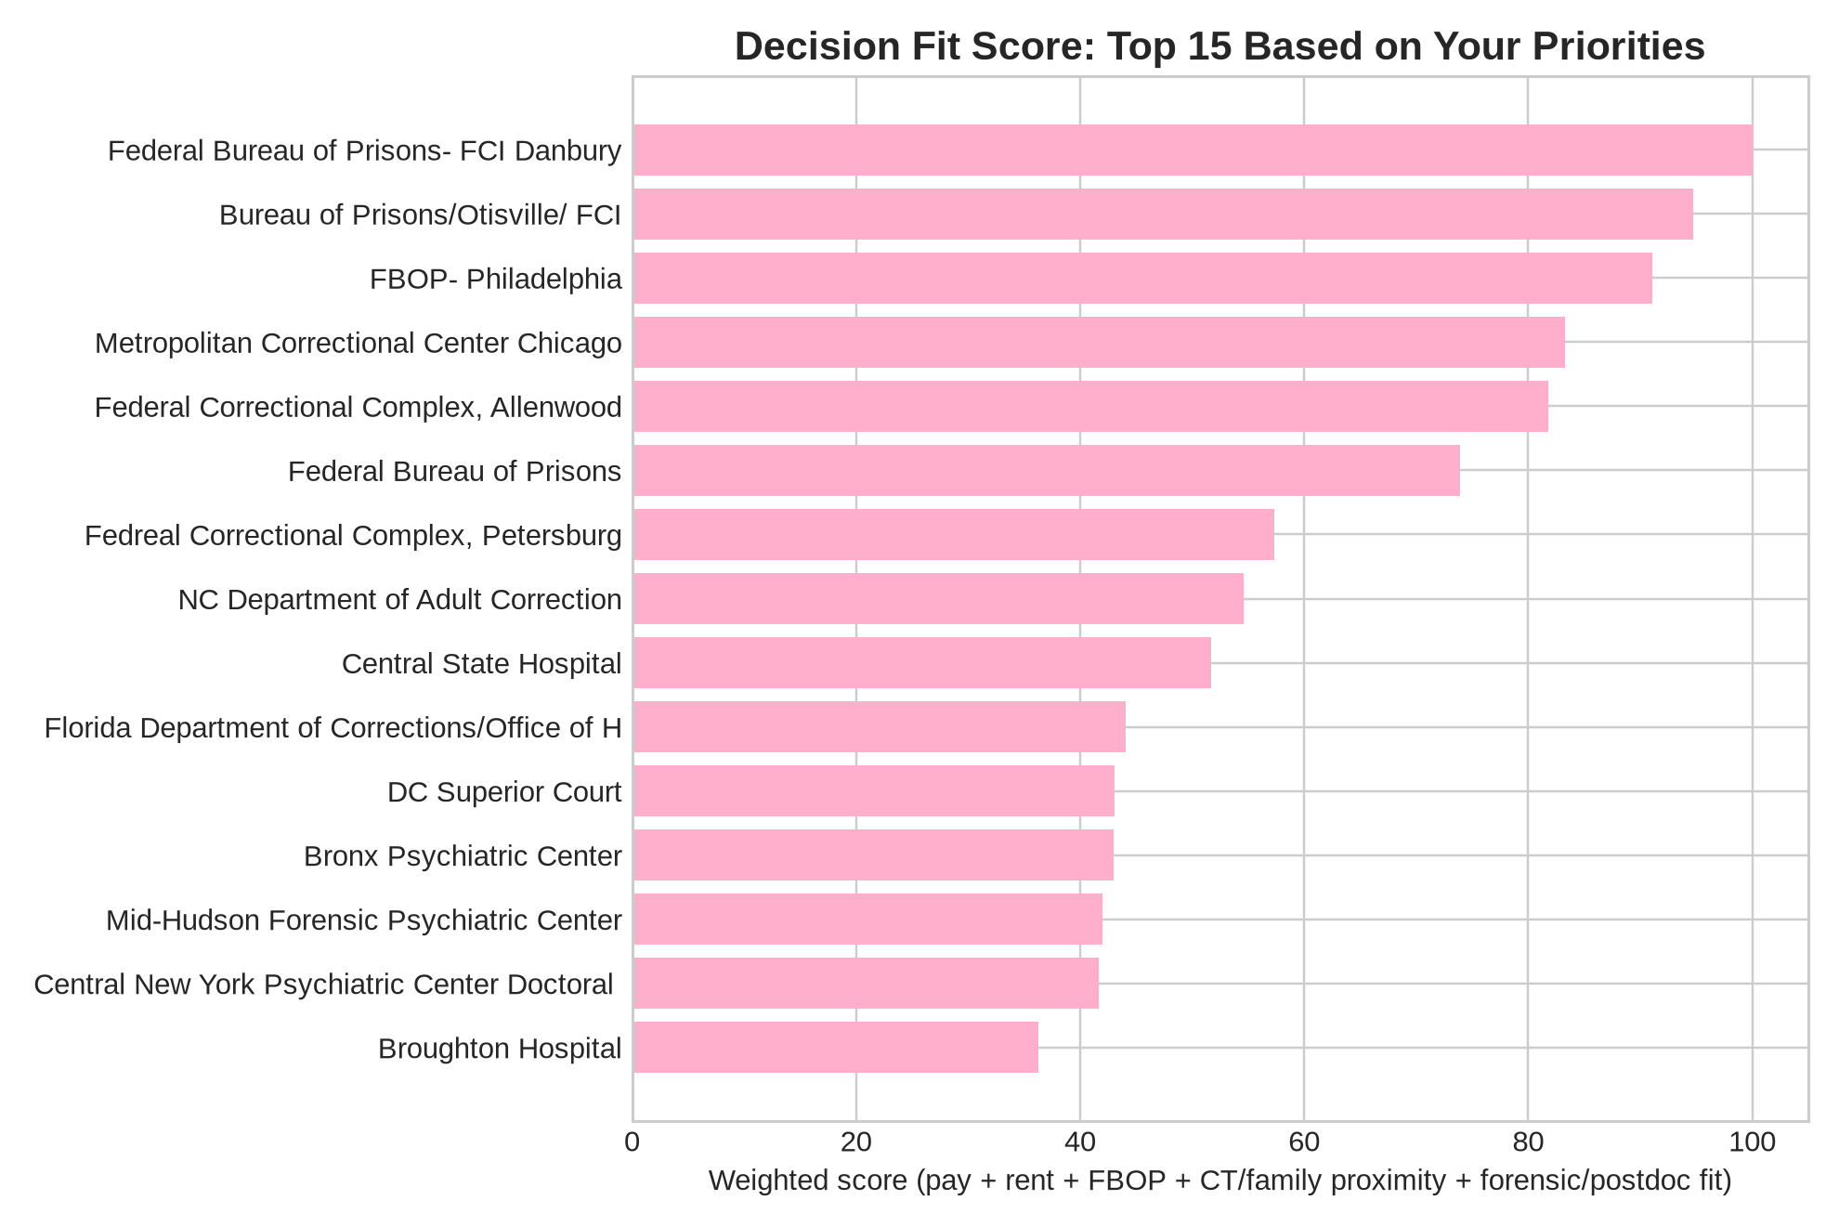
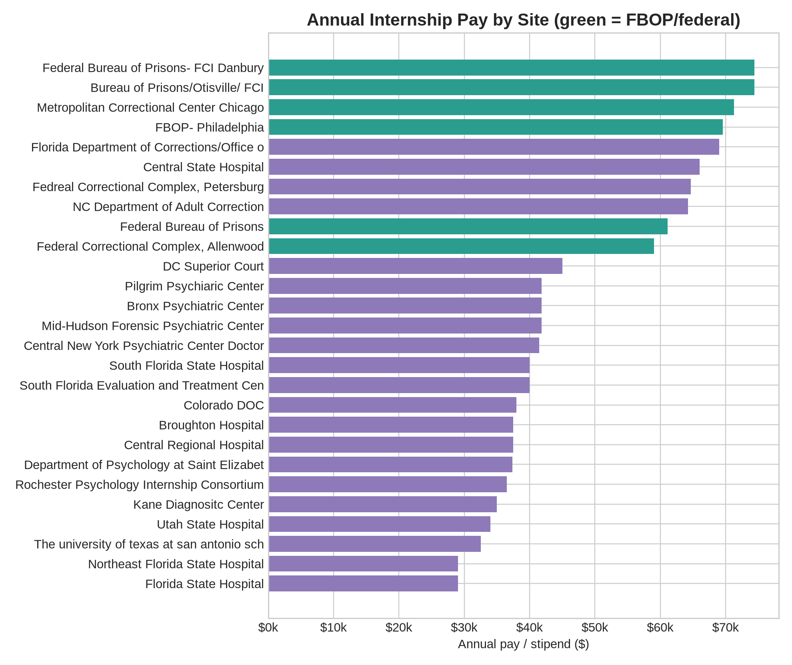
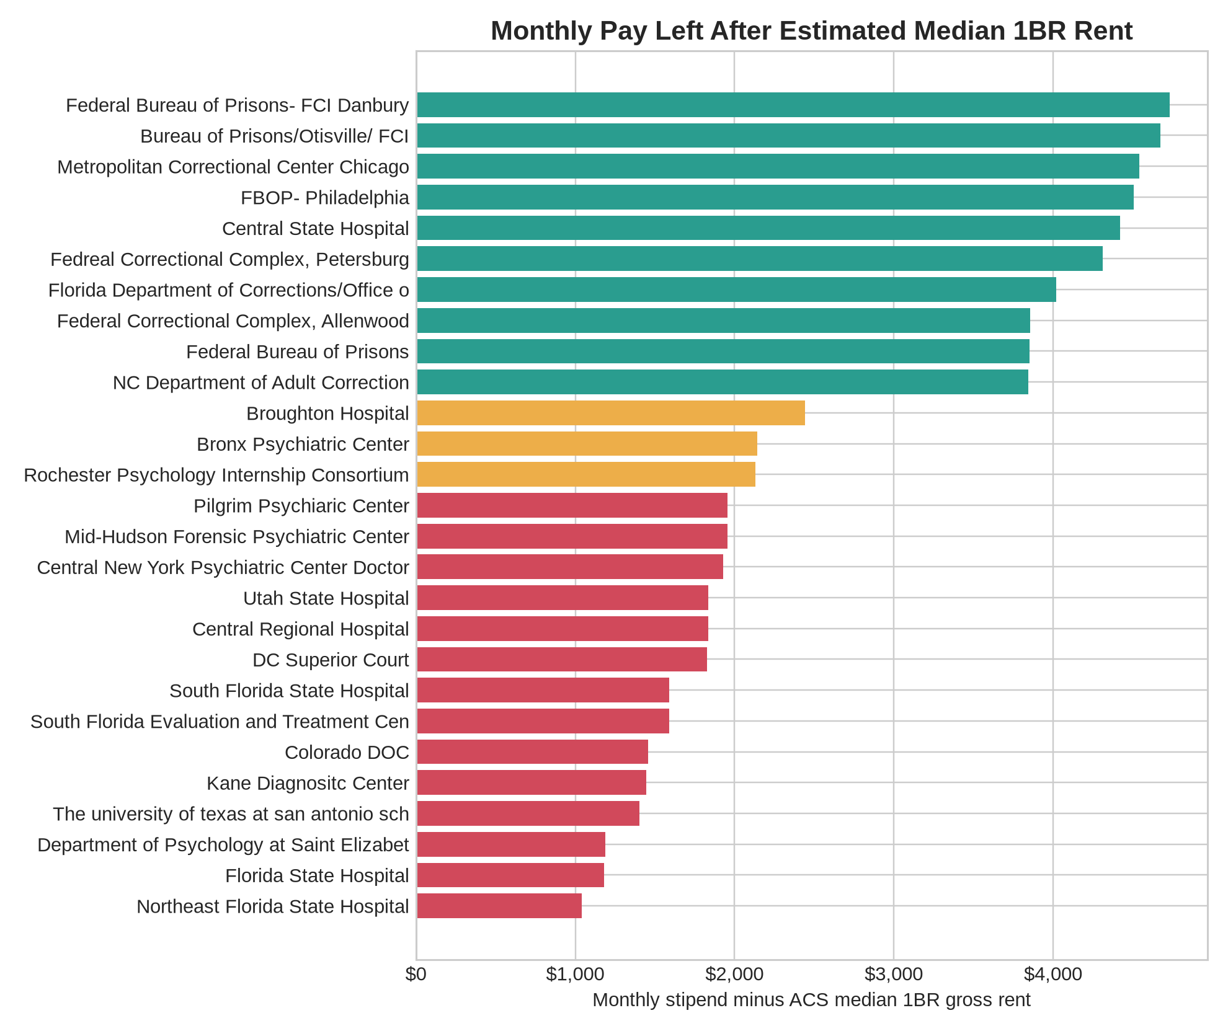
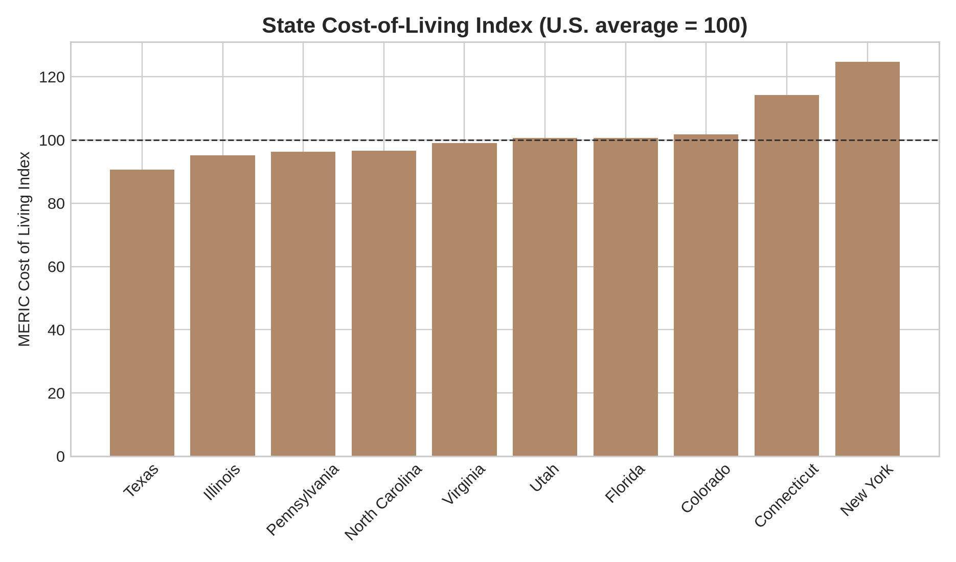

State-by-State Decision Notes

Colorado
Cost/rent/demographics: MERIC COL index 101.8 (rank 35; housing 107.4). State demographics: White non-Hispanic 63.6%, Black non-Hispanic 4.0%, Hispanic/Latino 23.2%, Asian non-Hispanic 3.4%.
State pros: DOC rotations and assessment flexibility; Denver has professional networks and quality of life.
State cons/cautions: Pay is modest relative to Denver costs; site geography split Denver/Canon City needs clarification.
Sites in this state: Colorado DOC

Connecticut
Cost/rent/demographics: MERIC COL index 114.2 (rank 42; housing 123.5). State demographics: White non-Hispanic 60.4%, Black non-Hispanic 9.9%, Hispanic/Latino 19.2%, Asian non-Hispanic 4.7%.
State pros: Closest to family; high pay site; Northeast professional network; feasible route into federal employment.
State cons/cautions: High cost of living and taxes; Danbury-specific housing may be tight; less explicit competency/testimony exposure from your notes.
Sites in this state: Federal Bureau of Prisons- FCI Danbury

Florida
Cost/rent/demographics: MERIC COL index 100.7 (rank 31; housing 101.1). State demographics: White non-Hispanic 49.1%, Black non-Hispanic 14.3%, Hispanic/Latino 28.7%, Asian non-Hispanic 3.0%.
State pros: Many options; no state income tax; several strong forensic/state hospital sites; warm climate and large correctional system.
State cons/cautions: Pay varies wildly; Miami/Tampa rent can eat stipend; some sites require in-person interviews; some roles seem strict or lower paid.
Sites in this state: Federal Bureau of Prisons; Florida Department of Corrections/Office of Health Services; South Florida Evaluation and Treatment Center; South Florida State Hospital; Florida State Hospital; Northeast Florida State Hospital

Illinois
Cost/rent/demographics: MERIC COL index 95.1 (rank 24; housing 84.7). State demographics: White non-Hispanic 57.1%, Black non-Hispanic 12.9%, Hispanic/Latino 19.4%, Asian non-Hispanic 6.3%.
State pros: MCC Chicago is very strong for federal/forensic evaluation and pay; Kane offers court-ordered/youth-adult evaluations.
State cons/cautions: Chicago cost/safety/commute considerations; Kane pay is lower; farther from CT.
Sites in this state: Metropolitan Correctional Center Chicago; Kane Diagnositc Center

New York
Cost/rent/demographics: MERIC COL index 124.7 (rank 47; housing 172.3). State demographics: White non-Hispanic 51.9%, Black non-Hispanic 13.2%, Hispanic/Latino 20.2%, Asian non-Hispanic 9.4%.
State pros: Closer to CT/family; several forensic psychiatric and FBOP options; good court/competency exposure depending site.
State cons/cautions: State cost and taxes are higher; some rural sites may feel isolated; several sites pay much less than FBOP.
Sites in this state: Bureau of Prisons/Otisville/ FCI; Bronx Psychiatric Center; Mid-Hudson Forensic Psychiatric Center; Central New York Psychiatric Center Doctoral Internship in Health Psych; Rochester Psychology Internship Consortium; Pilgrim Psychiaric Center

North Carolina
Cost/rent/demographics: MERIC COL index 96.6 (rank 26; housing 91.7). State demographics: White non-Hispanic 59.0%, Black non-Hispanic 19.5%, Hispanic/Latino 12.0%, Asian non-Hispanic 3.6%.
State pros: Moderate cost of living; several correctional/state hospital options; practical assessment/forensic exposure.
State cons/cautions: Pay is middle/lower unless DOC Raleigh; farther from CT; some sites less directly aligned with competency/restoration.
Sites in this state: NC Department of Adult Correction; Broughton Hospital; Central Regional Hospital

Pennsylvania
Cost/rent/demographics: MERIC COL index 96.2 (rank 25; housing 84.1). State demographics: White non-Hispanic 71.9%, Black non-Hispanic 10.1%, Hispanic/Latino 9.4%, Asian non-Hispanic 4.1%.
State pros: Philadelphia and Allenwood FBOP options; close enough to Northeast/family; strong post-internship job pathway potential.
State cons/cautions: Philadelphia rent/city stress; Allenwood may be rural/isolating; some site notes lack forensic/testimony detail.
Sites in this state: FBOP- Philadelphia; Federal Correctional Complex, Allenwood

Texas
Cost/rent/demographics: MERIC COL index 90.7 (rank 13; housing 77.7). State demographics: White non-Hispanic 37.8%, Black non-Hispanic 12.0%, Hispanic/Latino 40.3%, Asian non-Hispanic 6.0%.
State pros: Lower cost than many Northeast/West Coast options; large Hispanic community fit; major academic medical setting.
State cons/cautions: Only takes very few students; farther from CT/family; pay is modest compared with FBOP.
Sites in this state: The university of texas at san antonio school of medicine

Utah
Cost/rent/demographics: MERIC COL index 100.6 (rank 30; housing 110.8). State demographics: White non-Hispanic 73.1%, Black non-Hispanic 1.2%, Hispanic/Latino 16.9%, Asian non-Hispanic 2.7%.
State pros: Utah State Hospital appears very strong for competency, reports, court submissions, research, and 4-day schedule.
State cons/cautions: Low stipend; far from CT/family; cultural/geographic fit needs serious reflection.
Sites in this state: Utah State Hospital

Virginia
Cost/rent/demographics: MERIC COL index 99.1 (rank 28; housing 99.1). State demographics: White non-Hispanic 57.4%, Black non-Hispanic 17.9%, Hispanic/Latino 11.6%, Asian non-Hispanic 7.1%.
State pros: Strong pay; Petersburg FBOP and Central State Hospital match forensic/correctional interests; reasonable cost index.
State cons/cautions: Farther from CT; some site notes are incomplete; need verify postdoc pipeline and forensic depth by rotation.
Sites in this state: Fedreal Correctional Complex, Petersburg; Central State Hospital

Washington DC
Cost/rent/demographics: MERIC COL index N/A (rank N/A; housing N/A). State demographics: White non-Hispanic 36.2%, Black non-Hispanic 40.7%, Hispanic/Latino 12.6%, Asian non-Hispanic 4.9%.
State pros: Excellent court/forensic exposure; close-ish to CT by flight/train; strong federal/legal psychology network.
State cons/cautions: Very high cost of living and rent; not FBOP; pay-to-rent ratio is weaker.
Sites in this state: DC Superior Court; Department of Psychology at Saint Elizabeth Hospital

Detailed Site Profiles

Federal Bureau of Prisons- FCI Danbury — Danbury, CT
Decision tier: Top priority | Fit score: 100.0
Your Excel details: Pay $74,417; hours needed: Therapy: 320, assessment:80; other requirements: males and females, different rotations; CR/incompetence: no; interview: In person; misc: ability to shadow program adminsitration stuff, m-f: 7-3:30pm, ability to earn up to $124,000 by third year, state tax will be around 5.5%, around $2000 biweekly.
External decision factors: State COL index 114.2 (housing 123.5); estimated median 1-bedroom gross rent in Danbury, CT: $1,469/mo; estimated monthly stipend after 1BR rent: $4,732.
City racial/ethnic demographics: White non-Hispanic 46.3%; Black non-Hispanic 11.9%; Hispanic/Latino 26.1%; Asian non-Hispanic 5.2%. State comparison: White non-Hispanic 60.4%; Black non-Hispanic 9.9%; Hispanic/Latino 19.2%; Asian non-Hispanic 4.7%.
Pros:
- Matches your strong FBOP/federal preference and likely strengthens federal job pipeline after graduation.
- Forensic/correctional exposure appears aligned with your interests.
- Assessment/reporting exposure is present or likely meaningful.
- High stipend relative to most sites on your list.
Cons / verify:
- Interview may require travel or extra planning.
Postdoc/job pathway read: Strongest pathway signal because federal internship experience can support later BOP/federal applications. Ask about conversion patterns, staff psychologist hiring, and postdoc availability nearby.

Bureau of Prisons/Otisville/ FCI — Otisville, NY
Decision tier: Top priority | Fit score: 94.7
Your Excel details: Pay $74,417; hours needed: doesnt say, SMI, trauma, and general corrections rotation; other requirements: not listed; CR/incompetence: not listed; interview: not listed; misc: not listed.
External decision factors: State COL index 124.7 (housing 172.3); estimated median 1-bedroom gross rent in Otisville, NY: $1,530/mo; estimated monthly stipend after 1BR rent: $4,671.
City racial/ethnic demographics: White non-Hispanic 51.4%; Black non-Hispanic 3.3%; Hispanic/Latino 29.4%; Asian non-Hispanic 9.1%. State comparison: White non-Hispanic 51.9%; Black non-Hispanic 13.2%; Hispanic/Latino 20.2%; Asian non-Hispanic 9.4%.
Pros:
- Matches your strong FBOP/federal preference and likely strengthens federal job pipeline after graduation.
- Forensic/correctional exposure appears aligned with your interests.
- High stipend relative to most sites on your list.
- Still relatively closer to CT/family than southern/western options.
Cons / verify:
- Hours/requirements need verification before ranking.
Postdoc/job pathway read: Strongest pathway signal because federal internship experience can support later BOP/federal applications. Ask about conversion patterns, staff psychologist hiring, and postdoc availability nearby.

FBOP- Philadelphia — Philadelphia, PA
Decision tier: Top priority | Fit score: 91.1
Your Excel details: Pay $69,583; hours needed: 400 intervention; 100 assessment; other requirements: typical prison screenings; CR/incompetence: no; interview: in person; misc: not listed.
External decision factors: State COL index 96.2 (housing 84.1); estimated median 1-bedroom gross rent in Philadelphia, PA: $1,291/mo; estimated monthly stipend after 1BR rent: $4,508.
City racial/ethnic demographics: White non-Hispanic 32.8%; Black non-Hispanic 37.7%; Hispanic/Latino 16.4%; Asian non-Hispanic 8.3%. State comparison: White non-Hispanic 71.9%; Black non-Hispanic 10.1%; Hispanic/Latino 9.4%; Asian non-Hispanic 4.1%.
Pros:
- Matches your strong FBOP/federal preference and likely strengthens federal job pipeline after graduation.
- Forensic/correctional exposure appears aligned with your interests.
- Assessment/reporting exposure is present or likely meaningful.
- High stipend relative to most sites on your list.
Cons / verify:
- Interview may require travel or extra planning.
Postdoc/job pathway read: Strongest pathway signal because federal internship experience can support later BOP/federal applications. Ask about conversion patterns, staff psychologist hiring, and postdoc availability nearby.

Metropolitan Correctional Center Chicago — Chicago, IL
Decision tier: Top priority | Fit score: 83.3
Your Excel details: Pay $71,299; hours needed: doesnt say; other requirements: primarily focuses on forensic evaluations which is perfect :), pretrial detainees, primarily males with a small female population, administrative-custody facility (all levels of security), M-F 7:30-4. general correctional psych rotation, SMI rotation, forensic evaluation rotation (optional), susbtance use, 7:30am-4pm; CR/incompetence: not listed; interview: not listed; misc: not listed.
External decision factors: State COL index 95.1 (housing 84.7); estimated median 1-bedroom gross rent in Chicago, IL: $1,399/mo; estimated monthly stipend after 1BR rent: $4,543.
City racial/ethnic demographics: White non-Hispanic 32.3%; Black non-Hispanic 25.8%; Hispanic/Latino 30.2%; Asian non-Hispanic 7.8%. State comparison: White non-Hispanic 57.1%; Black non-Hispanic 12.9%; Hispanic/Latino 19.4%; Asian non-Hispanic 6.3%.
Pros:
- Matches your strong FBOP/federal preference and likely strengthens federal job pipeline after graduation.
- Forensic/correctional exposure appears aligned with your interests.
- Assessment/reporting exposure is present or likely meaningful.
- High stipend relative to most sites on your list.
Cons / verify:
- Hours/requirements need verification before ranking.
Postdoc/job pathway read: Strongest pathway signal because federal internship experience can support later BOP/federal applications. Ask about conversion patterns, staff psychologist hiring, and postdoc availability nearby.

Federal Correctional Complex, Allenwood — Allenwood, PA
Decision tier: Top priority | Fit score: 81.8
Your Excel details: Pay $59,021; hours needed: 400 intervention; 100 assessment; other requirements: work with violent offenders, and severe personality pathology; CR/incompetence: not listed; interview: not listed; misc: not listed.
External decision factors: State COL index 96.2 (housing 84.1); estimated median 1-bedroom gross rent in Allenwood, PA: $1,064/mo; estimated monthly stipend after 1BR rent: $3,854.
City racial/ethnic demographics: White non-Hispanic 98.8%; Black non-Hispanic 0.0%; Hispanic/Latino 0.0%; Asian non-Hispanic 0.0%. State comparison: White non-Hispanic 71.9%; Black non-Hispanic 10.1%; Hispanic/Latino 9.4%; Asian non-Hispanic 4.1%.
Pros:
- Matches your strong FBOP/federal preference and likely strengthens federal job pipeline after graduation.
- Forensic/correctional exposure appears aligned with your interests.
- Assessment/reporting exposure is present or likely meaningful.
- Still relatively closer to CT/family than southern/western options.
Cons / verify:
- Main caution is to verify current APPIC details, rotations, supervision, and postdoc/job outcomes.
Postdoc/job pathway read: Strongest pathway signal because federal internship experience can support later BOP/federal applications. Ask about conversion patterns, staff psychologist hiring, and postdoc availability nearby.

Federal Bureau of Prisons — Tallahassee, FL
Decision tier: Strong option | Fit score: 73.9
Your Excel details: Pay $61,111; hours needed: Intervention hours: 400, assessment hours: 100; other requirements: females and male offenders, hours are from 7am-4pm; CR/incompetence: didnt really say; interview: In person; misc: Work day: 7am-4:30, male and female offenders,.
External decision factors: State COL index 100.7 (housing 101.1); estimated median 1-bedroom gross rent in Tallahassee, FL: $1,239/mo; estimated monthly stipend after 1BR rent: $3,854.
City racial/ethnic demographics: White non-Hispanic 49.2%; Black non-Hispanic 31.4%; Hispanic/Latino 8.9%; Asian non-Hispanic 4.9%. State comparison: White non-Hispanic 49.1%; Black non-Hispanic 14.3%; Hispanic/Latino 28.7%; Asian non-Hispanic 3.0%.
Pros:
- Matches your strong FBOP/federal preference and likely strengthens federal job pipeline after graduation.
- Forensic/correctional exposure appears aligned with your interests.
- Assessment/reporting exposure is present or likely meaningful.
- Estimated rent burden looks relatively manageable for the stipend.
Cons / verify:
- Interview may require travel or extra planning.
Postdoc/job pathway read: Strongest pathway signal because federal internship experience can support later BOP/federal applications. Ask about conversion patterns, staff psychologist hiring, and postdoc availability nearby.

Fedreal Correctional Complex, Petersburg — Petersburg, VA
Decision tier: Consider if specific fit | Fit score: 57.3
Your Excel details: Pay $64,665; hours needed: 400 intervention hours, 100 assessment; other requirements: 3 rotations, drug abuse, general/correctional mental health rotation, and sexual abuse, mock testimony opportunity, weekly case law meetings,; CR/incompetence: big emphasis on sexual offenders, 7:30am-4pm, Monday-Friday; interview: not listed; misc: not listed.
External decision factors: State COL index 99.1 (housing 99.1); estimated median 1-bedroom gross rent in Petersburg, VA: $1,079/mo; estimated monthly stipend after 1BR rent: $4,310.
City racial/ethnic demographics: White non-Hispanic 14.4%; Black non-Hispanic 74.2%; Hispanic/Latino 6.5%; Asian non-Hispanic 1.3%. State comparison: White non-Hispanic 57.4%; Black non-Hispanic 17.9%; Hispanic/Latino 11.6%; Asian non-Hispanic 7.1%.
Pros:
- Forensic/correctional exposure appears aligned with your interests.
- Assessment/reporting exposure is present or likely meaningful.
- Estimated rent burden looks relatively manageable for the stipend.
Cons / verify:
- Main caution is to verify current APPIC details, rotations, supervision, and postdoc/job outcomes.
Postdoc/job pathway read: Needs verification. Ask where interns commonly work after graduation and whether forensic/correctional postdocs are nearby.

NC Department of Adult Correction — Raleigh, NC
Decision tier: Consider if specific fit | Fit score: 54.6
Your Excel details: Pay $64,211; hours needed: 400 intervention hours: 100 assessment; other requirements: variety of things, assessments, therapy, full day on wednesdays is for administrative stuff, working with the parole board too for evaluations; CR/incompetence: not listed; interview: not listed; misc: not listed.
External decision factors: State COL index 96.6 (housing 91.7); estimated median 1-bedroom gross rent in Raleigh, NC: $1,508/mo; estimated monthly stipend after 1BR rent: $3,843.
City racial/ethnic demographics: White non-Hispanic 50.9%; Black non-Hispanic 24.9%; Hispanic/Latino 13.0%; Asian non-Hispanic 5.4%. State comparison: White non-Hispanic 59.0%; Black non-Hispanic 19.5%; Hispanic/Latino 12.0%; Asian non-Hispanic 3.6%.
Pros:
- Forensic/correctional exposure appears aligned with your interests.
- Assessment/reporting exposure is present or likely meaningful.
- Estimated rent burden looks relatively manageable for the stipend.
Cons / verify:
- Main caution is to verify current APPIC details, rotations, supervision, and postdoc/job outcomes.
Postdoc/job pathway read: Needs verification. Ask where interns commonly work after graduation and whether forensic/correctional postdocs are nearby.

Central State Hospital — Petersburg, VA
Decision tier: Consider if specific fit | Fit score: 51.7
Your Excel details: Pay $66,000; hours needed: 500 intervention; 100 assessment; other requirements: drug testing and background check, a copy of report, 3 letters of recc; CR/incompetence: Yes and can to testimony and do the interviewin and testing; interview: online; misc: personal office space.
External decision factors: State COL index 99.1 (housing 99.1); estimated median 1-bedroom gross rent in Petersburg, VA: $1,079/mo; estimated monthly stipend after 1BR rent: $4,421.
City racial/ethnic demographics: White non-Hispanic 14.4%; Black non-Hispanic 74.2%; Hispanic/Latino 6.5%; Asian non-Hispanic 1.3%. State comparison: White non-Hispanic 57.4%; Black non-Hispanic 17.9%; Hispanic/Latino 11.6%; Asian non-Hispanic 7.1%.
Pros:
- Assessment/reporting exposure is present or likely meaningful.
- High stipend relative to most sites on your list.
- Estimated rent burden looks relatively manageable for the stipend.
Cons / verify:
- Main caution is to verify current APPIC details, rotations, supervision, and postdoc/job outcomes.
Postdoc/job pathway read: Potentially useful pathway through hospital/court/state system experience. Ask directly about nearby forensic postdocs, staff openings, and alumni placements.

Florida Department of Corrections/Office of Health Services — Tampa, FL
Decision tier: Lower priority / backup | Fit score: 44.1
Your Excel details: Pay $69,000; hours needed: Combined: 400 hours; other requirements: can go to different rotations (facilities), 3 letters of rec; CR/incompetence: didnt really say; interview: Online; misc: Work day: M-F 7am-4:30, male population , disseration proposed, drug screening, background check.
External decision factors: State COL index 100.7 (housing 101.1); estimated median 1-bedroom gross rent in Tampa, FL: $1,732/mo; estimated monthly stipend after 1BR rent: $4,018.
City racial/ethnic demographics: White non-Hispanic 44.3%; Black non-Hispanic 19.3%; Hispanic/Latino 25.6%; Asian non-Hispanic 5.3%. State comparison: White non-Hispanic 49.1%; Black non-Hispanic 14.3%; Hispanic/Latino 28.7%; Asian non-Hispanic 3.0%.
Pros:
- High stipend relative to most sites on your list.
Cons / verify:
- Main caution is to verify current APPIC details, rotations, supervision, and postdoc/job outcomes.
Postdoc/job pathway read: Needs verification. Ask where interns commonly work after graduation and whether forensic/correctional postdocs are nearby.

DC Superior Court — Washington, DC
Decision tier: Lower priority / backup | Fit score: 43.1
Your Excel details: Pay $45,000; hours needed: 100 assessment hours; other requirements: M-T in person but Fridays are virtual days,; CR/incompetence: oh yes, first hand. I really like this site; interview: Online and in person; misc: I really like this site, and there are alot of benefits, the population is primarily adolescents but there is an opportunity to work with adults.
External decision factors: State COL index nan (housing nan); estimated median 1-bedroom gross rent in District of Columbia: $1,922/mo; estimated monthly stipend after 1BR rent: $1,828.
City racial/ethnic demographics: White non-Hispanic 36.2%; Black non-Hispanic 40.7%; Hispanic/Latino 12.6%; Asian non-Hispanic 4.9%. State comparison: White non-Hispanic 36.2%; Black non-Hispanic 40.7%; Hispanic/Latino 12.6%; Asian non-Hispanic 4.9%.
Pros:
- Forensic/correctional exposure appears aligned with your interests.
- Assessment/reporting exposure is present or likely meaningful.
- Still relatively closer to CT/family than southern/western options.
Cons / verify:
- Estimated 1-bedroom rent may take a large share of monthly stipend.
- Interview may require travel or extra planning.
Postdoc/job pathway read: Potentially useful pathway through hospital/court/state system experience. Ask directly about nearby forensic postdocs, staff openings, and alumni placements.

Bronx Psychiatric Center — Bronx, NY
Decision tier: Lower priority / backup | Fit score: 43.0
Your Excel details: Pay $41,845; hours needed: 500 intervention hours/50 assessment hours; other requirements: LOOK BACK @ THIS SITE IN THE SRPING (APRIL-AUGUAST); CR/incompetence: yes and you can go to court; interview: online; misc: not listed.
External decision factors: State COL index 124.7 (housing 172.3); estimated median 1-bedroom gross rent in Bronx borough, Bronx County, NY: $1,344/mo; estimated monthly stipend after 1BR rent: $2,143.
City racial/ethnic demographics: White non-Hispanic 8.6%; Black non-Hispanic 28.4%; Hispanic/Latino 55.4%; Asian non-Hispanic 4.3%. State comparison: White non-Hispanic 51.9%; Black non-Hispanic 13.2%; Hispanic/Latino 20.2%; Asian non-Hispanic 9.4%.
Pros:
- Forensic/correctional exposure appears aligned with your interests.
- Assessment/reporting exposure is present or likely meaningful.
- Still relatively closer to CT/family than southern/western options.
Cons / verify:
- Main caution is to verify current APPIC details, rotations, supervision, and postdoc/job outcomes.
Postdoc/job pathway read: Potentially useful pathway through hospital/court/state system experience. Ask directly about nearby forensic postdocs, staff openings, and alumni placements.

Mid-Hudson Forensic Psychiatric Center — New Hampton, NY
Decision tier: Lower priority / backup | Fit score: 42.0
Your Excel details: Pay $41,845; hours needed: Therapy: 500, assessment: 50; other requirements: primarily males, get a hazardous work pay,; CR/incompetence: kind of, can help with this and shadow and go to court; interview: Online; misc: ability to work with clients who have already been found incompetent, 1.5 hours from manhattan.
External decision factors: State COL index 124.7 (housing 172.3); estimated median 1-bedroom gross rent in New Hampton: $1,530/mo; estimated monthly stipend after 1BR rent: $1,957.
City racial/ethnic demographics: White non-Hispanic 51.9%; Black non-Hispanic 13.2%; Hispanic/Latino 20.2%; Asian non-Hispanic 9.4%. State comparison: White non-Hispanic 51.9%; Black non-Hispanic 13.2%; Hispanic/Latino 20.2%; Asian non-Hispanic 9.4%.
Pros:
- Forensic/correctional exposure appears aligned with your interests.
- Assessment/reporting exposure is present or likely meaningful.
- Still relatively closer to CT/family than southern/western options.
Cons / verify:
- Main caution is to verify current APPIC details, rotations, supervision, and postdoc/job outcomes.
Postdoc/job pathway read: Potentially useful pathway through hospital/court/state system experience. Ask directly about nearby forensic postdocs, staff openings, and alumni placements.

Central New York Psychiatric Center Doctoral Internship in Health Psych — Marcy, NY
Decision tier: Lower priority / backup | Fit score: 41.7
Your Excel details: Pay $41,485; hours needed: therapy: 100 assessment: 100; other requirements: males and females i think; CR/incompetence: No, just mock trials; interview: Online; misc: ability to shadow psychological autopsies, exposure to competency restoration and court related evaluations, 4 hours away from manhattan.
External decision factors: State COL index 124.7 (housing 172.3); estimated median 1-bedroom gross rent in Marcy, NY: $1,530/mo; estimated monthly stipend after 1BR rent: $1,927.
City racial/ethnic demographics: White non-Hispanic 92.5%; Black non-Hispanic 0.0%; Hispanic/Latino 7.5%; Asian non-Hispanic 0.0%. State comparison: White non-Hispanic 51.9%; Black non-Hispanic 13.2%; Hispanic/Latino 20.2%; Asian non-Hispanic 9.4%.
Pros:
- Forensic/correctional exposure appears aligned with your interests.
- Assessment/reporting exposure is present or likely meaningful.
- Still relatively closer to CT/family than southern/western options.
Cons / verify:
- Main caution is to verify current APPIC details, rotations, supervision, and postdoc/job outcomes.
Postdoc/job pathway read: Potentially useful pathway through hospital/court/state system experience. Ask directly about nearby forensic postdocs, staff openings, and alumni placements.

Broughton Hospital — Morganton, NC
Decision tier: Lower priority / backup | Fit score: 36.3
Your Excel details: Pay $37,500; hours needed: 200 intervention; 100 assessment; other requirements: drug testing, background check,; CR/incompetence: doesnt look like really any of this but a minor in forensics court stuff; interview: Online; misc: Mon-Friday 8-5, 3 assessments.
External decision factors: State COL index 96.6 (housing 91.7); estimated median 1-bedroom gross rent in Morganton, NC: $681/mo; estimated monthly stipend after 1BR rent: $2,444.
City racial/ethnic demographics: White non-Hispanic 58.4%; Black non-Hispanic 14.3%; Hispanic/Latino 22.6%; Asian non-Hispanic 1.3%. State comparison: White non-Hispanic 59.0%; Black non-Hispanic 19.5%; Hispanic/Latino 12.0%; Asian non-Hispanic 3.6%.
Pros:
- Forensic/correctional exposure appears aligned with your interests.
- Assessment/reporting exposure is present or likely meaningful.
- Estimated rent burden looks relatively manageable for the stipend.
Cons / verify:
- Lower stipend
- budget fit needs careful review.
Postdoc/job pathway read: Potentially useful pathway through hospital/court/state system experience. Ask directly about nearby forensic postdocs, staff openings, and alumni placements.

Rochester Psychology Internship Consortium — Rochester, NY
Decision tier: Lower priority / backup | Fit score: 36.0
Your Excel details: Pay $36,500; hours needed: therapy: 400, assessment : 200; other requirements: looks like its really heavy into research and; CR/incompetence: yes competency evaluations; interview: online; misc: 5 hours from manhattan.
External decision factors: State COL index 124.7 (housing 172.3); estimated median 1-bedroom gross rent in Rochester, NY: $912/mo; estimated monthly stipend after 1BR rent: $2,130.
City racial/ethnic demographics: White non-Hispanic 38.8%; Black non-Hispanic 31.3%; Hispanic/Latino 21.1%; Asian non-Hispanic 3.0%. State comparison: White non-Hispanic 51.9%; Black non-Hispanic 13.2%; Hispanic/Latino 20.2%; Asian non-Hispanic 9.4%.
Pros:
- Forensic/correctional exposure appears aligned with your interests.
- Assessment/reporting exposure is present or likely meaningful.
- Still relatively closer to CT/family than southern/western options.
- Estimated rent burden looks relatively manageable for the stipend.
Cons / verify:
- Lower stipend
- budget fit needs careful review.
Postdoc/job pathway read: Needs verification. Ask where interns commonly work after graduation and whether forensic/correctional postdocs are nearby.

South Florida State Hospital — Miami, FL
Decision tier: Lower priority / backup | Fit score: 30.0
Your Excel details: Pay $40,000; hours needed: Therapy: 400, assessment: 75; other requirements: lots of running group, research projects, reports required, etc; CR/incompetence: Yes AND TESTIFYING; interview: online; misc: ability to work with an interpreter for 1 report, will need to do research presentations, mock trials, work day: m-f 8-4:30,.
External decision factors: State COL index 100.7 (housing 101.1); estimated median 1-bedroom gross rent in Miami, FL: $1,743/mo; estimated monthly stipend after 1BR rent: $1,590.
City racial/ethnic demographics: White non-Hispanic 13.3%; Black non-Hispanic 10.0%; Hispanic/Latino 71.5%; Asian non-Hispanic 1.8%. State comparison: White non-Hispanic 49.1%; Black non-Hispanic 14.3%; Hispanic/Latino 28.7%; Asian non-Hispanic 3.0%.
Pros:
- Forensic/correctional exposure appears aligned with your interests.
- Assessment/reporting exposure is present or likely meaningful.
Cons / verify:
- Estimated 1-bedroom rent may take a large share of monthly stipend.
Postdoc/job pathway read: Potentially useful pathway through hospital/court/state system experience. Ask directly about nearby forensic postdocs, staff openings, and alumni placements.

South Florida Evaluation and Treatment Center — Miami, FL
Decision tier: Lower priority / backup | Fit score: 30.0
Your Excel details: Pay $40,000; hours needed: doesnt say how many; other requirements: not listed; CR/incompetence: Yes AND TESTIFYING; interview: In person; misc: work day: m-4 8-4:30, forensic psychiatric hospital 249 beds.
External decision factors: State COL index 100.7 (housing 101.1); estimated median 1-bedroom gross rent in Miami, FL: $1,743/mo; estimated monthly stipend after 1BR rent: $1,590.
City racial/ethnic demographics: White non-Hispanic 13.3%; Black non-Hispanic 10.0%; Hispanic/Latino 71.5%; Asian non-Hispanic 1.8%. State comparison: White non-Hispanic 49.1%; Black non-Hispanic 14.3%; Hispanic/Latino 28.7%; Asian non-Hispanic 3.0%.
Pros:
- Forensic/correctional exposure appears aligned with your interests.
Cons / verify:
- Estimated 1-bedroom rent may take a large share of monthly stipend.
- Interview may require travel or extra planning.
- Hours/requirements need verification before ranking.
Postdoc/job pathway read: Potentially useful pathway through hospital/court/state system experience. Ask directly about nearby forensic postdocs, staff openings, and alumni placements.

Utah State Hospital — Provo, UT
Decision tier: Lower priority / backup | Fit score: 28.0
Your Excel details: Pay $34,000; hours needed: 200 intervention; 50 assessment hours; other requirements: 4 day work week,; CR/incompetence: yes so much forensics stuff and can actually submit reports to the court; interview: Online; misc: needs to do at least 10 assessments, running groups, mock testimony, really good opportunities for research.
External decision factors: State COL index 100.6 (housing 110.8); estimated median 1-bedroom gross rent in Provo, UT: $998/mo; estimated monthly stipend after 1BR rent: $1,835.
City racial/ethnic demographics: White non-Hispanic 74.7%; Black non-Hispanic 2.2%; Hispanic/Latino 14.9%; Asian non-Hispanic 2.5%. State comparison: White non-Hispanic 73.1%; Black non-Hispanic 1.2%; Hispanic/Latino 16.9%; Asian non-Hispanic 2.7%.
Pros:
- Forensic/correctional exposure appears aligned with your interests.
- Assessment/reporting exposure is present or likely meaningful.
Cons / verify:
- Lower stipend
- budget fit needs careful review.
Postdoc/job pathway read: Potentially useful pathway through hospital/court/state system experience. Ask directly about nearby forensic postdocs, staff openings, and alumni placements.

Pilgrim Psychiaric Center — W. Brentwood, NY
Decision tier: Lower priority / backup | Fit score: 27.0
Your Excel details: Pay $41,845; hours needed: combined: 300 hours; other requirements: looked like the ability to do alot, especially research; CR/incompetence: exposure to this population; interview: Online; misc: has animal assisted therapy via the barn and horticultural therapy (greenhouse), 1 hour from manhattan.
External decision factors: State COL index 124.7 (housing 172.3); estimated median 1-bedroom gross rent in W. Brentwood: $1,530/mo; estimated monthly stipend after 1BR rent: $1,957.
City racial/ethnic demographics: White non-Hispanic 51.9%; Black non-Hispanic 13.2%; Hispanic/Latino 20.2%; Asian non-Hispanic 9.4%. State comparison: White non-Hispanic 51.9%; Black non-Hispanic 13.2%; Hispanic/Latino 20.2%; Asian non-Hispanic 9.4%.
Pros:
- Still relatively closer to CT/family than southern/western options.
Cons / verify:
- Main caution is to verify current APPIC details, rotations, supervision, and postdoc/job outcomes.
Postdoc/job pathway read: Needs verification. Ask where interns commonly work after graduation and whether forensic/correctional postdocs are nearby.

Kane Diagnositc Center — St. Charles, IL
Decision tier: Lower priority / backup | Fit score: 26.5
Your Excel details: Pay $35,000; hours needed: not listed; other requirements: court ordered clients, special topic seminars, evaluations, work with youth and adults, consultation with the courts system, court mandated evaluations!, ridealongs; CR/incompetence: not listed; interview: not listed; misc: not listed.
External decision factors: State COL index 95.1 (housing 84.7); estimated median 1-bedroom gross rent in St. Charles, IL: $1,473/mo; estimated monthly stipend after 1BR rent: $1,444.
City racial/ethnic demographics: White non-Hispanic 74.7%; Black non-Hispanic 2.9%; Hispanic/Latino 12.3%; Asian non-Hispanic 4.9%. State comparison: White non-Hispanic 57.1%; Black non-Hispanic 12.9%; Hispanic/Latino 19.4%; Asian non-Hispanic 6.3%.
Pros:
- Forensic/correctional exposure appears aligned with your interests.
- Assessment/reporting exposure is present or likely meaningful.
Cons / verify:
- Lower stipend
- budget fit needs careful review.
- Estimated 1-bedroom rent may take a large share of monthly stipend.
- Hours/requirements need verification before ranking.
Postdoc/job pathway read: Potentially useful pathway through hospital/court/state system experience. Ask directly about nearby forensic postdocs, staff openings, and alumni placements.

Department of Psychology at Saint Elizabeth Hospital — Washington, DC
Decision tier: Lower priority / backup | Fit score: 24.4
Your Excel details: Pay $37,336; hours needed: Therapy: 400, assessment: 100; other requirements: you get $50 in public transportation, random drug testing,; CR/incompetence: Doesnt really say; interview: Online; misc: diverse team, primarily black clients,.
External decision factors: State COL index nan (housing nan); estimated median 1-bedroom gross rent in District of Columbia: $1,922/mo; estimated monthly stipend after 1BR rent: $1,189.
City racial/ethnic demographics: White non-Hispanic 36.2%; Black non-Hispanic 40.7%; Hispanic/Latino 12.6%; Asian non-Hispanic 4.9%. State comparison: White non-Hispanic 36.2%; Black non-Hispanic 40.7%; Hispanic/Latino 12.6%; Asian non-Hispanic 4.9%.
Pros:
- Assessment/reporting exposure is present or likely meaningful.
- Still relatively closer to CT/family than southern/western options.
Cons / verify:
- Lower stipend
- budget fit needs careful review.
- Estimated 1-bedroom rent may take a large share of monthly stipend.
Postdoc/job pathway read: Potentially useful pathway through hospital/court/state system experience. Ask directly about nearby forensic postdocs, staff openings, and alumni placements.

Central Regional Hospital — Butner, NC
Decision tier: Lower priority / backup | Fit score: 22.0
Your Excel details: Pay $37,500; hours needed: 450 intervention; 50 assessment; other requirements: drug testing, background check; CR/incompetence: yes and can go to testimony; interview: online; misc: ability to observe blind/deaf testing, mock testimony required, Monday-Friday 8-5.
External decision factors: State COL index 96.6 (housing 91.7); estimated median 1-bedroom gross rent in Butner, NC: $1,292/mo; estimated monthly stipend after 1BR rent: $1,833.
City racial/ethnic demographics: White non-Hispanic 44.0%; Black non-Hispanic 27.8%; Hispanic/Latino 24.9%; Asian non-Hispanic 0.2%. State comparison: White non-Hispanic 59.0%; Black non-Hispanic 19.5%; Hispanic/Latino 12.0%; Asian non-Hispanic 3.6%.
Pros:
- Assessment/reporting exposure is present or likely meaningful.
Cons / verify:
- Lower stipend
- budget fit needs careful review.
Postdoc/job pathway read: Potentially useful pathway through hospital/court/state system experience. Ask directly about nearby forensic postdocs, staff openings, and alumni placements.

Florida State Hospital — Tallahassee, FL
Decision tier: Lower priority / backup | Fit score: 21.7
Your Excel details: Pay $29,020; hours needed: doesnt say how many; other requirements: this site is pretty strict; CR/incompetence: YES AND TESTIFYING; interview: Online/in person; misc: Uses DBT, cant have nose piercing, during an emergency, might have to stay there for 72 hours, does everything i want.
External decision factors: State COL index 100.7 (housing 101.1); estimated median 1-bedroom gross rent in Tallahassee, FL: $1,239/mo; estimated monthly stipend after 1BR rent: $1,179.
City racial/ethnic demographics: White non-Hispanic 49.2%; Black non-Hispanic 31.4%; Hispanic/Latino 8.9%; Asian non-Hispanic 4.9%. State comparison: White non-Hispanic 49.1%; Black non-Hispanic 14.3%; Hispanic/Latino 28.7%; Asian non-Hispanic 3.0%.
Pros:
- Forensic/correctional exposure appears aligned with your interests.
Cons / verify:
- Lower stipend
- budget fit needs careful review.
- Estimated 1-bedroom rent may take a large share of monthly stipend.
- Interview may require travel or extra planning.
- Hours/requirements need verification before ranking.
Postdoc/job pathway read: Potentially useful pathway through hospital/court/state system experience. Ask directly about nearby forensic postdocs, staff openings, and alumni placements.

Colorado DOC — Denver / Canon City, CO
Decision tier: Lower priority / backup | Fit score: 13.2
Your Excel details: Pay $38,000; hours needed: 300 intervention hours, 75 assessment hours; other requirements: lots of different rotations to choose from, can primarily do assessments; CR/incompetence: not listed; interview: not listed; misc: not listed.
External decision factors: State COL index 101.8 (housing 107.4); estimated median 1-bedroom gross rent in Denver, CO: $1,711/mo; estimated monthly stipend after 1BR rent: $1,456.
City racial/ethnic demographics: White non-Hispanic 53.3%; Black non-Hispanic 8.9%; Hispanic/Latino 28.3%; Asian non-Hispanic 3.7%. State comparison: White non-Hispanic 63.6%; Black non-Hispanic 4.0%; Hispanic/Latino 23.2%; Asian non-Hispanic 3.4%.
Pros:
- Assessment/reporting exposure is present or likely meaningful.
Cons / verify:
- Estimated 1-bedroom rent may take a large share of monthly stipend.
Postdoc/job pathway read: Needs verification. Ask where interns commonly work after graduation and whether forensic/correctional postdocs are nearby.

Northeast Florida State Hospital — Jacksonville, FL
Decision tier: Lower priority / backup | Fit score: 10.0
Your Excel details: Pay $29,020; hours needed: Therapy: 500, Assessment: 200, Combined: 700; other requirements: not listed; CR/incompetence: I presume so; interview: online; misc: Work day: 8-4:30,.
External decision factors: State COL index 100.7 (housing 101.1); estimated median 1-bedroom gross rent in Jacksonville, FL: $1,377/mo; estimated monthly stipend after 1BR rent: $1,041.
City racial/ethnic demographics: White non-Hispanic 45.6%; Black non-Hispanic 28.8%; Hispanic/Latino 13.9%; Asian non-Hispanic 5.1%. State comparison: White non-Hispanic 49.1%; Black non-Hispanic 14.3%; Hispanic/Latino 28.7%; Asian non-Hispanic 3.0%.
Pros:
- Assessment/reporting exposure is present or likely meaningful.
Cons / verify:
- Lower stipend
- budget fit needs careful review.
- Estimated 1-bedroom rent may take a large share of monthly stipend.
Postdoc/job pathway read: Potentially useful pathway through hospital/court/state system experience. Ask directly about nearby forensic postdocs, staff openings, and alumni placements.

The university of texas at san antonio school of medicine — San Anotonio, TX
Decision tier: Lower priority / backup | Fit score: 9.9
Your Excel details: Pay $32,500; hours needed: doesnt say how many; other requirements: mostly working with hispanics (says that), $500 travel stipend; CR/incompetence: Yes; interview: Online; misc: Different tracks (only takes 2 students).
External decision factors: State COL index 90.7 (housing 77.7); estimated median 1-bedroom gross rent in San Anotonio: $1,307/mo; estimated monthly stipend after 1BR rent: $1,401.
City racial/ethnic demographics: White non-Hispanic 37.8%; Black non-Hispanic 12.0%; Hispanic/Latino 40.3%; Asian non-Hispanic 6.0%. State comparison: White non-Hispanic 37.8%; Black non-Hispanic 12.0%; Hispanic/Latino 40.3%; Asian non-Hispanic 6.0%.
Pros:
- Potential fit, but needs more verification from APPIC/site materials.
Cons / verify:
- Lower stipend
- budget fit needs careful review.
- Estimated 1-bedroom rent may take a large share of monthly stipend.
- Hours/requirements need verification before ranking.
Postdoc/job pathway read: Needs verification. Ask where interns commonly work after graduation and whether forensic/correctional postdocs are nearby.

Original Excel Ranking Notes
- 1. Connecticut (Danbury) | FBOP
- 2. Pennsylvania (Philadelphia) | FBOP
- 3. New York (Otisville) | FBOP
- 4.Illinois (Chicago) | Metropolitan Correctional Center Chicgao
- 5. Florida (Miami) | South Florida State Hospital
- 6. Pennsylvania | Federal Correcitional Complex, Allenwood
- 7. Washington DC | Superior Courts
- 8. New York (Brentwood) | Pilgrim Psychitaric Center
- 11. Florida (Tampa) | Florida Department of Corrections
- 9. Florida (Tallhassee) | FBOP
- 10. North Carolina (Raleigh) | NC Department of Adult Corrections
- 12. Virgina (Petersburg) | Federal Correctional Conplex, Petersburg
- 13. New York (Marcy) | Central New York Psychiatric Center
- 14. Virgina | Central State Hospital
- 15. Illinois | Kane Diagnostic Center

Questions to Ask Every Site During Interviews
- How many competency/criminal responsibility/court-related evaluations do interns realistically complete, not just observe?
- Do interns write reports that are used by the court/facility, and do they receive direct feedback on forensic writing?
- Is there testimony, mock testimony, case law seminar, or court observation? How often?
- What percentage of interns pursue BOP/federal/state hospital/court jobs after graduation?
- Are there postdoc opportunities at the site or nearby? If not, where did recent interns match for postdoc?
- What are the actual weekly hours, commute/security-entry time, and on-call/emergency expectations?
- What is the supervision style and how much autonomy do interns receive by mid-year?
- For lower-pay sites: is there parking/transportation support, meal support, relocation help, or moonlighting allowance?

Sources and Notes
- User-provided Excel file: Internship Sites (1).xlsx. All site names, pay values, hours, requirements, CR/incompetence notes, interview type, and misc notes were carried forward from the spreadsheet.
- APPIC Directory / APPIC internship application materials should be used as the official verification source for each internship listing, rotations, dates, eligibility, and interview format. Source: https://www.appic.org/Directory
- MERIC Cost of Living Data Series for state cost-of-living and housing index. Source: https://meric.mo.gov/data/cost-living-data-series
- Census Reporter / U.S. Census Bureau ACS latest 5-year estimates: city/state racial and ethnic demographics and median gross rent for renter-occupied 1-bedroom units. Census variables include B03002 race/ethnicity and B25031 median gross rent by bedrooms.
- Rent is a planning estimate, not a guaranteed market listing. Before ranking final applications, pull 3–5 current apartment listings within a realistic commute of each interview site.

