Министерство науки и высшего образования Российской Федерации
Муромский институт (филиал)
Федерального государственного бюджетного образовательного учреждения высшего образования
«Владимирский государственный университет
имени Александра Григорьевича и Николая Григорьевича Столетовых»

Факультет ИТР
Кафедра ПИн

ЛАБОРАТОРНАЯ
РАБОТА №4

По Протоколы и интерфейсы информационных систем
Тема Кэширование содержания

Руководитель
Белякова А.С.
(фамилия, инициалы)

(подпись) (дата)

Студент ПИН-122
(группа)
Загребин Д. А.
(фамилия, инициалы)

(подпись) (дата)

Муром 2025
Лабораторная работа №4

Тема: Кэширование содержание
Цель работы: научиться использовать бэкенд кеширования Memcached и Redis
Задачи:
1. Установить и сконфигурировать бэкенд кеширования Memcached
2. Научиться отслеживать сервер Radis на сайте администрирования

Ход работы:
Листинг 1 – settings.py

from pathlib import Path

# Build paths inside the project like this: BASE_DIR / 'subdir'.
BASE_DIR = Path(__file__).resolve().parent.parent

# Quick-start development settings - unsuitable for production
# See https://docs.djangoproject.com/en/5.0/howto/deployment/checklist/

# SECURITY WARNING: keep the secret key used in production secret!
SECRET_KEY = 'django-insecure-bb$lg15^q$=xee=9c%xbh+lhuvmiw$1(u&c+9+^4#cnr7fx+nz'
# SECURITY WARNING: don't run with debug turned on in production!
DEBUG = True

ALLOWED_HOSTS = []

MEDIA_URL = '/media/'
MEDIA_ROOT = BASE_DIR / 'media'

# Application definition

INSTALLED_APPS = [
'debug_toolbar',
'courses.apps.CoursesConfig',
'students.apps.StudentsConfig',
'embed_video',
'django.contrib.admin',
'django.contrib.auth',
'django.contrib.contenttypes',
'django.contrib.sessions',
'django.contrib.messages',
'django.contrib.staticfiles',
]

# для memcashed
CACHES = {
'default': {
'BACKEND':
'django.core.cache.backends.memcached.PyMemcacheCache',
'LOCATION': '127.0.0.1:11211',
}
}

# для radis

# CACHES = {
# 'default': {
# 'BACKEND':
# 'django.core.cache.backends.redis.RedisCache',
# 'LOCATION': 'redis://127.0.0.1:6379'
# }
# }

LOGIN_REDIRECT_URL = 'students:student_course_list'
LOGOUT_REDIRECT_URL = 'courses:subject_list'
LOGIN_URL = 'login'

MIDDLEWARE = [
'debug_toolbar.middleware.DebugToolbarMiddleware',
'django.middleware.security.SecurityMiddleware',
'django.contrib.sessions.middleware.SessionMiddleware',
'django.middleware.cache.UpdateCacheMiddleware',
'django.middleware.common.CommonMiddleware',
'django.middleware.cache.FetchFromCacheMiddleware',
'django.middleware.csrf.CsrfViewMiddleware',
'django.contrib.auth.middleware.AuthenticationMiddleware',
'django.contrib.messages.middleware.MessageMiddleware',
'django.middleware.clickjacking.XFrameOptionsMiddleware',
]

ROOT_URLCONF = 'educa.urls'

TEMPLATES = [
{
'BACKEND': 'django.template.backends.django.DjangoTemplates',
'DIRS': [],
'APP_DIRS': True,
'OPTIONS': {
'context_processors': [
'django.template.context_processors.debug',
'django.template.context_processors.request',
'django.contrib.auth.context_processors.auth',
'django.contrib.messages.context_processors.messages',
],
},
},
]

WSGI_APPLICATION = 'educa.wsgi.application'

# Database
# https://docs.djangoproject.com/en/5.0/ref/settings/#databases

DATABASES = {
'default': {
'ENGINE': 'django.db.backends.sqlite3',
'NAME': BASE_DIR / 'db.sqlite3',
}
}

# Password validation
# https://docs.djangoproject.com/en/5.0/ref/settings/#auth-password-validators

AUTH_PASSWORD_VALIDATORS = [
{
'NAME': 'django.contrib.auth.password_validation.UserAttributeSimilarityValidator',
},
{
'NAME': 'django.contrib.auth.password_validation.MinimumLengthValidator',
},
{
'NAME': 'django.contrib.auth.password_validation.CommonPasswordValidator',
},
{
'NAME': 'django.contrib.auth.password_validation.NumericPasswordValidator',
},
]

# Internationalization
# https://docs.djangoproject.com/en/5.0/topics/i18n/

LANGUAGE_CODE = 'en-us'

TIME_ZONE = 'UTC'

USE_I18N = True

USE_TZ = True

# Static files (CSS, JavaScript, Images)
# https://docs.djangoproject.com/en/5.0/howto/static-files/

STATIC_URL = '/static/'

# Default primary key field type
# https://docs.djangoproject.com/en/5.0/ref/settings/#default-auto-field

DEFAULT_AUTO_FIELD = 'django.db.models.BigAutoField'

# Auth redirects
LOGIN_REDIRECT_URL = 'courses:manage_course_list'
LOGOUT_REDIRECT_URL = 'courses:subject_list'

INTERNAL_IPS = [
'127.0.0.1',
]

CACHE_MIDDLEWARE_ALIAS='default'
CACHE_MIDDLEWARE_SECONDS=60*15 # 15 МИНУТ
CACHE_MIDDLEWARE_KEY_PREFIX='educa'

Листинг 2 – course/views.py
from django.contrib.auth.mixins import LoginRequiredMixin
from django.core.cache import cache
from django.db.models import Count
from django.shortcuts import get_object_or_404, redirect, render
from django.urls import reverse_lazy
from django.views.generic import DetailView, ListView
from django.views.generic.base import TemplateResponseMixin, View
from django.views.generic.edit import CreateView, DeleteView, UpdateView

from .forms import CONTENT_MODEL_MAP, ModuleFormSet
from .models import Content, Course, Module, Subject

class SubjectListView(ListView):
model = Subject
template_name = 'courses/subject/list.html'
context_object_name = 'subjects'

class CourseListView(TemplateResponseMixin, View):
model = Course
template_name = 'courses/course/list.html'

def get(self, request, subject=None):

subjects = cache.get('all_subjects')
if not subjects:
subjects = Subject.objects.annotate(
total_courses=Count('courses')
)
cache.set('all_subjects', subjects)

all_courses = Course.objects.annotate(
total_modules=Count('modules')
).select_related('subject', 'owner')

if subject:
subject_obj = get_object_or_404(Subject, slug=subject)
key = f'subject_{subject_obj.id}_courses'
courses = cache.get(key)
if not courses:
courses = all_courses.filter(subject=subject_obj)
cache.set(key, courses, 600)
else:
courses = cache.get('all_courses')
if not courses:
courses = all_courses
cache.set('all_courses', courses, 600)

return self.render_to_response({
'subjects': subjects,
'subject': subject_obj if subject else None,
'courses': courses,
})

class CourseDetailView(DetailView):
model = Course
template_name = 'courses/course/detail.html'
context_object_name = 'course'
slug_field = 'slug'
slug_url_kwarg = 'slug'

def get_context_data(self, **kwargs):
ctx = super().get_context_data(**kwargs)
try:
from students.forms import CourseEnrollForm
except Exception:
CourseEnrollForm = None

if CourseEnrollForm is not None:
ctx['enroll_form'] = CourseEnrollForm(initial={'course': self.object})
return ctx

class OwnerCourseMixin(LoginRequiredMixin):
def get_queryset(self):
return Course.objects.filter(owner=self.request.user)

class ManageCourseListView(OwnerCourseMixin, ListView):
template_name = 'courses/manage/course/list.html'
context_object_name = 'courses'

class OwnerCourseEditMixin(OwnerCourseMixin):
model = Course
fields = ['subject', 'title', 'slug', 'overview']
success_url = reverse_lazy('courses:manage_course_list')
template_name = 'courses/manage/course/form.html'

class CourseCreateView(OwnerCourseEditMixin, CreateView):
def form_valid(self, form):
form.instance.owner = self.request.user
return super().form_valid(form)

class CourseUpdateView(OwnerCourseEditMixin, UpdateView):
pass

class CourseDeleteView(OwnerCourseMixin, DeleteView):
model = Course
success_url = reverse_lazy('courses:manage_course_list')
template_name = 'courses/manage/course/delete_confirm.html'

class CourseModuleUpdateView(OwnerCourseMixin, View):
template_name = 'courses/manage/module/formset.html'

def get(self, request, pk):
course = get_object_or_404(self.get_queryset(), pk=pk)
formset = ModuleFormSet(instance=course)
return render(request, self.template_name, {'course': course, 'formset': formset})

def post(self, request, pk):
course = get_object_or_404(self.get_queryset(), pk=pk)
formset = ModuleFormSet(instance=course, data=request.POST)
if formset.is_valid():
formset.save()
return redirect('courses:manage_course_list')
return render(request, self.template_name, {'course': course, 'formset': formset})

class ModuleContentListView(OwnerCourseMixin, View):
template_name = 'courses/manage/content/list.html'

def get(self, request, module_id):
module = get_object_or_404(Module, id=module_id, course__owner=request.user)
return render(request, self.template_name, {'module': module})

class ContentCreateUpdateView(OwnerCourseMixin, View):
template_name = 'courses/manage/content/form.html'

def get_model_form(self, model_name):
return CONTENT_MODEL_MAP.get(model_name)

def get(self, request, module_id, model_name, id=None):
module = get_object_or_404(Module, id=module_id, course__owner=request.user)
model, form_class = self.get_model_form(model_name)
if model is None:
return redirect('courses:module_content_list', module_id=module.id)
obj = None
if id:
obj = get_object_or_404(model, id=id, owner=request.user)
form = form_class(instance=obj)
return render(request, self.template_name, {'form': form, 'object': obj, 'model_name': model_name, 'module': module})

def post(self, request, module_id, model_name, id=None):
module = get_object_or_404(Module, id=module_id, course__owner=request.user)
model, form_class = self.get_model_form(model_name)
if model is None:
return redirect('courses:module_content_list', module_id=module.id)
obj = None
if id:
obj = get_object_or_404(model, id=id, owner=request.user)
form = form_class(instance=obj, data=request.POST or None, files=request.FILES or None)
if form.is_valid():
item = form.save(commit=False)
item.owner = request.user
item.save()
if not id:
Content.objects.create(module=module, item=item)
return redirect('courses:module_content_list', module_id=module.id)
return render(request, self.template_name, {'form': form, 'object': obj, 'model_name': model_name, 'module': module})

class ContentDeleteView(OwnerCourseMixin, View):
def post(self, request, id):
content = get_object_or_404(Content, id=id, module__course__owner=request.user)
module = content.module
item = content.item
content.delete()
if item:
item.delete()
return redirect('courses:module_content_list', module_id=module.id)

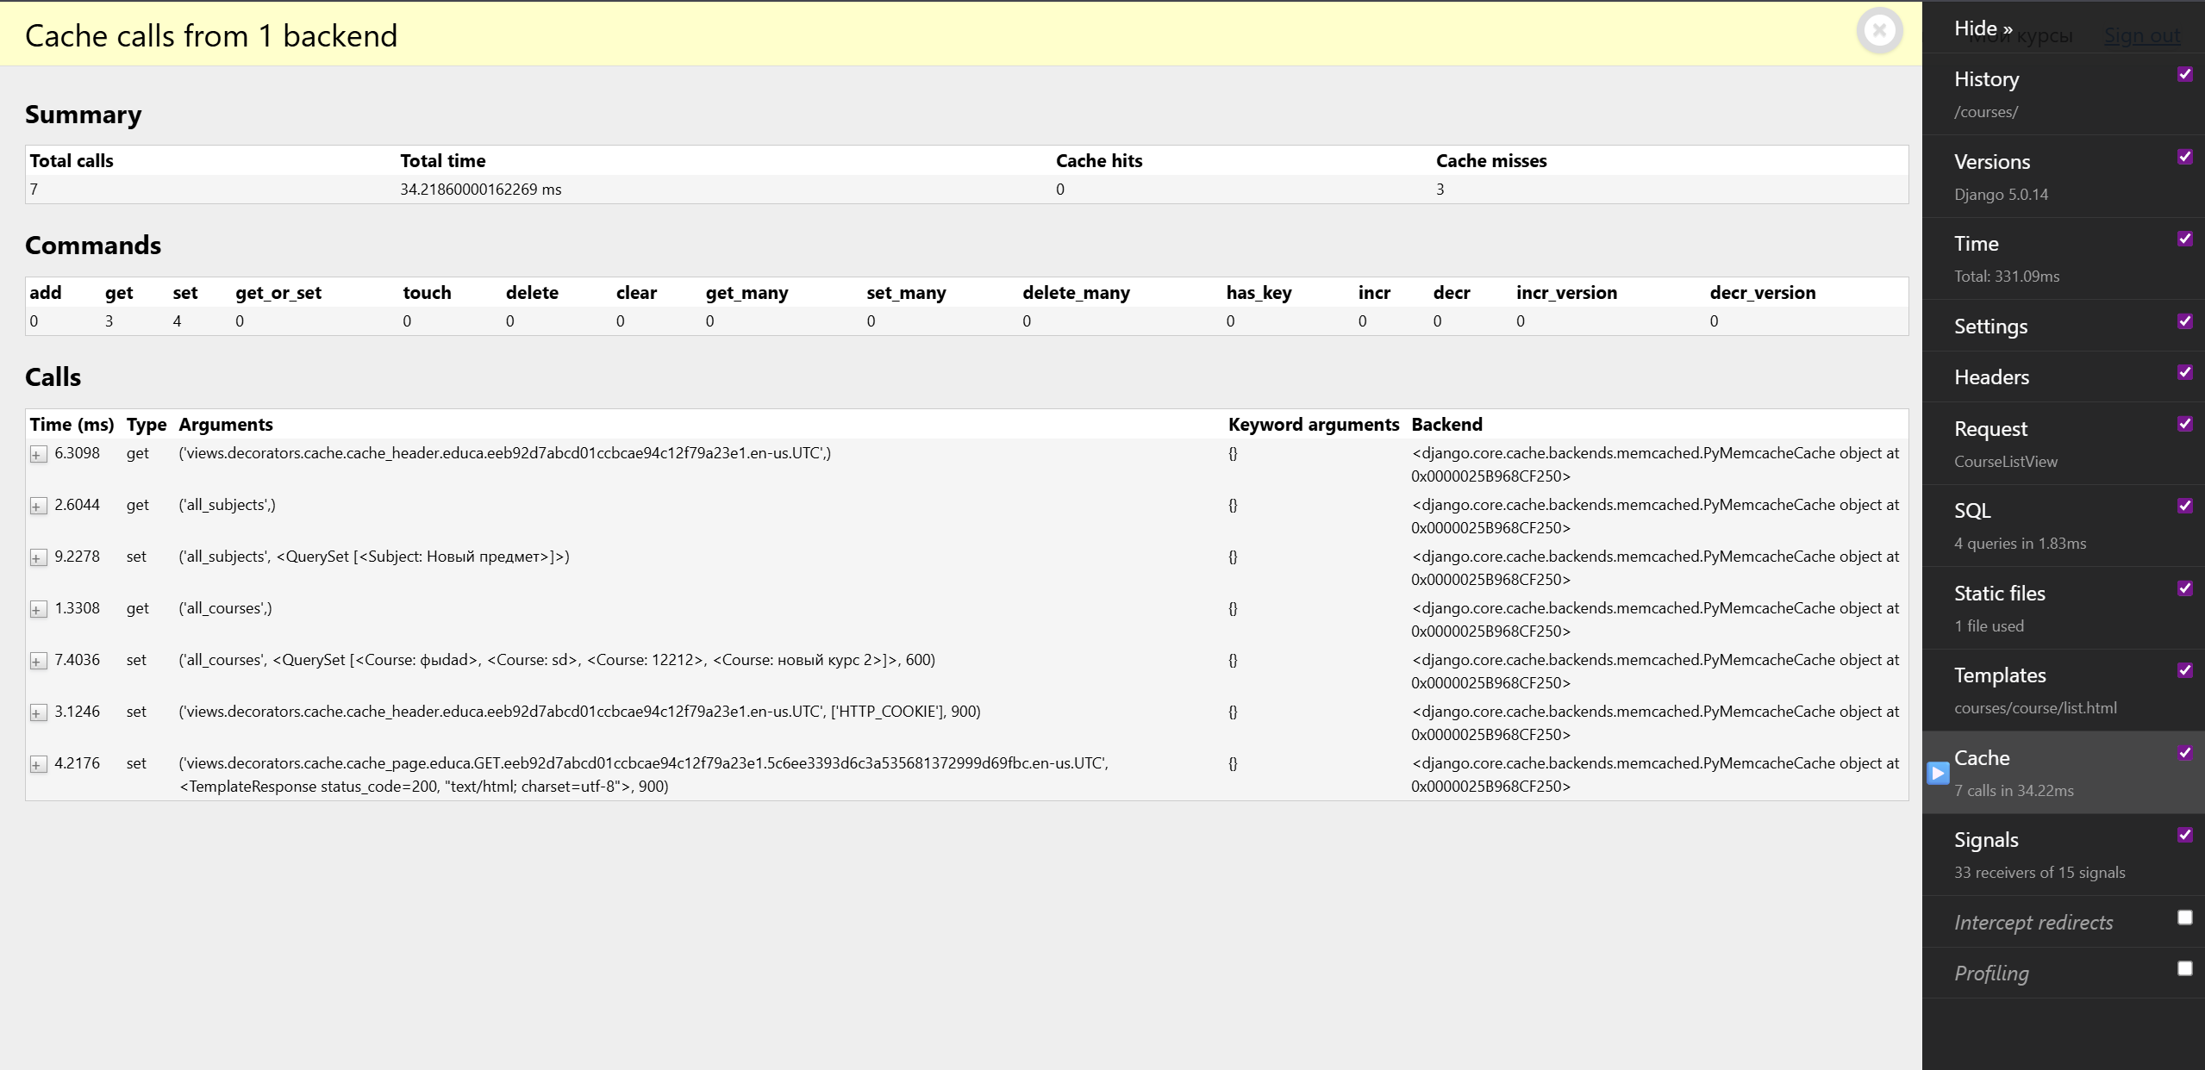
Рисунок 1 – Кеширование с помощью Redis

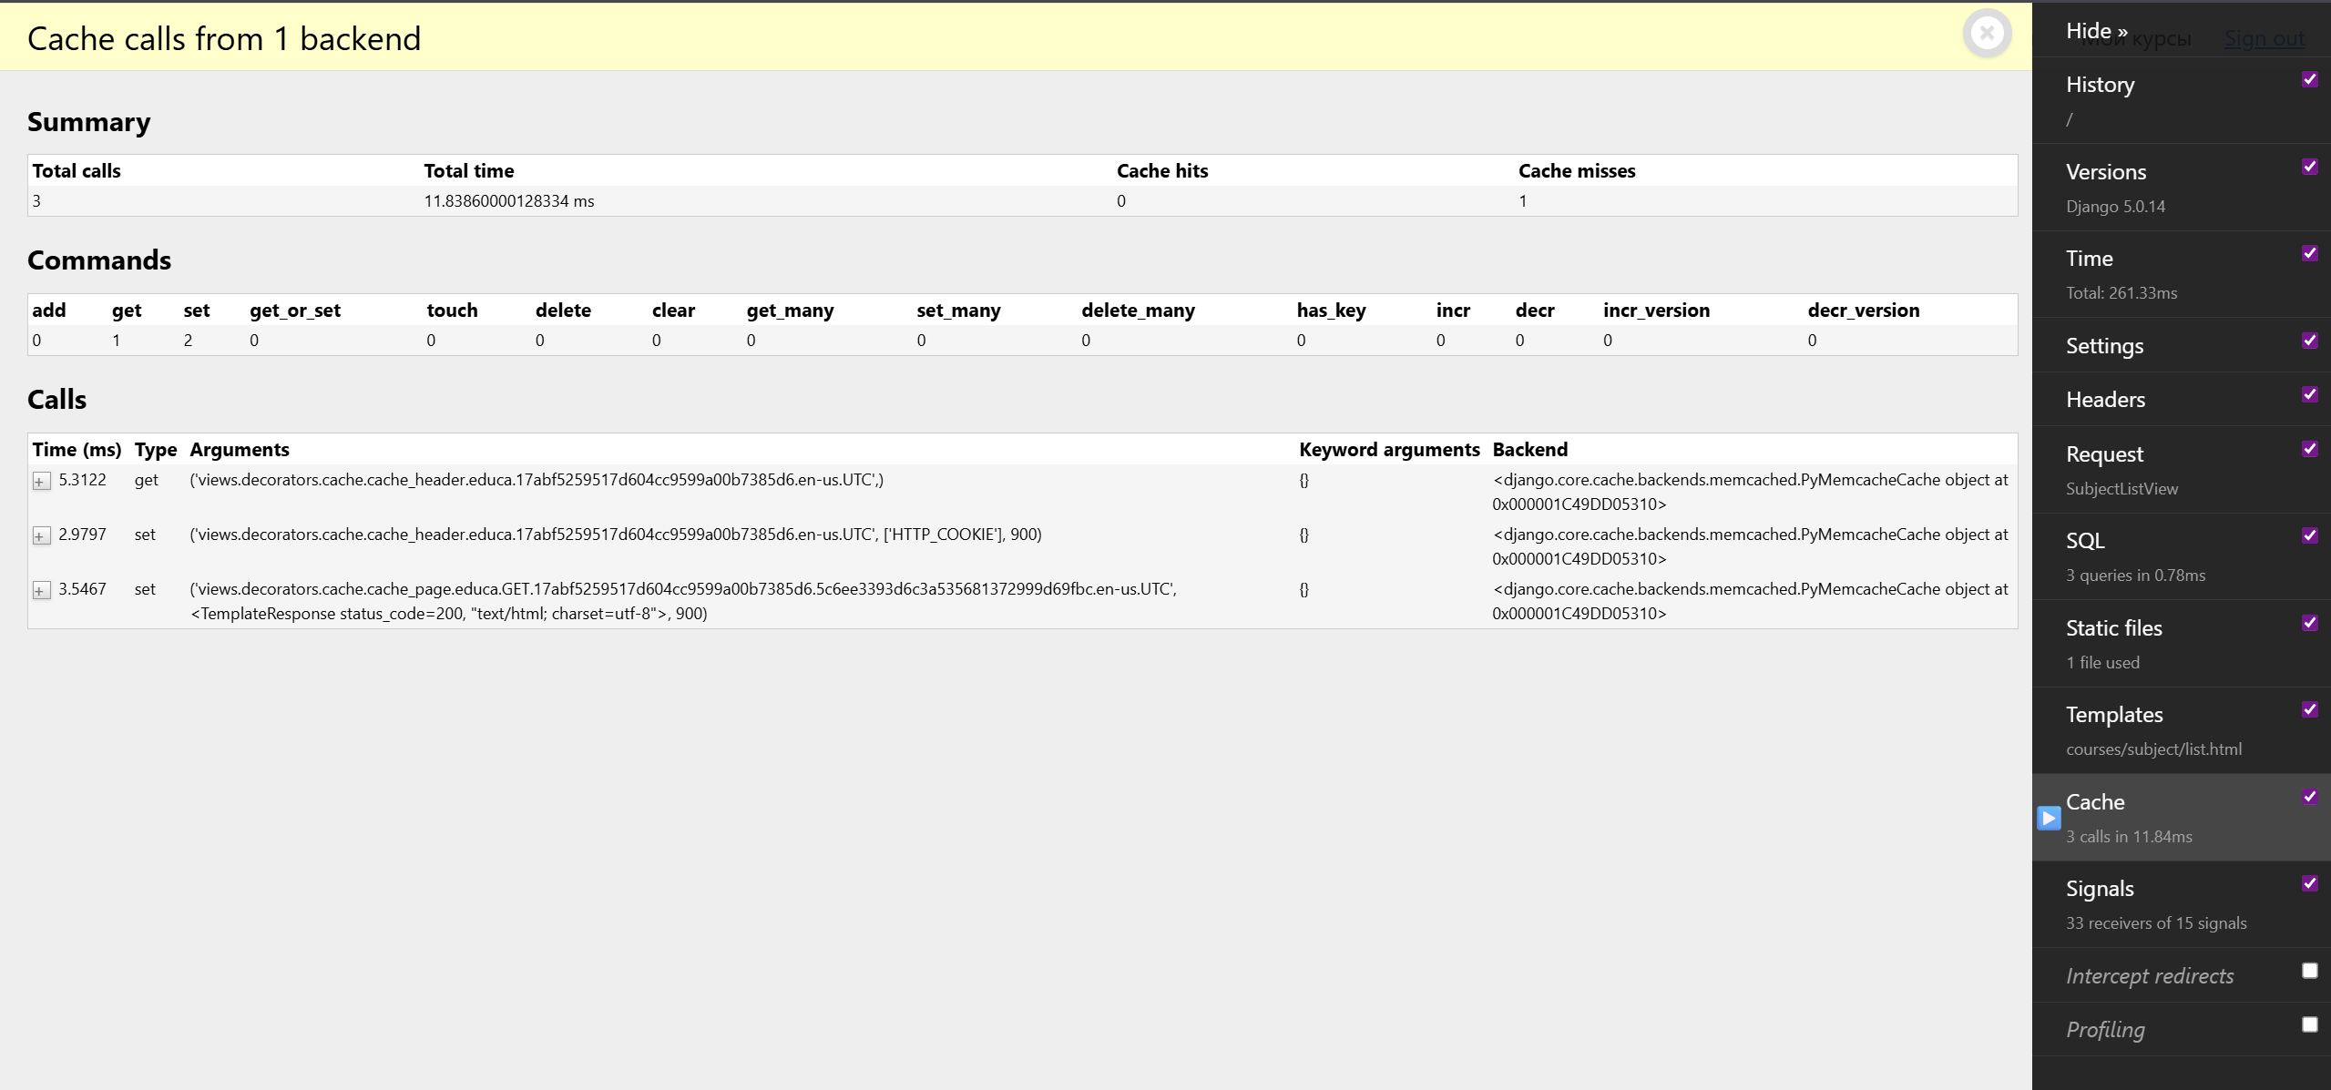
Рисунок 2 – Кеширование с помощью Memcached

Вывод: В ходе выполнения лабораторной работы был использован бэкенд кеширования Memcached и Redis

