WB plots

## R Markdown

This is an R Markdown document. Markdown is a simple formatting syntax for authoring HTML, PDF, and MS Word documents. For more details on using R Markdown see <http://rmarkdown.rstudio.com>.

When you click the **Knit** button a document will be generated that includes both content as well as the output of any embedded R code chunks within the document. You can embed an R code chunk like this:

## -- Attaching packages --------------------------------------- tidyverse 1.3.1 --

## v ggplot2 3.3.5 v purrr 0.3.4  
## v tibble 3.1.4 v dplyr 1.0.7  
## v tidyr 1.1.3 v stringr 1.4.0  
## v readr 2.0.1 v forcats 0.5.1

## -- Conflicts ------------------------------------------ tidyverse_conflicts() --  
## x tidyr::extract() masks magrittr::extract()  
## x dplyr::filter() masks stats::filter()  
## x dplyr::lag() masks stats::lag()  
## x purrr::set_names() masks magrittr::set_names()

## [[1]]  
## [1] "magrittr" "stats" "graphics" "grDevices" "utils" "datasets"   
## [7] "methods" "base"   
##   
## [[2]]  
## [1] "forcats" "stringr" "dplyr" "purrr" "readr" "tidyr"   
## [7] "tibble" "ggplot2" "tidyverse" "magrittr" "stats" "graphics"   
## [13] "grDevices" "utils" "datasets" "methods" "base"   
##   
## [[3]]  
## [1] "patchwork" "forcats" "stringr" "dplyr" "purrr" "readr"   
## [7] "tidyr" "tibble" "ggplot2" "tidyverse" "magrittr" "stats"   
## [13] "graphics" "grDevices" "utils" "datasets" "methods" "base"

## Rows: 3978 Columns: 6

## -- Column specification --------------------------------------------------------  
## Delimiter: ","  
## chr (4): Var, Sim, Region, Activity  
## dbl (2): Year, Value

##   
## i Use `spec()` to retrieve the full column specification for this data.  
## i Specify the column types or set `show_col_types = FALSE` to quiet this message.

## # A tibble: 1 x 4  
## Var Sim Region Activity  
## <int> <int> <int> <int>  
## 1 2 1 21 7

## [[1]]  
## . Freq  
## 1 PX 1989  
## 2 XP 1989  
##   
## [[2]]  
## . Freq  
## 1 BaU 3978  
##   
## [[3]]  
## . Freq  
## 1 CHN 238  
## 2 CIV 136  
## 3 ETH 170  
## 4 GHA 136  
## 5 hic 238  
## 6 KEN 170  
## 7 lmy 238  
## 8 MOZ 136  
## 9 NGA 102  
## 10 ROW 238  
## 11 SEN 204  
## 12 TZA 204  
## 13 USA 238  
## 14 WEU 238  
## 15 wld 238  
## 16 XCF 136  
## 17 XEA 238  
## 18 XEC 204  
## 19 XSC 102  
## 20 XWF 170  
## 21 ZAF 204  
##   
## [[4]]  
## . Freq  
## 1 E_C-a 442  
## 2 E_G-a 578  
## 3 E_H-a 714  
## 4 E_O-a 680  
## 5 E_S-a 612  
## 6 E_W-a 476  
## 7 E_X-a 476

#~~~~~~~~~~~~~~~~~~~~~~~~~~~~~~~~~~~~~~~~~~~~~~~~~~~~~~~~~~~~~~~~~~~~~~~~~~~~~~~~~~~~~~~~~~~~~~~~~~~~~~~~~~~~~~~~~~~~~~~~~~~~~~  
## Energy structure ----  
  
d_energy <- d %>%   
 filter( Var == "XP",  
 Year %in% gyears4,  
 Region %in% list_ctries,  
 Sim %in% gsims_bau )  
   
#' Estimate shares by year-region  
d_energy %<>%   
 group_by(Region, Year) %>%  
 mutate( total = sum(Value),  
 share = Value/total)   
  
#' update Activity names  
#' if some levels are not found then there will be NAs  
d_energy %<>%   
 mutate( Activity = factor(Activity,  
 levels = activity_names$levels,  
 labels = activity_names$labels))   
  
  
#' create a function that creates the plots  
#my.plot <- function(x){  
 #debug   
 x = list_ctries[1]  
   
 # create title  
 ctitle <- paste(x, ": Energy composition in baseline" )  
   
 # filter  
 d_energy %>%   
 filter(Region == x) %>%   
 ggplot(., aes(x=Year,  
 y=share,  
 fill=Activity)) +   
 geom_col(position=position_dodge(),  
 width = 4) +  
 ggtitle(title) +  
 labs(title = ctitle,   
 subtitle = "Power source shares of total energy generation",  
 x = "Year",  
 y = "shares",  
 fill = "Power source:") +   
 scale_fill_manual(values = c("lightsteelblue1", "lightskyblue", "dodgerblue", "blue", "navy","black" )) +  
 scale_y_continuous(limits = c(0, 1), breaks=seq(0,1,0.1),   
 labels = scales::number_format(accuracy = 0.1)) +  
 scale_x_continuous(position = "bottom" , breaks=seq(2020,2030,10)) #+ # reorginize the ticks of x-axis

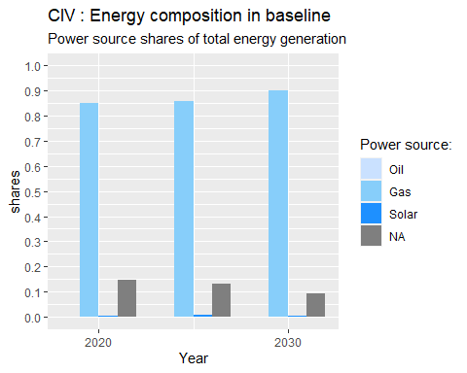

# my_theme2  
 # save plot  
 # ggsave( file.path(chart_dir, paste0("energy_baseline_", x, ".pdf")),  
 # width=10,  
 # height=6)   
#}

## Including Plots

The text can contain numbers calculated with the data. Eg the number of rows in the data is 3978

#sapply(list_ctries[1], my.plot)

Note that the echo = FALSE parameter was added to the code chunk to prevent printing of the R code that generated the plot.